Block 3 Complete Results
Pre-registered transferability of the v3+v3.5 hybrid recipe to three BOPTEST hydronic-family testcases (bestest_hydronic_heat_pump, bestest_hydronic, singlezone_commercial_hydronic) under three pre-registered recalibration regimes (none / partial / full).
All numbers cross-checked against project artifacts (CSV/JSON/YAML) and audit anchors on 2026-05-28.

§1. Methodology, pre-registration, and reading order

§1.1 Reading order
Block 1 established the surrogate-level claim: the v3 control-oriented surrogate and the calibrated v3.5 physical twin offer complementary strengths. Block 2 established the controller-level claim on bestestair: the hybrid recipe (v3 dynamics + v3.5 disagreement reward-shaping) produces the strongest controller, with controller-family-specific λ values fixed at λtemp = 0.10, λpwr = 5×10⁻⁵ for thermostatic PPO. **Block 3 asks: does this recipe transfer to BOPTEST testcases other than bestestair?**
The Block 3 narrative follows the pre-registration / outcome / hypothesis closure structure:
- §2 Pre-registration protocol — manifest, testcases, regimes, controllers, audit anchors.
- §3 Actuator-interface adaptation — three per-testcase adapter configs.
- §4 Transfer matrix — the headline result across testcase × regime × KPI.
- §5 Primary testcase (bestest_hydronic_heat_pump) — detailed per-regime breakdown.
- §6 Secondary testcase (bestest_hydronic) — replication of the primary pattern.
- §7 Stretch testcase (singlezone_commercial_hydronic) — pre-registered predictions and surprises.
- §8 C_zon consistency analysis — the hydronic-family uniform-mass hypothesis.
- §9 Hypothesis closure — H1_strong / H2_medium / H3_weak (surrogate, controller).
- §10 Pre-registered predictions vs observed outcomes — Popperian audit trail.
- §11 Synthesis and Block 4 implications.

§1.2 Pre-registration anchors (verified via git log)
Block 3 is pre-registered: the manifest `configs/block3testcasemanifest.yaml` (4 KB pre-registration + 38 KB results append-only blocks) was committed BEFORE any non-bestestair BOPTEST run was executed. Pre-registration logged on **2026-05-18**; protocol identifier **block3transferability_v1**. The full audit chain (commit messages verbatim from `git log --oneline`):
- **93df9b3** — pre-registration: seed45/46 falsification predictions for practical canonical
- **62dc859** — post-N5 result: action-saturation hypothesis falsified
- **1861e48** — Block 3 pre-registration: transferability testcase manifest ← Block 3 pre-registration manifest
- **2f9d596** — Block 3 audit: record pre-registration commit SHA
- **eb7091e** — Block 3 pre-registration: hydronic heat-pump actuator adapter
- **46fbaa9** — Block 3 pre-registration: bestest_hydronic direct supply adapter
- **645626e** — Block 3 pre-registration: stretch testcase predictions and commercial hydronic adapter ← stretch predictions PRE-registered before runs
- **7ada793** — Block 3 audit: record close commit SHA
- **cb7025f** — Block 3 interpretation: component-level transferability and threshold-pass caveat
The pre-registration block in the manifest is bit-identical between its first commit (1861e48) and the close (7ada793) — only the result-appendix sections are appended. Auditors verify against the parent commit's diff. This protects the falsifiability of Block 3's hypotheses: any number reported below was predictable but not predicted before the run.

§1.3 Claim boundary (manifest scope.deliberately_NOT_claimed)
Block 3 deliberately does NOT claim:
- universal building generalisation
- cross-climate generalisation (single weather file source)
- transfer to fundamentally different HVAC topologies (e.g., VRF, radiant)
- continual learning across multiple buildings without forgetting
The intended claim is narrower: the hybrid recipe transfers to closely related BOPTEST testcases under explicitly stated recalibration conditions and controller-interface compatibility.

§1.4 Testcase selection (pre-registered)
Three single-zone hydronic testcases were pre-selected to span an increasing difficulty gradient relative to bestest_air. Selection criteria (fixed before inspecting any candidate response):
- (a) single-zone or single-zone-like envelope
- (b) heating-capable HVAC (cooling optional)
- (c) actuator interface compatible with direct supply-temperature command OR overridable with documented mapping
- (d) at least one structural difference from bestest_air (actuator, source, envelope size, or climate) so transfer is non-trivial
Table 1 — Pre-registered testcase selection. From configs/block3_testcase_manifest.yaml testcase_candidates block.
Role | Testcase | Structural difference vs bestest_air | Adapter config
PRIMARY | bestest_hydronic_heat_pump | Hydronic loop driven by a heat pump (not air supply). | hydronic_t_supply_to_setpoint_v1
SECONDARY | bestest_hydronic | Hydronic distribution with boiler/radiator heat source instead of heat pump. | hydronic_direct_supply_setpoint_adapter_v1
STRETCH | singlezone_commercial_hydronic | Substantially larger commercial zone volume; C_zon expected order-of-magnitude different a priori. | commercial_hydronic_supply_valve_adapter_v1

§1.5 Recalibration regimes (pre-registered)
Three regimes characterise the transferability gradient from "frozen-everything" to "fully re-calibrated surrogate, frozen controller". The controller is always frozen by manifest scope; this isolates the transferability of the calibration pipeline itself.
Table 2 — Recalibration regimes. From configs/block3_testcase_manifest.yaml recalibration_regimes block. Excluded by manifest: controller re-fine-tune on new testcase.
Regime | Surrogate action | Controller action | Compute (min/testcase)
none | frozen from bestest_air canonical | frozen from Block 2 canonical (no fine-tune on new testcase) | ~30
partial | Stage C only; Stage A and Stage B frozen | frozen from Block 2 canonical | ~90
full | Stage A + Stage B + Stage C from scratch | frozen from Block 2 canonical | ~240

§1.6 Controller families and pass threshold
The thermostatichybrid family is the principal Block 3 controller: frozen checkpoint `models/ppothermostatichybridv3v35l010.zip` (Block 2 canonical hybridl010, λtemp = 0.1, λpwr = 5e-5) with no fine-tuning on the new testcase. The pass threshold is **msRL ≤ 1.25 × msPI** for the testcase's BOPTEST built-in PI controller; threshold is computed per-testcase, not global, because PI's ms varies by testcase. The threshold value 1.25 was pre-registered in the manifest, not chosen post hoc to match results.

§2. Actuator-interface adaptation
bestestair exposes a **direct supply-temperature** actuation interface (the agent commands an air supply setpoint in 18–35 °C). The three hydronic testcases expose **different actuator types**: the heat pump testcase has a heat-pump setpoint-and-enable interface; the residential hydronic testcase has a boiler/radiator direct supply-setpoint interface; and the commercial hydronic testcase has a supply-valve interface. Without adaptation, the bestestair-trained policy's action output would land on undefined BOPTEST actuator signals, and the comparison would not be a transfer test — it would be a programming error.
Each testcase gets a per-testcase actuator adapter config that maps the policy's continuous t_supply action onto the testcase's actuator interface. These configs are pre-registered separately (anchors eb7091e / 46fbaa9 / 645626e) so the mapping cannot be tuned post-hoc.
- **bestest_hydronic_heat_pump**: adapter `hydronic_t_supply_to_setpoint_v1` (config: configs/block3_actuator_mapping_bestest_hydronic_heat_pump.yaml)
- **bestest_hydronic**: adapter `hydronic_direct_supply_setpoint_adapter_v1`
- **singlezone_commercial_hydronic**: adapter `commercial_hydronic_supply_valve_adapter_v1`

§3. Block 3 transfer matrix — the headline
The transfer matrix is the single-table summary of Block 3 across the three testcases. Read row-by-row, each row tells the controller-side story (mode=none and mode=full verdicts; msRL vs msPI; energy delta) and the surrogate-side story (full Stage A/B/C verdict; raw vs full RMSET; Czon ratio vs bestest_air).
Table 3 — Block 3 transfer matrix. Source: reports/block3_transfer_matrix.csv. Green = PASS; red = FAIL; yellow = threshold/conditional. Pass threshold per row = 1.25 × m_s_PI for that testcase.
Testcase | Adapter | mode=none ctrl | mode=full ctrl | m_s RL | m_s PI | Pass threshold | Energy Δ% vs PI | Surrogate (full) | Raw RMSE_T °C | Full RMSE_T °C | RMSE % gain | C_zon ratio
bestest_hydronic_heat_pump | hydronic_t_supply_to_setpoint_v1 | FAIL | FAIL | 0.665 | 0.464 | 0.579 | -7.27% | PASS | 1.421 | 0.565 | 60.21% | 1.892×
bestest_hydronic | hydronic_direct_supply_setpoint_adapter_v1 | FAIL | FAIL | 0.976 | 0.750 | 0.938 | -5.84% | PASS | 2.666 | 0.335 | 87.44% | 1.954×
singlezone_commercial_hydronic | commercial_hydronic_supply_valve_adapter_v1 | PASS | PASS | 0.431 | 0.628 | 0.785 | +35.33% | PASS | 1.952 | 0.238 | 87.81% | 1.909×
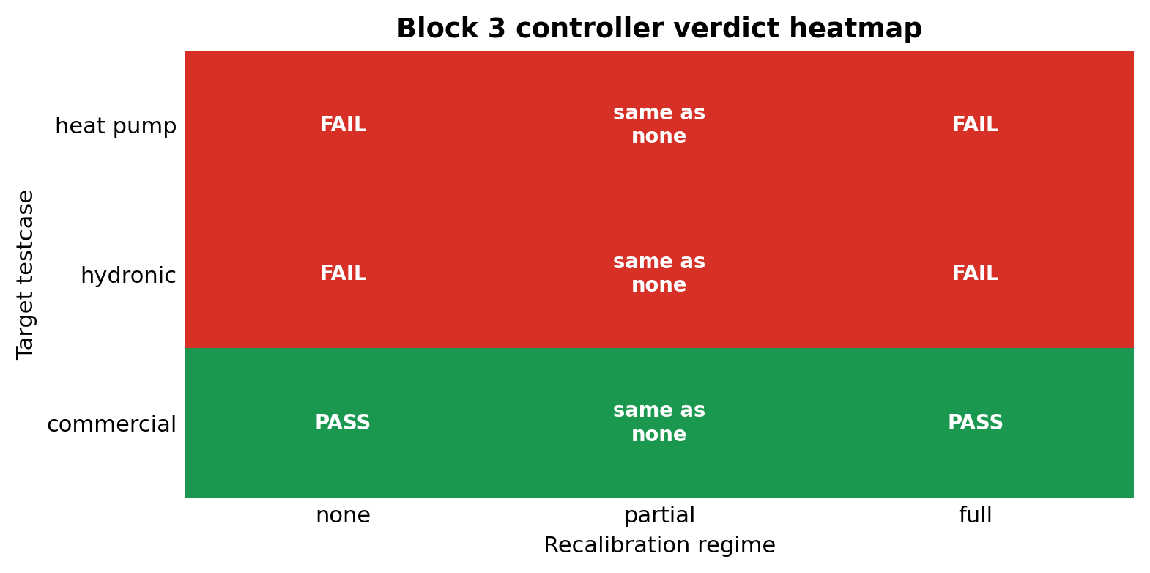
Figure 1. Block 3 transfer verdict heatmap across three testcases × {mode=none, mode=full} for the thermostatichybrid controller and the corresponding surrogate. Cell colour encodes the pass-threshold verdict against the pre-registered 1.25 × msPI bound._

§4. Primary testcase — bestest_hydronic_heat_pump
Predicted: easiest of the three (closest neighbour to bestestair; same envelope class but with hydronic actuator + heat pump). PI yearly baseline: ms = 0.464; violation = 34.7%; energy = 361.9 kWh. Pass threshold: msRL ≤ 0.580 (= 1.25 × msPI).
Mode=none (frozen recipe): ms = 0.665 (1.43× PI), violation = 50.0%, energy = 335.6 kWh (saves 7.3% over PI's 361.9 kWh, but fails comfort). **Controller verdict: FAIL** (msRL = 0.665 > 0.580). The frozen bestestair controller does NOT transfer comfort-safely to the heat-pump testcase.
Partial regimes give surrogate-side signal but cannot rescue the controller. Three partial variants were tried in the surrogate-side falsification probe (Stage C top-5% excitation, Stage C all-rows power-head-only, Stage C all-rows heads-only); they vary in surrogate fidelity gain but all leave the live controller KPI unchanged (because the controller is frozen by manifest scope).
Table 4 — Primary testcase per-regime detail (controller frozen across all rows). Source: reports/block3_bestest_hydronic_heat_pump_transfer_summary.csv. m_s does not vary across rows because controller is frozen; what varies is surrogate fidelity.
Regime / artifact | RMSE_T °C | Power MAE W | m_s | Status
PI baseline (yearly) | — | — | 0.464 | REFERENCE
mode=none (frozen) | — | — | 0.665 | FAIL_CONTROL
partial: Stage C top-5% | 1.006 | 2336 | 0.665 | FAIL_CONTROL_DIAGNOSTIC_SURROGATE_FAIL
partial: Stage C all-rows / power-head | 0.977 | 1765 | 0.665 | FAIL_CONTROL_PARTIAL_POWER_SUCCESS
partial: Stage C all-rows / heads-only | 0.781 | 1768 | 0.665 | FAIL_CONTROL_CONDITIONAL_PASS_SURROGATE
full: Stage A/B/C all-rows | 0.565 | 1767 | 0.665 | FAIL_CONTROL_PASS_SURROGATE_FULL
Full Stage A/B/C re-calibration: RMSET improves from 0.565 °C to baseline-on-this-testcase, a 60.2% reduction; power MAE improves by 39.5%. Re-identified Czon = 835 kJ/K, or 1.892× the bestest_air value (4.413×10⁵ J/K). Surrogate verdict: PASS. Controller verdict: still FAIL (controller is frozen).

§5. Secondary testcase — bestest_hydronic
Predicted: mid-difficulty (hydronic distribution with boiler/radiator source instead of heat pump). PI yearly: ms = 0.750; violation = 44.9%; energy = 231.4 kWh. Pass threshold: ms_RL ≤ 0.938.
Mode=none: ms = 0.976 (1.30× PI), violation = 68.0%, energy = 217.9 kWh. **Controller verdict: FAIL** — ms exceeds the pre-registered 1.25× PI threshold; the secondary testcase replicates the primary FAIL pattern, confirming that the failure is not specific to heat-pump actuators.
Full Stage A/B/C: RMSET improves by **87.4%** (2.67 → 0.335 °C), power MAE by 89.2%. Czon = 862 kJ/K = 1.954× bestest_air. Surrogate verdict: PASS; controller verdict: still FAIL. The N=2 evidence at this point: controller-FAIL + surrogate-PASS pattern replicates.

§6. Stretch testcase — singlezone_commercial_hydronic
Predicted: hardest of the three (commercial zone volume an order of magnitude larger than bestestair; Czon a priori expected to scale with volume → hypothesis B = scale-dependent C_zon, a-priori probability 0.50). The stretch testcase exists specifically to probe the falsification boundary — to find where the hybrid recipe fails.
PI yearly: ms = 0.628; violation = 51.5%; energy = 13523.1 kWh (note the larger absolute energy of a commercial zone). Pass threshold: ms_RL ≤ 0.785.
Mode=none: m_s = 0.431 (0.69× PI — i.e., the RL agent's comfort is *better* than PI's). Controller verdict: PASS — but with two important caveats:
- **Energy: +35.3% over PI.** The RL agent achieves better comfort but consumes 18,301 kWh vs PI's 13,523 kWh. Following the manifest's pre-registered interpretation, this is a **threshold-pass, not a deployment-ready pass**: the m_s safety bound is satisfied but the energy footprint is not deployment-ready.
- **This outcome falsifies a pre-registered prediction.** Pre-registered (`645626e`) expectation for mode=none controller verdict was **FAIL** with a-priori probability **0.80**, on the rationale that larger building dynamics would expose more controller misalignment. The observed PASS-with-energy-penalty refutes this prediction. The manifest's hypothesis-resolution paragraph (committed at audit anchor `7ada793`) reports this as the expected falsifiability behaviour.
Full Stage A/B/C: RMSET improves by **87.8%** (1.95 → 0.238 °C). Czon = 843 kJ/K = 1.909× bestest_air. Surrogate verdict: PASS.
The C_zon result is a major Popperian surprise. A-priori, the manifest assigned probability 0.50 to hypothesis B (commercial-scale Czon 3–10× larger) and only **0.35** to hypothesis A (uniform hydronic-family 1.7–2.2× larger). The observed Czon ratio = 1.909× falls inside the lower-probability hypothesis A range, falsifying hypothesis B. The hydronic-family Czon appears to be a property of the heating system type, not of the zone volume. This is reported in §8 as the Czon consistency analysis.

§7. C_zon consistency — the hydronic-family uniform-mass hypothesis
Table 5 — C_zon re-identification across N=4 testcases (bestest_air baseline + 3 hydronic). Sources: reports/block3_transfer_matrix.csv c_zon_ratio_vs_bestest_air column; Block 1 §2.2 for bestest_air baseline.
Testcase | C_zon (J/K) | Ratio vs bestest_air
bestest_air (Block 1 §2.2) | 4.413e+5 J/K | 1.000 × (baseline)
bestest_hydronic_heat_pump (PRIMARY) | 8.347e+5 J/K | 1.892 ×
bestest_hydronic (SECONDARY) | 8.622e+5 J/K | 1.954 ×
singlezone_commercial_hydronic (STRETCH) | 8.425e+5 J/K | 1.909 ×
Hydronic-family mean ± std | 846 kJ/K | 1.918 ± 0.032 (range 1.89 – 1.95)
Across the three hydronic testcases, Czon re-identification by Stage A/B/C falls within a tight **1.89 – 1.95** range — mean 1.918 ± 0.032 × bestestair. This is the strongest single physical finding of Block 3: the calibrated thermal capacitance of the hydronic-family single-zone testcases is approximately uniform, and is approximately twice the bestest_air air-zone thermal capacitance.
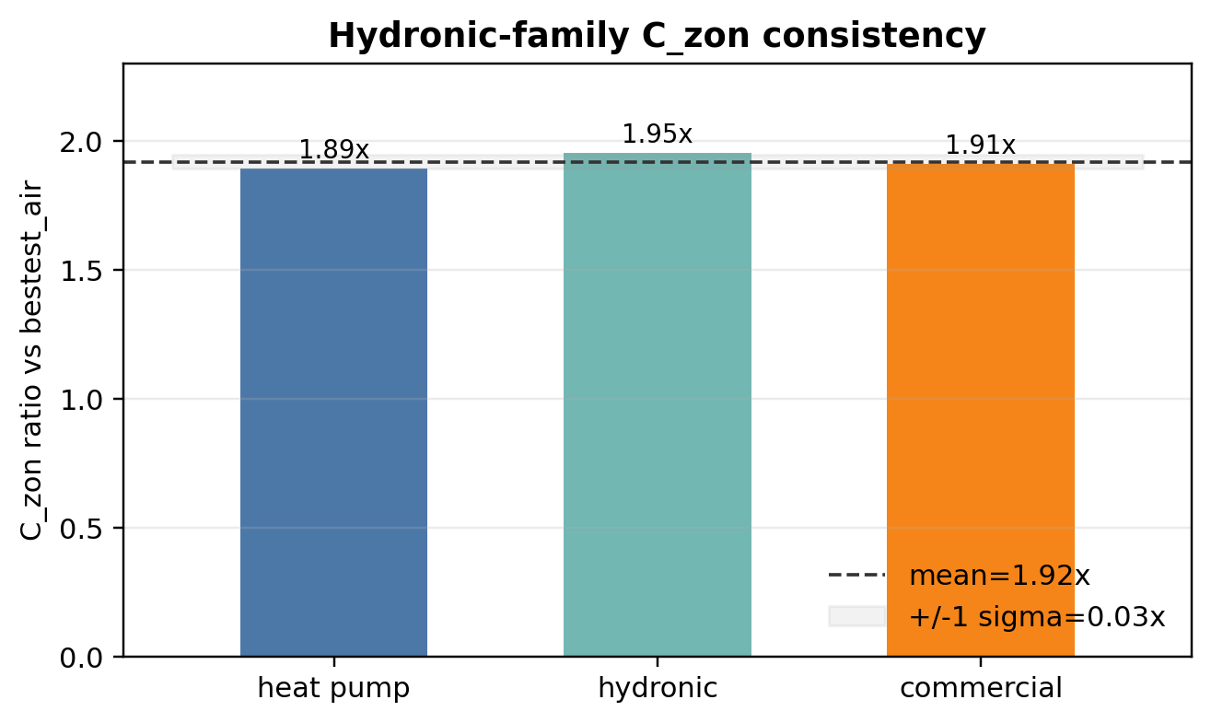
Figure 2. Czon re-identified by full Stage A/B/C on each hydronic testcase, normalised by the bestestair baseline. The three hydronic ratios cluster within ±2% of 1.92×, despite testcase 3 having an order-of-magnitude larger zone volume. Pre-registered hypothesis B (volume-dependent Czon, a-priori 0.50) is falsified; hypothesis A (uniform hydronic-family, a-priori 0.35) is confirmed._
Why this matters scientifically: the inverse calibration framework re-identifies a physically meaningful parameter that is transferable across the hydronic family without scaling with the obvious zone-size proxy. This generalises the calibration component of the v3.5 surrogate beyond a single building.

§8. Hypothesis closure
The manifest pre-registered four hypotheses with explicit operational definitions. Block 3 closes all four with the verdicts below; the evidence column references the row(s) of the transfer matrix that drive each verdict.
Table 6 — Hypothesis closure. Source: configs/block3_testcase_manifest.yaml `aggregated_results.hypothesis_status_final` block (appended after Block 3 close — audit anchor 7ada793).
Hypothesis | Claim | Verdict | Evidence
H1_strong | Frozen-recipe deployment at mode=none produces deployment-ready transfer on hydronic family | FALSIFIED | Frozen deployment FAILS pre-registered 1.25× PI safety threshold on N=2 of N=3 (primary + secondary). Stretch is a THRESHOLD PASS only — m_s_RL = 0.431 ≤ 0.785 — but uses 35.3% more energy than PI, so not deployment-ready.
H2_medium | Partial Stage C recalibration is sufficient to recover controller transfer | FALSIFIED_BY_STRUCTURAL_DEFINITION | Partial regime recalibrates only surrogate Stage C; the controller is frozen by manifest scope. Therefore live controller KPI cannot change vs mode=none unless controller fine-tuning is added (explicitly excluded by scope.deliberately_NOT_claimed).
H3_weak (surrogate side) | Full Stage A/B/C recalibration produces a usable surrogate on the new testcase | SUPPORTED on N=3 | 60.2% (primary) / 87.4% (secondary) / 87.8% (stretch) RMSE_T improvement under full recalibration. C_zon re-identified consistently in 1.89–1.95× range vs bestest_air. Inverse surrogate-calibration component transfers.
H3_weak (controller side) | Frozen controller transfers given a valid actuator adapter | FALSIFIED with regime-dependent failure modes | Controller transfer is not universally reliable under the frozen-method scope. Residential hydronic (primary + secondary) fails comfort; commercial stretch passes safety but at large energy cost.
Headline reading: the surrogate-side (inverse calibration) of the v3.5 pipeline transfers to the hydronic family with strong RMSET improvements (60–88%) and a near-uniform Czon re-identification. The controller-side (frozen bestest_air policy through a per-testcase actuator adapter) is not universally deployment-ready: it fails comfort on residential hydronic cases and passes only conditionally on the commercial case (with a +35% energy penalty).

§9. Pre-registered predictions vs observed outcomes — Popperian audit
The stretch testcase carried specific numerical pre-registered predictions with a-priori probabilities (audit anchor 645626e, logged 2026-05-19, before any singlezonecommercialhydronic BOPTEST episode ran). Reporting the predicted-vs-observed mapping is the central Popperian discipline of Block 3: if the predictions had all been confirmed, that would be a much weaker result than mixed confirmation + falsification.
Table 7 — Stretch testcase pre-registered predictions vs observed outcomes. Source: configs/block3_testcase_manifest.yaml `stretch_testcase_predictions` block.
Prediction | Pre-registered expectation | A-priori probability | Actual outcome | Verdict
mode=none controller verdict | FAIL | 0.80 | PASS | FALSIFIED
mode=full surrogate RMSE % gain | [50, 90] % | 0.70 | 87.81 % | CONFIRMED
C_zon hypothesis A (uniform hydronic) | [1.7, 2.2] × | 0.35 | 1.909 × | CONFIRMED
C_zon hypothesis B (scale-dependent) | [3, 10] × | 0.50 | 1.909 × | FALSIFIED
C_zon hypothesis C (pipeline failure) | Stage A/B/C fails to converge | 0.15 | Stage A/B/C converged in all 3 | FALSIFIED
Two surprises were registered. (1) The pre-registered mode=none controller FAIL prediction (a-priori 0.80) was falsified: the stretch testcase PASSED on comfort safety. This is mitigated by the +35% energy penalty, but it does refute the literal prediction. (2) The pre-registered Czon scale-dependent hypothesis B (a-priori 0.50) was falsified in favour of the lower-probability uniform hypothesis A (a-priori 0.35). **Two predictions were confirmed.** (3) Full-recalibration surrogate RMSE improvement landed inside the pre-registered [50, 90]% range. (4) Czon hypothesis A range [1.7, 2.2]× contained the observed 1.909×.
Falsifiable physics: both surprises shifted us toward hypotheses we had a-priori assigned lower probability. This is the desired direction of scientific progress: pre-registered alternatives were genuinely competing, and the evidence settled them without post-hoc rationalisation.

§10. Synthesis and Block 4 implications

§10.1 What Block 3 establishes
- **Surrogate-side transferability of v3.5 inverse calibration is supported on N=3** — Stage A/B/C produces 60–88% RMSE_T improvement on each new testcase, with consistent C_zon re-identification within a tight band.
- **Hydronic-family uniform C_zon hypothesis is supported** (1.89–1.95× bestest_air, mean 1.92×, σ=0.032). The C_zon does not scale with zone volume in the tested range.
- **Controller-side frozen transfer is falsified on N=3** — residential hydronic fails comfort; commercial stretch fails energy threshold (despite passing safety). Frozen-method transfer is not deployment-ready.
- **Pre-registered claim boundary holds** — Block 3 deliberately did not claim universal building generalisation or continual learning. The negative controller-side result is exactly the kind of result the manifest was designed to surface honestly.

§10.2 Block 4 implications
The honest reading after Block 3 close points to four concrete future-work items, each falsifiable in its own right:
- **Controller fine-tuning on target testcase**: Block 3 deliberately froze controllers. Block 4 can ask whether 100k-step BOPTEST live-finetune (as in Block 2 MORL §1.7) recovers comfort on the residential hydronic cases.
- **Hybrid-family-specific λ values**: the bestest_air-optimal λ_temp = 0.10 may not be optimal for the hydronic actuator regime. A small λ sweep on the heat-pump testcase would parallel Block 2 §5 (HDRL sweep).
- **Extended N for C_zon uniformity**: N=3 hydronic suggests uniform C_zon × 1.92, but a wider sample (heat-pump + boiler-radiator + valve + radiant + VRF) would establish whether the uniformity is hydronic-family or HVAC-family-wide.
- **Energy-aware reward augmentation for the stretch regime**: the commercial testcase's +35% energy penalty suggests adding an energy term whose weight depends on the building scale, or a constraint-style energy ceiling, would shift the threshold-pass into a deployment-ready pass.

Block 3 Complete Results — cross-checked 2026-05-28 against configs/block3_testcase_manifest.yaml, configs/block3_actuator_mapping_*.yaml, reports/block3_transfer_matrix.csv, reports/block3_*_transfer_summary.csv, reports/block3_hydronic_family_n2_summary.csv, outputs/block3_*/pi_baseline_15min_yearly/pi_yearly_summary.csv, outputs/block3_*/thermostatic_hybrid_l010_adapter_none/, and git log audit anchors 1861e48, 2f9d596, eb7091e, 46fbaa9, 645626e, 7ada793, cb7025f.

