When Predictive Surrogates Fail as RL Environments:
A Calibrated Physical Twin as Soft Regularizer for HVAC Control
Almaz Sapargali
[TODO] Affiliation, address, country.
Target journal: Results in Engineering (Elsevier, Q1)

Abstract
Reinforcement learning controllers for HVAC systems are typically trained on neural-network surrogates because high-fidelity simulators are too slow for the millions of environment steps consumed by modern policy-gradient methods. A natural assumption is that a more physically faithful surrogate produces a better training environment. We test that assumption on the BOPTEST bestest_air testcase and report a negative result: a calibrated physical twin with explicit zone thermal capacitance reaches a 24-hour rollout RMSE of 0.64 C versus 1.47 C uncalibrated, yet fails as a stand-alone RL training environment with live closed-loop RMSE above 4 C. We resolve the gap by using the calibrated twin as a frozen soft physical regularizer for a smoother control-oriented surrogate. The canonical hybrid backend sustains 1,786.8 environment steps/s on one CPU thread, an 85.0x speed-up over the live BOPTEST RTE HTTP loop under the same 15-min protocol, and restores live closed-loop RMSE to 0.795 C on the peak window and 0.633 C on the typical window. The optimal regularization strength is controller-family specific: lambda_temp=0.10 for thermostatic PPO, but lambda_temp=0.00 for HDRL and 17D MORL. A pre-registered transferability block further shows that the Stage A/B/C inverse surrogate-calibration pipeline transfers across three hydronic BOPTEST testcases with 60.2-87.8% RMSE_T improvement and consistent C_zon re-identification near 1.9x bestest_air, whereas frozen controller transfer is regime-dependent and not deployment-ready without target-specific fine-tuning. All numerical justifications are provided in Supplementary Tables S1-S11.
Keywords: HVAC control; deep reinforcement learning; digital twin; physics-informed machine learning; BOPTEST; multi-objective reinforcement learning.

1. Introduction
The paper is organized around a falsifiable question: does improving predictive fidelity of a building surrogate automatically improve downstream RL training utility? Our experiments show that the answer is no. The physically calibrated twin is valuable, but its best role is not to replace the control-oriented surrogate; it is to regularize it. We then ask a second, pre-registered transferability question: which parts of the recipe transfer beyond bestest_air? The answer is component-level rather than binary: the surrogate calibration pipeline transfers strongly, while the frozen controller does not transfer in a deployment-ready sense.

Contributions
1. A comfort-oriented v3 surrogate for direct supply-temperature control and RL rollout generation.
2. A physically informed v3.5 grey-box surrogate with explicit C_zon identified through Stage A/B/C inverse calibration.
3. A hybrid backend where v3 supplies the smooth RL dynamics and calibrated v3.5 acts as a frozen physical disagreement regularizer.
4. Controller-family-specific evidence: lambda_temp=0.10 for thermostatic PPO, lambda_temp=0.00 for HDRL and 17D MORL.
5. A pre-registered transferability analysis across three hydronic BOPTEST testcases, showing uniform surrogate-side transfer under full Stage A/B/C recalibration and regime-dependent frozen-controller transfer.
6. A reproducible Hou-and-Evins-style numerical audit with S1-S11 supplementary tables and real-data figures.

2. Related Work

2.1 Deep reinforcement learning for HVAC control
[TODO] Position PPO, hierarchical RL, safe RL, and MORL HVAC literature.

2.2 Surrogate and digital twin models for building energy
[TODO] Contrast predictive surrogate validity with closed-loop RL training utility.

2.3 Physics-informed and physics-guided machine learning
[TODO] Distinguish hard PINN constraints from the soft frozen regularizer used here.

2.4 BOPTEST benchmarking
[TODO] Describe BOPTEST, bestest_air, KPI definitions, and why BOPTEST RTE is the live evaluation layer.

3. Methodology

3.1 Control-oriented surrogate v3
The v3 surrogate is a direct-TSup, two-headed neural surrogate trained from BOPTEST trajectories. Its primary value is control-oriented smoothness: it gives PPO a stable local environment with temperature and power heads. Its limitation is interpretability: it is a black-box dynamics model without explicit thermal capacitance.

3.2 Physically informed surrogate v3.5 and inverse calibration
The v3.5 surrogate introduces a physical backbone with explicit zone thermal capacitance C_zon. Stage A cleans and aligns telemetry, Stage B solves the inverse task by identifying C_zon on excitation windows, and Stage C calibrates residual heads while freezing the identified physical parameter.

3.3 Hybrid backend
The hybrid backend evolves the policy under v3 dynamics and computes an auxiliary disagreement penalty against frozen calibrated v3.5. Thus v3.5 does not enter the policy forward pass; it shapes the loss only.
L_total = L_PPO + lambda_temp ||T_v3 - T_v3.5||^2 + lambda_power ||P_v3 - P_v3.5||^2
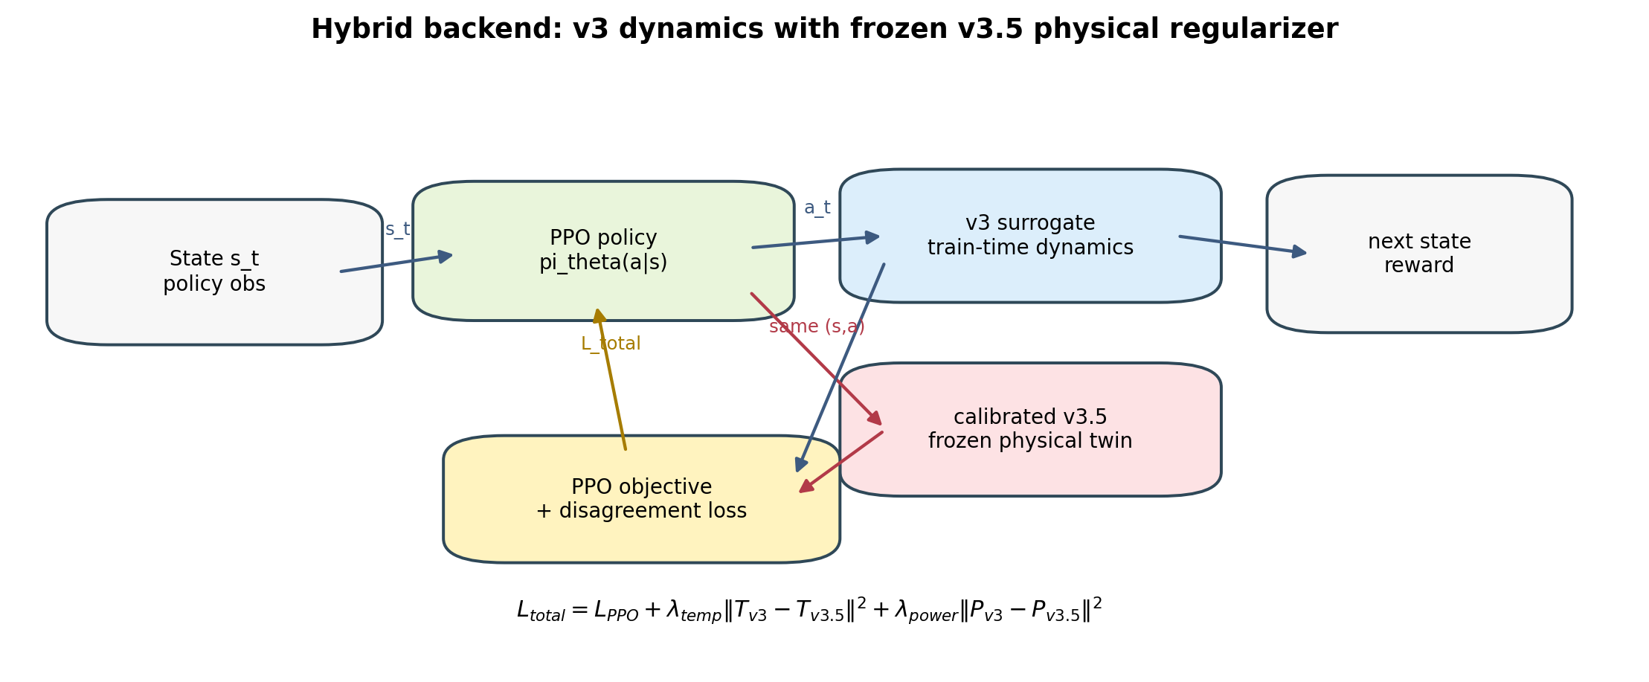
Figure 1. Hybrid backend schematic. The PPO policy rolls out through the smooth v3 surrogate while the calibrated v3.5 physical twin remains frozen and contributes only the disagreement regularizer.

3.4 Controller families
The controller stack contains the BOPTEST built-in PI reference, thermostatic PPO, HDRL, and 17D preference-conditioned MORL. Each family is evaluated under the same 15-min control protocol where possible.

4. Experimental Setup

4.1 Testbed
Blocks 1 and 2 use the BOPTEST bestest_air testcase through boptest_rte HTTP. This choice is deliberate: the same serving layer used in experiments is also used in the speed benchmark. Block 3 extends the evaluation to three related single-zone hydronic testcases: bestest_hydronic_heat_pump, bestest_hydronic, and singlezone_commercial_hydronic. These transfer cases are adapter-mediated because their actuator interfaces are not literal direct supply-temperature interfaces.

4.2 Sample generation and preprocessing
The data generation, sample-size justification, split representativeness, Stage A preprocessing, scaling, input independence, and hyperparameters are reported in Supplementary Tables S1-S8.

4.3 Runtime characteristics
Backend | Steps/s | Median step ms | P95 step ms | Speed-up
boptest_rte_http | 21.0 | 14.915 | 19.251 | 1.0x
v3_surrogate | 4,626.3 | 0.165 | 0.273 | 220.2x
v35_calibrated_surrogate | 2,399.5 | 0.359 | 0.495 | 114.2x
hybrid_v3_v35_surrogate | 1,786.8 | 0.507 | 0.648 | 85.0x
Table 1. CPU throughput benchmark under the same 15-min control protocol. Source: reports/speed_benchmark_table.csv.

4.4 Evaluation protocol
All live-control results use 900 s control steps and 14-day monthly scenarios unless otherwise stated. Comfort is evaluated against the 21-24 C zone-temperature band. The main scalar safety metric is m_s, reported together with violation percentage and energy so that single-axis threshold decisions do not hide multi-objective trade-offs.

Evaluation horizons: per-window versus yearly
We use a deliberate two-horizon evaluation protocol. The 14-day peak_heat_window and typical_heat_window scenarios are used for the in-testcase analyses of Sections 5 and 6 because they isolate controller-family behaviour at the operating extremes of the bestest_air scope: worst-case cold stress and mild average operation. The full yearly horizon is used for the transferability analysis of Section 7 because cross-testcase normalisation against each testcase's built-in PI baseline is fairest under full-year KPI averaging, which includes the target testcase's complete heating and non-heating regimes. Both evaluations share the same delta t = 900 s control protocol, the same comfort band [21, 24] C, and the same composite m_s metric; only the time horizon and the consequent normalisation differ.

4.5 Reproducibility and audit trail
The project repository is https://github.com/Almaz-2001/HVAC_DRL_MORL.git. The reproducibility roadmap is maintained in roadmap.md, and the Block 3 pre-registration manifest is configs/block3_testcase_manifest.yaml. Three audit anchors are cited in the paper: MORL canonical pre-registration commit 93df9b364657ac77bbe3642e4bc277d1eb8a8b60; MORL post-N=5 falsification commit 62dc859d02f5f4a75fa4b55d8477c1d4e6206449; and Block 3 open/close commits 1861e48dc0eacb2e2c466ba0e0d03502d9185723 / b915bfc635c287dd1da907ce84ce44c81378edd5. A follow-up audit commit 7ada793bde6d9ae1483c389b813b11cc60bdec8a records the Block 3 close SHA in the manifest.
Experiments use BOPTEST RTE version 1.0.0-dev through the HTTP-Docker service. The local analysis environment used for this document reports Python 3.11.9 and PyTorch 2.10.0+cpu; training and BOPTEST control runs are configured for CPU execution only (configs/*/agent.yaml device=cpu, surrogate_device=cpu), with no GPU used. Seed handling explicitly propagates the seed through Python random, NumPy, PyTorch, PYTHONHASHSEED, and action/observation spaces where available. A fixed-checkpoint BOPTEST replay test was bit-identical across all 12 monthly scenarios, so canonical seed variance is attributed to RL training stochasticity rather than simulator nondeterminism.

5. Results I: Digital Twin Fidelity

5.1 Architecture comparison
Variant | Role | Physics | C_zon | Peak m_s | Typical m_s | Peak energy | Typical energy | Article position
v3 | control-oriented direct-TSup surrogate | no | no | 0.073 | 0.095 | 322.2 | 368.3 | best pure control baseline
v35_calibrated | physics-oriented calibrated twin | yes | yes | 1.046 | 1.102 | 556.2 | 580.5 | best physical baseline, poor control surrogate
hybrid_l010 | v3 dynamics regularized by calibrated v3.5 | partial | regularizer-only | 0.087 | 0.041 | 305.3 | 352.8 | best verified compromise
Table 2. Architecture comparison of v3, calibrated v3.5, and hybrid_l010. Source: reports/hou_evins_architecture_justification_table.csv.

5.2 Predictive validity
Model | Horizon | RMSE_T | MAE_T | R2_T | RMSE_P | MAE_P
v3 | 1h | 1.471 | 1.200 | -0.982 | 1,227.6 | 815.5
v3 | 4h | 1.579 | 1.274 | -1.303 | 1,218.2 | 814.4
v3 | 8h | 1.579 | 1.274 | -1.355 | 1,201.7 | 807.1
v3 | 24h | 1.558 | 1.258 | -1.411 | 1,187.6 | 805.0
v3.5_calibrated | 1h | 0.321 | 0.220 | 0.905 | 688.8 | 480.7
v3.5_calibrated | 4h | 0.575 | 0.424 | 0.694 | 679.8 | 475.3
v3.5_calibrated | 8h | 0.638 | 0.476 | 0.616 | 664.7 | 468.0
v3.5_calibrated | 24h | 0.644 | 0.482 | 0.588 | 648.2 | 462.5
hybrid_l010 | 1h | 1.471 | 1.200 | -0.982 | 1,227.6 | 815.5
hybrid_l010 | 4h | 1.579 | 1.274 | -1.303 | 1,218.2 | 814.4
hybrid_l010 | 8h | 1.579 | 1.274 | -1.355 | 1,201.7 | 807.1
hybrid_l010 | 24h | 1.558 | 1.258 | -1.411 | 1,187.6 | 805.0
Table 3. Predictive validity over 1h/4h/8h/24h horizons. Source: reports/hou_evins_predictive_validity_table.csv.
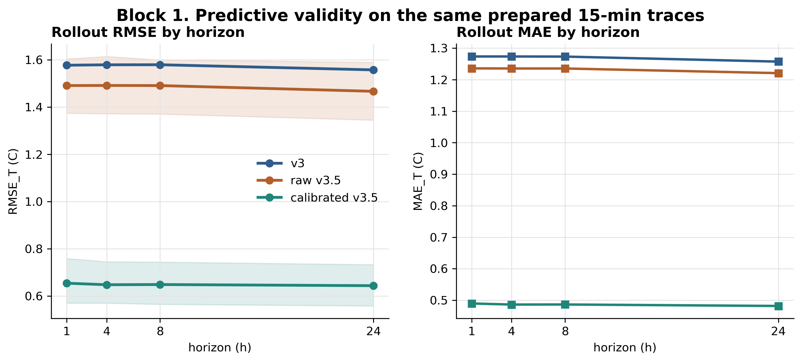
Figure 2. Block 1 predictive validity across 1h/4h/8h/24h horizons. The calibrated v3.5 twin improves long-horizon temperature prediction relative to raw v3.5 and establishes the physical twin's predictive value.

5.3 Fidelity-to-control gap
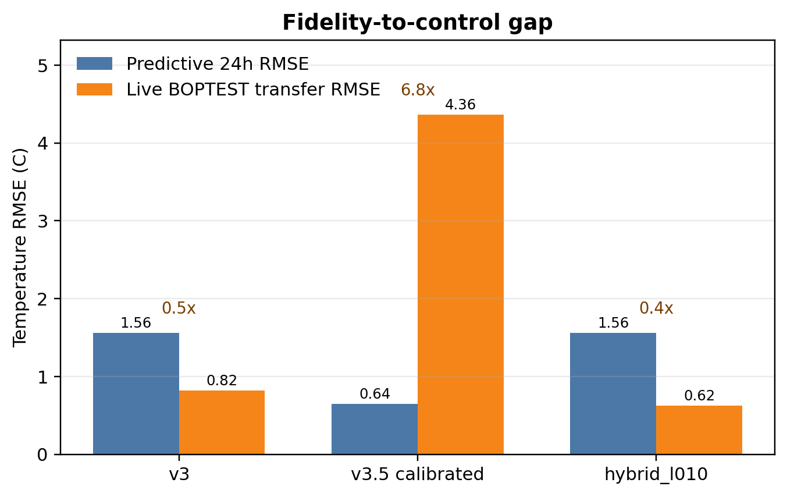
Figure 3. Fidelity-to-control gap. Predictive 24h RMSE alone does not determine live closed-loop utility: calibrated v3.5 is most predictive but has the largest live BOPTEST transfer error when used as the standalone RL backend.
The calibrated v3.5 twin is predictive but not a good standalone RL training environment. Its live closed-loop transfer RMSE exceeds 4 C in the failure experiments, motivating the hybrid regularizer rather than direct replacement of v3. Residual distributions and programmatic 24h rollout traces are kept as supplementary/defense figures rather than main-body figures.

6. Results II: Control Performance

6.1 PI baseline
The BOPTEST built-in PI controller is used as the reproducible standard reference, not as a custom-tuned strong PI baseline. Under yearly evaluation it has m_s=0.910, violation=63.59%, energy=104.07 kWh, and RMSE=3.395 C.

6.2 Negative control: direct v3.5 warm-start
The direct v3.5 warm-start is a negative control: better physical predictive fidelity does not by itself create a better RL backend. The evaluation summaries show worse closed-loop transfer than scratch in the relevant BOPTEST KPIs, so v3.5 is used as a frozen regularizer rather than the rollout environment.

6.3 Thermostatic PPO with hybrid regularization
Model | Scenario | m_s | Violation % | Energy kWh | RMSE center C
pure_v3 | peak_heat_window | 0.073 | 1.49 | 322.2
pure_v3 | typical_heat_window | 0.095 | 4.39 | 368.3
hybrid_l010 | peak_heat_window | 0.087 | 4.69 | 305.3 | 0.795
hybrid_l010 | typical_heat_window | 0.041 | 2.38 | 352.8 | 0.633
Table 4. Thermostatic pure-v3 versus hybrid_l010 BOPTEST KPIs.
Thermostatic PPO is the controller family that benefits most clearly from temperature disagreement regularization. The hybrid_l010 backend improves typical-window safety and energy relative to the pure-v3 controller while keeping the training loop in the fast in-process surrogate regime.

Unified evaluator sanity check
The new universal yearly validation runner uses testcase-aware presets so that bestest_air is evaluated with the article-style observation encoding while hydronic transfer cases use the Block 3 adapter presets. Table 4b records the current bestest_air thermostatic yearly output from the universal runner; it is included as an audit/sanity table rather than replacing the frozen Block 2 KPI table above.
Scenario | m_s | Violation % | Energy kWh | RMSE C | T min | T max | T mean
Jan_Winter | 0.153 | 9.52 | 421.7 | 1.011 | 19.79 | 24.51 | 22.51
Feb_Winter | 0.124 | 6.40 | 411.3 | 0.840 | 19.74 | 23.92 | 22.27
Mar_Spring | 0.116 | 8.41 | 318.7 | 0.944 | 20.34 | 24.49 | 22.43
Apr_Spring | 0.193 | 14.96 | 229.3 | 0.691 | 20.09 | 22.96 | 21.69
May_Spring | 0.260 | 20.68 | 144.7 | 0.822 | 19.88 | 22.44 | 21.31
Jun_Summer | 0.462 | 37.05 | 129.2 | 1.030 | 19.09 | 22.41 | 21.12
Jul_Summer | 0.549 | 44.94 | 137.6 | 1.091 | 18.91 | 22.75 | 21.15
Aug_Summer | 0.556 | 45.91 | 151.4 | 1.160 | 18.97 | 23.11 | 21.15
Sep_Autumn | 0.358 | 24.63 | 184.3 | 1.039 | 18.65 | 23.78 | 21.64
Oct_Autumn | 0.214 | 16.07 | 205.9 | 0.868 | 19.88 | 24.16 | 21.81
Nov_Autumn | 0.081 | 4.99 | 286.2 | 0.701 | 20.34 | 23.91 | 22.18
Dec_Winter | 0.121 | 7.29 | 450.8 | 1.055 | 20.69 | 25.15 | 22.71
MEAN | 0.266 | 20.07 | 255.9 | 0.938 | 19.70 | 23.63 | 21.83
Table 4b. Universal yearly validation sanity check for bestest_air thermostatic PPO. Source: outputs/universal_validation/bestest_air/thermostatic_bestest_air_article/thermostatic_universal_yearly_summary.csv.

6.4 HDRL sensitivity to physical regularization
Variant | Scenario | m_s | Violation % | Energy kWh | RMSE center C
l000 | peak_heat_window | 0.180 | 6.10 | 329.6 | 0.751
l003 | peak_heat_window | 0.307 | 11.90 | 311.5 | 0.993
l005 | peak_heat_window | 0.418 | 20.98 | 298.1 | 1.303
l010 | peak_heat_window | 0.440 | 22.99 | 300.4 | 1.343
l000 | typical_heat_window | 0.234 | 3.12 | 385.1 | 0.691
l003 | typical_heat_window | 0.296 | 9.38 | 369.6 | 0.959
l005 | typical_heat_window | 0.512 | 27.38 | 354.5 | 1.491
l010 | typical_heat_window | 0.511 | 30.65 | 357.1 | 1.455
Table 5. HDRL lambda_temp sweep. Source: reports/block2_hdrl_lambda_sweep_summary.csv.
HDRL provides the main negative result for the temperature channel. As lambda_temp increases, the safety metric and violation rate degrade; the best HDRL configuration is lambda_temp=0. This prevents a generic claim that physical disagreement penalties are always beneficial.

6.5 MORL and Pareto front
Kind | Label | w comfort | w energy | m_s | Violation % | Energy kWh | RMSE C
morl_pareto | comfort_000_energy_100 | 0.00 | 1.00 | 1.588 | 86.76 | 0.3 | 8.359
morl_pareto | comfort_025_energy_075 | 0.25 | 0.75 | 0.173 | 11.39 | 220.0 | 0.912
morl_pareto | comfort_050_energy_050 | 0.50 | 0.50 | 0.193 | 12.92 | 237.0 | 0.939
morl_pareto | comfort_050_energy_050 | 0.50 | 0.50 | 0.103 | 6.77 | 239.3 | 0.769
morl_pareto | comfort_050_energy_050 | 0.50 | 0.50 | 0.141 | 9.34 | 238.2 | 0.879
morl_pareto | comfort_050_energy_050 | 0.50 | 0.50 | 0.187 | 11.97 | 236.7 | 0.895
morl_pareto | comfort_050_energy_050 | 0.50 | 0.50 | 0.310 | 24.05 | 212.8 | 0.985
morl_pareto | comfort_075_energy_025 | 0.75 | 0.25 | 0.057 | 3.08 | 249.5 | 0.700
morl_pareto | comfort_075_energy_025 | 0.75 | 0.25 | 0.087 | 5.47 | 247.0 | 0.716
morl_pareto | comfort_075_energy_025 | 0.75 | 0.25 | 0.117 | 7.82 | 234.9 | 0.769
morl_pareto | comfort_075_energy_025 | 0.75 | 0.25 | 0.160 | 9.42 | 253.1 | 0.903
morl_pareto | comfort_075_energy_025 | 0.75 | 0.25 | 0.276 | 20.37 | 216.9 | 0.909
morl_pareto | comfort_100_energy_000 | 1.00 | 0.00 | 0.032 | 1.49 | 260.6 | 0.631
morl_reference | legacy_canonical_080_020 | 0.80 | 0.20 | 0.099 | 4.87 | 248.6 | 0.725
baseline | pi_yearly_builtin |  |  | 0.910 | 63.59 | 104.1 | 3.395
Table 6. MORL Pareto front and PI baseline. Source: reports/morl_pareto_front_table.csv.
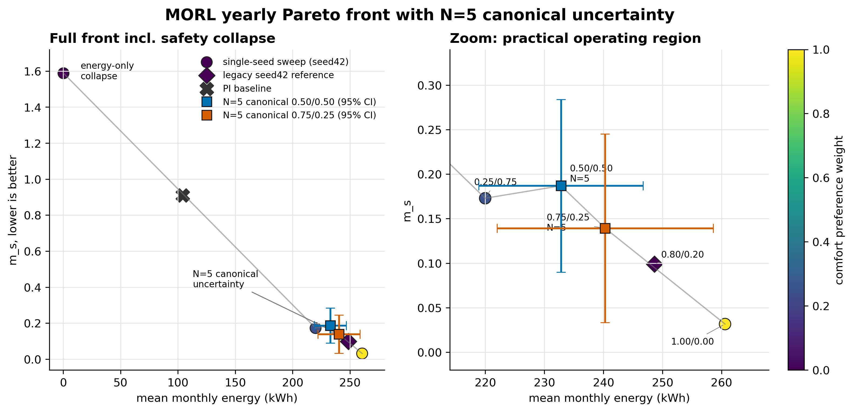
Figure 4. Block 2 MORL Pareto front with PI reference. Non-canonical sweep points are seed42-only; the two pre-registered canonical points are shown as N=5 means with 95% CI error bars. The energy-only endpoint demonstrates expected safety collapse, while canonical uncertainty shows that MORL remains promising but not deployment-stable.

MORL N=5 falsification result
The neutral canonical w=(0.50,0.50,0.00) closes at m_s=0.187 +/- 0.078 over five seeds (sigma/mean=0.418). The practical canonical w=(0.75,0.25,0.00) improves the mean operating point to m_s=0.139 but remains high-variance at N=5. The replay test showed bit-identical BOPTEST yearly evaluation for a fixed checkpoint, so the variance is attributed to RL training stochasticity rather than simulator nondeterminism. The post-N=5 test falsified the action-saturation/seasonal-inversion hypothesis; the correct article claim is therefore that MORL is promising but not deployment-stable without future policy stabilization such as validation-based checkpoint selection or ensemble policy selection.

7. Results III: Transferability and Generalization
Block 3 reports a pre-registered transferability characterization of the hybrid recipe across three related BOPTEST hydronic testcases. Unlike Sections 5 and 6, which operate inside bestest_air, this section asks which components of the recipe transfer to a different actuator and envelope regime. The manifest was committed before Block 3 BOPTEST runs; result cells are appended rather than rewriting the pre-registration block.

7.1 Pre-registered protocol
The protocol crosses three testcases with recalibration regimes none, partial, and full. The target testcases are bestest_hydronic_heat_pump, bestest_hydronic, and singlezone_commercial_hydronic. The primary live-control verdict is m_s_RL <= 1.25 x m_s_PI under the same 15-min yearly evaluation protocol. Controller fine-tuning on the target-recalibrated surrogate is explicitly excluded from Block 3; it is reserved as future Block 4 work.

7.2 Actuator-interface adaptation
bestest_air exposes a direct supply-temperature style interface, but the hydronic testcases expose heat-pump, pump, valve, boiler, radiator, or commercial AHU variables. Therefore Block 3 transfer is adapter-mediated, not literal direct-TSup transfer. Each adapter mechanically maps the frozen policy's temperature-like action to documented hydronic setpoint and enable variables. The adapter is not learned and is smoke-tested before yearly evaluation.

7.3 Transfer matrix
Testcase | None | Full | m_s RL | m_s PI | Energy delta | Full RMSE gain | C_zon ratio | Interpretation
bestest_hydronic_heat_pump | FAIL | FAIL | 0.665 | 0.464 | -7.3% | 60.2% | 1.89x | Residential hydronic heat-pump transfer fails on controller safety but succeeds on full surrogate recalibration.
bestest_hydronic | FAIL | FAIL | 0.976 | 0.750 | -5.8% | 87.4% | 1.95x | Residential hydronic transfer replicates controller-side FAIL and surrogate-side PASS.
singlezone_commercial_hydronic | PASS | PASS | 0.431 | 0.628 | 35.3% | 87.8% | 1.91x | Commercial stretch falsifies expected controller FAIL: safety passes but energy increases substantially; surrogate-side PASS and C_zon ratio remains near 1.9x.
Table 7. Block 3 transfer matrix. Controller verdicts use the pre-registered threshold m_s_RL <= 1.25 x m_s_PI. Full surrogate gains are diagnostic because the controller remains frozen by protocol. Source: reports/block3_transfer_matrix.csv.
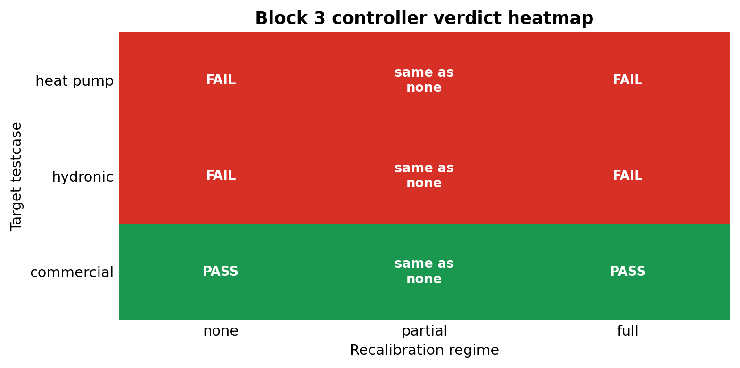
Figure 5. Block 3 transferability matrix. Red/green cells show the pre-registered controller verdict across three target testcases and three recalibration regimes. The partial regime is structurally identical to none for live-control KPIs because the controller remains frozen.

7.4 Testcase-level interpretation
The primary testcase, bestest_hydronic_heat_pump, fails controller transfer at mode=none: m_s_RL=0.665 versus m_s_PI=0.464 and threshold 0.579. Energy is 7.3% below PI, so the failure mode is comfort rather than energy. Full Stage A/B/C recalibration is strongly positive on the surrogate side, reducing RMSE_T from 1.421 C to 0.565 C and re-identifying C_zon at 1.89x the bestest_air value.
The secondary testcase, bestest_hydronic, replicates this residential hydronic pattern. The frozen controller has m_s_RL=0.976 against threshold 0.938 and saves 5.8% energy versus PI, again failing on comfort. Full recalibration reduces RMSE_T from 2.666 C to 0.335 C and re-identifies C_zon at 1.95x bestest_air.
The stretch testcase, singlezone_commercial_hydronic, breaks the binary failure pattern in a useful way. It is a threshold PASS on safety (m_s_RL=0.431 versus m_s_PI=0.628 and threshold 0.785), but it consumes 35.3% more energy than PI. Full recalibration again succeeds on the surrogate side, reducing RMSE_T from 1.952 C to 0.238 C and identifying C_zon at 1.91x bestest_air.

7.5 Aggregate finding
Two patterns emerge. First, the surrogate component is uniformly transferable: full Stage A/B/C recalibration improves RMSE_T by 60.2%, 87.4%, and 87.8% across the three hydronic testcases, while C_zon ratios are tightly clustered at 1.89x, 1.95x, and 1.91x. This supports testcase-portability of the Hou-and-Evins inverse calibration pipeline on the hydronic family.
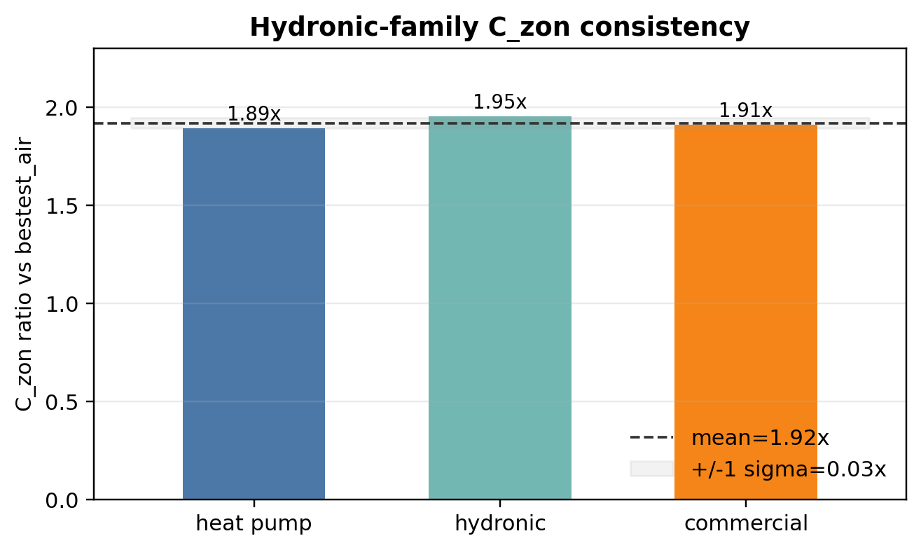
Figure 6. Block 3 C_zon consistency. Full Stage A/B/C recalibration re-identifies the hydronic-family thermal capacitance at approximately 1.9x the bestest_air canonical value across all three target testcases.
Second, the frozen controller component is regime-dependent and not deployment-ready. On the two residential hydronic testcases it fails the safety threshold while saving energy. On the commercial hydronic testcase it passes the safety threshold but inflates energy by 35.3%. Both modes reflect the same boundary: the transferred policy was trained on the direct-supply-temperature geometry of bestest_air, and a mechanical adapter cannot make it understand the target actuator's response curve.

7.6 Hypothesis closure and threshold caveat
H1_strong is falsified: frozen mode=none transfer is not deployment-ready across N=3 hydronic testcases. H2_medium is falsified by structural definition because partial recalibration updates only the surrogate while the live controller remains frozen. H3_weak is split: it is supported on the surrogate side and falsified on the controller side. The commercial cell also exposes a limitation of single-axis thresholds: it is a pre-registered threshold PASS on m_s, but not a deployment-ready pass because energy deteriorates by 35.3% versus PI.

8. Discussion

8.1 Predictive validity versus RL training utility
The central methodological result is that predictive validity and RL training utility are related but not equivalent. Predictive validation starts from held-out real BOPTEST states and measures whether a model can reproduce the next trajectory under known actions. Closed-loop RL training repeatedly visits states generated by the surrogate itself; small biases can therefore reshape the policy's experienced state distribution and produce qualitatively different control behavior. This explains why calibrated v3.5 can be a strong predictive twin and still fail as a standalone RL backend.
The hybrid backend resolves this mismatch by separating roles. The smoother v3 model remains the rollout environment, preserving a learnable control landscape. The calibrated v3.5 model acts only as a frozen soft regularizer, injecting physical information without forcing the policy to optimize inside the grey-box model's own closed-loop dynamics. This is the main reason the paper frames v3.5 as a regularizer rather than as a replacement simulator.

8.2 Controller-family specificity
The regularizer is not universally beneficial. Thermostatic PPO benefits from the physical anchor because its observation/action interface is low-dimensional and the disagreement penalty stabilizes the local temperature-power trade-off. HDRL and 17D MORL are more sensitive to the temperature disagreement channel and perform best with lambda_temp=0 or power-only regularization. This controller-family specificity is important: the article does not claim a universal physics-guided penalty, but a measured role for physical disagreement that depends on the controller architecture.
The MORL findings sharpen this point. The 17D observation interface makes the Pareto sweep possible, but the canonical seed analysis remains high-variance at N=5. The failed action-saturation hypothesis is reported as a falsification result rather than hidden as noise. For deployment-oriented MORL, the next methodological layer should be policy stabilization, for example validation-based checkpoint selection, early stopping, or seed ensembles. Those techniques are deliberately not applied post-hoc in this paper because they would change the pre-registered canonical evaluation protocol.

8.3 Transferability boundary
Block 3 decomposes transferability into a surrogate component and a controller component. The surrogate component transfers strongly: full Stage A/B/C recalibration improves RMSE_T by 60.2-87.8% across all three hydronic testcases, and the identified C_zon ratios are tightly clustered near 1.9x bestest_air. This consistency suggests that the inverse-calibration pipeline is portable across the tested hydronic family and that the hydronic cases are physically distinct from bestest_air rather than simple actuator aliases.
The controller component does not transfer in a deployment-ready sense. On the two residential hydronic cases, the frozen controller saves energy but fails the comfort/safety threshold. On the commercial hydronic case, it passes the pre-registered m_s threshold but uses 35.3% more energy than PI. These two failure modes have the same root: the transferred policy was trained for direct supply-temperature geometry and a mechanical adapter cannot teach it the target actuator response curve. The natural Block 4 experiment is therefore controller fine-tuning on the target-recalibrated surrogate, not further surrogate calibration alone.

8.4 Threats to validity
Several limits remain. The bestest_air controller evidence uses one weather file and targeted sensitivity analysis rather than full hyperparameter optimization. HDRL is single-seed. MORL canonical points use N=5 but remain high-variance, so MORL is reported as promising rather than deployment-stable. Block 3 uses three related hydronic testcases, not arbitrary building archetypes, multi-zone systems, or climate zones. The 85x speed-up is measured against the practical BOPTEST RTE HTTP-Docker deployment rather than bare FMU evaluation; a direct-FMU benchmark is logged as a platform-limited reproducibility item.
Two-horizon evaluation protocol. Sections 6 and 7 use different time horizons: 14-day peak/typical windows for in-testcase controller diagnostics and yearly evaluation for cross-testcase transferability. This is a deliberate methodological split documented in Section 4.4 rather than a silent change of metric. The two horizons can in principle disagree on relative controller ranking; therefore we do not interpret the Block 2 targeted-window results as yearly deployment guarantees. The qualitative findings that calibration improves predictive validity, that the hybrid backend resolves the fidelity-to-RL gap, and that hydronic transfer is limited by the frozen controller-adapter interface are not based on a hidden switch of comfort band, time step, or safety metric.
The Block 3 threshold also has a known limitation. The pre-registered verdict uses m_s_RL <= 1.25 x m_s_PI, which is useful for auditability but can mask individual KPI deterioration. The commercial hydronic testcase is the example: it is a threshold PASS on m_s but not a deployment-ready pass because energy increases by 35.3% versus PI. Future transferability protocols should use a tiered verdict: composite safety threshold plus per-KPI floors for energy and violation rate.

9. Conclusion
This paper tests a common assumption in physics-informed RL for buildings: that a more predictive physical twin should be the better RL environment. On BOPTEST bestest_air, the answer is negative. Calibrated v3.5 improves long-horizon predictive fidelity, but direct use as the RL backend fails in live closed-loop control. The successful role of the calibrated twin is narrower and more useful: it serves as a frozen soft regularizer for a smoother v3 rollout backend.
The resulting hybrid recipe gives a reproducible control improvement for thermostatic PPO and preserves the speed advantage required for RL training. It also clarifies limits. HDRL rejects the temperature disagreement channel, and MORL produces a usable 17D Pareto front but remains high-variance at N=5 canonical seeds. These are not hidden weaknesses; they define where the method works and where additional stabilization is required.
The transferability block extends the contribution beyond bestest_air. Across three hydronic BOPTEST testcases, the Stage A/B/C inverse surrogate-calibration pipeline transfers robustly, with 60.2-87.8% RMSE_T improvement and consistent C_zon re-identification near 1.9x bestest_air. The frozen controller component does not transfer in a deployment-ready sense: residential hydronic cases fail comfort, while the commercial case passes the scalar threshold only by accepting a large energy penalty. The final conclusion is therefore component-level: the surrogate physics representation transfers; the controller-adapter interface is the bottleneck.
The immediate next experiment is not another surrogate diagnostic, but target-specific controller fine-tuning on the target-recalibrated surrogate under a tiered comfort-energy transfer criterion. That experiment is intentionally left outside the current pre-registered scope so that the present paper can report the falsifications and boundaries without moving the goalposts.

Data availability
All numerical values are sourced from CSV artifacts under reports/ and outputs/. The figure-source manifest is reports/article_real_figures_manifest.csv.

Supplementary Material: Hou and Evins Numerical Artifacts
The following tables summarize the eleven article-facing numerical artifacts. The complete machine-readable versions remain in reports/hou_evins_*.csv.

S1. Sample generation (reports/hou_evins_sample_generation_table.csv)
dataset_id | rows | step_sec | controller_or_policy_mix | intended_role | article_status
v3_hourly_direct_tsup | 51,200.0 | 3,600.0 | cool,heat,mixed,random | broad seasonal direct-TSup control surrogate training corpus | control-oriented base corpus
v35_prepared_15min_bootstrap | 10,744.0 | 900.0 | hdrl,thermostatic | 15-minute closed-loop bootstrap dataset for initial rollout-oriented calibration | controller-biased bootstrap corpus
v35_collected_15min_exploration | 48,384.0 | 900.0 | cool,heat,mixed,pulse,random,thermostatic_noise | broader 15-minute exploration dataset for transfer-stability analysis | exploratory robustness corpus

S2. Sample-size justification (reports/hou_evins_sample_size_justification_table.csv)
dataset_id | rows | primary_metric_name | primary_metric_value | decision | justification
v3_hourly_direct_tsup | 51,200.0 | thermostatic_m_s_mean | 0.084 | retain | Broadest seasonal-policy coverage and strongest pure-control baseline; retained as the control-oriented surrogate corpus.
v35_prepared_15min_bootstrap | 10,744.0 | calibrated_rollout_24h_rmse_c | 0.644 | retain | Smallest 15-minute corpus that already supports explicit C_zon identification and the canonical calibrated v3.5 backend without additional live collection cost.
collected_15min_exploration | 48,384.0 | h4_rmse_c | 1.115 | reject_as_canonical | Much larger 15-minute corpus required new BOPTEST collection time, but still underperformed the prepared bootstrap corpus on rollout-safety metrics.
collected_15min_focus | 24,192.0 | h4_rmse_c | 0.921 | reject_as_canonical | More targeted heating-focused recollection reduced cost relative to the full collected corpus, but still did not beat the prepared bootstrap corpus on 1-hour safety fidelity.

S3. Split representativeness (reports/hou_evins_split_representativeness_table.csv)
pipeline | split_mode | train_rows | val_rows | representativeness_assessment | assessment_note
v3_hourly_control_backbone | row_index_contiguous_80_20 | 40,960.0 | 10,240.0 | limited | Validation keeps all control policies but only covers the tail of the ordered corpus (autumn-only by season), so final claims rely on external BOPTEST benchmarks, not this split alone.
v35_inverse_canonical_power_head_only | episode_id_80_20_plus_excitation_subselection | 8,058.0 | 2,686.0 | moderate | Both heating scenarios are present in train and val; val is smaller and thermostatic-only, but the final branch is still tested downstream on live BOPTEST transfer.
hybrid_thermostatic_downstream | no_internal_dataset_split |  |  | external_tested | Downstream control claims are based on explicit out-of-training BOPTEST evaluation rather than a held-out supervised split, which is the more relevant test for controller utility.

S4. Stage A processing (reports/hou_evins_stage_a_processing_table.csv)
stage_a_operation | implementation | parameter_or_rule | purpose
latency compensation search | _undo_delay_array over candidate lags | lag in [0, max_latency_search] | undo thermostat/telemetry delay before calibration
temperature bias removal | median residual offset subtraction | bias_est = median(t_obs_next - t_pred) | avoid fitting static sensor bias as building physics
power affine normalization | least-squares fit p_obs ≈ scale * p_pred + bias | scale_est, bias_p_est from linear solve | separate systematic meter scaling from dynamic error
rolling denoise | rolling median + exponential moving average | smooth_window = 5 | stabilize downstream inverse calibration
causal delta recomputation | delta_t = t_zone_next - t_zone after preprocessing | derived from corrected current and next temperature | avoid propagating artifact-driven temperature-history features

S5. Feature significance and encoding (reports/hou_evins_feature_justification_table.csv)
variant | obs_ablation | power_feature_mode | t_zone_feature_mode | peak_m_s | typical_m_s | decision
with_power_raw | none | raw | raw | 1.270 | 1.290 | reference-only
no_power | no_power | raw | raw | 1.281 | 1.290 | rejected
no_delta_t | no_delta_t | raw | raw | 1.036 | 1.121 | retained-as-direction
no_power_no_delta_t | no_power_no_delta_t | raw | raw | 1.062 | 1.123 | rejected
no_prev_action | no_prev_action | raw | raw | 1.259 | 1.280 | rejected
no_temp_history | no_temp_history | raw | raw | 1.085 | 1.149 | rejected
causal_smooth | none | raw | raw | 1.129 | 1.187 | rejected
no_delta_t_powerlog | no_delta_t | clipped_log | raw | 1.090 | 1.120 | retained-intermediate
no_delta_t_powerlog_tzone | no_delta_t | clipped_log | comfort_centered | 1.046 | 1.102 | retained-diagnostic

S6. Scaling (reports/hou_evins_scaling_table.csv)
variable | context | scaling_method | parameters | justification
surrogate_t_zone | v3/v3.5 surrogate input | affine min-max to [-1, 1] | min=15 C; max=35 C | Keeps the learned thermal state within the training support used by the direct-TSup surrogate.
surrogate_t_amb | v3/v3.5 surrogate input | affine min-max to [-1, 1] | min=-10 C; max=40 C | Normalizes outdoor-air temperature for the heat and power heads.
hour | v3/v3.5 surrogate input and TSup controller observation | cyclic sine/cosine | sin(2*pi*hour/24); cos(2*pi*hour/24) | Avoids discontinuity between hour 23 and hour 0.
day | v3/v3.5 surrogate input and TSup controller observation | cyclic sine/cosine | sin(2*pi*day/365); cos(2*pi*day/365) | Represents seasonal phase without an artificial year-end jump.
a0_raw | direct supply-temperature action | native action domain | [-1, 1] maps to 18..35 C supply temperature | Preserves the PPO action coordinate while keeping physical supply-temperature bounds explicit.
a1_raw | direct fan action | native action domain | [-1, 1] maps to 0..1 fan command | Keeps fan modulation aligned with the controller action range.
p_total | TSup controller observation, raw mode | affine min-max to [-1, 1] | min=0 W; max=5500 W | Raw power normalization for ablation baselines.
p_total | canonical TSup controller observation | clipped log transform to [-1, 1] | clip at 2500 W; 2*log1p(p)/log1p(2500)-1 | Compresses high-power tails and improved transfer in the canonical hybrid branch.
delta_t | TSup controller observation, raw mode | linear clipping | clip(delta_t/5 C, -1, 1) | Baseline delta-temperature history encoding.
delta_t | MORL 17D TSup-style observation | causal smooth tanh | clip to +/-1.5 C; tanh(delta/1.25) | Reduces action discontinuities from noisy short-step temperature changes.
controller_t_zone | TSup controller observation, raw mode | affine min-max to [-1, 1] | min=5 C; max=40 C | Wide physical range for controller-side temperature observation.
controller_t_zone | TSup controller observation, comfort-centered ablation | comfort-centered clipping | clip((T_zone-22.5 C)/3 C, -1, 1) | Ablation tested a comfort-local coordinate, but canonical thermostatic hybrid uses raw mode.
power_head_output | v3 surrogate output | Softplus multiplied by P_MAX | P_MAX=5500 W | Guarantees non-negative predicted HVAC power.
C_zon | v3.5 physics backbone | positive reparameterization | softplus(log_c_zon)+c_min; c_min=5e4 J/K | Constrains the identified thermal capacitance to physically meaningful positive values.

S7. Input independence (reports/hou_evins_input_independence_table.csv)
feature_i | feature_j | pearson_r | normalized_mutual_info | interpretation
t_zone | t_amb | -0.145 | 0.062 | low_to_moderate_dependency
t_zone | hour_sin | -0.363 | 0.058 | low_to_moderate_dependency
t_zone | hour_cos | -0.003 | 0.056 | low_to_moderate_dependency
t_zone | day_sin | -0.144 | 0.050 | low_to_moderate_dependency
t_zone | day_cos | 0.112 | 0.051 | low_to_moderate_dependency
t_zone | prev_action_a0 | 0.130 | 0.111 | low_to_moderate_dependency
t_zone | prev_action_a1 | 0.148 | 0.047 | low_to_moderate_dependency
t_zone | power_history_proxy | 0.245 | 0.051 | low_to_moderate_dependency
t_zone | delta_t_history | -0.179 | 0.042 | low_to_moderate_dependency
t_amb | hour_sin | -0.308 | 0.084 | low_to_moderate_dependency
t_amb | hour_cos | -0.366 | 0.084 | low_to_moderate_dependency
t_amb | day_sin | 0.025 | 0.229 | low_to_moderate_dependency
t_amb | day_cos | 0.013 | 0.195 | low_to_moderate_dependency
t_amb | prev_action_a0 | -0.801 | 0.248 | moderate_dependency_expected_from_physics_or_time
t_amb | prev_action_a1 | -0.058 | 0.122 | low_to_moderate_dependency
t_amb | power_history_proxy | -0.638 | 0.227 | moderate_dependency_expected_from_physics_or_time
t_amb | delta_t_history | 0.061 | 0.016 | low_to_moderate_dependency
hour_sin | hour_cos | -0.000 | 0.573 | moderate_dependency_expected_from_physics_or_time

S8. Training hyperparameters (reports/hou_evins_training_hyperparams_table.csv)
param | value | source_file | justification
active_v3_training_entrypoint | surrogate/train_surrogate_backbone.py | surrogate/train_surrogate_backbone.py | Canonical comfort-oriented direct-TSup v3 backbone training script currently present in active contour.
legacy_train_surrogate_py | not present in active contour | surrogate/train_surrogate.py | The former generic entrypoint is not part of the current active contour; v3 training is reported through train_surrogate_backbone.py.
epochs | 500 | surrogate/train_surrogate_backbone.py | Default CLI value; upper budget constrained by early stopping.
batch_size | 256 | surrogate/train_surrogate_backbone.py | Default DataLoader batch size used for stable mini-batch estimates on the BOPTEST corpus.
learning_rate | 1e-3 | surrogate/train_surrogate_backbone.py | Default AdamW learning rate for the v3 backbone.
hidden_dim | 64 | surrogate/train_surrogate_backbone.py | Default hidden width used by RCNeuralODEv2 heat and power heads.
optimizer | AdamW | surrogate/train_surrogate_backbone.py | Weight-decayed Adam optimizer stabilizes the black-box residual heads without changing the physical inputs.
weight_decay | 1e-4 | surrogate/train_surrogate_backbone.py | Explicit optimizer regularization in the canonical v3 training loop.
scheduler | CosineAnnealingLR(T_max=epochs) | surrogate/train_surrogate_backbone.py | Smooth learning-rate decay over the configured epoch budget.
early_stopping | patience=30; improvement_threshold=1e-6 | surrogate/train_surrogate_backbone.py | Stops training when the selected validation metric no longer improves.
checkpoint_metric | val_loss default; rollout_rmse optional | surrogate/train_surrogate_backbone.py | Default keeps one-step supervised fidelity; rollout_rmse was added for rollout-aware selection when explicitly requested.
gradient_clip_norm | 1.0 | surrogate/train_surrogate_backbone.py | Limits unstable updates from multi-step rollout loss.
multi_horizons | [2, 4] | surrogate/train_surrogate_backbone.py | Default short rollout horizons for one-step-plus-local-rollout training.
loss_lambda_temp | 1.0 | surrogate/train_surrogate_backbone.py | Primary temperature fidelity term.
loss_lambda_power | 0.1 | surrogate/train_surrogate_backbone.py | Power-head term is normalized by P_MAX and weighted below the temperature term.
loss_lambda_multi | 0.5 | surrogate/train_surrogate_backbone.py | Balances local rollout consistency against one-step fit.
loss_lambda_physics | 0.05 | surrogate/train_surrogate_backbone.py | Penalizes implausibly large one-step temperature jumps.

S9. Architecture justification (reports/hou_evins_architecture_justification_table.csv)
variant | role | explicit_physics | explicit_c_zon | peak_control_m_s | typical_control_m_s | article_position
v3 | control-oriented direct-TSup surrogate | no | no | 0.073 | 0.095 | best pure control baseline
v35_calibrated | physics-oriented calibrated twin | yes | yes | 1.046 | 1.102 | best physical baseline, poor control surrogate
hybrid_l010 | v3 dynamics regularized by calibrated v3.5 | partial | regularizer-only | 0.087 | 0.041 | best verified compromise

S10. Targeted sensitivity (reports/hou_evins_targeted_sensitivity_table.csv)
sensitivity_axis | tested_values | selection_metric | winner | numerical_reason
observation_ablation | none,no_power,no_delta_t,no_power_no_delta_t,no_prev_action,no_temp_history | thermostatic transfer/control stability | no_delta_t | Best direct v3.5 diagnostic row was no_delta_t with peak m_s=1.0361 and typical m_s=1.1208.
feature_encoding | raw,causal_smooth,clipped_log,comfort_centered | reduced transfer-gap without reopening full model search | power=clipped_log,t_zone=raw,delta=removed | Encoding tests were evaluated through direct v3.5 transfer diagnostics and then reused in the canonical hybrid branch instead of running a global architecture search.
hybrid_lambda_temp_disagree | 0.05,0.10,0.15 | mean thermostatic m_s across peak/typical | l010 | lambda 0.010 achieved the best mean m_s among the tested values (0.0639).

S11. Predictive validity (reports/hou_evins_predictive_validity_table.csv)
model | horizon | RMSE_T | MAE_T | RMSE_P | MAE_P | source_note
v3 | 1h | 1.471 | 1.200 | 1,227.6 | 815.5 | direct-TSup v3 primary dynamics
v3 | 4h | 1.579 | 1.274 | 1,218.2 | 814.4 | direct-TSup v3 primary dynamics
v3 | 8h | 1.579 | 1.274 | 1,201.7 | 807.1 | direct-TSup v3 primary dynamics
v3 | 24h | 1.558 | 1.258 | 1,187.6 | 805.0 | direct-TSup v3 primary dynamics
v3.5_calibrated | 1h | 0.321 | 0.220 | 688.8 | 480.7 | calibrated v3.5 physical backbone and power head
v3.5_calibrated | 4h | 0.575 | 0.424 | 679.8 | 475.3 | calibrated v3.5 physical backbone and power head
v3.5_calibrated | 8h | 0.638 | 0.476 | 664.7 | 468.0 | calibrated v3.5 physical backbone and power head
v3.5_calibrated | 24h | 0.644 | 0.482 | 648.2 | 462.5 | calibrated v3.5 physical backbone and power head
hybrid_l010 | 1h | 1.471 | 1.200 | 1,227.6 | 815.5 | v3 primary rollout dynamics; calibrated v3.5 disagreement regularizer used during control training
hybrid_l010 | 4h | 1.579 | 1.274 | 1,218.2 | 814.4 | v3 primary rollout dynamics; calibrated v3.5 disagreement regularizer used during control training
hybrid_l010 | 8h | 1.579 | 1.274 | 1,201.7 | 807.1 | v3 primary rollout dynamics; calibrated v3.5 disagreement regularizer used during control training
hybrid_l010 | 24h | 1.558 | 1.258 | 1,187.6 | 805.0 | v3 primary rollout dynamics; calibrated v3.5 disagreement regularizer used during control training

References
[TODO] Populate from bibliography.bib: Hou and Evins (2024), BOPTEST, PPO, PINN, DRL-HVAC, MORL-HVAC, and physics-guided ML references.

