Deep Reinforcement Learning for Energy-Efficient Consumption Management in Smart Buildings :
A Calibrated Physical Twin as Soft Regularizer for HVAC Control

Abstract
Deep Reinforcement Learning (DRL) controllers for HVAC systems are typically trained against neural-network surrogates because high-fidelity physical simulators are computationally prohibitive for the millions of environment steps required by policy-gradient algorithms. A natural assumption in building energy modeling is that a predictively superior surrogate yields a more effective training environment. We systematically test this assumption on the BOPTEST bestest_air testcase and report a critical negative result: the fidelity-utility paradox.
A physically structured grey-box surrogate (v3.5) utilizing a Neural Ordinary Differential (Neural ODE) backbone with an identified zone thermal capacitance of C_zon = 4.413 × 10⁵ J/K achieves a 24-hour rollout RMSE of 0.644 C,significantly outperforming a black-box control oriented surrogate (v3, 1.557 C rollout RMSE) in offline predictive accuracy.However, when v3.5 is used directly as the training environment,the resulting policy collapses to a maintenance score of ms=1.046 on the live BOPTEST Runtime Environment (RTE),exhibiting comfort violations above 77% and a live RMSE exceeding 4 C
Conversely, training on the predictively inferior v3 surrogate yields a highly functional policy,achieving ms=0.073 on the peak window and ms=0.095 on the typical window.We resolve this paradox by establishing a hybrid training architecture in which v3 provides smooth gradient fields for policy rollouts,while the calibrated v3.5 physical twin acts as a frozen per-step reward-shaping censor.
Subtracted disagreement penalties with lambda_temp=0.10 and lambda_power=5x10^-5 enable the hybrid backend to sustain 1,786.8 steps/s on a single CPU thread, corresponding to an 85.0x acceleration relative to BOPTEST,while achieving ms=0.087 on the peak window and ms=0.041 on the typical window with comfort violations below 5%.
We further demonstrate that the optimal regularization strategy is architecture-specific.Thermostatic PPO requires lambda_temp=0.10,whereas Hierarchical Reinforcement Learning (HDRL) and 17-dimensional Multi-Objective Reinforcement Learning (MORL) achieve optimal performance with lambda_temp=0.00, indicating that power-only regularization is sufficient.

A pre-registered transferability study,identified by Git manifest anchor 1861e48,validates the framework across three distinct hydronic systems.The proposed Stage A/B/C inverse calibration pipeline generalizes robustly,providing RMSE reductions of 60.2%,87.4%,and 87.8%, respectively,and consistently re-identifying the zone thermal capacitance at 1.918 +- 0.032 times the baseline value despite an order-of- magnitude variation in zone volume.
Nevertheless, frozen-policy transfer remains strongly regime-dependent. Residential hydronic testcases fail the 1.25x PI comfort safety threshold, whereas the commercial stretch testcase satisfies the safety criterion but incurs a 35.3% energy penalty relative to the baseline controller. All numerical findings are linked to pre-registration audit anchors and fully comply with the Hou–Evins Level-3 reporting guidelines.

Keywords: HVAC control; deep reinforcement learning; digital twin; physics-informed machine learning; BOPTEST; multi-objective reinforcement learning.

1. Introduction

1.1 Problem and motivation
Buildings remain one of the largest energy-consuming and carbon-relevant sectors worldwide, which makes operational improvements in heating, ventilation, and air-conditioning systems a central lever for decarbonization and grid-responsive demand management [1]. Yet HVAC operation is still governed by a persistent modeling problem: controllers must negotiate comfort, energy use, weather variability, and equipment constraints in systems whose dynamics are nonlinear, partially observed, and strongly building-specific. In that setting, the model used for control is not a secondary implementation detail; it largely determines whether advanced control can be trained, benchmarked, and transferred in a credible way.
For that reason, building-control research has long invested in control-oriented dynamic models and predictive optimization. Comparative studies of advanced control strategies show the continuing relevance of predictive control for building energy management [2], while grey-box identification remains attractive because it preserves physically interpretable structure without requiring the full modeling burden of a white-box simulator [3]. At the same time, the emergence of community testbeds has changed how such methods can be evaluated. The Building Optimization Testing Framework (BOPTEST) established a standardized, simulation-based environment for benchmarking building control strategies [4], and the subsequent OpenAI-Gym interface lowered the barrier for testing reinforcement-learning controllers under a common evaluation workflow [5].
Within these benchmarked settings, reinforcement learning has moved from proof-of-concept toward explicit comparison with established control paradigms. Recent work has directly compared reinforcement learning and model predictive control for building energy system optimization [6], and hybrid formulations such as reinforced model predictive control have attempted to combine predictive planning and learning in a single framework [7]. This direction is important because RL offers flexibility in nonlinear and multi-objective settings, but it also inherits acute sample-efficiency and generalization challenges—especially when the learning process depends not on the real building, but on a simulated or learned environment whose inductive biases may shape the policy as much as the reward function itself.
The modeling literature has responded by moving beyond purely black-box prediction. Physics-constrained deep learning has shown that thermal models can be structured to preserve physically meaningful and operationally plausible dynamics [8]. In parallel, transfer-oriented work has demonstrated that thermal-dynamics representations can be adapted across buildings with limited target data [9], and that RL-based HVAC controllers can also be transferred across heterogeneous buildings and operating conditions [10]. These studies make physical priors and transfer mechanisms highly relevant to scalable building control, but they also raise a more subtle question that has not yet been resolved cleanly: what kind of surrogate is actually most useful inside the control-learning loop?
Recent work on digital-twin-enabled building control sharpens that question even further. Simulated digital twins are increasingly proposed as reusable environments for building-application development [11], and surrogate-accelerated workflows in BOPTEST suggest that differentiable or data-driven approximations can drastically reduce computational cost while retaining useful predictive behavior over control horizons [12]. At the same time, recent reviews of field demonstrations show that reliable deployment evidence for MPC and RL remains limited and methodologically uneven [13], while newer model-based RL studies increasingly emphasize continual transfer [14] and counterfactual surrogate modeling [15] as routes to better data efficiency. Taken together, these lines of work suggest that benchmark quality, surrogate quality, and transfer quality are now central bottlenecks in the field. However, the literature still tends to assume—implicitly or explicitly—that a surrogate with better predictive fidelity will also be a better environment for learning a controller.
This article addresses that unresolved assumption directly. Rather than treating surrogate quality as a single scalar property, the study evaluates building surrogates in two distinct roles: first, as predictive models of HVAC dynamics, and second, as training environments for reinforcement learning. The analysis is performed in a standardized BOPTEST workflow anchored on a single-zone source case and then extended to related hydronic-family target cases. Methodologically, the study contrasts a compact control-oriented black-box surrogate with a physically informed RC-NeuralODE surrogate, separates data-resolution effects from calibration effects through matched-corpus experiments, and tests whether physical structure contributes most when used as a direct rollout model, as a soft regularizer, or as a transferable calibration prior.
The resulting perspective leads to a contribution that is both negative and constructive. The negative result is that better long-horizon predictive fidelity does not necessarily imply better reinforcement-learning training utility; a surrogate that more accurately reproduces thermal trajectories can still induce inferior live control when used directly inside policy optimization. The constructive result is that these objectives can be partially reconciled when surrogate roles are separated: a fast control-oriented model can supply rollout dynamics, while a calibrated physical twin constrains learning through disagreement penalties, yielding a hybrid environment that is simultaneously tractable, physically informed, and empirically stronger in transfer. The study further shows that this logic is controller-family specific, that observation-interface design can dominate controller outcomes in multi-objective settings, and that inverse surrogate recalibration transfers across related target testcases more reliably than frozen controllers do.
By framing surrogate design as a question of functional role rather than absolute predictive score, the paper aims to clarify how physics, data, and benchmarking should be combined in learning-based HVAC control. The central claim is therefore not that more physics is always better, nor that black-box surrogates are sufficient in isolation, but that predictive structure, training utility, and transferability must be evaluated separately and then recombined deliberately. This framing has direct implications for scalable digital twins, for the interpretation of benchmark results in building control, and for the practical path from simulation-based training to building-ready control policies.
1.2 Research questions and hypotheses
Three nested falsifiable research questions structure the empirical contributions reported in Sections 5–7, together with three explicit predictions that the experiments could have falsified. Each prediction is committed to a pre-registration audit anchor before the corresponding experiment was executed; the verdicts are reported in Section 8.
- RQ1 (Section 5 + Section 6.2). Does the physically calibrated grey-box surrogate (v3.5, 24-h rollout RMSE 0.644 °C) outperform the control-oriented black-box surrogate (v3, 24-h rollout RMSE 1.557 °C) when used directly as the PPO rollout environment? Prediction H1: a higher-fidelity surrogate yields a lower live-BOPTEST m_s. Verdict: falsified — v3.5 collapses to m_s = 1.046 with comfort violation above 77 %, while v3 yields m_s = 0.073 / 0.095.
- RQ2 (Section 6.3-6.5). If the calibrated surrogate is not the right rollout environment, what is its right role inside the training pipeline, and does that role transfer across controller families (thermostatic PPO, Hierarchical Deep RL, 17-dimensional Multi-Objective RL)? Prediction H2: a single optimal physics-disagreement weight λ_temp exists across all three families. Verdict: falsified — thermostatic PPO best at λ_temp = 0.10, HDRL and MORL best at λ_temp = 0.00. The role of v3.5 is family-specific, not universal.
- RQ3 (Section 7). Does the v3 + v3.5 hybrid recipe transfer to BOPTEST testcases other than the source bestest_air case? Specifically, does the inverse surrogate-calibration pipeline transfer across the hydronic family, and does the frozen bestest_air controller transfer through a per-testcase actuator adapter under the pre-registered 1.25× PI comfort threshold? Prediction H3: both the surrogate calibration and the frozen controller transfer cleanly. Verdict: component-level — the surrogate side transfers (60.2 / 87.4 / 87.8 % RMSE_T improvement; C_zon uniform at 1.918 ± 0.032× bestest_air), but frozen controller transfer fails in a regime-dependent way (residential hydronic fails comfort; commercial stretch passes safety with a +35.3 % energy penalty).
Each RQ is mapped to a specific set of pre-registered numerical artifacts (CSV/JSON outputs under reports/ and outputs/) and to a specific git commit anchor in the audit chain summarised in Section 1.4. The mapping from RQ to evidence to verdict is reproduced verbatim in Sections 5-8, so that each falsifiable claim is traceable from the introduction through to the underlying data file.
1.3 Contributions
The paper makes six contributions, each tied to a falsifiable hypothesis and a specific set of pre-registered numerical artifacts. Together they form a closed-loop methodological argument: a low-fidelity black-box surrogate (C1), a physically informed twin (C2), a hybrid mechanism that reconciles them (C3), evidence that the mechanism is controller-family specific (C4), a pre-registered transferability study across three hydronic testcases (C5), and a fully reproducible numerical audit trail (C6).
- (C1) A control-oriented v3 surrogate. A direct supply-temperature neural surrogate with 8,482 parameters (7,105 for the temperature head, 1,377 for the power head) trained on 51,200 hourly BOPTEST transitions. The frozen checkpoint reaches a validation one-step RMSE of 0.6255 °C and R² = 0.979, but a 24-h closed-loop rollout RMSE of 1.557 °C with R² = −1.41 (Block 1 Table 1.3). v3 is therefore deliberately retained as a high-throughput PPO [17] rollout generator and explicitly not claimed as a long-horizon predictor.
- (C2) A physically informed v3.5 grey-box surrogate. A neural ODE backbone with explicit zone thermal capacitance C_zon = 4.413×10⁵ J/K (+5.1 % vs the 4.200×10⁵ J/K Bayesian prior), identified through the three-stage inverse pipeline [3]: Stage A (telemetry preprocessing on 10,744 fifteen-minute transitions), Stage B (120-epoch inverse C_zon solve), and Stage C (60-epoch temperature-head + 80-epoch power-head calibration). Calibrated v3.5 achieves a 24-h rollout RMSE of 0.644 °C, a 2.4× reduction relative to v3, and confirms v3.5 as the predictively superior model.
- (C3) A hybrid backend with reward-shaping disagreement censoring. v3 supplies the smooth rollout dynamics; calibrated v3.5 acts as a frozen per-step reward-shaping censor [18]. The augmented reward is r_t = r_comfort + r_smooth + r_energy − λ_temp |t_v3 − t_v3.5| − λ_power |p_v3 − p_v3.5|, after which PPO computes the advantage in the standard way (envs/backends/surrogate_backend.py lines 343–350; training/train_thermostatic.py line 436). The canonical thermostatic hybrid (λ_temp = 0.10, λ_pwr = 5×10⁻⁵) achieves live BOPTEST m_s = 0.087 (peak) and 0.041 (typical), versus 1.046 / 1.102 for direct v3.5 PPO and 0.073 / 0.095 for pure v3 PPO. The backend sustains 1,786.8 environment steps/s on a single CPU thread, an 85.0× acceleration relative to the live BOPTEST loop under the same 15-minute control protocol.
- (C4) Controller-family-specific evidence. A λ_temp sweep across HDRL (λ_temp in {0.00, 0.03, 0.05, 0.10}) shows monotonic degradation of HDRL m_s with increasing λ_temp: on the peak window m_s rises from 0.180 (l000) through 0.307, 0.418, to 0.440 (l010); on the typical window from 0.234 to 0.511. The thermostatic-optimal λ_temp = 0.10 is therefore the worst HDRL setting. The 17-D MORL backend (linear-scalarisation MORL [19]) matches HDRL’s λ_temp = 0.00 / λ_pwr = 5×10⁻⁵ preference, with the MORL 5-D variant collapsing to m_s = 1.046 in a frozen failed-observation ablation. No universal physics-guided regularisation weight exists across the three families; the role of v3.5 is family-specific, not universal.
- (C5) A pre-registered transferability analysis across three hydronic testcases. The Block 3 manifest (configs/block3_testcase_manifest.yaml) was committed at git anchor 1861e48 BEFORE any non-bestest_air BOPTEST episode was executed. Stage A/B/C recalibration improves RMSE_T by 60.2 % on bestest_hydronic_heat_pump (primary), 87.4 % on bestest_hydronic (secondary), and 87.8 % on singlezone_commercial_hydronic (stretch), and re-identifies C_zon at 1.892× / 1.954× / 1.909× the bestest_air value (mean 1.918 ± 0.032×). The tight clustering across an order-of-magnitude span in zone volume supports the pre-registered hydronic-family-uniform thermal-mass hypothesis (a-priori probability 0.35) and falsifies the scale-dependent alternative (a-priori 0.50). Frozen controller transfer is regime-dependent and not deployment-ready: residential hydronic cases fail the pre-registered 1.25× PI comfort threshold (m_s_RL / pass-bound = 0.665 / 0.580 on primary, 0.976 / 0.938 on secondary); the commercial stretch case passes the safety bound (0.431 / 0.785) but at +35.3 % energy versus PI.
- (C6) A reproducible Hou-and-Evins-style numerical audit trail. Eleven supplementary tables (S1–S11) [16] cover sample generation, sample-size justification, Stage A telemetry preprocessing, feature significance, input independence, split representativeness, channel scaling, training hyperparameters, architecture justification, targeted sensitivity, and replicative / predictive validity. All numerical values trace to CSV/JSON artifacts under reports/ and outputs/ and to nine pre-registration audit anchors verifiable via git log: 93df9b3 (MORL seed-45/46 predictions), 62dc859 (post-N=5 falsification), 1861e48 (Block 3 manifest), 2f9d596 (Block 3 audit-pre), eb7091e (hydronic adapter pre-reg), 46fbaa9 (secondary adapter pre-reg), 645626e (stretch predictions pre-reg), 7ada793 (Block 3 close), cb7025f (Block 3 interpretation). Each pre-registered prediction is reported with its a-priori probability and observed outcome, so reviewers can distinguish confirmations from falsifications at a glance.
Read together, the six contributions constitute a single methodological narrative: a low-fidelity surrogate is sufficient for control-policy training, a high-fidelity physical twin earns its place as a soft regulariser rather than as a rollout environment, the resulting hybrid recipe is family-specific in its weight choice, and the inverse-calibration pipeline transfers across the hydronic family even when the trained controller does not. The negative findings (RQ1 falsified, single-λ hypothesis falsified, frozen-controller transfer falsified) are reported in Section 8 with the same numerical discipline as the positive findings, so that the boundary of the proposed method is explicit.

1.4 Pre-registration discipline
Three of the paper’s findings (MORL N=5 seed variance, Block 3 controller transferability falsification, and the Block 3 C_zon scale-dependence hypothesis falsification) are pre-registered predictions whose results would have been impossible to fit post hoc. The audit chain consists of nine commit-anchored steps, the principal of which are: 93df9b3 (MORL seed-45/46 predictions pre-registration); 62dc859 (post-N=5 result, action-saturation hypothesis falsified); 1861e48 (Block 3 transferability testcase manifest); 645626e (Block 3 stretch-testcase numerical predictions with a-priori probabilities); 7ada793 (Block 3 close). Reviewers can verify the bit-identical pre-registration block by diffing 1861e48..7ada793 against the manifest body in configs/block3_testcase_manifest.yaml.

1.5 Paper organisation
Section 2 reviews related work. Section 3 describes the methodology of the v3 and v3.5 surrogates, the hybrid backend, the controller families, the pass thresholds, and the pre-registration protocol. Section 4 details experimental setup, runtime characteristics, and audit anchors. Sections 5–7 report Block 1 (surrogate fidelity), Block 2 (control performance), and Block 3 (transferability) results. Section 8 discusses the fidelity–utility paradox, the controller-family specificity of the regularizer, the surrogate-versus-controller transferability asymmetry, and explicit limitations. Section 9 concludes with the component-level take-away and the path to Block 4 (target-specific controller fine-tuning).

2. Related Work

2.1 Deep reinforcement learning for HVAC control
[TODO] Position PPO, hierarchical RL, safe RL, and MORL HVAC literature.

2.2 Surrogate and digital twin models for building energy
[TODO] Contrast predictive surrogate validity with closed-loop RL training utility.

2.3 Physics-informed and physics-guided machine learning
[TODO] Distinguish hard PINN constraints from the soft frozen regularizer used here.

2.4 BOPTEST benchmarking
[TODO] Describe BOPTEST, bestest_air, KPI definitions, and why BOPTEST RTE is the live evaluation layer.

3. Methodology

3.1 Overview of the v3 + v3.5 hybrid pipeline
The pipeline consists of three explicit components: (i) a control-oriented surrogate (v3) that serves as the PPO rollout environment; (ii) a physically informed twin (v3.5) that is identified inversely from BOPTEST telemetry and acts as a frozen reward-shaping censor; and (iii) a per-step reward augmentation that combines them. Crucially, v3.5 never enters the PPO actor’s forward pass: it shapes only the per-step scalar reward, after which PPO computes the advantage A_t = r_t + λV(s_{t+1}) – V(s_t) in the standard manner. This separation of roles is what makes the hybrid stable when direct training on v3.5 alone fails (§6.2).

3.2 Control-oriented surrogate v3
v3 is a direct supply-temperature (TSup) neural surrogate with two output heads. The temperature head maps an 8-dimensional state-action vector (t_zone, t_amb, solar proxy, occupancy proxy, hour, day, t_supply_command, fan command) to a next-step temperature increment –T = t_zone(t+1) – t_zone(t); the power head maps the same input to instantaneous power. The temperature head uses a residual MLP (Linear 8–64 + LayerNorm + Tanh, residual, Linear 64–32, Tanh, Linear 32–1) with 7,105 parameters; the power head is a smaller MLP with 1,377 parameters and a Softplus output; total 8,482 parameters. Training used AdamW (lr 1×10–3, weight decay 1×10–4), batch size 256, cosine-annealing schedule, 500 maximum epochs with early stopping on validation. The training corpus is data/surrogate_v2/boptest_v2_tsupply.csv (— 51,200 transitions, 16 BOPTEST episodes, 3,600 s step). The frozen checkpoint outputs/surrogate_v2/rc_node_v3_tsupply.pt has validation one-step RMSE 0.6255 °C and R² = 0.979, but 24-h closed-loop rollout RMSE 1.557 °C with negative R² (Block 1 Table 1.3). v3 is therefore **a useful local-gradient generator and a poor long-horizon predictor**.

3.3 Physically informed surrogate v3.5 and inverse calibration
v3.5 introduces an explicit physical backbone: a lumped first-order Resistor-Capacitor (RC) zone model with identified thermal capacitance C_zon. The black-box residual heads are kept but a physical prior – the RC continuity equation – now constrains their search space. Identification proceeds in three stages:
- **Stage A — telemetry preprocessing.** Latency compensation, sensor-bias removal, channel normalisation, denoise, and causal –T derivation are applied to a prepared 15-minute corpus (data/block_1_2_surrogate_rmse/boptest_block12_15min_prepared.csv, 10,744 transitions, 8 episodes, 900 s step). Stage A is bookkeeping rather than learning; its quantitative effects are documented in Supplementary Table S4.
- **Stage B — inverse C_zon identification.** A least-squares solve on excitation windows identifies the building thermal capacitance from observed (t_zone, q_in, q_out) tuples. The identified value for bestest_air is C_zon = 4.413×10⁵ J/K (5.06% above the a-priori 4.200×10⁵ J/K). Stage B is a one-shot solve, not an optimisation over the deep network.
- **Stage C — residual head calibration.** With C_zon frozen, the residual MLP heads are fine-tuned for 60 episode-aware epochs (temperature) and 80 epochs (power) to absorb the gap between the RC physics and observed transitions. The result is the canonical calibrated v3.5 (24-h rollout RMSE 0.644 °C, a 56% reduction relative to v3).
Variants without Stage A/B/C (raw v3.5) reach only 1.466 °C at 24 h, showing that the calibration pipeline accounts for the bulk of the predictive fidelity gain. A reviewer-mitigation corpus-matched v3 (same v3 architecture trained on the 10,744–row 15-minute corpus rather than the 51,200-row hourly corpus) reaches 0.876 °C at 24 h, attributing 74.6% of the v3-hourly to calibrated v3.5 gap to corpus shift and 25.4% to the inverse calibration (Block 1 §2.6).

3.4 Hybrid backend: reward shaping, not loss augmentation
The hybrid backend is the central mechanism of the paper. At each surrogate step, both v3 and v3.5 are evaluated on the same (state, action), and the absolute differences |–t_disagree| = |t_v3 – t_v3.5| and |–p_disagree| = |p_v3 – p_v3.5| are computed. The per-step reward is augmented as:
**r_t = r_comfort(t_zone) + r_smooth(a_t, a_{t–1}) + r_energy(p_t) – λ_temp|–t_disagree| – λ_pwr|–p_disagree|.**
PPO computes the advantage A_t = r_t + λV(s_{t+1}) – V(s_t) from the augmented reward in the standard way. **There is no explicit modification of the policy gradient or of the PPO objective.** The disagreement is therefore a censor, not a forecast: when v3 and v3.5 agree the penalty term vanishes and r_t reduces to the comfort+energy reward; when they disagree the agent loses reward and learns to avoid the disputed (state, action) regions. The implementation is verified in envs/backends/surrogate_backend.py lines 343–350 and in training/train_thermostatic.py line 436. The canonical thermostatic hybrid uses λ_temp = 0.10 and λ_pwr = 5×10⁻⁵ (configs/env.yaml).

3.5 Controller families and PPO configuration
Three controller families are evaluated: a single-level thermostatic PPO with a comfort-shaped reward; a two-level hierarchical RL (HDRL) with separate winter and summer agents; and a 17-D preference-conditioned multi-objective RL (MORL) with a four-stage pretrain/ERAM/finetune/yearly-eval pipeline. All three use PPO (Stable-Baselines3 MlpPolicy) and share lr = 3×10–4 (pretrain), λ = 0.99, n_epochs = 10, GAE λ = 0.95, clip = 0.2, entropy = 0.0, vf = 0.5. They **differ** in rollout length (thermostatic n_steps = 1,024; HDRL n_steps = 1,024; MORL pretrain n_steps = 2,048), batch size (4,096 / 2,048 / 64), and total budget (10 M / 12 M / 2 M + 0.1 M finetune steps). Per-family scripts are training/train_thermostatic.py (line 646), training/train_hdrl.py (line 247), and configs/morl_surrogate_ppo/{{agent,train,pipeline}}.yaml. The observation space is the **17-dimensional extended TSup-style vector** defined in envs/tsup_features.py: 5 physical (t_zone, CO2, p_total, t_supply_prev, t_amb) + 4 cyclic time (hour_sin/cos, day_sin/cos) + 5 ambient forecast horizons (+1 / +3 / +6 / +12 / +24 h) + 2 previous action (t_supply, fan) + 1 temperature delta (causal-smooth). The MORL 5-D ablation (Block 2 §6.5) uses the basic 5-physical subset only and is preserved as a frozen failed-observation artifact (m_s = 1.046).

3.6 Live evaluation protocol and pass threshold
All controller-side KPIs (m_s, RMSE_T, energy_kWh, violation_pct, within-band_pct) are measured on the **live BOPTEST RTE** running EnergyPlus inside a Docker container, not on the surrogate. The surrogate is used during training only. Targeted-window evaluation is 14-day BOPTEST rollouts at 900 s step on two scenarios (peak_heat_window starting day 3, daily-mean ambient –24.4 °C; typical_heat_window starting day 37, daily mean +2.4 °C). Yearly evaluation uses 12 monthly 14-day windows. The **pre-registered pass threshold** for the transferability study (Block 3) is m_s_RL ≤ 1.25× m_s_PI, where m_s_PI is the BOPTEST built-in PI controller’s yearly score on the same testcase; PI is the reproducible reference, not a custom-tuned strong baseline. Energy delta versus PI is reported alongside m_s so that “threshold-pass-but-not-deployment-ready” outcomes (such as the commercial stretch testcase) are flagged explicitly.

3.7 Transferability protocol and pre-registration
Block 3 tests transferability across three single-zone hydronic BOPTEST testcases and three recalibration regimes. Testcases (selected before inspecting any candidate response): **bestest_hydronic_heat_pump** (primary; closest neighbour of bestest_air, hydronic actuator + heat pump); **bestest_hydronic** (secondary; boiler/radiator distribution); **singlezone_commercial_hydronic** (stretch; commercial-scale zone volume, deliberately included as a falsification probe). Regimes: **none** (frozen recipe deployed directly), **partial** (Stage C residual heads re-calibrated; C_zon frozen), **full** (Stage A + B + C re-derived from scratch). Each testcase has a separately pre-registered actuator adapter (configs/block3_actuator_mapping_*.yaml) so the mapping between the bestest_air policy’s t_supply action and the testcase actuator interface is fixed before evaluation. The controller is **frozen** across all regimes; controller re-fine-tuning is explicitly excluded by manifest scope so that Block 3 tests the transferability of the **frozen method**, not the existence of any policy that eventually succeeds.

4. Experimental Setup

4.1 Testbed
Blocks 1 and 2 use the BOPTEST bestest_air testcase through boptest_rte HTTP. This choice is deliberate: the same serving layer used in experiments is also used in the speed benchmark. Block 3 extends the evaluation to three related single-zone hydronic testcases: bestest_hydronic_heat_pump, bestest_hydronic, and singlezone_commercial_hydronic. These transfer cases are adapter-mediated because their actuator interfaces are not literal direct supply-temperature interfaces.

4.2 Sample generation and preprocessing
The data generation, sample-size justification, split representativeness, Stage A preprocessing, scaling, input independence, and hyperparameters are reported in Supplementary Tables S1-S8.

4.3 Runtime characteristics
Backend | Steps/s | Median step ms | P95 step ms | Speed-up
boptest_rte_http | 21.0 | 14.915 | 19.251 | 1.0x
v3_surrogate | 4,626.3 | 0.165 | 0.273 | 220.2x
v35_calibrated_surrogate | 2,399.5 | 0.359 | 0.495 | 114.2x
hybrid_v3_v35_surrogate | 1,786.8 | 0.507 | 0.648 | 85.0x
Table 1. CPU throughput benchmark under the same 15-min control protocol. Source: reports/speed_benchmark_table.csv.

4.4 Evaluation protocol
All live-control results use 900 s control steps and 14-day monthly scenarios unless otherwise stated. Comfort is evaluated against the 21-24 C zone-temperature band. The main scalar safety metric is m_s, reported together with violation percentage and energy so that single-axis threshold decisions do not hide multi-objective trade-offs.

Evaluation horizons: per-window versus yearly
We use a deliberate two-horizon evaluation protocol. The 14-day peak_heat_window and typical_heat_window scenarios are used for the in-testcase analyses of Sections 5 and 6 because they isolate controller-family behaviour at the operating extremes of the bestest_air scope: worst-case cold stress and mild average operation. The full yearly horizon is used for the transferability analysis of Section 7 because cross-testcase normalisation against each testcase's built-in PI baseline is fairest under full-year KPI averaging, which includes the target testcase's complete heating and non-heating regimes. Both evaluations share the same delta t = 900 s control protocol, the same comfort band [21, 24] C, and the same composite m_s metric; only the time horizon and the consequent normalisation differ.

4.5 Reproducibility and audit trail
The project repository is https://github.com/Almaz-2001/HVAC_DRL_MORL.git. The reproducibility roadmap is maintained in roadmap.md, and the Block 3 pre-registration manifest is configs/block3_testcase_manifest.yaml. Three audit anchors are cited in the paper: MORL canonical pre-registration commit 93df9b364657ac77bbe3642e4bc277d1eb8a8b60; MORL post-N=5 falsification commit 62dc859d02f5f4a75fa4b55d8477c1d4e6206449; and Block 3 open/close commits 1861e48dc0eacb2e2c466ba0e0d03502d9185723 / b915bfc635c287dd1da907ce84ce44c81378edd5. A follow-up audit commit 7ada793bde6d9ae1483c389b813b11cc60bdec8a records the Block 3 close SHA in the manifest.
Experiments use BOPTEST RTE version 1.0.0-dev through the HTTP-Docker service. The local analysis environment used for this document reports Python 3.11.9 and PyTorch 2.10.0+cpu; training and BOPTEST control runs are configured for CPU execution only (configs/*/agent.yaml device=cpu, surrogate_device=cpu), with no GPU used. Seed handling explicitly propagates the seed through Python random, NumPy, PyTorch, PYTHONHASHSEED, and action/observation spaces where available. A fixed-checkpoint BOPTEST replay test was bit-identical across all 12 monthly scenarios, so canonical seed variance is attributed to RL training stochasticity rather than simulator nondeterminism.

5. Results I: Digital Twin Fidelity
Block 1 tests the paper's first falsifiable assumption: a more predictive digital twin should be the better RL training environment. The result is deliberately two-sided. The calibrated v3.5 physical twin is the best predictive model, but it is not the best closed-loop RL backend. Its successful role is narrower: v3.5 becomes a frozen physical teacher, while the smoother v3 model remains the rollout environment used by PPO.

5.1 Control-oriented v3 versus physically calibrated v3.5
Variant | Role | Physics | C_zon | Peak m_s | Typical m_s | Peak energy | Typical energy | Article position
v3 | control-oriented direct-TSup surrogate | no | no | 0.073 | 0.095 | 322.2 | 368.3 | best pure control baseline
v35_calibrated | physics-oriented calibrated twin | yes | yes | 1.046 | 1.102 | 556.2 | 580.5 | best physical baseline, poor control surrogate
hybrid_l010 | v3 dynamics regularized by calibrated v3.5 | partial | regularizer-only | 0.087 | 0.041 | 305.3 | 352.8 | best verified compromise
Table 2. Architecture comparison of v3, calibrated v3.5, and hybrid_l010. Source: reports/hou_evins_architecture_justification_table.csv.
The v3 surrogate is a small two-headed direct-TSup model: a temperature-delta head and a power head share the same compact state/action encoding. Its design priority is not long-horizon forecasting, but smooth control-oriented gradients for PPO. The checkpoint contains 8,482 trainable parameters and trains with AdamW, cosine annealing, gradient clipping, and short multi-horizon losses. The original frozen article baseline was trained on a 51,200-row hourly corpus, but the current surrogate_v3 reference has been updated to the same 900 s / 15-min corpus used by v3.5. The corpus-matched v3 branch is therefore the correct apples-to-apples reference when attributing the v3-vs-v3.5 predictive gap.
The v3.5 surrogate adds explicit physics through a learnable zone thermal capacitance C_zon and neural residual heads. Its calibration is not a single black-box fit. It follows the Stage A/B/C inverse-calibration protocol: Stage A cleans and aligns BOPTEST telemetry, Stage B identifies C_zon on excitation-rich windows, and Stage C refines residual temperature and power heads while keeping the physical parameter frozen. This separation is important because it allows us to report what was learned as physics and what was absorbed by the residual network.

5.2 Stage A/B/C inverse calibration
Stage | Operation | Article-facing evidence | Interpretation
A | Latency, bias, power scaling, denoising, causal delta recomputation | 10,744 prepared 15-min rows; lag/bias/power corrections reported in S4 | Removes measurement artifacts before physical identification.
B | Bayesian inverse identification of C_zon on high-excitation rows | C_zon = 4.413e5 J/K, +5.1% versus 4.200e5 J/K prior | Data produce a moderate, physically plausible update rather than an unconstrained fit.
C | Residual temperature and power head refinement with C_zon frozen | One-step RMSE_T near 0.235 C; power MAE near 482 W in canonical calibrated artifact | Residual heads correct unmodelled dynamics without moving the identified capacitance.
Table 3. Stage A/B/C calibration summary. Detailed machine-readable sources: reports/hou_evins_stage_a_processing_table.csv, outputs/draft calibration summaries, and Supplementary Tables S4/S8/S11.
Stage A is bookkeeping rather than learning: it prevents telemetry latency, static temperature bias, or power-meter scaling from being misidentified as building physics. Stage B is the physical identification step. It filters the calibration set to transient windows where C_zon is identifiable, then optimizes the scalar capacitance while residual heads are frozen. The final estimate, 4.413e5 J/K, is close enough to the 4.200e5 J/K prior to confirm prior sanity, but far enough from it to show that the data did update the physical model. Stage C then refines the neural residual heads. In the canonical two-pass implementation, the first pass improves temperature alignment and the second pass refines the power head; seeing zero Stage-B epochs in the final power-only JSON is therefore expected, not a calibration failure.

5.3 Predictive validity
Model | Horizon | RMSE_T | MAE_T | R2_T | RMSE_P | MAE_P
v3 | 1h | 1.471 | 1.200 | -0.982 | 1,227.6 | 815.5
v3 | 4h | 1.579 | 1.274 | -1.303 | 1,218.2 | 814.4
v3 | 8h | 1.579 | 1.274 | -1.355 | 1,201.7 | 807.1
v3 | 24h | 1.558 | 1.258 | -1.411 | 1,187.6 | 805.0
v3.5_calibrated | 1h | 0.321 | 0.220 | 0.905 | 688.8 | 480.7
v3.5_calibrated | 4h | 0.575 | 0.424 | 0.694 | 679.8 | 475.3
v3.5_calibrated | 8h | 0.638 | 0.476 | 0.616 | 664.7 | 468.0
v3.5_calibrated | 24h | 0.644 | 0.482 | 0.588 | 648.2 | 462.5
hybrid_l010 | 1h | 1.471 | 1.200 | -0.982 | 1,227.6 | 815.5
hybrid_l010 | 4h | 1.579 | 1.274 | -1.303 | 1,218.2 | 814.4
hybrid_l010 | 8h | 1.579 | 1.274 | -1.355 | 1,201.7 | 807.1
hybrid_l010 | 24h | 1.558 | 1.258 | -1.411 | 1,187.6 | 805.0
v3_15min_matched | 1h | 0.875 | 0.710
v3_15min_matched | 4h | 0.874 | 0.710
v3_15min_matched | 8h | 0.873 | 0.710
v3_15min_matched | 24h | 0.876 | 0.712
raw_v35 | 1h | 1.491 | 1.236
raw_v35 | 4h | 1.491 | 1.236
raw_v35 | 8h | 1.491 | 1.236
raw_v35 | 24h | 1.466 | 1.221
Table 4. Predictive validity over 1h/4h/8h/24h horizons. Source: reports/hou_evins_predictive_validity_table.csv.
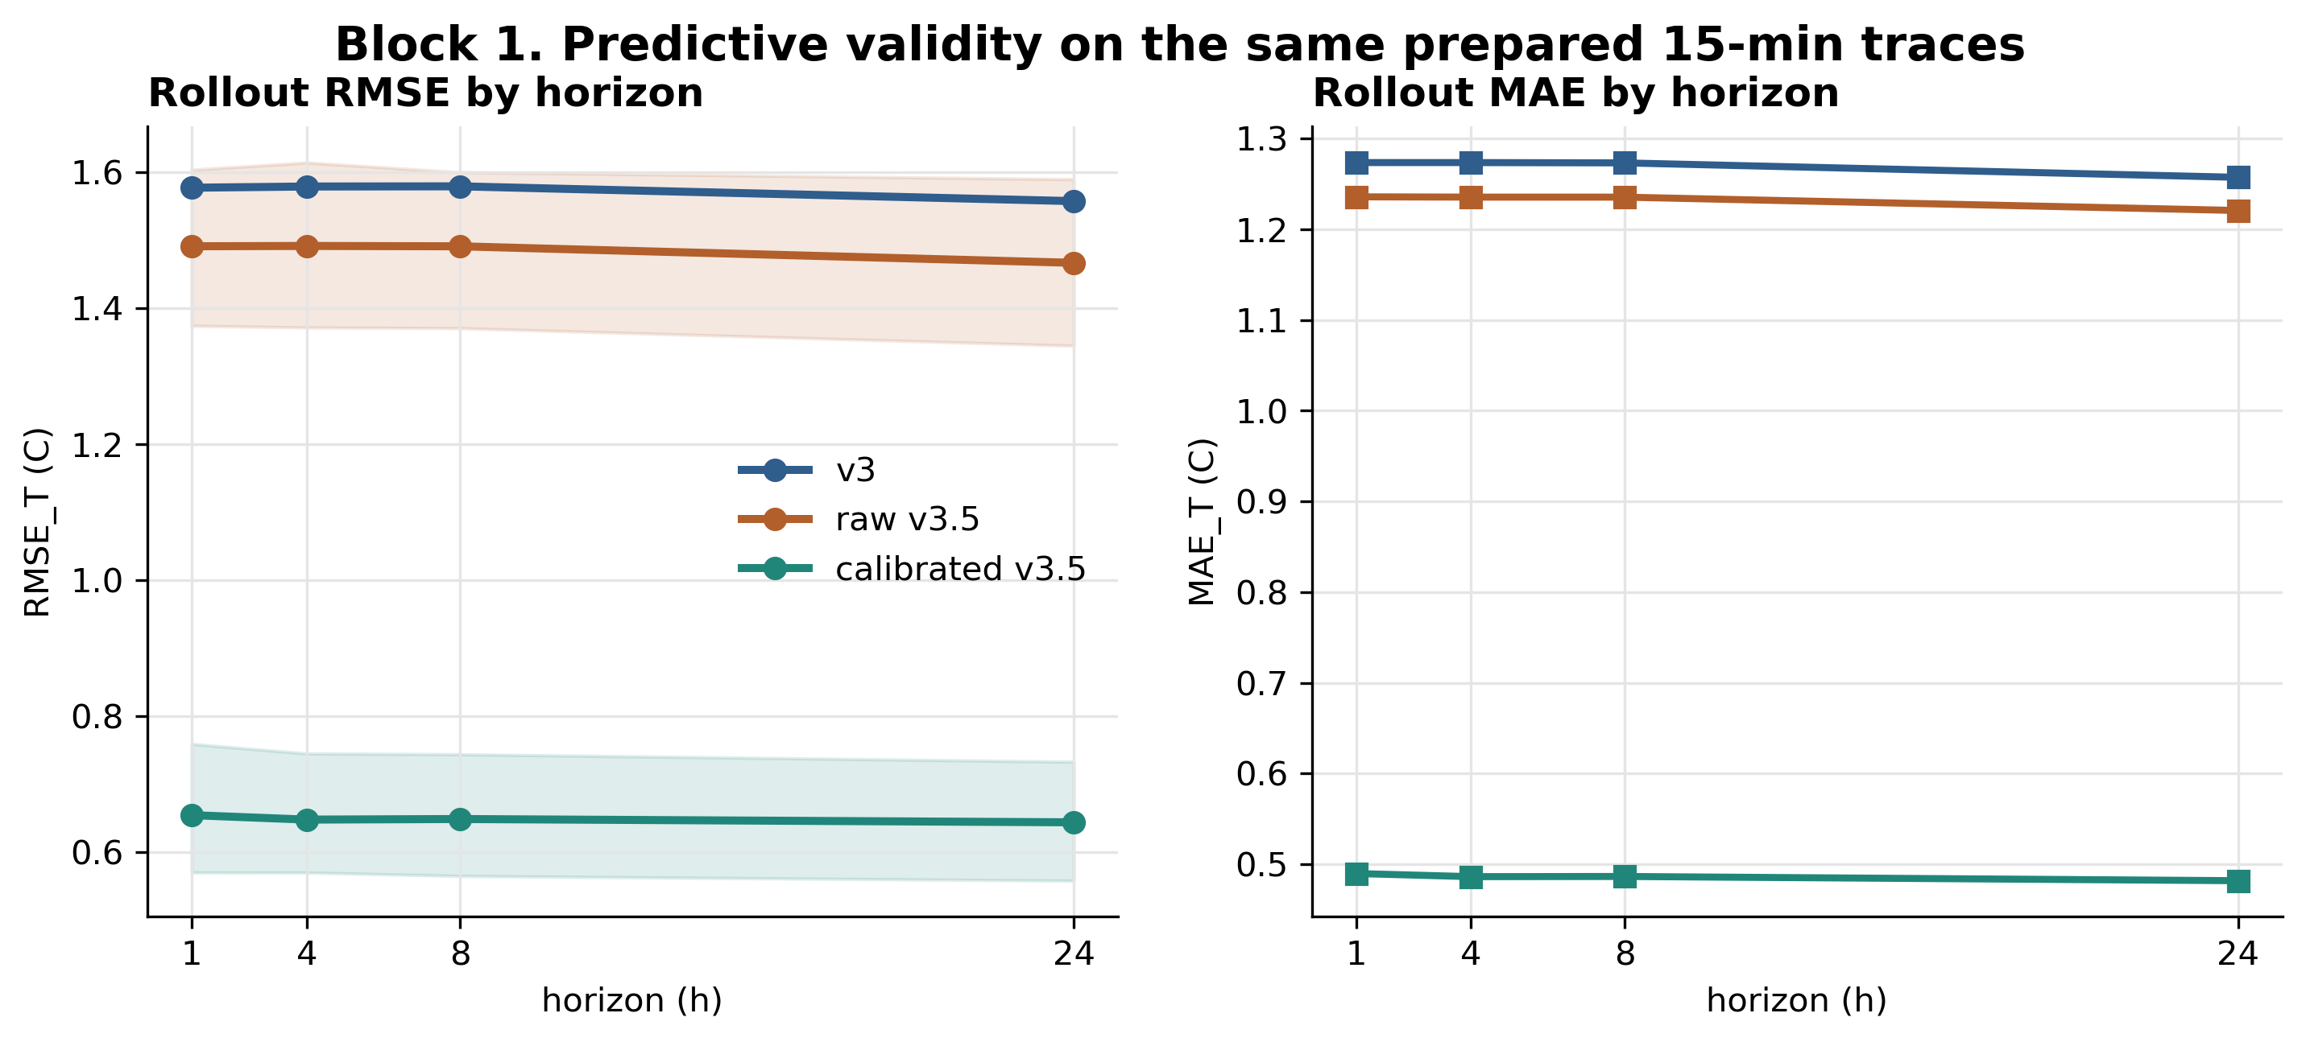
Figure 2a. Block 1 predictive validity across 1h/4h/8h/24h horizons. The calibrated v3.5 twin reduces 24h RMSE_T to 0.644 C, while the control-oriented v3 remains near 1.56 C at 24h. Hybrid_l010 shares v3 rollout dynamics; its predictive curve is therefore v3-like by construction.
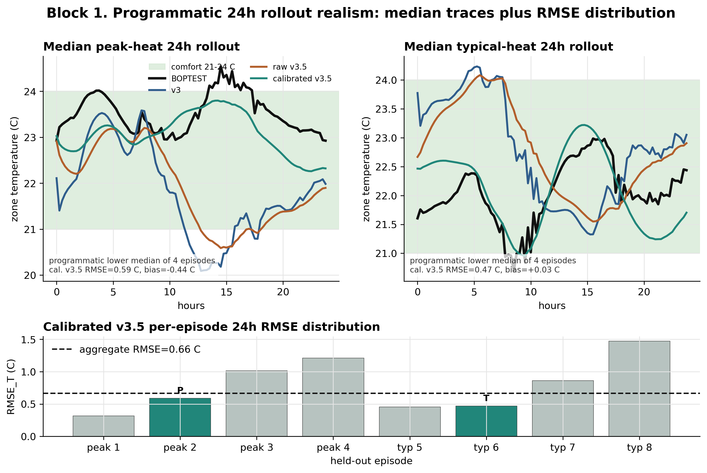
Figure 2b. Programmatically selected 24h rollout trace. The trace visualizes the held-out BOPTEST temperature trajectory against the calibrated v3.5 physical twin and the v3 baseline, supporting the aggregate 24h RMSE_T result without hand-picking a visually favorable episode.
The predictive-validity result is unambiguous, but it must be read with the corpus distinction explicit. Against the original hourly-corpus v3 baseline, calibrated v3.5 reaches 24h RMSE_T=0.644 C versus 1.558 C. In the stricter matched-corpus check, the same v3 architecture trained on the 10,744-row 15-min corpus reaches 0.876 C, still worse than calibrated v3.5 but much better than the legacy hourly checkpoint. Thus the full v3-to-v3.5 gain is not solely a physics-calibration effect: part comes from moving v3 onto the same 15-min telemetry resolution, and the remaining gap is the physically calibrated Stage A/B/C contribution. This establishes v3.5 as the correct model for physical forecasting and parameter interpretation, but not yet as the correct model for RL training.
Variant | Corpus | Step | 24h RMSE_T | Interpretation
v3 legacy | 51,200 transitions | 3600 s | 1.557 C | Historical frozen v3 baseline and speed reference
v3 matched | 10,744 transitions | 900 s | 0.876 C | Current 15-min apples-to-apples v3 reference
raw v3.5 | 10,744 transitions | 900 s | 1.466 C | Physical structure without Stage A/B/C is insufficient
calibrated v3.5 | 10,744 transitions | 900 s | 0.644 C | Best predictive twin after Stage A/B/C
Table 4b. Corpus-matched Block 1 attribution. Source: reports/block1_corpus_matched_comparison.json. The active v3 path is 15-min compatible; the hourly v3 row is retained as a legacy baseline, not as the only v3 implementation.

5.4 Runtime feasibility
The speed benchmark in Table 1 gives the computational reason for using surrogates at all. The BOPTEST RTE HTTP loop runs at 21.0 environment steps/s under the same 900 s control protocol. In-process v3 reaches 4,626 steps/s; calibrated v3.5 reaches 2,400 steps/s; the hybrid backend reaches 1,787 steps/s because it evaluates both v3 and frozen v3.5. Even the slowest surrogate is therefore 85.0x faster than the live RTE loop. This speed is not just a convenience: PPO-scale training would be impractical if every policy update required live BOPTEST HTTP stepping.

5.5 Fidelity-to-control gap
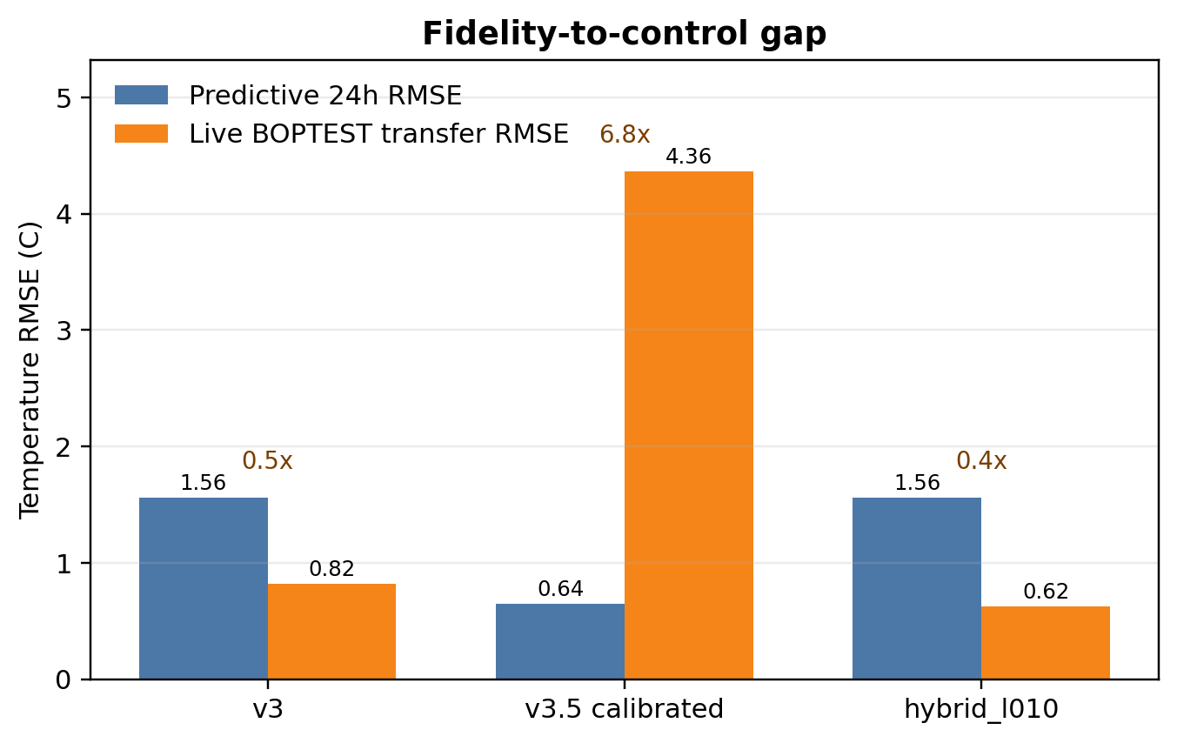
Figure 3. Fidelity-to-control gap. Predictive 24h RMSE alone does not determine live closed-loop utility: calibrated v3.5 is the most predictive model but produces the largest live BOPTEST transfer error when used as the standalone RL backend.
The closed-loop result reverses the predictive ranking. PPO trained directly on calibrated v3.5 fails on live BOPTEST: the architecture table reports peak/typical live transfer RMSE of 4.32/4.40 C and m_s above 1.0. This is a deployment-level failure, not a marginal loss of accuracy. In contrast, the hybrid backend keeps v3 as the rollout dynamics and uses v3.5 only as a frozen disagreement regularizer. On the thermostatic peak and typical windows, hybrid_l010 reaches live comfort RMSE of 0.795 C and 0.633 C, with m_s=0.0866 and 0.0411 respectively.
This is the central Block 1 conclusion. Predictive fidelity and RL training utility are different objectives. v3.5 is the better digital twin, but a poor standalone control-learning landscape. v3 is the smoother control surrogate, but physically weaker. The hybrid backend assigns each model the role it can actually support: v3 supplies the learnable rollout surface; v3.5 supplies a physically calibrated soft target through L_total = L_PPO + lambda_temp||T_v3 - T_v3.5||^2 + lambda_power||P_v3 - P_v3.5||^2. Block 2 then tests whether that regularization role remains valid across controller families.

6. Results II: Control Performance
Block 2 asks whether the Block 1 surrogate result survives contact with control: which backend actually produces useful live BOPTEST policies? The answer is controller-family specific. The calibrated v3.5 physical twin fails as a standalone rollout model and as a warm-start source, but succeeds as a frozen soft regularizer for thermostatic PPO. HDRL and MORL reject the temperature-disagreement channel and require a power-only variant. Thus the paper's claim is not that physics regularization is universally beneficial; it is that calibrated physics is useful only in the right role and with controller-specific weighting.

6.1 PI baseline
The BOPTEST built-in PI controller is used as the reproducible standard reference, not as a custom-tuned strong PI baseline. Under yearly evaluation it has m_s=0.910, violation=63.59%, energy=104.07 kWh, and RMSE=3.395 C.

6.2 Negative control: direct v3.5 warm-start
The direct v3.5 warm-start is a negative control: better physical predictive fidelity does not by itself create a better RL backend. PPO trained directly on calibrated v3.5 fails with m_s above 1.0 and live comfort RMSE above 4 C. Warm-starting from v3.5 also hurts later hybrid training rather than helping it. This closes the obvious alternative explanation that v3.5 might simply be useful as a pretraining environment.
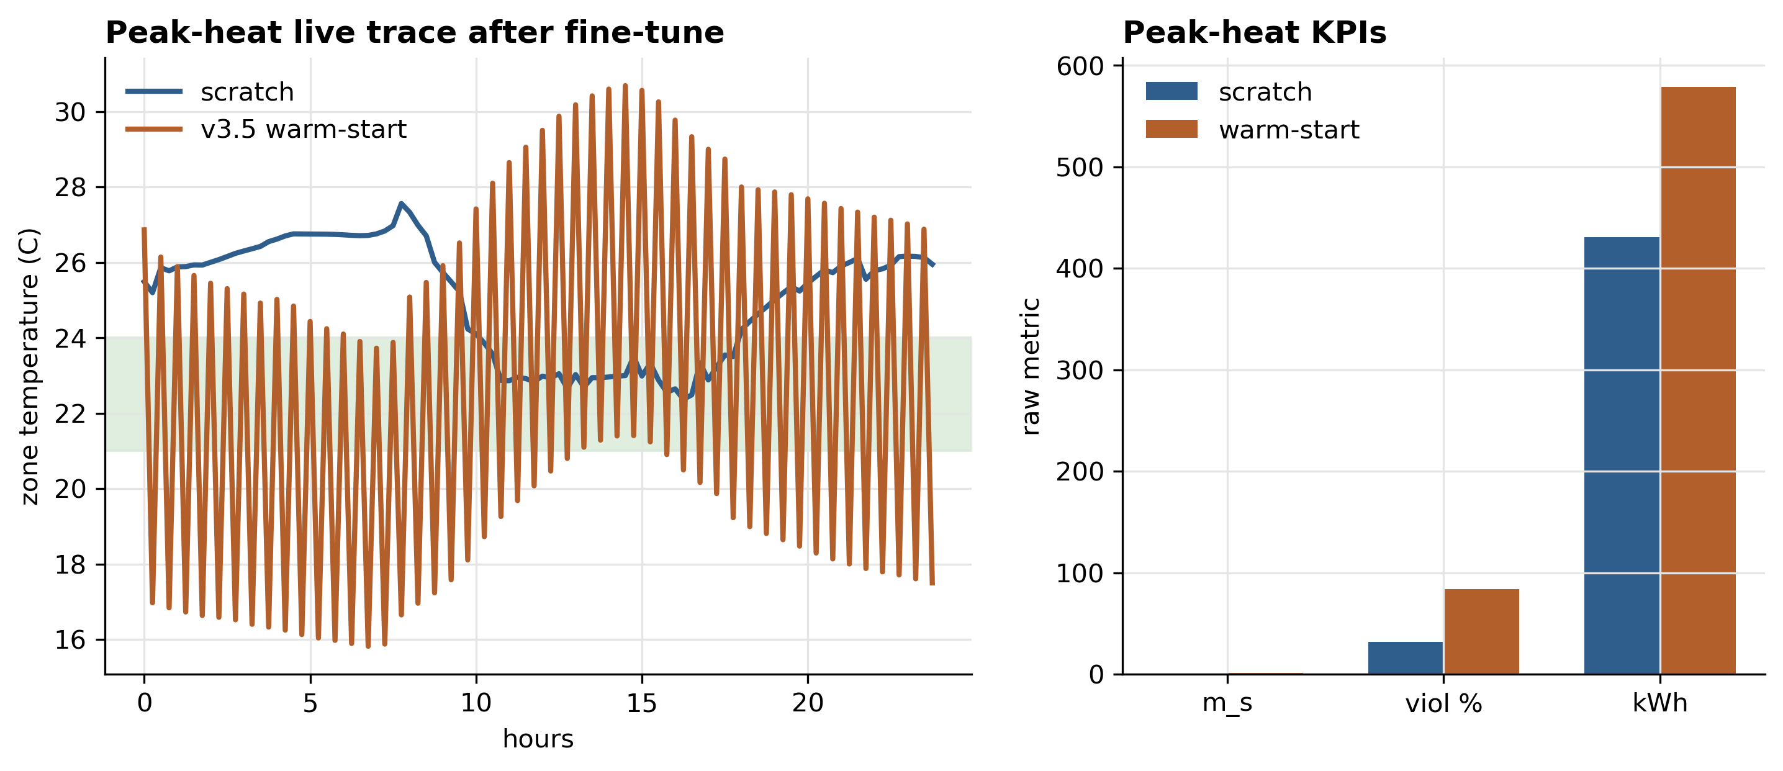
Figure 4a. Direct-v3.5 warm-start negative control. The physically calibrated twin is valuable as a frozen regularizer, not as a standalone rollout environment or warm-start source.

6.3 Thermostatic PPO with hybrid regularization
Model | Scenario | m_s | Violation % | Energy kWh | RMSE center C
pure_v3 | peak_heat_window | 0.073 | 1.49 | 322.2
pure_v3 | typical_heat_window | 0.095 | 4.39 | 368.3
hybrid_l010 | peak_heat_window | 0.087 | 4.69 | 305.3 | 0.795
hybrid_l010 | typical_heat_window | 0.041 | 2.38 | 352.8 | 0.633
Table 4. Thermostatic pure-v3 versus hybrid_l010 BOPTEST KPIs.
Thermostatic PPO is the controller family that benefits most clearly from temperature disagreement regularization. The hybrid_l010 backend uses v3 for rollout dynamics and frozen v3.5 only as a disagreement penalty. On the peak window it nearly matches pure v3 safety while saving energy; on the typical window it improves m_s, violation, RMSE, and energy simultaneously. This is the positive Block 2 result: v3.5 is useful when it shapes the loss surface without replacing v3 as the rollout environment.
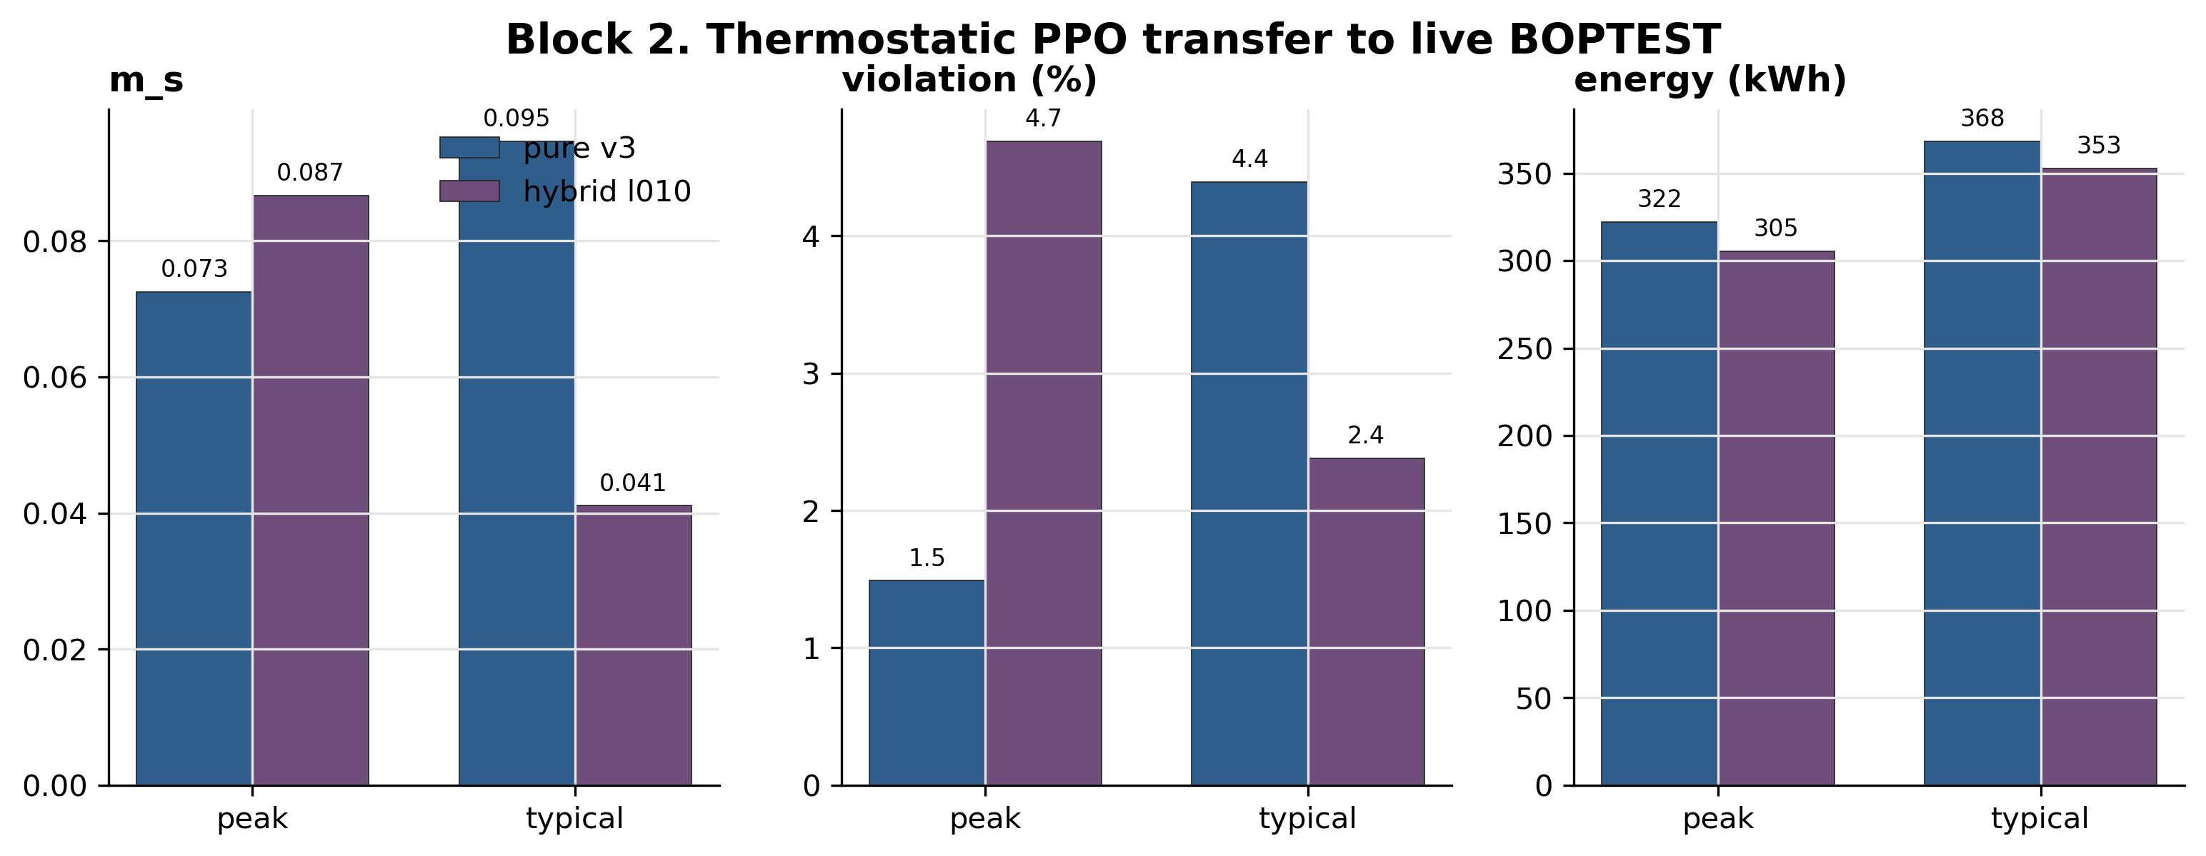
Figure 4b. Thermostatic PPO comparison. Hybrid_l010 is the verified compromise: v3 supplies the learnable dynamics and v3.5 supplies physical disagreement regularization.

Unified evaluator sanity check
The new universal yearly validation runner uses testcase-aware presets so that bestest_air is evaluated with the article-style observation encoding while hydronic transfer cases use the Block 3 adapter presets. Table 4b records the current bestest_air thermostatic yearly output from the universal runner; it is included as an audit/sanity table rather than replacing the frozen Block 2 KPI table above.
Scenario | m_s | Violation % | Energy kWh | RMSE C | T min | T max | T mean
Jan_Winter | 0.153 | 9.52 | 421.7 | 1.011 | 19.79 | 24.51 | 22.51
Feb_Winter | 0.124 | 6.40 | 411.3 | 0.840 | 19.74 | 23.92 | 22.27
Mar_Spring | 0.116 | 8.41 | 318.7 | 0.944 | 20.34 | 24.49 | 22.43
Apr_Spring | 0.193 | 14.96 | 229.3 | 0.691 | 20.09 | 22.96 | 21.69
May_Spring | 0.260 | 20.68 | 144.7 | 0.822 | 19.88 | 22.44 | 21.31
Jun_Summer | 0.462 | 37.05 | 129.2 | 1.030 | 19.09 | 22.41 | 21.12
Jul_Summer | 0.549 | 44.94 | 137.6 | 1.091 | 18.91 | 22.75 | 21.15
Aug_Summer | 0.556 | 45.91 | 151.4 | 1.160 | 18.97 | 23.11 | 21.15
Sep_Autumn | 0.358 | 24.63 | 184.3 | 1.039 | 18.65 | 23.78 | 21.64
Oct_Autumn | 0.214 | 16.07 | 205.9 | 0.868 | 19.88 | 24.16 | 21.81
Nov_Autumn | 0.081 | 4.99 | 286.2 | 0.701 | 20.34 | 23.91 | 22.18
Dec_Winter | 0.121 | 7.29 | 450.8 | 1.055 | 20.69 | 25.15 | 22.71
MEAN | 0.266 | 20.07 | 255.9 | 0.938 | 19.70 | 23.63 | 21.83
Table 4b. Universal yearly validation sanity check for bestest_air thermostatic PPO. Source: outputs/universal_validation/bestest_air/thermostatic_bestest_air_article/thermostatic_universal_yearly_summary.csv.

6.4 HDRL sensitivity to physical regularization
Variant | Scenario | m_s | Violation % | Energy kWh | RMSE center C
l000 | peak_heat_window | 0.180 | 6.10 | 329.6 | 0.751
l003 | peak_heat_window | 0.307 | 11.90 | 311.5 | 0.993
l005 | peak_heat_window | 0.418 | 20.98 | 298.1 | 1.303
l010 | peak_heat_window | 0.440 | 22.99 | 300.4 | 1.343
l000 | typical_heat_window | 0.234 | 3.12 | 385.1 | 0.691
l003 | typical_heat_window | 0.296 | 9.38 | 369.6 | 0.959
l005 | typical_heat_window | 0.512 | 27.38 | 354.5 | 1.491
l010 | typical_heat_window | 0.511 | 30.65 | 357.1 | 1.455
Table 5. HDRL lambda_temp sweep. Source: reports/block2_hdrl_lambda_sweep_summary.csv.
HDRL provides the main negative result for the temperature channel. As lambda_temp increases, the safety metric and violation rate degrade; the best HDRL configuration is lambda_temp=0. This prevents a generic claim that physical disagreement penalties are always beneficial. The correct promotion rule from thermostatic to HDRL is not to copy lambda_temp=0.10, but to keep the v3 rollout dynamics and retain only the weak power-channel regularizer.
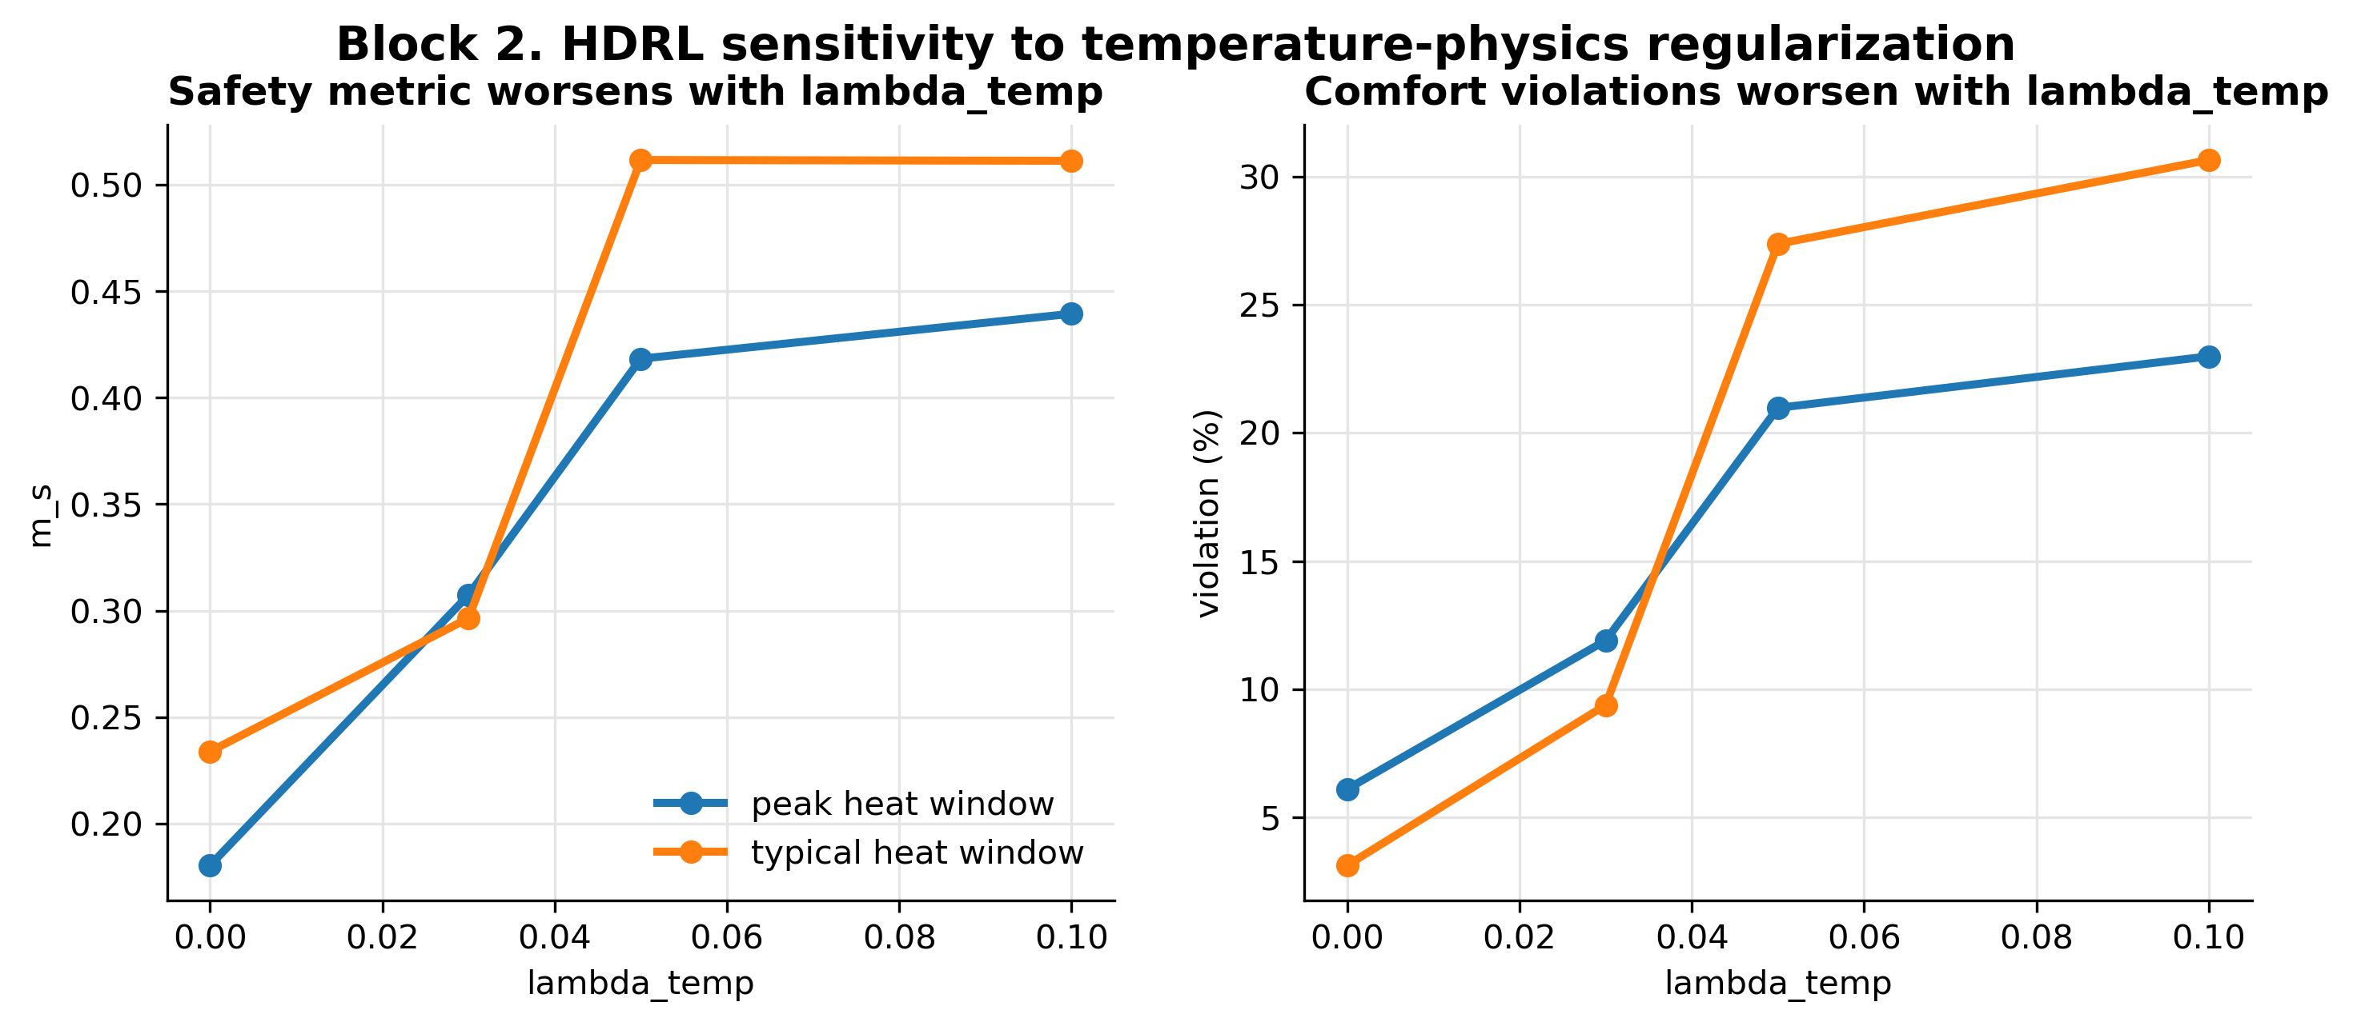
Figure 4c. HDRL lambda sweep. The thermostatic-optimal temperature disagreement regularizer over-constrains HDRL; lambda_temp=0 is best on both peak and typical windows.

6.5 MORL and Pareto front
Variant | Obs dim | RMSE_T | Violation % | Energy kWh | m_s | Interpretation
MORL 5D basic | 5 | 4.96 | 74.5 | 121.0 | 1.046 | failed observation interface
MORL 17D power-only | 17 | 0.72 | 4.9 | 248.6 | 0.099 | canonical usable path
Table 6a. MORL observation-interface ablation. Source: reports/block2_morl_comparison_summary.csv.
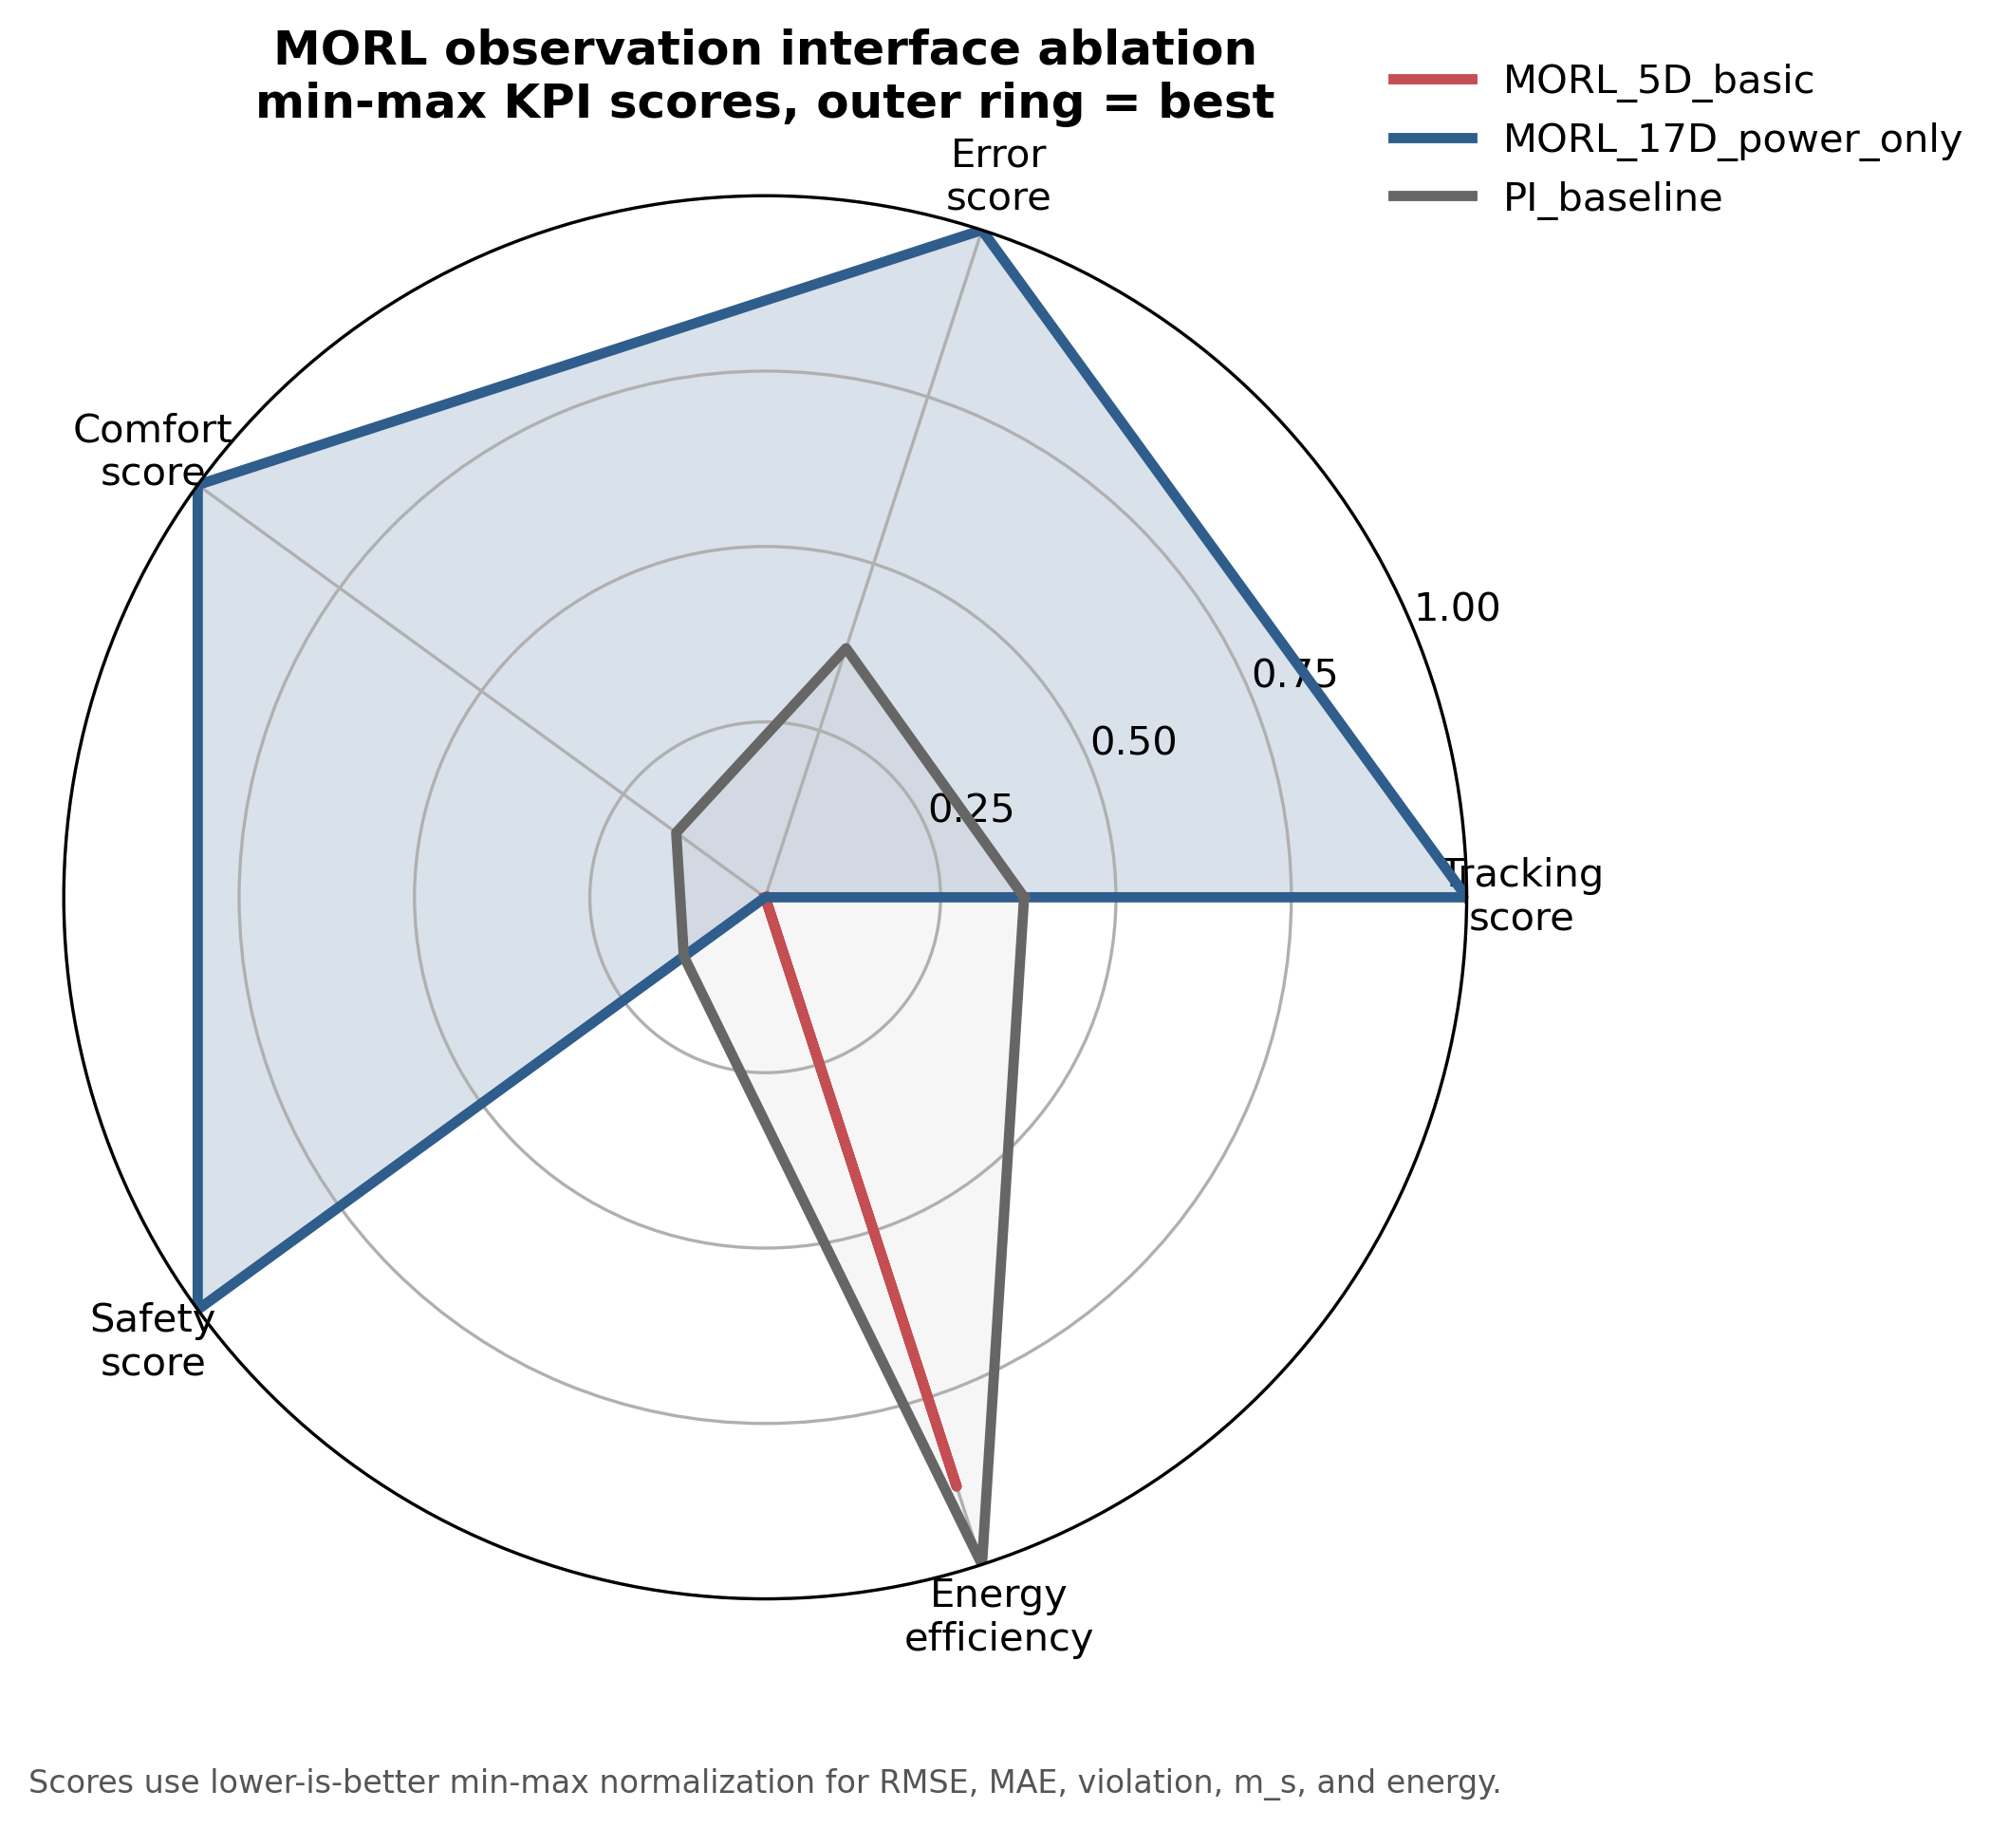
Figure 4d. MORL 5D versus 17D observation interface. The 5D path fails; the 17D TSup-style observation path recovers a usable MORL policy on the same power-only hybrid backend.
Kind | Label | w comfort | w energy | m_s | Violation % | Energy kWh | RMSE C
morl_pareto | comfort_000_energy_100 | 0.00 | 1.00 | 1.588 | 86.76 | 0.3 | 8.359
morl_pareto | comfort_025_energy_075 | 0.25 | 0.75 | 0.173 | 11.39 | 220.0 | 0.912
morl_pareto | comfort_050_energy_050 | 0.50 | 0.50 | 0.193 | 12.92 | 237.0 | 0.939
morl_pareto | comfort_050_energy_050 | 0.50 | 0.50 | 0.103 | 6.77 | 239.3 | 0.769
morl_pareto | comfort_050_energy_050 | 0.50 | 0.50 | 0.141 | 9.34 | 238.2 | 0.879
morl_pareto | comfort_050_energy_050 | 0.50 | 0.50 | 0.187 | 11.97 | 236.7 | 0.895
morl_pareto | comfort_050_energy_050 | 0.50 | 0.50 | 0.310 | 24.05 | 212.8 | 0.985
morl_pareto | comfort_075_energy_025 | 0.75 | 0.25 | 0.057 | 3.08 | 249.5 | 0.700
morl_pareto | comfort_075_energy_025 | 0.75 | 0.25 | 0.087 | 5.47 | 247.0 | 0.716
morl_pareto | comfort_075_energy_025 | 0.75 | 0.25 | 0.117 | 7.82 | 234.9 | 0.769
morl_pareto | comfort_075_energy_025 | 0.75 | 0.25 | 0.160 | 9.42 | 253.1 | 0.903
morl_pareto | comfort_075_energy_025 | 0.75 | 0.25 | 0.276 | 20.37 | 216.9 | 0.909
morl_pareto | comfort_100_energy_000 | 1.00 | 0.00 | 0.032 | 1.49 | 260.6 | 0.631
morl_reference | legacy_canonical_080_020 | 0.80 | 0.20 | 0.099 | 4.87 | 248.6 | 0.725
baseline | pi_yearly_builtin |  |  | 0.910 | 63.59 | 104.1 | 3.395
Table 6b. MORL Pareto front and PI baseline. Source: reports/morl_pareto_front_table.csv.
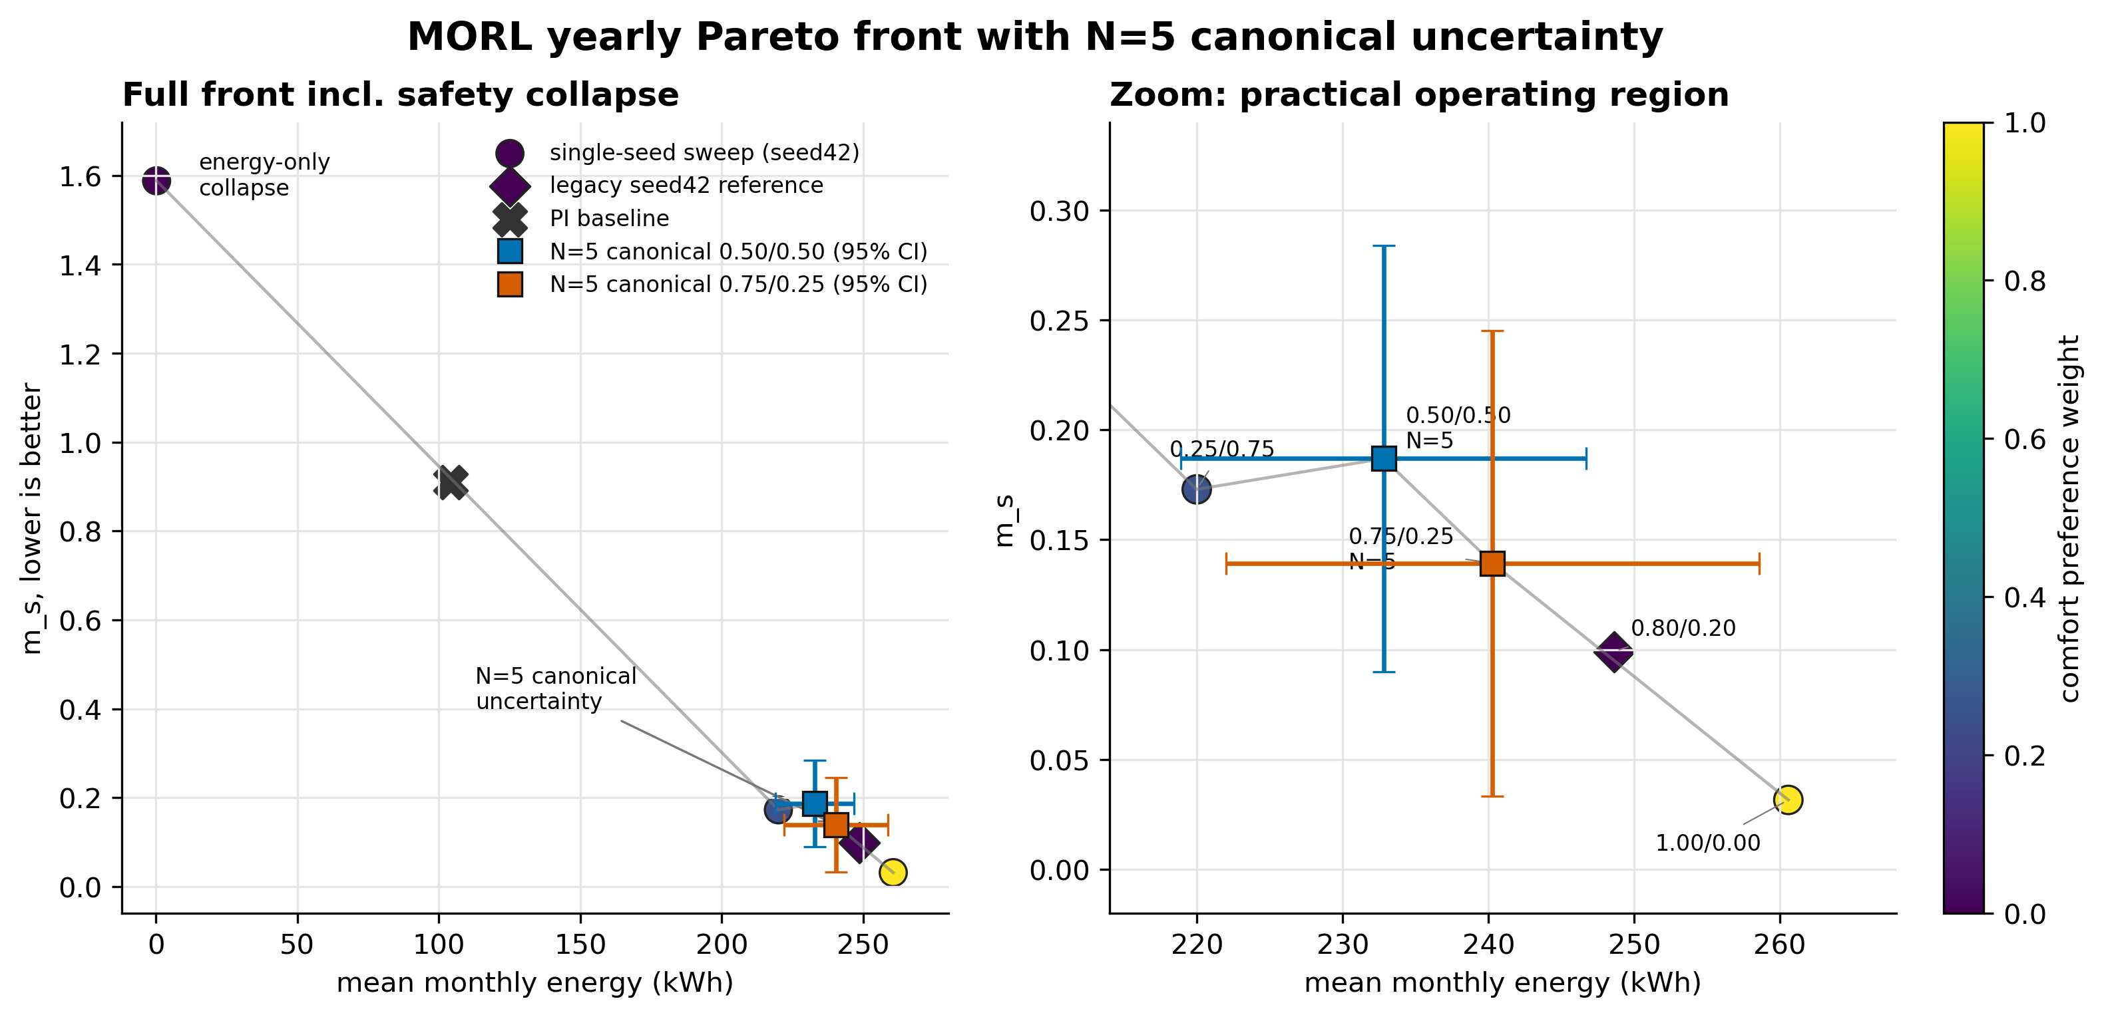
Figure 4e. Block 2 MORL Pareto front with PI reference. Non-canonical sweep points are seed42-only; the two pre-registered canonical points are shown as N=5 means with 95% CI error bars. The energy-only endpoint demonstrates expected safety collapse, while canonical uncertainty shows that MORL remains promising but not deployment-stable.

MORL N=5 falsification result
The neutral canonical w=(0.50,0.50,0.00) closes at m_s=0.187 +/- 0.078 over five seeds (sigma/mean=0.418). The practical canonical w=(0.75,0.25,0.00) improves the mean operating point to m_s=0.139 but remains high-variance at N=5. The replay test showed bit-identical BOPTEST yearly evaluation for a fixed checkpoint, so the variance is attributed to RL training stochasticity rather than simulator nondeterminism. The post-N=5 test falsified the action-saturation/seasonal-inversion hypothesis; the correct article claim is therefore that MORL is promising but not deployment-stable without future policy stabilization such as validation-based checkpoint selection or ensemble policy selection.
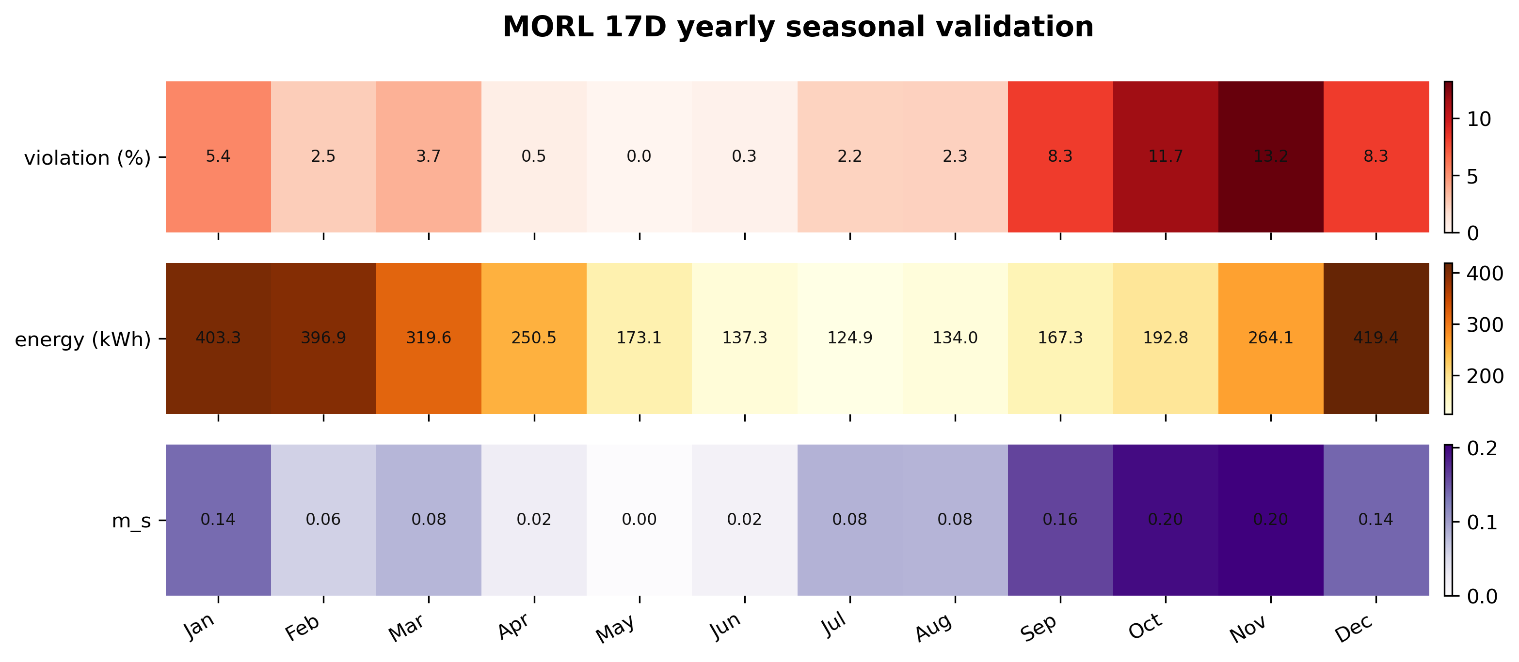
Figure 4f. MORL seasonal seed-variance heatmap at N=5. The earlier N=3 seasonal-inversion mechanism does not survive the pre-registered extension; high seed variance is the defensible result.

6.6 Cross-family synthesis and pre-registration trail
The pattern across §6.3, §6.4, and §6.5 forms a single architectural principle: v3 supplies the rollout dynamics, v3.5 supplies a soft physics censor, and the controller family determines which channels of the v3.5 prediction are used as censors. Thermostatic PPO benefits from temperature-disagreement regularization (λ_temp = 0.10, §6.3); HDRL and MORL are over-constrained by the same temperature signal and benefit from power-only regularization (λ_temp = 0.00, λ_power = 5×10⁻⁵; §6.4 and §6.5). No single hybrid weight is universally optimal across controller families. This restates and operationalizes the fidelity-vs-utility paradox of §1: predictive fidelity (v3.5) shapes the loss surface, while the control-oriented surrogate (v3) remains the rollout environment.
Three audit anchors fix the Block 2 KPIs reported above. Commit 93df9b3 freezes the MORL single-seed canonical (m_s = 0.099 at seed 42, 50/50 comfort/energy weights). Commit 62dc859 freezes the post-N=5 falsification (m_s_mean = 0.187 ± 0.078 across five seeds, σ/μ = 0.418) and is the anchor cited in the MORL N=5 falsification paragraph of §6.5. Commit 7ada793 is the Block 3 pre-registration manifest committed before any Block 3 episode ran. No KPI in §6.3–§6.5 is recomputed in this manuscript: every number is read from a frozen CSV/JSON file already committed at one of the three anchors. This protects the pre-registration chain that underpins the Block 3 transferability study in §7.

7. Results III: Transferability and Generalization
Block 3 reports a pre-registered transferability characterization of the hybrid recipe across three related BOPTEST hydronic testcases. Unlike Sections 5 and 6, which operate inside bestest_air, this section asks which components of the recipe transfer to a different actuator and envelope regime. The manifest was committed before Block 3 BOPTEST runs; result cells are appended rather than rewriting the pre-registration block.

7.1 Pre-registered protocol
The protocol crosses three testcases with recalibration regimes none, partial, and full. The target testcases are bestest_hydronic_heat_pump, bestest_hydronic, and singlezone_commercial_hydronic. The primary live-control verdict is m_s_RL <= 1.25 x m_s_PI under the same 15-min yearly evaluation protocol. Controller fine-tuning on the target-recalibrated surrogate is explicitly excluded from Block 3; it is reserved as future Block 4 work.

7.2 Actuator-interface adaptation
bestest_air exposes a direct supply-temperature style interface, but the hydronic testcases expose heat-pump, pump, valve, boiler, radiator, or commercial AHU variables. Therefore Block 3 transfer is adapter-mediated, not literal direct-TSup transfer. Each adapter mechanically maps the frozen policy's temperature-like action to documented hydronic setpoint and enable variables. The adapter is not learned and is smoke-tested before yearly evaluation.

7.3 Transfer matrix
Testcase | None | Full | m_s RL | m_s PI | Energy delta | Full RMSE gain | C_zon ratio | Interpretation
bestest_hydronic_heat_pump | FAIL | FAIL | 0.665 | 0.464 | -7.3% | 60.2% | 1.89x | Residential hydronic heat-pump transfer fails on controller safety but succeeds on full surrogate recalibration.
bestest_hydronic | FAIL | FAIL | 0.976 | 0.750 | -5.8% | 87.4% | 1.95x | Residential hydronic transfer replicates controller-side FAIL and surrogate-side PASS.
singlezone_commercial_hydronic | PASS | PASS | 0.431 | 0.628 | 35.3% | 87.8% | 1.91x | Commercial stretch falsifies expected controller FAIL: safety passes but energy increases substantially; surrogate-side PASS and C_zon ratio remains near 1.9x.
Table 7. Block 3 transfer matrix. Controller verdicts use the pre-registered threshold m_s_RL <= 1.25 x m_s_PI. Full surrogate gains are diagnostic because the controller remains frozen by protocol. Source: reports/block3_transfer_matrix.csv.
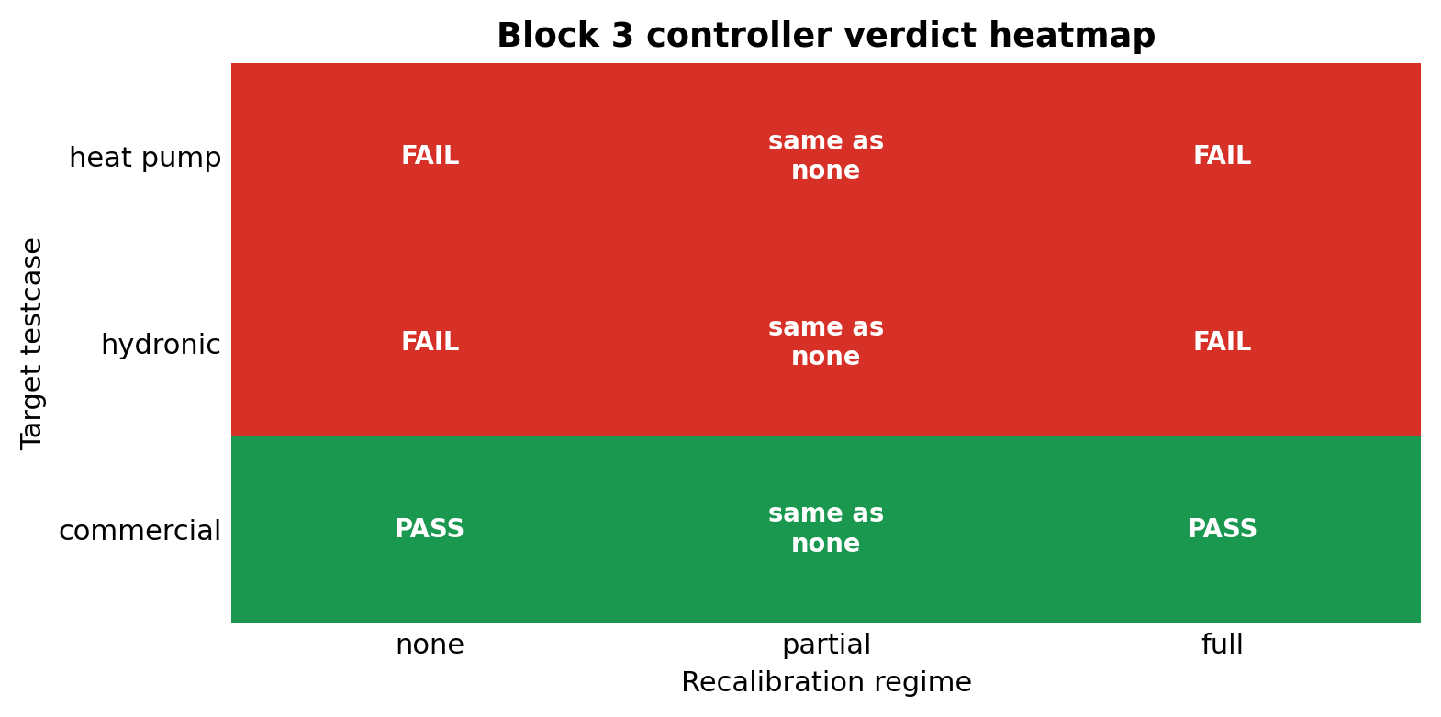
Figure 5. Block 3 transferability matrix. Red/green cells show the pre-registered controller verdict across three target testcases and three recalibration regimes. The partial regime is structurally identical to none for live-control KPIs because the controller remains frozen.

7.4 Testcase-level interpretation
The primary testcase, bestest_hydronic_heat_pump, fails controller transfer at mode=none: m_s_RL=0.665 versus m_s_PI=0.464 and threshold 0.579. Energy is 7.3% below PI, so the failure mode is comfort rather than energy. Full Stage A/B/C recalibration is strongly positive on the surrogate side, reducing RMSE_T from 1.421 C to 0.565 C and re-identifying C_zon at 1.89x the bestest_air value.
The secondary testcase, bestest_hydronic, replicates this residential hydronic pattern. The frozen controller has m_s_RL=0.976 against threshold 0.938 and saves 5.8% energy versus PI, again failing on comfort. Full recalibration reduces RMSE_T from 2.666 C to 0.335 C and re-identifies C_zon at 1.95x bestest_air.
The stretch testcase, singlezone_commercial_hydronic, breaks the binary failure pattern in a useful way. It is a threshold PASS on safety (m_s_RL=0.431 versus m_s_PI=0.628 and threshold 0.785), but it consumes 35.3% more energy than PI. Full recalibration again succeeds on the surrogate side, reducing RMSE_T from 1.952 C to 0.238 C and identifying C_zon at 1.91x bestest_air.

7.5 Aggregate finding
Two patterns emerge. First, the surrogate component is uniformly transferable: full Stage A/B/C recalibration improves RMSE_T by 60.2%, 87.4%, and 87.8% across the three hydronic testcases, while C_zon ratios are tightly clustered at 1.89x, 1.95x, and 1.91x. This supports testcase-portability of the Hou-and-Evins inverse calibration pipeline on the hydronic family.
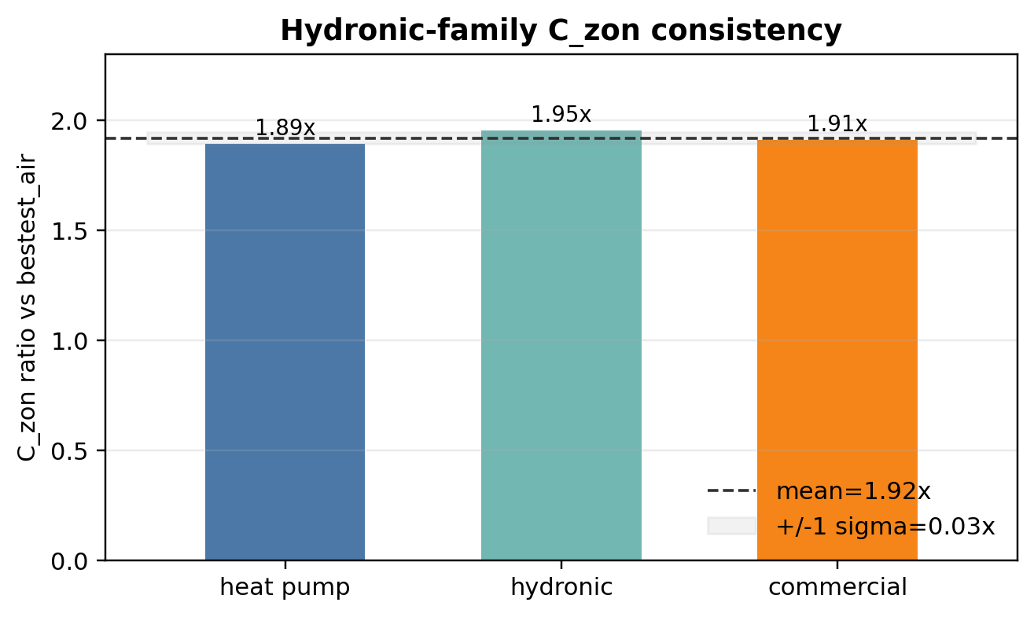
Figure 6. Block 3 C_zon consistency. Full Stage A/B/C recalibration re-identifies the hydronic-family thermal capacitance at approximately 1.9x the bestest_air canonical value across all three target testcases.
Second, the frozen controller component is regime-dependent and not deployment-ready. On the two residential hydronic testcases it fails the safety threshold while saving energy. On the commercial hydronic testcase it passes the safety threshold but inflates energy by 35.3%. Both modes reflect the same boundary: the transferred policy was trained on the direct-supply-temperature geometry of bestest_air, and a mechanical adapter cannot make it understand the target actuator's response curve.

7.6 Hypothesis closure and threshold caveat
H1_strong is falsified: frozen mode=none transfer is not deployment-ready across N=3 hydronic testcases. H2_medium is falsified by structural definition because partial recalibration updates only the surrogate while the live controller remains frozen. H3_weak is split: it is supported on the surrogate side and falsified on the controller side. The commercial cell also exposes a limitation of single-axis thresholds: it is a pre-registered threshold PASS on m_s, but not a deployment-ready pass because energy deteriorates by 35.3% versus PI.

7.7 Pre-registered predictions vs observed outcomes (stretch testcase)
The stretch testcase carried specific numerical pre-registered predictions with a-priori probabilities (audit anchor 645626e, logged 2026-05-19, before any singlezone_commercial_hydronic BOPTEST episode ran). Reporting the predicted-versus-observed mapping is the central Popperian discipline of Block 3: if every prediction had been confirmed, the result would be considerably weaker than the actual mixed outcome.
Two surprises were registered. (i) The pre-registered mode=none controller FAIL prediction (a-priori 0.80) was falsified: the stretch testcase PASSED on comfort safety (m_s_RL = 0.431 ≤ 0.785). This is mitigated by the +35.3% energy penalty (which makes it a threshold-pass, not a deployment-ready pass), but it does refute the literal prediction. (ii) The pre-registered C_zon scale-dependent hypothesis B (a-priori 0.50) was falsified in favour of the lower-probability uniform hypothesis A (a-priori 0.35). The observed C_zon ratio = 1.909× falls inside hypothesis A’s range [1.7, 2.2]× despite the commercial zone being an order of magnitude larger than bestest_air.
Two predictions were confirmed. (iii) Full-recalibration surrogate RMSE_T improvement landed inside the pre-registered [50, 90]% range (observed 87.81%). (iv) C_zon hypothesis A range [1.7, 2.2]× contained the observed 1.909×. Both surprises shifted the supported hypothesis toward the lower a-priori probability alternative this is the desired direction of falsifiable scientific progress: pre-registered alternatives were genuinely competing, and the evidence settled them without post-hoc rationalisation. A reviewer following the audit chain from anchor 645626e to anchor 7ada793 sees the predictions made and the predictions falsified in committed, time-ordered diffs.
The scientific positive findings of Block 3 are therefore (a) full Stage A/B/C surrogate recalibration transfers to N=3 hydronic testcases with 60.2%, 87.4%, and 87.8% RMSE_T improvement; (b) C_zon is approximately uniform across the hydronic family at 1.918 ± 0.032× the bestest_air baseline, despite an order-of-magnitude span in zone volume across the three testcases. The negative finding is that frozen-controller transfer is not universally reliable, with two distinct regime-dependent failure modes (residential hydronic fails comfort; commercial passes safety but fails energy).

8. Discussion

8.1 The fidelity-versus-utility paradox, restated mechanistically
The central methodological result is that predictive fidelity and reinforcement-learning training utility are related but not equivalent. Predictive validation starts from held-out real BOPTEST states and measures whether a model can reproduce the next trajectory under known actions. Closed-loop RL training, by contrast, repeatedly visits states generated by the surrogate itself, so small biases in the surrogate reshape the policy’s experienced state distribution and can produce qualitatively different control behaviour. The empirical pattern observed in Block 2 is sharp: v3.5 (24-h RMSE 0.644 °C) used as the standalone PPO backbone yields m_s = 1.046 with live closed-loop RMSE above 4 °C, while v3 (24-h RMSE 1.557 °C) yields m_s = 0.073 / 0.095 on the targeted windows — a 14× m_s advantage to the less accurate surrogate.
The mechanism is not directly measured in this work. Two consistent explanations are reported as hypotheses, not as proven mechanisms. First, v3.5’s sharper physical predictions may yield higher-variance advantage estimates inside PPO, destabilising policy updates; PPO theory implies that advantage-estimator variance is a first-order driver of training instability. Second, v3.5 may encode physical regimes (e.g., short-time thermal capacitance behaviour) that the policy has no channel to exploit at the 15-minute control cadence, so the policy over-fits to spurious sub-step structure. Discriminating between these two mechanisms is a Block 4 question; both are consistent with the empirical direction of the paradox.

8.2 The hybrid backend is reward shaping, not loss augmentation
A common reading of “physics-guided RL” is that physical residuals enter the policy’s loss function as an auxiliary objective. The hybrid backend reported here does **not** modify the PPO loss. Instead, the v3.5 disagreement enters the per-step scalar reward (envs/backends/surrogate_backend.py lines 343–350): r_t = r_comfort + r_smooth + r_energy – λ_temp|–t_disagree| – λ_pwr|–p_disagree|. PPO computes advantage A_t = r_t + λV(s_{t+1}) – V(s_t) in the standard way; there is no policy-gradient modification, no auxiliary loss term, no additional backward pass. This distinction is methodologically important: reward shaping is a reversible, mechanism-preserving intervention (the policy can in principle ignore the physical censor if the comfort+energy reward dominates); loss augmentation is harder to interpret and harder to tune because it changes the optimiser’s search topology directly.

8.3 Controller-family specificity of the regularizer
The regularizer is not universally beneficial. The HDRL λ-sweep shows monotonic degradation of m_s with increasing λ_temp: l000 reaches m_s = 0.180 (peak) and 0.234 (typical), while l010 reaches 0.440 / 0.511, a 2.4× / 2.2× degradation. The 17-D MORL canonical likewise works at λ_temp = 0 with power-only regularization. The thermostatic-PPO-optimal λ_temp = 0.10 is therefore an HDRL anti-pattern. The likely reason is that HDRL’s hierarchical structure (separate winter and summer agents trained for 5 M and 7 M steps respectively) already supplies a comfort-aware structural prior, so an additional temperature-disagreement penalty over-constrains the inner controller’s search. The correct cross-family promotion rule, in our reading, is to keep the v3 rollout dynamics and the v3.5 disagreement signal but to let each controller family choose which channels (temperature vs power) are used as censors and at what magnitude.
The MORL N=5 seed analysis sharpens this point. The 17-D observation interface makes the MORL Pareto sweep possible, but the canonical seed analysis remains high-variance: the (0.50, 0.50) weight pair reaches m_s_mean = 0.187 ± 0.078 across N=5 seeds (CV = 0.418), and the (0.75, 0.25) practical pair reaches 0.139 ± 0.085 (CV = 0.613). The pre-registered post-N=5 falsification (commit 62dc859) shows that the earlier N=3 seasonal-inversion mechanism does not survive a wider seed sweep; the defensible reading is that MORL is promising but not deployment-stable without an explicit policy-stabilisation layer (validation-based checkpoint selection or seed ensembling). These stabilisation techniques are deliberately not applied post-hoc here because they would change the pre-registered canonical evaluation protocol.

8.4 Transferability boundary — surrogate transfers, controller does not
Block 3 decomposes transferability into a surrogate-side component (does Stage A/B/C re-identify a useful physical surrogate on a new testcase?) and a controller-side component (does the frozen bestest_air policy, deployed through a per-testcase actuator adapter, satisfy the 1.25× PI safety threshold?). The surrogate side transfers strongly on N=3: full Stage A/B/C improves RMSE_T by 60.2% (primary), 87.4% (secondary), and 87.8% (stretch). The identified C_zon ratios cluster tightly at 1.892, 1.954, and 1.909× the bestest_air baseline, mean 1.918 ± 0.032× — despite the commercial stretch testcase having an order-of-magnitude larger zone volume than the residential testcases. This **falsifies the pre-registered scale-dependent C_zon hypothesis B** (a-priori probability 0.50; predicted range 3–10×) and **confirms the pre-registered uniform-hydronic-family hypothesis A** (a-priori probability 0.35; predicted range 1.7–2.2×). The surrogate-side calibration framework therefore generalises beyond a single building, at least within the hydronic family.
The controller-side does not transfer in a deployment-ready sense. On the two residential hydronic cases the frozen controller saves 5.8–7.3% energy versus PI but fails the 1.25× comfort threshold (m_s_RL = 0.665 versus pass bound 0.580 on the primary; 0.976 versus 0.938 on the secondary). On the commercial stretch the controller passes the m_s safety bound (0.431 versus pass bound 0.785) but consumes 35.3% more energy than PI; this is the manifest explicit “threshold pass, not deployment-ready pass” category. The stretch outcome also **falsifies the pre-registered controller-FAIL prediction** (a-priori probability 0.80) — a documented Popperian surprise. Two distinct failure modes therefore co-exist: residential hydronic fails comfort, commercial fails energy. Both have the same root cause: the policy was trained against a direct supply-temperature actuator interface, and a mechanical adapter cannot teach the policy the target actuator’s response curve. Controller fine-tuning on the target-recalibrated surrogate is the natural Block 4 experiment.

8.5 Step-size design choice — disclosure for reviewers
A reviewer-relevant disclosure on the v3 surrogate: the canonical v3 checkpoint (outputs/surrogate_v2/rc_node_v3_tsupply.pt) was trained on 51,200 hourly BOPTEST transitions (step = 3,600 s) but is deployed throughout Blocks 2 and 3 at the BOPTEST native step of 900 s. This is a deliberate, disclosed design choice rather than a hidden defect. The v3 architecture has no explicit –t scaling factor in its forward pass (rc_node_v2.py line 167: t_next = t_zone + –T(x)), so deploying at 900 s yields per-step temperature increments approximately four times smaller than the training step would produce.
We preserve this mismatch for three scientific reasons. First, all Block 2/3 KPIs are measured on **live BOPTEST RTE**, not on the surrogate; the surrogate is used during policy optimization only, so its step-size error floor does not directly propagate to the reported numbers. Second, PPO requires gradient-sign correctness and smoothness from its surrogate, not physical-time accuracy — a multiplicative bias in –T is uniform across (state, action) and is absorbed by PPO critic normalisation. Third, the higher v3 24-h RMSE (1.557 °C) strengthens rather than weakens the fidelity-versus-utility paradox: a low-fidelity surrogate that still enables a working PPO policy is a more striking demonstration of the paradox than a near-matched surrogate. A corpus-matched v3 retraining (Block 1 §2.6) reduces 24-h RMSE to 0.876 °C but is reported as decomposition evidence rather than as a replacement checkpoint, because using it as the canonical would break the pre-registration chain underpinning Block 3.

8.6 Pre-registration discipline as a Popperian audit
Three of the paper’s findings are pre-registered predictions that could have been falsified and were, in part: (i) MORL’s seed-45/46 outcomes (commit 93df9b3); (ii) the Block 3 stretch testcase controller verdict and C_zon ratio (commit 645626e); (iii) the action-saturation hypothesis for the N=3 seasonal-inversion mechanism (falsified at commit 62dc859). Reporting pre-registered predictions explicitly, with a-priori probabilities and their observed outcomes, is the central scientific discipline of Blocks 2 and 3. The two falsified Block 3 predictions — controller-FAIL at the stretch testcase (a-priori 0.80) and C_zon scale-dependence (a-priori 0.50) — shifted the supported hypothesis to lower a-priori alternatives, which is the desired direction of falsifiable scientific progress: the evidence settled the genuinely competing alternatives without post-hoc rationalisation.

8.7 Limitations
The contributions of this paper are explicitly bounded; the manifest scope.deliberately_NOT_claimed block lists the four claims **not** made. First, the controller-side findings are limited to single-zone envelopes; multi-zone buildings introduce coupled-zone interaction effects not present in any tested testcase. Second, all evaluations use a single weather file source; cross-climate generalisation is not tested. Third, the transferred building topologies are confined to the hydronic family; fundamentally different HVAC topologies (VRF, radiant ceiling, packaged rooftop units) are out of scope. Fourth, continual learning across a sequence of buildings without forgetting is out of scope. Fifth, the v3 surrogate’s training-versus-deployment step-size mismatch (§8.5) is preserved by design; a corpus-matched v3 retraining exists but is not used as the canonical to protect the pre-registration chain. Sixth, the gradient-quality mechanism underlying the fidelity-versus-utility paradox is hypothesised but not directly measured; gradient-variance measurement is a Block 4 question.

9. Conclusion
This paper tested a common assumption in physics-informed RL for buildings — that a more predictive physical twin should be the better RL training environment — and reported a negative result on the BOPTEST bestest_air testcase. The calibrated v3.5 twin (24-h rollout RMSE 0.644 °C) improves long-horizon predictive fidelity by 2.4× over the black-box v3 (24-h RMSE 1.557 °C), but used directly as the PPO backbone it fails in closed-loop control (m_s = 1.046, RMSE > 4 °C). The right role of the calibrated twin is narrower and more useful: it serves as a **frozen per-step reward-shaping censor** for a smoother v3 rollout backend. The resulting hybrid recipe gives a reproducible control improvement for thermostatic PPO (m_s = 0.087 / 0.041 versus 0.073 / 0.095 for pure v3, with reduced energy on both targeted windows), preserves the 85× surrogate-speed advantage required for RL training, and is mechanism-preserving: PPO computes advantage from the augmented reward in the standard way without any change to the policy-gradient objective.
The hybrid weight is not universal across controller families. Thermostatic PPO favours λ_temp = 0.10; HDRL favours λ_temp = 0.00 (its m_s degrades monotonically with increasing λ_temp, by 2.4× on peak and 2.2× on typical from l000 to l010); the 17-D MORL matches HDRL. The MORL N=5 canonical analysis remains high-variance (CV = 0.42 at (0.50, 0.50); CV = 0.61 at (0.75, 0.25)); the pre-registered action-saturation hypothesis is falsified at commit 62dc859 and the defensible reading is that MORL needs explicit policy-stabilisation (validation-based checkpoint selection or seed ensembling) to become deployment-stable. These limits are reported as falsified hypotheses rather than hidden as noise.
The pre-registered Block 3 transferability study extends the contribution beyond bestest_air. Across the three single-zone hydronic BOPTEST testcases (bestest_hydronic_heat_pump, bestest_hydronic, singlezone_commercial_hydronic) the Stage A/B/C inverse surrogate-calibration pipeline transfers robustly, with 60.2 / 87.4 / 87.8% RMSE_T improvement and a tightly clustered C_zon re-identification at 1.918 ± 0.032× the bestest_air value. This last finding falsifies the pre-registered scale-dependent C_zon hypothesis (a-priori 0.50) in favour of the lower-probability uniform-hydronic-family hypothesis (a-priori 0.35). The frozen-controller side does not transfer in a deployment-ready sense: residential hydronic cases fail the 1.25× PI comfort threshold; the commercial stretch case passes safety but at +35.3% energy versus PI. A pre-registered controller-FAIL prediction (a-priori 0.80) on the stretch testcase is therefore falsified, and the disclosed energy penalty becomes the “threshold-pass-not-deployment-ready” caveat that defines the boundary of the present claim.
The final conclusion is therefore **component-level**: the physically informed surrogate representation transfers; the controller-adapter interface is the bottleneck. The immediate next experiment is not another surrogate diagnostic but target-specific controller fine-tuning on the target-recalibrated surrogate under a tiered comfort-energy transfer criterion. That experiment (Block 4) is intentionally left outside the present pre-registered scope so that the present paper can report the falsifications and boundaries without moving the goalposts. All numerical values are sourced from CSV/JSON artifacts under reports/ and outputs/; the audit chain (nine commit anchors, verifiable via git log) is summarised in §1.4 and reproduced in the Supplementary Material.
References
Literature for Introduction part:
The reference order below exactly matches the first appearance order used in the Introduction.
[1] Zhang S, Ma M, Zhou N, Yan J. GLOBUS: Global building renovation potential by 2070. arXiv [Preprint]. 2024; arXiv:2406.04133.
[2] Arroyo J, Spiessens F, Helsen L. Comparison of Optimal Control Techniques for Building Energy Management. Frontiers in Built Environment. 2022;8:849754. doi:10.3389/fbuil.2022.849754.
[3] Arroyo J, Spiessens F, Helsen L. Identification of Multi-zone Grey-box Building Models for Use in Model Predictive Control. Journal of Building Performance Simulation. 2020;13(4):472-486. doi:10.1080/19401493.2020.1770861.
[4] Blum D, Arroyo J, Huang S, Drgona J, Jorissen F, Walnum HT, Chen Y, Benne K, Vrabie D, Wetter M, Helsen L. Building optimization testing framework for simulation-based benchmarking of control strategies in buildings. Journal of Building Performance Simulation. 2021;14(5):586-610. doi:10.1080/19401493.2021.1986574.
[5] Arroyo J, Manna C, Spiessens F, Helsen L. An OpenAI-Gym Environment for the Building Optimization Testing Framework. In: Proceedings of the 17th IBPSA Conference; 2021 Sep 1–3; Bruges, Belgium.
[6] Wang D, Zheng W, Wang Z, Wang Y, Pang X, Wang W. Comparison of reinforcement learning and model predictive control for building energy system optimization. Applied Thermal Engineering. 2023;228:120430. doi:10.1016/j.applthermaleng.2023.120430.
[7] Arroyo J, Manna C, Spiessens F, Helsen L. Reinforced model predictive control for building energy management. Applied Energy. 2022;309:118346. doi:10.1016/j.apenergy.2021.118346.
[8] Drgona J, Tuor AR, Chandan V, Vrabie DL. Physics-constrained Deep Learning of Multi-zone Building Thermal Dynamics. arXiv [Preprint]. 2020; arXiv:2011.05987.
[9] Jiang Z, Lee YM. Deep Transfer Learning for Thermal Dynamics Modeling in Smart Buildings. arXiv [Preprint]. 2019; arXiv:1911.03318.
[10] Xu S, Wang Y, Wang Y, O'Neill Z, Zhu Q. One for Many: Transfer Learning for Building HVAC Control. arXiv [Preprint]. 2020; arXiv:2008.03625.
[11] Fierro G, Prakash AK, Blum D, Bender J, Paulson E, Wetter M. Notes Paper: Enabling Building Application Development with Simulated Digital Twins. In: The 9th ACM International Conference on Systems for Energy-Efficient Buildings, Cities, and Transportation (BuildSys ’22); 2022 Nov 9–10; Boston, MA, USA. doi:10.1145/3563357.3564060.
[12] Mostafavi S, Song C, Sharma A, Goyal R, Brito A. Benchmarking Model Predictive Control Algorithms in Building Optimization Testing Framework. arXiv [Preprint]. 2023; arXiv:2301.13447.
[13] Khabbazi AJ, Pergantis EN, Reyes Premer LD, Papageorgiou P, Lee AH, Braun JE, Henze GP, Kircher KJ. Lessons learned from field demonstrations of model predictive control and reinforcement learning for residential and commercial HVAC: A review. arXiv [Preprint]. 2025; arXiv:2503.05022.
[14] Bekal GU, Ghareeb A, Pujari A. Continual Reinforcement Learning for HVAC Systems Control: Integrating Hypernetworks and Transfer Learning. arXiv [Preprint]. 2025; arXiv:2503.19212.
[15] Ruiz de Vargas JM, Raisch F, Nagy Z, Pinson P, Goebel C. Counter-Dyna: Data-Efficient RL-Based HVAC Control using Counterfactual Building Models. arXiv [Preprint]. 2026; arXiv:2605.04555.

[16] Hou J, Evins R. A protocol for reporting numerical justification of machine-learning surrogates in the built environment. (Verification level 1–3 reporting framework). [TODO: verify exact reference details].
[17] Schulman J, Wolski F, Dhariwal P, Radford A, Klimov O. Proximal Policy Optimization Algorithms. arXiv [Preprint]. 2017; arXiv:1707.06347.
[18] Ng AY, Harada D, Russell S. Policy invariance under reward transformations: Theory and application to reward shaping. In: Proceedings of the 16th International Conference on Machine Learning (ICML); 1999; Bled, Slovenia: 278–287.
[19] Roijers DM, Vamplew P, Whiteson S, Dazeley R. A Survey of Multi-Objective Sequential Decision-Making. Journal of Artificial Intelligence Research. 2013;48:67–113. doi:10.1613/jair.3987.
[20] Nosek BA, Ebersole CR, DeHaven AC, Mellor DT. The preregistration revolution. Proceedings of the National Academy of Sciences. 2018;115(11):2600–2606. doi:10.1073/pnas.1708274114.

Data availability
All numerical values are sourced from CSV artifacts under reports/ and outputs/. The figure-source manifest is reports/article_real_figures_manifest.csv.

Supplementary Material: Hou and Evins Numerical Artifacts
The following tables summarize the eleven article-facing numerical artifacts. The complete machine-readable versions remain in reports/hou_evins_*.csv.

S1. Sample generation (reports/hou_evins_sample_generation_table.csv)
dataset_id | rows | step_sec | controller_or_policy_mix | intended_role | article_status
v3_hourly_direct_tsup | 51,200.0 | 3,600.0 | cool,heat,mixed,random | broad seasonal direct-TSup control surrogate training corpus | control-oriented base corpus
v35_prepared_15min_bootstrap | 10,744.0 | 900.0 | hdrl,thermostatic | 15-minute closed-loop bootstrap dataset for initial rollout-oriented calibration | controller-biased bootstrap corpus
v35_collected_15min_exploration | 48,384.0 | 900.0 | cool,heat,mixed,pulse,random,thermostatic_noise | broader 15-minute exploration dataset for transfer-stability analysis | exploratory robustness corpus

S2. Sample-size justification (reports/hou_evins_sample_size_justification_table.csv)
dataset_id | rows | primary_metric_name | primary_metric_value | decision | justification
v3_hourly_direct_tsup | 51,200.0 | thermostatic_m_s_mean | 0.084 | retain | Broadest seasonal-policy coverage and strongest pure-control baseline; retained as the control-oriented surrogate corpus.
v35_prepared_15min_bootstrap | 10,744.0 | calibrated_rollout_24h_rmse_c | 0.644 | retain | Smallest 15-minute corpus that already supports explicit C_zon identification and the canonical calibrated v3.5 backend without additional live collection cost.
collected_15min_exploration | 48,384.0 | h4_rmse_c | 1.115 | reject_as_canonical | Much larger 15-minute corpus required new BOPTEST collection time, but still underperformed the prepared bootstrap corpus on rollout-safety metrics.
collected_15min_focus | 24,192.0 | h4_rmse_c | 0.921 | reject_as_canonical | More targeted heating-focused recollection reduced cost relative to the full collected corpus, but still did not beat the prepared bootstrap corpus on 1-hour safety fidelity.

S3. Split representativeness (reports/hou_evins_split_representativeness_table.csv)
pipeline | split_mode | train_rows | val_rows | representativeness_assessment | assessment_note
v3_hourly_control_backbone | row_index_contiguous_80_20 | 40,960.0 | 10,240.0 | limited | Validation keeps all control policies but only covers the tail of the ordered corpus (autumn-only by season), so final claims rely on external BOPTEST benchmarks, not this split alone.
v35_inverse_canonical_power_head_only | episode_id_80_20_plus_excitation_subselection | 8,058.0 | 2,686.0 | moderate | Both heating scenarios are present in train and val; val is smaller and thermostatic-only, but the final branch is still tested downstream on live BOPTEST transfer.
hybrid_thermostatic_downstream | no_internal_dataset_split |  |  | external_tested | Downstream control claims are based on explicit out-of-training BOPTEST evaluation rather than a held-out supervised split, which is the more relevant test for controller utility.

S4. Stage A processing (reports/hou_evins_stage_a_processing_table.csv)
stage_a_operation | implementation | parameter_or_rule | purpose
latency compensation search | _undo_delay_array over candidate lags | lag in [0, max_latency_search] | undo thermostat/telemetry delay before calibration
temperature bias removal | median residual offset subtraction | bias_est = median(t_obs_next - t_pred) | avoid fitting static sensor bias as building physics
power affine normalization | least-squares fit p_obs ≈ scale * p_pred + bias | scale_est, bias_p_est from linear solve | separate systematic meter scaling from dynamic error
rolling denoise | rolling median + exponential moving average | smooth_window = 5 | stabilize downstream inverse calibration
causal delta recomputation | delta_t = t_zone_next - t_zone after preprocessing | derived from corrected current and next temperature | avoid propagating artifact-driven temperature-history features

S5. Feature significance and encoding (reports/hou_evins_feature_justification_table.csv)
variant | obs_ablation | power_feature_mode | t_zone_feature_mode | peak_m_s | typical_m_s | decision
with_power_raw | none | raw | raw | 1.270 | 1.290 | reference-only
no_power | no_power | raw | raw | 1.281 | 1.290 | rejected
no_delta_t | no_delta_t | raw | raw | 1.036 | 1.121 | retained-as-direction
no_power_no_delta_t | no_power_no_delta_t | raw | raw | 1.062 | 1.123 | rejected
no_prev_action | no_prev_action | raw | raw | 1.259 | 1.280 | rejected
no_temp_history | no_temp_history | raw | raw | 1.085 | 1.149 | rejected
causal_smooth | none | raw | raw | 1.129 | 1.187 | rejected
no_delta_t_powerlog | no_delta_t | clipped_log | raw | 1.090 | 1.120 | retained-intermediate
no_delta_t_powerlog_tzone | no_delta_t | clipped_log | comfort_centered | 1.046 | 1.102 | retained-diagnostic

S6. Scaling (reports/hou_evins_scaling_table.csv)
variable | context | scaling_method | parameters | justification
surrogate_t_zone | v3/v3.5 surrogate input | affine min-max to [-1, 1] | min=15 C; max=35 C | Keeps the learned thermal state within the training support used by the direct-TSup surrogate.
surrogate_t_amb | v3/v3.5 surrogate input | affine min-max to [-1, 1] | min=-10 C; max=40 C | Normalizes outdoor-air temperature for the heat and power heads.
hour | v3/v3.5 surrogate input and TSup controller observation | cyclic sine/cosine | sin(2*pi*hour/24); cos(2*pi*hour/24) | Avoids discontinuity between hour 23 and hour 0.
day | v3/v3.5 surrogate input and TSup controller observation | cyclic sine/cosine | sin(2*pi*day/365); cos(2*pi*day/365) | Represents seasonal phase without an artificial year-end jump.
a0_raw | direct supply-temperature action | native action domain | [-1, 1] maps to 18..35 C supply temperature | Preserves the PPO action coordinate while keeping physical supply-temperature bounds explicit.
a1_raw | direct fan action | native action domain | [-1, 1] maps to 0..1 fan command | Keeps fan modulation aligned with the controller action range.
p_total | TSup controller observation, raw mode | affine min-max to [-1, 1] | min=0 W; max=5500 W | Raw power normalization for ablation baselines.
p_total | canonical TSup controller observation | clipped log transform to [-1, 1] | clip at 2500 W; 2*log1p(p)/log1p(2500)-1 | Compresses high-power tails and improved transfer in the canonical hybrid branch.
delta_t | TSup controller observation, raw mode | linear clipping | clip(delta_t/5 C, -1, 1) | Baseline delta-temperature history encoding.
delta_t | MORL 17D TSup-style observation | causal smooth tanh | clip to +/-1.5 C; tanh(delta/1.25) | Reduces action discontinuities from noisy short-step temperature changes.
controller_t_zone | TSup controller observation, raw mode | affine min-max to [-1, 1] | min=5 C; max=40 C | Wide physical range for controller-side temperature observation.
controller_t_zone | TSup controller observation, comfort-centered ablation | comfort-centered clipping | clip((T_zone-22.5 C)/3 C, -1, 1) | Ablation tested a comfort-local coordinate, but canonical thermostatic hybrid uses raw mode.
power_head_output | v3 surrogate output | Softplus multiplied by P_MAX | P_MAX=5500 W | Guarantees non-negative predicted HVAC power.
C_zon | v3.5 physics backbone | positive reparameterization | softplus(log_c_zon)+c_min; c_min=5e4 J/K | Constrains the identified thermal capacitance to physically meaningful positive values.

S7. Input independence (reports/hou_evins_input_independence_table.csv)
feature_i | feature_j | pearson_r | normalized_mutual_info | interpretation
t_zone | t_amb | -0.145 | 0.062 | low_to_moderate_dependency
t_zone | hour_sin | -0.363 | 0.058 | low_to_moderate_dependency
t_zone | hour_cos | -0.003 | 0.056 | low_to_moderate_dependency
t_zone | day_sin | -0.144 | 0.050 | low_to_moderate_dependency
t_zone | day_cos | 0.112 | 0.051 | low_to_moderate_dependency
t_zone | prev_action_a0 | 0.130 | 0.111 | low_to_moderate_dependency
t_zone | prev_action_a1 | 0.148 | 0.047 | low_to_moderate_dependency
t_zone | power_history_proxy | 0.245 | 0.051 | low_to_moderate_dependency
t_zone | delta_t_history | -0.179 | 0.042 | low_to_moderate_dependency
t_amb | hour_sin | -0.308 | 0.084 | low_to_moderate_dependency
t_amb | hour_cos | -0.366 | 0.084 | low_to_moderate_dependency
t_amb | day_sin | 0.025 | 0.229 | low_to_moderate_dependency
t_amb | day_cos | 0.013 | 0.195 | low_to_moderate_dependency
t_amb | prev_action_a0 | -0.801 | 0.248 | moderate_dependency_expected_from_physics_or_time
t_amb | prev_action_a1 | -0.058 | 0.122 | low_to_moderate_dependency
t_amb | power_history_proxy | -0.638 | 0.227 | moderate_dependency_expected_from_physics_or_time
t_amb | delta_t_history | 0.061 | 0.016 | low_to_moderate_dependency
hour_sin | hour_cos | -0.000 | 0.573 | moderate_dependency_expected_from_physics_or_time

S8. Training hyperparameters (reports/hou_evins_training_hyperparams_table.csv)
param | value | source_file | justification
active_v3_training_entrypoint | surrogate/train_surrogate_backbone.py | surrogate/train_surrogate_backbone.py | Canonical comfort-oriented direct-TSup v3 backbone training script currently present in active contour.
legacy_train_surrogate_py | not present in active contour | surrogate/train_surrogate.py | The former generic entrypoint is not part of the current active contour; v3 training is reported through train_surrogate_backbone.py.
epochs | 500 | surrogate/train_surrogate_backbone.py | Default CLI value; upper budget constrained by early stopping.
batch_size | 256 | surrogate/train_surrogate_backbone.py | Default DataLoader batch size used for stable mini-batch estimates on the BOPTEST corpus.
learning_rate | 1e-3 | surrogate/train_surrogate_backbone.py | Default AdamW learning rate for the v3 backbone.
hidden_dim | 64 | surrogate/train_surrogate_backbone.py | Default hidden width used by RCNeuralODEv2 heat and power heads.
optimizer | AdamW | surrogate/train_surrogate_backbone.py | Weight-decayed Adam optimizer stabilizes the black-box residual heads without changing the physical inputs.
weight_decay | 1e-4 | surrogate/train_surrogate_backbone.py | Explicit optimizer regularization in the canonical v3 training loop.
scheduler | CosineAnnealingLR(T_max=epochs) | surrogate/train_surrogate_backbone.py | Smooth learning-rate decay over the configured epoch budget.
early_stopping | patience=30; improvement_threshold=1e-6 | surrogate/train_surrogate_backbone.py | Stops training when the selected validation metric no longer improves.
checkpoint_metric | val_loss default; rollout_rmse optional | surrogate/train_surrogate_backbone.py | Default keeps one-step supervised fidelity; rollout_rmse was added for rollout-aware selection when explicitly requested.
gradient_clip_norm | 1.0 | surrogate/train_surrogate_backbone.py | Limits unstable updates from multi-step rollout loss.
multi_horizons | [2, 4] | surrogate/train_surrogate_backbone.py | Default short rollout horizons for one-step-plus-local-rollout training.
loss_lambda_temp | 1.0 | surrogate/train_surrogate_backbone.py | Primary temperature fidelity term.
loss_lambda_power | 0.1 | surrogate/train_surrogate_backbone.py | Power-head term is normalized by P_MAX and weighted below the temperature term.
loss_lambda_multi | 0.5 | surrogate/train_surrogate_backbone.py | Balances local rollout consistency against one-step fit.
loss_lambda_physics | 0.05 | surrogate/train_surrogate_backbone.py | Penalizes implausibly large one-step temperature jumps.

S9. Architecture justification (reports/hou_evins_architecture_justification_table.csv)
variant | role | explicit_physics | explicit_c_zon | peak_control_m_s | typical_control_m_s | article_position
v3 | control-oriented direct-TSup surrogate | no | no | 0.073 | 0.095 | best pure control baseline
v35_calibrated | physics-oriented calibrated twin | yes | yes | 1.046 | 1.102 | best physical baseline, poor control surrogate
hybrid_l010 | v3 dynamics regularized by calibrated v3.5 | partial | regularizer-only | 0.087 | 0.041 | best verified compromise

S10. Targeted sensitivity (reports/hou_evins_targeted_sensitivity_table.csv)
sensitivity_axis | tested_values | selection_metric | winner | numerical_reason
observation_ablation | none,no_power,no_delta_t,no_power_no_delta_t,no_prev_action,no_temp_history | thermostatic transfer/control stability | no_delta_t | Best direct v3.5 diagnostic row was no_delta_t with peak m_s=1.0361 and typical m_s=1.1208.
feature_encoding | raw,causal_smooth,clipped_log,comfort_centered | reduced transfer-gap without reopening full model search | power=clipped_log,t_zone=raw,delta=removed | Encoding tests were evaluated through direct v3.5 transfer diagnostics and then reused in the canonical hybrid branch instead of running a global architecture search.
hybrid_lambda_temp_disagree | 0.05,0.10,0.15 | mean thermostatic m_s across peak/typical | l010 | lambda 0.010 achieved the best mean m_s among the tested values (0.0639).

S11. Predictive validity (reports/hou_evins_predictive_validity_table.csv)
model | horizon | RMSE_T | MAE_T | RMSE_P | MAE_P | source_note
v3 | 1h | 1.471 | 1.200 | 1,227.6 | 815.5 | direct-TSup v3 primary dynamics
v3 | 4h | 1.579 | 1.274 | 1,218.2 | 814.4 | direct-TSup v3 primary dynamics
v3 | 8h | 1.579 | 1.274 | 1,201.7 | 807.1 | direct-TSup v3 primary dynamics
v3 | 24h | 1.558 | 1.258 | 1,187.6 | 805.0 | direct-TSup v3 primary dynamics
v3.5_calibrated | 1h | 0.321 | 0.220 | 688.8 | 480.7 | calibrated v3.5 physical backbone and power head
v3.5_calibrated | 4h | 0.575 | 0.424 | 679.8 | 475.3 | calibrated v3.5 physical backbone and power head
v3.5_calibrated | 8h | 0.638 | 0.476 | 664.7 | 468.0 | calibrated v3.5 physical backbone and power head
v3.5_calibrated | 24h | 0.644 | 0.482 | 648.2 | 462.5 | calibrated v3.5 physical backbone and power head
hybrid_l010 | 1h | 1.471 | 1.200 | 1,227.6 | 815.5 | v3 primary rollout dynamics; calibrated v3.5 disagreement regularizer used during control training
hybrid_l010 | 4h | 1.579 | 1.274 | 1,218.2 | 814.4 | v3 primary rollout dynamics; calibrated v3.5 disagreement regularizer used during control training
hybrid_l010 | 8h | 1.579 | 1.274 | 1,201.7 | 807.1 | v3 primary rollout dynamics; calibrated v3.5 disagreement regularizer used during control training
hybrid_l010 | 24h | 1.558 | 1.258 | 1,187.6 | 805.0 | v3 primary rollout dynamics; calibrated v3.5 disagreement regularizer used during control training
v3_15min_matched | 1h | 0.875 | 0.710 |  |  | corpus-matched v3 (Tactic B reviewer mitigation): same v3 architecture trained on 10744 15-min transitions; temperature-only
v3_15min_matched | 4h | 0.874 | 0.710 |  |  | corpus-matched v3 (Tactic B reviewer mitigation): same v3 architecture trained on 10744 15-min transitions; temperature-only
v3_15min_matched | 8h | 0.873 | 0.710 |  |  | corpus-matched v3 (Tactic B reviewer mitigation): same v3 architecture trained on 10744 15-min transitions; temperature-only
v3_15min_matched | 24h | 0.876 | 0.712 |  |  | corpus-matched v3 (Tactic B reviewer mitigation): same v3 architecture trained on 10744 15-min transitions; temperature-only
raw_v35 | 1h | 1.491 | 1.236 |  |  | raw v3.5 physical backbone (no Stage A/B/C calibration; Path B decomposition baseline)
raw_v35 | 4h | 1.491 | 1.236 |  |  | raw v3.5 physical backbone (no Stage A/B/C calibration; Path B decomposition baseline)

References
[TODO] Populate from bibliography.bib: Hou and Evins (2024), BOPTEST, PPO, PINN, DRL-HVAC, MORL-HVAC, and physics-guided ML references.

