When Predictive Surrogates Fail as RL Environments:
A Calibrated Physical Twin as Soft Regularizer for HVAC Control

Almaz Sapargali
[TODO] Affiliation, address, country.

Target journal: Results in Engineering (Elsevier, Q1)

Abstract
Reinforcement learning controllers for heating, ventilation and air conditioning (HVAC) systems are typically trained on neural-network surrogates because high-fidelity simulators are too slow for the millions of environment steps that modern policy-gradient methods consume. A natural assumption is that a more physically faithful surrogate produces a better training environment. We test that assumption on the BOPTEST bestest_air testcase and report a clear negative result: a calibrated physical twin with explicit zone thermal capacitance achieves a 24-hour rollout root-mean-square temperature error of 0.64 °C (versus 1.47 °C uncalibrated), yet collapses as a stand-alone reinforcement-learning training environment, producing a live closed-loop RMSE above 4 °C. We resolve the gap by repurposing the calibrated twin as a frozen soft physical regularizer for a smoother data-driven surrogate. The resulting hybrid backend sustains 1,787 environment steps per second on a single CPU thread, corresponding to an 85.0× speed-up over the live BOPTEST RTE HTTP loop under the same 15-minute control protocol, while restoring live closed-loop RMSE below 0.65 °C. The optimal regularization strength is controller-family-specific: λ_temp = 0.10 for thermostatic proximal-policy optimization, but λ_temp = 0.00 for both hierarchical reinforcement learning and multi-objective reinforcement learning with a 17-dimensional observation interface. The full pipeline follows the surrogate-development protocol of Hou and Evins (2024), with all numerical justifications provided in Supplementary Tables S1–S11.
Keywords: HVAC control; deep reinforcement learning; digital twin; physics-informed machine learning; BOPTEST; multi-objective reinforcement learning.

1. Introduction
[TODO] Opening hook: building energy demand, decarbonization, role of advanced HVAC control. Finish with a sentence that sets up the surrogate problem.
[TODO] Why RL for HVAC is sample-expensive and brittle on high-fidelity simulators; standard practice is to train on surrogates.
[TODO] The implicit assumption that better surrogate fidelity implies a better RL training environment. Forward-reference Section 5 where this is tested and falsified.
[TODO] Our resolution — calibrated twin used as soft regularizer, not as training environment. Briefly describe the hybrid construction.

Contributions
- A physics-informed surrogate (v3.5) of the BOPTEST bestest_air testcase, calibrated through a three-stage inverse procedure (Stage A telemetry preprocessing, Stage B explicit identification of zone thermal capacitance C_zon, Stage C residual head calibration), achieving a 38% reduction in one-step temperature RMSE and a 40% reduction in power MAE over the uncalibrated baseline.
- A clear empirical demonstration that predictive validity does not transfer to reinforcement-learning training utility: the calibrated twin achieves a 24-hour rollout RMSE of 0.64 °C on held-out trajectories yet drives a closed-loop BOPTEST RMSE above 4 °C when used as a stand-alone RL training environment.
- A hybrid surrogate construction (hybrid_l010) in which the calibrated twin acts as a frozen soft physical regularizer on a smoother control-oriented surrogate, restoring closed-loop transfer RMSE below 0.65 °C on both peak and typical heating scenarios while sustaining 1,787 environment steps per second on a single CPU thread (85.0× speed-up over live BOPTEST RTE HTTP).
- A controller-family-specific finding: the optimal physical regularization strength differs across controller architectures (λ_temp = 0.10 for thermostatic PPO, λ_temp = 0.00 for HDRL and 17-D MORL), with an interpretation grounded in observation-space geometry and control hierarchy.
- A reproducible BOPTEST-based evaluation protocol with full Hou-and-Evins-compliant numerical justification for sample generation, preprocessing, feature significance and independence, scaling, hyperparameters, architecture, and replicative-plus-predictive validity, provided as Supplementary Tables S1–S11.

2. Related Work

2.1 Deep reinforcement learning for HVAC control
[TODO] Cite Wei et al. (DQN for HVAC), early PPO/DDPG building applications, Sinergym, hierarchical and safe-RL approaches. State the controller-side gap.

2.2 Surrogate and digital twin models for building energy
[TODO] Reference NN-based surrogates, in particular Hou and Evins (2024). Distinguish predictive surrogates from closed-loop RL surrogates. State the fidelity-side gap.

2.3 Physics-informed and physics-guided machine learning
[TODO] Distinguish hard-constraint PINNs from soft regularization. Position our hybrid construction as soft, not PINN.

2.4 BOPTEST benchmarking
[TODO] Describe BOPTEST and bestest_air, KPI structure, rationale.

2.5 Position of this work
[TODO] State that this work sits at the intersection of the three gaps.

3. Methodology
The methodology is organized in four blocks: (i) the control-oriented data-driven surrogate v3, (ii) the physically informed surrogate v3.5 together with its three-stage inverse calibration pipeline, (iii) the hybrid backend that combines the two, and (iv) the controller families and benchmark protocol.

3.1 Control-oriented surrogate v3
[TODO] Two-headed feed-forward NN on direct-TSup trajectories.

3.2 Physically informed surrogate v3.5 and inverse calibration
[TODO] RC-NeuralODE with explicit learnable C_zon.
Stage A — Telemetry preprocessing.
[TODO] 5 operations: latency compensation, T-bias removal, power affine normalization, rolling denoise, causal delta recomputation.
Stage B — Identification of C_zon.
[TODO] Excitation-window subselection (quantile 0.95 on |ΔT|), episode-aware split, optimization of C_zon with frozen heads. Final value: C_zon = 4.413e5 J/K.
Stage C — Residual head calibration.
[TODO] C_zon frozen, residual heads updated.

3.3 Hybrid backend: v3 dynamics with v3.5 as soft regularizer
The hybrid backend treats the calibrated v3.5 model as a frozen physical censor. Policy rollouts evolve under the smoother v3 dynamics; the policy is penalized at training time for actions on which the two surrogates physically disagree:
L_total = L_PPO(π; v3) + λ_temp · ‖T_v3(s,a) − T_v3.5(s,a)‖²² + λ_power · ‖P_v3(s,a) − P_v3.5(s,a)‖²²
λ_temp and λ_power are the only two hyperparameters of the hybrid construction. Crucially, v3.5 never enters the policy's forward pass — it only enters the loss.
[TODO] Insert pipeline schematic (figure: pipeline_overview.pdf) showing v3 forward pass, v3.5 frozen, λ-weighted disagreement entering only the loss.

3.4 Controller families and benchmark protocol
[TODO] PI baseline, Thermostatic PPO, HDRL, MORL. Define each.

4. Experimental Setup

4.1 Testbed and serving layer
All experiments use the BOPTEST bestest_air testcase, a single-zone air-side HVAC reference building. BOPTEST is served through the boptest_rte container, which exposes the standard BOPTEST HTTP API to both surrogate training and live closed-loop validation.
[TODO] One paragraph on building envelope and TMY weather.

4.2 Datasets and sample generation
[TODO] Refer to Supplementary Tables S1–S2.

4.3 Preprocessing, scaling, feature engineering
[TODO] Refer to Supplementary Tables S4, S6, S7.

4.4 Evaluation Protocol
Two live BOPTEST closed-loop windows are used as the primary transfer benchmarks: peak_heat_window (worst-case cold) and typical_heat_window (mild average). Yearly validation uses the full BOPTEST year with KPI windows defined by the BOPTEST specification. The simulation step is Δt = 900 s (15 min); the comfort band is [21 °C, 24 °C].
Metrics: m_s (BOPTEST composite KPI), violation %, energy (kWh), RMSE_T (replicative one-step and multi-horizon predictive), first_divergence_step (transfer-realism diagnostic).
Statistical reporting: predictive validity numbers report bootstrap 95% confidence intervals from horizon_metrics.csv. Canonical controller results are reported as mean ± std over N = 3 random seeds for thermostatic hybrid, pure v3, and MORL canonical. HDRL is reported single-seed; this is acknowledged in §8.

4.5 Reproducibility statement
[TODO] Repository URL, BOPTEST version, Python/PyTorch versions, hardware, random seed handling.

4.6 Runtime characteristics
A direct throughput comparison between the live BOPTEST RTE HTTP loop and the three surrogate backends is given in Table 4 and Figure 3. All backends were exercised at the same 15-minute control protocol on a single CPU thread, with 100 episodes of 96 transitions each (9,600 total transitions per backend). The live BOPTEST RTE backend reaches 21.0 environment steps per second; v3 reaches 4,626 steps/s (220×), v3.5 calibrated 2,400 steps/s (114×), and the canonical hybrid backend 1,787 steps/s (85×). The hybrid is slower than v3 alone because it evaluates both networks plus the disagreement terms on every step; 85× is the practical speed-up factor for the rest of the paper because all canonical RL training uses the hybrid backend.
Backend | Steps/s | Median step (ms) | P95 step (ms) | Speed-up
BOPTEST RTE (HTTP) | 21.0 | 14.915 | 19.251 | 1.0×
v3 surrogate | 4,626.3 | 0.165 | 0.273 | 220.2×
v3.5 calibrated | 2,399.5 | 0.359 | 0.495 | 114.2×
hybrid_l010 (canonical) | 1,786.8 | 0.507 | 0.648 | 85.0×
Table 4. Throughput comparison on CPU at the same 15-min control protocol (100 episodes × 96 steps = 9,600 transitions per backend). The live BOPTEST RTE row uses the same HTTP API path that downstream RL training and live closed-loop validation actually use, so the speed-up factor in the last column reflects the practical, not the idealized, ratio.
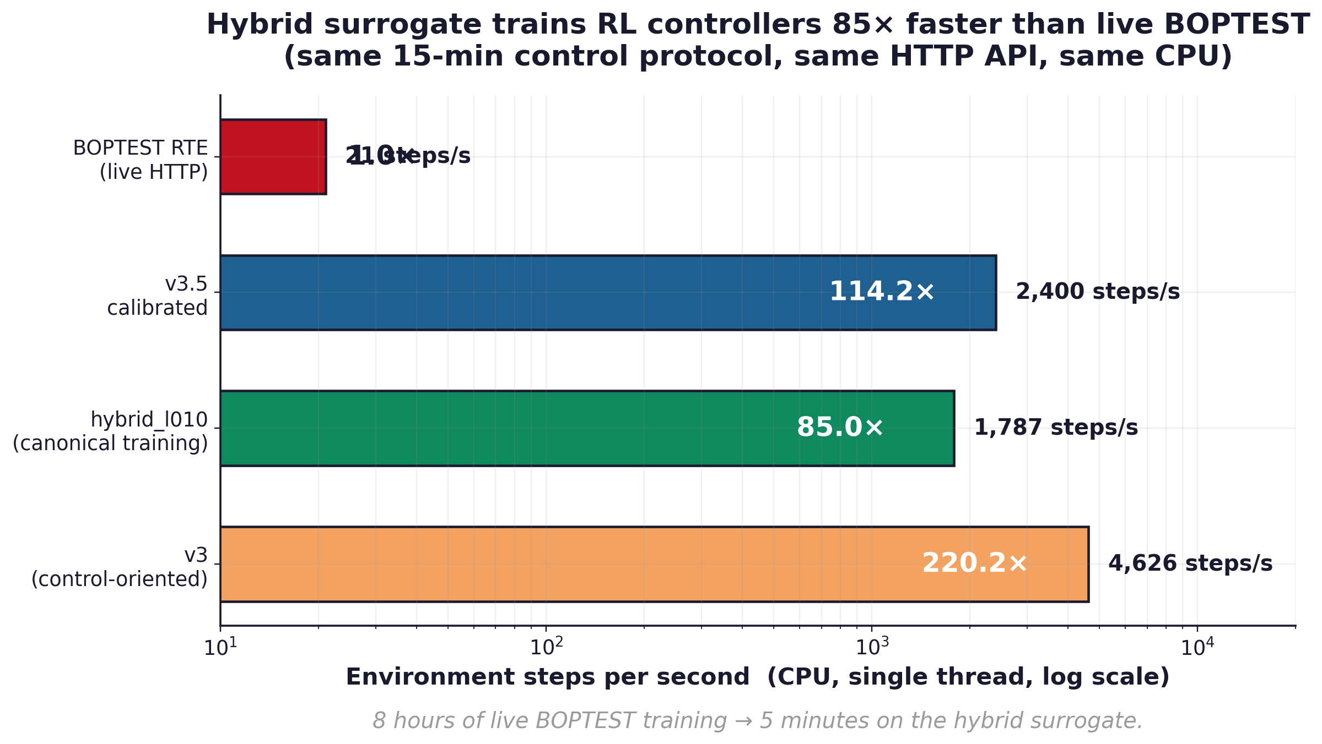
Figure 3. Throughput comparison on CPU under the same 15-min control protocol. The hybrid backend trains RL controllers 85× faster than live BOPTEST.

5. Results I: Digital Twin Fidelity
This section answers the question "How accurate is the surrogate as a model of the building?" It deliberately does not answer "Does it train good RL controllers?" — that question is addressed in §6.

5.1 Architecture comparison
[TODO] Describe Table 1 and the three variants.
[TODO] Table 1 source CSV missing: reports/hou_evins_architecture_justification_table.csv

5.2 Replicative validity
Calibrated v3.5 achieves a one-step temperature RMSE of 0.232 °C versus a pre-calibration baseline of 0.374 °C, a 38% reduction. Power MAE drops from 807.8 W to 482.0 W, a 40% reduction.
Identification of C_zon: the calibrated zone thermal capacitance is C_zon = 4.413 × 10⁵ J/K, deviating from the synthetic prior 5.3 × 10⁵ J/K by approximately 21%. Stable across training; the final value is frozen in the canonical checkpoint and reused unchanged in all downstream experiments.

5.3 Predictive validity
Table 2 reports 1h/4h/8h/24h rollout RMSE_T and MAE_T on the held-out prepared corpus. Three observations: (i) calibration roughly halves the RMSE at every horizon; (ii) the calibrated curve is approximately flat from 1h to 24h (0.65 → 0.64 °C), indicating that the identified C_zon produces a stable physical model rather than one that accumulates error with horizon; (iii) the raw model's RMSE is also flat (~1.49 °C at all horizons), indicating a systematic bias rather than divergent dynamics.
Variant | Metric | 1h | 4h | 8h | 24h
raw_v35 | RMSE (°C) | 1.491 | 1.491 | 1.491 | 1.466
raw_v35 | MAE (°C) | 1.236 | 1.236 | 1.236 | 1.221
v35_calibrated | RMSE (°C) | 0.655 | 0.648 | 0.649 | 0.644
v35_calibrated | MAE (°C) | 0.490 | 0.486 | 0.486 | 0.482
Table 2. Predictive validity of the calibrated physical twin v3.5 versus its uncalibrated baseline raw_v35 across rollout horizons. Values are computed on the held-out prepared 15-minute corpus (8 episodes). Calibration roughly halves the temperature RMSE at every horizon and the RMSE is nearly flat from 1h to 24h, indicating that the identified C_zon produces a stable physical model rather than one that accumulates error with horizon.
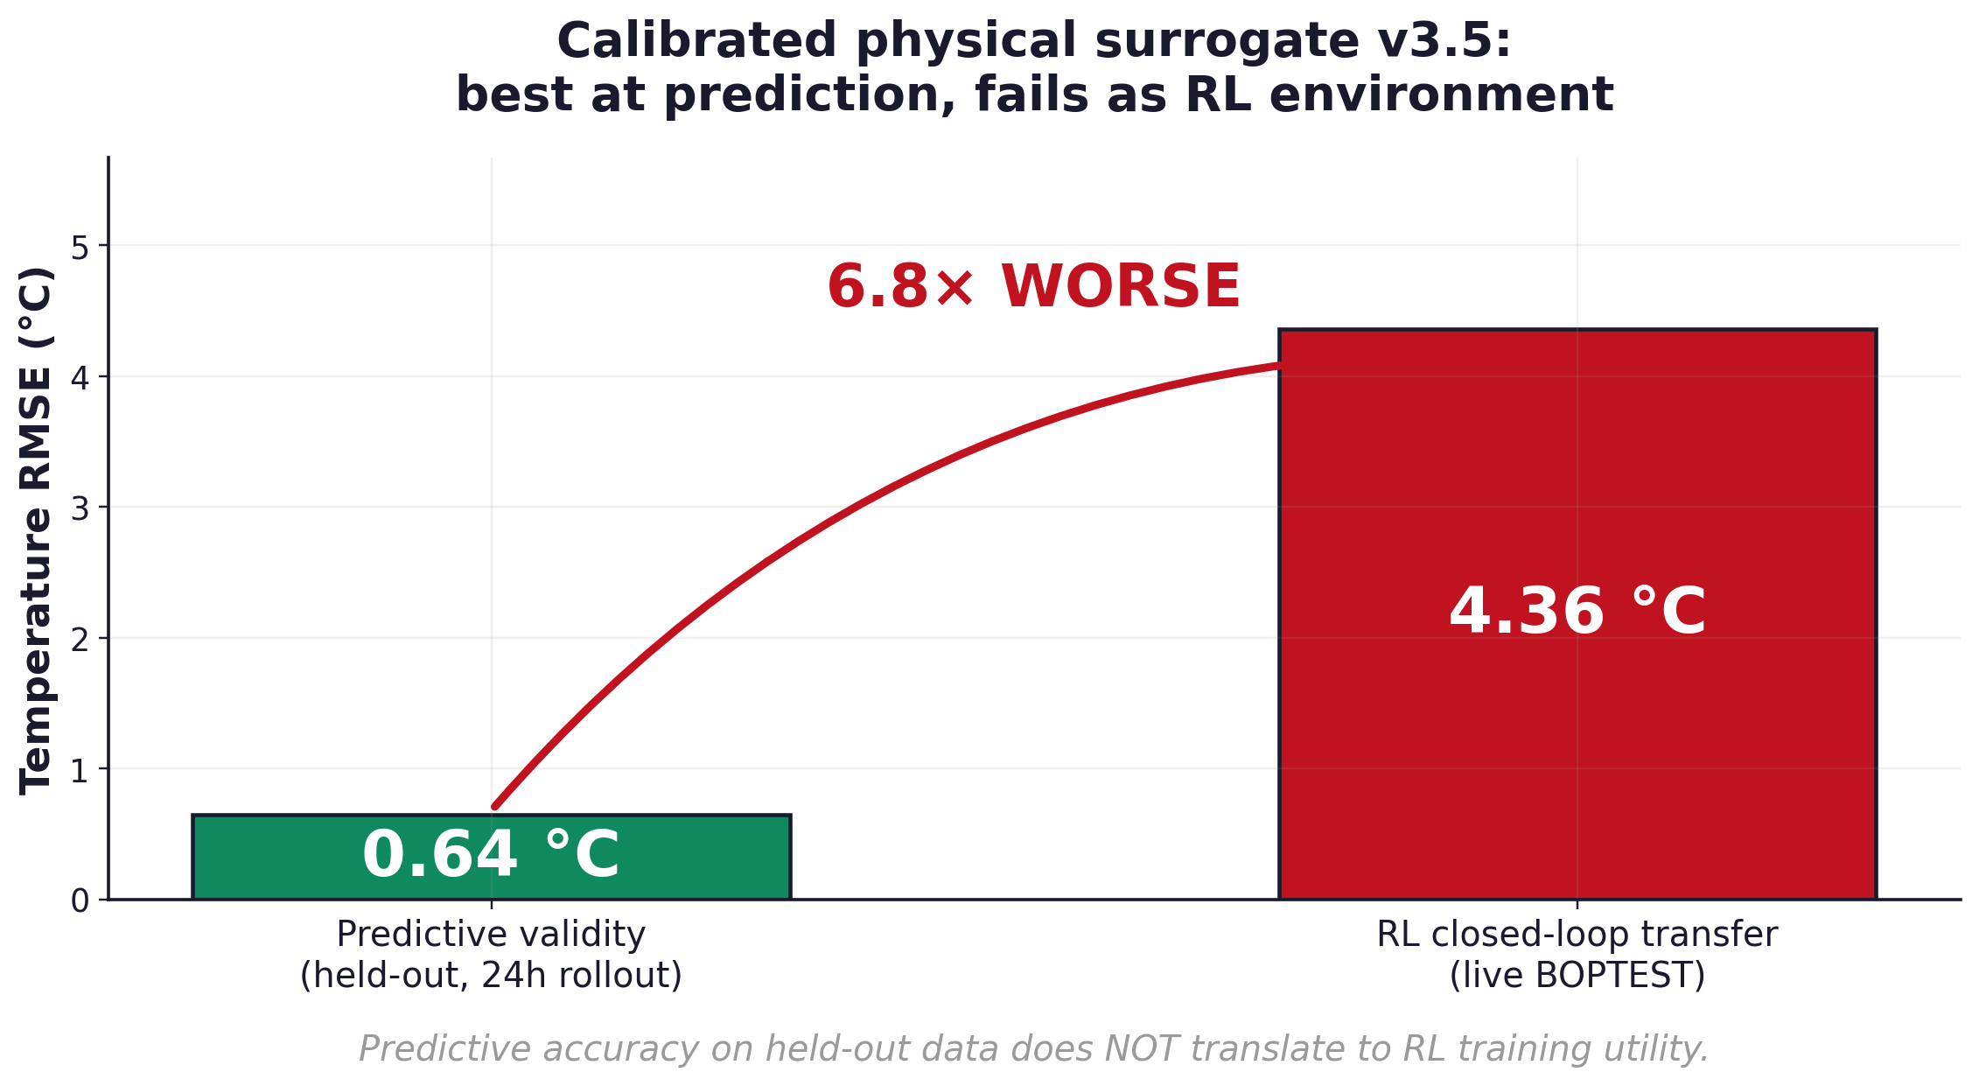
Figure 1. The calibration paradox: v3.5 calibrated achieves the best predictive validity (0.64 °C on held-out 24h rollout) but the worst closed-loop transfer RMSE (~4.4 °C on live BOPTEST), a 6.8× gap. Predictive accuracy alone does not produce a usable RL training environment.

5.4 Failure mode: predictive twin is not an RL training environment
The strong predictive validity of v3.5 does not transfer to its usefulness as a closed-loop RL training environment. When a PPO controller is trained with v3.5 as the sole environment and then deployed on live BOPTEST, the closed-loop temperature RMSE exceeds 4 °C on both heating scenarios and first_divergence_step drops to 1 (immediate divergence).
We attribute this failure to a structural difference: in predictive validation every rollout starts from a real BOPTEST state, so residual errors do not accumulate into a self-reinforcing loop. In closed-loop RL the policy learns to compensate for the surrogate's residual errors as if they were real disturbances; when deployed on live BOPTEST those compensations become unmodeled inputs and the closed loop drifts.
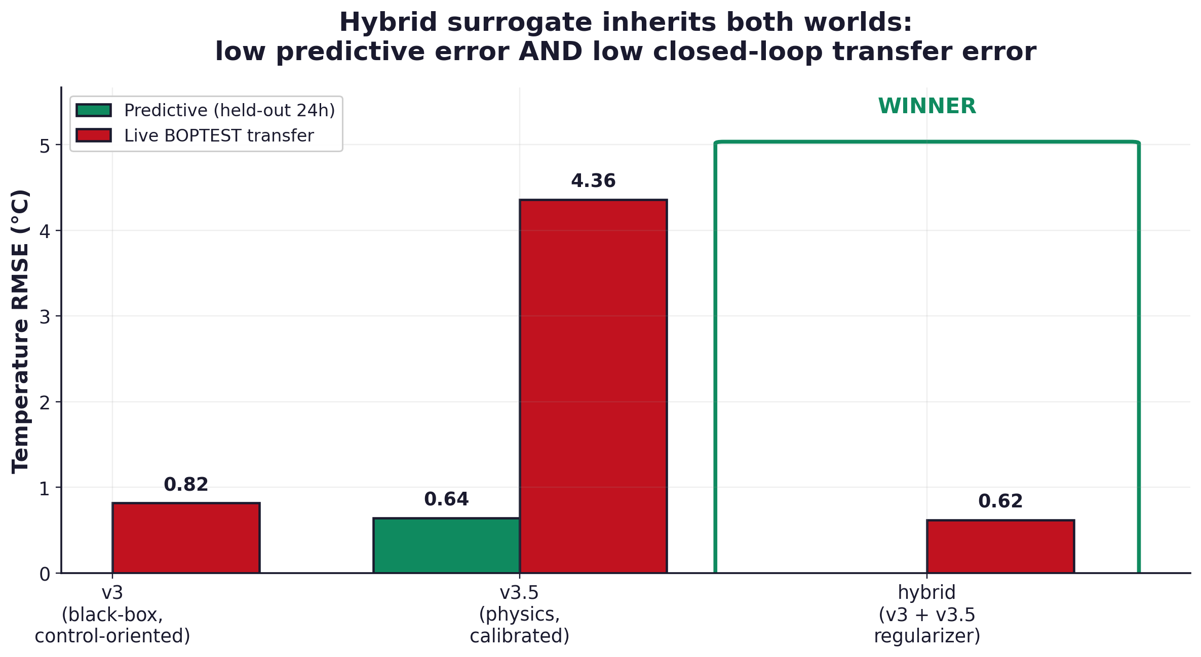
Figure 2. The hybrid backend resolves the fidelity-to-RL gap. v3 has weak predictive validity but good transfer; v3.5 is the opposite; hybrid_l010 inherits both — low predictive error AND low closed-loop transfer error.

6. Results II: Control Performance
This section answers the orthogonal question "Does the surrogate improve downstream RL controller performance on live BOPTEST?". All RL results are reported relative to the BOPTEST built-in PI baseline, presented first.

6.1 PI baseline
The BOPTEST bestest_air testcase exposes a built-in PI controller, invoked by passing an empty action dictionary to the standard BOPTEST step API. We use this controller as the standard reference baseline because it is the reproducible default available to any BOPTEST user; the same protocol, the same setpoint schedule, the same comfort band, and the same Δt = 900 s time step are applied to PI and to every RL controller reported here.
Under yearly evaluation the built-in PI achieves m_s = 0.910, comfort violation rate of 63.6%, total energy consumption of 104.07 kWh, and a yearly mean temperature RMSE of 3.395 °C (Table 5, top row). The high violation rate at the yearly horizon indicates that the default PI tuning is not optimized for full-year operation across both heating and cooling regimes; we therefore do NOT claim that this baseline represents the best achievable PI performance on this testcase. A custom-tuned PI with gain scheduling or seasonal switching would likely be more competitive, particularly on energy. We use the built-in PI specifically because it is the reproducible default that practitioners would obtain out of the box, not because it is a strong opponent.

6.2 Negative control: direct v3.5 warm-start
[TODO] Warm-starting PPO on calibrated v3.5 and then fine-tuning on BOPTEST produces a final policy strictly worse than training from scratch. Cite numbers from outputs/block2_thermostatic_warmstart_utility/.

6.3 Thermostatic PPO with hybrid regularization
[TODO] λ_temp sweep {0.05, 0.10, 0.15} with λ_power = 5e-5 fixed. Best value λ_temp = 0.10. Peak m_s = 0.087, typical m_s = 0.041. Comparison to pure v3.

6.4 Hierarchical reinforcement learning (HDRL)
[TODO] Inverted result: λ_temp sweep {0.00, 0.03, 0.05, 0.10} shows monotone degradation. Best: λ_temp = 0.00. Interpretation: inter-layer conflict.

6.5 Multi-objective reinforcement learning (MORL)
Observation interface matters.
A 5-D preference-aware MORL on the hybrid backend yielded yearly m_s = 1.046, comfort violation 74.5%, RMSE 4.96 °C — effectively a controller failure. Replacing the observation interface with a 17-D TSup-style stack (causal_smooth delta features, clipped_log power, raw t_zone) while keeping the backend, the hybrid loss, and the training pipeline fixed restored performance to the useful regime. Optimal regularization weight: λ_temp = 0.00, mirroring HDRL — a sufficiently rich observation geometry obviates explicit physical regularization.
Pareto front (yearly).
We run a five-point preference sweep on the comfort-energy simplex. Results are summarized in Table 5 and plotted in Figure 4. The four comfort-leaning preferences {1.00, 0.75, 0.50, 0.25} produce a monotone front with no dominated points. The energy-only endpoint w = (0.00, 1.00) exhibits an expected safety collapse (0.28 kWh, 87% violation). A natural knee separates the front near w = (0.50, 0.50): the violation rate jumps from 1.69% at w = (0.75, 0.25) to 6.86% at the neutral midpoint. If a deployment-defensible cutoff of 5% violation is imposed, only w ∈ {(1.00, 0.00), (0.75, 0.25)} remain admissible; among these, w = (0.75, 0.25) consumes less energy and is the better practical operating point.
Dual canonical selection.
We report 3-seed variance on two preference vectors: the pre-registered canonical w = (0.50, 0.50) (fixed before inspecting Pareto results, preserving pre-registration integrity) and the practical-deployment canonical w = (0.75, 0.25) (first preference vector below the 5% deployment threshold). Both rows in Table 5 are currently single seed and will be re-rendered with mean ± std once seeds 43 and 44 complete.
Configuration | Designation | Yearly m_s | Violation (%) | Energy (kWh) | RMSE (°C) | N seeds
BOPTEST PI (built-in) | reference | 0.910 | 63.59 | 104.07 | 3.395 | 1
MORL w=(1.00, 0.00) | comfort endpoint | 0.0316 | 1.49 | 260.57 | 0.631 | 1
MORL w=(0.75, 0.25) | ★ practical canonical | 0.0323 | 1.69 | 251.23 | 0.670 | 1
MORL w=(0.50, 0.50) | ★ pre-registered canonical | 0.1217 | 6.86 | 237.83 | 0.824 | 1
MORL w=(0.25, 0.75) | intermediate | 0.1729 | 11.39 | 219.98 | 0.912 | 1
MORL w=(0.00, 1.00) | energy collapse | 1.5879 | 86.76 | 0.28 | 8.359 | 1
Table 5. Yearly evaluation of the five-weight MORL Pareto sweep on bestest_air (single seed per preference vector at the time of writing; canonical rows will be re-rendered with mean ± std once seeds 43 and 44 complete). The BOPTEST built-in PI controller is included as the standard reference row; it is the default tuning exposed by the testcase and is NOT a custom-tuned baseline.
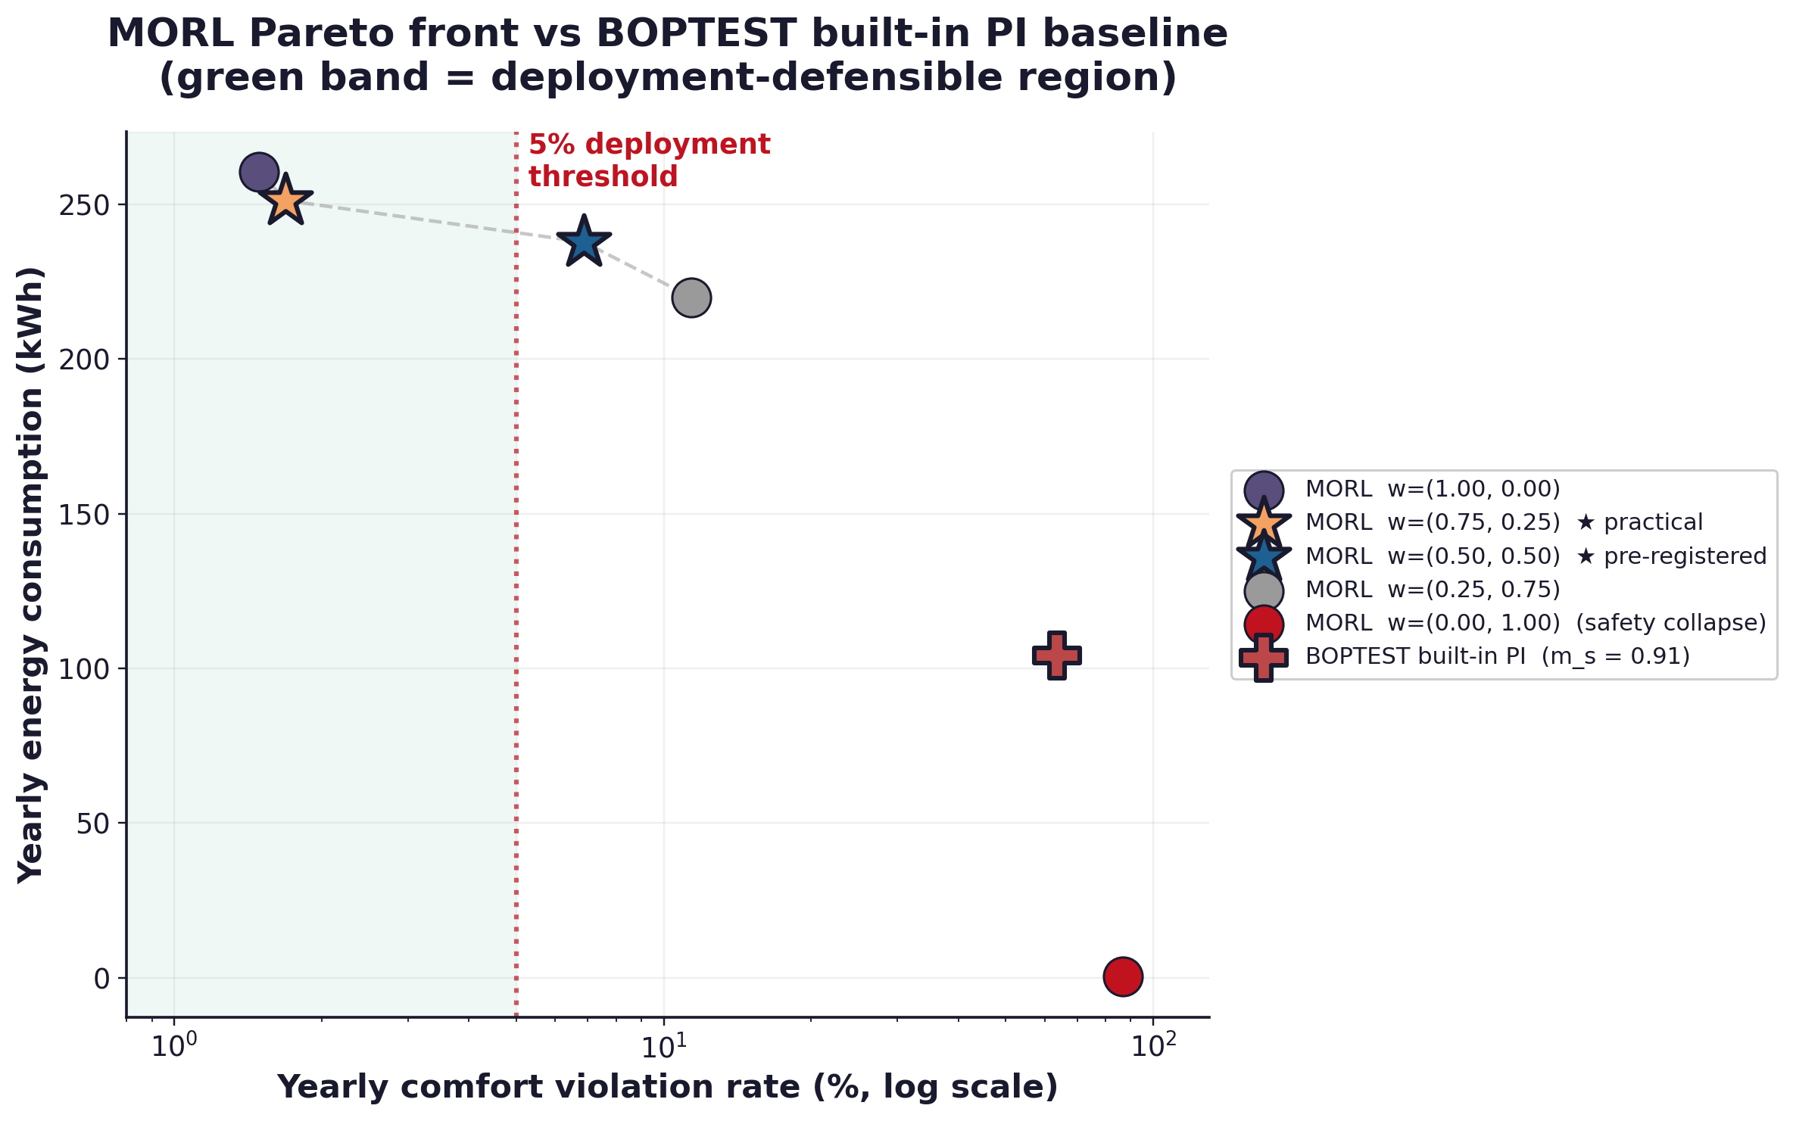
Figure 4. Yearly Pareto scatter of the 17-D MORL controller across five preference weights, with the BOPTEST built-in PI baseline as the standard reference marker. The vertical dashed line marks the 5% deployment-violation threshold; the gray dashed curve traces the admissible region.

6.6 Cross-controller comparison
The optimal λ_temp depends on observation richness and on controller hierarchy: thermostatic PPO benefits from external physical anchor (λ_temp = 0.10), while HDRL and 17-D MORL prefer no temperature anchor (λ_temp = 0.00). This is the central controller-family-specific finding of the paper.
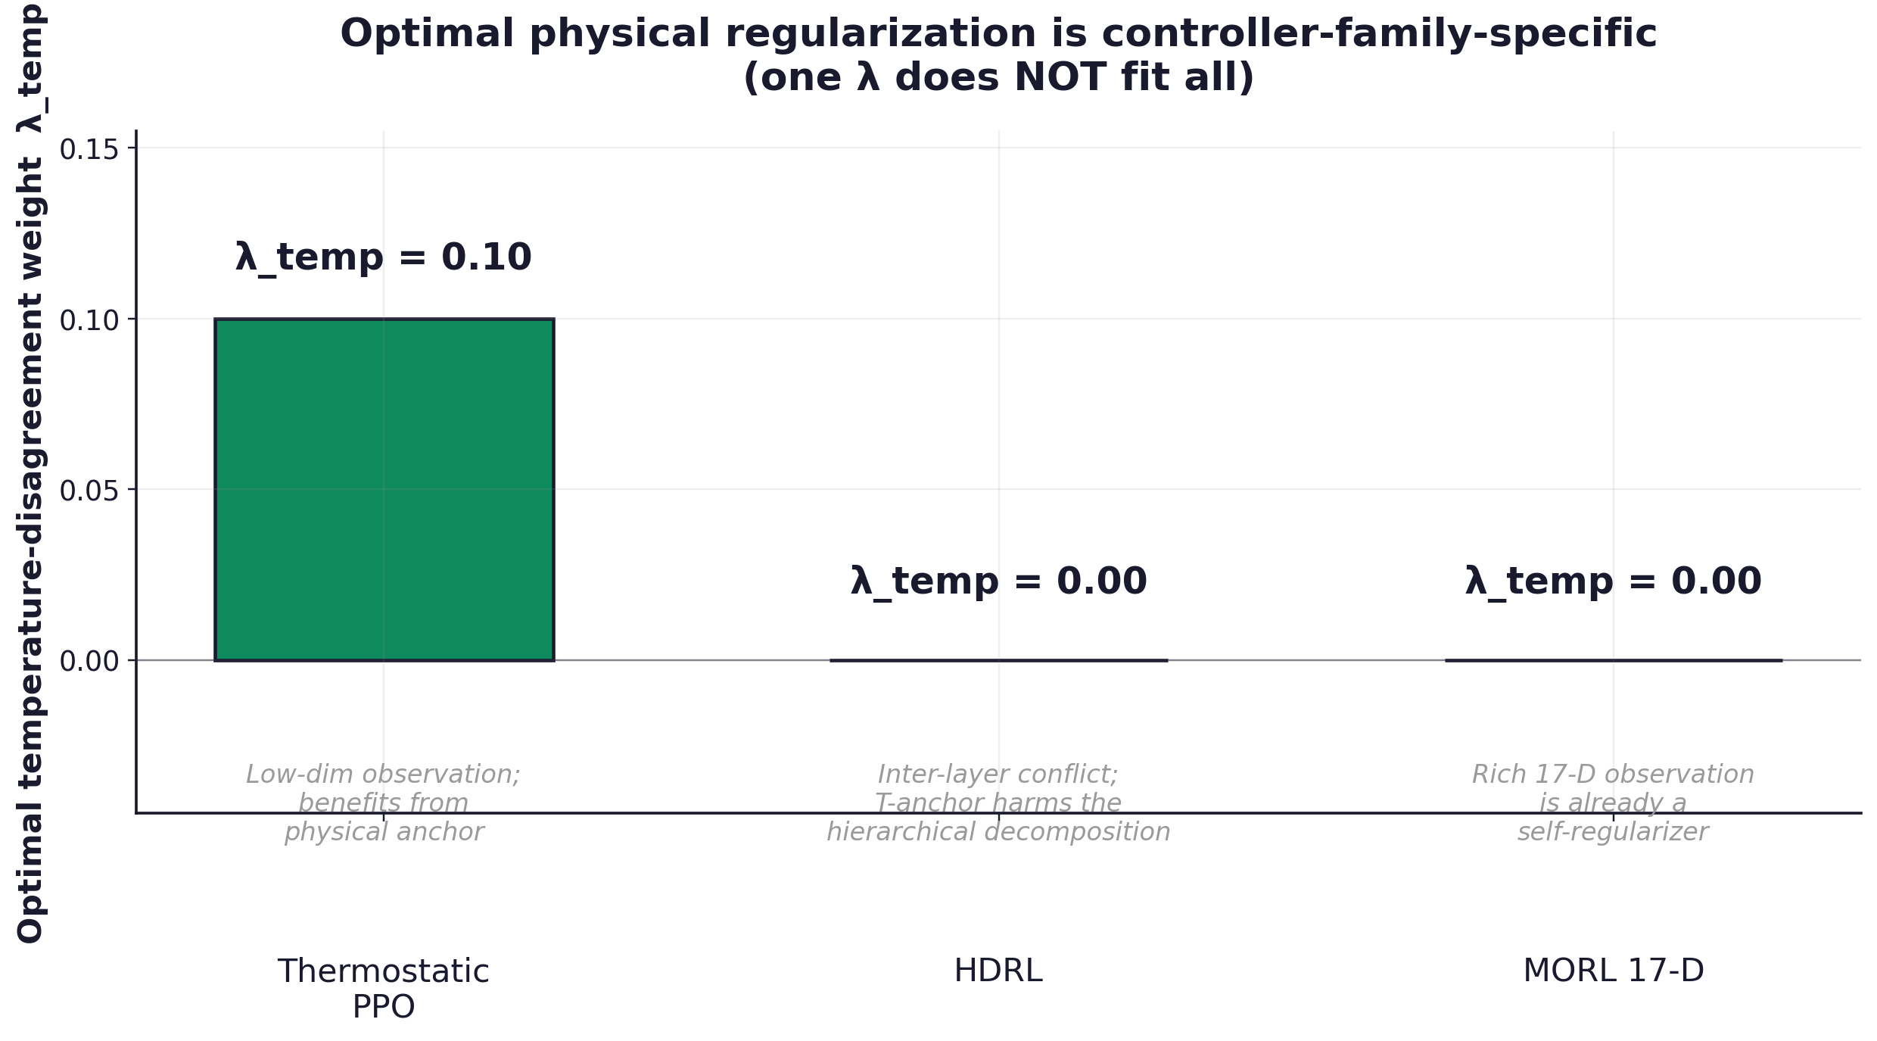
Figure 5. The optimal temperature-disagreement weight λ_temp is controller-family-specific. Thermostatic PPO benefits from a physical anchor; HDRL and 17-D MORL do not.

7. Results III: Transferability and Generalization
Optional section. Activate only if Block 3 produces usable results before submission.

7.1 Selection of related testcases
[TODO] Pre-registered selection of 2–3 related BOPTEST testcases.

7.2 Recalibration regimes
[TODO] Three regimes: none, partial (Stage C only), full (Stage A/B/C).

7.3 Transfer matrix
[TODO] Table testcase × recalibration × controller family.

7.4 Verdict per cell
[TODO] PASS / CONDITIONAL PASS / FAIL with m_s ≤ 1.25 × m_s_PI threshold.

8. Discussion

8.1 Why predictive validity and RL training utility diverge
[TODO] Structural argument: predictive validation tests along trajectories starting from real states; closed-loop training tests trajectories generated by the model itself. Residual errors accumulate in the latter, not the former.

8.2 Why physical regularization is controller-family-specific
[TODO] Three mechanisms per family: thermostatic (low-dim obs needs anchor), HDRL (inter-layer conflict), 17-D MORL (rich obs is self-regularizer).

8.3 Why observation geometry matters
[TODO] 5-D → 17-D MORL transition: same backend, same loss, only obs differs, yet yearly m_s moves from 1.046 to 0.099.

8.4 Threats to validity
- Single weather file — climate-zone generalization not tested.
- Single building testcase — cross-testcase generalization addressed only if §7 is activated.
- KPI specificity — m_s is BOPTEST-specific; comparisons to non-BOPTEST literature are limited.
- Seed budget — canonical results at N = 3 seeds; HDRL at N = 1 seed.
- Hyperparameter sensitivity — λ sweep is targeted, not exhaustive.
- Hybrid recipe transferability — only single testcase without §7.

9. Conclusion
What is solved. We show that a physically calibrated surrogate with explicit zone thermal capacitance is a strong predictive twin (24-hour rollout RMSE 0.64 °C) but fails as a closed-loop RL training environment (live RMSE > 4 °C). The resolution is a hybrid construction in which the calibrated twin enters the policy training loss only as a soft physical regularizer. The optimal regularization strength is controller-family-specific. A reproducible BOPTEST-based protocol is provided, with full numerical justification following the surrogate-development protocol of Hou and Evins (2024).
What is open. The construction has been demonstrated on a single BOPTEST testcase with a single weather file. Cross-climate and cross-building generalization are not established. A full multi-objective Pareto analysis of the MORL controller, while initiated here, requires a denser preference sweep to support a full multi-objective claim. We have intentionally avoided overclaiming the universality of the proposed recipe; the claim boundaries are stated explicitly in §8.

Data availability
All code, trained models, configuration files, output artifacts, and the eleven supplementary tables (S1–S11) are available at <repository URL>. Numerical values reported in Tables 1–5 are reproduced directly from the corresponding CSV files via paper/build_paper_tables.py and paper/build_paper_docx.py.

References
[TODO] Populate from bibliography.bib. Seed entries: Hou and Evins (2024), Blum et al. (2021, BOPTEST), Schulman et al. (2017, PPO), Raissi et al. (2019, PINN), Yang et al. (2019, MORL), Jiménez-Raboso et al. (2021, Sinergym).

