The Group Project

Twitter tops
on Google Cloud Platform

Course: «Research seminar»
Big Data Systems Master degree program

Completed by
- Almaz Murzabekov
- Habibullah Wardak
- Kakit Law
- Daria Kiseleva
- Sidhardha Neupane
- Li Zhonghua

Moscow, May 2020

Goal of the work and its estimating

The main goal of this practical assignment is to provide for students hands-on experience with Big Data Ecosystem, Hadoop Framework, HDFS, MapReduce, and Spark. In this project, we will deploy Hortonworks HDP distribution which contains most of Big Data Frameworks into Google Cloud Platform (GCP).

Prerequisites:
- Valid GCP account
- A student's personal account for this environment

Research Seminar Group Project - Twitter Tops

Part 1: Preparing the environment

- Assume that student has a valid GCP account and student have done the authorization and verification process. After those processes student will be able to see home page, that looks like in picture presented bellow.

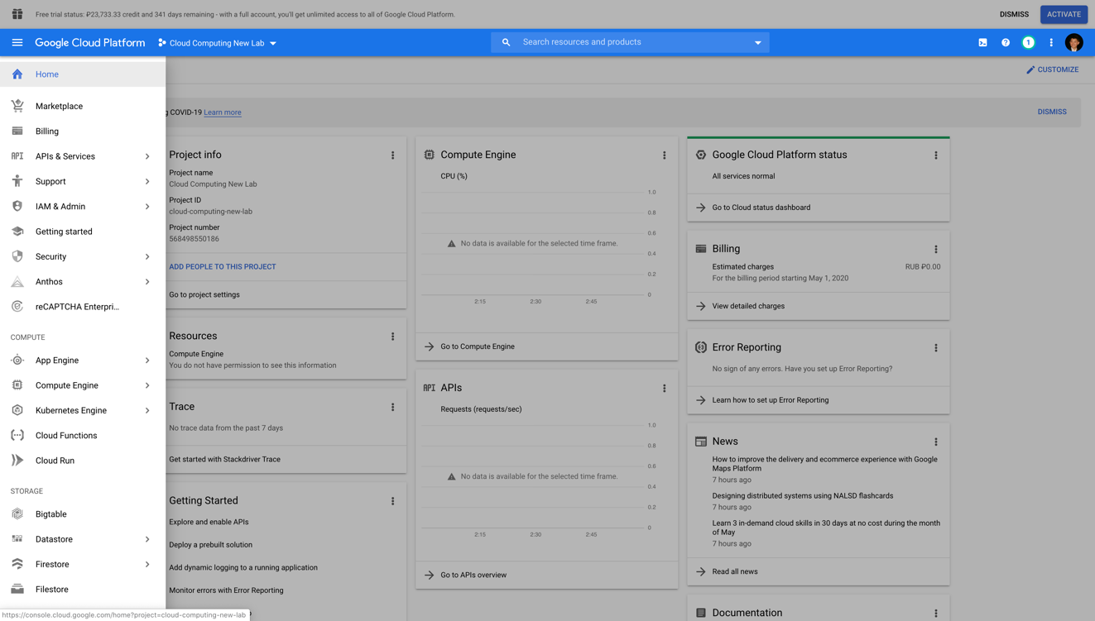

- Creating a new project: Cloud Computing New Lab
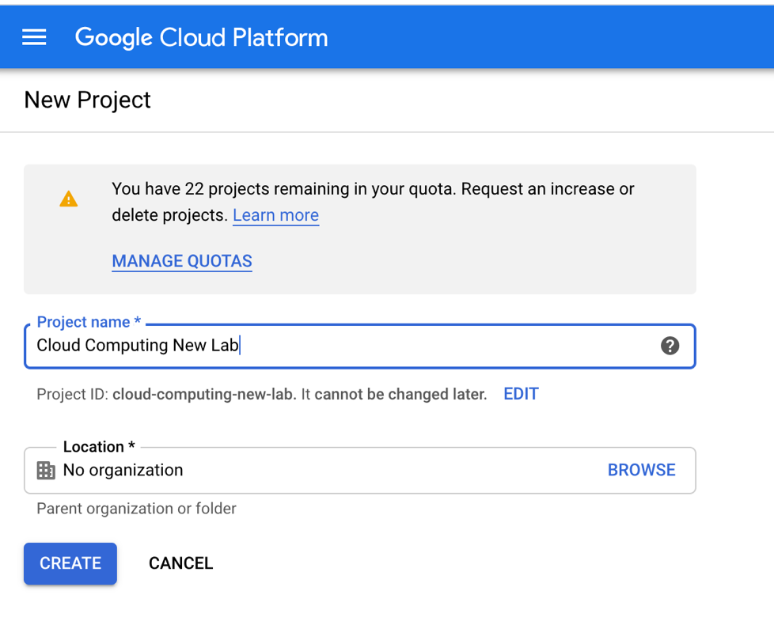
- Create a new Virtual Machine with provided parameters
- Name: cloud-compute-lab
- Region and Zone leave as default
- Machine Family: General-purpose
- Series: N1
- Machine Type: Custom
- Cores: 20v CPU
- Memory: 100Gb
- Boot Disk: Ubuntu 16.04 LTS 100Gb Standard persistent disk
- Firewall: Allow HTTP & HTTPS traffic
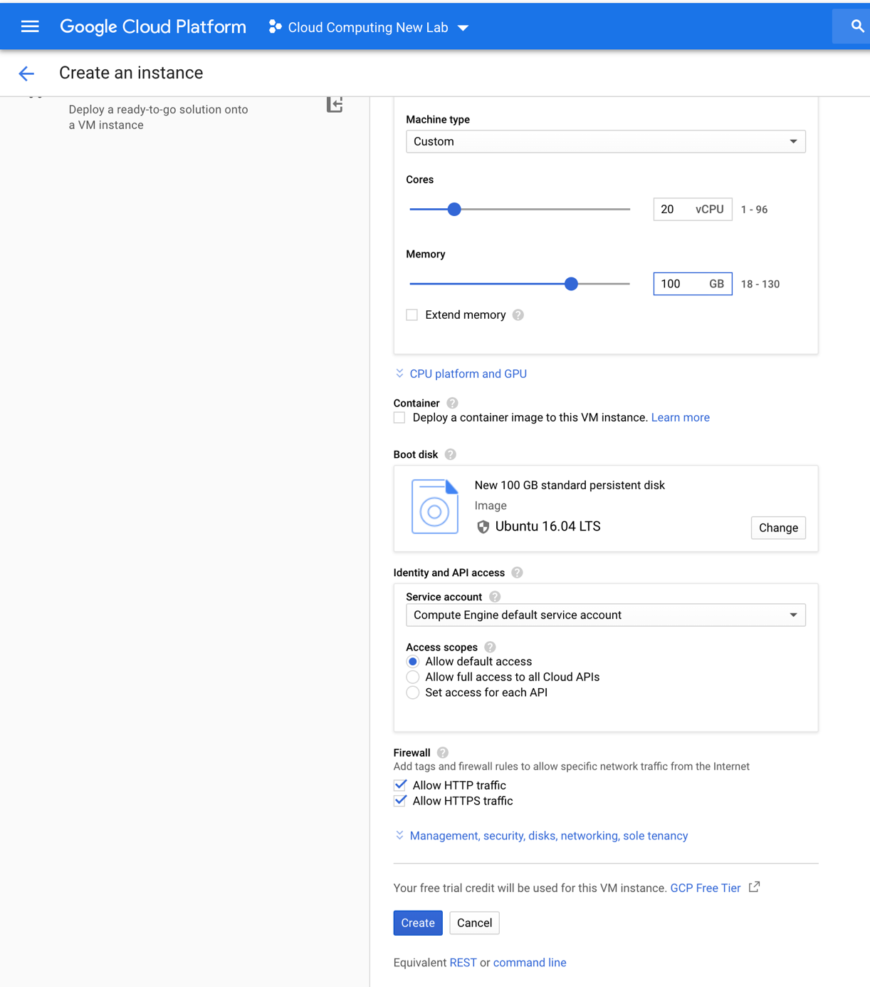
- After step-3 you will get running virtual machine like this
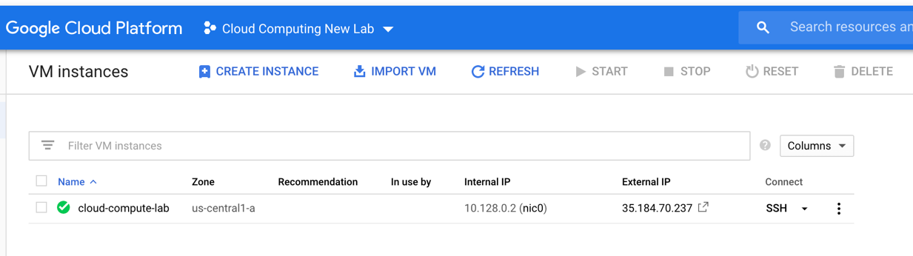

Part 2: Setting up firewalls
- Go to left panel, select VPC network -> Firewall rules
- Click “Create firewall rule” on the top toolbar
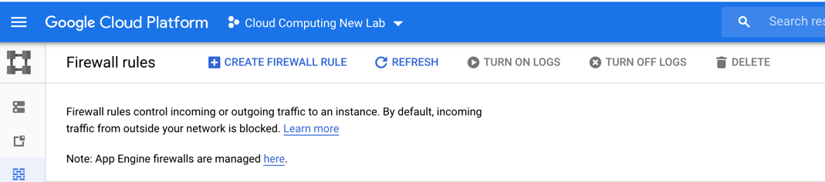

- Create a firewall rule, with settings as follows: (note: Select “Allow all” in protocol and ports section)
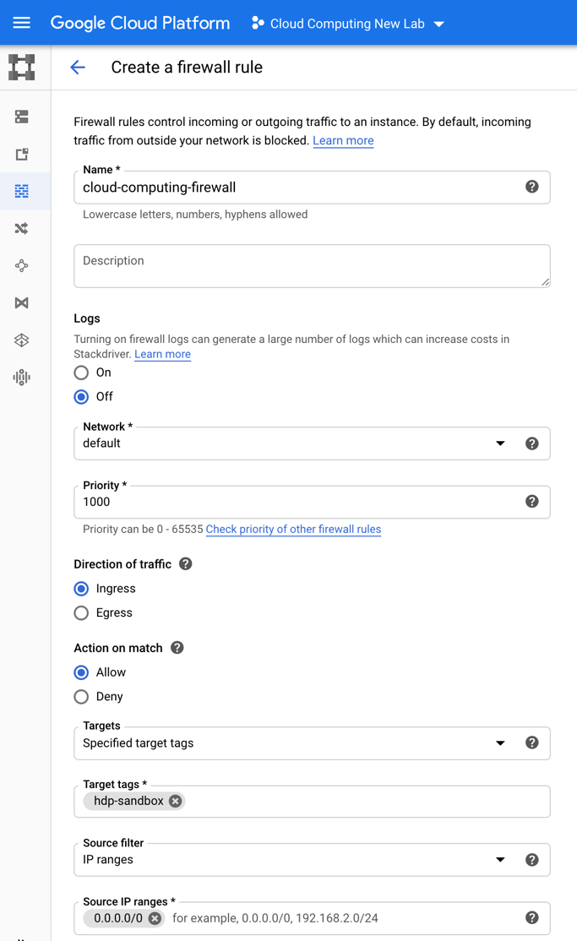

- After step-3 you will see the created firewall on the Firewall Rules page

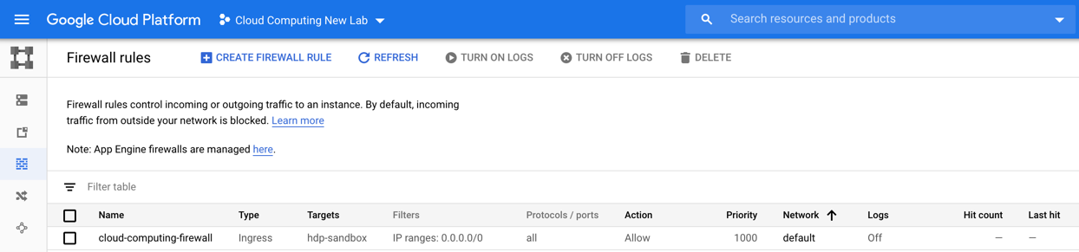
- Reserve static IPv4 address for VM-instance: Go to left panel, Select VPC network -> External IP addresses
  - Click on “Reserve static address”
  - Create a static IPv4 address with following parameters:
    - Name: cloud-computing
    - Description: leave it empty
    - Network Service Tier: Premium
    - IP version: IPv4
    - Type: Regional
    - All other fields leave with default params
  - Click on “Reserve” button
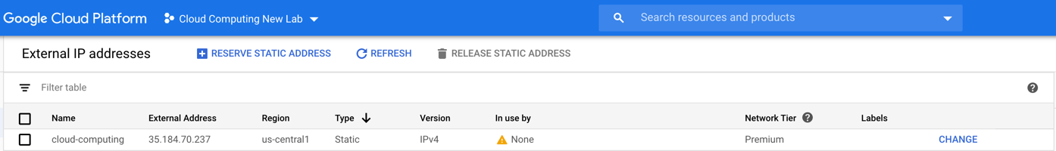
- Attach static IPv4 address for VM-instance
  - Click “CHANGE” button on created Static IPv4 Address “cloud-computing”
  - On the “Attach” field choose created VM-instance – cloud compute lab
  - Click OK
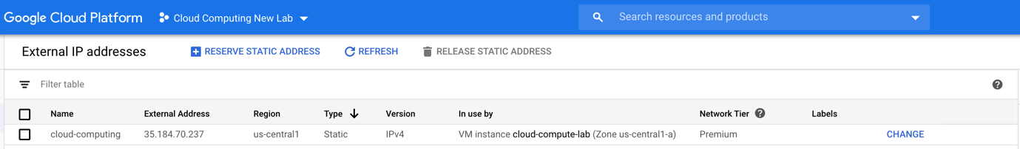

Part 3: Preparing the Kafka VM
- Go to left panel, select Compute Engine -> VM Instances
- Click to SSH button to connect with VM instance, which was created in step-4. On new page you will be able to see a web-terminal for VM instance
- Installing the docker engine
  - First of all, we need update apt-get tool. For that type
sudo apt-get update
  - Allow apt-get to use a repository over HTTPS (type Y if needed)
sudo apt-get install apt-transport-https ca-certificates curl gnupg-agent software-properties-common
  - Add Docker’s official GPG key:
curl -fsSL https://download.docker.com/linux/ubuntu/gpg | sudo apt-key add
  - Use the following command to set up the stable repository.
sudo add-apt-repository "deb [arch=amd64] https://download.docker.com/linux/ubuntu $(lsb_release -cs) stable"
  - Update the apt package index, and install the latest version of Docker Engine and container. (type Y if needed)
sudo apt-get update
sudo apt-get install docker-ce docker-ce-cli containerd.io
  - Verify that Docker Engine is installed correctly by running the hello-world image.
sudo docker run hello-world

  - sudo apt-get install docker-compose

- sudo apt-get update
- sudo apt-get install default-jre

wget http://mirror.linux-ia64.org/apache/kafka/2.5.0/kafka_2.12-2.5.0.tgz

tar -xzf kafka_2.12-2.5.0.tgz

bin/zookeeper-server-start.sh config/zookeeper.properties

Part 4: Install HDP-sandbox
- install unzip package
sudo apt install unzip -y
- Download HDP-sandbox zip package
wget https://archive.cloudera.com/hwx-sandbox/hdp/hdp-3.0.1/HDP_3.0.1_docker-deploy-scripts_18120587fc7fb.zip

- Unzip downloaded HDP-sandbox zip package
unzip HDP_3.0.1_docker-deploy-scripts_18120587fc7fb.zip
- Run HDP-sandbox. Note: this command may take a while for several minutes
sudo bash docker-deploy-hdp30.sh
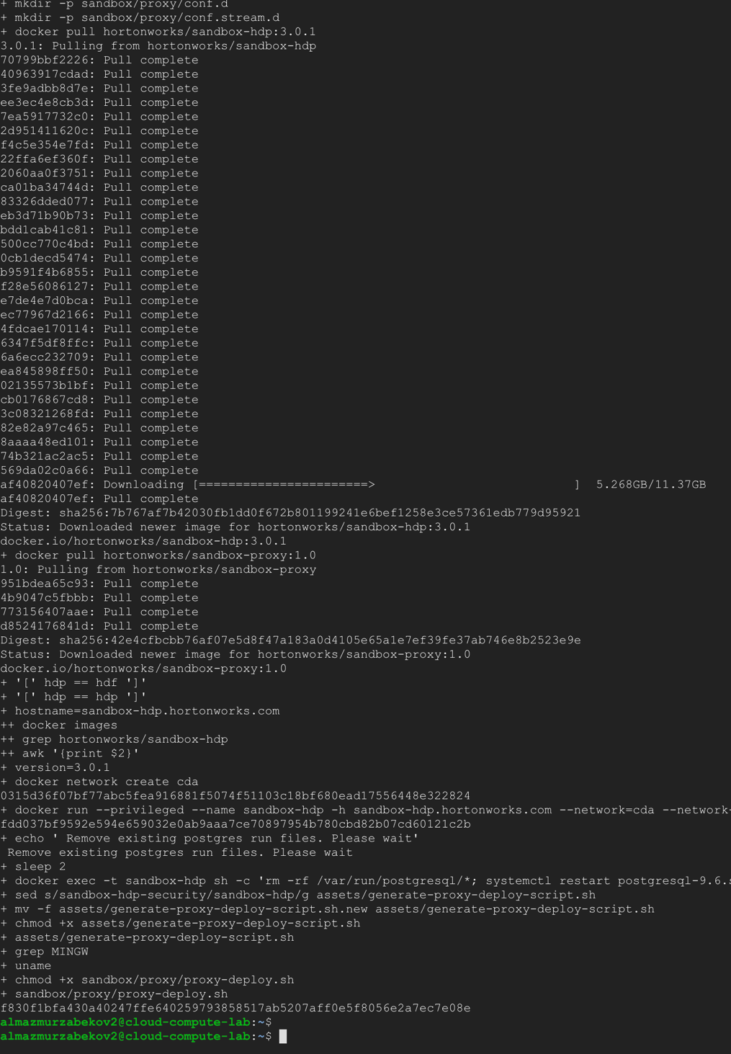

- Check running docker images
sudo docker ps

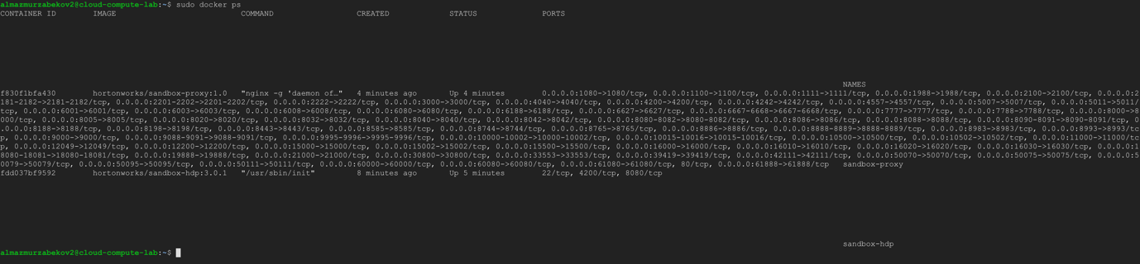

Configure alias naming. Replace {IP-address} to real external IP-address of your VM
echo '{IP-Address} sandbox-hdp.hortonworks.com sandbox-hdf.hortonworks.com' | sudo tee -a /etc/hosts
Example:
echo '35.184.70.237 sandbox-hdp.hortonworks.com sandbox-hdf.hortonworks.com' | sudo tee -a /etc/hosts
- Check installation
  - Open http://{IP-address}:8080 for ambari GUI

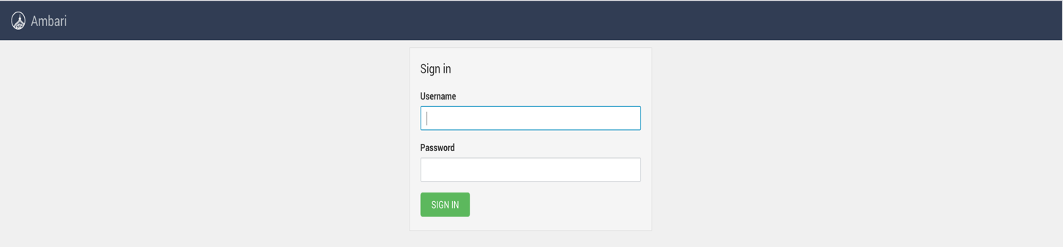

Part 5: Configuring Ambari GUI
- Connect to docker container
  - Get a container ID
sudo docker ps

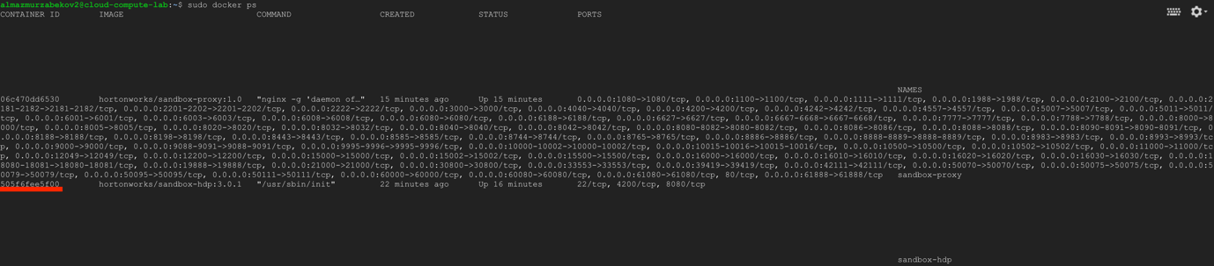
  - Connect to docker container
sudo docker exec -it [Container ID] bash
Example:
sudo docker exec -it 505f6fee5f00 bash

- Reset admin password (remember it as admin password)
ambari-admin-password-reset

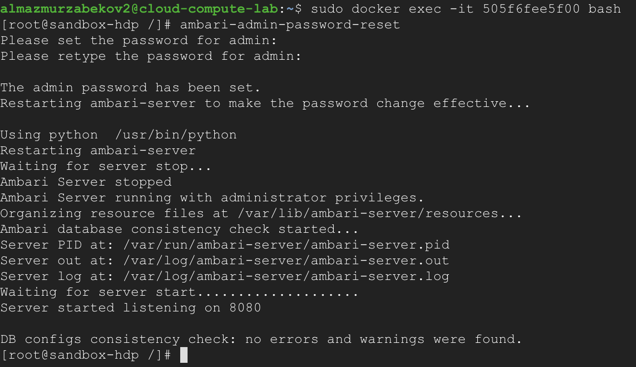

- Check Ambari GUI again
  - Open: http://{IP-address}:8080
    - user name “admin”
    - password admin’s password
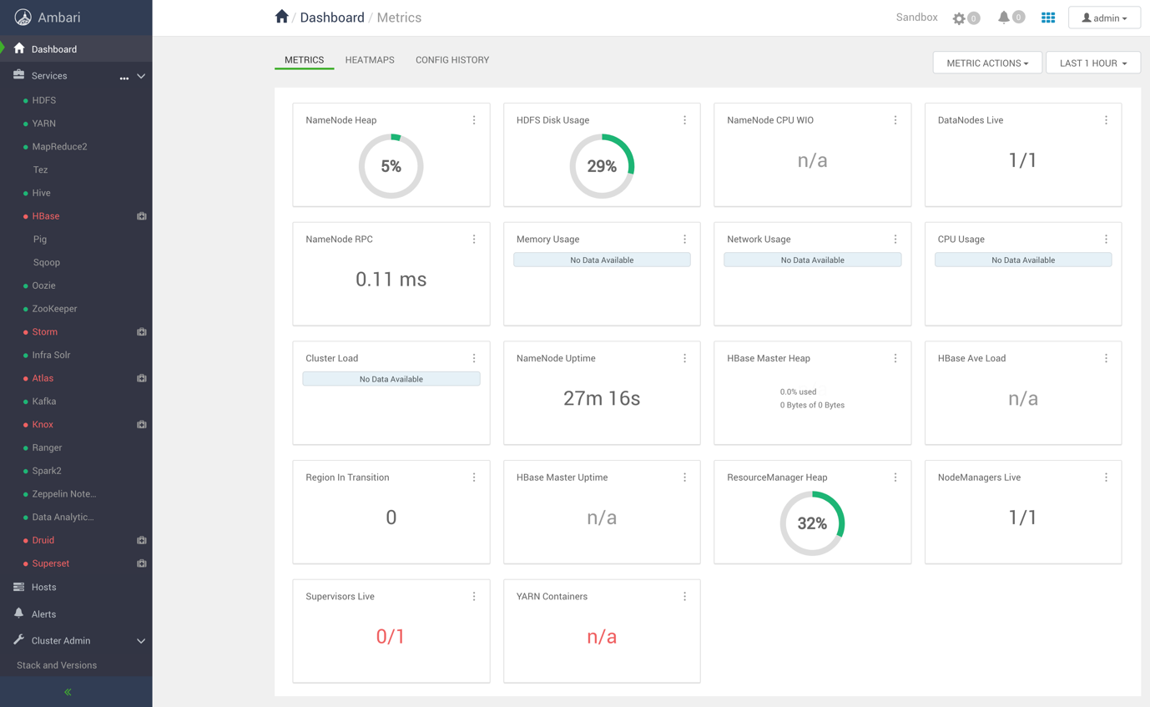

Part 6: Preparing the dataset
- Create and navigate folder dataset in /
mkdir dataset
cd dataset /

- Download Sample of Full-Text-Corpus data from
wget https://www.corpusdata.org/iweb_samples/text0.zip

- Unzip downloaded file
unzip text0.zip -d text/

- Cat all text files from different folders into one file

find text/ -name "*.txt" -exec cat {} + > dataset.txt

- Upload downloaded files into HDFS and check it

hdfs dfs -copyFromLocal dataset.txt

hdfs dfs -ls

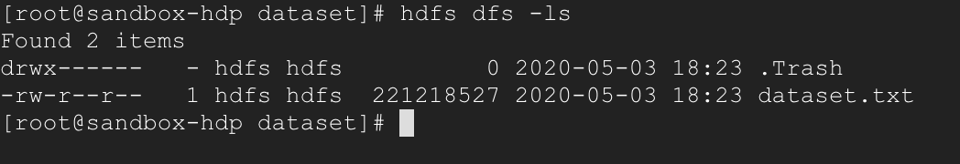

- Check file in GUI
  - Open Ambari sandbox
  - Navigate to HDFS menu
  - Click on NameNode UI on the right side menu
  - On NameNode UI page click on Utilities -> Browse the file system
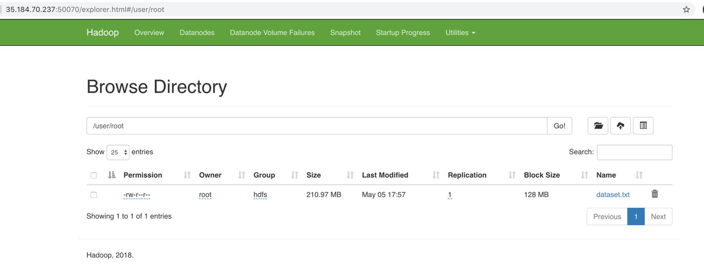

Part 7: Running Spark word-count example on Zeppelin

- Go to the Ambari Console (Web-page) Open: http://{IP-address}:8080
- Click on the Zeppelin Notebook -> Quick Links (on the right side) -> Zeppelin UI
- Create a new Note with name “HelloWorld” and “spark2” interpreter

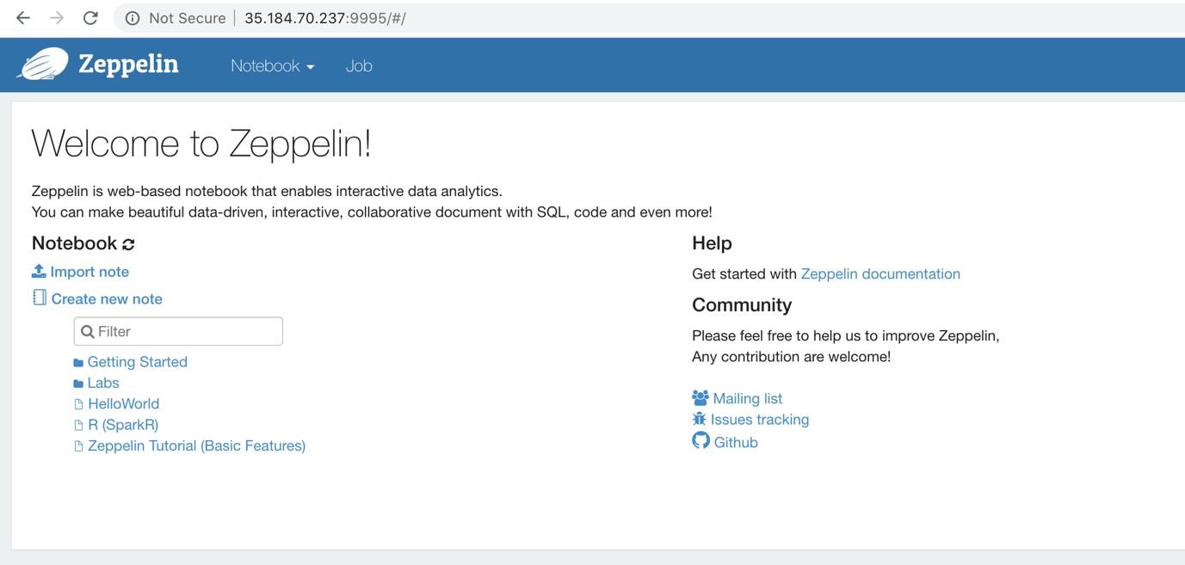

- Check that Zeppelin works correctly. On the first paragraph write presented in the below code and run it. Note: At the first time your code submition and execution will took a quite long time.
%spark2.spark
spark.version

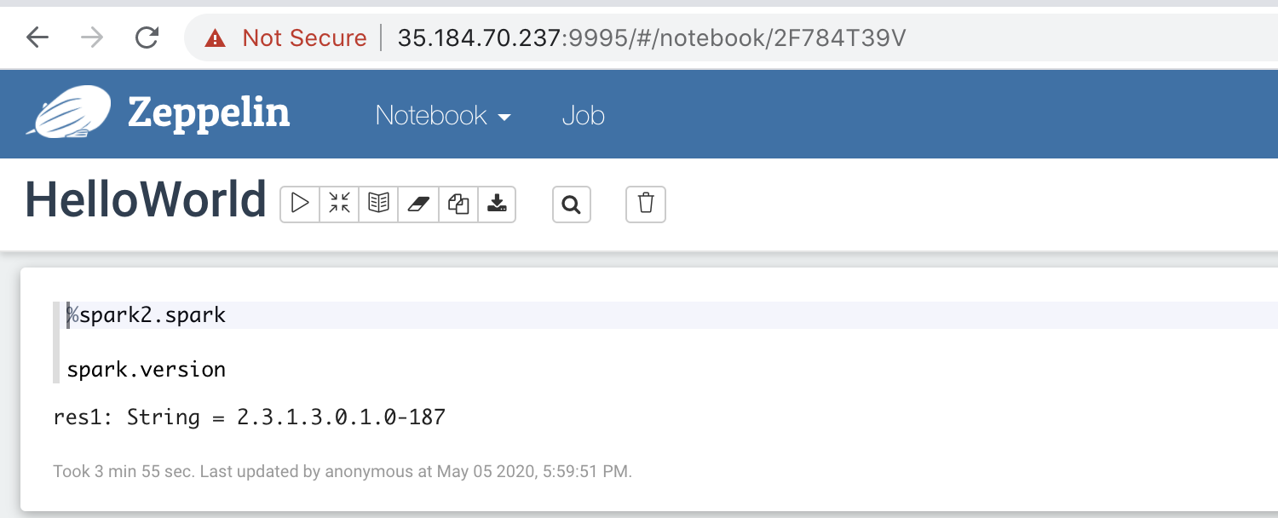

- Read a dataset that we uploaded from internet and uploaded into HDFS
val path = "/user/root/dataset.txt"
val dataset = spark.read.text(path)
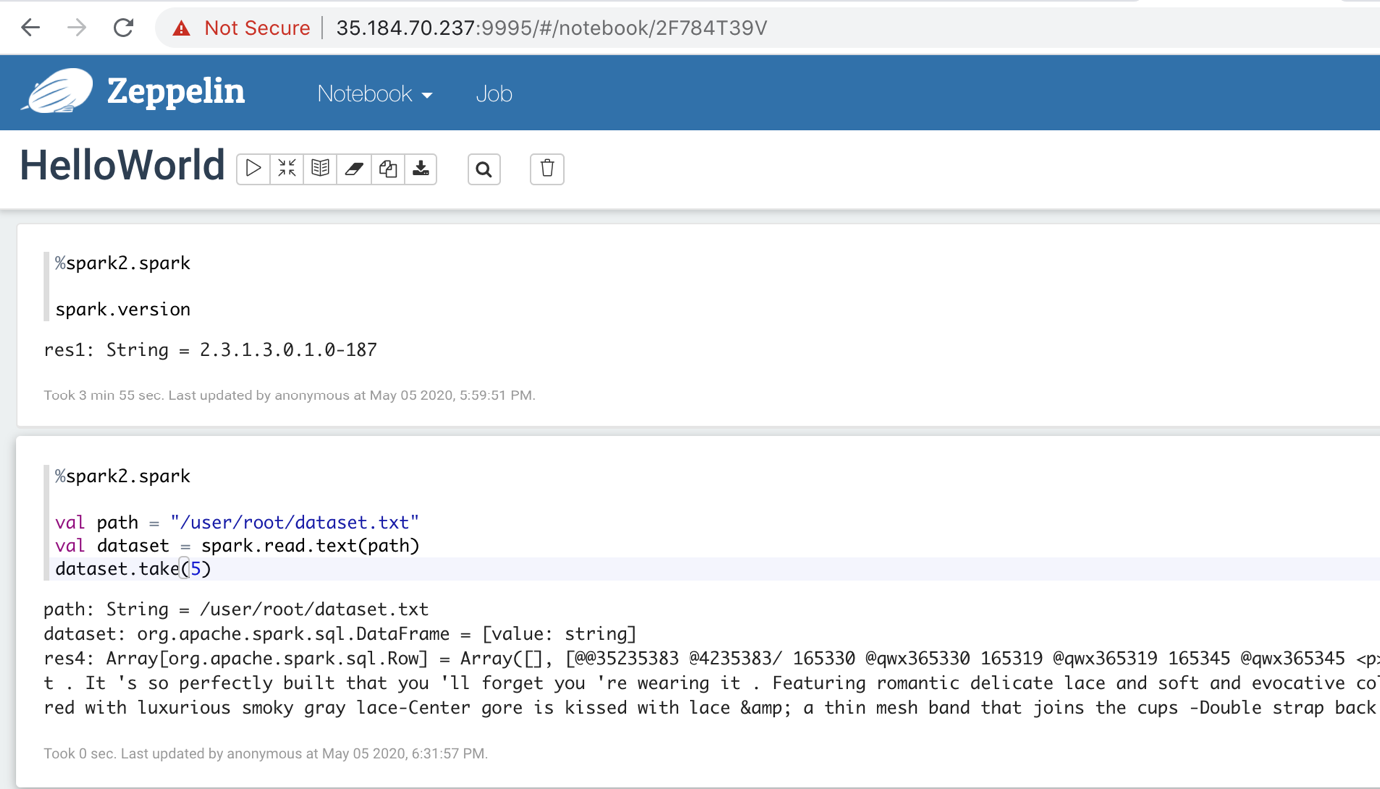

- Split Spark Dataset of Text Lines into Spark Dataset of Words
val regexText = """\w+|[^\w\s]""".r
val regexNumbers = """\d+""".r

val datasetAsText = dataset.select("value").as[String]
val words = datasetAsText
.flatMap(_.split("\\s+"))
.filter(text => regexText.pattern.matcher(text).matches)
.filter(text => !regexNumbers.pattern.matcher(text).matches)
.filter(_.length > 2)
.map(_.toLowerCase())

words.take(5)

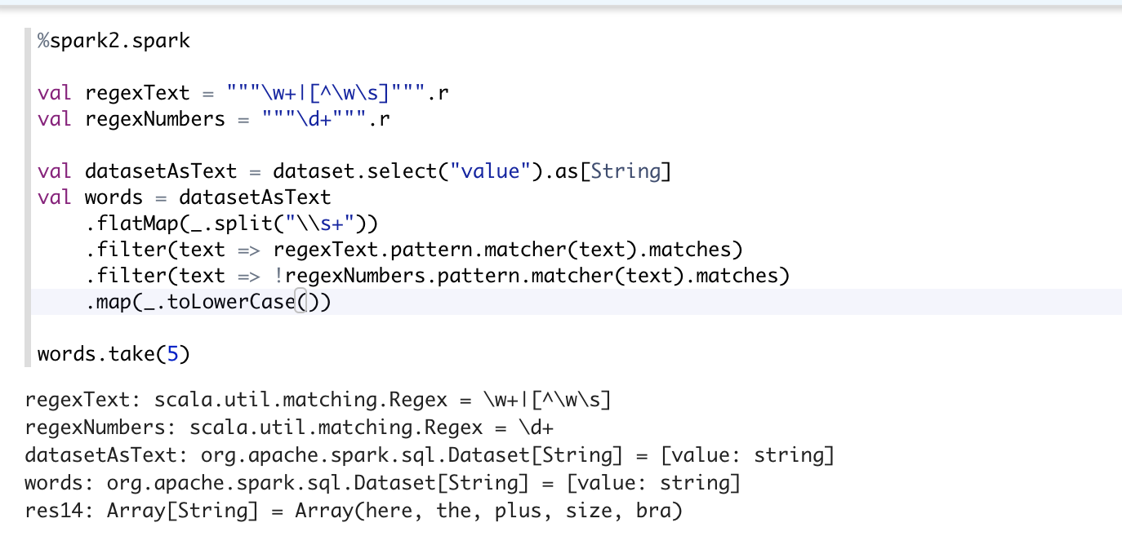

- Compute a word-count
words
.groupByKey(value => value)
.count()
.orderBy($"count(1)" desc)
.show()

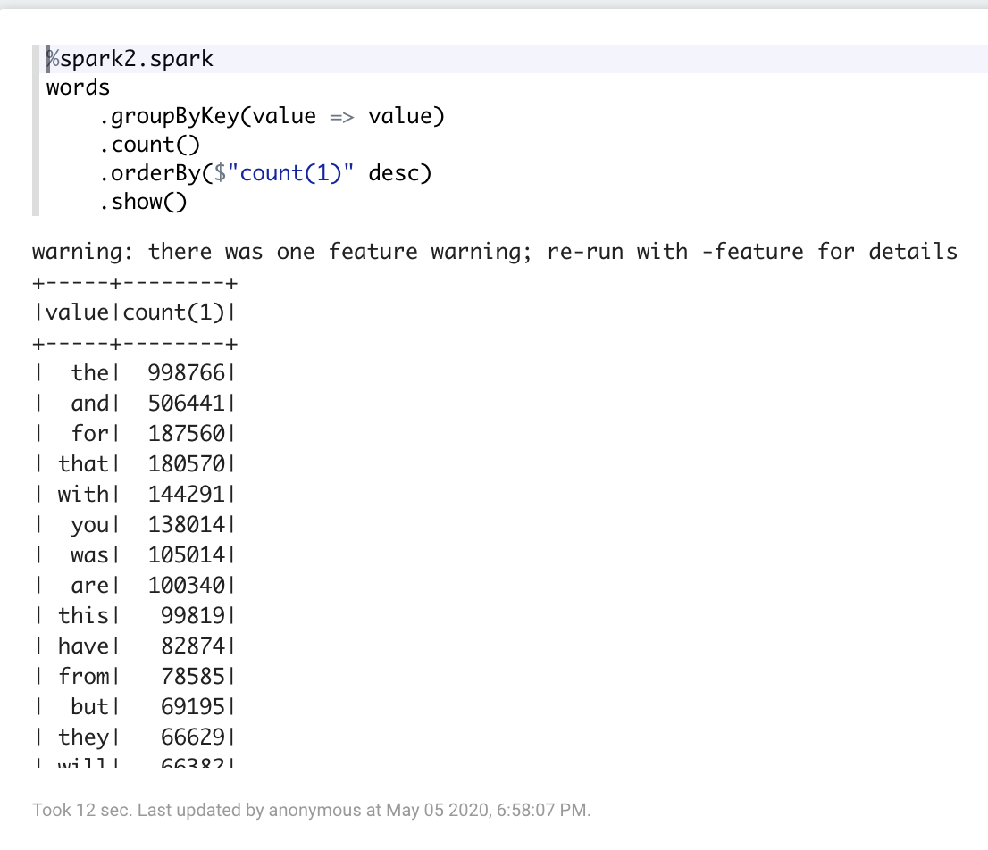

RESOURCES:
- Google Cloud Platform: https://cloud.google.com/
- Apache Foundation: https://www.apache.org/foundation/
- Apache Hadoop: https://hadoop.apache.org/
- Apache Hadoop Overview: https://hadoop.apache.org/docs/stable/
- Apache Hadoop HDFS: https://hadoop.apache.org/docs/r1.2.1/hdfs_design.html
- Apache Spark https://spark.apache.org/
- Apache Ambari: https://ambari.apache.org/
- Hortonworks Data Platform HDP: https://www.cloudera.com/downloads/hortonworks-sandbox/hdp.html
- Docker: https://www.docker.com/

