Exam format – one theoretical question and a number (4-6) of multiple choice questions which may or may not involve calculations. The multiple choice tasks are, in fact, a practice side of the theoretical questions – they cover the same topics, no lengthy calculations are expected; mostly, check of concept.

Theoretical questions
- Derive the formula for the effective interest rate in the following three cases: i) you invest $$PV$ now and get $$FV$ in $T$ years, ii) the interest is compounded $m$ times a year, iii) a continuous compounding scheme. Do you expect the effective rate in ii) to be higher or lower than the annual rate of return r offered by the bank? Give the interpretation of (iii).
- Interest rates under inflation. Fisher’s formula for a scheme with compounding $m$ times a year. Explain what you expect from this formula. What is a rough estimate of the interest rate under inflation?
- The principle and need for discounting. Why does money as of today cost less than in the future? What is, roughly, the present value of a certain amount of money that is to be paid to you in 1000 years?
- Discounting and arbitrage opportunities. Explain the connection and give an example.
- NPV – definition, use as a decision rule. Sketch a plot of NPV as function of the discount rate. Can NPV increase as r grow? (consider the derivative of NPV w.r.t. r). What is the point where NPV turns to zero?
- What can you state with certainty about NPV, IRR, and PI when a project has a zero NPV?
- Nominal and real cash flows and discount rates. NPV under inflation.
- Internal rate of return (IRR). The equation for IRR, use in the decision making process. Discuss the projects of the investment and financing types.
- Known issues with IRR (multiplicity of values, a scale problem) and possible remedies.
- Use of relative measures of profitability (IRR,PI) for the mutually exclusive projects. Give a simple example.
- Bonds – definition and parameters. Bond prices as a function of interest rate.
- Yield-to-maturity – definition, use for decision making. Draw a graph showing the dependence of the market value of a bond on YTM. Relationship between the market price, face value of a bond, its YTM and coupon rate.
- Duration of a cash flow. Duration of a bond. Duration of a zero-coupon bond. What is the duration of cash? Explain.
- Price change of an asset due to change of the interest rate. Role of duration.
- Immunization of liabilities against the interest rate changes. General concept (explained, perhaps, by an example).
- The portfolio theory: representation of assets as points in a risk-return diagram. Using that diagram, give a simple example of an unambiguous selection between two (or more) assets. Provide an example when the selection is not obvious (discuss on what it may depend).
- The portfolio theory: weights, their properties. Can the weights be negative? Using two risky assets draw an feasible set of portfolios constructed from the two assets. In doing so, discuss the role of the correlation coefficient. Formula for the expected return and risk of such portfolio.
- The portfolio theory: case of n assets, the most beneficial part of the feasible set. Adding the risk-free asset. The capital market line and the market (tangential) portfolio. Why should the CML be considered? Which point of the CML should be chosen? How can this choice be formalized?
- The capital asset pricing model (CAPM). The regression equation for the random variables. Beta-coefficient. The equation for the expected returns. Justify the latter equation by considering the Treynor ratios of two assets. The SML (security market line) and its use.
- Under the CAPM, derivation of risk of a portfolio made up of n assets. Decomposition of risk into the systematic (market) and unsystematic components. What happens to the unsystematic part at large n ? Demonstrate assuming the unsystematic risk is the same for all assets. When does beta serve as a measure of risk?
- The idea behind the Glosten-Milgrom model. The aims and implications.

Sample multiple choice questions

1. The future value interest factor is computed as:
A. (1 + r)^{t}.
b. (1 + rt).
c. (1 + r) t. <- something incorrect
d. 1 + r t.
e. (1+ r) r^{t}.
2.Your grandmother invested one lump sum 42 years ago at 3.5 percent interest. Today, she gave you the proceeds of that investment which totaled $28,204.37. How much did your grandmother originally invest?
a. $4,500
B. $6,650
c. $7,200
d. $7,500
e. $9,000
3. Which of the following statements concerning the effective annual rate are correct?
I. When making financial decisions, you should compare effective annual rates rather than annual percentage rates.
II. The more frequently interest is compounded, the higher the effective annual rate given a fixed annual percentage rate.
III. A quoted rate of 6 percent compounded continuously has a higher effective annual rate than if the rate were compounded daily.
IV. When choosing which loan to accept, you should select the offer with the highest effective annual rate.
a. I and II only
b. I and IV only
C. I, II, and III only
d. II, III, and IV only
e. I, II, III, and IV

4. The highest effective annual rate that can be derived from an annual percentage rate of 9 percent is computed as:
a. .09e 1.
b. e^{.09} q.
c. e (1 + .09).
D. e^{.09} - 1.
e. (1 + .09)^{q}.

5. If the annual real rate of interest is 5% and the expected inflation rate is 4%, the nominal rate of interest would be approximately
A. 1%.
B. 9%.
C. 20%.
D. 15%.
E. none of the above.
6. All else constant, a bond will sell at _____ when the coupon rate is _____ the yield to maturity.
a. a premium; less than
b. a premium; equal to
C. a discount; less than
d. a discount; higher than
e. par; less than
7. You are purchasing a 30-year, zero coupon bond. The yield to maturity is 9.1 percent and the face value is $1,000. What is its current market price?
a. $2.20
b. $69.27
C. $73.33
d. $263.20
e. $270.79

8.The discount rate that makes the net present value of an investment exactly equal to zero is called the:
a. external rate of return.
B. internal rate of return.
c. average accounting return.
d. profitability index.
e. equalizer

9.Which one of the following statements is correct?
a. A positive NPV signals a reject decision.
b. Projects should be accepted when the PI is less than one.
c. A payback period that is greater than the required period signals an accept decision.
d. When the IRR exceeds the required return, a project should be rejected.
E. When the NPV is positive, both the PI and the IRR will indicate acceptance.

9.A project will produce cash inflows of $2,250 a year for five years. The project initially costs $11,400 to get started. In year six, the project will end and will provide a final cash flow of $1,500. What is the net present value of this project if the required rate of return is 14.4 percent?
a. $1,080.08
b. $783.72
c. $461.07
D. $919.92
e. $1,207.50

10.You are considering the following two mutually exclusive projects. Both projects will be depreciated using straight-line depreciation to a zero book value over the life of the project. Neither project has any salvage value.
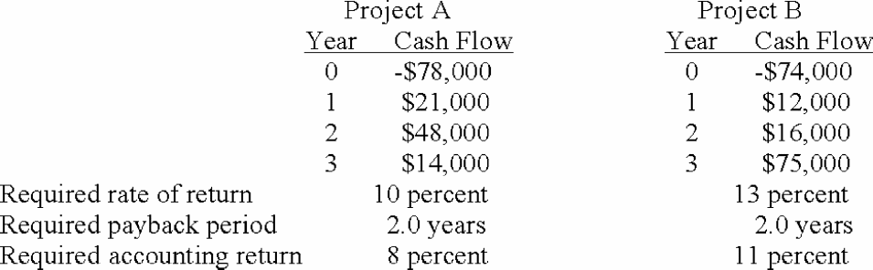
What should you do based on IRR analysis?
a. reject both project A and project B
b. accept project A and reject project B
c. accept both project A and project B
d. accept project B and reject project A
E. ignore the IRR rule and use another method of analysis
11. The positively sloped linear function which illustrates the relationship between an asset's expected return and its beta coefficient is the:
a. reward-to-risk ratio.
b. portfolio weight.
c. portfolio risk.
D. security market line.
e. market risk premium.
12.Which one of the following should earn the most risk premium based on CAPM?
a. diversified portfolio with returns similar to the overall market
B. stock with a beta of 1.23
c. stock with a beta of .98
d. U.S. Treasury bill
e. portfolio with a beta of 1.16
13.Winston Brothers stock has a beta of 1.36. The risk-free rate of return is 5.25 percent and the market rate of return is 11.70 percent. What is the risk premium on this stock?
a. 6.45 percent
B. 8.77 percent
c. 10.99 percent
d. 14.37 percent
e. 16.95 percent
Risk premium = 1.36 (.117 .0525) = .08772 = 8.77 percent

