BEYOND THE ETL:
LAMBDA AND KAPPA ARCHITECTURES FOR DATA-PROCESSING ON THE CLOUD PLATFORMS

Course: «Cloud computing»
Big Data Systems Master degree program
Almaz Murzabekov

Moscow, May 2020
The advancement of technology has allowed companies to reap the benefits of streamlined processes and cost-efficient operations. But the one thing that has become a game changer for businesses of all sizes is the availability of data from every source imaginable – social media, sensors, business applications, and many more. These large stores of data that bombard companies day in and day out is collectively known as big data. Most have heard of it, many aim to maximize its potential to propel their business forward, and yet, only few have truly succeeded in doing so.
At the same time, enterprises have adopted cloud computing to improve their IT operations and develop better software, faster. Merging big data with cloud computing is a powerful combination that can transform organization.
The benefits of moving to the cloud are well documented. But these benefits take on a bigger role when we talk of big data analytics. Big data involves manipulating petabytes (and perhaps soon, exabytes and zettabytes) of data, and the cloud’s scalable environment makes it possible to deploy data-intensive applications that power business analytics. The cloud also simplifies connectivity and collaboration within an organization, which gives more employees access to relevant analytics and streamlines data sharing.
While it’s easy for IT leaders to recognize the advantages of putting big data in the cloud, it may not be as simple to get C-suite executives and other primary stakeholders on board. But there’s a business case to be made for the big data + cloud pairing because it gives executives a better view of the business and boosts data-driven decision making. For instance, optimization of the supply chain and efficient tracking of defects – both principal concerns of a COO of a physical product company – is made easier with material data on hand. Data is also key for the CMO looking to increase customer engagement and loyalty, and for the CFO seeking new opportunities for cost reduction, revenue growth, and strategic investments. And all of these insights can be easily presented to the CEO to inform fast, strategic decision making. Whatever perspective you may have, big data complemented with an agile cloud platform can affect significant change in the way your organization does business and achieves your objectives.
Bringing big data to the cloud presents huge opportunities, but there are some challenges that need to be overcome.

Pros of putting big data in the cloud:
- requires zero CAPEX
- enables faster scalability
- lowers the cost of analytics
- encourages an agile and innovative culture
- enables better business continuity and disaster recovery
Cons of putting big data in the cloud:
- less control over security
- less control over compliance
- network dependency and latency issues

Big data deals with massive structured, semi-structured or unstructured data to store and process it for data analysis purpose. There are five aspects of Big Data which are described through 5Vs (Volume – the amount of data, Variety – different types of data, Velocity – data flow rate in the system, Value – the value of data based on the information contained within, Veracity – data confidentiality and availability)

Cloud computing offers services to the users on a pay-as-you-go model. Cloud providers offer three primary services, these services are outlined below:
- Infrastructure as a Service (IAAS)
- Platform as a Service (PAAS)
- Integration Platform as a Service (iPaaS)
- Software as a Service (SAAS)

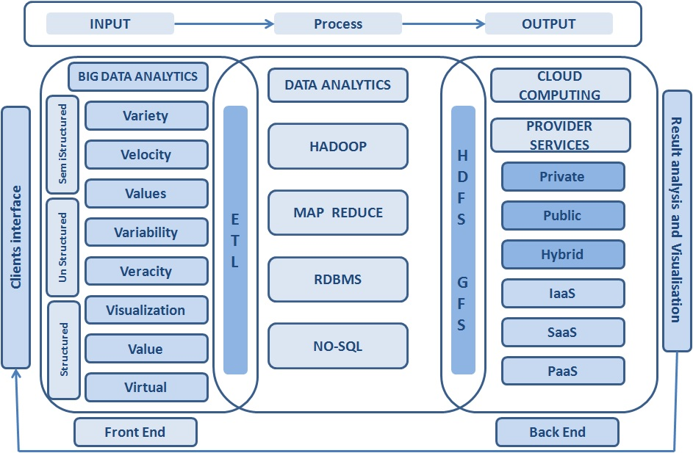
ETL approach in data-integration

This article is primarily focus on Integration Platform as a Service model. Integration Platform as a Service (iPaaS) is a suite of cloud services enabling development, execution and governance of integration flows connecting any combination of on premises and cloud-based processes, services, applications and data within individual or across multiple organizations.

Since the dawn of big data, the ETL (extract, transform, and load) process has been the heart that pumps information through modern business networks. Today, cloud-based ETL is a critical tool for managing massive data sets, and one that companies will increasingly rely on in the future. The reason is simple: in today’s competitive landscape.
ETL is the global standard for processing large amounts of data. ETL distributes the process across a set of linked processors which operate over a common framework (such as Apache Hadoop.) The ETL process includes three distinct functions:
- Extract. During the extraction process, raw data is pulled from an array of sources including databases, network appliances, security hardware and software applications, and others. This is streaming data rushes through digital networks and is collected in near real-time.
- Transform. In the transformation phase of the ETL process, rivers of information are channeled into usable data for business. At the same time, the ETL engine reduces data volume by detecting and eliminating duplicate data. The data is then standardized and formatted for later use and/or analysis. Finally, data is then sorted and verified before it is passed on to the next phase.
- Load. The last stage of the ETL process deposits the data into the desired destinations. These include analysis tools, databases or lakes, cold network repositories, or other applicable uses.

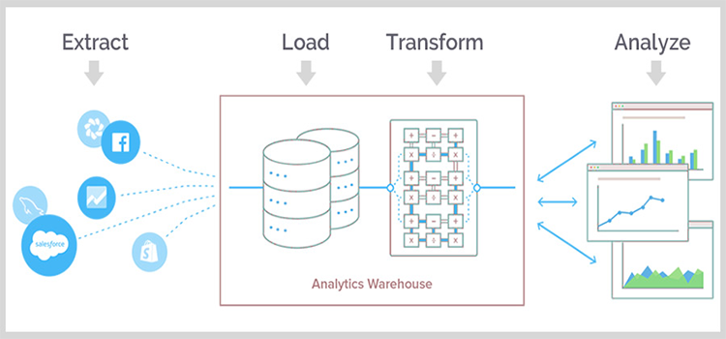

In relative terms, ETL has been around for ages. But the way it has been used to turn raw data into business intelligence hasn’t just evolved with the times — it’s also helped pave the way for cloud technology.

Before fiber optics and globally distributed cloud resources were developed, ETL processes were managed locally. In the late 1970s, the value of databases exploded when the tools used to standardize (or transform) data into common formats became widely accessible. Some of the most important ETL projects of this era included
- Research facilities sharing large volumes of scientific data
- Early collaborations in what became the World Wide Web, the forerunner of the modern internet
- The standardization of a communications protocol (TCP/IP) from which most modern data and telecommunications evolved
The ancestor of modern digital marketing technologies that aggregate consumer data and tailor advertisements to specific demographics For much of ETL’s history, the process was performed locally, or physically, near the scientists and analysts who used it. Data streamed into secure facilities through a
system of cables and was extracted via simple algorithms. The data was then transformed into a standardized or “clean” format, and loaded into databases where humans could manipulate and learn from it. This approach laid the foundation for many of the technology and communication options we know today. Despite its importance, traditional ETL had some serious limitations. In the days before miniaturization, the cost of the ETL process and the need for massive amounts of storage were often cost-prohibitive. In addition, maintaining all of this valuable data in a single location brought the added risk of catastrophic loss through natural disaster, theft, or technological failure.
Flash forward to 2018. Cheap data storage options, fiber networks, and ever-increasing processor speeds guarantee three things about data:
- The amount of data flowing through modern businesses will continue to grow exponentially.
- The value of that data will continue to climb.
- The computing power needed to process all that data — and the challenge of putting it to the right business use — means that ETL in the cloud will play a vital role in big data of tomorrow.
As national and global networks evolved in both speed and capacity, the need to store mountains of data at local sites gradually declined. By 2013, commercially available fiber optic connections increased throughput to as much as 1 gigabyte per second. This dramatic change in speed, along with the proliferation of cheap, replaceable storage, were the catalysts that transformed ETL from a local, expensive, and cumbersome process to what we know of today as cloud-based ETL.
Cloud-native ETL follows the familiar three-step process, but changes the way the steps are completed. The Apache Hadoop framework became the road over which cloud-based ETL developed. Hadoop distributes the computing processes, which means that data from divergent sources can be remotely extracted, transformed via a network of computing resources, and then transformed for local analysis. Cloud-native ETL depends on shared computing clusters. These may be geographically scattered around the globe, but through Hadoop operate as individual, logical entities that share the work of massive computing tasks. The ETL tasks once executed next door or in the basement are now processed over scattered clusters via cloud interfaces. Most remarkably, all this can happen at orders of magnitude faster than traditional, on-site ETL. Companies still using ETL in an on-premise or hybrid environment are already falling behind in a key competitive category: speed.
There are many options when choosing the best ETL tools. Cloud-based ETL tools offer real-time, streaming data processing, scalability and integrations with a constantly growing number of data sources. These are some of the more popular ETL tools:
- Fivetran will quickly replicate all your business data to your data warehouse, without the need for maintenance, configuration, or data pipelines. Connect anything from Facebook ads to Zendesk, without having to write tons of code, and provides for ELT transformation.
- Blendo enables you to integrate your data in minutes, with no maintenance, no coding required, and no ETL scripts. It is built especially for more non-technical users, and allows you to collect data from any cloud service, load it into your data warehouse, and it optimizes your data according to your data warehouse. You can choose how often you want to pull data from your source, and monitor your usage.
- Stitch describe themselves as a “cloud-first, developer-focused platform for rapidly moving data.” Stitch, which is built on open source Singer, supports the integration of data from a wide variety of sources, and their offering includes free historical data from your database and SaaS tools, selective replication, multiple user accounts and integrates with many data warehouses and analysis tools. Getting started is easy with self-serve and freemium options.
- Matillion is purpose-built for Google BigQuery and Amazon Redshift, and allows you to integrate with a number of sources. It has many Amazon integration specifically, so if your organization is already using Amazon products, this could be a good addition, but does tie you down somewhat to a specific vendor.
- SnapLogic is a platform to integrate applications and data, allowing you to quickly connect apps and data sources. The company is also branching out into connecting and integrating data from IoT devices.
In another hand, Open source ETL tools can be a low-cost alternative to commercial ETL solutions. Open source ETL tools are tried and tested, and most are kept up-to-date by a community invested in their success. Most open source ETL tools will not work for organizations’ specific needs out of the box, but will require custom coding and integrations. In case of using this tool in the cloud with pricing model as PaaS, these project becomes most efficient in terms of maintenance costs and IT-investments.
- Apache Airflow (currently in “incubator” status, meaning that is is not yet endorsed by the Apache Software Foundation) is a workflow automation and scheduling system. It can be used to build a data pipeline to populate a data warehouse and (with some coding) can be used to develop reusable and parameterizable ETL processes. While it is used in the ETL process, Airflow is not an interactive ETL tool.
- Apache Kafka is an open-source stream-processing software platform developed by the Apache Software Foundation. Kafka enables stream processing using the Kafka Streams API, whereby the stream processor receives one record at a time, processes it, and can produce one or more output records for downstream processors. The data is then loaded onto the target system. Kafka is based around four APIs: the Producer API, the Consumer API, the Streams API, and the Connector API.
- Apache NiFi is designed to automate the flow of data between software systems. It features a web-based user interface and is highly configurable. It is known for its security options, data provenance and extensibility. While it can form part of an ETL solution, it is not in and of itself an interactive ETL tool.
Lambda Architecture
Lambda architecture is a data processing technique that is capable of dealing with huge amount of data in an efficient manner. The efficiency of this architecture becomes evident in the form of increased throughput, reduced latency and negligible errors. While we mention data processing we basically use this term to represent high throughput, low latency and aiming for near-real-time applications. Which also would allow the developers to define delta rules in the form of code logic or natural language processing (NLP) in event-based data processing models to achieve robustness, automation and efficiency and improve the data quality. Moreover, any change in the state of data is an event to the system and as a matter of fact it is possible to give a command, queried or expected to carry out delta procedures as a response to the events on the fly. Event sourcing is a concept of using the events to make prediction as well as storing the changes in a system on the real time basis a change of state of a system, an update in the databases or an event can be understood as a change. For instance if someone interact with a web page or a social network profile, the events like page view, likes or Add as a Friend request etc… are triggering events that can be processed or enriched and the data stored in a database.
Data processing deals with the event streams and most of the enterprise software that follow the Domain Driven Design use the stream processing method to predict updates for the basic model and store the distinct events that serve as a source for predictions in a live data system. To handle numerous events occurring in a system or delta processing, Lambda architecture enabling data processing by introducing three distinct layers. Lambda architecture comprises of Batch Layer, Speed Layer (also known as Stream layer) and Serving Layer.
Batch layer - New data keeps coming as a feed to the data system. At every instance it is fed to the batch layer and speed layer simultaneously. Any new data stream that comes to batch layer of the data system is computed and processed on top of a Data Lake. When data gets stored in the data lake using databases such as in memory databases or long term persistent one like NoSQL based storages batch layer uses it to process the data using MapReduce or utilizing machine-learning (ML) to make predictions for the upcoming batch views.
Speed Layer (Stream Layer) - The speed layer uses the fruit of event sourcing done at the batch layer. The data streams processed in the batch layer result in updating delta process or MapReduce or machine learning model which is further used by the stream layer to process the new data fed to it. Speed layer provides the outputs on the basis enrichment process and supports the serving layer to reduce the latency in responding the queries. As obvious from its name the speed layer has low latency because it deals with the real time data only and has less computational load.
Serving Layer - The outputs from batch layer in the form of batch views and from speed layer in the form of near-real time views are forwarded to the serving layer which uses this data to cater the pending queries on ad-hoc basis.
Here is a basic diagram of what Lambda Architecture model would look like:

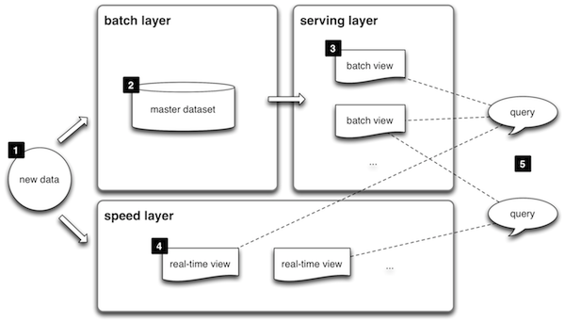

Kapp Architecture
In 2014 Jay Kreps started a discussion where he pointed out some discrepancies of Lambda architecture that further led the big data world to another alternate architecture that used less code resource and was capable of performing well in certain enterprise scenarios where using multi layered Lambda architecture seemed like extravagance.
Kappa Architecture cannot be taken as a substitute of Lambda architecture on the contrary it should be seen as an alternative to be used in those circumstances where active performance of batch layer is not necessary for meeting the standard quality of service. This architecture finds its applications in real-time processing of distinct events. Here is a basic diagram for the Kappa architecture that shows two layers system of operation for this data processing architecture.

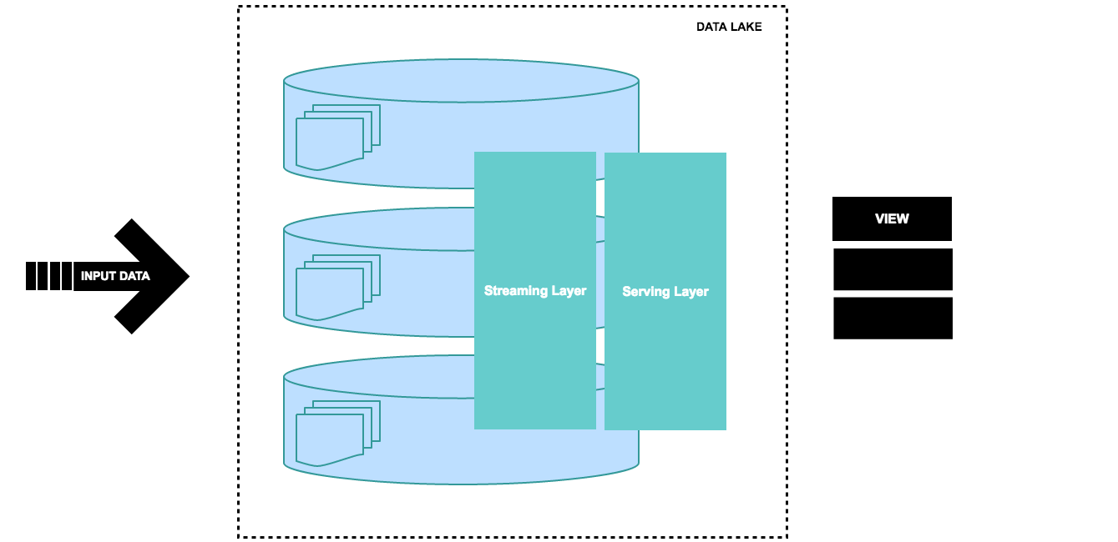

Some variants of social network applications, devices connected to a cloud based monitoring system, Internet of things (IoT) use an optimized version of Lambda architecture which mainly uses the services of speed layer combined with streaming layer to process the data over the data lake. Kappa architecture can be deployed for those data processing enterprise models where:
- Multiple data events or queries are logged in a queue to be catered against a distributed file system storage or history.
- The order of the events and queries is not predetermined. Stream processing platforms can interact with database at any time.
- It is resilient and highly available as handling Terabytes of storage is required for each node of the system to support replication.
It allows a better mechanism for governing the data-streams. A balanced control on the stream processors and databases makes it possible for the applications to perform as per expectations. Kafka retains the ordered data for longer durations and caters the analogous queries by linking them to the appropriate position of the retained log. LinkedIn and some other applications use this flavor of big data processing and reap the benefit of retaining large amount of data to cater those queries that are mere replica of each other.
Absence of batch layer might result in errors during data processing or while updating the database that requires having an exception manager to reprocess the data or reconciliation.

RESOURCES:

- Beyond Lambda: Introducing Delta Architecture: https://shorturl.at/iqRY1
- Lambda vs Azure Databricks Delta Architecture https://adatis.co.uk/lambda-vs-azure-databricks-delta-architecture/
- Introduction to Delta Architecture https://www.thedigitaltalk.com/blog/2019-9-introduction-to-delta-architecture/
- A Deep Dive Into Google BigQuery Architecture https://panoply.io/data-warehouse-guide/bigquery-architecture/
- Questioning the Lambda Architecture https://www.oreilly.com/radar/questioning-the-lambda-architecture/
- Kappa Architecture : In Practice https://medium.com/@anishekagarwal/kappa-architecture-in-practice-b0a4870f3da6
- Анти-введение в Big Data — Владимир Красильщик (youtube): https://youtu.be/7RhFo6U2NrY
- BigПочта: как мы строили DataLake в Почте России (youtube): https://youtu.be/6JwMho6UfK4
- ETL Process and The Challenges: https://softtechgroup.us/blog/etl-process-and-the-challenges
- A brief introduction to two data processing architectures — Lambda and Kappa for Big Data: https://towardsdatascience.com/a-brief-introduction-to-two-data-processing-architectures-lambda-and-kappa-for-big-data-4f35c28005bb
- Kappa Architecture Our Experience at ASP GEMS http://www.datascienceassn.org/sites/default/files/Kappa%20Architecture%20-%20Pros%20and%20Cons.pdf
- Questioning the Lambda Architecture: https://www.oreilly.com/radar/questioning-the-lambda-architecture/
- Kappa Architecture : In Practice: https://medium.com/@anishekagarwal/kappa-architecture-in-practice-b0a4870f3da6
- From Lambda to Kappa: A Guide on Real-time Big Data Architectures: https://medium.com/@Talend/from-lambda-to-kappa-a-guide-on-real-time-big-data-architectures-fe63f3079d3e
- ETL Tools: Comparing the Best Cloud-Based and Open Source Tools https://panoply.io/data-warehouse-guide/etl-tools/

