The practical work № 3

Getting hands-on experience on the big data ecosystem using
Google Cloud Platform

Course: «Cloud computing»
Big Data Systems Master degree program

Completed by
- Kakit Law
- Almaz Murzabekov
- Habibullah Wardak

Moscow, May 2020

Goal of the work and its estimating

The main goal of this practical assignment is to provide students hands-on experience with Big Data Ecosystem, Hadoop Framework, HDFS, MapReduce, and Spark. In this project, we will deploy Hortonworks HDP distribution which contains most of Big Data Frameworks into Google Cloud Platform (GCP).

Prerequisites:
- Valid GCP account. A free trial of 365-day and $300 free credits is provided during trial period.
- A student's personal account for this environment.
- Basic understandings of cloud platform.

Evaluation of Student’s work result
- You need to demonstrate a base working environment at the lesson, write your observations about your work and complete all tasks below, send this report to the e-mail of the teacher.
- Use this document as a basis when you are preparing your lab report.
- To complete each ask, please attach a screenshot of your completed step. Make sure you run every part correctly.
- The value of the final grade for the laboratory. There are 7 parts in this practical work. For completion of 1-2 task – 4 points; 3-4 tasks – 6 points; 5-6 tasks - 7 points. 7 parts – 8 points. Modify Part 7 and come up with your own variant of application of HDFS and spark – 10 points.

Description
In Big data system, Apache software play a very important part of the ecosphere. Apache Hadoop is a collection of open-source software utilities that facilitate using a network of many computers to solve problems involving massive amounts of data and computation. It provides a software framework for distributed storage and processing of big data using the MapReduce programming model.

The core of Apache Hadoop consists of a storage part, known as Hadoop Distributed File System (HDFS), and a processing part which is a MapReduce programming model, which would be Spark in the laboratory. Except HDFS and Spark, Apache also provides many solutions which served for different purposes. See the below figure for its family.

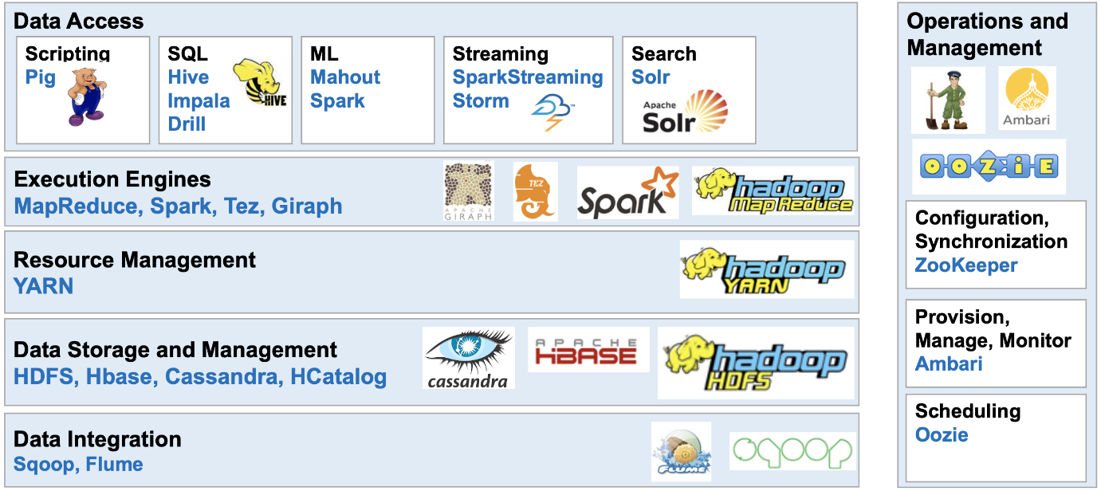
Figure 1: Families of Apache Ecosystem
A basic understanding of Apache ecosystem framework would be helpful for everyone who start learning big data systems.

On the other hand, Apache systems would be too demanding if installing on local machines. It requires a Linux operating system and consume too much resources to operate to maximize its usability. To isolate the environment and to protect local system, using dockers on Linux Virtual machine would be a good alternative way to install Apache software.

Docker is a set of platforms as a service (PaaS) products that uses OS-level virtualization to deliver software in packages called containers. Containers are isolated from one another and bundle their own software, libraries and configuration files; they can communicate with each other through well-defined channels.

By using Apache and dockers together, it makes environment deployment easier and to better protect data by isolating software needed.

Part 1: Preparing the environment

- Assume that student has a valid GCP account and student have done the authorization and verification process. After those steps student will be able to see home page, that looks like in picture presented below.

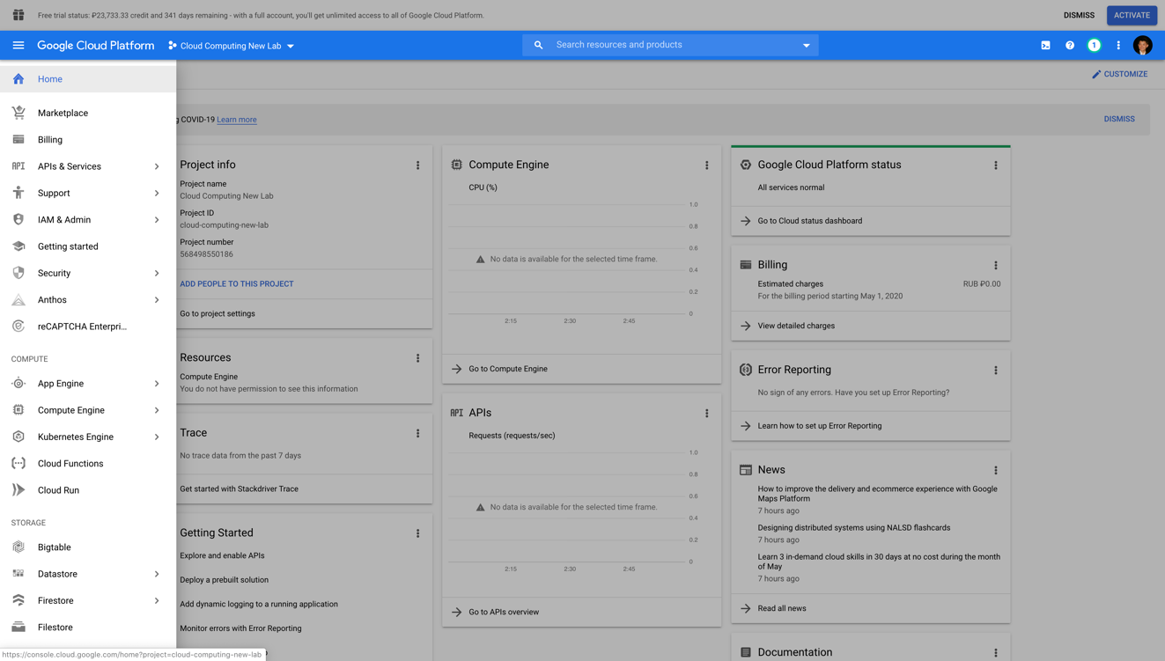

- Creating a new project: Cloud Computing New Lab
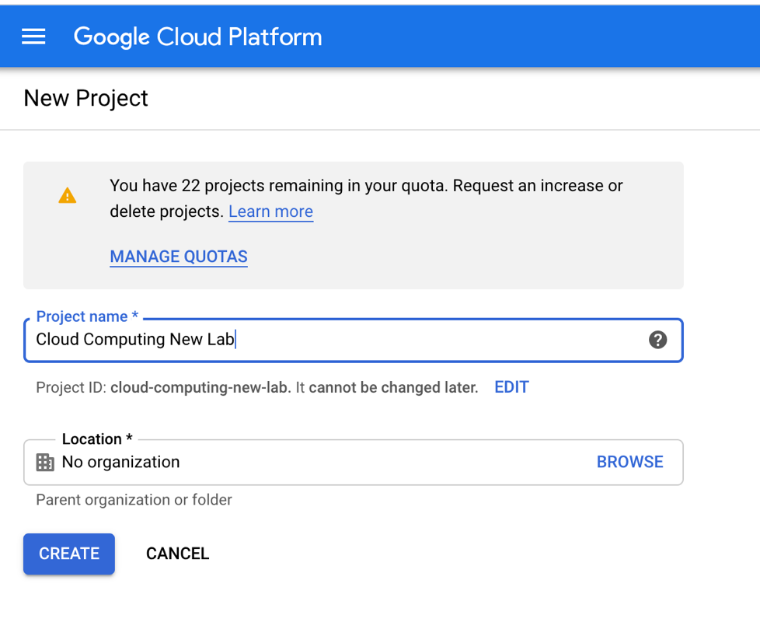
- Create a new Virtual Machine with provided parameters
- Name: cloud-compute-lab
- Region and Zone leave as default
- Machine Family: General-purpose
- Series: N1
- Machine Type: Custom
- Cores: 20v CPU
- Memory: 100Gb
- Boot Disk: Ubuntu 16.04 LTS 100Gb Standard persistent disk
- Firewall: Allow HTTP & HTTPS traffic
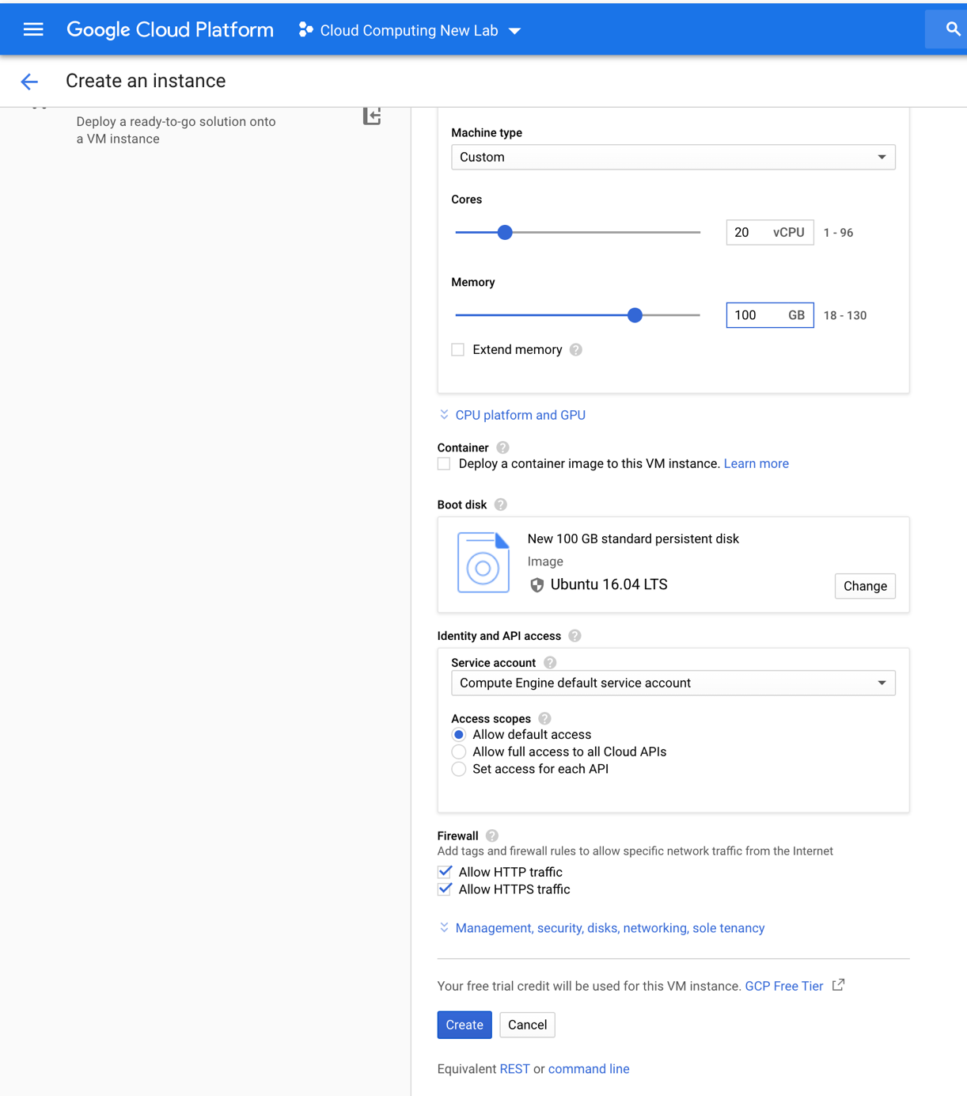
- After step-3 you will get running virtual machine like this
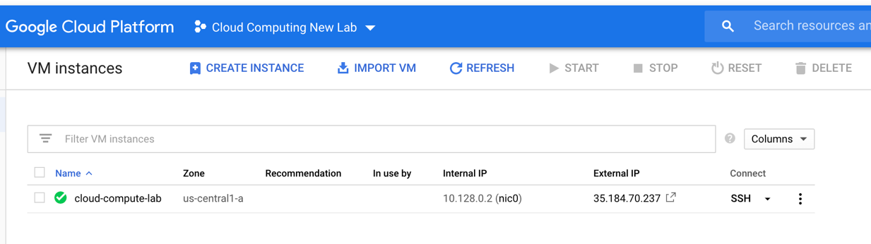
- Post your screenshot after creating VM below.

Part 2: Setting up firewalls
- Go to left panel, select VPC network -> Firewall rules
- Click “Create firewall rule” on the top toolbar
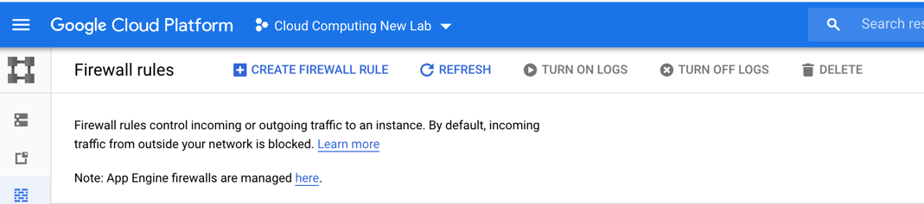

- Create a firewall rule, with settings as follows: (note: Select “Allow all” in protocol and ports section)
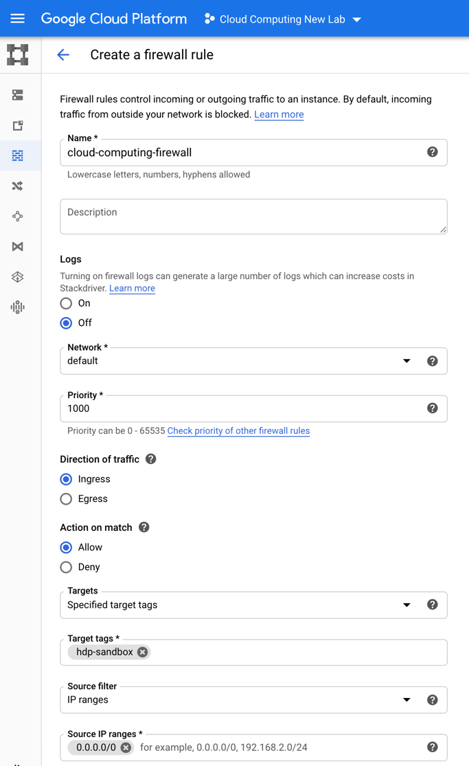

- After step-3 you will see the created firewall rule on the Firewall Rules page

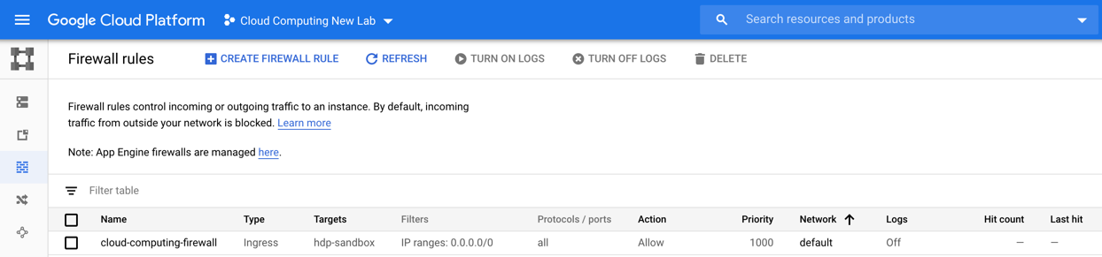
- Reserve static IPv4 address for VM-instance: Go to left panel, Select VPC network -> External IP addresses
  - Click on “Reserve static address”
  - Create a static IPv4 address with following parameters:
    - Name: cloud-computing
    - Description: leave it empty
    - Network Service Tier: Premium
    - IP version: IPv4
    - Type: Regional
    - All other fields leave with default params
  - Click on “Reserve” button
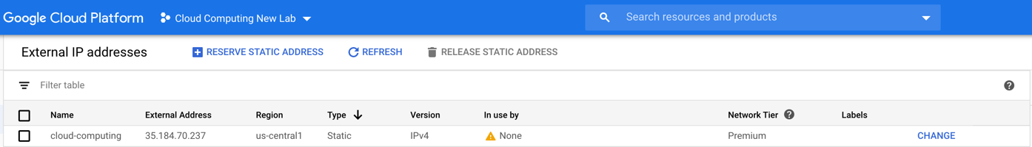
- Attach static IPv4 address for VM-instance
  - Click “CHANGE” button on created Static IPv4 Address “cloud-computing”
  - On the “Attach” field choose created VM-instance – cloud compute lab
  - Click OK
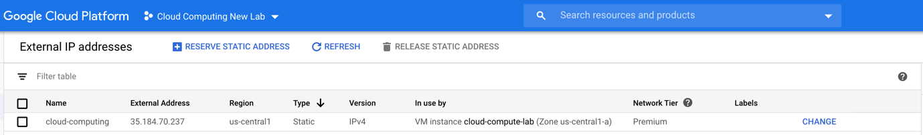
- Post your screenshot of firewall setup after step 6 below

Part 3: Preparing the virtual machine
- Go to left panel, select Compute Engine -> VM Instances
- Click to SSH button to connect with VM instance, which was created in Part1.4. On new page you will be able to see a web-terminal for VM instance
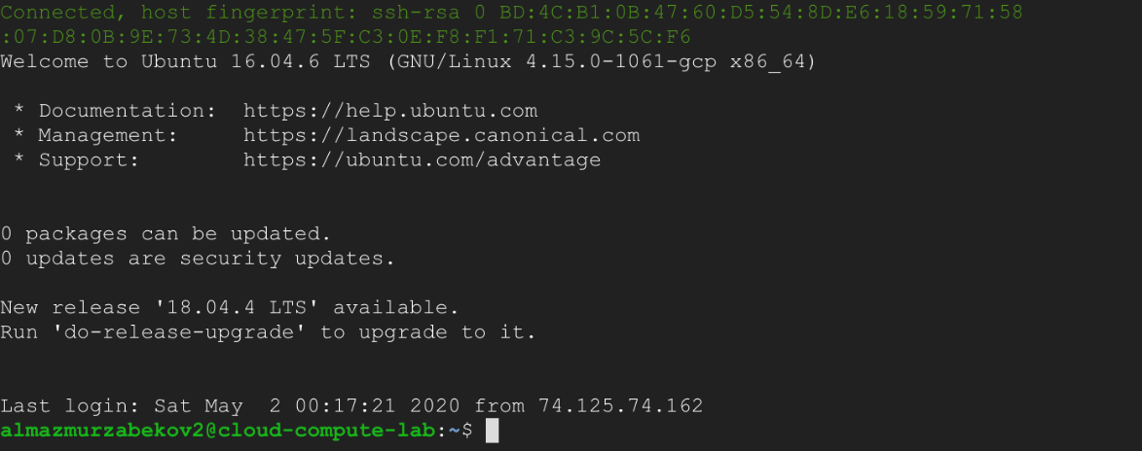
- Installing the docker engine
  - First of all, we need update apt-get tool. For that type
sudo apt-get update
  - Allow apt-get to use a repository over HTTPS (type Y if needed)
sudo apt-get install apt-transport-https ca-certificates curl gnupg-agent software-properties-common
  - Add Docker’s official GPG key:
curl -fsSL https://download.docker.com/linux/ubuntu/gpg | sudo apt-key add
  - Use the following command to set up the stable repository.
sudo add-apt-repository "deb [arch=amd64] https://download.docker.com/linux/ubuntu $(lsb_release -cs) stable"
  - Update the apt package index, and install the latest version of Docker Engine and container. (type Y if needed)
sudo apt-get update
sudo apt-get install docker-ce docker-ce-cli containerd.io
  - Verify that Docker Engine is installed correctly by running the hello-world image.
sudo docker run hello-world
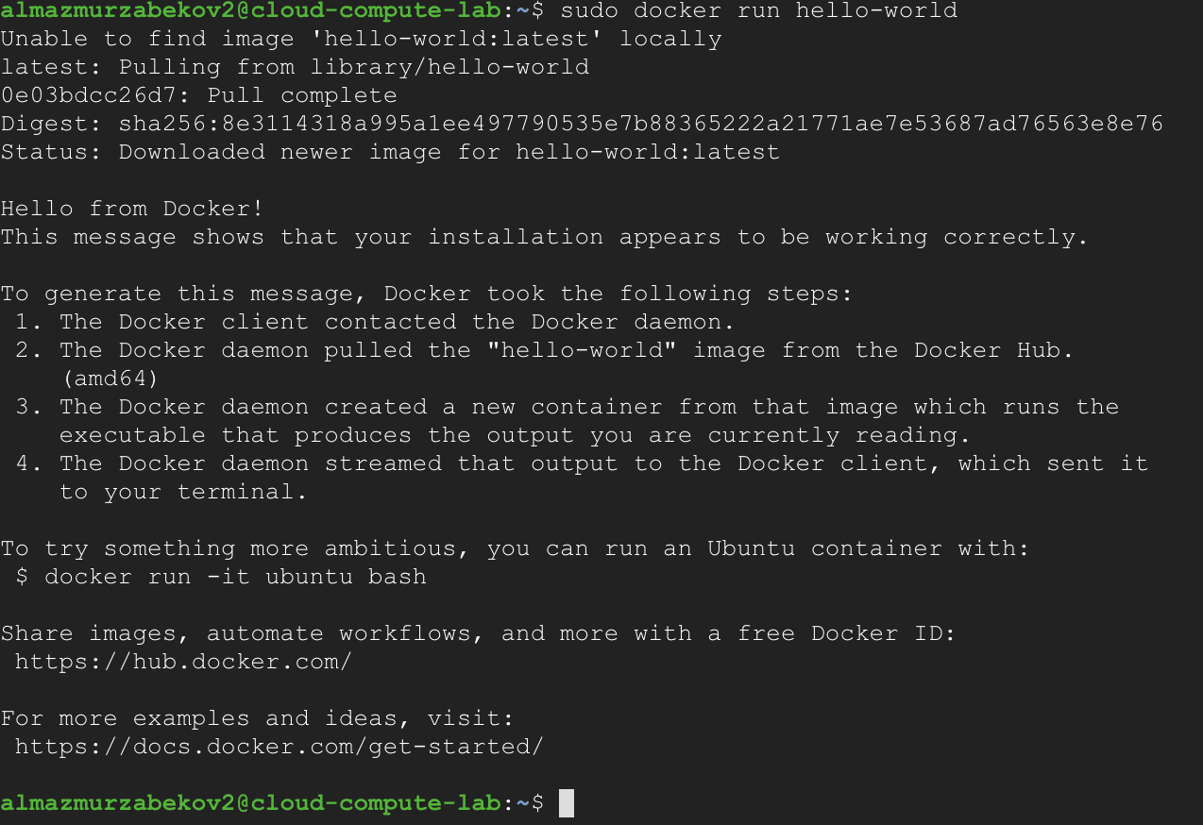

Part 4: Install HDP-sandbox
- install unzip package
sudo apt install unzip -y
- Download HDP-sandbox zip package
wget https://archive.cloudera.com/hwx-sandbox/hdp/hdp-3.0.1/HDP_3.0.1_docker-deploy-scripts_18120587fc7fb.zip

- Unzip downloaded HDP-sandbox zip package
unzip HDP_3.0.1_docker-deploy-scripts_18120587fc7fb.zip
- Run HDP-sandbox. Note: this command may take a while for several minutes
sudo bash docker-deploy-hdp30.sh
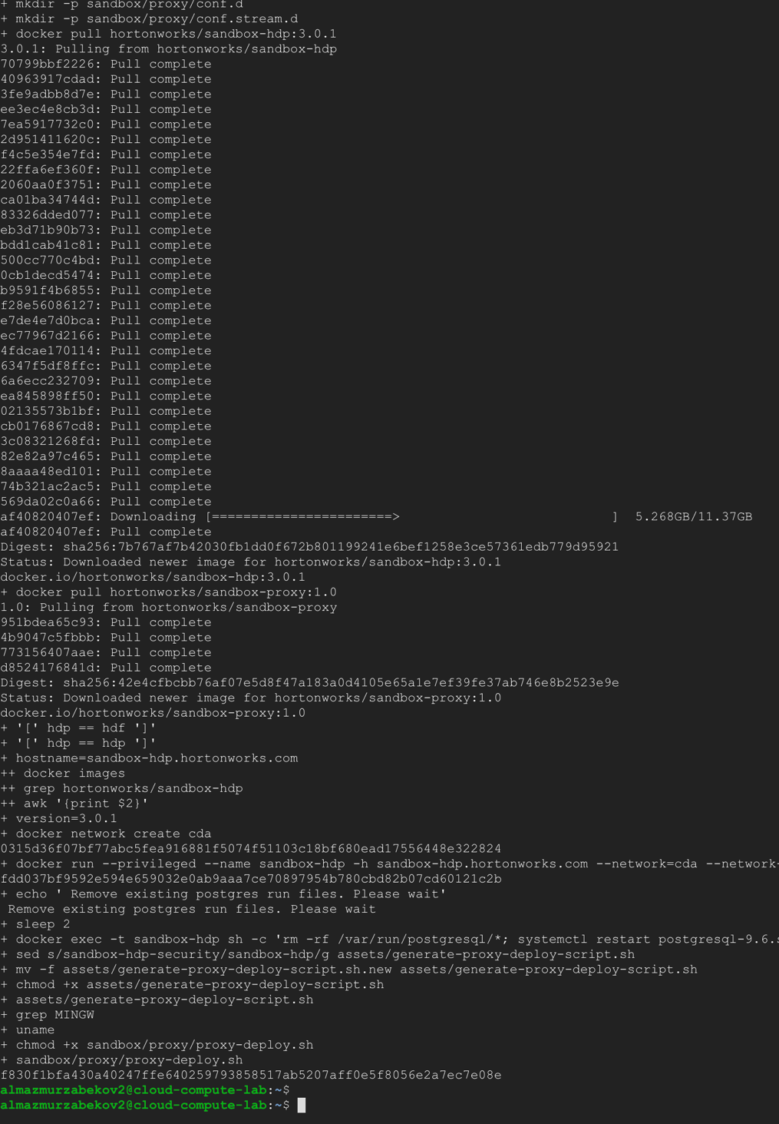

- Check running docker images
sudo docker ps

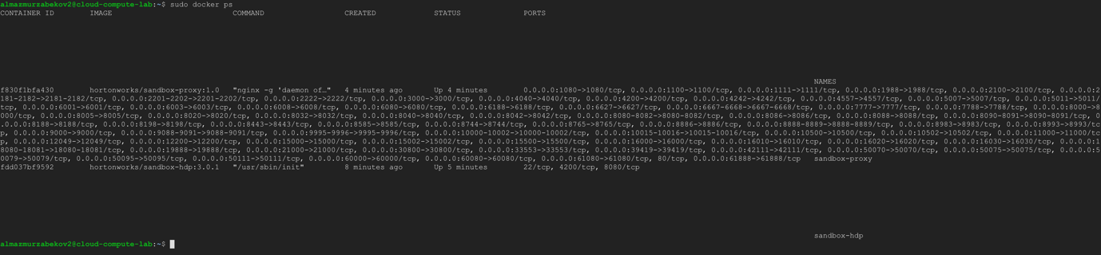

- Post your own version of sudo docker ps command result below

Configure alias naming. Replace {IP-address} to real external IP-address of your VM
echo '{IP-Address} sandbox-hdp.hortonworks.com sandbox-hdf.hortonworks.com' | sudo tee -a /etc/hosts
Example:
echo '35.184.70.237 sandbox-hdp.hortonworks.com sandbox-hdf.hortonworks.com' | sudo tee -a /etc/hosts
- Check installation
  - Open http://{IP-address}:8080 for ambari GUI

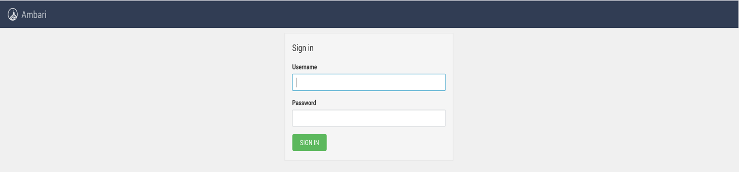
- Post your ambari GUI login page for your own VM machine with your static up shown in the browser url.

Part 5: Configuring Ambari GUI
- Connect to docker container
  - Get a container ID
sudo docker ps

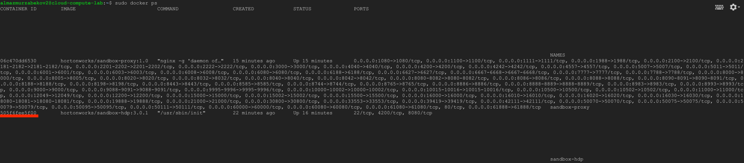
  - Connect to docker container
sudo docker exec -it [Container ID] bash
Example:
sudo docker exec -it 505f6fee5f00 bash

- Reset admin password (remember it as admin password)
ambari-admin-password-reset

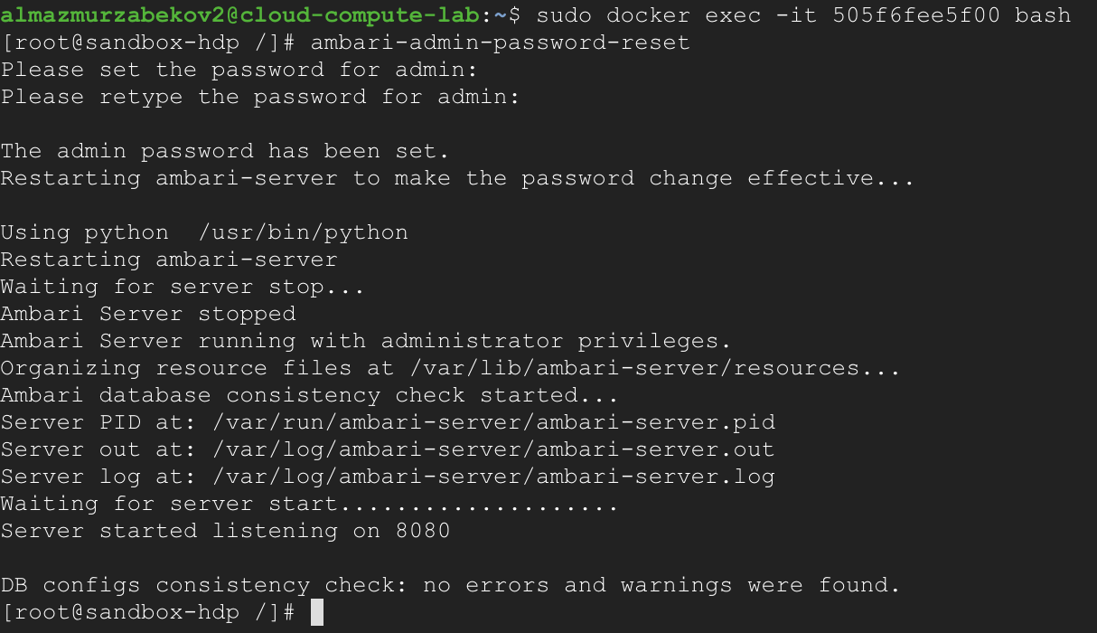

- Check Ambari GUI again
  - Open: http://{IP-address}:8080
    - user name “admin”
    - password admin’s password
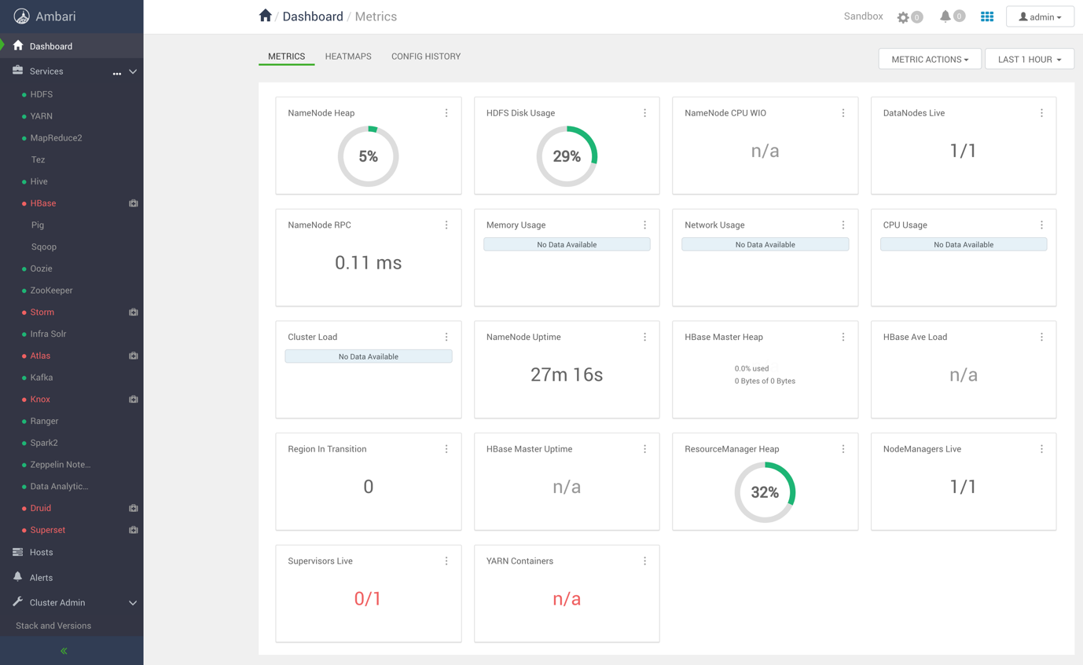
- Post your own version of Ambari dashboard with your static ip shown in browser url.

Part 6: Preparing the dataset
- Create and navigate to folder dataset in /
mkdir dataset
cd dataset /

- Download Sample of Full-Text-Corpus data from
wget https://www.corpusdata.org/iweb_samples/text0.zip

- Unzip downloaded file
unzip text0.zip -d text/

- Cat all text files from different folders into one file

find text/ -name "*.txt" -exec cat {} + > dataset.txt

- Upload downloaded files to HDFS and check it

hdfs dfs -copyFromLocal dataset.txt

hdfs dfs -ls

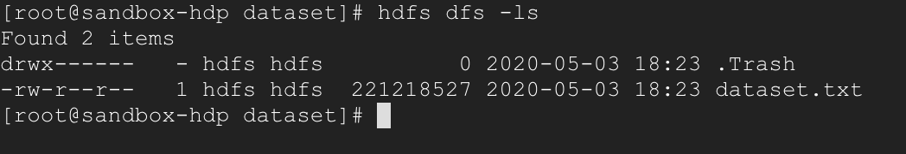

- Check file in GUI
  - Open Ambari sandbox
  - Navigate to HDFS menu
  - Click on NameNode UI on the right side menu
  - On NameNode UI page click on Utilities -> Browse the file system
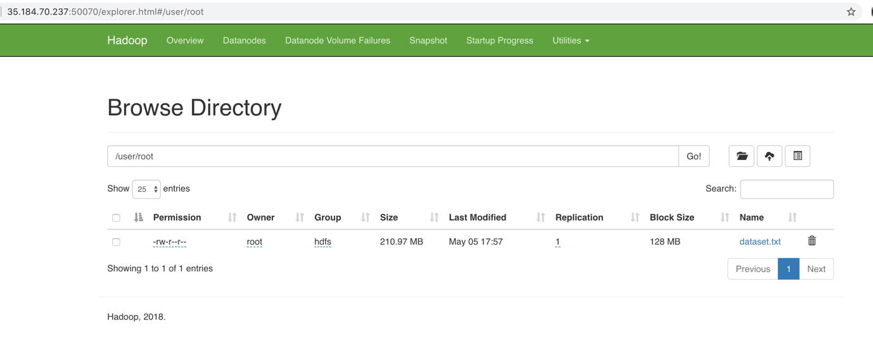

Part 7: Running Spark word-count example on Zeppelin

- Go to the Ambari Console (Web-page) Open: http://{IP-address}:8080
- Click on the Zeppelin Notebook -> Quick Links (on the right side) -> Zeppelin UI
- Create a new Note with name “HelloWorld” and “spark2” interpreter

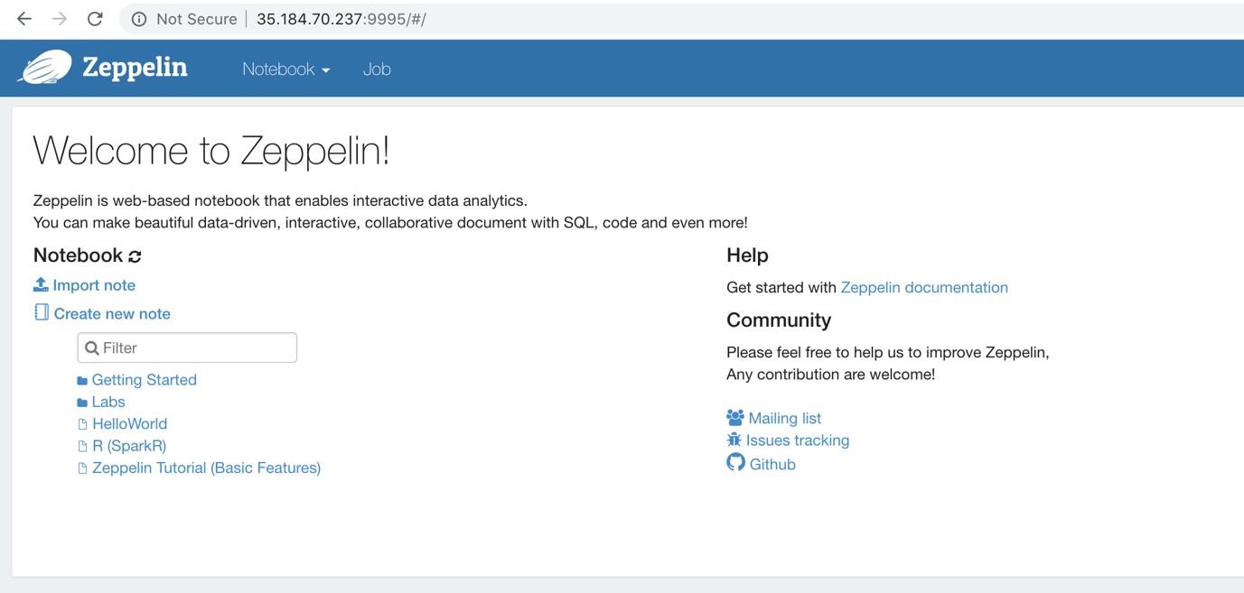

- Check that Zeppelin works correctly. On the first paragraph write the code below and run it. Note: At the first time your code submission and execution will take a long time.
%spark2.spark
spark.version

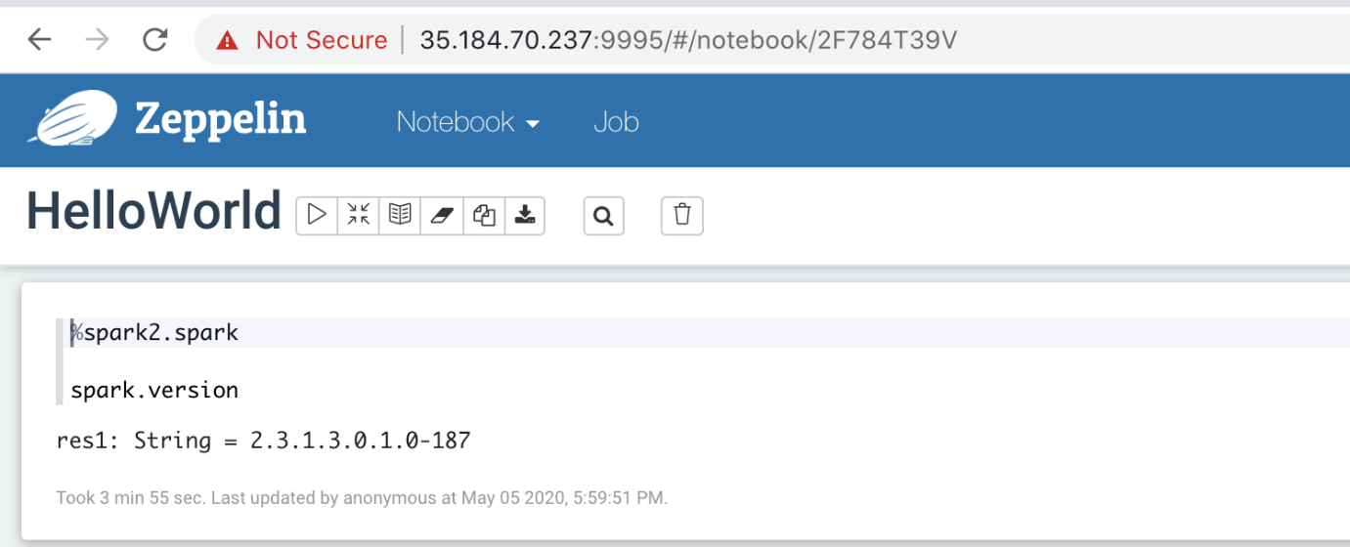

- Read a dataset that we uploaded from internet and uploaded into HDFS
val path = "/user/root/dataset.txt"
val dataset = spark.read.text(path)
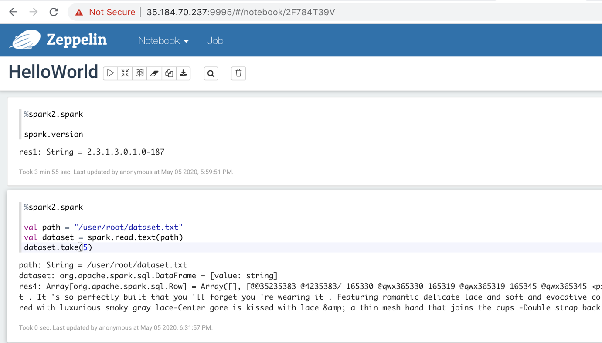

- Split Spark Dataset of Text Lines into Spark Dataset of Words
val regexText = """\w+|[^\w\s]""".r
val regexNumbers = """\d+""".r

val datasetAsText = dataset.select("value").as[String]
val words = datasetAsText
.flatMap(_.split("\\s+"))
.filter(text => regexText.pattern.matcher(text).matches)
.filter(text => !regexNumbers.pattern.matcher(text).matches)
.filter(_.length > 2)
.map(_.toLowerCase())

words.take(5)

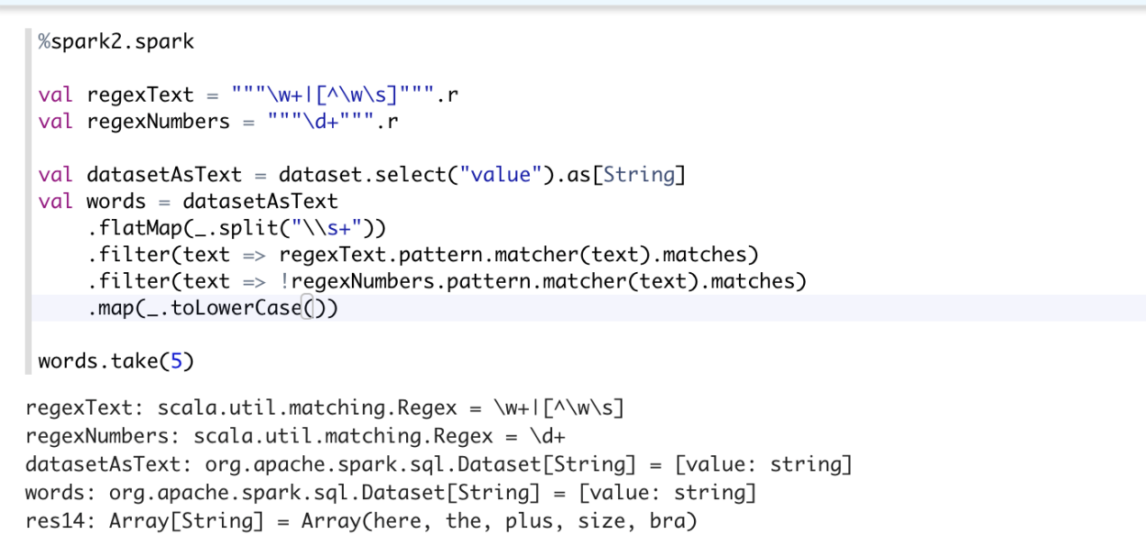

- Compute a word-count
words
.groupByKey(value => value)
.count()
.orderBy($"count(1)" desc)
.show()

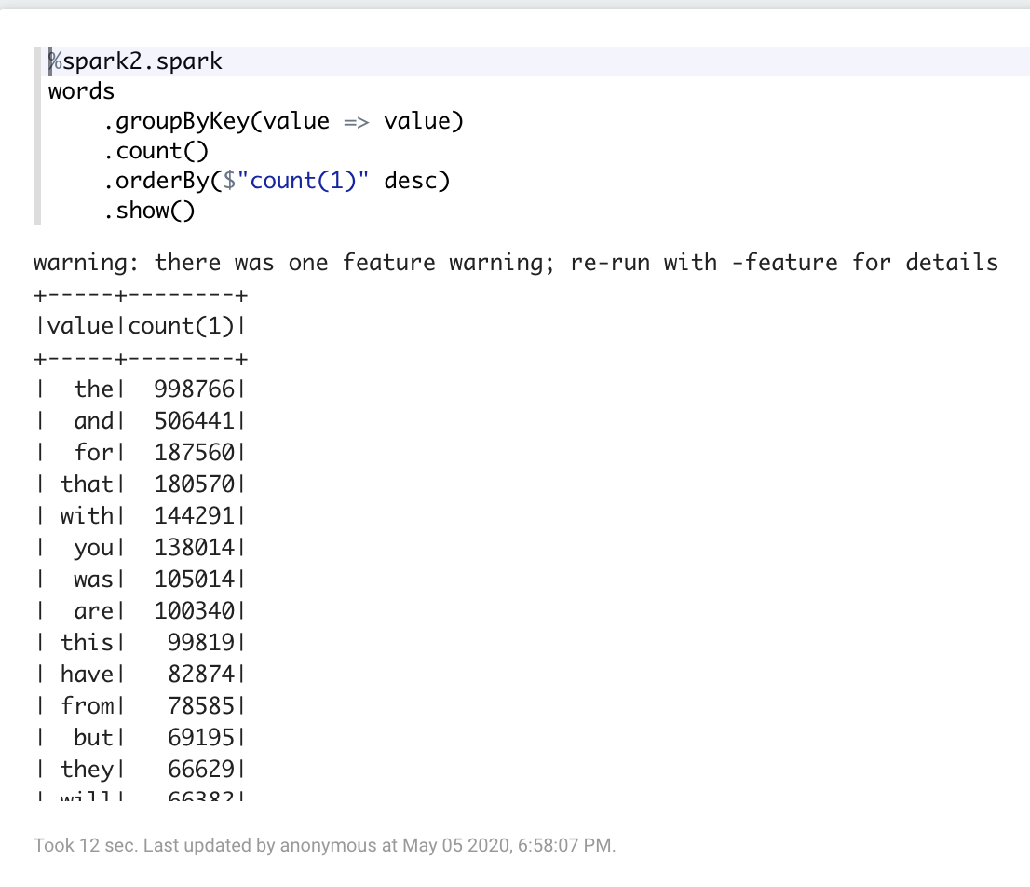

- Show your results of word count with your code shown in Zeppelin notebook.
- Modify the script to show interesting statistics to get additional score.
RESOURCES:
- Google Cloud Platform: https://cloud.google.com/
- Apache Foundation: https://www.apache.org/foundation/
- Apache Hadoop: https://hadoop.apache.org/
- Apache Hadoop Overview: https://hadoop.apache.org/docs/stable/
- Apache Hadoop HDFS: https://hadoop.apache.org/docs/r1.2.1/hdfs_design.html
- Apache Spark https://spark.apache.org/
- Apache Ambari: https://ambari.apache.org/
- Hortonworks Data Platform HDP: https://www.cloudera.com/downloads/hortonworks-sandbox/hdp.html
- Docker: https://www.docker.com/

