TOPIC
- Analyze enterprise architecture definition from position of new management paradigm
- Compare position of Craig, some peculiarities of TOGAF and our point consideration and in case of difference discuss evolution and preferences

REQUIREMENTS
- Self-confidence and independency in opinion statements
- All citations MUST be referred
- Correct English
- 4Kb MSOffice.doc format

CONTENT
- What is the main idea of new management paradigm?
- What is an enterprise and an enterprise architecture?
- The EA from position of new management paradigm
- The open group architecture framework (TOGAF)
In recent decades, any activity of an organization takes place in an ever-changing environment. Adaptation has become a vital feature of any modern business. The new management paradigm corresponds to fast and sometimes unpredictable changes in the external environment and allows to quickly adapt to constantly changing conditions. It is based on innovation, on the use of knowledge. Today's companies are very different from companies of the past, and the main difference is using knowledge. Today, intellectual capital determines the capital of the entire company, and this implies that each employee must participate in the activities of the organization, actively using their intelligence, offering work improvements.[1]. The new management paradigm is new approaches to managing firms and organizations that shift the emphasis of managerial influences on innovative processes, on communications, marketing, and knowledge management. This paradigm is at the intersection of three approaches that assess the prospects for the development of a modern organization: the new management model, the concept of social synergy and the concept of knowledge management. In more detail, the core components of the new management paradigm are: the concept of the new management is based on an “entrepreneurial” model of behavior, in which the key principle is debureaucratization of processes [2], empowerment of all employees of the company, humanization of company personnel management and special attention to employee qualifications. The concept of social synergy (the theory of self-organization) suggests that the company as an organism is constantly under continuous changes and the driver of these changes is innovation. The concept of knowledge management involves the management of knowledge creation processes, the links of knowledge with the processes of the organization, as well as company employees who create and use this knowledge. In the new economic conditions, intellectual work, special knowledge and communications become factors of competitiveness and economic development of organizations.[3]
“An enterprise is a conceptual organization of people and entities which interact with one another at certain times and at certain places with the intent of accomplishing something”.[4] An enterprise has many entities like people, processes, technologies, data, raw material, money and many other things, which all of them are supposed to work together to create and deliver value so that the customer will buy whatever the business is providing. For this statement also fits the thieves craft, because a burglar who breaks into homes is also an enterprise: he uses his skills, processes, tools and even external services like Google Maps and Facebook's to rob his victims. Another example, is a group of people distributed across the world but banded together fighting for a common cause like against a company that is polluting pristine water is an enterprise – it is also enterprise.
All enterprises have unique structure as known as enterprise architecture. The common statement about enterprise architecture is from Gartner’s glossary: “Enterprise architecture (EA) is a discipline for proactively and holistically leading enterprise responses to disruptive forces by identifying and analyzing the execution of change toward desired business vision and outcomes. EA delivers value by presenting business and IT leaders with signature-ready recommendations for adjusting policies and projects to achieve targeted business outcomes that capitalize on relevant business disruptions” [5]. Enterprise architecture is a way to understand how an organization works. For surviving in this world organization must be flexible and must know own processes, structures, weaknesses to fight with competitors like startups, other companies, new regulations, new customer’s expectations.
The main focus of EA is to simplify the complexity and to understand how business and technology work together because business models change and the technology is advancing fast. For solving this complexity EA has four main domains:
- Business architecture is about how a business operates.
- Application architecture defines the software solutions that help businesses do their jobs
- Data architecture describes the data in the organization, like sources, formats, management, quality and lot of other things.
- Technology architecture describes the underlying infrastructure ultimately needed to run the business applications.
To serve business we need a comprehensive view of all four of these domains. EA is the best way to do that way technology falls into place for the business to achieve its goals making them real by supporting its operations. IT has to make sure that whatever is built can adapt to change because the business will always change and that's because their market environment and customers change.
From point of view of the new management paradigm, enterprise architecture should be flexible, easily scalable, EA should be the foundation for any business transformations otherwise an organization lose the competition.
Today all businesses use software and IT-infrastructure for them but designing and using the right software is not trivial. Over time, each software solution evolves and changes under the influence of new requirements for enterprise processes. The organization must be able to adapt its software on time to remain competitive in the market and meet new environmental requirements. To adapt effectively in a world of continuous change, an organization must have a flexible architecture. TOGAF is one of many describing enterprise architecture tools.
The Open Group Architecture Framework (TOGAF) is a platform for describing enterprise architecture that offers an approach to designing, planning, implementing, and managing an enterprise’s architecture. TOGAF's design approach is based on an iterative model. The main component of TOGAF is the architecture development method (ADM) and by ADM architecture development provides a set of instructions for implementing enterprise architecture. This process consists of several stages, presented below in figure 1[6]:
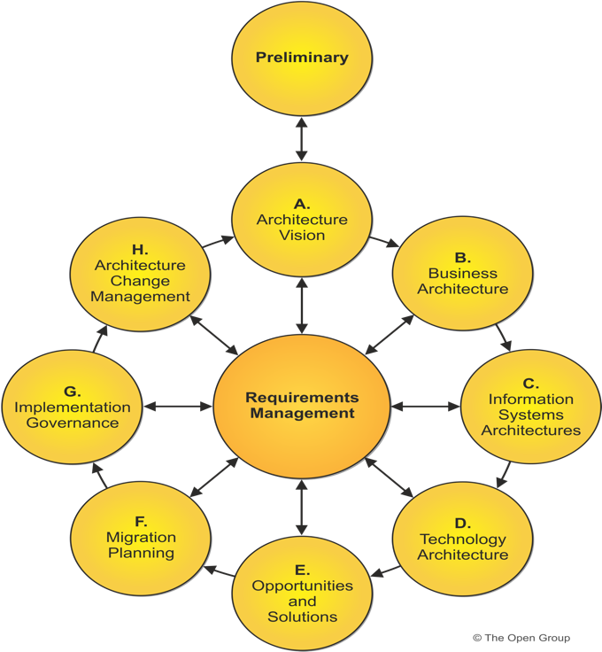
Figure 1: Architecture development method
TOGAF's iterations (also known as TOGAF cycles) are usually extremely time-consuming and it is one of the main arguments in criticizing TOGAF [7]. TOGAF has a huge count of models, many components and processes which are defined very broadly. Often the question raises of the appropriateness of using this approach because it requires a huge amount of time and resources for the implementation of new business processes in the organization. Besides, TOGAF suggests a detailed knowledge of the organization's processes and its data, but that knowledge is not always available to the organization or they are extremely expensive. To summarize, TOGAF is a comprehensive framework for describing and implementing architectural objects but also has own drawbacks.
REFERENCES:
- The New Management paradigm: A review of principles and practices, Arnold Levine, Jeff Luck, RUND Publishing house, ISBN: 0-8330-1571-0
- Frederic Laloux on a New Management Paradigm: [https://www.youtube.com/watch?v=uyMBQDmzfUY]
- Forbes: The New Management Paradigm &amp; John Mackey's Whole Foods: https://www.forbes.com/sites/stevedenning/2013/01/05/the-new-management-paradigm-john-mackeys-whole-foods/#528d80417a19
- An Enterprise Architecture Introduction, Craig Martin, YouTube lesson, https://www.youtubecom/watch?v=UnhC9xk9wiE
- Gartner IT-glossary: https://www.gartner.com/it-glossary/enterprise-architecture-ea/
- TOGAF Standard, version 9.2, Internet resource: https://pubs.opengroup.org/architecture/togaf9-doc/arch/index.html
- Быть или не быть TOGAF: https://www.ibm.com/developerworks/ru/library/r-temnenco/
- Методика TOGAF https://www.intuit.ru/studies/courses/995/152/lecture/4236?page=7
- Enterprise Architecture vs алхимия предприятия. Ключевые мифы https://habr.com/ru/post/345424/

