STUDY CASE
- People-centered production design

REQUIREMENTS
- Self-confidence and independency in opinion statements
- All citations MUST be referred

CONTENT
- Description of the company
- Strategic goal and sub-goals of the company
- Review of “to-be” processes
- Conclusion
Company B

In this essay, I should describe my understandings and thoughts about the “People-Centered production design” topic based on case reports on a worldwide operating SME producing floor cleaning machines from “S-BPM in the production industry” chapter 5 [1]. First of all, I need to describe the topic, briefly tell the story of the company and then outline the environment surrounding this company. After all, I need to define my understandings of the topic.

Description of the company

Company B is a small-medium enterprise (SME) operating in the professional cleaning market with a focus on the production of floor cleaning machines on a worldwide level. The company has about 95 employees and a turnover of about 25 million Euros. It is a family-owned business, as many of the Italian SMEs. The internationalized system of selling and purchasing enables the company to buy pieces all around the world, assemble cleaning machines, and sell them in more than 70 countries while competing with large internationally structured companies. The majority of the company’s customers are retailers in many different countries all around the globe.
Company B distinguishes itself from its competitors by providing highly customizable high-quality products. Employees are one of the “most-valuable resources” to the management. However, the initial situation reveals significant improvement opportunities related to employee involvement and empowerment concerning workplace re-design.
The proposed subject-oriented solution aims to involve shop floor workers in workplace (re-)design by providing them structural empowerment means such as social media for suggestion proposals, discussions and negotiations. Furthermore, the newly introduced features are designed to allow for context-sensitive reporting of suggestions and errors. Context-sensitive elicitation provides the basis for analyzing impacts of changes (e.g. the affected location or worker) and visualizing potential improvement areas within the shop floor. The S-BPM process handling has been integrated with a semantic wiki allowing for context-sensitive workplace improvement elicitation and change propagation analysis.
Company B is very sensitive to the quality of its products and achieving high-quality standards. These attempts are physically reflected in the factory layout itself. Company B implements a road to quality throughout the whole factory covering areas as the “quality checking—incoming goods area” and the “final check area”.

Strategic goal and sub-goals of the company
Company B considers humans as one of the most important assets of its operation by putting the worker at the center of the workplace design. The development team has identified the global goal as “subject-oriented re-design of production workplaces to empower workers and stimulate teamwork” with three sub-goals addressed through the use case implementation at Company B. The first sub-goal is to improve the internal communication and collaboration considering the re-design of workplaces. The second sub-goal aims at an increased understanding of the relevant work context. Thereby, work context includes all aspects considering the workplace itself (e.g. temperature, time, conditions of illumination, etc.), as well as all facets regarding the situation of a specific work task (e.g. a worker interacts with others; a worker requires special skills/knowledge to accomplish a certain task, etc.). The last sub-goal is to increase the traceability of suggestions considering error detection.

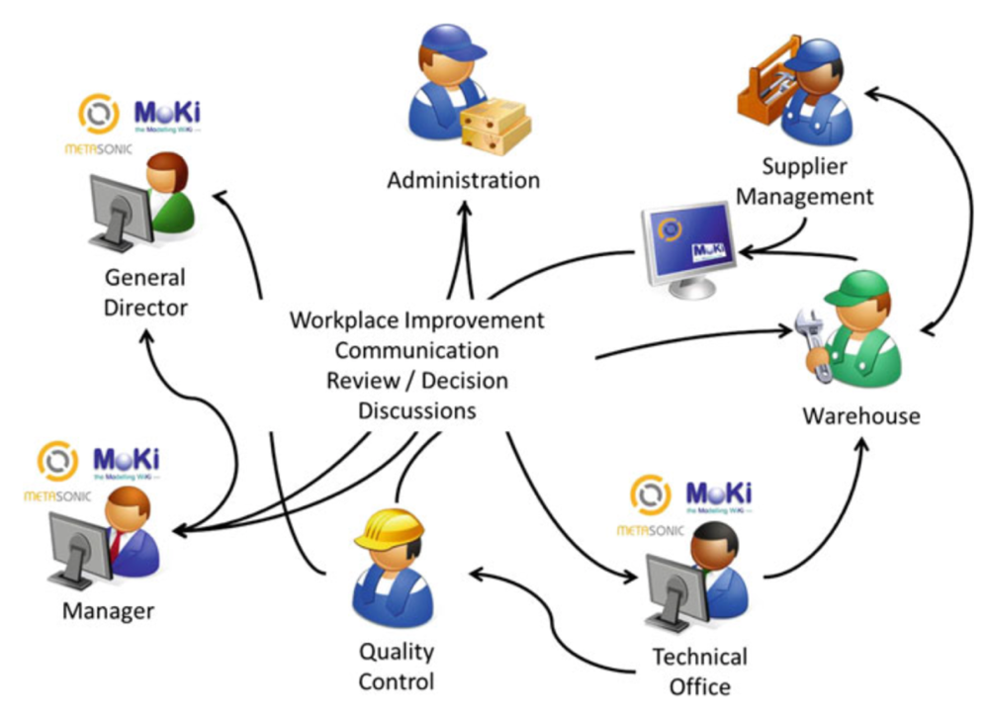
Figure 1. Interactions receiving and quality departments workers
Review of “to-be” processes
The organizational requirements for this use case are understood as a transition from the current situation “as-is” to a desired situation “to-be” at Company B. The as-is process of making suggestions for workplace improvement at Company B is completely unstructured. Suggestions are made by workers directly to their supervisor in face-to-face interaction, even though the supervisor is not the person in charge of that specific type of issue. In Company B, indeed, it is often the case that the same person is in charge of more than one responsibility, thus becoming the reference person to whom workers communicate every kind of problem, request, and suggestion. The consequence of this single point of reference is, on the one hand, workers’ frustration, lack of self-awareness and trust in the management; on the other hand, it has effects at the production level. The lack of transparency and traceability of communication makes this process easily subject to delays and unattended requests, thus also potentially causing errors at the production level. No technological means are used for the internal communication at Company B, while an internal network and an ERP server are used for connecting all the partner companies and for managing the administrative and the warehouse department, respectively. The proposal for the improvement of ‘as-is’ processes to the ‘to-be’ processes in terms of the interaction between several departments presented above in Figure 1. Figure 2 shows the envisioned suggestion making the process at the SME. The displayed Subject Interaction Diagram depicts the interaction of the involved actors, namely Worker, QM Area manager, Warehouse manager, Purchase manager, and Logistics manager. Additionally, for communication with external process participants, the external subject Supplier is included in this model.
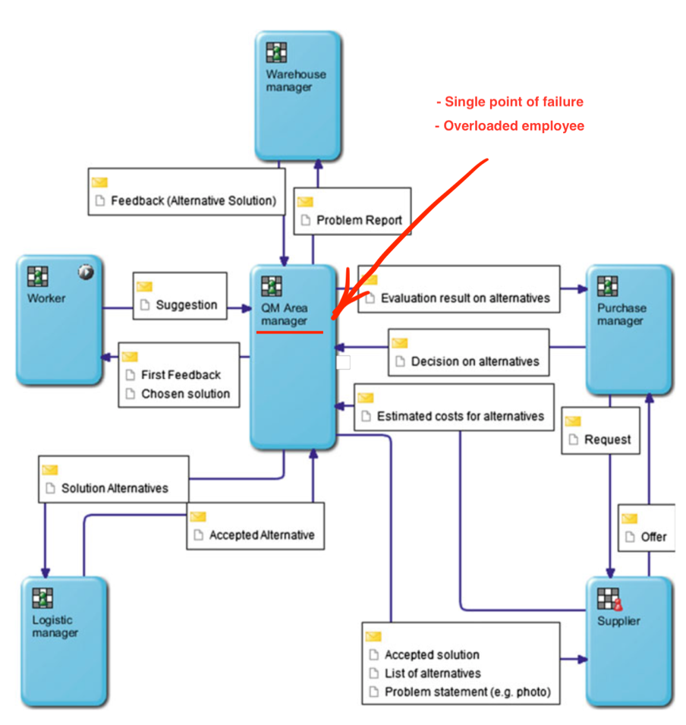
Figure 2. To-be suggestion making process at Company B
The suggestion making process starts with a worker raising a suggestion and sending it to the quality area manager. The quality area manager first analyses the suggestion and provides promptly the first feedback on whether the suggestion will be further processed or not. In the latter case, the reason for not further following a suggestion has to be fed back. In case the suggestion is handled further, the quality area manager creates a problem report and sends it to the warehouse manager, who sends back feedback that may contain an alternative solution. The quality area manager also collects solution ideas from other shop floor areas and compiles them into a list of possible solutions. These are called solution alternatives and are subsequently sent to the logistics manager, who decides upon the alternatives. The accepted alternative is sent back to the quality area manager. The process is split up in several branches at this stage, according to the concerned decision-makers. Finally, all decision branches are merged into one last action: the worker gets informed about the chosen solution.
REFERENCES:
- S-BPM in the production industry. A stakeholder approach. Springer Open, Matthias Neubauer, Christian Stary ISBN 978-3-319-48466-2 (eBook)

