Software Design Patterns
Assignment 6
by Sabirzhanov Emil, SE-2533
Observer Class Diagram
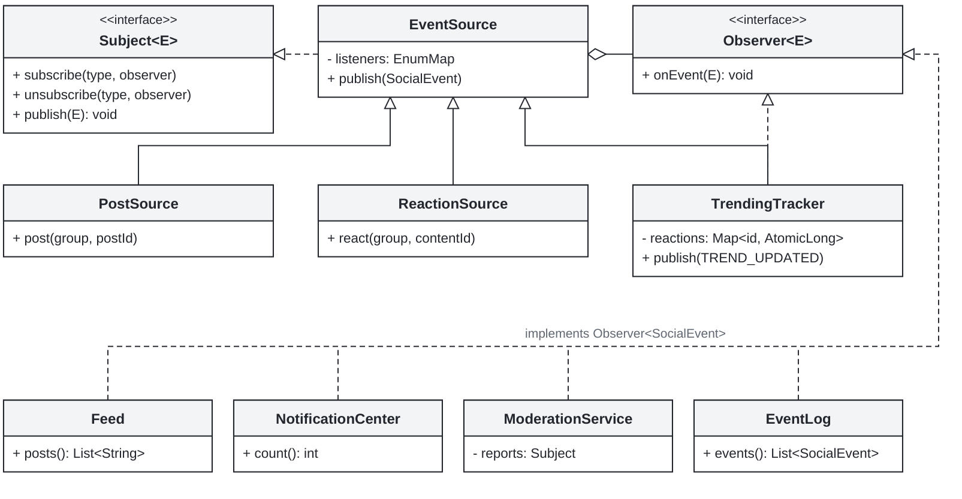
Push delivery; subscriptions by event type; snapshot listener registry.
Moderation Sequence Diagram
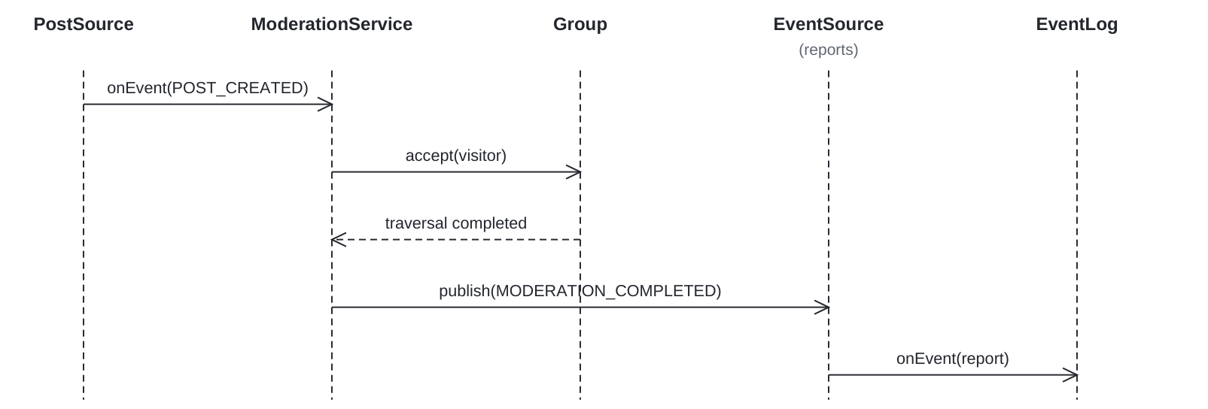
Only the event group is visited. Each event gets its own ModerationVisitor.

Composite and Visitor Class Diagram
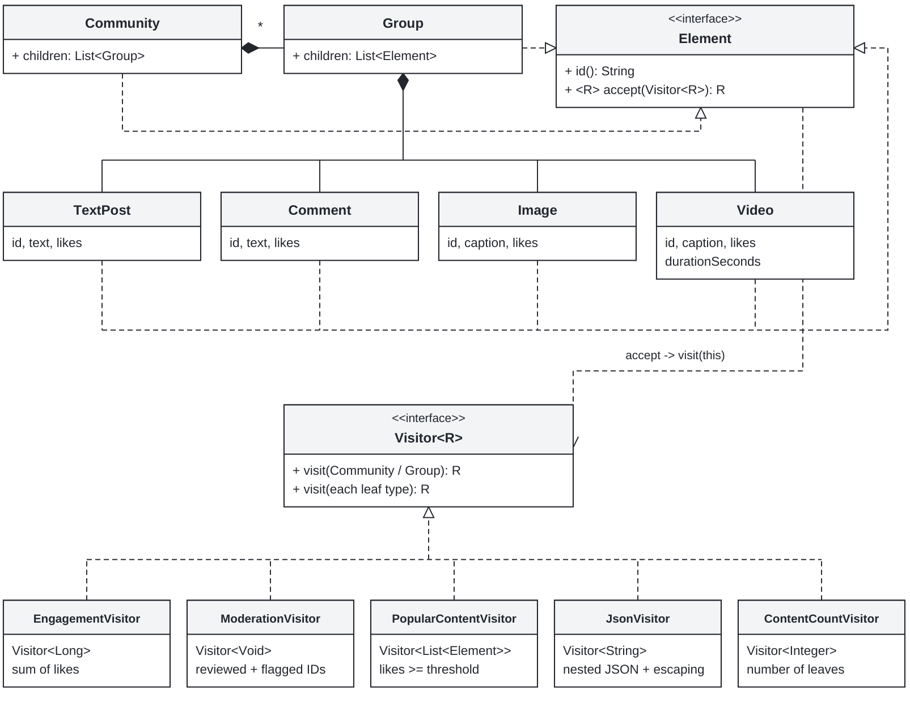
Variant 16 - Social Network
Immutable tree: Community -> Group -> posts, comments, images and videos.
Visitors own traversal. Element.accept calls visitor.visit(this) for double dispatch.
Engagement: 10 + 2 + 5 + 7 + 3 = 27; 5 leaves; flagged content: c1.
30 JUnit 5 tests passed, including 4 threads x 1,000 events with exact counts.
ExecutorService: 3+ configurable producers, thread-safe state, graceful shutdown.
Trade-off commits: 066c3d4 adds a Visitor; 08a1dac adds Video and updates all visitors.
GitHub Repository
https://github.com/AlmazCode/SDP-A6

