**COSC296**  
**Introduction to Information Technology**   
**Assessment 1: My Profile**  
  
***Personal Information:***   
Moustafa Al-Meahi  
[S3887033@student.rmit.edu.au](mailto:S3887033@student.rmit.edu.au)Born and raised in Australia with great opportunities around me. My family comes from the dry lands of Iraq, raised by Iraqi Parents I learnt to speak the Arabic language and English language. Seventeen years of age I recently graduated from High School in late September this year. I did not attend my HSC exams and did not go for ATAR since I had different plans for my career, I changed my mind last minute and decided to pick up some units to pursue a career in the world of technology. I am very passionate about my culture. I come from an Arab tribe called’ Taghlib’ . It is a branch from the ’Rabiah’ Tribe. My people were a people of disgrace who would die in battle over camels until Allah honored us with Islam. Fun fact about my Tribe is that the Royal Family of Saudi Arabia ’Al Saud’ and the Royal Family of Kuwait ’Al Sabah’ are also from the same tribe as me, they may be from my tribe they still wouldn’t give me any oil money.  
*(I don’t take any photos so this is the best one I got; I hope you guys don’t mind!)*  
  
***What is your interest in IT? When did your interest in IT start?***  
***Was there a particular event or person that sparked your interest? Outline your IT experience (if any)***  
My first particular experience that triggered a ripple effect and got me interested in Information Technology was back in 2017. I played a lot of video games growing up including CSGO and back in 2017 Intel was holding their first Extreme Masters in Sydney, I was excited for this event since it was the first gaming tournament I ever went to, I told my friends and we got tickets and we made our way there a few months later. There were a lot of PC brands from MSI to PLE to Razer and most importantly Intel since they were hosting the event. I really enjoyed all the crazy PC Builds and wanted to learn more so I went home and began watching PC Builds on YouTube and eventually built my own PC. Since then, I have always been interested in reading about new technological discoveries and working Information Technology (I took IT electives in High School).  
***Why did you choose to come to RMIT?***  
As I did finish High School but did not attend my HSC Exams to get myself an ATAR to enter a university. RMIT University were the only ones accepting open enrolments and they’re ranked high in Australia overall so I had to take in this opportunity before I miss out!   
***What do you expect to learn during your studies?***  
A Basic way to understand and comprehend technological functions and to get an idea how the different fields in Information Technology works.   
  
  
***Ideal Job***  
[Job link](https://careers.microsoft.com/professionals/us/en/job/931261/IT-Service-Operations-Manager)  
[Snapshot](https://ibb.co/Hrdvb3P)Microsoft is looking for a new Manager to lead a new team for their Information Technology Service Operations. Managing and leading a team to develop, update and fix their Office products such Excel, Word, Endnote, etc. The fact that I can lead the team that develops the applications I have been using in primary school all the way up to high school is amazing to me. One must have at least Five years in enterprise level and another two years' experience leading and motivating a diverse workforce. I believe I am the best candidate for this position due to my experience in leadership programs that I have done in School, I also have an understanding on how technology works in the back end and front end and it's not hard for me to adapt to understand new concepts. I will begin by doing traineeships to gain a small amount of experience kick starting my career in the Information Technology world and from there obtain enterprise positions in IT departments, Though I will get a certificate IV in Business to get that enterprise position.   
  
  
***Personal Profile***   
**Role**: Analyst  
**Strategy**: Constant Improvement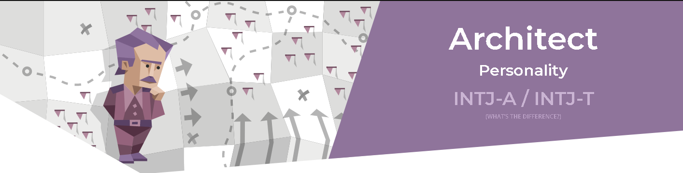

* Introverted 61%
* Intuitive 56%
* Thinking 68%
* Judging 51%
* Turbulent 54%

**Strength:**

* Rational
* Informed
* Independent
* Determined
* Curious
* Versatile

**Weakness:**

* Arrogant
* Dismissive of Emotions
* Overly Critical
* Combative
* Romantically Clueless

[For more here](https://www.16personalities.com/intj-personality)  
  
**Truity Test:**This above table is my results from the Truity test. The Truity test is a Powerful, scientifically validated personality test to help you grow and find your way in life.**Openness 56%   
Conscientiousness 44%  
Extraversion 69%  
Agreeableness 46%   
Neuroticism 42%**[**more here**](https://www.truity.com/personality-test/17315/test-results/30339405)  **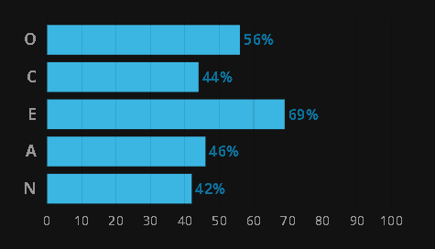  
  
  
  
  
  
  
  
Learning style quiz:**

**Activist style:** 0.294

**Reflector style:** 0.294

**Theorist style:** 0.222

**Pragmatist style:** 0.100

**Primary learning style:** Activist Style

Activists like to immerse themselves fully in new experiences. They enjoy the ‘here and now’ and tend to be more open minded, enthusiastic and flexible. They have a tendency to act first and consider the consequences later, and they often seek to centre themselves around themselves.

learning methods:

* Brainstorming
* Problem setting
* Group discussions
* Role Playing

**Secondary learning style**: Reflector style

Reflectors prefer to stand back and observe. They tend to be cautious, preferring to take a back seat. They like to collect and analyse information to help them reach their conclusions, which they may take considerable time and effort to develop.

learning methods:

* Paired discussions
* Self analysis questionnaires
* Time out
* Showcase / Demonstrations
* Feedback from others
* Coaching

**Tertiary learning style**:Theorists style

Theorists like to think through problems in a logical manner. They value rationality and objectivity and like to assimilate disparate facts into coherent theories.

Learning methods:

* Models
* Classrooms response systems
* story telling
* quotes
* tutorials

**Quaternary learning style:** Pragmatist style

Pragmatists need to be able to see how to put the learning into practice in the real world. Abstract concepts and games are of limited use unless they can see a way to put the ideas into action.

Learning methods:

* Practicals
* Case studies
* Problems setting
* Discussions

***What do the results of these tests mean for you?***It describes me in a way no one has ever done, to be frank with you I really enjoy reading what they have to say about my character and how I learn. Some like the 16 personality test kinda boosted my ego up with the “it can be lonely at the top”.   
***How do you think these results may influence your behaviour in a team?***I don’t think these results are wrong, It tells me a lot about myself and it seems like I tend to avoid all responsibilities this includes

***How should you take this into account when forming a team?***I should consider how much task load I am taking and if I am being just with others!  
  
**Project Idea**

Similar to Airbnb but for mobility. Let me explain, Instead of ordering for a home, apartment or a place for a night to stay out. You can rent out a car or vehicle from the application. Individuals or corporations can list their vehicles on the car to be booked and used for a day or two or for however long one decides to order it for. The application will have strong verification to prevent criminals from abusing the application and causing crime. Clean and simple user interface where we connect both the car owners and consumers without a hustle.   
  
With countless websites to rent a car just in Australia alone, from CarRentalExpress to drive away to many more. A simple application where both individuals and corporations can cut down expenses for businesses, earn money for car owners.  
  
List where users can list their vehicle with a price tag for each night, hour, etc. With an availability status if the vehicle is available and a schedule for future bookings. To ensure car owners do not get their vehicle stolen, every user will be responsible for damages done to the car. To ensure Users are not blamed for the vehicles damages, all vehicles on the application will be tested and approved before listed. To ensure safety for all parties.   
  
Simple Application with a database so all data can be uploaded.   
Knowledge in clouding, programming and security.

No more dodgy website with terrible response times, simple and quick orders and communications in the application.