Mapua Institute of Technology

School of Electrical, Electronics and Computer Engineering

Muralla St., Intramuros, Manila

**Vita-Vault**

**(Inventory Management System)**

in partial fulfilment of the requirements in

**Software Design Laboratory**

**(CPE106-L/B2)**

Submitted by:  
Alipio, Cyris Ken M.

Macaro, Neil Emmanuel R.

Sarmiento, Paolo B.

Submitted To:

Sir Dionis Padilla

Submitted On:

May 09, 2024

**Community Needs and Requirements**

Effective management of medical supplies is essential in the healthcare industry, particularly in the Philippines, to guarantee that patients receive the necessary care. However, it can be challenging for healthcare practitioners to meet community requirements when faced with problems like running out of supplies, expiring products, and ineffective inventory systems. A medical inventory management system that prioritizes the community's requirements is becoming increasingly necessary. The supplies that are used and the transactions would all be monitored by this system. Maintaining thorough documentation can assist in cutting down on waste and guarantee that the most crucial materials are always available in the right amount. It would also simplify refilling and discarding expired items since this system aims to track the medical items stored in the facility. A user-friendly interface would encourage more healthcare practitioners to adopt the system. This system could significantly change how medical supplies are managed, ultimately leading to better patient care in the Philippines, provided it is scalable, data secure, and compliant.

**Group’s Analysis (Features)**

**Main Menu**

The medical inventory management system's main menu provides quick access to key functionality with four buttons: Inventory, Transaction, Supplier, and Exit.

Inventory Management

The Inventory Management feature in the system's Inventory window makes tracking and managing medical supplies stored in inventory easier. It allows you to search, add, modify, and remove items and record essential item information such as description, quantity, unit pricing, and supplier details.

**Transaction Management**

The medical inventory management system's transaction management capability makes inserting, updating, deleting, and finding various medical supply transactions easy. Users may successfully manage inventory movements and monitor changes to item characteristics, supplier data, transaction types, and quantities with its assistance.

**Supplier Management**

The system's Supplier window includes a function called Supplier Management, which makes it easier to manage supplier data, such as adding, updating, removing, and searching suppliers. Users can also keep track of the supplier's contact information, such as phone numbers and emails.

**GUI**

One of the most essential features of the medical inventory management system is its user-friendly interface, designed to make it more accessible and beneficial to users with varying levels of technical competence. It has user-friendly features and design cues to make navigation easier and encourage ease of use.

**Use Case Diagram**

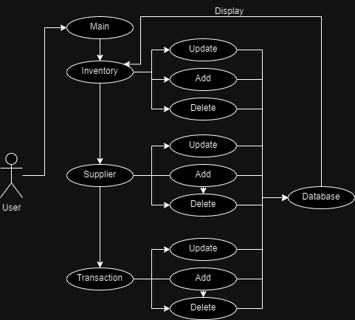

**Class Diagram**

