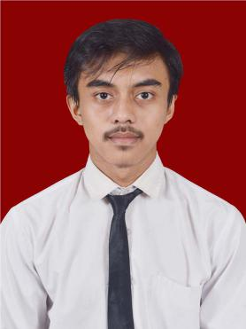

**2022.01- Internship 2**

**2022.04** Bulog, Jakarta

**2021.10- Internship 1**

**2022.01** BPPT, Tangerang Selatan

Talented Junior Software Engineer adept at working with customers, team members and project leaders to accomplish software engineering and updating tasks according to timelines. Solid understanding of full development lifecyle. Skilled working with wide range of front- and back-end technologies to produce and evaluate code.

Born：1999-08-24 Mobile：123-456-7890

Education：Postgraduate Email：almibchr@gmail.com

Address: Kamasan

Bandung, Jawa Barat, 40377

Work experience

Skills

Education

**2012-1015 Junior High School 2 Banjaran**

**2015-2018 Vocational High School 10 Bandung**

**2018-2022 D4 Informatics Engineering Politeknik Pos Indonesia**

2

**Programming language PHP, HTML, Python**

**Software applications**

**Database programming**

**Database management software**

**Algorithm implementation**

CV

x

**Career Objective：Programmer**

**Almi Bachri**

**Freely modify the size and color, copy and paste can be used**

**personal：**

**jobs：**

**education：**

**phone：**

**email：**

**address：**

**motion：**

**Hobby：**

**other：**

Gift editable small ion