Application should be built using .Net MVC C# and contain the following:

A list with 6 items, every item will have the following attributes (integer: Position, string: Name, integer: Score). List items will have pre-defined Names and their Score attributes will start with value of 0. The Position attribute represents the position within the list for that item.

|  |  |  |
| --- | --- | --- |
| Position | Name | Score |
| 1 | Item1 | 0 |
| 2 | Item2 | 0 |
| 3 | Item3 | 0 |
| 4 | Item4 | 0 |
| 5 | Item5 | 0 |
| 6 | Item6 | 0 |



A button that will trigger an event.

When the button event is triggered, the user will be presented with a form that contains labels that will represent any two items from the list, input fields for those items and a submit button.

Example:

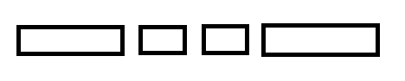

1 

2 

1 

2 



3

1. List item name
2. Input field
3. Submit button

The user will input a numeric value to each of the input fields and click submit.

After the submit event is triggered, the list item with the higher value will have its Score attribute value increased by one.

After the submit event, the user will be presented with two new list items that will be compared and the list will be sorted by the value of the Score attribute. This will continue until every item is compared with every other item in the list.