PWM – Software Architecture Design Document

Version | Description | Author
0.1 | Initial version | Binh Tran

Contents
1 Introduction 6
1.1 Scope 6
1.2 References 6
1.3 Acronyms and Abbreviations 7
1.4 Features 8
2 Architecture 13
2.1 Driver Architecture 13
2.2 Component Architecture 13
2.2.1 MCU 13
2.2.2 PORT 14
2.2.3 DET 14
2.2.4 DEM (Diagnostic Event Manager) 14
2.2.5 SchM 14
2.2.6 OS (Operating System) 14
2.3 File Architecture 16
3 Limitations 17

List of Tables
Table 1 References 6
Table 2 Abbreviations 7

List of Figures
Figure 1 PWM signal description 8
Figure 2 PWM waveform Center Alignment 9
Figure 3 PWM waveform Left Alignment 10
Figure 4 TC waveform Left Alignment 10
Figure 5 TC waveform Center Alignment 11
Figure 6 TC waveform can be reset at any time by an external event or a software trigger 12
Figure 7 Context Diagram (Software to Hardware Interface) 13
Figure 8 Component Architecture 15
Figure 9 Files Structure 16

Introduction
This document describes the architecture design for the development of AUTOSAR version 24-11 compliant driver for PWM Module. The PWM driver is designed for Microchip’s SAMA7 family Microcontrollers.

Scope
The scope of this document is to specify the Architectural design of PWM driver module. It covers functionality, APIs definitions, sequences of API calls, Configuration items and error handling. The intended audience for this document is the developer who is responsible for the higher layers of BSW module.

References
Table 1 References
No | Document name | Version
 | Specification of PWM Driver  (AUTOSAR_CP_SWS_PWMDriver.pdf) | R24-11
 | Software Requirement Specification  SRS_PWM_ASR24_11.xlsm | 0.3
 | Hardware User Manual of the SAMA7G5 variant  (SAMA7G5-Series-Data-Sheet-DS60001765.pdf) | DS60001765D  Rev. D - 03/2025
 | SAMA7G5 Series Silicon Errata and Data Sheet - Clarifications - SAMA7G5 Series  (SAMA7G5-Series-Silicon-Errata-and-Data-Sheet-Clarification-DS80001016.pdf) | DS80001016H  Rev. H - 01/2026
 | SAMA7 Functional Safety Manual  (Draft_SAMA7G54_Functional_Safety_Manual_June_2024.pdf) | Rev. A - 06/2024

Acronyms and Abbreviations
This is a list of definitions, acronyms, & abbreviations used throughout this document.
Table 2 Abbreviations
Abbreviations | Description
API | Application Programming Interface
ARM | Advanced RISC Machines
AUTOSAR | AUTomotive Open System ARchitecture
BSW | Basic Software
DEM | Diagnostic Event Manager – Module to handle diagnostic relevant events
DET | Default Error Tracer
ECU | Electronic Control Unit
GCLK | Generic Clock
ISR | Interrupt Service Routine
MCAL | Micro Controller Abstraction Layer
MCLK | Main Clock
MCU | Micro Controller Unit
SAM | Smart ARM Microcontroller
SchM | BSW Scheduler Module
PWM | Pulse Width Modulation

Features
The PWM driver controls the Timer Counter and PWM peripherals and provides following features:
- PWM driver provides functions for initialization and control of the microcontroller internal PWM stage (pulse width modulation). The PWM module generates pulses with variable pulse width. It allows the selection of the duty cycle and signal period.
Figure 1 PWM signal description
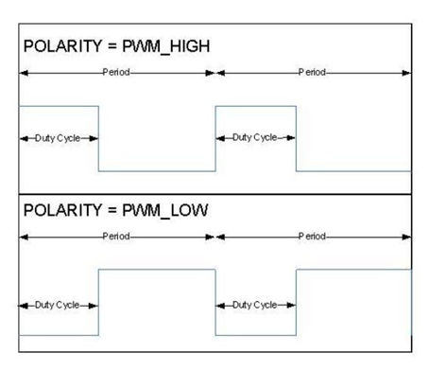

- The PWM driver allows channels using the PWM peripheral to select waveform alignment. The output waveform can be left- or center-aligned.
Figure 2 PWM waveform Center Alignment
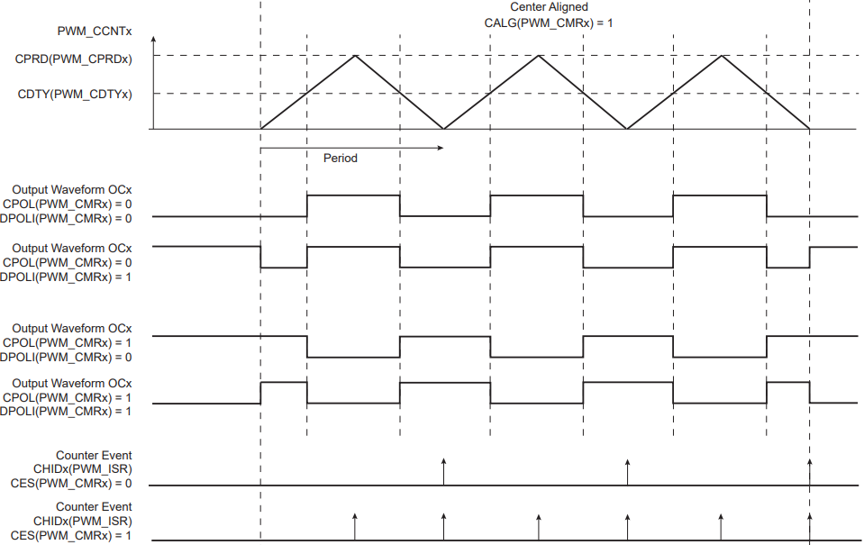

Figure 3 PWM waveform Left Alignment
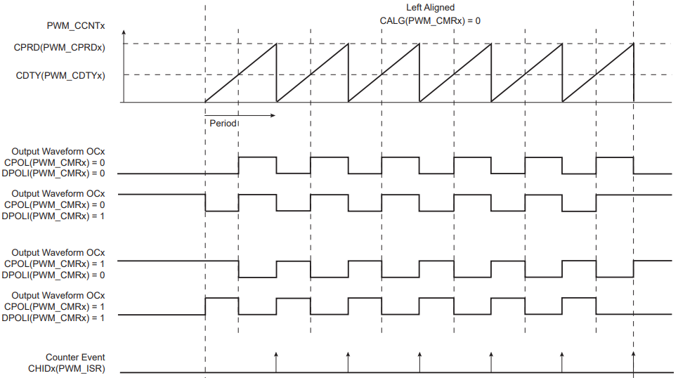

- The PWM driver allows channels using the TC peripheral to select waveform alignment. The output waveform can be left- or center-aligned.
Figure 4 TC waveform Left Alignment
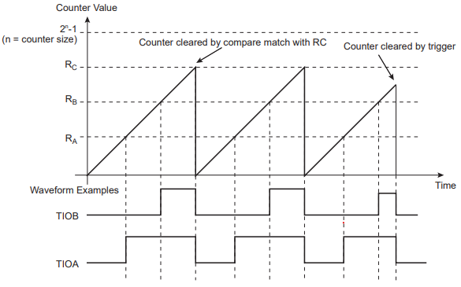

Figure 5 TC waveform Center Alignment
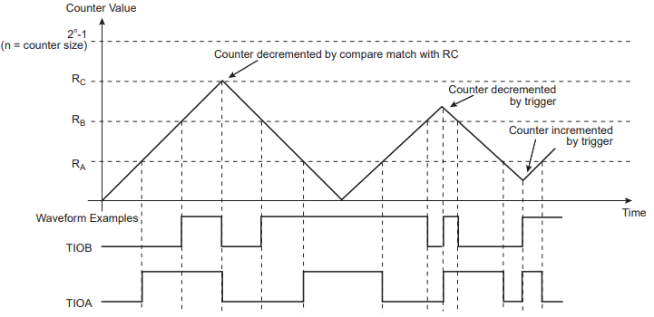

- The PWM driver allows channels using the TC peripheral to reset TC_CV at any time by an external event.
Figure 6 TC waveform can be reset at any time by an external event or a software trigger
if both are programmed correctly.
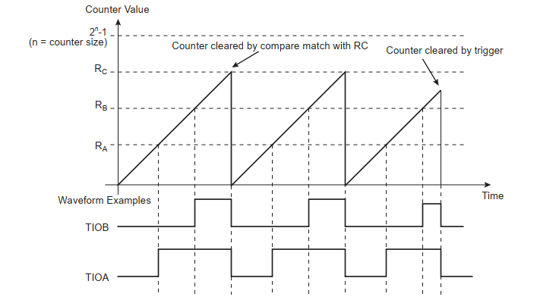

Architecture

Driver Architecture
PWM Driver in AUTOSAR MCAL Layer will interact with Timer/Counter, Pulse Width Modulation, Advanced interrupt controller and Event system peripherals on SAMA7D6/SAMA7G5 microcontroller.
SAD_PWM_1 (SRS_PWM_3, SRS_PWM_4, SRS_PWM_168 )
Figure 7 Context Diagram (Software to Hardware Interface)

Component Architecture
The PWM module depends on or interfaces with MCU, PORT, DEM, DET, and SchM.

MCU
The PWM driver depends on the system clock, prescaler(s) and PLL. Hence the length of a PWM timer tick depends on the clock settings made in the module MCU.

The architecture design of the MCU module, including interfaces (Section 6) and sequence diagrams (Section 8), is described in the MCU_SAD document.

PORT
The configuration of port pins used for the PWM as outputs is done by the PORT driver. Hence the PORT driver must be initialized prior to the use of PWM functions. Otherwise PWM functions will exhibit undefined behavior.

The architecture design of the PORT module, including interfaces (Section 6) and sequence diagrams (Section 8), is described in the PORT document.

DET
PWM module will report development errors to DET module.

DEM (Diagnostic Event Manager)
PWM module will report errors to DEM module in safety functions.

SchM
The Basic Software Scheduler module will be called whenever a critical section protection function is called.

OS (Operating System)
The PWM driver uses interrupts and therefore depends on the OS, which configures the interrupt sources. The OS provides only the callback functions.
The PWM driver will not take care of setting the registers for interrupt association in its
Init function. The overall assignment and activation of the interrupt system is done by
the Operating System.

SAD_PWM_2 (SRS_PWM_21, SRS_PWM_124, SRS_PWM_133, SRS_PWM_166, SRS_PWM_194)
Figure 8 Component Architecture

All PWM interfaces are realized in Section 6.
All MCU interfaces are available in MCU document Section 6.
All PORT interfaces are available in PORT document Section 6.
All DET, DEM, SchM interfaces are mentioned in Section 6.4.

File Architecture
SAD_PWM_3 (SRS_PWM_3, SRS_PWM_4, SRS_PWM_31)
Figure 9 Files Structure

Limitations
- For MCAL PWM channels that are generated from a hardware PWM module, the Pwm_GetOutputState() API does not support returning the internal state of the PWM channel. Instead, this functionality is only supported for channels generated using the Timer/Counter (TC) hardware unit, because the PWM hardware module does not provide a register to read the output value.
- TC supports 32 bit counter while PWM only supports 16 bit counter so that all PWM channels are based on underlying 16-bit wide timer hardware and the range of PWM periods as well as duty cycle is limited to 16-bit.
- PWM MCAL channels configured without end-of-period update enabled have the possibility of generating glitches on the PWM output.
- PWM MCAL channels generated from a PWM hardware module do not support notifications on both edges. This capability is only available for channels generated from a TC hardware module, where the effective behavior is determined by the combination of polarity configuration and edge notification settings.
- If the target device is SAMA7G54, PWM MCAL channels shall not be configured to use Timer Counter 0 Channel 2 due to a hardware erratum.
- For PWM MCAL channels configured to be generated from a PWM hardware module, the relationship between the value in the Period Register (PWM_CPRDx) and the Duty Cycle Register (PWM_CDTYx) helps the user select the appropriate clock. The event number written in the Period Register gives the PWM accuracy. The Duty-Cycle quantum cannot be lower than 1/CPRDx value. The higher the value of PWM_CPRDx, the greater the PWM accuracy.
- For edge notifications, only PWM hardware Channel 0 supports both rising-edge and falling-edge notifications. For all other PWM hardware channels, the supported edge notification type is restricted to either rising-edge or falling-edge notification based on the configured alignment and polarity settings.
- The PWM driver uses both Timer Counter (TC) and PWM peripherals to implement PWM functionality, leveraging the available TC and PWM hardware resources.
  - For TC peripheral, driver is designed on both Timer A (TIOAx) and Timer B (TIOBx). Each Timer is configured as Waveform mode, using TC_RA and TC_RB compare register to control Duty Cycle, TC_RC compare register to control Period.
The value of TC_CV is incremented from 0 to the value of RC, then automatically reset on a RC Compare. Once the value of TC_CV has been reset, it is then incremented and so on.
TIOBx and TIOAx are configured as outputs and use compare register to generate the waveforms. Therefore, XC0 is selected as External Event Selection.
Supports two output pins (TIOA and TIOB) with the same duty cycle and period for each channel, but only supports notification for TIOA to avoid unexpected behavior caused by simultaneous interrupts. Available only for TC0 or TC1.
  - For the PWM peripheral, the driver is designed such that the waveform alignment can be selected:
    - If the waveform is left-aligned, then the output waveform period depends on the counter source clock and can be calculated:
By using the PWM peripheral clock divided by a given prescaler value “X” (where X = 2^{PREA} is 1, 2, 4, 8, 16, 32, 64, 128, 256, 512, or 1024). The resulting period formula is:
$$\frac{X × CPRD }{f peripheral clock }$$
By using the PWM peripheral clock divided by a given prescaler value “X” (see above) and by either the DIVA or the DIVB divider. The formula becomes, respectively:

$$\frac{(X × CPRD × DIVA)}{f peripheral clock } or \frac{(X × CPRD × DIVB)}{f peripheral clock }$$
    - If the waveform is center-aligned, then the output waveform period depends on the counter source clock and can be calculated:
By using the PWM peripheral clock divided by a given prescaler value “X” (where X = 2^{PREA} is 1, 2, 4, 8, 16, 32, 64, 128, 256, 512, or 1024). The resulting period formula is:
$$\frac{(2 × X × CPRD) }{f peripheral clock }$$
By using the PWM peripheral clock divided by a given prescaler value “X” (see above) and by either the DIVA or the DIVB divider. The formula becomes, respectively:
$$\frac{(2×X × CPRD × DIVA)}{f peripheral clock } or \frac{(2 ×X × CPRD × DIVB)}{f peripheral clock }$$
    - Each PWM channel provides two outputs (PWMH and PWML). However, for monitoring purposes during the testing phase, only the PWMH output of the specific channel is considered.
  - TC hardware modules are also used by the GPT MCAL and ICU MCAL. The same TC hardware module channel can be configured and used by no more than one MCAL. For example, configuring a PWM channel in the PWM MCAL to be generated from TC hardware module #0 channel #0 thereby precludes the use of TC hardware module #0 channel #0 in either the GPT MCAL or ICU MCAL.
  - PWM MCAL channels configured to be generated from a PWM hardware module can generate output pulses on 4 Asynchronous channels independently according to parameters defined per channel.

