Software Requirements Specification

for

Capture The Flag Practice

Prepared by

Group Name: *Software Engineering 2 CTF Team*

| *Christopher Wallisky* |
| --- |
| *Haoming Xu* |
|  |

| Instructor: | *Prof. Doug Lim* |
| --- | --- |
| Course: | *COSC 4303 Software Engineering II* |
| Version: | *1.0* |
| Date: | *9/27/2023* |

Table of Contents

Table of Contents........................................................................................................................................................... Ii

Introduction..................................................................................................................................................................... 1

1.1 Document Purpose.......................................................................................................................................... 1

1.2 Product Scope ................................................................................................................................................. 1

1.3 Definitions, Acronyms and Abbreviations......................................................................................................... 1

1.4 References and Acknowledgments.................................................................................................................. 2

2 Overall Description........................................................................................................................................... 3

2.1 Product Functionality.......................................................................................................................... 3

2.2 End Users and Characteristics.......................................................................................................... 3

2.3 System Stakeholders......................................................................................................................... 3

2.4 Operating Environment...................................................................................................................... 4

3 Specific Requirements..................................................................................................................................... 5

3.1 User Interface. .................................................................................................................................. 5

3.2 Functional Requirements................................................................................................................... 6

3.3 Use Case Diagram............................................................................................................................ 7

4 Non-functional Requirements........................................................................................................................... 8

4.1 Software Quality Attributes................................................................................................................ 9

5 Other Requirements....................................................................................................................................... 10

5.1 Database Requirement……………………………………………………………………………………. 10

Appendix A - Group Log............................................................................................................................................... 11

# **1** **Introduction**

## **1.1** **Document Purpose**

The purpose of this Software Requirements Specification (SRS) document is to provide a detailed and comprehensive description of the requirements, functionalities, constraints, and specifications for the development of the Capture The Flag (CTF) Practice Application. This document is intended to serve as a reference guide for all stakeholders involved in the project, including developers, testers, project managers, and end-users.

## **1.2** **Product Scope**

The software is designed to mimic the testing environment of a Capture the Flag competition. It will consist of 2 parts, a questionnaire prompt of 5 different categories and a virtual practice environment to use in order to find answers. Combined the two parts will create a separate but mutually interactable testing environment tailored towards questions and challenges asked in a Real-World CTF challenge test, in order to allow participants to form teams and prepare for the competition.

## **1.3** **Definitions, Acronyms and Abbreviations**

| **Use Case** | **Definition** |
| --- | --- |
| CTF | Capture the Flag |
| OS | Operating System |
| SRS | Software Requirements Specification |

## **1.4** **References and Acknowledgments**

### 1.4.1 References

* Microsoft Visual Studio Documentation

URL: <https://docs.microsoft.com/en-us/visualstudio/>

* MetaCTF | Cybersecurity Capture the Flag Competition

URL: <https://metactf.com/>

* VirtualBox User Manual

URL: <https://www.virtualbox.org/manual/UserManual.html>

### 1.4.2 Acknowledgments

The successful completion of this project would not have been possible without the support, guidance, and contributions of many individuals and organizations. We would like to extend our thanks to:

* **Prof. Douglas Lim**: For providing valuable insights, mentorship, and guidance throughout the course, which greatly contributed to the development of this project.
* **Dr. Glyn Gowing**: Our esteemed client and advisor, whose expertise, feedback, and vision for this project have been instrumental in shaping its direction and ensuring its alignment with real-world cybersecurity challenges.
* **The MetaCTF Team**: For hosting the contest for which this project was made for, and providing the inspiration for many of the design features of the project.

# **2** **Overall Description**

## **2.1** **Product Functionality**

* **Practice Test**
  + Track Scores of individuals and teams
  + Display 5 different categories of questions taken from a database of previous competition questions
  + Give hints towards answers
  + Submission of flags for answers
* **Virtual Machine**
  + Provides functional applications that will be used to determine answers to questions
  + Is resettable
  + Can interact with files detailed or given in questions

## **2.2** **End Users and Characteristics**

* **Student/Test Takers**: Will interact with the product through use of its implementations. Will be able to access their own account and their team’s scores.
* **Administrators**: Will have operator privileges that will enable changes in the Student/Test Takers environments, consisting of question database management and user accounts.

## **2.3** **System Stakeholders**

* **Development Team**: Designs and constructs the testing environment, the Question repository database, and the Virtual Machine used to determine answers.
* **Project Manager**: Describes requirements and necessary features for the project.
* **End-Users**: Students and CTF test takers using the application for practice before the competition.
* **Administrators**: Will manage the product’s additive features such as the Question repository database, adding and subtracting questions as needed and monitoring and managing the End-Users while using the application.

## **2.4** **Operating Environment**

### 2.4.1 Software Environment

* **Operating System**: Windows 10 or later version
* **Web Browser**: Google Chrome, Mozilla Firefox, or Microsoft Edge
* **Internet Connectivity**: High-speed internet for a smooth user experience

### 2.4.2 Hardware Environment

* **Processor**: Multi-core processor with virtualization support.
* **Storage**: Minimum 50 GB free disk space for application, databases, virtual machine, and the practice test storage.
* **RAM**: 4 GB required, 8 GB or more recommended.
* **Display**: High definition (720p) display that is greater than 9” diagonally.
* **Network Interface**: Ethernet or Wi-Fi for internet connectivity.
* The Host system should be capable of running a kali linux virtual machine and the questionnaire. It should be able to allow both to connect to each other and for the databases holding the question repositories to connect to each other. In addition, the Host system should be able to run any associated systems that may be required or optional for testing.

# **3** **Specific Requirements**

## **3.1** **User Interface**

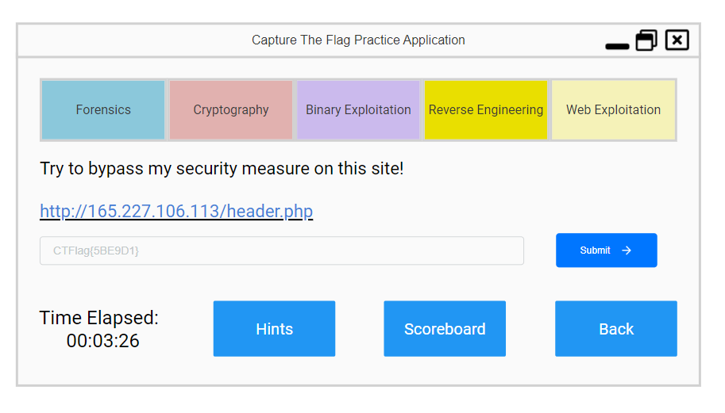

There are two distinct user interfaces for the product. Firstly there will be a startup screen that will be used to view scores of individuals and of their group, as well as a start button to load up the practice test. The second user interface will consist of 5 tabs, each displaying a different question in their respective categories. It will also have a submit button for sending in the flags, a running clock, a hint button for the presented question, a scoreboard to view progress, and a back button to return to another interface.

## **3.2** **Functional Requirements**

* **Home Page Features**: Will include current scores for both the user and their team, and a start button to begin a practice test.
* **User Registration and Authentication**: Each individual user will have their own username and password required to use the application, and will be linked to their associated team members under the same team name.
* **Challenge Categories**: Will include 5 categories, Forensics, Cryptography, Binary Exploitation, Reverse Engineering, Web Exploitation
* **Challenge Creation and Management**: Will include access to a set of databases of previous CTF competition questions that will be selected at random to be questions prompted in the user environment.
* **Hint System**: Gives a hint on how to find the correct answer in exchange for a minor point penalty.
* **Flag Submission**: The "Flag Submission" functionality allows registered competitors to submit flags they have discovered for specific challenges.
* **Scoring and Ranking**: Will keep track of individual and team scores in all categories and rank them in order to keep track of progress and preparedness.
* **Administrator Functions**: Allows development team and Administrators to monitor users and change key attributes such as practice questions and team names.
* **Virtual environment integration**: Specifies the system's capability to seamlessly launch and manage virtual environments for users to safely test and solve challenges within the Capture The Flag (CTF) platform.

## **3.3** **Use Case Diagram**

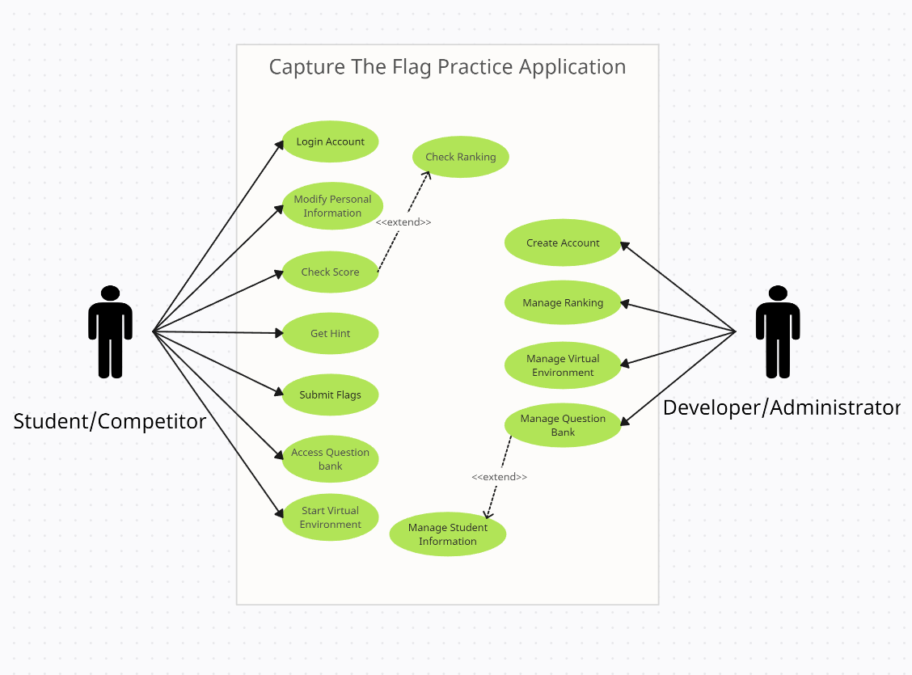

**Student/Competitor**: Interacts with the application while running, and uses the Graphical Interface to interact with the product.

**Developer/Administrator**: Manages the behind-the-scenes, including accounts and available questions from the database.

# **4** **Non-functional Requirements**

## **4.1** **Software Quality Attributes**

The CTF Practice Application must adhere to various software quality attributes to ensure a seamless and secure user experience. These attributes are essential for the application's overall performance and reliability. The non-functional requirements related to software quality are as follows:

### 4.1.1 Performance

**Response Time**: The application must have responsive user interfaces and APIs. The maximum acceptable response time for standard user interactions (e.g., loading challenges, submitting flags) should be less than 2 seconds.

**Scalability**: The system should be designed to handle a growing number of users and challenges. It must scale horizontally to accommodate increased load during peak usage times.

### 4.1.2 Security

**Data Encryption**: All sensitive user data (e.g., passwords) and communication between the client and server must be encrypted using strong cryptographic protocols.

**Access Control**: Role-based access control (RBAC) should be implemented to ensure that users can only access the features and data relevant to their role (e.g., competitors, administrators).

**Authentication**: User authentication should be secure, requiring strong, unique passwords.

**Authorization**: Authorization rules must be enforced at both the application and database levels to prevent unauthorized access to data and functionality.

**Data Protection**: User-submitted flags and sensitive challenge information must be stored securely, and mechanisms for data backup and recovery should be in place.

### 4.1.3 Reliability

**Availability**: The application will have a high-availability ratio and be able to be accessed by both competitors and administrators at any time.

### 4.1.4 Usability

* **User-Friendly Interfaces**: The user interfaces should be intuitive and user-friendly, requiring minimal training for competitors and administrators.

### 4.1.5 Compatibility

* **Cross-Browser Compatibility**: The application should be compatible with major web browsers (e.g., Chrome, Firefox, Safari, Edge) to provide a consistent user experience.
* **Windows OS Compatibility:** The application shall be compatible with the following versions of the Windows operating system:
  + Windows 10
  + Windows 11

### 4.1.6 Performance Testing

* **Load Testing**: Conduct load testing to assess the application's performance under heavy concurrent user loads, ensuring it can handle peak competition participation.
* **Security Testing**: Regularly perform security assessments, including penetration testing, to identify and address vulnerabilities and potential threats.
* **Scalability Testing**: Validate the application's ability to scale horizontally and handle increasing numbers of challenges and users.
* **Usability Testing**: Conduct usability testing with representative users to gather feedback on the user interface and make necessary improvements.

# **5** **Other Requirements**

## **5.1 Database Requirements**

There shall be a total of five distinct databases, each meticulously organized to house question prompts relevant to the specific question categories. These databases include:

* **Forensics Database**: This database shall exclusively store question prompts pertaining to the "Forensics" category.
* **Cryptography Database**: Designed to hold question prompts exclusively related to the "Cryptography" category.
* **Binary Exploitation Database**: Reserved for question prompts specific to the "Binary Exploitation" category.
* **Reverse Engineering Database**: Dedicated to the storage of question prompts associated with the "Reverse Engineering" category.
* **Web Exploitation Database**: This database shall contain question prompts exclusively associated with the "Web Exploitation" category.

Appendix A - Group Log

| Date | Duration | Location | Notes |
| --- | --- | --- | --- |
| 09/26/2023 | 12:00-14:30 | ASFC | Wrote SRS Documents, discussed software requirement details. |