Architecture & Design
System Architecture

We are using a monolithic architecture, as specified in the task.

The entire application will be in a single executable file written in Go.

Main modules:
- Handbook (the main logic of the reference book) — stores languages ​​and categories
- Search (search by language or category name)
- Stats (pageview statistics)
- Admin (adding new languages ​​— for teachers or moderators)

Data flow:
User → HTTP request (browser) → Go server (net/http) → in-memory map (or database later) → JSON response to the client.

Module responsibilities:
- Handbook: CRUD operations with languages ​​(Create, Read, Update, Delete)
- Search: filtering and searching
- Stats: counting views and language popularity

At this stage (Milestone 1), we use an in-memory map for data storage.

In the future, we may migrate to SQLite or PostgreSQL.

Diagrams (see below):

1. Use-Case diagram — shows who can do what.
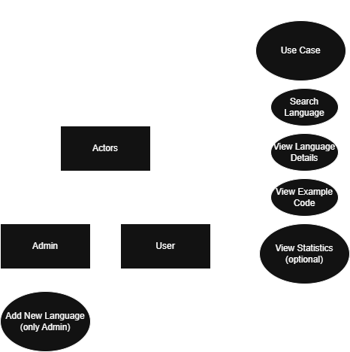
2. ERD — entities and relationships.
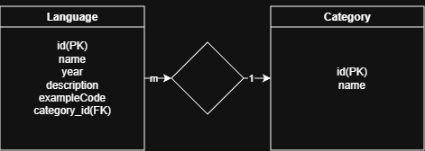
3. UML Class diagram — basic structures and methods.
