

University of Bahrain

College of Engineering

Department of Chemical Engineering

CHENG 423

Chemical Plant Design II

SEM. 1 2024-2025

**COMPUTER-AIDED REVAMP STUDY OF CRUDE DISTILLATION UNIT AND VACUUM FIRED HEATER**

Submitted to: Dr. Sabri Mrayed and Dr Kamal Almuteer

|  |  |  |
| --- | --- | --- |
| Name | ID | Contribution |
| Ali Osama | 202009520 | 25% |
| Noof Abdulla | 202002226 | 25% |
| Fajer Janahi | 202006106 | 25% |
| Mariam Haitham | 20196723 | 25% |

# SUMMARY

This study presents a comprehensive simulation of a crude distillation unit (CDU) and a vacuum distillation unit (VDU) using Aspen Hysys. Initially, an overview of a refinery was conducted, including EP1 and EP2 calculations where EP1 was found to be $4.52 x 109 and EP2 was found to be $3,237,448,405 over 25 years. The simulation aimed to optimize the process for energy efficiency and product quality. The CDU and VDU were simulated using industry-standard values and data obtained from BAPCO. The simulation results provided valuable insights into product yields, energy consumption, and potential improvements. However, data limitations necessitated several assumptions, which may have influenced the accuracy of the results. The CDU flow rates were nearly identical to the BAPCO data with the overhead product being the only deviation. In the VDU, the LVGO D86T5% was 319°C, and for the HVGO the D2887T5% was 304 °C and the D2887T95% was 505 °C. Pinch analysis was conducted using Aspen Energy Analyzer to identify opportunities for heat integration and energy savings. Several scenarios were evaluated, and the most promising scenario demonstrated significant reductions in energy consumption and operational costs, which was scenario C where the total cost was 0.2503 Cost/s in that scenario. The fired heater design was also done by Aspen EDR and yielded an overall efficiency of 87.68% with a capital cost equivalent to $7244005.11.

# TABLE OF CONTENTS

SUMMARY ii

TABLE OF CONTENTS iii

LIST OF FIGURES vi

LIST OF TABLES vii

1 CHAPTER 1: INTRODUCTION 1

2 CHAPTER 2: OVERVIEW OF A REFINERY 2

2.1 PROCESS DESCRIPTION 2

2.1.1 Feed System 3

2.1.2 Pre-Heating System 3

2.1.3 Pre-Flash Section 3

2.1.4 Atmospheric Section 3

2.1.5 Vacuum Section 4

2.2 ENERGY INTEGRATION 4

2.2.1 Heat Integration Through Pinch Technology 4

2.2.2 Steam Network Optimization 5

2.2.3 Flue Gas Heat Recovery Systems 5

2.2.4 Petrochemical Integration 6

2.3 MATERIAL BALANCE ON CDU 6

2.4 ECONOMIC IMPACT 8

3 CHAPTER 3: PROCESS SIMULATION AND PINCH ANALYSIS 11

3.1 PROCESS SIMULATION 11

3.1.1 Crude Assay 11

3.1.2 Base Case Description 11

3.1.3 Assumptions 13

3.1.4 CDU and VDU Simulation 13

3.1.5 Mass and Energy balance 15

3.1.6 Simulation Results 15

3.2 PINCH ANALYSIS 17

3.2.1 Introduction to Pinch Analysis 17

3.2.2 Energy Integration Opportunities 18

3.2.3 Scenarios Considered in Pinch Analysis 19

3.2.4 Results Of Pinch Analysis 25

3.3 CONSTRAINS AND CONSIDERATIONS 26

3.3.1 Constrains 26

3.3.2 Process Safety and Health Considerations 26

3.3.3 Environmental Considerations 27

3.3.4 Economic Considerations 27

3.3.5 Design Sustainability 27

4 CHAPTER 4: FIRED HEATER DESGN and Hazop Analysis 28

4.1 Fired Heater Description 28

4.1.1 Vacuum Fired Heater 30

4.2 Process Conditions and Streams 30

4.3 Duty and Utility Requirements 31

4.4 Mechanical Design 32

4.4.1 Sizing Procedure 32

4.4.2 Material Selection 32

4.4.3 Firebox and Radiant Zone of the Fired Heater 33

4.4.4 Firebox Dimensions 33

4.4.5 Burner Configuration 34

4.4.6 Radiant Zone Heat Transfer 34

4.4.7 Flue Gas Takeoff System 34

4.4.8 Thermal Insulation and Stability Systems 35

4.4.9 Convection Zone/Banks of the Fired Heater 35

4.4.10 Tube Arrangement and Flow Configuration 35

4.4.11 Tube Material and Surface Enhancements 36

4.4.12 Fins Design and Heat Transfer Enhancement 36

4.4.13 Process Streams and Heat Recovery 37

4.4.14 Flue Gas Flow Characteristics 37

4.4.15 Convection Bank Bundle Details 37

4.5 Design Results 38

4.6 Cost Estimations 39

4.7 Hazop Analysis 40

5 CHAPTER 5: CONCLUSION AND FUTURE WORKS 43

6 REFERENCES 45

7 APPENDICES 48

# 

# LIST OF FIGURES

Figure ‎2‑1: Distillation Curve. 7

Figure ‎2‑2: Concept flow diagram for crude distillation unit. 8

Figure ‎3‑1: Simulated process using Aspen Hysys. 14

Figure ‎3‑2 :Composite curve for base case. 20

Figure ‎3‑3: HEN for Scenario A. 20

Figure ‎3‑4: Pinch lines in HEN for base case. 21

Figure ‎3‑5: HEN for Scenario B. 22

Figure ‎3‑6: Pinch lines in HEN for Scenario B. 22

Figure ‎3‑7: HEN for alternative scenario 4. 23

Figure ‎3‑8: Pinch lines at HEN for scenario C. 24

Figure ‎4‑1:Heaters with different tubes orientation [13]. 29

Figure ‎7‑1: Main specifications for the ATM column in Aspen Hysys. 48

Figure ‎7‑2: Main specifications for the vacuum column in Aspen Hysys. 48

Figure ‎7‑3: Vacuum column side draw summary. 49

Figure ‎7‑4: Mass balance from Aspen Hysys. 49

Figure ‎7‑5:Energy balance from Aspen Hysys. 50

Figure ‎7‑6:: Aspen Energy Analyzer energy savings for the process. 54

Figure ‎7‑7: CDU PFD. 59

Figure ‎7‑8:VDU PFD. 61

Figure ‎7‑9: HEN for alternative scenario 1. 63

Figure ‎7‑10: HEN for alternative scenario 2. 63

Figure ‎7‑11: HEN for alternative scenario 3. 63

Figure ‎7‑12: HEN for alternative scenario 5. 64

Figure ‎7‑13: HEN for alternative scenario 6. 64

Figure ‎7‑14: Mechanical properties of 5Cr-0.5Mo Steel [2]. 65

Figure ‎7‑15: Fired heater capital cost calculations. 66

Figure ‎7‑16:Duty manual calculations. 69

# LIST OF TABLES

Table ‎2‑1: Product quantities and volume percentages. 7

Table ‎2‑2: Ep1 and market prices of the CDU products. 9

Table ‎2‑3: Crude oil market price and contribution to EP1. 9

Table ‎2‑4: Summary of the results based on the calculations. 10

Table ‎3‑1: Performance summary table for Scenario A. 21

Table ‎3‑2: Capital and operational costs for Scenario A. 21

Table ‎3‑3: Performance summary table for Scenario B. 23

Table ‎3‑4: Capital and operational costs for Scenario B. 23

Table ‎3‑5: Performance summary table for Scenario C. 24

Table ‎3‑6: Capital and operational costs for Scenario C. 24

Table ‎3‑7: Main results of all the scenarios. 26

Table ‎4‑1: Process Conditions and Streams 30

Table ‎4‑2: Recap of Design from EDR. 38

Table ‎4‑3:HAZOP Analysis for fired heater. 40

Table ‎7‑1: Atmospheric column products flow rates 50

Table ‎7‑2: Distillation temperature of VDU products comparison. 51

Table ‎7‑3:API gravities of petroleum products. 51

Table ‎7‑4: Flash points of petroleum products. 52

Table ‎7‑5:RVP of product streams. 53

Table ‎7‑6: EDR API sheet of combustion design. 67

Table ‎7‑7: EDR API sheet of Mechanical design. 67

Table ‎7‑8:EDR API sheet of process conditions. 68

NOMENCLATURE

|  |  |  |
| --- | --- | --- |
| Symbol | Description | Unit |
| CDU | Crude distillation unit | - |
| VDU | Vacuum Distillation unit | - |
| BAPCO | Bahrain petroleum company. | - |
| LPG | Liquified petroleum gas | - |
| LVGO | Light vacuum gas oil | - |
| HVGO | Heavy vacuum gas oil | - |
| BSGO | Bright stock gas oil | - |
| BPH | Barrels per hour | - |
|  | Symbol of heat transfer and duty |  |
|  | mass flow rate |  |
|  | Temperature difference across two points |  |
|  | Minimum temperature difference between cold and hot streams |  |
| EDR | Exchanger design and rating software by Aspen Tech. | - |

# CHAPTER 1: INTRODUCTION

The refining of crude oil lies at the heart of both the energy and petrochemical industries, enabling the transformation of crude hydrocarbons into a wide range of important products such as gasoline, kerosene, diesel, and heavy fuel oils. The Crude Distillation Unit (CDU) and the Vacuum Distillation Unit (VDU) are the two most important separation units to separate crude oil into its basic fractions according to their boiling points. These fractions then become either feedstocks for further processing or end products. Refining is more than a simple separation technique, it is a three-dimensional balancing act between economic strategies, technological innovations, and safety measures. All these elements are the pillars of profitability, better efficiency, and compliance with both industrial and environmental regulations.

BAPCO is a leading player in this industry in Bahrain, operating advanced facilities that match worldwide demand while focusing on efficiency and sustainability. However, improving these operations has become more important as energy prices rise and environmental concerns increase.

For instance, in the Middle East, there are common types of crude oil such as Dubai Crude, Arab Light, Basrah Light, and Iranian Heavy. Changes in the prices of these oils because of supply and demand directly affect how much refineries earn. At the same time, in places like the United States, prices are higher because of taxes and market factors, while markets in the Middle East enjoy lower prices because they are close to the supply sources.

These economic considerations predominated in the first objective of this project, which was to assess the profitability of refining operations by making a comprehensive economic assessment. With a view to understanding market trends and potential refining revenue, the assignment looked at the evaluation of crude oil and product pricing.

Building on this economic foundation, the second task drilled into the technical details of crude oil refining, more specifically the CDU and VDU processes used by BAPCO. Process simulation was performed using Aspen HYSYS in order to analyze many variables such as material and energy balances, product flow rates, and operating efficiency. Since some actual data for these processes were not available, the work utilized industry-accepted assumptions and values to replicate real-world operations as closely as possible.

Pinch analysis using the Aspen Energy Analyzer was another major focus in task 2 where it was employed to optimize energy integration in terms of heat recovery and reducing external energy input. Additionally, various scenarios were analyzed to make suggestions for improving the heat exchanger network.

Moreover, the third and final task builds on the previous review, shifting from an overall scan of the entire refining operation to a detailed analysis of a crucial element, which is the vacuum fired heater. In this regard, an elaborate design and performance analysis of the fired heater was carried out as in the Equipment Design Report (EDR). Key aspects, such as process conditions, heat requirements, material selection and mechanical design of the employed fired heater are at the core of this exploration. A HAZOP study was also carried out to determine risks associated with the fired heater, thus providing proactive safety measures in refinery operations.

Taking everything into consideration, these three tasks offer comprehensive insight into refinery operations through workable solutions that can be used in improving refinery processes and bringing them into compliance with economic, environmental, and industry norms. Each of these tasks offers a different perspective that, when combined, gives a comprehensive picture of the difficulties and optimization potential related to crude oil refining.

# CHAPTER 2: OVERVIEW OF A REFINERY

## PROCESS DESCRIPTION

The crude distillation unit is one of the most critical units in any refinery as it is one of the first steps. It basically takes the crude oil as a raw material and separates it into different fractions. Each of these fractions can be further processed and benefit from.

### Feed System

The crude oil first enters a feed booster pump where its pressure is increased and the pressure indicator across the suction screens indicates the pressure and makes sure the pressure doesn’t go above the limit. To control the crude inlet at the Then the discharge flows to turbine-driven pumps to increase the pressure before it is routed to the pre-heating system which is trains of shell and tube heat exchangers.

### Pre-Heating System

The discharge of the feed pumps is heater by two stages for cost efficiency as in the first stage it enters through heat exchangers where it exchanges heat with products in multiple heat exchanges with different products. This process is called heat integration, and it will make the pre heating more cost efficient.

### Pre-Flash Section

The pre-flash section in a crude distillation unit is used to improve efficiency by removing lighter hydrocarbons before the main atmospheric column. This reduces the column's load, lowers energy consumption, and optimizes the separation process by preventing unnecessary heating of lighter components, enhancing overall performance.

Crude oil typically passes through heat exchangers and a fired heater, gradually raising its temperature to about 150-200°C. The purpose of this preheating process is to remove lighter hydrocarbons, such as gases and naphtha, before the crude reaches the main column. The lighter hydrocarbons are flashed off and separated in a pre-flash drum or column, which helps to reduce the load on the main atmospheric distillation column and improves overall efficiency.

### Atmospheric Section

The Atmospheric section is the heart of the crude distillation process, where the majority of separation takes place. In this section, the heated crude oil enters a tall fractionating column at around 350-400°C. As the vaporized hydrocarbons rise through the column, they cool and condense at different trays or levels based on their boiling points. Heavier components, such as diesel and kerosene, are drawn off from lower trays, while lighter products, like naphtha and gases, are collected at the top. The atmospheric column operates at slightly above atmospheric pressure, allowing for the separation of various products without cracking the crude. The atmospheric residue, which is too heavy to vaporize, is sent to the next stage which is the vacuum section.

### Vacuum Section

The Vacuum section is used to further process the atmospheric residue, which still contains valuable heavy hydrocarbons. Since these heavy components have high boiling points, they would require extremely high temperatures to vaporize under normal atmospheric pressure, risking thermal cracking. To avoid this, the vacuum section operates at reduced pressure (vacuum conditions), which lowers the boiling points and allows for the separation of heavy gas oils and lubricating oils. The vacuum distillation unit typically consists of a large column where the remaining heavy fractions are separated, with the heaviest components being drawn off as vacuum residue or asphalt. This process maximizes the recovery of valuable products from crude oil, minimizing waste [1].

## ENERGY INTEGRATION

Energy integration is one of the key strategies in refining processes, which is designed to maximize heat recovery, minimize waste, and reduce dependence on external utilities. It involves the optimization of the interaction between hot and cold streams to achieve energy savings, cost reduction, and sustainability enhancement. Below are detailed examples of energy integration methods and their implementation in industrial settings.

### Heat Integration Through Pinch Technology

Pinch technology is extensively used in refineries for the optimization of the heat exchanger network and for effective recovery and reuse of thermal energy. During one refinery retrofitting, pinch analysis identified the opportunity to redesign heat exchangers within the preheat train. Recovering heat from product streams, such as diesel and kerosene, to preheat incoming crude oil resulted in a 9% reduction in heating utility demand and a 24% reduction in cooling utility demand at this refinery [2]. This enhancement offers better energy efficiency with capital payback of just more than two years, highlighting the ease with which heat integration can justify itself economically.

The importance of pinch technology lies in its ability to define a specific point in the process where hot and cold streams can exchange heat in order to reduce energy waste. Analyzing the temperature profile of the streams carefully helps refiners in designing systems to recover maximum heat, thus reducing fuel consumption in fired heaters and decreasing greenhouse gas emissions.

### Steam Network Optimization

Steam networks play a very important role in refineries for smooth distribution of energy to various units. The study on steam network optimization at a major refinery showed that the integration of process furnaces with waste heat recovery boilers resulted in significant reduction in fuel consumption [3]. Steam from flue gases was utilized to drive turbines and compressors, thus eliminating electrical drives that were energy intensive. This integration, therefore, allowed the refinery to utilize excess refinery gas effectively, without flaring, hence reducing environmental impacts.

The worth of this example lies in the dual benefits accruing from improved energy use and adherence to environmental regulations. By capturing waste heat for steam generation, the reliance on external utilities was reduced, together with a reduction in operational emissions, thereby exemplifying the contribution of steam networks toward overall refinery efficiency.

### Flue Gas Heat Recovery Systems

Flue gas heat recovery is another impactful energy integration strategy. Waste heat from flue gases in fired heaters is recovered for the preheating of combustion air or process fluids in many refineries. for instance, a study documented that the use of flue gas heat recovery systems, advanced pre-heater technologies in particular, has improved heater efficiency by up to 11%, thus lowering fuel consumption and associated CO2 emissions by a large percentage [4].

This example is a nice illustration of the use of what is usually thought of as "wasted" energy. By recovering and reusing heat in flue gases, refineries decrease their needs for energy input, increase thermal efficiency, and considerably reduce operating costs.

### Petrochemical Integration

Another dimension of energy integration involves advanced retrofitting, integrating refining and petrochemical processes. For example, one refinery integrated its operation with that of an aromatics complex by diverting naphtha streams to make paraxylene. Heat from such generation is recovered and utilized in downstream units, thereby further reducing overall energy consumption. This integration not only increased the energy efficiency of the refinery but also diversified the product portfolio, enhancing profitability​ [5] [6].

This integration is important because it can convert conventional by-products into premium output with a minimum consumption of energy. It helps strategies like this that keep the refineries competitive in the young and changing energy market.

Overall, these examples illustrate various ways in which refineries can implement energy integration. From heat exchanger network retrofitting to steam system optimization, waste heat recovery, and utilization of renewable energy sources, energy integration is indeed one of the most promising techniques in regard to efficiency enhancement, cost minimization, and sustainability attainment. Such measures will enable refineries not only to reduce their operational costs but also to meet strict ecological standards in order to remain competitive for a long period of time in the energy sector.

## MATERIAL BALANCE ON CDU

In chemical engineering, material balance relies on the principle of mass conservation, which states that the total mass entering a system must equal the total mass exiting, In the case of a crude distillation unit (CDU), material balance is used to monitor how the crude oil feed is separated into various output streams.

In order to predict the yields of various distillates like LPG, gasoline, kerosene, and diesel during the separation process in a distillation column a True Boiling Point (TBP) curve is generated using Aspen Hysys by plotting the cumulative mass or volume fraction of distilled crude oil as a function of increasing temperature. The shape of this curve reflects the volatility of the components within the crude, with lighter, more volatile fractions boiling at lower temperatures and heavier fractions at higher temperatures as shown in Figure 2-1.

Figure ‑: Distillation Curve.

The fundamental material balance equation for any process can be expressed as:

|  |  |
| --- | --- |
|  | **1** |

In the case of the crude distillation unit (CDU), assuming steady state operation, negligible losses and no chemical reaction the equation simplifies to:

|  |  |
| --- | --- |
|  | **2** |

Arabian crude oil is processed at a rate of 50,000 barrels per day (BPD).

Table ‎2‑1: Product quantities and volume percentages.

|  |  |  |
| --- | --- | --- |
| Component / fraction | Vol (%) | Output |
| Liquified petroleum gas | 4.4 | 2,200 |
| Gasoline | 26.1 | 13,050 |
| Kerosene | 15.1 | 7,550 |
| Diesel | 24.3 | 12,150 |
| Fuel oil | 30.1 | 15,050 |
| Total | 100 | 50,000 |

## ECONOMIC IMPACT

In this section, the economic analysis for the crude distillation unit is presented focusing on the results that have been obtained from calculation of the economic potential 1 (EP1). This calculation provides insights into whether the project is profitable or not under the market conditions by assessing the difference between the product value and raw material costs. This analysis considers the product yields which have been obtained using Aspen hysys, and crude oil pricing. The detailed steps of the calculation of EP1 are included in the appendix, while this section discusses the results and their implications for optimizing the crude distillation column profitability. To provide a clearer understanding of the process, Fig. 2-2 shows the process concept diagram for the crude distillation unit.

Figure ‑: Concept flow diagram for crude distillation unit.

50,000 BPD

The calculation of Economic Potential 1 for the crude distillation unit yielded a value of $516,762.5/day which represents a potential profit margin. Also, the prices are obtained from the U.S Energy Information Administration (EIA) that provided up-to-date market rates for gasoline, diesel, kerosene, fuel oil and liquified petroleum gas (LPG). A breakdown accounts for duct yields and their market prices is provided in Table 2-2, in which fuel oil, gasoline and diesel account for the largest portion of the unit’s profitability. Also, Table 2-3 shows the same information for the feed which is crude oil.

Table ‎2‑2: Ep1 and market prices of the CDU products.

|  |  |  |  |
| --- | --- | --- | --- |
| Product | Vol (%) | Market Price ($/barrel) | Contribution to EP1 ($/day) |
| Liquified petroleum gas | 4.4 | 27.72 | 60,984 |
| Gasoline | 26.1 | 86.1 | 1,123,605 |
| Kerosene | 15.1 | 108.93 | 822,421.5 |
| Diesel | 24.3 | 90.3 | 1,097,145 |
| Fuel oil | 30.1 | 70.14 | 1,055,607 |

Table ‎2‑3: Crude oil market price and contribution to EP1.

|  |  |  |  |
| --- | --- | --- | --- |
| Feed | Vol (%) | Market Price ($/barrel) | Contribution to EP1 ($/day) |
| Crude oil | 100 | 72.86 | 3,643,000 |

Consequently, the (EP1) value indicates that the crude distillation unit is operating at a favorable economic margin, and this is primarily due to the high yield of fuel oil, gasoline and diesel. However, the lower yield of liquified petroleum gas, which has the lowest market price slightly offsets the overall economic potential.

To make the study more realistic some additional costs have been calculated, the capital expenditure (CAPEX) and the operating expenditure (OPEX). The calculation was supported with information from Compass International INC [7]. The CAPEX and OPEX prices were the average prices for a refinery in the USA, a refinery in the USA was chosen since the provided prices for the raw materials and products were based on the USA market.

Capital expenditure (CAPEX) refers to the funds allocated for acquiring, upgrading, and maintaining the assets required for the operation of the crude distillation unit (CDU). This includes the cost of purchasing and installing equipment, infrastructure development, and other initial investments necessary for setting up the unit for a capacity of 50,000 barrels per day. The total CAPEX for the CDU amounts to $1,101,191,546.

This expenditure represents a one-time investment required to bring the unit into operational status. The CAPEX will depreciate over an estimated useful life of 25 years. This lifespan has been used for the calculation of long-term economic impact, allowing us to distribute the capital costs over the duration of the CDU’s operational phase. Moreover, Operating expenditure (OPEX) refers to the recurring costs incurred during the day-to-day operation of the crude distillation unit. These include the costs of utilities, maintenance, labor, catalysts and other operational expenses required to keep the unit running efficiently. The lifespan of the unit has been assumed to be 25 years, and OPEX has been calculated accordingly. The total OPEX for the CDU is estimated at $3,643,000 per year.

After calculating both the Capital Expenditure (CAPEX) and the Operating Expenditure (OPEX) for the crude distillation unit (CDU), it is important to assess the overall profitability of the project. This can be done by comparing the Economic Potential 1 (EP1) value over the assumed 25-year lifespan with the combined costs of CAPEX and OPEX. Table 5-3 Below shows a summary of the main results based on the calculations.

Table ‎2‑4: Summary of the results based on the calculations.

|  |  |  |
| --- | --- | --- |
| EP1 (25 years) | Total CAPEX (25 years) | Total OAPEX (25 years) |
| $4.52 x 109 | **$1,101,191,546** | **$183,531,924** |

By subtracting the total CAPEX and OPEX from the EP1 value, we obtained a positive total, indicating that the project is profitable. The final profit value is $3,237,448,405 showing that over the course of the unit’s lifespan, the project is expected to generate significant revenue beyond the initial and ongoing costs. This positive outcome suggests that investing in the CDU is economically viable and will provide a return on investment, covering both the initial capital expenses and the operating costs over time.

# CHAPTER 3: PROCESS SIMULATION AND PINCH ANALYSIS

## PROCESS SIMULATION

(C603) atmospheric column, and (C7001) vacuum column in BAPCO were simulated using Aspen Hysys using data obtained from BAPCO and industry standard values and conditions.

### Crude Assay

Four different crude assay data were given to be blended. Crude assay 1 used ASTM D86%. As for crude assay 2 ,3, and 4 ASTM D2887 is used to obtain the data required. The provided data were processed in the oil manager tool in Aspen Hysys to obtain four different crude oils blended into one crude oil stream used in the simulation of the process. Assay data are attached in Appendix B.

### Base Case Description

#### Crude Distillation Unit

The crude distillation unit (CDU) process starts by charging the crude oil feed to a pump preparing it for the preheating process where it is charged to several heat exchangers before charging it into the fired heater to raise the temperature of the crude oil stream before entering the atmospheric column. The crude oil is charged into the pumps at a temperature of 83 F and a pressure of 5 psig, and a flow rate of 2083 BPH. After exchanging heat with the products of the atmospheric and vacuum columns, the heated crude oil reaches a temperature of 325 F and a pressure of 255 psig before entering the fired heater. The heated crude oil stream leaves the fired heater and enters the fractionator column at a temperature and pressure of 605 F and 34 psig respectively, where it is separated into different products based on the boiling point. The fractionator column or the atmospheric column has 29 stages and the feed stage of the heated crude oil is the 22nd stage with steam injection at the bottom of the column to reduce the partial pressure of hydrocarbons allowing them to vaporize at lower temperatures, to strip light ends from the heavy fractions at the bottom of the tower, and to provide heat for vaporization enhancing the separation efficiency of the process. There are five different products from this process, the overhead product, the whole straight run naphtha product, the kerosene product, the diesel product with a, and the bottom residue which is the heaviest product leaving from the bottom of the column. There are two side strippers in this column for kerosene and diesel to improve the quality of the products by removing any lighter fractions. The kerosene side stripper is drawn from the 9th stage and is returned to the 8th stage. As for the diesel side stripper the stream is drawn from the 17th stage and is returned to the 16th stage. Furthermore, stripping steam streams are injected to the side strippers for both the diesel and kerosene to provide heat. To enhance the process by improving the separation efficiency a diesel pump around is installed where the stream leaving the diesel side stripper enters the pump around system and returns as a reflux to the 14th. The diesel and kerosene streams are utilized in heating the crude oil stream in the preheating train. The bottom product is also utilized in heating the crude oil feed before entering the vacuum distillation unit (VDU). A PFD of the process and the flow summary tables are provided in Appendix C.

#### Vacuum Distillation Unit

The bottom stream of the atmospheric column which is called atmospheric residue is further processed in the VDU unit to maximize the yield of valuable products. The atmospheric residue enters the fired heater where fuel gas and steam are injected, and the heated atmospheric residue enters the vacuum column at the bottom. In addition, a stripping steam stream enters the vacuum column at the bottom for the same aforementioned purposes. The VDU unit at hand yields five different products fractionated based on the difference on the boiling point the overhead product, the light vacuum gas oil (LVGO), the heavy vacuum gas oil (HVGO), the bright stock gas oil (BSGO), and the vacuum residue which is the bottom product of the vacuum column. HVGO, BSGO, and vacuum residue product streams are utilized in heating the vacuum unit feed. Moreover, two pumps around systems were installed to provide additional reflux enhancing the overall separation efficiency. A PFD for the process is provided in Appendix C.

### Assumptions

To simulate the process, few assumptions were made. The first assumption is zero sulfur content in the crude oil. The second assumption is the stripping steam flow rate and conditions, i.e. Temperature and Pressure. The third assumption is approximating the fired heater as a simple heater in Aspen Hysys for the sake of simplicity. In addition, the draw rates and stages and most of the conditions in the VDU and the heat exchanger shell and tube fluid allocation and pressure drops in the CDU are specified with the aid of engineering standard and typical values and heuristics for similar processes due to the shortage of data. Slight deviations in the simulation results due to the aforementioned assumptions.

### CDU and VDU Simulation

As shown in Figure. 2-1 below, 3 pumps and 6 shell and tube heat exchangers are used in the preheating train of the atmospheric column feed. In all of the heat exchangers the crude oil is allocated to the tube side which is the industry standard because of the tendency of crude oil to cause fouling and it is easier and cheaper to clean tubes than shells in a shell and tube heat exchanger, and the recycled products are allocated to the shell side. The pressure drops across all heat exchangers is assumed to be 6 psia in the shell side and 10 psia in the tube side with 1 shell pass and 2 tube passes and an AEL TEMA type which is pre-defined by the software. The second and third pumps are installed after the heat exchangers to raise the pressure and to ensure movement of the crude oil and prepare it for the fired heater. After, a heater is placed to operate as a fired heater. or the atmospheric column, a refluxed absorber is used in Aspen Hysys to simulate the column.

The atmospheric residue enters a pump and a series of heat exchangers where it is heated by the vacuum products. After that, the heated residue mixed with steam as shown in the simulation PFD before entering the heater which raises the temperature of the stream to 750 F before entering the vacuum column. To simulate the vacuum column an absorber is used with 12 stages. The main specifications used to solve and converge the atmospheric and vacuum columns are shown in Appendix A

In the vacuum column the LVGO pump around draw and return stages are 9 and 12 respectively counting bottom up. As for the HVGO, the draw rate is 5 and the return stage is 8.

Figure ‑: Simulated process using Aspen Hysys.

### Mass and Energy balance

Due to the nature of the process, the outlet and inlet flows of mass are expected to be equal with 0 imbalance. However, there is a very minute imbalance in flow of mass which is approximately 0% of the total flow. The reason behind this imbalance could be because of an error in the assumptions of the steam conditions or flow rates. A summary of the mass balance is shown in Appendix A. In the energy streams and total energy balance a minor imbalance is present with a small percentage of the total energy inlet streams as shown in Appendix A

### Simulation Results

To validate the results of the simulation, the petroleum properties of the product streams are compared to literature values. In addition to comparing the flow rates of the product streams to the given data. Table 4-1 in Appendix A shows that all the flow rates are accurate with reference to the provided data except the overhead product that had inaccurate flow rate.

For the vacuum column, ASTM-D86 T90% FOR LVGO and A STM-D2887 at 5% and 95% for HVGO are provided from BAPCO. Thus, to validate the VDU simulation, the obtained values from the simulation are compared to the BAPCO values in table 4-2 in Appendix A.

As expected, the obtained values from Aspen Hysys are slightly different from the provided values. However, the obtained values are considered acceptable since it is extremely difficult to obtain identical values because of the shortage of provided data. The draw rates of LVGO and HVGO greatly influence these properties, and since no data about the draw rates were provided, typical and standard values were used to determine the draw rates. In addition, the feed of the VDU in the simulation is steam and the atmospheric residue, which is not the usual case, where in real life streams from other processes are recycled to the VDU feed and processed along with the atmospheric residue. Furthermore, another reason that could be the cause of this discrepancy in the results is the process conditions and draw stages, changing the temperature and pressure of the feed stream and the stripping steam will increase/decrease the distillation temperature.

#### Key performance Indicators

To measure the performance and to further validate the results of the simulation, several parameters are investigated for the products and the whole process. The first parameter is the API gravity which is a measure of how heavy or light the petroleum product is which will help in assessing the value of the product. Less API indicates a heavier product and vice versa. The second parameter that will be considered in assessing the simulation results is the flash point which is the lowest temperature at which a liquid ignites with a mixture of air, and it is vital to identify the flammability of a liquid which is important for safety regulations. The third parameter is Reid vapor pressure (RVP), which is the absolute vapor pressure at 37.8°C. It is a vital parameter to measure evaporation characteristics of fuels to determine the possibility of vapor lock [8]. The fourth parameter is energy consumption and cost which are one of the most vital parameters in any process.

#### API Gravity

API gravity of each product stream from the Aspen Hysys simulation will be compared to literature typical values to measure the accuracy and the quality of the obtained products. The crude oil used in the simulation has an API gravity of 39.66 which classifies the crude oil as light and more valuable. As seen in Table. 7-3 in Appendix A, all product streams are relatively light indicating high quality of the petroleum products. However, the values fall out of the expected range slightly. Nevertheless, the results are reasonable and acceptable.

#### Flash Point

The flash point of the products will be compared with literature values to validate the accuracy of the simulation. As shown in Table. 7-4 in Appendix A, all values are within the typical range except HVGO which has an acceptable value considering the conditions of the process. This indicates the high accuracy of the simulation and the results.

#### Energy Consumption

As seen in Figure. 7-6 in Appendix A, the process has a high energy saving percentage of 47.12%, indicating good heat integration in the process. The main reason behind this high energy saving percentage is the utilization of the hot product stream in heating the crude oil before entering the fired heater. A summary of the energy savings obtained by Aspen Energy Analyzer is shown in the Appendix, including heating and cooling utility savings.

#### Reid Vapor Pressure

Table. 7-5 in Appendix A demonstrates that all values of RVP at 37.8 °C are within or close to the typical range. Most of the RVP values are close to zero which is extremely desirable for safe handling and storage and to avoid vapor lock. This indicates the high quality and performance of the simulated process [9].

## PINCH ANALYSIS

### Introduction to Pinch Analysis

Pinch analysis is a practical approach to improving energy efficiency in industrial processes by cutting down on the use of external heating and cooling. It works by finding opportunities to reuse heat within the system, based on an analysis of how heat is supplied and used across different streams. The process includes identifying hot and cold streams, pinpointing the "pinch point" (where the temperature gap is smallest), and designing a heat exchanger network to recover as much heat as possible without breaking the system’s limits. By doing this, businesses can save energy, reduce costs, and minimize their environmental footprint [10]. In our model we used (Aspen energy analyzer) to do pinch analysis, and the key steps can be summarized as follows: Generating composite curves, Identifying the pinch point, evaluating current utility usage and heat recovery opportunities.

### Energy Integration Opportunities

#### Applied Energy Integration Opportunities

The atmospheric residue, Kerosene, HVGO, VSGO presents significant potential for energy integration in our simulation within the preheat train for heating crude and also the vacuum Feed.

The atmospheric residue, exiting the bottom of the atmospheric column, is first used to heat three heat exchangers. It transfers heat to the crude oil in the preheat train as it progresses toward the sixth heat exchanger. After cooling in the sixth exchanger, the atmospheric residue flows to the fourth heat exchanger, where it continues to heat the crude. The residue then proceeds to the first heat exchanger, where it provides additional thermal energy to preheat the crude oil.

The diesel pump-around stream, withdrawn from the atmospheric column, is recycled back to the second heat exchanger to heat the crude oil further. Upon leaving the second exchanger, the diesel returns to the column as a cold reflux at a controlled temperature of 100°F, ensuring stable pump-around operation. Additionally, kerosene from the atmospheric column heats the crude oil in the third heat exchanger, exiting the kerosene product stream. Similarly, the diesel product is directed to the fifth heat exchanger, where it continues to contribute to the preheating of the crude oil.

After the crude oil passes through the preheat train, it is routed to two pumps to increase its pressure before entering the fired heater. This ensures the crude reaches the required conditions for further processing.

The atmospheric residue, after leaving the first heat exchanger, is routed to a pump to counteract pressure drops on the tube side and prevent negative pressure formation. From the pump, it is directed to the vacuum unit's preheat system, where it enters the seventh heat exchanger. Here, its temperature is increased using HVGO (Heavy Vacuum Gas Oil). Subsequently, the residue is further heated in the second exchanger of the VDU using the hot BSGO products stream. In the third heat exchanger of the VDU, the vacuum residue transfers its heat to the atmospheric residue, enhancing the overall energy recovery.

This integrated approach leverages thermal energy from multiple streams to minimize utility consumption and improve process efficiency. By recycling heat from various process streams, the system reduces operational costs and lowers the environmental impact of the unit.

#### Other Possible Heat ****Integration Opportunities****

Further opportunities are possible to enhance energy efficiency through strategic heat integration. Waste heat from the fired heater's flue gases could be utilized to preheat combustion air or crude oil prior to entering the heater, significantly reducing fuel consumption. Incorporating air preheaters to recover this heat would boost the combustion process's efficiency by raising the temperature of incoming air [11].

HVGO pump-around streams offer another potential improvement, as they can be employed to preheat the atmospheric residue before it enters the vacuum column, enhancing heat recovery. Additionally, implementing a pump-around system for BSGO (Bottom Slop Gas Oil) would enable it to heat the vacuum column feed while serving as a cold reflux upon returning to the column, ensuring efficient thermal utilization.

Lastly, the residual heat in the fuel leaving the fired heater can be recovered and directed to preheat either the crude oil or the vacuum column feed, further reducing reliance on external heating utilities. These enhancements would maximize heat recovery, cut energy costs, and improve overall sustainability of the process.

### Scenarios Considered in Pinch Analysis

To perform pinch analysis, the base case simulation is optimized by using the built-in optimization tool in Aspen Energy Analyzer. In addition, 6 different alternative scenarios were designed by the automatic design tool in the software, and the alternative with the best results is chosen to be compared with the base case results. The delta T minimum is set to 10 °C which is the default value set by the software, and the composite curves chart is set according to this value as seen in Figure. 3-1 below. A delta T value of 10°C will result in a larger heat exchanger area and increased heat recovery. This indicates a trade-off between the two parameters, where optimizing one may impact the other.

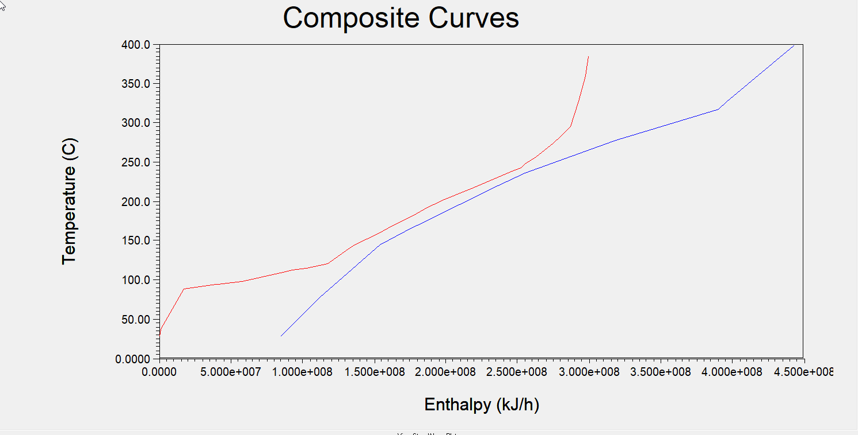

Pinch Point

Figure ‑ :Composite curve for base case.

From the pinch analysis conducted for the base case using Aspen Energy Analyzer, the pinch point was identified at an enthalpy of 2.525 × 10⁸ kJ. At this point, the corresponding temperature on the cold composite curve is 230°C, while the temperature on the hot composite curve is 245°C. The minimum temperature difference ()at the pinch point can be calculated by taking the difference between the hot and cold streams. This value of represents the minimum allowable temperature difference for heat exchange at the pinch point, ensuring efficient heat recovery without violating thermodynamic constraints. The identification of this pinch point serves as the basis for exploring energy saving opportunities by reconfiguring heat exchangers and optimizing process streams.

#### Scenario A: Base case

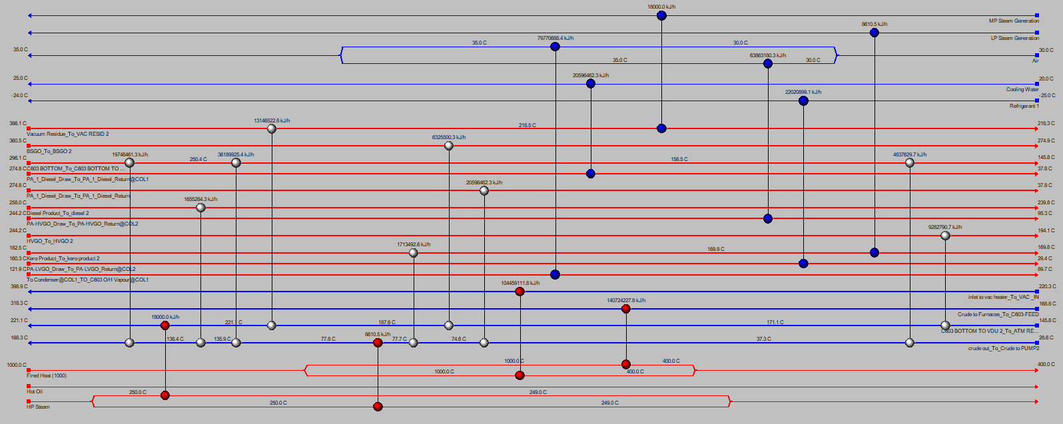

Figure ‑: HEN for Scenario A.

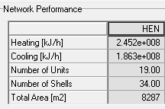Figure 3-2 above demonstrates the heat exchanger network (HEN) for the base case which demonstrates the configuration of the heat exchangers and the connections between the hot streams and cold streams for each heat exchanger including cold and hot utility. Figure. 3-3 below shows the pinch lines between the process streams and utilities. Table. 3-1 highlights the key values for the base case. And Table 3-2 shows the costs of the base case.

Table ‑: Performance summary table for Scenario A.

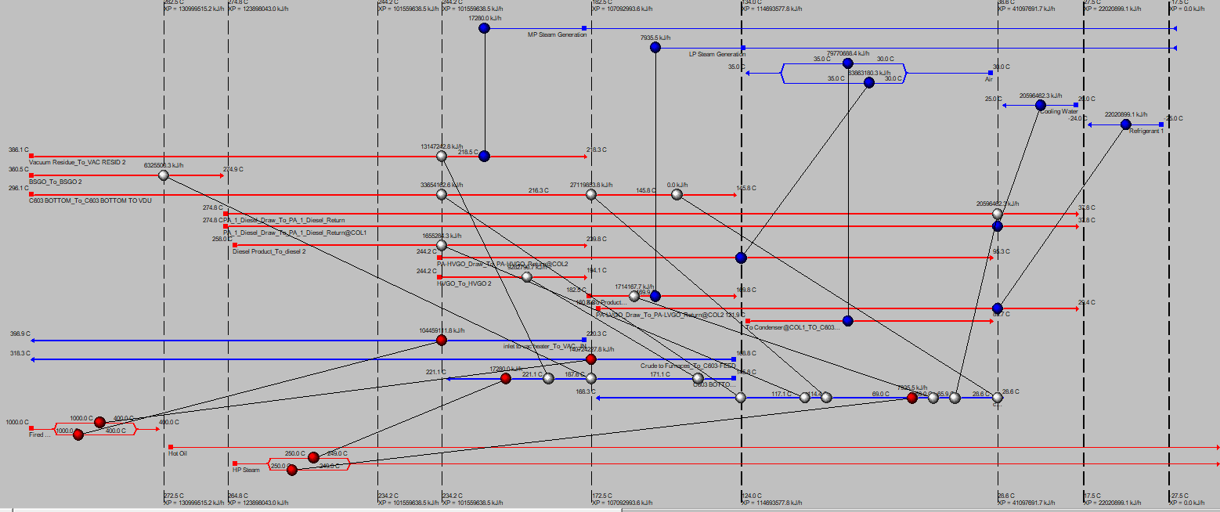

Figure ‑: Pinch lines in HEN for base case.

Table ‑: Capital and operational costs for Scenario A.

|  |  |
| --- | --- |
| Operating Cost | 0.3074 Cost/s |
| Capital Cost | **10378893 Cost** |
| Total Cost | **0.3942 Cost/s** |

#### Scenario B: Base case optimized

Figure ‑: HEN for Scenario B.

The base case is optimized by using the optimization tool in AEA to obtain the heat exchanger network shown in Figure. 3-4 above. The pinch lines for the HEN are shown in Figure. 3-5 below.

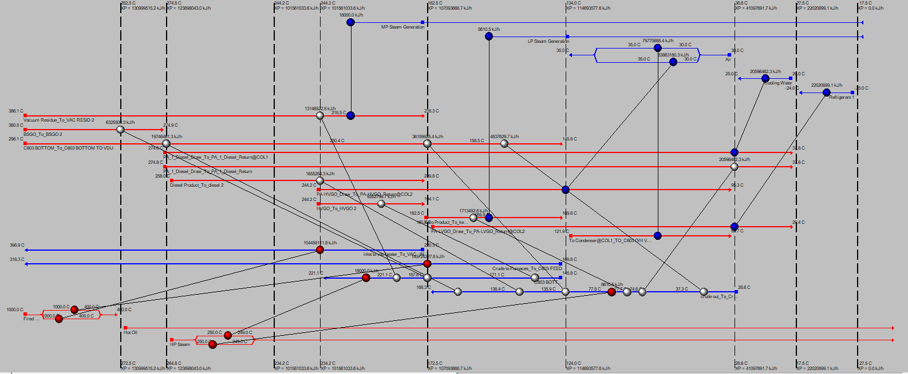

Figure ‑: Pinch lines in HEN for Scenario B.

Table ‑: Performance summary table for Scenario B.

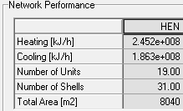

Table. 3-3 above shows the main findings for the optimized case.

Table ‑: Capital and operational costs for Scenario B.

|  |  |
| --- | --- |
| Operating Cost | 0.3074 Cost/s |
| Capital Cost | **10287303 Cost** |
| Total Cost | **0.3935 Cost/s** |

Table. 3-4 above shows the capital and operational for the optimized case.

#### Scenario C: Alternative 4 Using Automatic Design Tool

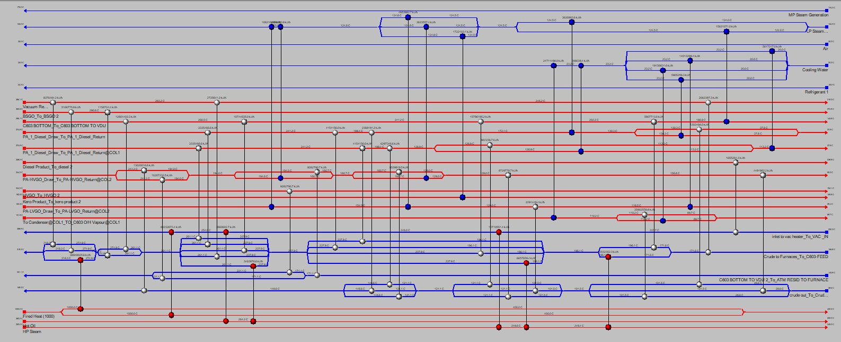

Figure ‑: HEN for alternative scenario 4.

To explore better alternatives beyond the base case and the base case optimized, the Automatic Design Tool (Recommended Designs) in Aspen Energy Analyzer was utilized. This tool generated a new configuration for heat integration.

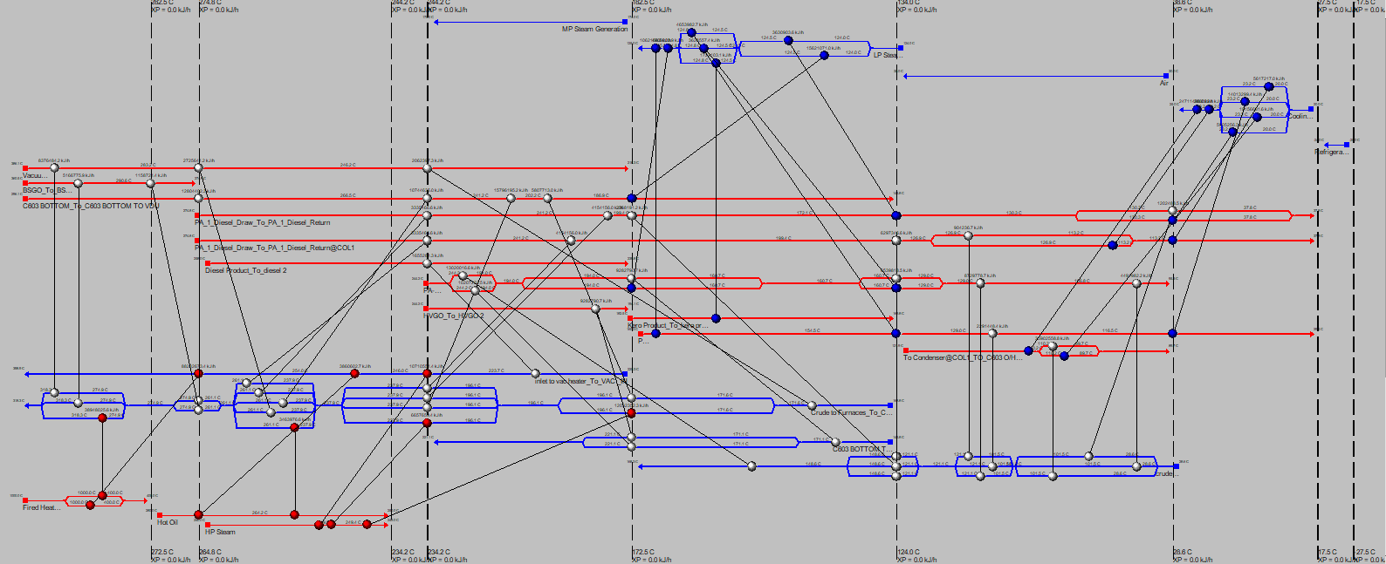This design reduces the total heat load near the pinch by redistributing heat duties more efficiently among streams and heat exchangers. The tool likely minimized overlapping heat requirements and adjusted the stream matches to lower the total energy demand near the pinch point. Consequently, while the pinch temperatures stayed the same due to unchanged , the improved energy recovery upstream and downstream resulted in less enthalpy accumulation at the pinch. This reflects better overall energy utilization and reduced dependency on external utilities.

Figure ‑: Pinch lines at HEN for scenario C.

Table ‑: Performance summary table for Scenario C.

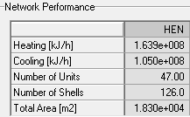

Table. 3-3 above shows the main findings for scenario C.

Table ‑: Capital and operational costs for Scenario C.

|  |  |
| --- | --- |
| Operating Cost | 0.1632 Cost/s |
| Capital Cost | **10416190 Cost** |
| Total Cost | **0.2503 Cost/s** |

Table. 3-4 above shows the capital and operational for scenario C.

### Results Of Pinch Analysis

The results of the pinch analysis highlight significant differences in energy efficiency and costs across the evaluated cases.

In addition, the total area for scenario A, B, and Care **8287 m2**, **8040 m2, and 1.83x104** **m2** respectively. This discrepancy can be attributed to the more complex heat exchanger network design in Scenario C, where additional exchangers or larger units were incorporated to improve heat recovery and optimize the stream matches.

Furthermore, the **capital cost** for scenarios with a higher total area is typically expected to be higher due to the increased number of heat exchangers and equipment. This aligns with the findings, where the total cost was calculated as **10378893 Cost** for scenario A and **10287303 Cost** for scenario B, compared to a higher cost of **10416190 Cost** for Scenario C. The bigger area and increased number of units in scenario C resulted in an improved heat and energy integration system reflected in the significant decrease in the operating cost that led to a much lower total cost of 0.2503 Cost/s, and 0.3942 Cost/s in Scenario A, and 0.3942 Cost/s in Scenario B. This demonstrates that, despite the higher total area and capital cost in Scenario C, the improved efficiency in heat recovery and optimized energy and heat load distribution resulted in reduced overall costs, making Scenario C the most economical and energy-efficient option.

Scenario C is the most favorable alternative for energy integration, offering superior heat recovery, significantly reduced operating costs while maintaining a close capital cost value. Additionally, despite its higher total heat exchanger area **1.830 × 10⁴ m2,** Scenario C's total cost is significantly lower than the other scenarios. This indicates efficient use of the area to achieve better heat integration which makes scenario C the most economical and sustainable solution, balancing infrastructure investment with long-term operational savings.

The similarity in the results between scenarios A and B which are the base case, and the optimized case indicates the high quality and accuracy of simulation for the given heat exchangers configuration in the base case leaving little room for improvements in the optimized case. Table. 3-7 below show the key findings of the pinch analysis.

Table ‑: Main results of all the scenarios.

|  |  |  |  |
| --- | --- | --- | --- |
| Scenario  Parameter | A | B | C |
| Heating and Cooling (kJ/h) | **4.315e8** | **4.315e8** | **2.689e8** |
| Area (m2) | **8,287** | **8,040** | **18,300** |
| Total Cost (Cost/s) | **0.3942** | **0.3935** | **0.2503** |

## CONSTRAINS AND CONSIDERATIONS

### Constrains

One of the main constraints in the project was the limited availability of data for the vacuum distillation unit (VDU), which necessitated several assumptions to complete the simulations. Key missing information included the conditions for utilities, such as temperature and pressure, leading to estimated values based on typical industry standards. Additionally, the assumption of zero sulfur content in the crude oil was made to simplify the process. These assumptions, while necessary due to insufficient data, may have introduced slight deviations in the simulation results.

### Process Safety and Health Considerations

Safety and health considerations were central to the proposed retrofit design for the crude distillation unit (CDU) and vacuum distillation unit (VDU). The inclusion of improved heat integration measures, such as preheating using product streams, reduces the risk of overheating in the fired heater and minimizes equipment failure. Stripping steam injection was carefully optimized to prevent pressure build-up while maintaining separation efficiency. Additionally, the fired heater's operational parameters were reviewed to ensure compliance with safety regulations, reducing exposure to high-temperature surfaces and preventing fuel gas leaks.

### Environmental Considerations

The proposed design minimizes the environmental footprint by implementing energy-efficient measures in the crude distillation unit (CDU) and vacuum distillation unit (VDU). Additionally, the integration of hot product streams, such as kerosene and diesel, to preheat the crude feed reduces the need for external heating utilities, further lowering the overall energy consumption and associated indirect emissions. The design also optimizes the use of stripping steam to reduce waste generation and flaring in the VDU, ensuring compliance with environmental regulations and supporting sustainable refinery operations.

### Economic Considerations

The Aspen Energy Analyzer was used to evaluate the economic feasibility of the heat integration improvements in the CDU and VDU. The project demonstrated significant economic benefits through energy optimization, achieving a **47.12%** reduction in total utility consumption. Heating utilities were reduced by **41.45%**, while cooling utilities saw a **54.57%** savings. These energy savings not only lower operational costs but also reduce carbon emissions by **25.04 Mlb/hr**, contributing to a more cost-effective and environmentally sustainable process.

### Design Sustainability

The long-term sustainability of the retrofit design was addressed by enhancing the heat integration system and optimizing energy usage in the crude distillation unit (CDU) and vacuum distillation unit (VDU). For example, the use of kerosene, diesel, and atmospheric residue streams to preheat the crude feed reduces reliance on external utilities, extending the operational life of the fired heater by minimizing thermal stress. In the VDU, the addition of pump-around systems not only enhances separation efficiency but also lowers energy requirements, supporting a more sustainable operation. Stripping steam rates were carefully adjusted to optimize hydrocarbon recovery while maintaining flexibility for varying feedstock compositions and regulatory compliance. By leveraging these enhancements, the retrofitted CDU and VDU can maintain high performance and adapt to evolving operational demands over time.

# CHAPTER 4: FIRED HEATER DESGN and Hazop Analysis

## Fired Heater Description

A fired heater is an industrial device used in heating a variety of fluids, and most of the time, it is related to oil refineries. Its main purpose is to transfer heat to a fluid, normally a hydrocarbon-based substance, through the burning of fuel.

The combustion is conducted inside the fired heater through a combustion chamber to products of hot gasses. These resultant hot gasses are passed through circulating coiled or straight tubes, accommodating the fluid to be heated. The fluid to be heated is passed around and through these tubes or coils internally, which absorbs heat into the fluid from combustion gases and thus raises the temperature.

Moreover, fired heaters employ all three modes of heat transfer: conduction, convection, and radiation. Fired heaters have radiation in the radiant section, where heat energy directly emanates from the flames to the tubes exposed to them. In this manner, most of the heat is absorbed by the process fluid inside these tubes. The radiant section is designed in such a way that it maximizes the absorption while not overheating the tubes.

Convection, however, occurs in the convection section of the fired heater. In this, the flue gases that are exiting the radiant section circulate over the process tubes to transfer heat. This will pre-heat the fluid before entering the radiant section and increase energy efficiency, reducing thermal load in the radiant section. Optimum design of the convection section allows for maximum heat recovery, which reduces the overall operating costs.

Conduction is where the heat from the tubes' walls passes to the fluid inside the tubes. This direct heat transfer assures that energy absorbed in both the radiant and convection sections is put to effective use in the heating of the process fluid. In all, these modes of heat transfer combine to enable fired heaters to perform at high thermal efficiency ratings suitable for deployment in demanding industrial processes [12].

Temperatures inside fired heaters can get as high as 2,200° F. Heater and coil combinations vary by application, but cabin/box and cylindrical style are the main types of heaters. The main difference is the orientation of tubes in the radiant section as illustrated in Fig. 4-1. In a vertical cylindrical heater, the tubes are arranged vertically while a cabin heater's tubes are usually horizontal.

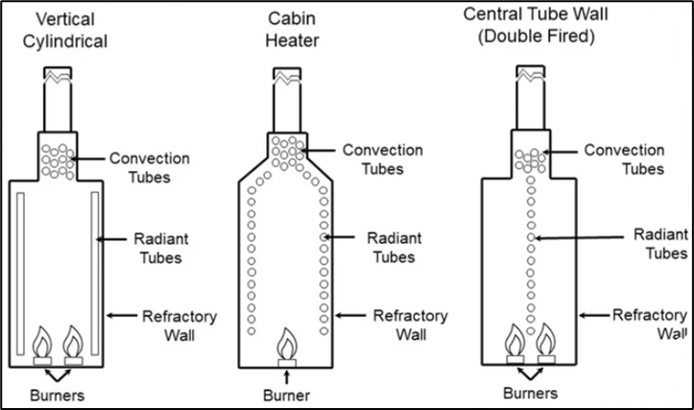

Figure ‑:Heaters with different tubes orientation [13].

Additionally, fired heaters have quite a wide range of applications within refineries. Of all the applications, refining crude oil is the most important one. Crude oil consists of various hydrocarbons, and some of them must be heated up to certain temperatures for different types of refining processes. Fired heaters facilitate these changes in temperature, enabling the separation, conversion, and treatment of various components in crude oil. Fired heaters are also part of distillation, cracking, and reforming processes, which all have to do with the need for precision in temperature regulation in order to produce such refined products as gasoline, diesel, and many other kinds of petrochemicals efficiently [13].

### Vacuum Fired Heater

Vacuum heaters are a special type of fired heaters and are usually cabin, box, or vertical cylindrical type design with firing on one side of the heater tube. Non-reactive box vacuum-fired heaters are used mainly in processes needing heat under vacuum conditions such as vacuum distillation.

Operating under reduced pressure, unlike standard fired heaters at atmospheric pressures, reduces the boiling points of fluids and hence allows for efficient heat transfer at lower temperatures. Therefore, they may be considered ideal in certain refining processes, such as vacuum distillation, in which sensitive products like kerosene, diesel, and other fractions need to be separated without risk of thermal cracking or degradation [14].

## Process Conditions and Streams

The designed non-reactive fired heater system is used to preheat the feed stream before it enters the downstream vacuum distillation column. The heater raises the temperature of the feed to ensure optimal conditions for the vacuum distillation process. The inlet and outlet conditions for the feed stream, as well as the air and fuel streams, are summarized in Table 4-1, which includes temperature, pressure, and flow rate data for each stream. The system also facilitates a significant phase change in the feed stream, with the vapor fraction increasing from 0.4657 at the inlet to 0.9288 at the outlet, indicating partial vaporization within the fired heater. This ensures efficient heat transfer and prepares the stream for the subsequent separation process.

Table ‑: Process Conditions and Streams

|  |  |  |  |
| --- | --- | --- | --- |
| *Streams* | *Temperature (oF)* | *Pressure (psia)* | *Flow Rate (lb/h)* |
| *Inlet* | **427.6402** | **23** | **350,197.6879** |
| *Outlet* | **750** | **3.481** | **350,197.6879** |
| *Air* | **89** | **14.5** | **101511** |
| *Fuel* | **420** | **29.1** | **5367** |

## Duty and Utility Requirements

To calculate the heat duty (Q) for the fired heater system, the specific heat equation was used, which is expressed as:

*m* is the mass flow rate of the fluid, *Cp* is the specific heat capacity, and is the temperature difference between the inlet and outlet streams. Using this equation, the heat duty required to raise the temperature of the fluid from 427.6402°F to 750°F was calculated to be approximately 9.4E+7 BTU/h using a heat capacity value of 0.6228 BTU/lb oF for inlet stream and 0.7121 BTU/lb oF for the outlet stream. Aspen EDR determined the fired heater duty to be 10.2E+7 BTU/h as seen in Table. 4-2 below, this discrepancy is expected since the calculated value by equation does not include all heat loses, assumes a constant CP, and it ignores phase change effects, thus the hysys value is expected to be higher. The value of heat duty represents the total heat energy that needs to be supplied to the fluid for the preheating process before entering the vacuum distillation column. In addition, for the fuel and air requirements, Aspen Hysys is employed to model and calculate the necessary quantities of fuel and air to achieve the required heat duty. The solver in Aspen Hysys determines the fuel consumption, with a value of 5367 lb/h and the air requirement for combustion, with a value of **101511** lb/h. These parameters are essential for determining the optimal operation conditions of the fired heater, ensuring both energy efficiency and compliance with combustion requirements. The air-to-fuel ratio is particularly important as it directly impacts the efficiency of the combustion process and the formation of flue gases. The fuel requirement determines the amount of energy that needs to be supplied by the fuel to meet the heat duty. Similarly, the air requirement ensures that there is enough oxygen to combust the fuel completely, avoiding any issues related to incomplete combustion or excess air that could reduce efficiency. Calculations are attached to Appendix E.

## Mechanical Design

### Sizing Procedure

To size a fired heater that is suitable for the vacuum unit in the proposed process, a trial-and-error procedure was used with the aid of Aspen EDR and Aspen Hysys software. First the process streams were imported from the simulated process in Aspen hysys into the EDR software which. Second, after ensuring that all the conditions are specified, the fired heater type was chosen to be a twin box and a refractory backed layout which is suitable for vacuum operations and recommended for the proposed process based on literature. Third, the dimensions for the fired heater were chosen from similar processes from the literature, and the main reference for the chosen dimensions was the solved example of a vacuum fired heater in aspen EDR. Lastly, the dimensions were changed according to the warnings shown in aspen EDR until all warnings are gone and the results are converged. A summary of the mechanical design obtained from Aspen EDR is attached to Appendix E.

### Material Selection

The choice of the material of construction (MOC) of the equipment is a crucial step in any design process to ensure safe and smooth operations to reach the desired specifications. The conditions and the type of the process are the main considerations in this decision. Where for the proposed process, high temperatures and low pressures (Vacuum distillation), it is desired to choose a material that can withstand these conditions and deliver a satisfactory performance. In vacuum unit where the fired heater is designed, the process temperature is in the range of 400-750 °F and pressures below 23 psi entering the furnace and below 4.5 psi leaving the furnace. Furthermore, cost is a key factor in this decision.

For the aforementioned reasons, 5Cr-0.5Mo Steel or ASTM A387 grade 5 steel alloy is chosen as the material of construction for the tubes in the fired heater. This steel alloy mainly is a chromium and molybdenum alloy, it can withstand extremely high temperatures up to 1200°F which is well above the process temperature making it an excellent choice from this viewpoint [15]. This material has a range of 230 to 350 MPa of the yield strength which is considered a good value to provide strength and to withstand the operational stresses and remain in the elastic region [16]. A summary of the mechanical properties of this material is attached to Appendix E. Cost wise, the material is considered a bit high compared to other steel alloys, however comparing it to the other possible materials for this high temperature process such as titanium, and considering the performance it delivers, the price of the material is considered reasonable.

As for the convection section carbon steel is chosen alongside 5Cr-0.5Mo Steel. Carbon steel provides a good option for moderate temperatures being a cost-effective option.

### Firebox and Radiant Zone of the Fired Heater

The fired heater under analysis is designed with a twin-box firebox configuration and incorporates a radiant zone optimized for efficient heat transfer and environmental compliance. The following report evaluates the key design parameters based on provided data, supported by insights from relevant literature.

### Firebox Dimensions

The firebox has dimensions of 17,000 mm (17 m) in height, 18,000 mm (18 m) in length, and 8,000 mm (8 m) in width. These dimensions provide a large radiant surface area for heat transfer, ensuring sufficient residence time for complete combustion. The twin-box configuration implies two radiant sections operating in parallel, which enhances thermal efficiency and allows for better heat distribution.

In comparison with Literature [17], Fireboxes of this size are consistent with high-capacity industrial heaters used for processes such as crude oil heating or reformer gas pre-heating. The substantial height of 17 m allows for long flame paths, which are essential for maximizing radiant heat transfer. According to standard industrial designs, large fireboxes ensure adequate space for burners while minimizing flame impingement on tubes. Which means that the design of the fired heater in relation to data from industry aligns with established practices and standards.

### Burner Configuration

The heater employs 20 burners, each with a diameter of 100 mm, located at the bottom of the firebox. These are natural draught, low NOx burners (API specification), designed to minimize nitrogen oxide emissions through staged combustion or reduced peak flame temperatures. The burners are strategically positioned to direct flames upward, optimizing heat distribution in the radiant zone. Bottom-fired configurations with low NOx burners ensure uniform heating, comply with environmental standards, and rely on precise flue gas system design for efficient natural draft operation [18].

### Radiant Zone Heat Transfer

The radiant zone consists of main and roof tubes made from 5Cr-0.5Mo steel, a material chosen for its excellent creep resistance and thermal conductivity at high temperatures and is widely used in radiant zones for its ability to withstand high temperatures and pressures. The tubes are configured as follows:

* Tube diameters range from [113.16 mm to 270.32 mm].
* Wall thicknesses vary from [8.56 mm to 15.09 mm].
* Tube spacing ranges between 124.48 mm and 298 mm.

The arrangement ensures maximum heat absorption while accommodating thermal expansion and preventing overheating. The refractory-backed layout further enhances insulation, reducing heat loss and protecting the steel shell from thermal damage.

### Flue Gas Takeoff System

The flue gas offtake system includes the following parameters: A Width of 1,600 mm, Length of 18,000 mm and Total Exit area of 28.8 m². This large total exit area ensures efficient removal of flue gases, reducing pressure drop and preventing backflow. The design minimizes erosion risks and supports downstream heat recovery systems. An exit area of 28.8 m² is significant for high-capacity fired heaters, ensuring low flue gas velocities to enhance efficiency and minimize component wear, compared to smaller heaters with 10–15 m² exit areas [19].

### Thermal Insulation and Stability Systems

The firebox is equipped with refractory backing, which enhances thermal efficiency by minimizing heat loss and protecting the structural components. Additionally, the twin-box configuration divides the firebox into multiple cells, ensuring operational flexibility and a uniform heat flux distribution. Multi-cell fireboxes are commonly used in industrial scale fired heaters to optimize heat transfer and maintain operational stability [20]. Refractory-backed designs are crucial for reducing energy losses and extending the heater's lifespan [21]. This combination of features allows for more efficient and reliable furnace operation.

The firebox design, with its large dimensions, twin-box configuration, and refractory-backed layout, demonstrates a robust and efficient approach to industrial heating. The inclusion of low NOx burners and a high-capacity flue gas offtake system ensures compliance with environmental regulations while maintaining operational efficiency. Compared to standard industrial designs, the heater’s parameters align well with best practices for high-capacity applications, highlighting its suitability for demanding refining and petrochemical processes.

### Convection Zone/Banks of the Fired Heater

The convection zone of a fired heater plays a critical role in recovering heat from flue gases after they leave the radiant section. This zone employs various heat transfer enhancements, such as finned tubes, to maximize efficiency and preheat process streams before further processing. The EDR data provided offers valuable insight into the design and configuration of the convection section, which is analyzed below in detail.

### Tube Arrangement and Flow Configuration

The convection zone consists of three banks of horizontally oriented tubes, each 17,400 mm long. Flue gases flow upward through the convection zone, transferring heat to the process streams flowing inside the tubes. The process flow is countercurrent, where the fluid in the tubes flows in the opposite direction to the flue gases, it is widely recommended for maximizing the temperature gradient and heat transfer efficiency. This design maximizes the temperature gradient across the tubes, enhancing the heat transfer rate.   
The horizontal tube arrangement ensures an even distribution of flue gas across the tube banks and simplifies maintenance procedures [22]. This configuration is consistent with best practices for convection zones, as noted in fired heater literature, where maximizing heat recovery and minimizing fouling are key design objectives.

### Tube Material and Surface Enhancements

The tubes in the convection zone are differentiated based on their surface characteristics and materials to optimize performance. Bank 1 (Tube 1) consists of plain tubes made from 5Cr-0.5Mo steel, which is ideal for handling high-temperature atmospheric residue due to its excellent creep strength and oxidation resistance [23]. Banks 2 and 3 (Tubes 2 and 3) feature solid finned tubes made of carbon steel, specifically designed to enhance the heat transfer surface area and enhance heat recovery, particularly in the lower-temperature regions of the flue gas flow [24]. These variations ensure that each bank of tubes performs optimally under different operating conditions. The tubes have a nominal bore of 4 inches, an outside diameter of 114.3 mm, and a wall thickness of approximately 6 mm (Schedule 40). These dimensions provide a balance between mechanical strength and heat transfer efficiency, ensuring durability under high-pressure and high-temperature conditions.

### Fins Design and Heat Transfer Enhancement

The finned tubes in Banks 2 and 3 are equipped with solid fins of 19 mm height and 1.3 mm thickness, with a fin density of 197 fins per meter. These fins are made of carbon steel, a cost-effective choice for convection zones where temperatures are moderate. The high fin density significantly increases the heat transfer surface area [25], compensating for the reduced temperature gradient in the lower-temperature regions of the convection zone.  
The use of fins aligns with standard industry practices, as fins are critical in convection zones where heat transfer primarily occurs through convection rather than radiation. The dimensions and frequency of the fins indicate an emphasis on maximizing energy recovery while ensuring efficient gas flow and minimizing pressure drop.

### Process Streams and Heat Recovery

Each bank in the convection zone is assigned a specific process stream to optimize heat recovery:  
• Bank 1: Preheats atmospheric residue entering the firebox. The plain tubes in this bank are designed for higher temperatures and fouling tendencies.  
• Bank 2: Further heats atmospheric residue using finned tubes to improve heat transfer.  
• Bank 3: Transfers residual heat from the flue gases to steam, a common practice to recover low-grade energy for downstream utility applications.  
This arrangement reflects an efficient heat recovery strategy, where high-temperature flue gases are used to preheat process fluids and generate steam, maximizing the heater’s thermal efficiency.

### Flue Gas Flow Characteristics

Flue gases flow upward through the convection zone, maintaining effective heat transfer and minimizing fouling by taking advantage of natural draft or forced draft designs. The duct dimensions 1739.9 mm in width and 17,400 mm in length ensure adequate residence time for heat transfer while maintaining a low-pressure drop. This balance is crucial for operational efficiency, as excessive pressure drop increases energy consumption in draft fans.

### Convection Bank Bundle Details

The convection bank design presented in the data includes several key parameters that directly influence heat transfer efficiency. The tube pitch is specified as 30 equilaterals, which optimizes flow distribution and minimizes stagnant fluid zones. The transverse pitch is 203.2 mm, ensuring adequate spacing between tubes to prevent flow obstruction, thus promoting better fluid movement and heat transfer. The longitudinal pitch is 175.98 mm, which increases the surface area for heat exchange but can lead to a higher pressure drop due to the tighter flow paths. The number of tubes and rows varies across the different banks: Bank 1 has 2 rows and 16 tubes, Bank 2 has 4 rows and 32 tubes, Bank 3 has 2 rows and 18 tubes, and Bank 4 follows a similar principle, but its configuration is not specified. These configurations are designed to increase the surface area for heat transfer, although more tubes and rows also result in a higher pressure drop. Additionally, the number of parallel paths per row influences flow uniformity and heat distribution, with more paths leading to more even flow and better heat transfer. These design choices together aim to balance heat transfer efficiency with pressure drop considerations.  
  
The convection zone design in the EDR data reflects an optimized approach to heat recovery, utilizing plain and finned tubes, a countercurrent flow configuration, and suitable material selection for efficient thermal performance and durability. It aligns with industry standards and demonstrates a solid understanding of heat transfer principles. While future optimizations, like advanced fin geometries or corrosion-resistant coatings, could enhance performance, the current design is robust, balancing efficiency, reliability, and cost effectively.

## Design Results

The design converged with satisfactory values and a relatively high efficiency as seen in Table 4-2 below. 87.68 is considered at the high end of the typical efficiency range for fired heaters indicating the excellent performance of the fired heater.

Table ‑: Recap of Design from EDR.

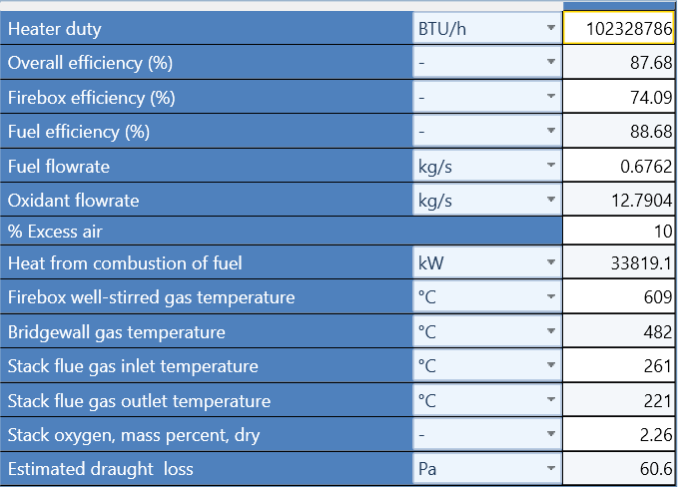

## Cost Estimations

The cost estimation for the fired heater system was performed using a series of equations tailored to model the specific parameters of the system. The base module cost (*CBM*) is calculated using Eq. (2)

where *Cp0* is the cost factor, and *FBM, Fp,* and *FT* are adjustment factors that account for the equipment, pressure, and temperature conditions, respectively. The values for these factors are determined based on system specific data. To calculate *Cp0*, which represents the base cost factor for the system, a logarithmic equation was employed represented in Eq. (3)

where *A* is the capacity or duty of the fired heater in kilowatts. *k1*, *k2*, and *k3* are constants. To determine the *FBM* factor, appropriate identification number for the is referred to with the corresponding graph to extract the necessary value. The *Fp* factor, which adjusts the cost based on the pressure, is calculated using Eq. (4)

where *P* represents the pressure in bar gauge. *C1*, *C2*, and *C3* are constants. Additionally, cost indexes for the years 2001 and 2024 are used to adjust the base cost for inflation, with the indexes being 169.3 for 2001 and 323.367 for 2024, according to Fred cost index for refinery machinery [26]. All constants are retrieved from the appendices found in *Analysis, Synthesis, and Design of Chemical Processes* (5th ed.) " [27].

After applying these equations, the *CBM* value was determined to be $7,244,005.11 as shown in Appendix E. This value reflects the estimated cost of the fired heater system, including both the purchase and installation costs. The calculated *CBM* indicates a significant investment, which is typical for complex process equipment like fired heaters, considering the size and capacity required for the system. This value will be essential for further economic evaluations, such as determining the return on investment and payback period for the project.

## Hazop Analysis

Fired heaters are obliged to work in extremely adverse conditions because fuels are combusted to produce the amount of energy needed to heat up process fluids. The combustion chamber is at very high temperatures, which poses great risk to equipment and personnel. Associated hazards with such high-temperature processes include deflagration and explosion, which have been recorded to cause severe equipment damage and injury to workers. Such failures in fired heaters can have really catastrophic results, therefore it is very important to have a comprehensive safety analysis throughout the design and operation of such units.

Safety analysis tools, like HAZOP, have been fundamental in the identification of potential hazards within the fired heater system. Systematic reviews undertaken by designers can identify risk and implement solutions to reduce dangerous events. These analyses set up protective systems and safety protocols that ensure the heater operates reliably and safely to prevent accidents before they happen. Table. 4-3 provides the possible scenarios that would lead to hazardous events along with the recommended actions to take in order to ensure smooth, safe operation.

Table ‑:HAZOP Analysis for fired heater.

|  |  |  |  |  |
| --- | --- | --- | --- | --- |
| **Word** | **Deviation** | **Possible Cause** | **Consequences** | **Actions** |
| More | Excessive fuel supply | Fuel valve malfunction or control system failure | Risk of overheating causing structural damage to the tubes and increasing coke formation, potentially leading to unsafe operating conditions | Adjust control system to handle increased fuel flow, enhance cooling efficiency |
| More | High temperature at the outlet | Inefficient heat exchange, flame impingement on tubes | Risk of tube failure, excessive coke formation and damage to downstream equipment | Optimize heat exchange efficiency |
| None | Startup failure | Bypassing purge sequence or improper burner ignition process | Accumulation of unburned fuel, explosion risk during ignition | Implement automated burner management system |
| No | Process fluid not flowing | Blocked process tubes due to fouling | Risk of rupture and potential fire hazard | Perform regular cleaning, monitor flow rates and tube temperatures |
| More | Overheating in the radiant section | Misaligned burners causing localized hotspots | Accelerated tube wear, increased risk of tube failure and product degradation | Inspect burner alignment and adjust to distribute heat evenly |
| More | More heat losses from the system | Damaged refractory or improper insulation | Higher fuel consumption increasing operational costs | Inspect and repair refractory linings |
| No | No combustion reaction | Incorrect air to fuel ratio or sudden fluctuation in fuel supply | Shutting down of heater or incomplete heating | Install flame detection systems and ensure proper burner tuning |
| Reverse | Back flow of flue gases | Pressure imbalance or stack blockage | Corrosion and potential system failure | Monitor pressure differences and ensure stack and exhaust paths are clear |
| Less | Less pressure drop across the heater | Fouling in the convection section | Reduced heat transfer efficiency, higher fuel consumption | Schedule regular cleaning, inspect fluid disruption and flow pattern |

# CHAPTER 5: CONCLUSION AND FUTURE WORKS

In conclusion, this project successfully simulated the crude distillation and vacuum distillation units (CDU and VDU) using Aspen HYSYS, providing valuable insights into process efficiency and product properties despite data limitations. Initially, an overview of a refinery was conducted, including EP1 and EP2 calculations, where EP1 was found to be $4.52 x 109 and EP2 was found to be $3,237,448,405 over 25 years. The CDU simulation accurately predicted product flow rates, including 343 BPH of whole straight-run naphtha, 418 BPH of kerosene, and 245 BPH of diesel, with minimal errors for most products. However, significant deviations, such as an 83.8% error in the overhead product flow rate, highlighted the impact of limited input data. Similarly, the VDU simulation showed deviations in key parameters, such as a 41°C difference in LVGO distillation temperature (319°C vs. 360°C), caused by assumed draw rates, feed conditions, and utility parameters or may be due to differences between the simplified simulation and real-world operations at BAPCO, where recycle streams from other units are utilized to preheat and optimize processes, while our simulation only considered the CDU and VDU systems. Also, energy integration analysis demonstrated a substantial energy saving of 47.12%, reflecting effective heat recovery strategies. However, assumptions like zero sulfur content in the crude oil and standard utility conditions for temperature and pressure, necessitated by insufficient data, may have introduced deviations in product quality and process performance. Overall, the project underscores the capability of process simulation tools to model and optimize refining operations even in the face of data constraints. Furthermore, pinch analysis was conducted using the Aspen Energy Analyzer. Various scenarios were generated, and Scenario C was selected as the optimal choice. This scenario demonstrated significant cost improvements, with a cost of 0.2503 cost/s, and energy savings compared to the base case and optimized base case which had a cost of 0.3942 cost/s, and 0.3935 cost/s respectively. In addition, a twin box vacuum fired heater was successfully designed with the aid of Aspen EDR, which yielded a high efficiency of 87.48% with a capital cost equivalent to $7,244,005.11.

For future work, implementing a fired heater instead of a simplified model will make the simulation more realistic and reflective of industrial operations. To further improve efficiency and reduce environmental impact, integrating carbon capture technologies into the process can be explored. These technologies could be used to capture CO2 emissions from the flue gas of the fired heater, aligning the process with sustainable and environment-friendly goals. Additionally, collecting more comprehensive data for the VDU and utilities, such as accurate feed compositions and utility conditions, will enhance simulation accuracy. Further optimization studies could also investigate advanced heat recovery configurations, alternative energy-saving techniques, and the integration of renewable energy sources to achieve a more efficient and sustainable refining process.

# REFERENCES

1. Bahrain Petroleum Company (Bapco) (January 2024) DMC 4A .C.D.U Process Training Manual.
2. Mrayed, S., Bin Shams, M., Al-Khayyat, M., & Alnoaimi, N. (2021). Application of pinch analysis to improve the heat integration efficiency in a crude distillation unit. *Cleaner Engineering and Technology*.
3. Marton, S., Svensson, E., Subiaco, R., Bengtsson, F., & Harvey, S. (2017). A Steam Utility Network Model for the Evaluation of Heat Integration Retrofits – A Case Study of an Oil Refinery. *Journal of Sustainable Development of Energy, Water and Environment Systems*, 5(4), pp. 560-578.
4. Souza Neto, J.N., Pacheco, J.G.A., Sacramento, L.A., Kalid, R.A., Magalhães, S.L.F., Queiroz, E.M., & Pessoa, F.L.P. (2005). Energy Integration - An Example in a Retrofit of a Petrochemical Plant. *2nd Mercosur Congress on Chemical Engineering, 4th Mercosur Congress on Process Systems Engineering*.
5. Gibson, W.C. & Zimola, M. (2009). Flameless Combustion Applied to Direct Fired Process Heaters for Reduction of NOx and CO2. *IFRF International Conference*, June 8-10, Boston, MA.
6. Jafari Nasr, M.R., Sahebdelfar, S., Takht Ravanchi, M., & Daftari Beshelli, M. (2011). Integration of Petrochemical and Refinery Plants as an Approach to Compete in Hydrocarbon Market. *9th Iran Petrochemical Forum*, 21-22 May, Tehran, Iran.
7. COMPASS INTERNATIONAL and McConville, J.G. (2018), CAPEX & OPEX Refinery Cost per Barrel a Day Benchmarks.
8. Gary, J.H., Handwerk, G.E. and Kaiser, M.J., 2007. *Petroleum Refining: Technology and Economics*. 5th ed. Boca Raton: CRC Press.
9. Jechura, J., 2019. *Feedstocks and Products*. [pdf] Available at: <https://people.mines.edu/jjechura/wp-content/uploads/sites/120/2019/02/CBEN409_02_Feedstocks_Products.pdf> [Accessed 18 November 2024].
10. “Introduction to pinch analysis” Available at : <https://www.cambridge.org/core/books/abs/developments-in-the-design-of-thermal-systems/introduction-to-pinch-analysis/3F082E1770108C829A38DB571AE97B63> (Accessed November 2024)
11. “Opportunities of waste heat recovery from various sources: Review of technologies and implementation/4.3. Passive air preheater” Available at: <https://www.sciencedirect.com/science/article/pii/S2405844023007971> (Accessed November 2024)
12. Barletta, T. (2004). Why vacuum unit fired heaters coke. *Digital Refining*. Available at: Digital Refining [Accessed 14 Dec. 2024].
13. XRG Technologies. (2021). What is a Fired Heater in a Refinery? For Dummies. *XRG Technologies*. Available at: XRG Technologies [Accessed 14 Dec. 2024].
14. Shires, G.L. (2011). FURNACES. *Thermopedia*. Available at: Thermopedia [Accessed 14 Dec. 2024].
15. Shijiazhuang Metalsin Pipeline Tech Co., Ltd. (2021). 5Cr-0.5Mo Alloy Steels. *Piping & Pipeline*. Available at: Piping & Pipeline [Accessed 14 Dec. 2024].
16. MakeItFrom.com. (2021). ASTM A387 Grade 5 (S50200) 5Cr-0.5Mo Steel. *MakeItFrom.com*. Available at: MakeItFrom.com [Accessed 14 Dec. 2024].
17. Tutar, M., Üstün, C.E., Campillo-Robles, J.M., Fuente, R., Cibrián, S., Arzua, I., Fernández, A., & López, G.A. (2021). Optimized CFD modelling and validation of radiation section of an industrial top-fired steam methane reforming furnace. *Computers & Chemical Engineering*, 155, 107504.
18. Ling, Z., Zeng, X., Ren, T., & Xu, H. (2015). Establishing a low-NOx and high-burnout performance in a large-scale, deep-air-staging laboratory furnace fired by a heavy-oil swirl burner. *Applied Thermal Engineering*, 79, pp. 117-123.
19. "API Standard 560: Fired Heaters for General Refinery Services," American Petroleum Institute, [latest edition].
20. Lackey, W. W. & Lince, G. S. (1995). "The Use of Multi-Cell Fireboxes in Fired Heaters." *Hydrocarbon Processing*, 74(7), 91-95.
21. **Avidan, A. A., & Farag, A. F. (2003). "Refractory Design for Fired Heaters."** Journal of the American Ceramic Society, 86(4), 672-678.
22. Askari Mahvelati, E., Forcinito, M., Fitschy, L., & Maesen, A. (2022). Tubes and flow arrangement in the convection section. *Three-Dimensional CFD Model Development and Validation for Once-Through Steam Generator (OTSG): Coupling Combustion, Heat Transfer and Steam Generation*.
23. Saucedo-Muñoz, M.L., Lopez-Hirata, V.M., Dorantes-Rosales, H.J., Villegas-Cardenas, J.D., Rivas-Lopez, D.I., Beltran-Zuñiga, M., Ferreira-Palma, C., & Moreno-Palmerin, J. (2022). Phase Transformations of 5Cr-0.5Mo-0.1C Steel after Heat Treatment and Isothermal Exposure. *Metals*, 12(8), 1378. Available at: MDPI [Accessed 14 Dec. 2024].
24. Anand Seamless Tubes. (2020). What Are Finned Tubes and Their Uses? *Anand Seamless Tubes*. Available at: Anand Seamless Tubes [Accessed 14 Dec. 2024].
25. Zaheer, M. (2021). What is the purpose of having vertical fins on a heat exchanger? *Quora*. Available at: Quora [Accessed 14 Dec. 2024].
26. U.S. Bureau of Labor Statistics. (2024). Producer Price Index by Industry: Oil and Gas Field Machinery and Equipment Manufacturing. *FRED, Federal Reserve Bank of St. Louis*. Available at: FRED [Accessed 14 Dec. 2024].
27. Turton, R., Shaeiwitz, J.A., Bhattacharyya, D., & Whiting, W.B. (2018). *Analysis, Synthesis, and Design of Chemical Processes*. 5th ed. Upper Saddle River, NJ: Prentice Hall.

# APPENDICES

## Appendix A: Process Simulation

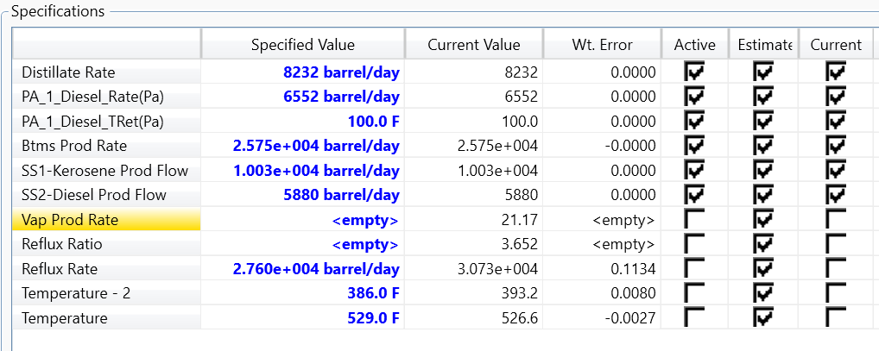

Figure ‑: Main specifications for the ATM column in Aspen Hysys.

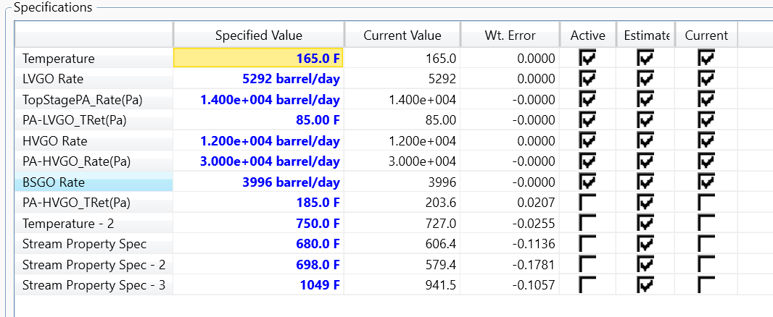

Figure ‑: Main specifications for the vacuum column in Aspen Hysys.

Figure ‑: Vacuum column side draw summary.

Figure ‑: Mass balance from Aspen Hysys.

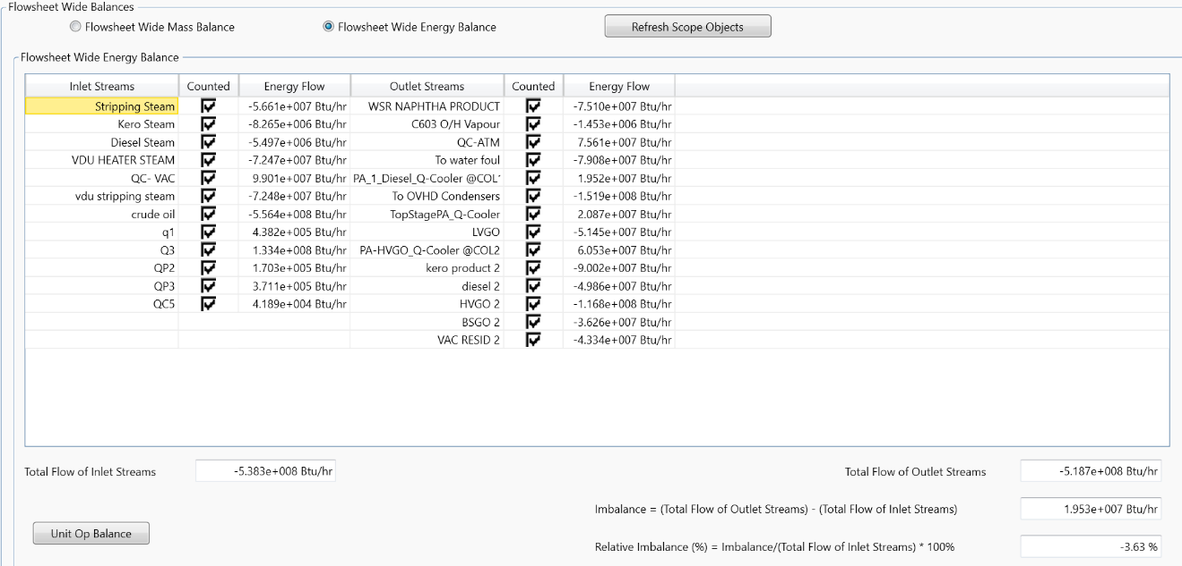

Figure ‑:Energy balance from Aspen Hysys.

Table ‑: Atmospheric column products flow rates

|  |  |  |  |
| --- | --- | --- | --- |
| Flow rates  Products | BAPCO Data | Aspen Hysys | Error (%) |
| Overhead | 8.212 Mlb/hr | 1.335 Mlb/hr | 83.80 |
| WSR Naphtha | 343 BPH | 343 BPH | 0 |
| Kerosene | 418 BPH | 418 BPH | 0 |
| Diesel | 245 BPH | 245 BPH | 0 |
| Bottom products | 1073 BPH | 1073 BPH | 0 |

Table ‑: Distillation temperature of VDU products comparison.

|  |  |  |
| --- | --- | --- |
| Reference  Property | BAAPCO Data | Aspen Hysys |
| ASTM-D86 T90% FOR LVGO | 360 °C | 319°C |
| ASTM-D2887 T5% For HVGO | 370 °C | 304 °C |
| ASTM-D2887 T95% For HVGO | 565 °C | 505°C |

Table ‑:API gravities of petroleum products.

|  |  |  |
| --- | --- | --- |
| API  Product | Literature [9] | Aspen Hysys |
| Overhead of ATM col | 60-70 | 85.5 |
| WSR Naphtha | 50-60 | 77.71 |
| Kerosene | 40-50 | 51.18 |
| Diesel | 30-40 | 40.86 |
| ATM residue | 10-20 | 26.13 |
| Overhead of vacuum | 20-30 | 13.1 |
| LVGO | 20-30 | 36.57 |
| HVGO | 10-30 | 28.27 |
| BSGO | 5-10 | 18.79 |
| Vacuum Residue | 5-10 | 15.26 |

Table ‑: Flash points of petroleum products.

|  |  |  |
| --- | --- | --- |
| Flash Point (°F)  Product | Industry Standard | Aspen Hysys |
| Kerosene | 99-149 | 100.9 |
| Diesel | 126-204 | 197.3 |
| ATM residue | 200+ | 263.8 |
| LVGO | 200-300 | 235.1 |
| HVGO | 250-400 | 283.1 |
| BSGO | 300+ | 338 |
| Vacuum Residue | 300+ | 341.1 |

Table ‑:RVP of product streams.

|  |  |  |
| --- | --- | --- |
| RVP (Psi)  Product | Industry Standard | Aspen Hysys |
| WSR Naphtha | 11-12.5 | 9.377 |
| Kerosene | >1 | 0.2067 |
| Diesel | >1 | 8.94e-6 |
| ATM residue | >0.1 | 2.5e- |
| LVGO | >0.1 | 3.8e-4 |
| HVGO | >0.1 | 1.83e-5 |
| BSGO | >0.1 | 2.5e-6 |
| Vacuum Residue | >0.1 | 2.4e-6 |

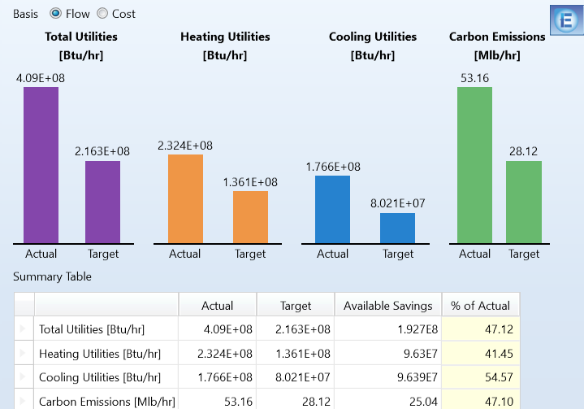

Figure ‑:: Aspen Energy Analyzer energy savings for the process.

## Appendix B: Crude Assay

**Assay data for Crude 1**

|  |  |  |
| --- | --- | --- |
| **Parameter** | **Result** | **UoM** |
| Liquid Flow Rate | 343 | MLB/HR |
| Specific Gravity @ 60/60 deg F | 0.6859 |  |
| Vapour Pressure, Reid, at 37.8 Kpa | 98.7 | Kpa |
| Sulfur | 355 | PPM |
| Density @ 15 deg C | 0.6857 | kg/litre |
| C1 Hydrocarbons, liquid Vol% | 0 | L. Vol% |
| C2 Hydrocarbons, liquid Vol% | 0 | L. Vol% |
| C3 Hydrocarbons, liquid Vol% | 1.7 | L. Vol% |
| n-C4 Hydrocarbons, liquid Vol% | 8.5 | L. Vol% |
| C5 Hydrocarbons, liquid Vol% | 15.7 | L. Vol% |
| C6 Hydrocarbons, liquid Vol% | 74.1 | L. Vol% |
| **ASTM D86 DISTILLATION (WITHOUT LIGHT ENDS)** | **vol%** |  |
| IBP deg C | 28.4 |  |
| 5% deg C | 41.05 |  |
| 10% deg C | 48.3 |  |
| 20% deg C | 58.65 |  |
| 30% deg C | 67.8 |  |
| 40% deg C | 76.4 |  |
| 50% deg C | 84.45 |  |
| 60% deg C | 92.1 |  |
| 70% deg C | 99.55 |  |
| 80% deg C | 107.35 |  |
| 90% deg C | 116.45 |  |
| 95% deg C | 123.8 |  |
| FBP deg C | 138.5 |  |

**Assay data for Crude 2**

|  |  |  |
| --- | --- | --- |
| **Parameter** | **Result** | **UoM** |
| Liquid Flow Rate | 418 | MLB/HR |
| Specific Gravity @ 60/60 deg F | 0.7884 |  |
| Flash Point, Abel, deg C | 26.5 | deg C |
| Sulfur | 0.22 | mass % |
| Density @ 15 deg C | 0.788 | kg/litre |
| **SIMDIST ASTM D2887** |  |  |
| Simulated Dist., wt%, IBP deg C | 129 | deg C |
| 1% deg C | 131 | deg C |
| 5% deg C | 148 | deg C |
| 10% deg C | 157 | deg C |
| 20% deg C | 166 | deg C |
| 30% deg C | 179 | deg C |
| 40% deg C | 188 | deg C |
| 50% deg C | 203 | deg C |
| 60% deg C | 217 | deg C |
| 70% deg C | 231 | deg C |
| 80% deg C | 249 | deg C |
| 90% deg C | 273 | deg C |
| 95% deg C | 289 | deg C |
| FBP deg C | 318 | deg C |

**Assay data for crude 3**

|  |  |  |
| --- | --- | --- |
| **Parameter** | **Result** | **UoM** |
| Liquid Flow Rate | 245 | MLB/HR |
| Flash Point, PM Closed Cup deg C | 102 | deg C |
| Acid Number, Total mg KoH/g | 0.02 | mg KoH/g |
| Specific Gravity @ 60/60 deg F | 0.8445 |  |
| Sulfur | 1.13 | mass % |
| Cloud Point | -5 | deg C |
| Cold Filter Plugging Point | -6 | deg C |
| Density @ 15 deg C | 0.8441 | kg/litre |
| **SIMIDIST ASTM D2887** |  |  |
| Simulated Dist., wt%, IBP deg C | 161 | deg C |
| 1% deg C | 178 | deg C |
| 5% deg C | 222 | deg C |
| 10% deg C | 244 | deg C |
| 20% deg C | 269 | deg C |
| 30% deg C | 285 | deg C |
| 40% deg C | 298 | deg C |
| 50% deg C | 311 | deg C |
| 60% deg C | 322 | deg C |
| 70% deg C | 333 | deg C |
| 80% deg C | 346 | deg C |
| 90% deg C | 363 | deg C |
| 95% deg C | 376 | deg C |
| FBP deg C | 404 | deg C |

**Assay data for crude 4**

|  |  |  |
| --- | --- | --- |
| **Parameter** | **Result** | **UoM** |
| Liquid Flow Rate | 1073 | MLB/HR |
| Carbon Residue, Micro mass % | 6.8 | mass % |
| Density @ 15 deg C kg/litre | 0.9392 | kg/litre |
| Specific Gravity @ 60/60 deg F | 0.9397 |  |
| Viscosity, Kinematic at 100 deg C, cSt | 11.35 | cSt |
| Viscosity, Kinematic at 50 deg C, cSt | 64.45 | cSt |
| Sulfur, mass% | 2.92 | mass % |
| **SIMDIST ASTM D2887** |  |  |
| Simulated Dist., wt%, IBP deg C | 156 | deg C |
| 1% deg C | 178 | deg C |
| 5% deg C | 232 | deg C |
| 10% deg C | 268 | deg C |
| 20% deg C | 317 | deg C |
| 30% deg C | 359 | deg C |
| 40% deg C | 392 | deg C |
| 50% deg C | 436 | deg C |
| 60% deg C | 476 | deg C |
| 70% deg C | 523 | deg C |
| 80% deg C | 565 | deg C |
| 90% deg C | 624 | deg C |
| 95% deg C | 663 | deg C |
| FBP deg C | 723 | deg C |

## Appendix C: Process Flow Diagram

Figure ‑: CDU PFD.

Figure ‑:VDU PFD.

## Appendix D : Pinch Analysis Data

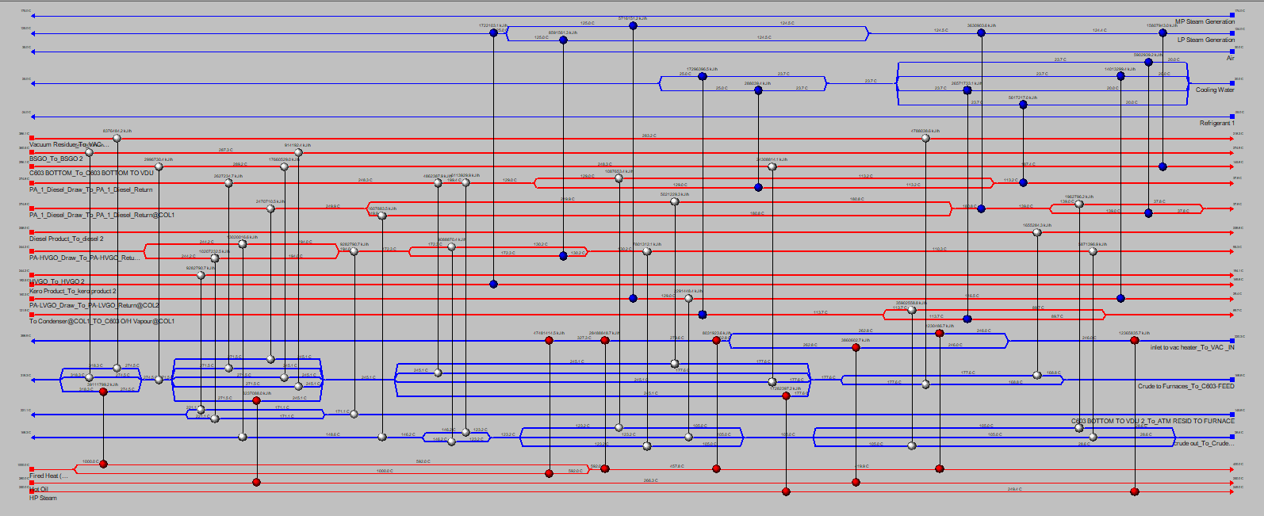

Figure ‑: HEN for alternative scenario 1.

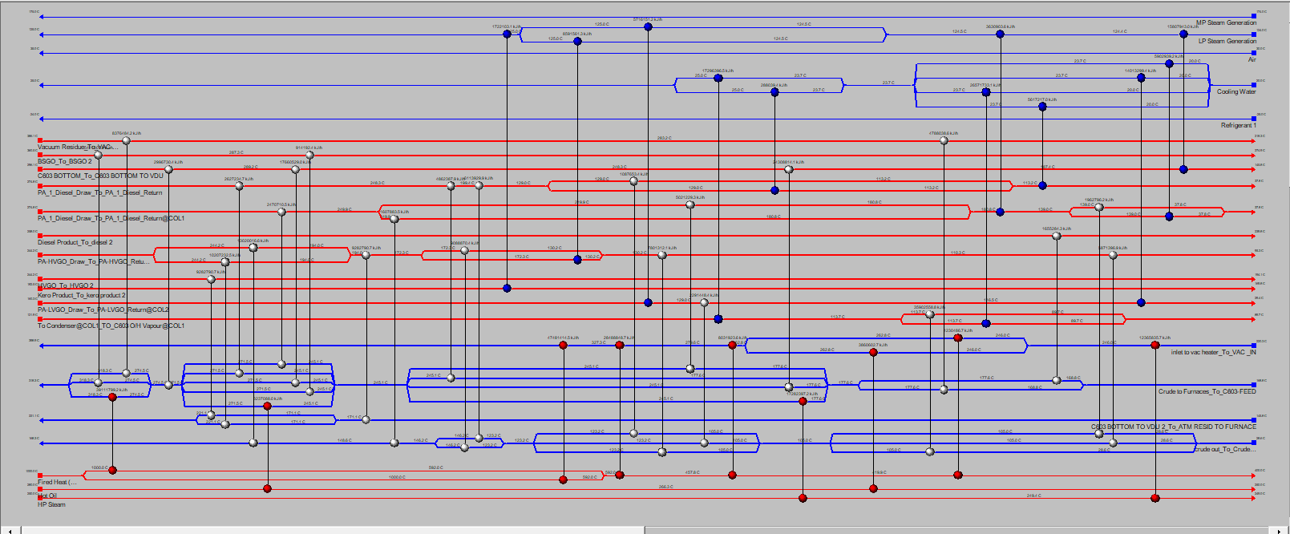

Figure ‑: HEN for alternative scenario 2.

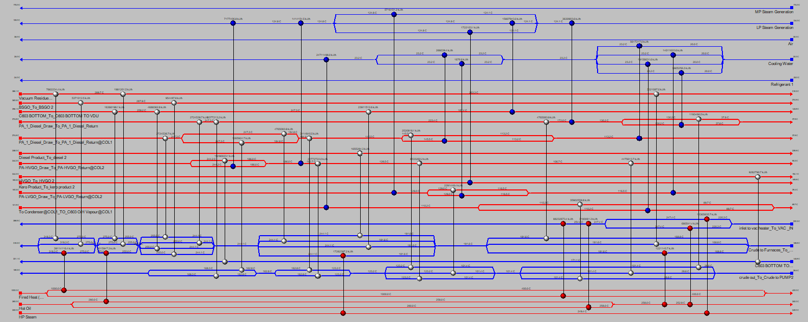

Figure ‑: HEN for alternative scenario 3.

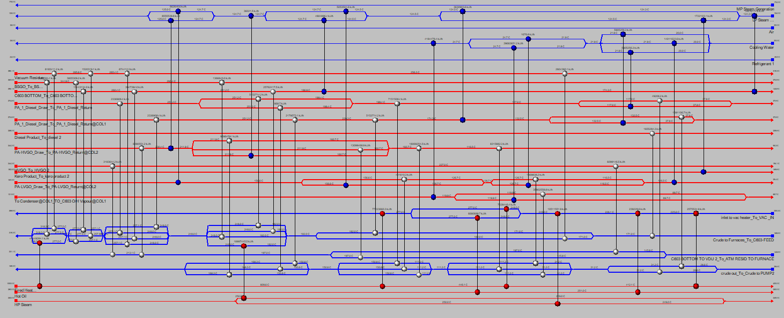

Figure ‑: HEN for alternative scenario 5.

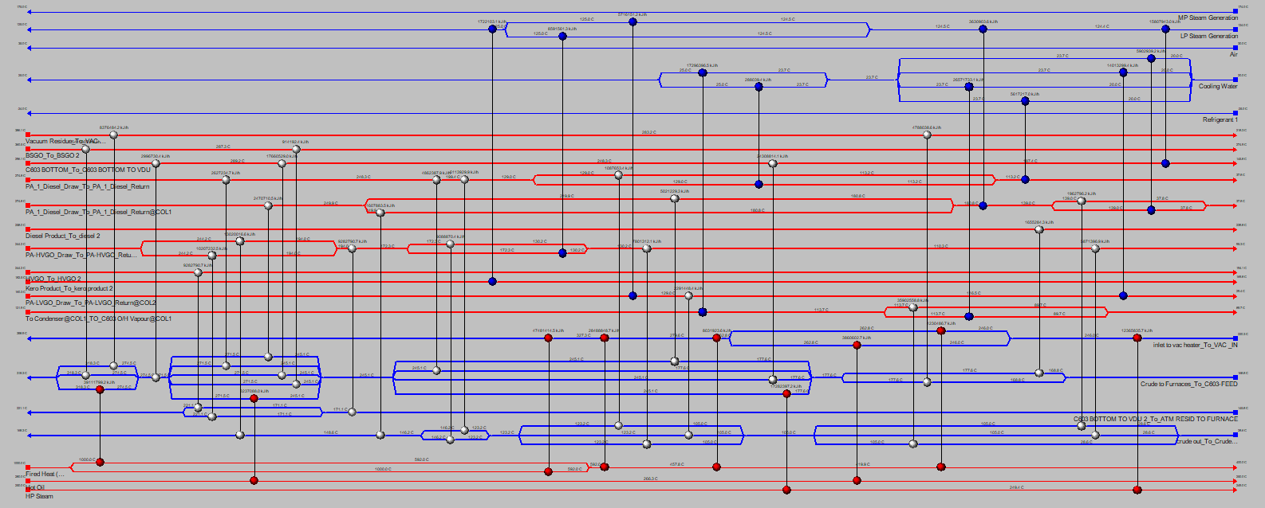

Figure ‑: HEN for alternative scenario 6.

## Appendix E: Fired Heater

Figure ‑: Mechanical properties of 5Cr-0.5Mo Steel [2].

Figure ‑: Fired heater capital cost calculations.

Table ‑: EDR API sheet of combustion design.

Table ‑: EDR API sheet of Mechanical design.

Table ‑:EDR API sheet of process conditions.

Figure ‑:Duty manual calculations.

