**STM32U5 Azure Quick Connect**

**Hardware Requirements**

* [B-U585I-IOT02A Discovery Kit](https://www.st.com/en/evaluation-tools/b-u585i-iot02a.html)
* Micro-USB Cable

**Create an Azure IoT Central Application**

Click the [Quick Connect Application Template](https://apps.azureiotcentral.com/build/new/78386d84-b743-43d7-b0e8-f6d0b06aa0eb) and login with a valid Microsoft account (no subscription required)

After choosing a unique Application name, URL, and Pricing plan click ‘Create’

**Add A Device Your Central Application**

In the menu on the left select ‘Devices’

Select ‘New’ to add a new device

Enter a unique ‘Device name’ and ‘Device ID’

Choose ‘B-U585I-IOT02A IoT Node 2 discovery kit.’ as the Device Template.

Make sure ‘Simulate this device’ is not selected

And select ‘Create’

Your new device should now populate in the devices tab

**Collect Connection Credentials**

Click on the ‘Device Name’ of the device you wish to connect to

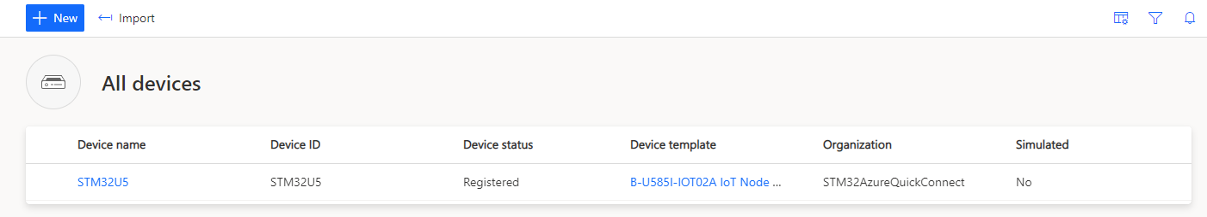

Click ‘Connect’

Here you can view all the required device Connection Credentials

In File Explorer Navigate to STM32_Azure_QuickConnect and open Config.txt

Enter the Wi-Fi SSID and Password for your 2.4Ghz network

Copy and Paste the ID Scope, Device ID, and Primary Key into this file and save.

**Run U5_QuickConnect.py**

Connect your Discovery Kit using the Micro-USB cable as pictured below

In File Explorer Navigate to STM32_Azure_QuickConnect and run the [OS]_STM32U5_Azure_QuickConnect executable

Script logs can be seen in the window:

**Monitor Device Activity**

Navigate back to your device in your central application and you can see a summary of the incoming data

Under ‘Raw data’ specific MQTT messages can be viewed

