Laboratory work #2
by Alnur Bekmurza

1)Creating table and attributtes

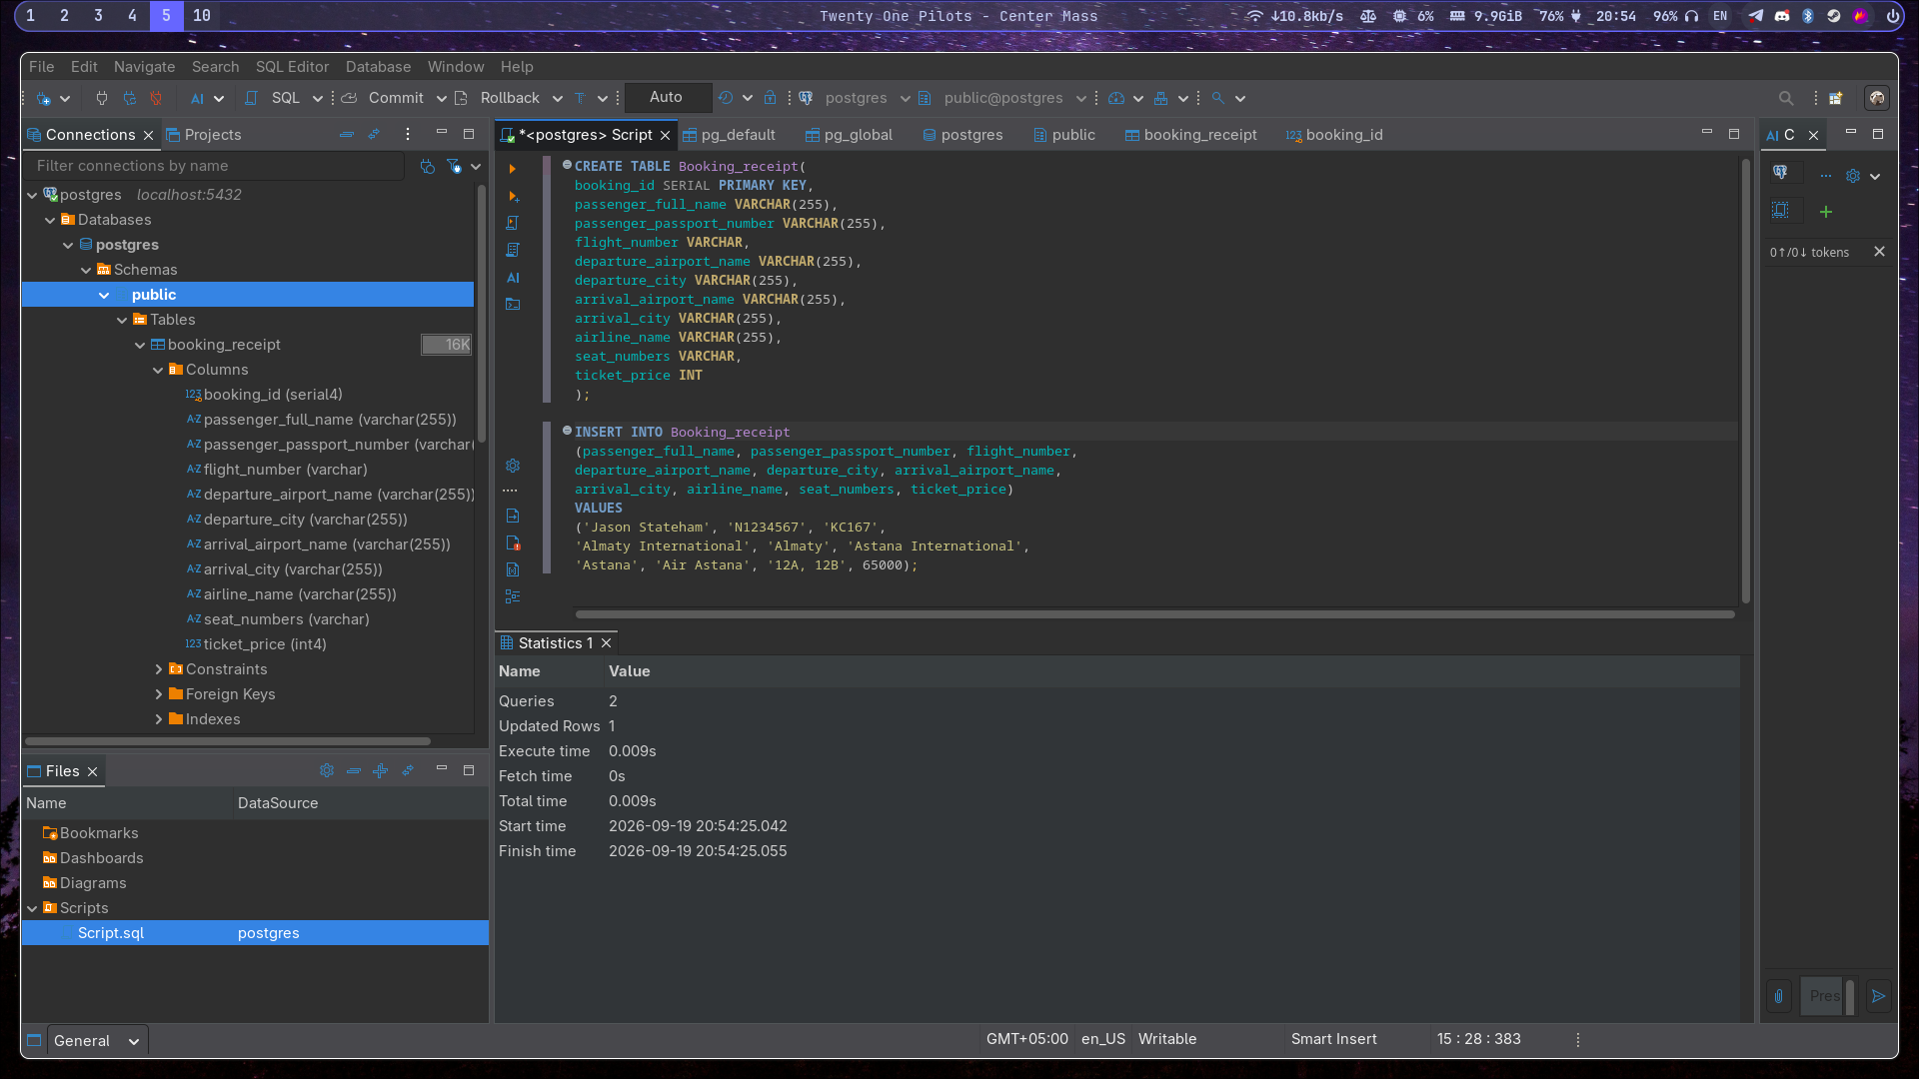
As we can see, this table violates 1NF,and the rule of 1NF says that it requires every cell to hold a single atomic value, by having column seat_numbers which stores comma separated list like in screenshot “12A,12B” it violates 1NF.2NF isnt violated, due to not having composite key, so it cant be violated if theres one primary key.However, 3NF in this case violated by transitive dependencies.flight_number determines lot of non-key columns like airline_name,departure airline_name,arrival_airport_name.
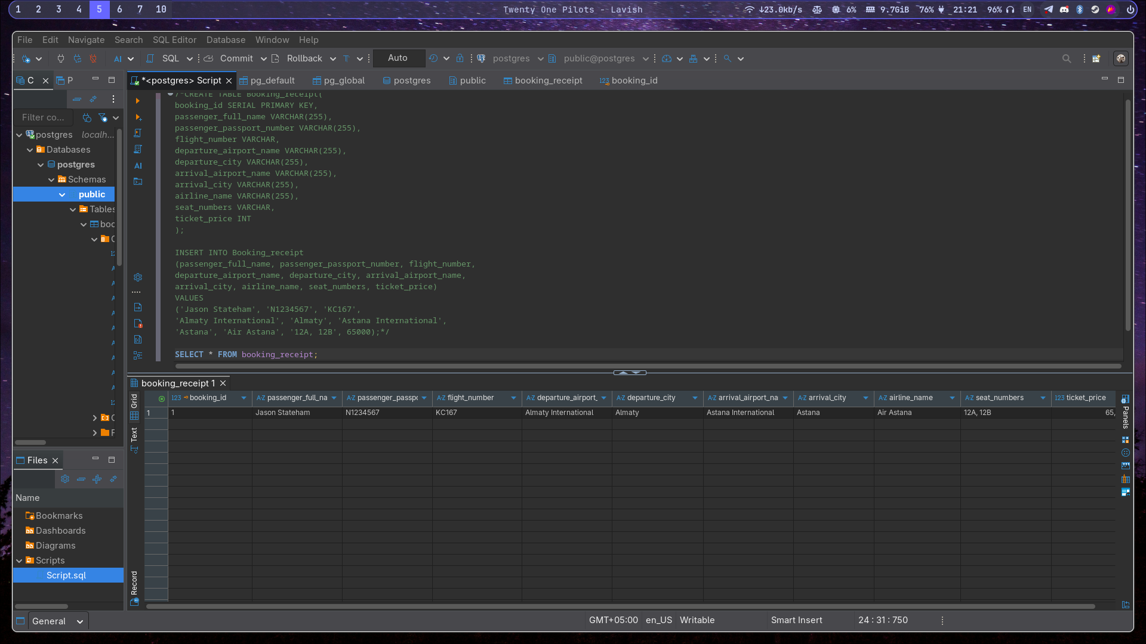
2)Bringing to 1NF by creating separate table named booking_seat(booking_id(FK) of booking_receipt,seat_number) for seat_numbers so it will store them by foreign key booking_id.2NF in this case is not violated due to having single column primary key,so dependencies can’t exist.
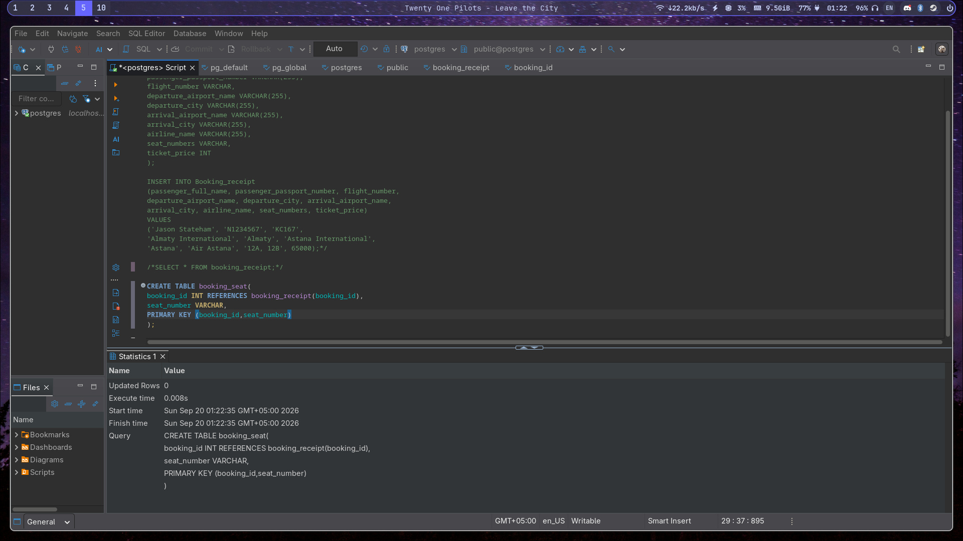
Normalizing table by 3NF,so to destroy transitive dependencies,there were created airport table containing airport_name as primary key, and city, passenger table with passport_number as primary key and full name, and flight table in which flight_number is primary key

so all the resulting tables which were created during normalization:
airport(airport_name, city)
passenger(passport_number, full_name)
flight(flight_number, airline_name, departure_airport_name (FK → airport), arrival_airport_name (FK → airport))
booking_receipt(booking_id, passenger_passport_number (FK → passenger), flight_number (FK → flight), ticket_price)
booking_seat(booking_id, (FK → booking_receipt), seat_number)
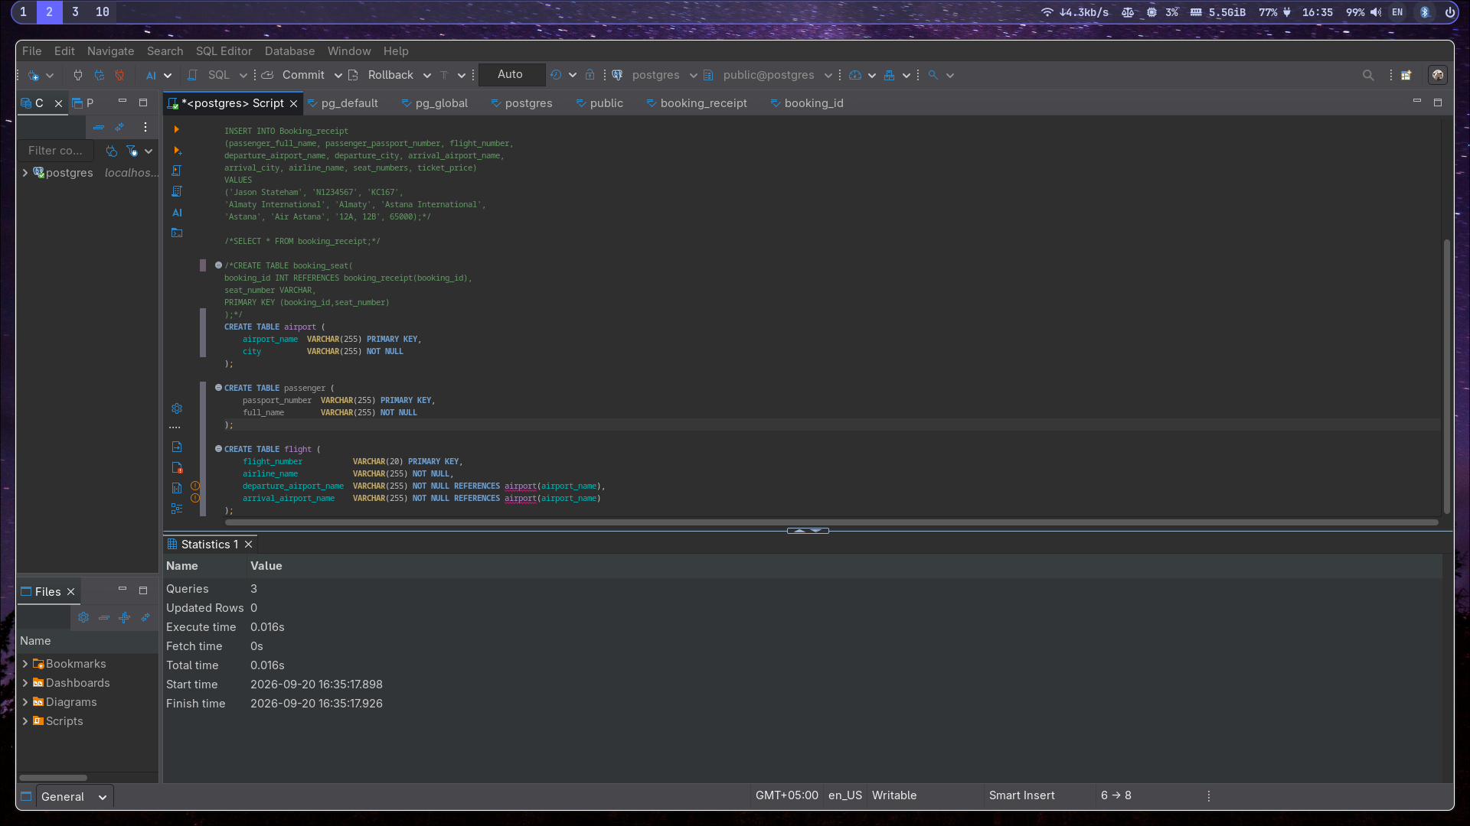
3)1NF:booking_id does not determine seat_number
2NF:booking_id->passenger_full_name, passenger_passport_number, flight_number,
departure_airport_name, departure_city, arrival_airport_name,
arrival_city, airline_name, seat_numbers, ticket_price.

3NF:passenger_passport_number -> passenger_full_name
departure_airport_name -> departure_city
arrival_airport_name -> arrival_city
flight_number -> airline_name, departure_airport_name,arrival_airport_name
booking_id ->passenger_passport_number, flight_number, ticket_price

4)Primary key:flight_id
Functional dependencies:flight_id → departing_gate, arriving_gate, created_at, updated_at, airline_id, departure_airport_id, arrival_airport_id, scheduled_departure_time, scheduled_arrival_time, actual_departure_time, actual_arrival_time
Primary key determines all the columns so there is no transitive dependencies

table Flights in 3NF, because every non key attribute is determined by flight_id and no other.
5)
2. The 3NF tables (from Task 2), with primary keys underlined and foreign keys marked:
- airport(airport_name, city)
- passenger(passport_number, full_name)
- flight(flight_number, airline_name, departure_airport_name (FK), arrival_airport_name (FK))
- booking_receipt(booking_id, passenger_passport_number (FK), flight_number (FK), ticket_price)
- booking_seat(booking_id (FK), seat_number)

