DAY 1

PHP: This stands for Hypertext Preprocessor

PHP is an open source server-side scripting language for building a dynamic web applications just like every other server-side languages e.g python, Ruby on Rails, java, Nodejs, etc.

NOTE: Because the browser does not understands php, it is embedded inside the html so that i can be displayed on the browser.

Syntax for writing php:

<?php

write the code to execute

?>

WHY LEARN PHP

Some of the major reasons/ benefits of using PHP are:

It is an open-source language. Meaning that PHP is freely available to use and implement by any developer.

It is an easy-to-learn language. Because it is very similar to how HTML codes hence, it is easy to understand and implement.

It is highly compatible since it can be integrated with multiple programming languages such as HTML, Javascript and supports different databases like MySQL, PostgreSQL, Oracle, etc.

It is platform-independent, which means that applications developed using PHP can run in any environment.

It has a large community of developers. Programming is all about helping and being helped; hence a large community would mean more help.

It is regularly updated and hence works well with the latest technologies.

Requirements to Learn PHP

1. Just HTML
2. XAMPP Control Panel

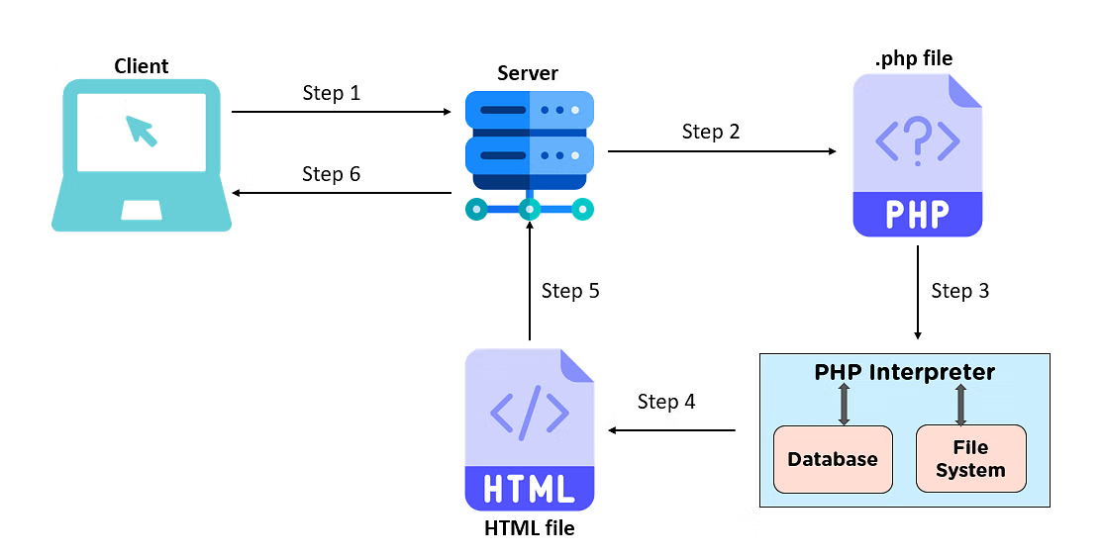How Does PHP Work?