**QUESTION 1**

**Output**

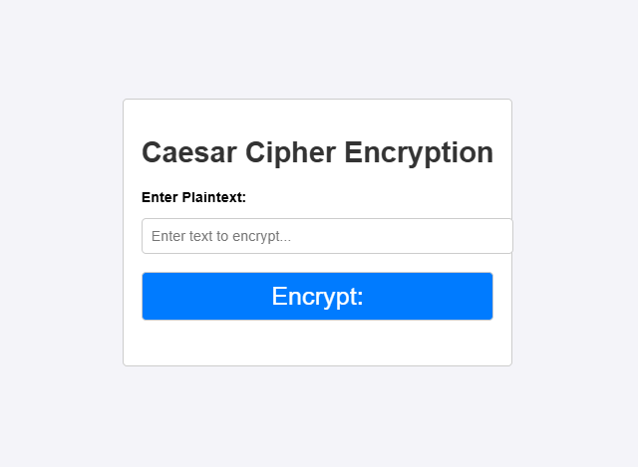

**STEPS:**

**Step1:**

. Input Collection (HTML)

* Creating the user interface with:
  + A text input field where the user enters the plaintext.
  + A button to trigger the encryption process.
  + A display area to show the encrypted text.

**Step2:**

JavaScript Logic for Encryption

* When the button is clicked:
  1. Read Input:
     + Get the plaintext from the input field and convert it to uppercase for consistency.
     + **Iterate Over Each Character:**
     + Check if the character is a letter.
     + Use the Caesar cipher formula to shift the letter by n=7n = 7n=7: Encrypted Character=(ASCII value of letter−65+n)mod  26+65\text{Encrypted Character} = \left( \text{ASCII value of letter} - 65 + n \right) \mod 26 + 65Encrypted Character=(ASCII value of letter−65+n)mod26+65
       - This formula works for uppercase letters ('A' to 'Z'), where 65 is the ASCII code for 'A'.
     + Leave non-alphabetic characters (like spaces or punctuation) unchanged.
  2. **Store the Result:**
     + Append each encrypted character to a result string.
  3. **Display the Result:**
     + Show the final encrypted text in the designated output area.