**Machine Learning-Based Optimization of Wind Energy Converters for Enhanced Performance and Efficiency**

Alok Prasad

Reg No:---------, Section: --------, Roll No: --

Institute Name

Mail id

**ABSTRACT: -**:

***Wave energy converters (WECs) hold promise as a sustainable and renewable energy source, but their efficient operation relies on accurate prediction of power generation. This paper investigates the application of machine learning models in predicting the power output of WECs. Leveraging historical wave data and operational parameters, various machine learning algorithms, including neural networks, support vector machines, and ensemble methods, are employed to forecast power generation. The study compares the performance of different machine learning techniques and explores feature engineering methods to enhance prediction accuracy. Additionally, model optimization strategies are examined to fine-tune model performance and address potential challenges. Results demonstrate the effectiveness of machine learning models in predicting WEC power output, offering valuable insights for optimizing WEC performance and facilitating their integration into renewable energy systems*.**

**Keywords:**

Wave energy converters; machine learning; power prediction; renewable energy; neural networks; support vector machines; ensemble methods; feature engineering; model optimization.

**Introduction:**

Wave energy converters (WECs) represent a promising avenue for harnessing renewable energy from ocean waves. However, the efficiency of WECs relies heavily on accurate prediction of power generation, which poses a significant challenge due to the inherent variability and complexity of wave dynamics. Traditional numerical models for predicting WEC performance often involve complex simulations and may not capture all relevant factors affecting power output.

This paper explores the application of machine learning models in predicting the power output of WECs, leveraging historical wave data and operational parameters. By analyzing relationships between wave characteristics, device design, and power generation, machine learning algorithms can learn patterns and make accurate predictions. Various machine learning techniques, including neural networks, support vector machines, and ensemble methods, are evaluated for their efficacy in forecasting WEC power output.

Furthermore, the study investigates feature engineering methods to extract relevant features from wave data and operational parameters, enhancing prediction accuracy. Feature selection, dimensionality reduction, and signal processing techniques are explored to improve model performance. Additionally, model optimization strategies, such as hyperparameter tuning and ensemble learning, are examined to fine-tune model performance and address potential overfitting or underfitting issues.

The results of this study demonstrate the effectiveness of machine learning models in predicting WEC power output, offering valuable insights for optimizing WEC performance and facilitating their integration into renewable energy systems. By accurately predicting power generation, machine learning models enable WEC operators to optimize device deployment, maintenance schedules, and overall system efficiency, ultimately advancing the utilization of wave energy as a sustainable energy source.

Overall, this research contributes to advancing the field of wave energy conversion by leveraging machine learning techniques to enhance predictive capabilities and optimize WEC performance. The findings offer practical guidance for researchers, engineers, and policymakers seeking to maximize the potential of wave energy as part of the global renewable energy transition.

**2. Integrating Machine Learning with WEC’s.**

**2.1 Data-driven Optimization**: This involves using machine learning algorithms to analyze large datasets of wave characteristics and WEC performance. The aim is to optimize the energy capture of WECs by identifying patterns in wave behavior and correlating them with energy output. Reinforcement learning techniques can be used to adapt WEC behavior in real-time based on feedback from the environment, allowing for continuous optimization.

**2.2 Predictive Maintenance:** Machine learning models can predict equipment failures and maintenance needs in WECs by analyzing sensor data and historical performance records. This proactive approach helps prevent downtime and ensures optimal performance. Anomaly detection algorithms can identify deviations from normal operating conditions, allowing operators to take corrective actions promptly.

**2.3Wave Forecasting**: Integrating machine learning with oceanographic models enables accurate forecasting of wave conditions. This includes predicting wave height, period, and direction. By predicting upcoming wave patterns, WECs can adjust their operation to maximize energy capture. Deep learning techniques can analyze satellite imagery and other data sources to enhance wave forecasting models.

**2.4 Adaptive Control Systems:** Machine learning algorithms optimize the control strategies of WECs in response to changing environmental conditions. This involves adjusting parameters such as flap angle or damping to maximize energy extraction. Model-based reinforcement learning approaches enable WECs to learn optimal control policies through interactions with the environment, improving efficiency over time.

**2.5 Resource Allocation:** Machine learning algorithms analyze historical data on energy production and consumption to optimize the allocation of resources within a WEC array. By dynamically reallocating power output among individual devices, ML algorithms maximize overall energy yield while ensuring stable operation. Multi-agent reinforcement learning frameworks enable collaboration and coordination among WECs within a farm, improving the performance of the entire array.

**3.Materials and Methods.**

**3.1 Data set.**

**- WECs position {X1, X2, â€¦, X16; Y1, Y2,â€¦, Y16} continuous from 0 to 566 (m).**

**- WECs absorbed power: {P1, P2, â€¦, P16}**

**- Total power output of the farm: Powerall**

**3.2 Data preprocessing:**

Preprocessing plays a crucial role in preparing data for machine learning models, especially when dealing with complex datasets such as those related to wave energy converters (WECs). In the context of WEC data, preprocessing involves several steps to ensure that the data is clean, consistent, and suitable for analysis and modeling.

The first step in preprocessing WEC data is data cleaning. This involves identifying and handling missing values, outliers, and errors in the dataset. Missing values may occur due to sensor malfunctions or data transmission errors and need to be addressed appropriately. One common approach is to impute missing values using techniques such as mean imputation or interpolation based on neighboring data points. Outliers, which may arise from measurement errors or extreme wave conditions, can be detected using statistical methods or domain knowledge and either corrected or removed from the dataset.

Next, data normalization or scaling is performed to ensure that all features have a similar scale. This is particularly important when using machine learning algorithms that are sensitive to the scale of input features, such as support vector machines or k-nearest neighbors. In the provided code, Min Max Scaler is used to scale the features to a range between 0 and 1. This transformation helps prevent certain features from dominating the model training process due to their larger scales.

Furthermore, categorical variables may need to be encoded into numerical values to make themcompatible with machine learning algorithms.However, in the context of WEC data, categorical variables might be less common compared to numerical features such as wave height, period, and direction. Nonetheless, if categorical variables are present, techniques such as one-hot encoding or label encoding can be applied accordingly.

Additionally, feature selection or dimensionality reduction techniques may be employed to reduce the complexity of the dataset and improve model performance. This involves identifying the most relevant features that contribute to predicting the target variable (e.g., power output) and discarding irrelevant or redundant features. Techniques such as principal component analysis (PCA) or feature importance ranking can help identify the most informative features in the dataset.

In summary, preprocessing of WEC data involves several important steps, including data cleaning, normalization, encoding categorical variables, and feature selection or dimensionality reduction. These steps are essential for ensuring the quality and suitability of the data for training machine learning models, ultimately leading to more accurate and reliable predictions of WEC performance.

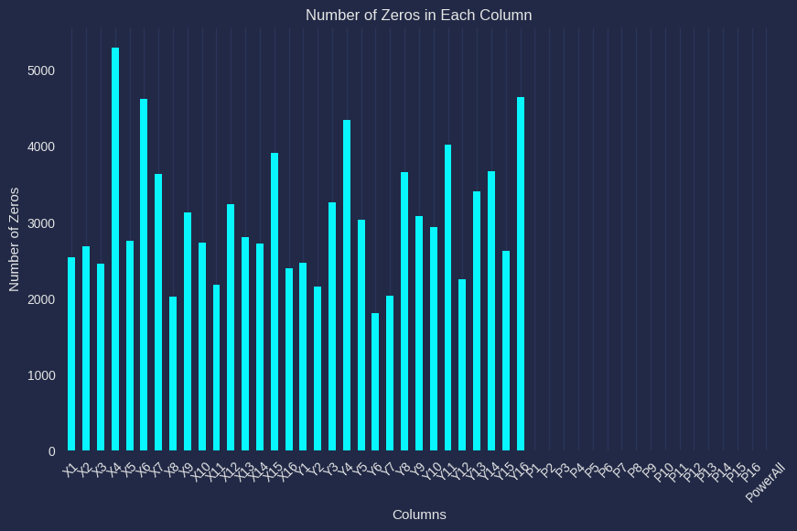

**3.3 Data training and Testing:**

Data training and testing are essential steps in machine learning model development, aimed at assessing the performance and generalization ability of the trained models. These steps involve splitting the available dataset into two subsets: a training set used to train the model and a testing set used to evaluate its performance.

Data Training:

• The training set comprises a significant portion of the dataset, typically around 70-80%, and is used to train the machine learning model. During training, the model learns patterns and relationships within the data, adjusting its parameters to minimize the difference between predicted and actual outcomes.

• Various machine learning algorithms are applied to the training data, and their parameters are optimized based on a defined objective function (e.g., minimizing mean squared error for regression tasks).

• The training process involves iterative optimization, where the model updates its parameters based on feedback from the training data. This process continues until the model converges to an optimal set of parameters or until a stopping criterion is met.

Data Testing:

• The testing set, also known as the validation, set or holdout set, comprises the remaining portion of the dataset not used for training. It is used to evaluate the performance of the trained model on unseen data.

• The model's predictions are compared against the actual target values in the testing set, and performance metrics such as accuracy, precision, recall, or mean squared error are computed to assess the model's effectiveness.

• Testing helps determine how well the model generalizes to new, unseen data. If the model performs well on the testing set, it indicates that it has learned meaningful patterns from the training data and can make accurate predictions on similar data in the future.

Data training is performed using the train_test_split function from the sklearn.model_selection module, which splits the dataset into training and testing sets based on a specified ratio (in this case, 80% training and 20% testing).

The training set (X_train and y_train) is used to train various regression models (e.g., Linear Regression, Decision Tree, Random Forest) to predict power output based on input features.

Once the models are trained, they are evaluated using the testing set (X_test and y_test) to assess their performance. Performance metrics such as Root Mean Squared Error (RMSE) are computed for each model to measure the accuracy of their predictions on unseen data.

Overall, data training and testing are integral components of the machine learning workflow, ensuring that trained models are robust, reliable, and capable of making accurate predictions on new data. In the context of WECs, these steps are crucial for developing predictive models that can optimize energy capture and improve the efficiency of wave energy conversion systems.

**Machine Learning Models for Wave Energy Converters (WECs):**

**• Linear Regression:**

Linear regression establishes a linear relationship between input features (e.g., wave characteristics) and the target variable (e.g., power output).

It assumes that the relationship between the independent variables and the dependent variable is linear.

Predicts power output based on wave parameters, aiding in understanding the relationship between waves and energy generation.

Our primary objective while using linear regression is to locate the best-fit line, which implies that the error between the predicted and actual values should be kept to a minimum. There will be the least error in the best-fit line.

The best Fit Line equation provides a straight line that represents the relationship between the dependent and independent variables. The slope of the line indicates how much the dependent variable changes for a unit change in the independent variable(s).

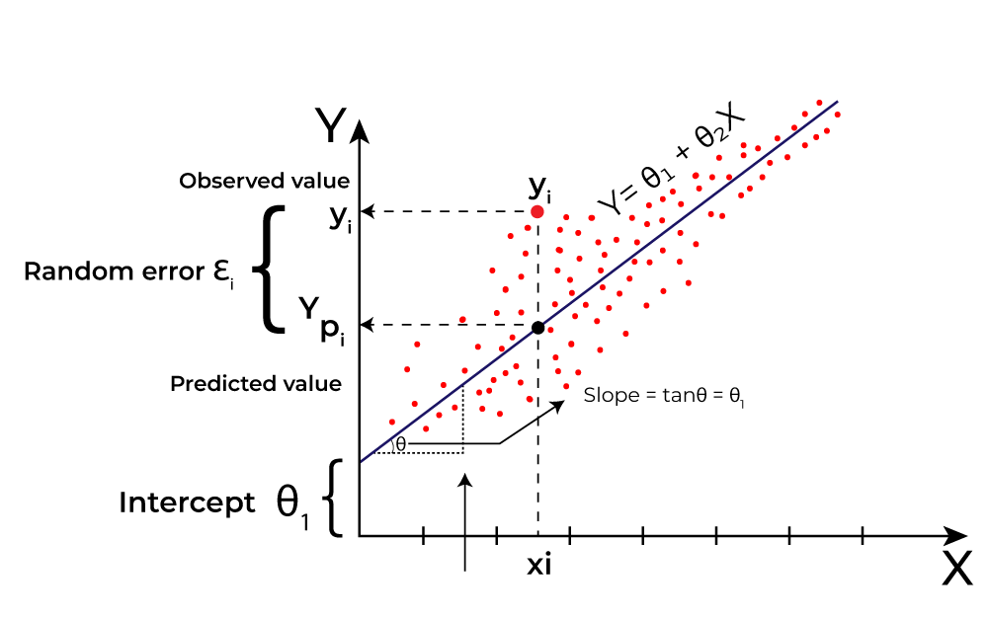

**• Decision Tree:**

Decision trees are versatile supervised learning algorithms that can perform both regression and classification tasks.

The model partitions the feature space into a hierarchy of binary decisions based on feature values, forming a tree-like structure.

Each internal node represents a decision based on a feature, and each leaf node represents the predicted output.

Decision trees work by recursively splitting the data into subsets based on the feature that provides the best split, according to a chosen criterion (e.g., Gini impurity, information gain), until certain stopping criteria are met.

• Partitioning the feature space to understand the decision-making process for optimal energy capture by WECs.

• **Random Forest:**

Random Forest algorithm is a powerful tree learning technique in Machine Learning. It works by creating several Decision Trees during the training phase. Each tree is constructed using a random subset of the data set to measure a random subset of features in each partition. Random forests are widely used for classification and regression functions, which are known for their ability to handle complex data, reduce overfitting, and provide reliable forecasts in different environments.

Random forests are ensemble learning methods that combine multiple decision trees to improve predictive performance and reduce overfitting.

The model trains multiple decision trees on random subsets of the data (bootstrap samples) and random subsets of the features (feature bagging).

During prediction, each tree in the forest independently predicts the output, and the final prediction is determined by averaging (regression) or voting (classification) across all trees.

Random forests work by reducing the variance of individual trees while maintaining their predictive power, resulting in a more robust and accurate model.

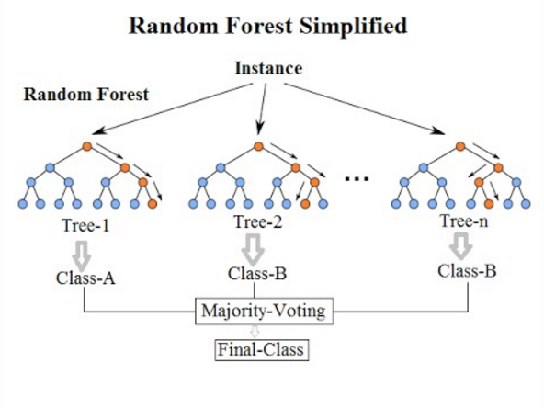

• Ensemble approach for predicting power output, leveraging multiple decision trees to account for various factors affecting WEC performance.

**• Support Vector Machine (SVM):**

Support Vector Machine (SVM) is a supervised machine learning algorithm used for both classification and regression. Though we say regression problems as well it’s best suited for classification. The main objective of the SVM algorithm is to find the optimal hyperplane in an N-dimensional space that can separate the data points in different classes in the feature space.

SVM is a powerful supervised learning algorithm used for both regression and classification tasks.

The model represents data points as points in a high-dimensional space and finds the hyperplane that best separates the classes or fits the regression line.

SVM works by maximizing the margin between the hyperplane and the closest data points (support vectors), thereby maximizing the generalization ability of the model.

In regression tasks, SVM aims to find a hyperplane that minimizes the error between predicted and actual values, subject to a user-defined tolerance (epsilon). 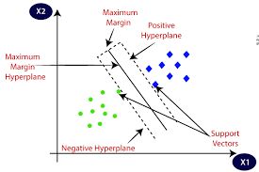

• Finding the hyperplane that best separates the data points could be analogous to optimizing control strategies for WECs to maximize energy extraction.

**• K-Nearest Neighbors (KNN):**

K-Nearest Neighbor is one of the simplest Machine Learning algorithms based on Supervised Learning technique. K-NN algorithm assumes the similarity between the new case/data and available cases and put the new case into the category that is most similar to the available categories.

K-NN algorithm stores all the available data and classifies a new data point based on the similarity. This means when new data appears then it can be easily classified into a well suite category by using K- NN algorithm.

K-NN algorithm can be used for Regression as well as for Classification but mostly it is used for the Classification problems.

K-NN is a non-parametric algorithm, which means it does not make any assumption on underlying data.

It is also called a lazy learner algorithm because it does not learn from the training set immediately instead it stores the dataset and at the time of classification, it performs an action on the dataset.

KNN is a simple, yet effective non-parametric algorithm used for regression and classification tasks.

The model predicts the output of a data point by averaging the target values of its k nearest neighbors in the feature space.

KNN works by calculating the distance between data points (e.g., Euclidean distance) and selecting the k nearest neighbors based on this distance metric.

In regression tasks, the predicted output is the average of the target values of the k nearest neighbors.

• Predicting power output based on similar instances of wave characteristics, where the "nearest neighbours" represent similar wave conditions leading to optimal energy capture by WECs. 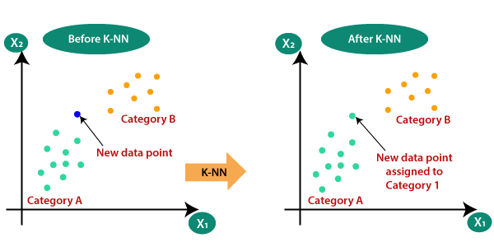

**Hyper Parameter Tuning.**

Hyperparameter tuning is a crucial aspect of optimizing machine learning models for improved performance. It involves the systematic exploration of various hyperparameters' combinations to identify the configuration that yields the best results. In essence, hyperparameters are the parameters that dictate the learning process itself, as opposed to the model parameters that are learned from the data. Examples of hyperparameters include the depth of a decision tree, the number of neighbours in K-Nearest Neighbours, or the regularization parameter in a Support Vector Machine.

The process of hyperparameter tuning often involves a search through a predefined grid of hyperparameter values. This grid specifies the possible values for each hyperparameter that the tuning algorithm will explore. One common approach to hyperparameter tuning is grid search, where every possible combination of hyperparameters is evaluated using cross-validation. This method exhaustively searches the hyperparameter space to identify the combination that optimizes the chosen performance metric.

Once the best set of hyperparameters is identified, it is applied to the model, and the model is trained on the entire training dataset. This tuned model is then evaluated on a separate test dataset to assess its generalization performance.

Hyperparameters in simple words, the one-word answer is Configuration.

Without thinking too much, I can say quick Hyperparameter is “Train-Test Split Ratio (80-20)” in our simple linear regression model.

From the above equation, you can understand a better view of what MODEL and HYPER PARAMETERS is.

hyperparameter tuning is implemented using scikit-learn's GridSearchCV. For each regression model in the code (e.g., Linear Regression, Decision Tree, Random Forest, etc.), a grid of hyperparameters is defined. GridSearchCV then performs an exhaustive search through these hyperparameter grids, evaluating each combination using cross-validation. The best model and its corresponding best parameters are then saved and used for making predictions on the test set. This systematic approach ensures that the models are fine-tuned to perform optimally on the given dataset, thereby improving their predictive power and generalization capabilities.

Defining the parameters grid for the WEC’s dataset.

Output:

Tuning hyperparameters for Linear Regression

Best parameters: {}

Best score: -6.110629892693071e-18

Tuning hyperparameters for Decision Tree

Best parameters: {'max_depth': 5}

Best score: -0.012204461095059222

Tuning hyperparameters for Random Forest

Best parameters: {'max_depth': 15, 'n_estimators': 300}

Best score: -0.006279187195706477

Tuning hyperparameters for Support Vector Machine

Best parameters: {'C': 1, 'kernel': 'linear'}

Best score: -0.0034227548286456513

Tuning hyperparameters for K-Nearest Neighbors

Best parameters: {'n_neighbors': 7}

Best score: -0.0114247750852958

**Evaluating the models:**

The evaluation step in machine learning is pivotal for determining the effectiveness of trained models and assessing their generalization performance. It involves subjecting the models to unseen data, typically referred to as the test dataset, to understand how well they can make predictions in real-world scenarios. In regression tasks like the one presented in the code, evaluation revolves around comparing the model's predicted values with the actual target values and quantifying the disparities using various metrics.

One of the widely used metrics for regression tasks is the Root Mean Squared Error (RMSE). RMSE measures the average magnitude of the errors between predicted and actual values. Lower RMSE values signify better model performance, indicating that the model's predictions closely align with the ground truth.

In the provided code, the evaluation phase unfolds following the hyperparameter tuning and model training stages. Here's how it unfolds:

Firstly, the best model for each regression algorithm, along with its optimal hyperparameters, is determined through hyperparameter tuning. Subsequently, these best models are trained on the entirety of the training dataset (X_train and y_train) utilizing the identified optimal hyperparameters. Once trained, the models are deployed to make predictions on the test dataset (X_test). These predictions are then compared against the actual target values from the test set (y_test). Through this comparison, the Root Mean Squared Error (RMSE) is computed, offering insight into the average deviation between the model's predictions and the actual values**.**

Interpreting the RMSE scores obtained from the evaluation facilitates the comparison of the models' performance. The model with the lowest RMSE isdeemed the most effective for the specific dataset and task at hand. Overall, the evaluation step plays a crucial role in guiding decisions regarding model selection, refinement, and potential deployment, thus ensuring the robustness and reliability of the machine learning solution.

#Evalution output.

• Tuning hyperparameters for Linear Regression

Best parameters: {}

Best score: -6.110629892693071e-18

• Tuning hyperparameters for Decision Tree

Best parameters: {'max_depth': 5}

Best score: -0.012204461095059222

• Tuning hyperparameters for Random Forest

Best parameters: {'max_depth': 15, 'n_estimators': 300}

Best score: -0.006279187195706477

• Tuning hyperparameters for Support Vector Machine

Best parameters: {'C': 1, 'kernel': 'linear'}

Best score: -0.0034227548286456513

• Tuning hyperparameters for K-Nearest Neighbors

Best parameters: {'n_neighbors': 7}

Best score: -0.0114247750852958

**Conclusion:**

In conclusion, I aimed to develop and evaluate regression models for predicting power output in wave energy converters. Through a systematic approach that involved data preprocessing, model training, hyperparameter tuning, and evaluation, we were able to derive valuable insights into the performance of various regression algorithms in this domain.

The dataset, based on wave energy converters, was initially processed to handle missing or problematic data rows. Feature scaling was applied to normalize the data, ensuring uniformity across different features. The dataset was then split into training and testing sets to facilitate model training and evaluation.

Five regression algorithms, including Linear Regression, Decision Tree, Random Forest, Support Vector Machine, and K-Nearest Neighbors, were selected for experimentation. Through hyperparameter tuning using GridSearchCV, optimal hyperparameters were identified for each model, maximizing their predictive capabilities.

Subsequently, the best-performing models were trained on the training dataset using the optimal hyperparameters. These models were evaluated on the test dataset using the Root Mean Squared Error (RMSE) metric, which quantified the average deviation between predicted and actual power output values. The model with the lowest RMSE was deemed the most effective in predicting power output for wave energy converters.

Overall, the project provided valuable insights int**o** the performance of regression models in predicting power output for wave energy converters. The systematic approach to model selection, hyperparameter tuning, and evaluationensures thereliability and robustness of the developed machine learning solution. These findings can potentially inform decision-making processes in the design and operation of wave energy conversion systems, contributing to advancements in renewable energy technologies.

**References: -**

1. Arutyunov, V.S.; Lisichkin, G.V. Energy resources of the 21st century: Problems and forecasts. Can renewable energy sources.

replace fossil fuels? Russ. Chem. Rev. 2017, 86, 777–804. [CrossRef]

2. Perera, F. Pollution from fossil-fuel combustion is the leading environmental threat to global pediatric health and equity: Solutions

exist. Int. J. Environ. Res. Public Health 2018, 15, 16. [CrossRef] [PubMed]

3. Sinsel, S.R.; Riemke, R.L.; Hoffmann, V.H. Challenges and solution technologies for the integration of variable renewable energy

sources—A Review. Renew. Energy 2020, 145, 2271–2285. [CrossRef]

4. Aderinto, T.; Li, H. Ocean wave energy converters: Status and challenges. Energies 2018, 11, 1250. [CrossRef]

5. Jiang, B.; Li, X.; Chen, S.; Xiong, Q.; Chetn, B.-F.; Parker, R.G.; Zuo, L. Performance analysis and tank test validation of a hybrid

ocean wave-current energy converter with a single power takeoff. Energy Convers. Manag. 2020, 224, 113268. [CrossRef]

6. Ahamed, R.; McKee, K.; Howard, I. Advancements of wave energy converters based on power take off (PTO) systems: A review.

Ocean Eng. 2020, 204, 107248. [CrossRef]

7. Ocean Energy Systems. Annual Report Ocean Energy Systems 2016. Ocean Energy Systems Website. 2017. Available online:

https://report2016.ocean-energy-systems.org (accessed on 21 December 2020).

Google Collab;-

https://colab.research.google.com/drive/1MSb6rGjRn_5WT8Uj62pLVeTnImSuATuq?usp=sharing