**Tools & Software recommendations**

* Intellij IDEA
* Java - jdk1.8.0_191

**How to Clone "Test Rig" from GitLab**

1. Copy Clone with HTTPS link for IVV-RIG project in GitLab

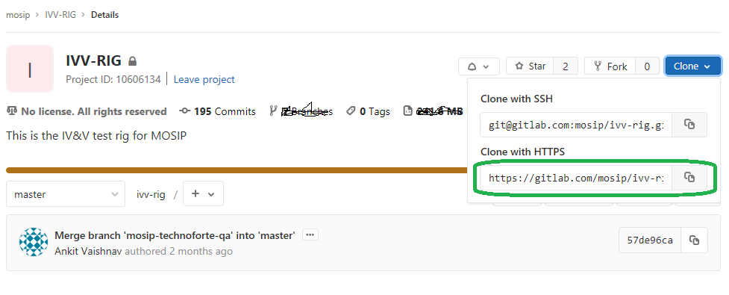

1. Open IntelliJ IDEA, select Git from Check out from Version Control drop down box

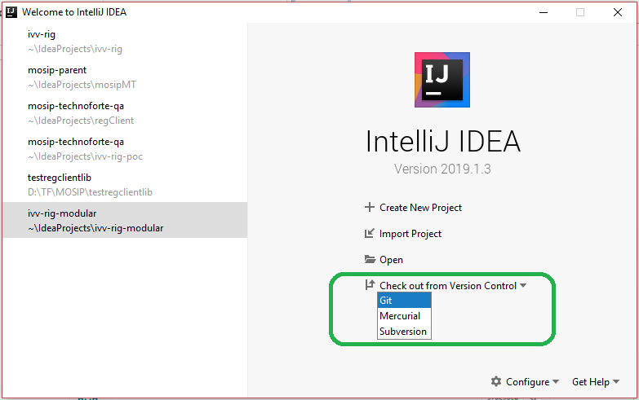

1. Paste the copied HTTPS link from GitLab in URL drop down field and click on Clone button. Complete the clone process

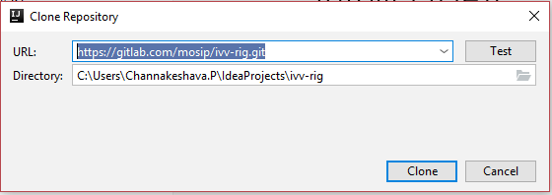

1. Right click on pom.xml file and select Add as Maven Project

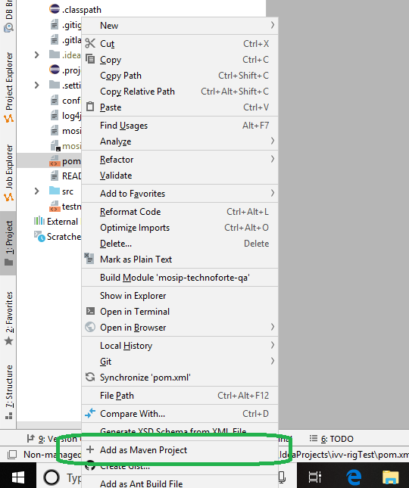

1. Rename config.properties.example file as config.properties

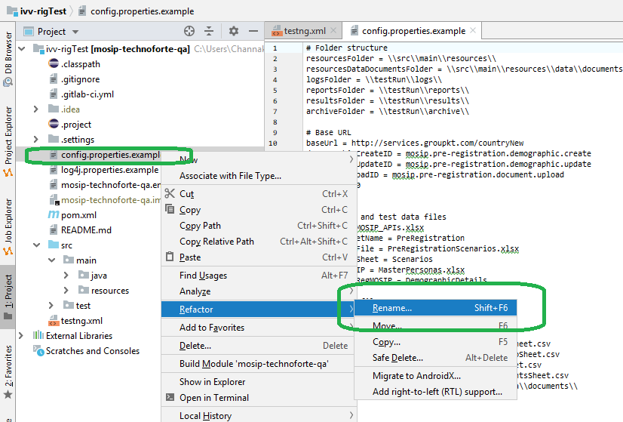

**Things need to setup/update Test Rig before execution**

**Test Run** Folder for Report and Log files

1. Create a folder as **testRun** under test rig root folder
2. Create a subfolder as **Reports** under **root/testRun** folder
3. Create a subfolder as **logs** under **root/testRun** folder

**Config.properties** configuration

**Check and update the following configurations**

*# Login - SendOTP and ValidateOTP***sendOtpID** = mosip.pre-registration.login.sendotp  
**validateOtpID** = mosip.pre-registration.login.useridotp

*# Demographic Create service ID***demographicCreateID** = mosip.pre-registration.demographic.create  
*# Demographic Update service ID***demographicUpdateID** = mosip.pre-registration.demographic.update  
*# Document Upload service ID***documentUploadID** = mosip.pre-registration.document.upload  
*# Booking Book service ID***bookingBookID** = mosip.pre-registration.booking.book  
*# Authentication Service ID***authenticationServiceID** = mosip.identity.auth  
*# API version***apiver** = 1.0  
*# Persona Sheet Path***PERSONA_SHEET**=\\src\\main\\resources\\PersonaSheet.csv  
*# Macros Sheet Path***MACROS_SHEET**=\\src\\main\\resources\\MacrosSheet.csv  
*# Documents Sheet Path***DOCUMENTS_SHEET**=\\src\\main\\resources\\DocumentsSheet.csv  
*# Document Data sheet path***DOCUMENT_DATA_PATH**=\\src\\main\\resources\\data\\documents\\  
*# DSL/Input Scenarios sheet path***SCENARIO_SHEET** = \\src\\main\\resources\\ScenarioSheet.csv

**Base Class test parameters**

**Set the following base class variables**

**baseUri** = "XXXXXX"*# provide API Host Details, e.g: https://eg.com*  
**baseVersion** = "XXXXXX"*# provide BasePath details, e.g: v1.0*   
**weekStartDay** = "SATURDAY" *# provide week start day of the week*

**dbAuditLogDBPath**= **"**XXXXX**"** *# provide Audit log DB location path*  
**dbKernelDBPath** = **"**XXXXX**"** *# provide kernel DB location path*

**dbUser** = **"**XXXXX**"** *# provide DB user name*  
**dbPassword** = **"**XXXXX**"** *# provide DB password*  
**otpEmail_hostname** = **""** # *e.g:* outlook.office365.com  
**otpEmail_username** = **""** *# provide email address*  
**otpEmail_password** = **""**  *# provide email account password*  
**otpOtherEmail_username** =**""** *# provide 2 user email address*

**Feeder Class – Test Parameters**

**Set scenario’s filter for execution and app email recipients for status email**

*//Scenario's filter for test rig execution*

scenariosFilter.add(**"Smoke_Test"**);  
scenariosFilter.add(**"Positive_Test"**);  
scenariosFilter.add(**"Negative_Test"**);  
scenariosFilter.add(**"ErrorCodes_Test"**);

*//Add SendEmail Recipients***BaseHelper**.email_recipients.add(**"XXXXXXX@email.com"**);  
**BaseHelper**.email_recipients.add(**"XXXXXXX@email.com"**);  
**BaseHelper**.email_recipients.add(**"XXXXXXX@email.com"**);

**DSL – Input scenario definition**

Key reference for input scenarios step definitions with variants

* **InvalidateToken()**
* **Login_Email() or Logn_Mobile()**
* **SendOTP**
  + **Variants**
    - InvalidRequestUserIdReceived
    - RequestIdIsInvalid
    - RequestVersionIsInvalid
    - RequestTimestampIsInvalid
* **ValidateOTP**
  + **Variants**
    - UserDetailDoesNotExist
    - OtpCanNotBeEmptyOrNull
    - OtpConsistsOtherThanNumerics
    - RequestIdIsInvalid
    - RequestVersionIsInvalid
    - RequestTimestampIsInvalid
    - RequestDateShouldBeCurrentDate
    - ValidationUnsuccessful
    - TokenIsNotPresentInTheHeader
* **LoginOtherUser**
* **AddApplication**
  + **Variants**
    - **invalidGender**
    - **invalidEmail**
    - **invalidPhone**
    - **RequestVersionIsInvalid**
    - **RequestTimestampIsInvalid**
    - **RequestDateShouldBeCurrentDate**
    - **LangCodeIsInvalid**
    - **MissingInputParameterIdentityFullname**
    - **MissingInputParameterIdentityDateofbirthIdentityAge**
    - **MissingInputParameterIdentityGender**
    - **MissingInputParameterIdentityResidencestatus**
    - **MissingInputParameterIdentityAddressline**
    - **MissingInputParameterIdentityRegion**
    - **MissingInputParameterIdentityProvince**
    - **MissingInputParameterIdentityCity**
    - **MissingInputParameterIdentityLocaladministrativeauthority**
    - **MissingInputParameterIdentityPostalcode**
    - **MissingInputParameterIdentityCnienumber**
    - **InvalidInputParameterIdentityPhone**
    - **InvalidInputParameterIdentityEmail**
* **AddApplicationAll**
* **GetApplication**
  + **Variants**
    - **RequestedPreRegistrationIdDoesNotBelongToTheUser**
* **DiscardApplication**
  + **Variants**
    - **InvalidPRID**
    - **RequestedPreRegistrationIdDoesNotBelongToTheUser**
* **UpdateDemographics**
  + **Variants**
    - **invalidGender**
    - **invalidEmail**
    - **invalidPhone**
    - **InvalidPRID**
    - **RequestIdIsInvalid**
    - **RequestVersionIsInvalid**
    - **RequestTimestampIsInvalid**
    - **RequestDateShouldBeCurrentDate**
    - **RequestedPreRegistrationIdDoesNotBelongToTheUser**
    - **MissingInputParameterIdentityFullname**
    - **MissingInputParameterIdentityDateofbirthIdentityAge**
    - **MissingInputParameterIdentityGender**
    - **MissingInputParameterIdentityResidencestatus**
    - **MissingInputParameterIdentityAddressline**
    - **MissingInputParameterIdentityRegion**
    - **MissingInputParameterIdentityProvince**
    - **MissingInputParameterIdentityCity**
    - **MissingInputParameterIdentityLocaladministrativeauthority**
    - **MissingInputParameterIdentityPostalcode**
    - **MissingInputParameterIdentityCnienumber**
    - **InvalidInputParameterIdentityPhone**
    - **InvalidInputParameterIdentityEmail**
* **AddDocuments**
  + **Variants**
    - **InvalidSize**
    - **InvalidPRID**
    - **ValidateInvalidPreRegID**
    - **InvalidDocCategory**
    - **InvalidDocType**
    - **ValidateInvalidOrEmptyRequestID**
    - **ValidateInvalidOrEmptyRequestVersion**
    - **ValidateInvalidOrEmptyRequestDateTime**
    - **ValidatePastRequestDate**
    - **ValidateInvalidDocumentCategoryCode**
    - **ValidateInvalidDocumentType**
    - **ValidateInvalidLanguageCode**
    - **RequestedPreRegistrationIdDoesNotBelongToTheUser**
* **AddDocumentAll**
* **GetDocument**
  + **Variants**
    - **RequestedPreRegistrationIdDoesNotBelongToTheUser**
* **DeleteDocument**
  + **Variants**
    - **RequestedPreRegistrationIdDoesNotBelongToTheUser**
* **DeleteDocumentsByPreRegID**
  + **Variants**
    - **InvalidPRID**
* **CopyDocument**
  + **Variants**
    - **InvalidPRID**
    - **ValidateRequestParameterIsMissing**
    - **ValidateCatagoryCodeIsInvalid**
    - **ValidateNoDataFoundForRequestedPreRegID**
* **BookAppointment**
  + **Variants**
    - **InvalidCenter**
    - **RegistrationCenterIdNotEntered**
    - **RequestedPreRegistrationIdDoesNotBelongToTheUser**
    - **InvalidPRID**
    - **NoSlots**
    - **UserHasNotSelectedTimeSlot**
    - **sameSlots**
    - **PASTDATE**
    - **InvalidBookingDateTimeFoundForPreregistrationId**
    - **Holiday**
    - **RequestIdIsInvalid**
    - **RequestVersionIsInvalid**
    - **RequestTimestampIsInvalid**
    - **RequestDateShouldBeCurrentDate**
    - **BookingDateTimeNotSelected**
    - **InvalidDateTimeFormat**
* **BookAppointmentAll**
  + **Variants**
    - **RequestIdIsInvalid**
    - **RequestVersionIsInvalid**
      * **RequestTimestampIsInvalid**
* **GetAppointment**
  + **Variants**
    - **RequestedPreRegistrationIdDoesNotBelongToTheUser**
* **CancelAppointment**
  + **Variants**
    - **InvalidPreReg**
    - **BookingDataNotFound**
* **GenerateAcknowledgement**
* **GenerateQRCode**
  + **Variants**
    - **RequestIdIsInvalid**
    - **RequestVersionIsInvalid**
    - **RequestTimestampIsInvalid**