**Implementation of Test Rig:**

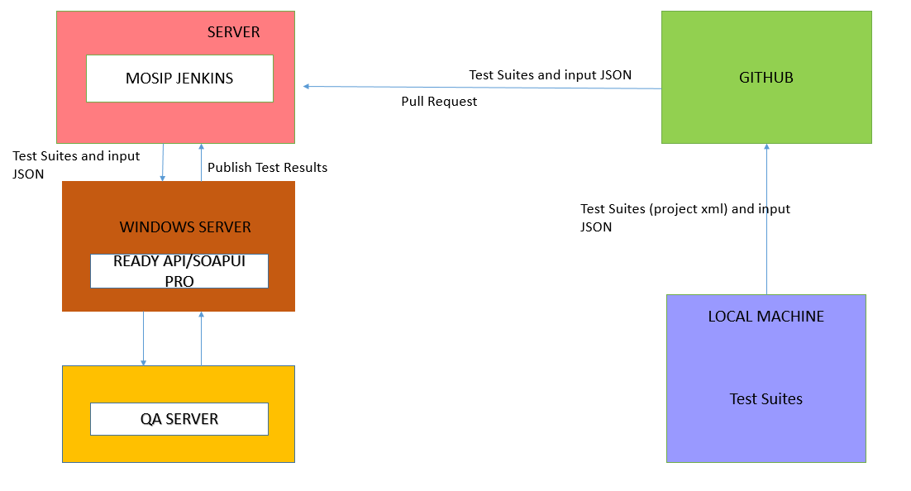

Note: Above diagram will be updated once docker is in place.

**Step1:**

Test Engineers will manually upload IDA project xml to be executed to github.

<https://github.com/mosip/mosip-test/tree/master/testprogress/IDA>/ida-soapui-project-readyapi-project.xml

Test Engineers will manually upload Kernel project xml to be executed to github.

<https://github.com/mosip/mosip-test/tree/master/testprogress/Kernel>/kernal-updated.xml

Test Engineers will manually upload Registration Processor project xml to be executed to github.

<https://github.com/mosip/mosip-test/tree/master/testprogress/Reg-Proc>/regproc-soapui-project-soapui-projectDemo.xml

**Step2:**

Input Test data files and required packets are pushed to github.

<https://github.com/mosip/mosip-test/tree/master/input-jsons>

**Note:** The format of the test data will be of MOSIP ID definition. Current test data files are for sample reference.

**Step3:**

Test Suites will be pulled from git for starting Test Execution.

In this process whole “mosip-test” repository is copied into Mosip Jenkins server and Jenkins workspace is created.

**Note:** This repository is for temporary purpose.Files will be moved to Mosip repository in future.

**Step4:**

Test data files are copied through ssh from Mosip Jenkins server to Ready API Windows server into C:\Program Files\SmartBear\ReadyAPI-2.5.0\bin

**Step5:**

Project xml files are copied through ssh from Mosip Jenkins server to Ready API Windows server into

C:\Mosip

**Step6:**

Following jars are placed in Windows Ready API server into C:\Program Files\SmartBear\ReadyAPI-2.5.0\bin\ext

CustomProperties.jar – input data population at suite level

DEMO.jar – sets the DB connection properties at global level

postgresql-9.3-1102-jdbc41.jar – to establish connection between QA database and scripts

**Step7:**

Global environment variables are set inside Ready API tool in Windows server.

**Step8:**

Command line is run via Jenkins job trigger and the project xmls placed in Windows Ready API server C:\Mosip are executed one by one.

**Step9:**

After execution, a folder with name “Mosip-Test-Reports” is created and html reports are generated inside the respective module wise individual folders.

Inside the reports we can view the test execution status like total number of test cases executed, number of failed test cases etc at Project level, Suite level and test case level.

