**MINI PROJECT**

(2019-20)

**IOT BASED CAR PARKING SYSTEM**

**MID TERM REPORT**



**GLA University, Mathura**

**Department of Computer Science and Engineering**

Submitted in partial fulfilment of the requirements for the

degree of Bachelor Technology

**Team Members**

ABHISHEK PANDEY(171500012)

ALOK KUMAR SINGH(171500030)

HIMANSHU SHEKHAR(171500139)

**Supervised By**

Mr. Amir Khan

(Technical Trainer)

**ACKNOWLEDGEMENT**

* This project itself is acknowledgements for all those people who have given us their heartfelt co-operation in making this project a grand success.
* We would like to express our special thanks of gratitude to our teacher Mr. Amir Khan (Technical Trainer) of G.L.A UNIVERSITY for providing valuable guidance at every stage of this project work.
* We would also like to thanks to all teacher of department of Computer Science And Engineering who gave us the golden opportunity to do this wonderful project on the topic IOT based car parking system which will also help us in doing a lot of research and we will come to know about so many new things.
* We would like to express my deep sense of gratitude and earnest thanks giving to my dear parents for their moral support and heartfelt cooperation in doing the main project.
* Finally, we would like to thank all those friends who are involved directly and indirectly in completion of our project.

**ABSTRACT**

This project aims to provide a user friendly, reliable and automated car parking system even if known many vehicles may pursue very limited parking spaces to cause serious traffic congestion. In this project, we design and implement a prototype of Car Parking System. The automatic car parking system is totally automated with the user being given a unique ID corresponding to the trolley being allocated to him or her this kind of equipment is useful to solve the issue of limited parking space available is busy cities. With the increase of economic behaviour and the upgrade of living standard, the ratio of people in India who own automobiles and motorcycles have recently increased giving a boost to Metropolitan Traffic. Therefore, parking issues will be a big challenge to facilitate traffic network and ensure urban life quality. Searching for parking space in most metropolitan areas, especially during the rush hours, is difficult for drivers. The difficulty arises from not knowing where the available spaces may be at that time.

**CHAPTER 1**

**INTRODUCTION**

The traditional parking systems such as multilevel or multi-store car parking systems (non-automated), robot car parking systems, automated multilevel car parking systems etc. have been implemented on a huge scale. But these systems have a major disadvantage of large space consumption which is successfully eliminated with the use of “Automatic car parking system”. In an automated car parking, the cars are left at the entrance and are further transported inside the building with mechanical structure. Similarly, they are retrieved by mechanical structure and placed at the exit for the owner to drive away. Our proposed system presents an Autonomous car parking that regulates the number of cars that can be parked in a given space at any given time based on the parking space availability. When a car arrives at the entrance, it will be stopped at the main gate and the driver de-boards the car. If the availability of Parking space is confirmed, the user commands the car to get parked to the designated slot. The car traces its path to the entrance of the parking area. Here, it waits and the details required for parking of car at the proper slot are communicated to the Car Control Unit. On receiving the information, the car will further trace its path to free parking spot. On successful parking, the data on the LCD will be updated automatically.

**1.1 Project Objective:**

* To develop an intelligent, user friendly automated car parking system which reduces the manpower and traffic congestion.
* To offer safe and secure parking slots within limited area.
* To minimise the effects of on street parking upon road safety and congestion.
* To reduce dependence on the car, particularly in town centres.
* To help maintain the vitality of town centres and to minimise out of town developments.
* To ensure that car parking provision and enforcement are broadly self-financing through the Decriminalisation of Parking Enforcement (DPE) process.
* To reduce, where possible, environmental damage caused by cars and car ownership, particularly in residential areas.
* To reduce, where possible, competition for road space, between residents and other groups.
* If through town centre regeneration and development more shoppers/visitors are attracted to the town centres surrounding roads will become increasingly congested. Some reduction in potential congestion may be achieved by encouraging through traffic to use other routes and by assessing the design and access to developments in terms of minimum access through the town centre core.

**1.2 Parking Lot Problems:**

* Difficulty in finding vacant spaces quickly finding a vacant space in a multilevel parking lot is difficult if not impossible, especially on weekends or public holidays. Finding spaces during weekends or public holidays can take more than 10 minutes for about 66% of visitors. Stadiums or shopping malls are crowded at peak period, and difficulty in finding vacant slots at these places is a major problem for customers. Insufficient car park spaces lead to traffic congestion and driver frustration.
* Improper parking if a car is parked in such a way that it occupies two parking slots rather than one, this is called improper parking. Improper parking can happen when a driver is not careful about another driver’s rights. This is tackled by the development of automated smart car parking system.

**CHAPTER 2**

**COMPONENTS**

* 1. **Hardware Specifications:**
* **ARDUINO:** Arduino is a single-board microcontroller meant to make the application more accessible which are interactive objects and its surroundings. The hardware features with an open-source hardware board designed around an 8-bit Atmel AVR microcontroller or a 32-bit Atmel ARM. Current models consists a USB interface, 6 analog input pins and 14 digital I/O pins. Arduino is a single-board microcontroller meant to make the application more accessible which are interactive objects and its surroundings. The hardware features with an open-source hardware board designed around an 8-bit Atmel AVR microcontroller or a 32-bit Atmel ARM. Current models consists a USB interface, 6 analog input pins and 14 digital I/O pins that allows the user to attach various extension boards.



The Arduino Uno board is a microcontroller based on the ATmega328. It has 14 digital input/output pins in which 6 can be used as PWM outputs, a 16 MHz ceramic resonator, an ICSP header, a USB connection, 6 analog inputs, a power jack and a reset button. This contains all the required support needed for microcontroller. In order to get started, they are simply connected to a computer with a USB cable or with a AC-to-DC adapter or battery. Arduino Uno Board varies from all other boards and they will not use the FTDI USB-to-serial driver chip in them. It is featured by the Atmega16U2 (Atmega8U2 up to version R2) programmed as a USB-to-serial converter.

* **IR** **SENSOR**: An infrared sensor is an electronic device, that emits in order to sense some aspects of the surroundings. An IR sensor can measure the heat of an object as well as detects the motion.These types of sensors measures only infrared radiation, rather than emitting it that is called as a passive IR sensor.

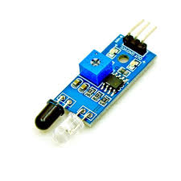

Usually in the infrared spectrum, all the objects radiate some form of thermal radiations. These types of radiations are invisible to our eyes, that can be detected by an infrared sensor.The emitter is simply an IR LED (Light Emitting Diode) and the detector is simply an IR photodiode which is sensitive to IR light of the same wavelength as that emitted by the IR LED. When IR light falls on the photodiode.

* **LCD DISPLAY**: LCD (Liquid Crystal Display) is a type of flat panel display which uses liquid crystals in its primary form of operation. LEDs have a large and varying set of use cases for consumers and businesses, as they can be commonly found in smartphones, televisions, computer monitors and instrument panels. LCDs were a big leap in terms of the technology they replaced, which include light-emitting diode (LED) and gas-plasma displays.

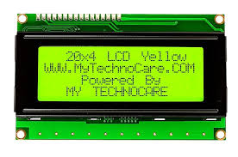

LCDs allowed displays to be much thinner than cathode ray tube (CRT) technology. LCDs consume much less power than LED and gas-display displays because they work on the principle of blocking light rather than emitting it.

* **IC:** An integrated circuit or monolithic integrated circuit (also referred to as an IC, a chip, or a microchip) is a set of electronic circuits on one small flat piece (or "chip") of semiconductor material that is normally silicon.

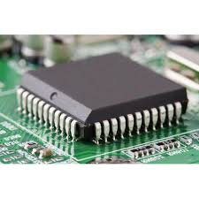

* **DC MOTOR:** A DC motor is any of a class of rotary electrical machines that converts direct current electrical energy into mechanical energy. The most common types rely on the forces produced by magnetic fields. Nearly all types of DC motors have some internal mechanism, either electromechanical or electronic, to periodically change the direction of current flow in part of the motor.

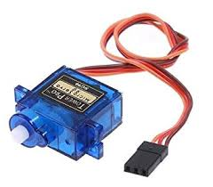

* **WIRES:** A wire is a single, usually cylindrical, flexible strand or rod of metal. Wires are used to bear mechanical loads or electricity and telecommunications signals.

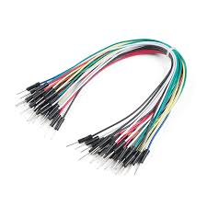

Wire is commonly formed by drawing the metal through a hole in a die or draw plate.

* **BREAD BOARD**: A breadboard is a solderless device for temporary prototype with electronics and test circuit designs.

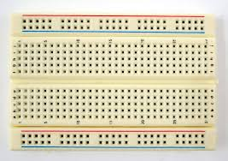

Most electronic components in electronic circuits can be interconnected by inserting their leads or terminals into the holes and then making connections through wires where appropriate.

* 1. **Software Specifications:**
* **AURDINO COMPILER:** The Arduino Integrated Development Environment or Arduino Software (IDE) contains a text editor for writing code, a message area, a text console, a toolbar with buttons for common functions and a series of menus. It connects to the Arduino and Genuino hardware to upload programs and communicate with them.
* **C PROGRAMMING LANGUAGE:** It was mainly developed as a system programming language to write an operating system. The main features of C language include low-level access to memory, a simple set of keywords, and clean style, these features make C language suitable for system programmings like an operating system or compiler development. Many later languages have borrowed syntax/features directly or indirectly from C language.

**CHAPTER 3**

**METHODOLOGY**

Since our project is composed of both hardware and software components, we have divided the methodology as we see fit. In the first phase which is covered in the semester project we have used the staged delivery to work on the project since we were working on the hardware section of the project. Staged delivery helped us in different aspects of the project, since we completed some part of the project and we were able to test it and move to the next stage with a full confidence that the current module is working according to the design requirements.

Requirements

Implementations

Planning and Design

The reason behind why we chose this methodology for our first phase of the project is that it helps us identify problems early and let us work on them before moving on to the other build.

Staged delivery model employs 3 phases:

**Requirement specification**: the phase wherein requirements and needs are defined.

**Planning**: in the requirement specification phase, needs were determined; for the planning phase, we set goals and what we hope to accomplish.

**Implementation and Testing**: To implements and test in real life.

**CHAPTER 4**

**SYSTEM DESIGN**

**FLOW CHART:**

Can’t park

Can park

NO

YES

Free slot?

Microcontroller receives analog signal from sensors

Microcontroller transmits trigger pulse to sensors

To sensor

START