**CHAPTER 1**

**INTRODUCTION**

**1.1. BACKGROUND**

As we see different parking areas filled with illegally parked cars, finding a free parking slot in a congested city is more difficult task. Here, if anyone wants to go outside from home with a personal car first thing that come to mind is about parking, where he/she will park his/her car. In most cases, people go to a parking stations and find that all parking slots are full and then have to go to another parking station hoping there will be space there. Most of them end up parking illegally creating traffic jam and making it hard for parking attendants.

Though it seems not like an issue but it is still quite an issue. Different buildings offer parking services in different parts of the city, it is a good start but lacks coordination among the different facilities because it doesn’t consider the fact that the driver needs to be physically present to find out if there is a parking slot available.

In recent research in metropolitan cities along with the increasing population their vehicle density on roads. Hence, this leads to annoying issue for the drivers to park their vehicles as it is very difficult to find a parking slot. The drivers usually waste time and effort and end up parking their vehicles finding a space on streets through luck. In worst case, people fail to find any parking space especially during peak hours and festive seasons.

In general parking is a huge pain spot for many drivers. Inefficient allocation of space, lack of knowledge about parking availability, and lack of visibility in regarding pedestrians, blind slots, and danger zones all greatly contribute to parking problems.

Let’s take a case scenario, Abhi is a resident in xyz working in some government office. Like many others in the city, he commutes to work each and everyday, so he uses his car quite frequently. He often has trouble parking slots, which gets frustrating. He frequently becomes stressed because of poor traffic conditions hinder his ability to find parking. Parking issues could have more serious problems, such as missing flight or having to confront management about untimeliness.

We researched on the topic further and found out the following statistics, from July 2011 study conducted by IBM across 20 major international cities, highlights existing parking related problems:

* Drivers in urban areas need nearly 20 minutes on average to find parking.
* Between 30 to 45 percent of traffic in cities is caused by drivers looking for parking.
* 60 percent of drivers reported giving up on finding parking at least once in the calendar year.
* 27 percent of the drivers surveyed got into arguments with fellow drivers over parking spaces.

The problems mentioned in the previous sections and in this section, all point to the same direction, we need some kind of efficient system to control all this and make everything better or at least take the first step in the right way. Different systems have been designed and implemented all over the world to bring down the problems caused by parking problems.

According to our research, a well laid parking system could result in 220,000 gallons of fuel savings till 2030 and approximately 300,000 gallons of fuel saved by 2050 if implemented successfully. Infrastructures are designed and built to last and be used for many years, but a lot of factors are not considered in the design phase. People are so eager to see their work come to life, they often dive into implementation without taking a look at the whole thing from a different perspective.

This is often true in many cases. Narrowing it down to our problem domain, roads are designed and built to handle traffic which doubles or triples in a quarterly rate. All these cars come to rest at some time, we see double parking everywhere and even triple parking (we had to come up with a term) because the drivers won’t take the risk of going elsewhere to park their car just because they have no idea of what awaits them in other parking areas.

**1.2. SIGNIFICANCE AND MOTIVATION**

An IoT [Internet of Things] based Parking System, as the name suggests is exactly what one would think it would be. Putting aside the implementation, what the project intend

to achieve is a way we can park our vehicles in a smart way. We are not planning to make cars so smart that they find a place to park for themselves, that is a different topic of interest rather we are trying to aid the parking system by introducing technology into the working system. With people’s desire to have their own cars and the car sales sector growing, we will need to consider “Space” as a factor. Space in our domain will be a parking slot, which is plenty if used properly and the right information about space is given to the right individuals at the right time. Another factor to the mix, “Information” which seems to be generated by the second and growing by the minute.

Information is a key for decision making, in our problem domain if all those drivers have the information about all the parking spaces available in the city they won’t double or triple park which apparently creates the risk of being hit by another car. Internet of things (IoT) plays a vital role in connecting the surrounding environmental things to the network and makes it easy to access those un-internet things from any remote location. It’s inevitable for the people to update with the growing technology and generally, people are facing problems on parking vehicles in parking slots in a city.

An IoT based Parking System informs the user to find out about the nearest parking area, gives availability of parking slots in that respective area and have the chance to reserve the parking spot before arrival. It mainly focuses on reducing time in finding the parking slots and also avoiding unnecessary travel through filled parking slots in a parking area. Thus, it reduces the fuel consumption which in turn reduces carbon footprints in the atmosphere.

**1.3. AIM AND OBJECTIVE**

The goal of this project is to create a user friendly and adaptable system that can be implemented in large, multi-level parking garages in order to alleviate parking hassles. The ultimate goal is that the ideas and planning demonstrated through this system can then be easily upgraded to an actual parking facility.

The purpose of the development of IoT based parking system is to eliminate the unnecessary frustration drivers experience as they waste priceless minutes circling parking garages looking for a slot. In addition, traffic flow within the area will be better regulated, creating a safe atmosphere for both drivers and pedestrians. What we plan to

do is get the right “information” about “Space” to the drivers in our city so they won’t waste their time looking for parking spaces or park inappropriately because of lack of information. With the right funding and wide scale implementation the project can be helpful in reducing illegal parking and in a way help with the traffic jams we see in our city.

Why do we need such a system?

* To accurately predict and sense slot/vehicle occupancy in real-time
* Guides residents and visitors of the city to available parking
* Simplifies the parking experience and adds value for parking stakeholders, such as drivers
* Help traffic in the city flow more freely leveraging IoT technology
* Plays a major role in creating better urban environment by reducing the emission of carbon dioxide and other pollutants
* It enables better and real time monitoring and managing of available parking space
* Overall benefits include:
* Gives the drivers information about parking spaces available
* Eliminates the hassle of circling a parking garage or area in search of a parking spot
* Helps the traffic flow because of less illegal parking
* Saves resources and time
* Allows drivers to reserve parking slots before arrival
* Creates a way for further advancements and research in the sector

Going to the bigger picture, systems like this can go well beyond avoiding the needless circling of blocks. They can also enable cities to develop fully integrated multi-modal intelligent transportation system that don’t rely on cars in the first place.

**1.4. METHODOLOGY**

Since our project is composed of both hardware and software components, we have to divided the methodology as we see fit. In first phase which is covered in the semester project we have used the staged delivery to work on the project since we were working

on the hardware section of the project. Staged delivery helped us in different aspects of the project, since we completed some part of the project and we were able to test it and move to the next stage with a full confidence that the current module is working according to the design requirements.

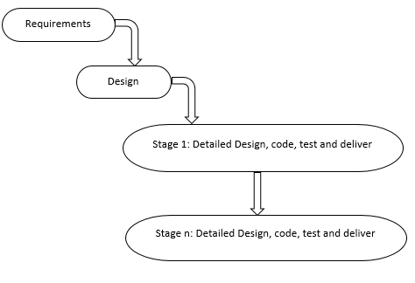

Figure 1: Staged Delivery

The reason behind why we chose this methodology for our first phase of the project is that it helps us identify problems early and let us work on them before moving on to the other build. Staged delivery model allows us to deliver our components in stages. It prioritizes the stages set by us and the general timeline for the semester. It is easier for us to allocate time and resources. Furthermore, it is a rather safe model to use and poses quite a contrast against flexible models that are risky for some.

Staged delivery model employs 4 phases:

* **Requirement specification**: The phase where requirements and needs are defined.
* **Planning**: In the requirement specification phase, needs were determined; for the planning phase, we set goals and what we hope to accomplish.
* **Implementation and Testing**: In phase 1 and phase 2 indicated the needs and goals; in the implementation and testing phases, the goals are being subdivided into smaller, more specific categories,with emphasis on priorities. The

subcategories such as designing, testing and distribution are being tested, thereby making them ready; should the project stop at any point.

* **Closure**: The phase wherein every document and result gathered from the project is assessed. Best practices are delivered here, and a careful evaluation of positive and negative outcomes of projects is then used for current and future tasks.

There are several advantages of using the staged delivery model. For one, it is rather predictable system that allows the project team(us) to easily detect problems before they happen. This way we can avoid unnecessary costs and resources when faced with issues along the way. Another advantage is that the product can be used right away before the full project is complete. Additionally, since testing is done more often, there is close interaction between team mates and advisor and other stakeholders of the project.

Lastly, since the project is divided into smaller tasks in the third phase, there is less room for error. In the second part of our project we have yet employed another methodology because we were focused on the software part of the system, which needed more through approach and a hand on iterative process than the hardware part of the project.

For the second phase of our project, we have chosen to follow Agile Software Development Methodology because it provides various benefits for our project described below. Agile software development allows us to have effective response to changes in our requirements and changes in priorities of requirements. Especially in our project it’s difficult to know in advance which software requirements will change and which will remain and also, it’s hard to know in advance which priorities will change. Agile software development allows our team to be structured in a way that encourages simplistic communication between team members. Moreover, we can’t get full information in advance about our design without trying out the implementation then we can iterate back to the design phase based on our augmented knowledge from the implementation.

Since we have big time constraints to make sure we’re on the right track to produce our product we need to observe parts of the working product first and then we will build on that incrementally. Agile Software also encourage important skills of team work such

as common focus, collaboration, decision making ability, mutual respect and self-organization. Among the many approaches to agile software development methodology we have chosen the Extreme Programming (XP) approach because it has the upcoming benefits to us and our project. Extreme programming, at the heart of its foundation are communication, simplicity, feedback, courage and respect. Most importantly we need our tasks to be as simple as possible (Simplicity) so we need to focus on our immediate needs only. This means XP creates faster software with less glitch.

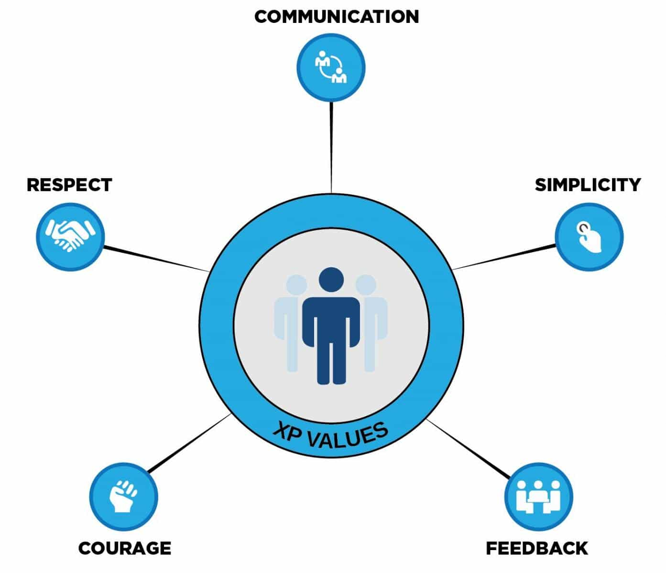

Figure 2: Extreme Programming Features

It also has better risk management because it uses pair programming and in pair programming every code is done by two programmers meaning one will focus on writing code and the other will try to understand the code and checks if it follows standards suitable for testing.