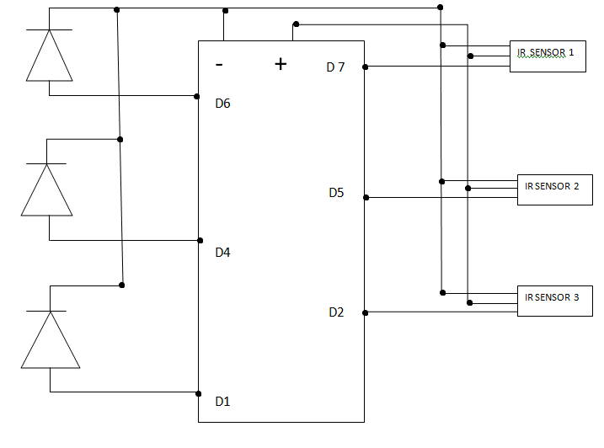

Figure 1: Circuit Diagram for Car Parking System