**Executive Summary**

**Objective:** Objective of this project is to maximize revenue from direct marketing campaigns for consumer loan, mutual fund and credit cards. For this analysis I would be using python.

**Data analysis:** For Analysis I used data set which consist of demographic details, product details and transaction details of client. Transaction details was for past three months which is important to tell the behaviour of client.

The data set consist of 1615 clients out of which for 969, targets, was provided and other than these 969 clients (646 clients) all are new clients and I have to predict sale of item and revenue generated. I would be using machine learning technique on 969 clients and create our model with highest performance on the data set. Before applying ML models, I will be doing some pre-processing on the data set and will perform imputations based on our assumptions for null values and incorrect details in age column.

For sale of mutual fund, we can see that males who are having nearly 100 months of tenure with the bank have high propensity to buy mutual fund similarly with age, in this new members or clients in their early ages are investing more in mutual funds. In both the cases males are investing more in mutual funds.

Those who are investing more in mutual funds are very less likely maintaining their savings and current account balance and not investing in any other products such as credit cards and consumer loan. They are most likely investing all money in mutual funds.

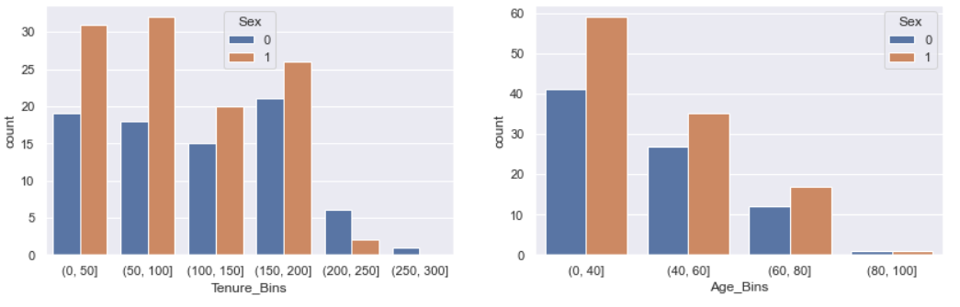

For credit cards, both male and female in their early ages, is showing interest but later the graph decreases. Male Clients are showing more interest in credit cards who are in their early ages. The clients who are investing credit cards are also investing in mutual funds, and rarely do the cash transaction but do more cashless transactions.

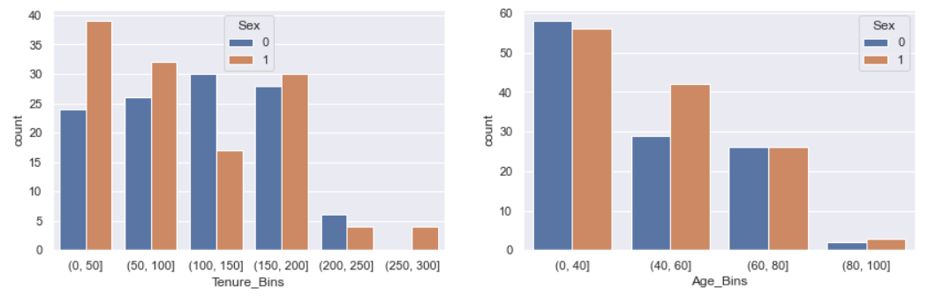

For consumer loan, we can see that more females are taking loans. These clients are not investing much in mutual funds and maintain their account balances. They are equally doing the cashless and cash transaction. We can customize our offers based on this analysis and target specific customer based on this.

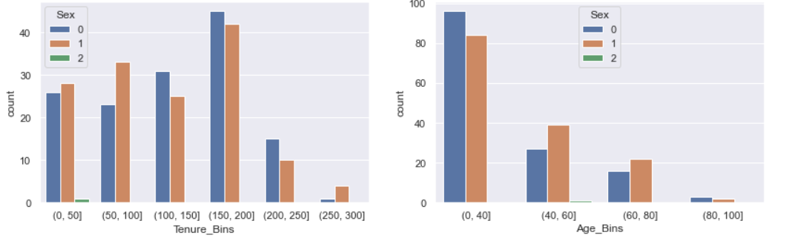

**Final Remark:** To maximise the revenue I would be creating three propensity models for sale of items and along with this I would be predicting the revenue from this. To find the maximum revenue I would be selecting the maximum expected revenue from the products sale based on their sale probability and revenue generated from the sale.

***Expected Revenue = PredictedProbability * RevenueGenerated***

Based on the above formula the maximum expected revenue for 100 people would be **Euro 1021.9402927453694** from the given data set.

In final recommendation maximum revenue can be generated by selling more consumer loan and then mutual funds and very less revenue is generated from credit cards sale.

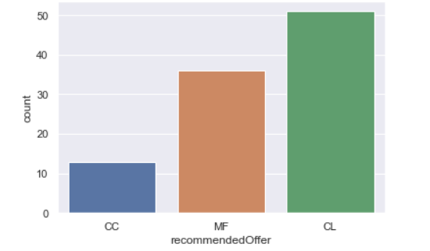

From this analysis we can see that consumer loan is playing important role in maximising the revenue and from above analysis we know that female clients are more interested in consumer loan so we can design our offers accordingly to increase the revenue.

For direct marketing campaigns we can focus more on consumer loan and mutual funds.