1. Sample of Storage of PII information in the database or file system (if any) used in the applications.

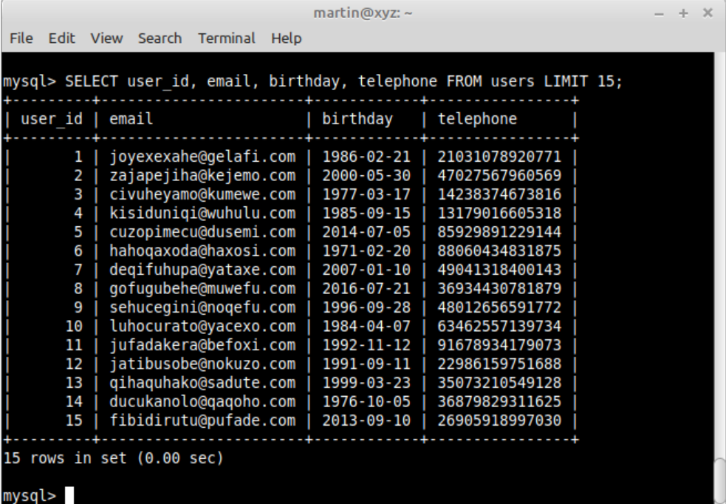

1. Sample logs for application, error logs, access logs and server logs

Application log

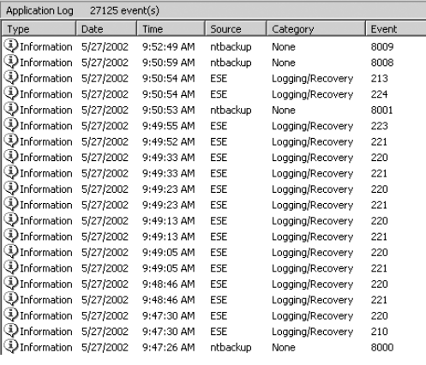

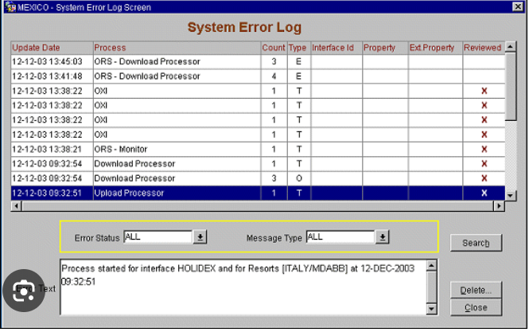

Access log

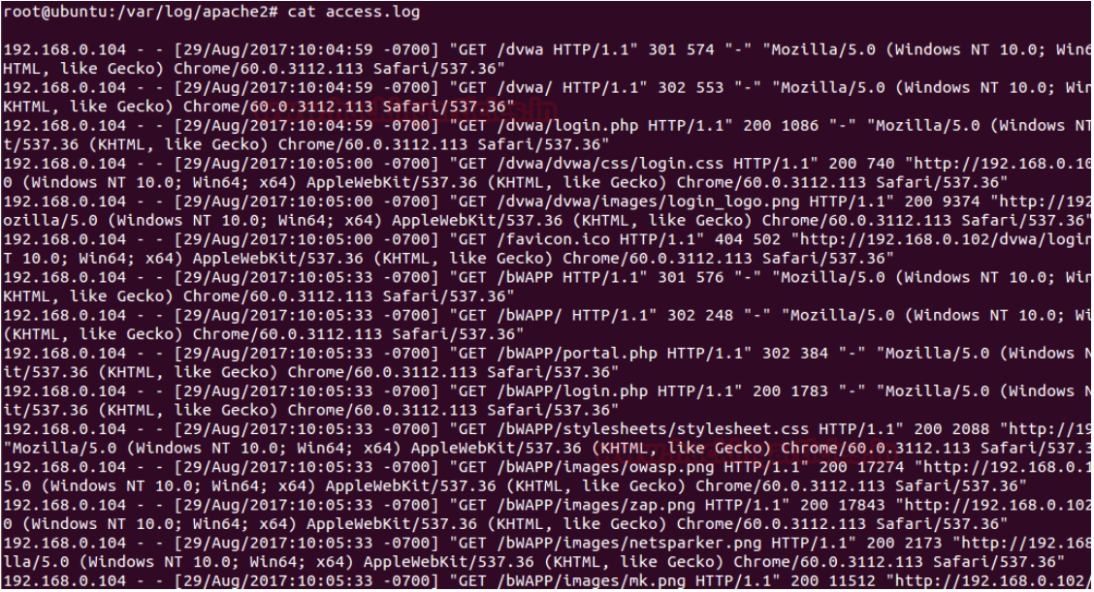

SERVER LOG

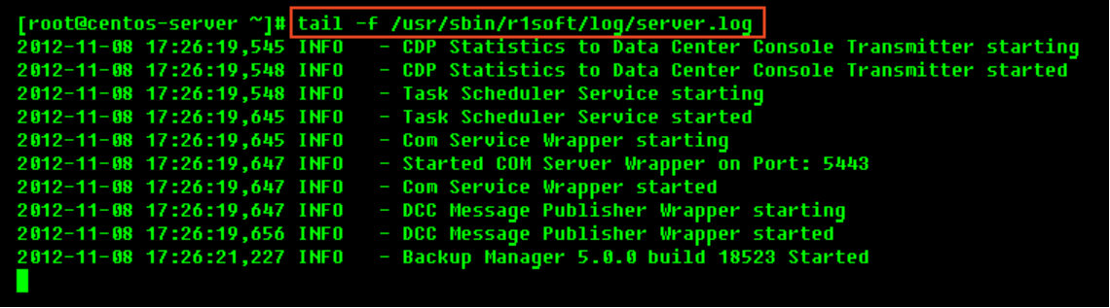

1. Last security clearance certificate issued date with evidence.



1. Sample Screenshot of password storage in DB.

1. Sample of password embedded in the DB password connection string? (Clear text/encrypted/hashed)



1. Whether files being uploaded (via the application) are being stored in file system or Database?

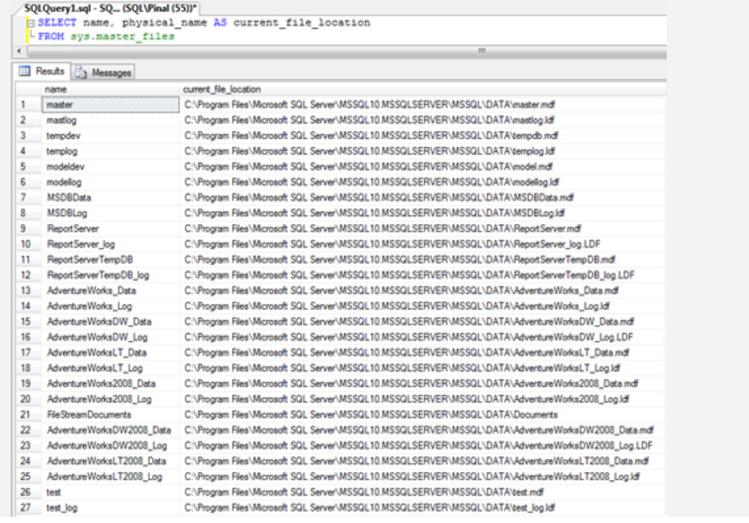

END OF DOCUMENT