- Spring IoC Container (or Application Context)
  - It is the Bean Factory.
  - All the center or everything is the ApplicationContext -- Spring’s IoC.
  - Spring IoC Container (Inversion of Control Container) is the core part of the Spring Framework responsible for:
    - creating objects (beans)
    - managing their life cycle
    - injecting dependencies
    - configuring them using annotations/XML/Java config
  - The container controls your objects → NOT you.
  - In simple terms --- The Spring IoC Container is the engine that creates and manages all Spring beans and performs dependency injection.
- Beans
  - A Spring Bean is simply a Java object that is
    - Instantiated by spring
    - Configured by spring
    - Managed throughout its life cycle by spring
  - Beans forms the backbone of a spring application and are the code building locks that are wired together to create the application.
  - In simple terms --- A Spring Bean is an object that Spring creates and manages inside the ApplicationContext.
  - Analogy:
    - Think of the IoC container as a restaurant kitchen:
    - You (developer) write the recipe (class definitions).
    - Spring (IoC container) cooks the dishes (creates objects).
    - Spring serves the dishes wherever needed (dependency injection).
  - Classes annotated with the following annotations will automatically become Spring Bean:
    - @Component
    - @Service
    - @Repository
    - @Controller
    - @RestController
  - If you want a class should be managed by Spring only; you don’t want to handle that by your own, then use @Component annotation.
    - 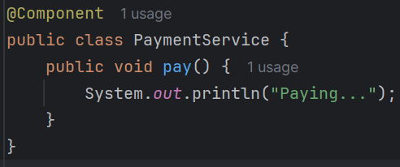
    - It is the bean. We created the bean now. But still we need to inject it.
  - To inject the bean, use the @Autowired annotation.
    - 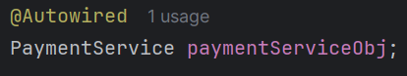
    - @Autowired tells Spring: “Give me the bean for this dependency from the IoC container.”
  - 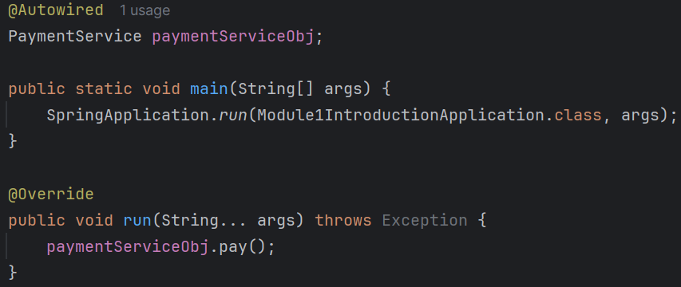
    - You can see here, we didn’t initialize the paymentServiceObj by our own. But it works because Spring created the bean (@Component) and it was injected here (@Autowired).
- There is an interface CommandLineRunner which is an functional interface containing one abstract function run.
  - This run method is executed by Spring framework by it self after all the beans are created.
  - CommandLineRunner in Spring Boot is a functional interface that lets you run some code immediately after the Spring Boot application starts, right after the ApplicationContext is fully initialized.

- Lets say you want to take control of the method of creation of Beans (Spring managed Objects).
  - Lets say the Class (out of which Bean will be created by Spring) is having some parameterized constructor and you want to take control and saying Spring that you need to pass this and that Object while creating the Bean (or creating the Object) of this class.
  - In this case you need to create one class using the annotation @Configuration.
  - The class having @Configuration will be treated as the Bean creation rule-book.
  - Inside this class, write methods which will return the Object of the particular classes you want to make Bean from. (classes means those Bean classes).
  - These methods should be written with the annotation @Bean.
  - 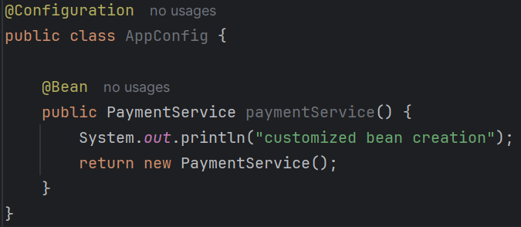
    - Here I don’t have any parameterized constructor, I just gave example of how to customize creation of Beans.
    - The bean name will be same as this i.e. paymentService -----------------
  - NOTE:
    - You are taking control of only the way of creation. Creation & Injection will be handled by Spring only.
    - No need of giving annotations like @Component, @Service ..etc before the Bean class (class from which beans will be created. here: PaymentService class) when you are creating bean with @Configuration and @Bean annotation.
      - Even if those annotation is there, @Bean will override those.
- Bean Life-cycle
  - Bean Created ==> Dependency Injected ==> Bean Initialized ===> Bean is Used ===> Bean is Destroyed
  - 2 Bean life-cycle methods are there: @PostConstruct, @PreDestroy.
  - As the name suggests, @PostConstruct will be called right after the Bean is initialized (between bean initialized and bean is used).
  - @PreDestroy is called after the bean being used and before destroying the bean. (between bean is used and bean is destroyed)
  - 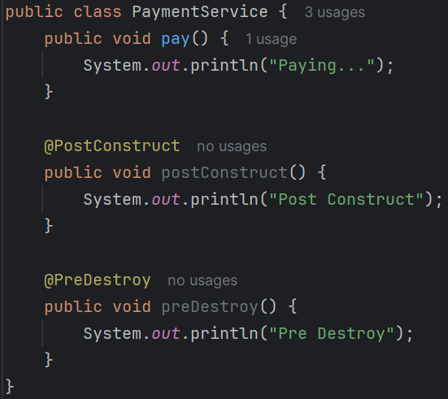
    - I added 2 methods using those annotations .
    - 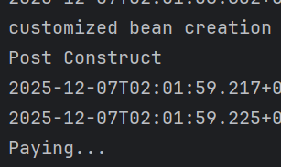
      - Customized bean creation was mentioned in the @Bean method.
    - So you can see, the Pre Destroy is not called yet; because it is run before destroying the Bean.
    - 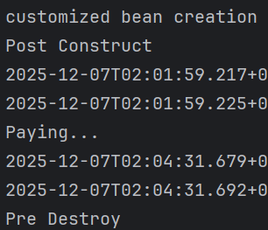
      - I stopped the run and it was executed.

- Bean Scope
  - By default the bean scope is Singleton (one instance of bean will be created and shared everywhere).
    - 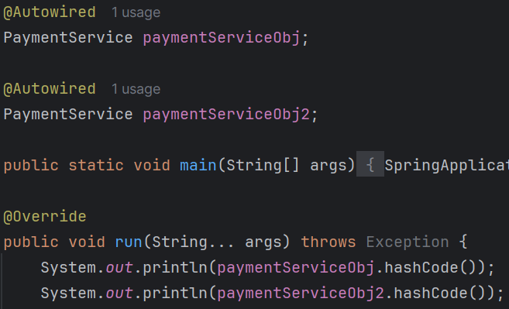
    - Created 2 instance of this bean.
    - 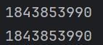
      - But if you see both are same. Because by default Spring created Singleton.
  - Now I am changing the scope to prototype.
    - It means it’ll create one instance per object.
    - 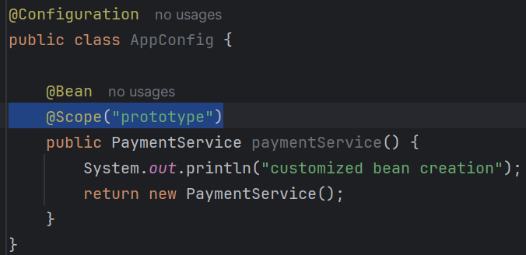
    - You can write like this using the annotation @Scope
    - 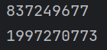
      - Now the hashcodes are different because both are different beans.

- Dependency Injection
  - DI is a design pattern where an object receives its dependencies from the outside, instead of creating them itself.
  - Lets say we have one interface NotificationService.
  - 2 classes are there which implement this interface: EmailNotificationService, SmsNotificationService.
  - Now we can create one object of type NotificationService and instantiate any type of NotificationService (either email or sms).
  - So, now lets make these classes as bean by adding the annotation @Component.
  - But now what will happen, Spring will be confused about which Bean (i.e. EmailNotificationService or SmsNotificationService) should be injected.
  - So for this, we can make one Class as primary so that when Spring will be having more than 1 option, it’ll go ahead with the Primary.
  - 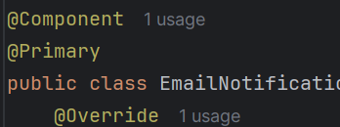
  - Before we were using @Autowired to inject the Bean. But that is not preferable because that is not safe.
  - It should be injected through the constructor.
  - 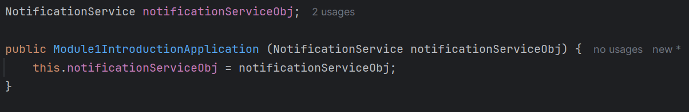
    - Here you can see, I have not mentioned @Autowired still it is working. Because by default, if the class is having only one constructor, then Spring will automatically treat that constructor like @Autowired
  - The above is same as below:
    - 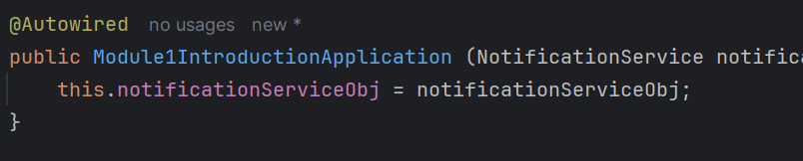

  - Types of dependency injection:
    - Constructor ==> @Autowired (optional) ==> Highly recommended
    - Setter ==> @Autowired (required) ==> Ok ok
    - Field ==> @Autowired (required) ==> Avoid in production
  - We were previously using the Field type of dependency injection.
  - Lets say you have 2 similar Beans but you don’t want to make anyone Primary (discussed above) then you can use @Qualifier
    - 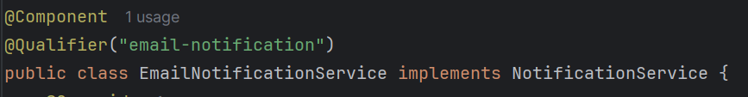
      - You can use the qualifier like this.
  - You can also use conditional selection of Bean using application.properties file.
    - 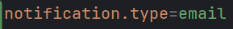
      - Write some key value pair in application.properties file.
    - 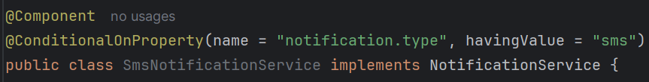
    - In sms class: @ConditionalOnProperty(name = "notification.type", havingValue = "sms")
    - In Email class: @ConditionalOnProperty(name = "notification.type", havingValue = "email")
  - Now no need of specifying the @Qualifier in the constructor. By default it’ll take depending upon the value of application.properties file.
  - If you want to inject all the beans i.e. if you want to send both email as well as sms then you can use Map
    - 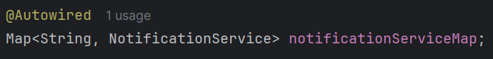
      - This one is more preferable.

- Classpath:
  - The list of places where Java should look for .class files when running your program.
  - You can set the classpath by your own.
  - In my case it is there in target/classes
    - 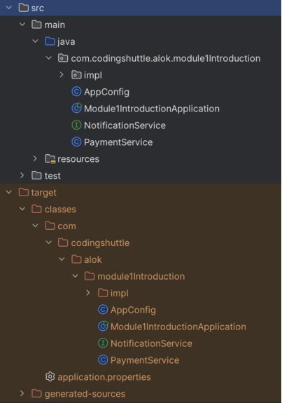
  - If you see here, src contains the .java files. target/classes contains the .class files.
  - Classpath DOES NOT include src/main/java. Why?
    - Because .java files are NOT executed by JVM.
    - Only bytecode (.class) is executed → so classpath always uses:
      - target/classes
      - external JARs
      - resource folders
- Build path
  - In short this is the src directory where .java files are present. Along with this the packages which are .class files (like ArrayList.class, Collections.class …etc).
  - Build path tells the IDE/compiler: “Where should I look for .java files AND library .class files so I can compile your source code?”
- Build Path = the list of places/tools the IDE (IntelliJ/Eclipse) uses to COMPILE your code.
- Classpath = the list of places the JVM uses to RUN your compiled code.

- pom.xml (Project Object Model)
  - It is used by spring to build the application.
  - 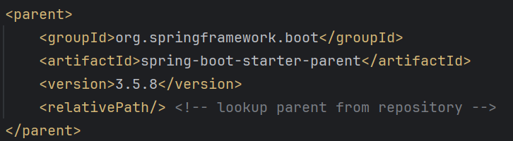
  - You can see this type of parent dependency spring-boot-starter-parent.
  - 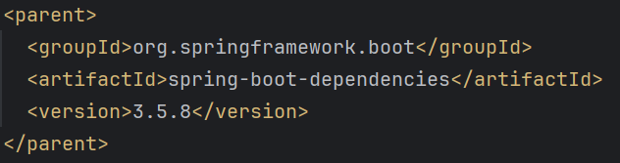
  - When you open that spring-boot-starter-parent, you’ll get one more parent in that parent xml file.
  - If you again go to this parent xml file, you’ll find the following:
    - 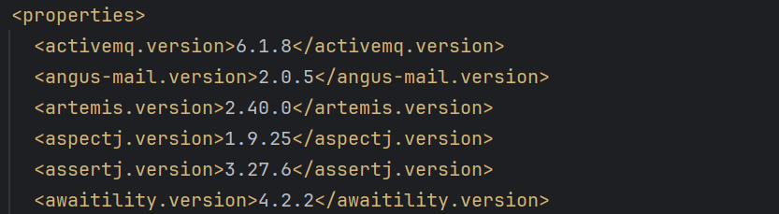
    - Here you can find a lot of dependencies.
    - Spring maintains the versions of these dependencies; we don’t have to manage the versions of the dependencies when we pull those dependencies.
    - These are springboot starters dependencies.
  - Maven is a popular build automation tool used in many Java projects. In a spring boot project, dependencies are specified in the pom.xml. Maven then resolves these dependencies and includes them n the classpath.
    - First it’ll go inside the pom.xml
    - It’ll go to all the parent dependencies till parents are present.
    - At the end, it’ll get to know about the versions which it has to fetch. (the above image <properties>)
    - Then it loads the dependencies that are required by Springboot application inside classpath.
  - Starters like spring-boot-starter-parent include a ton of third-party libraries into your project - by default. Its AutoConfigurations use these dependencies to setup and preconfigure these libraries automatically.
    - It dig through all the dependencies file (if parents are there it’ll go to the end and for every dependencies it’ll do that), and then fetch all the dependencies and store in the “External Libraries” folder.
      - 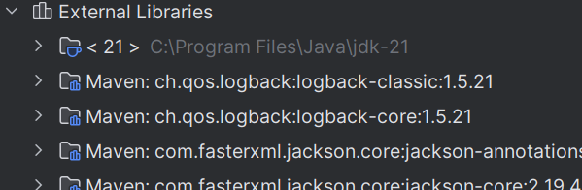
    - For example, if the spring-boot-starter-parent is added, then all the dependencies to which this is dependent will also be added.
  - There is one package inside the External Libraries foldere which is autoconfigure.
    - 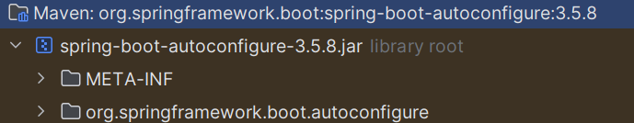
- Inside that autoconfigure package you’ll find one Autoconfiguration.imports file.
  - 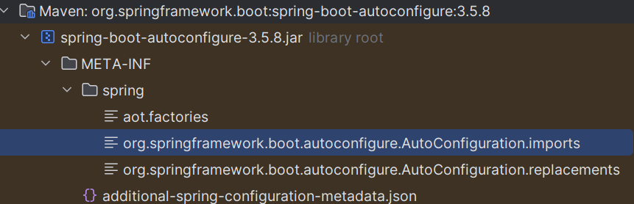
  - Here all the dependencies that Springboot will gonna auto-configure are mentioned.
    - It contains fully qualified class names of auto-configuration classes.
      - 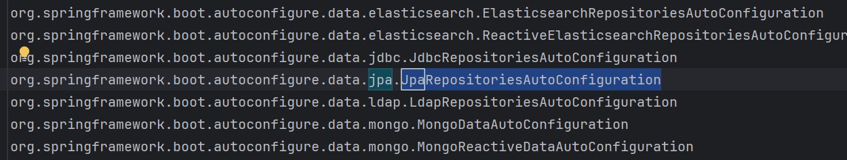
  - I opened that jpa auto-configure class file and inside which multiple conditionals are there. When all the conditions becomes true then only Bean will be created out of this class.
    - 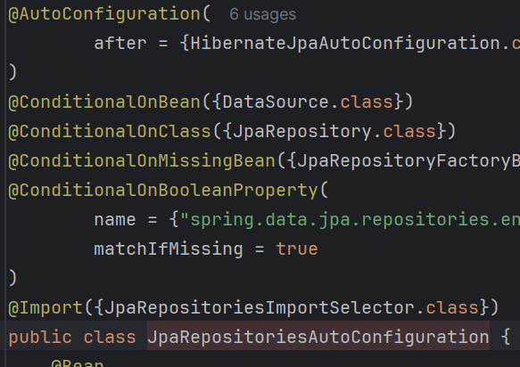
    - Lets say one class name is there in the Autoconfigure.imports but the .class file is not there in the classpath.
      - In this case, due to @ConditionalOnClass, Spring Boot simply skips that auto-configuration and does NOT create its beans.
- How Autoconfiguration works?
  - Classpath Scanning
    - Spring boot scans the classpath for the presence of certain libraries and classes.
    - Based on what it finds, it applies corresponding configurations.
  - Configuration Classes
    - Spring boot contains numerous autoconfiguration classes, each responsible for configuring a specific part of the application.
  - Conditional Beans
    - Each autoconfiguration class uses conditional checks to decide if it should be applied.
    - These conditions include the presence of specific classes, the absence of user-defined beans, and specific property settings.
- Enhanced Conditional Support
  - Spring boot comes with its own set of additional @Conditional annotations, which make developers’ lives easier.
  - @ConditionalOnBean(DataSource.class)
    - This condition is true only if the user specified a DataSource @Bean in a configuration.
  - @ConditionalOnClass(DataSource.class)
    - This condition is true if the DataSource class is on the classpath.
  - @ConditionalOnProperty(“my.property”)
    - This condition is true if my.property is set.
- @PropertySource
  - It loads a .properties file into Spring’s Environment, so that you can use the keys/values inside your classes.
  - 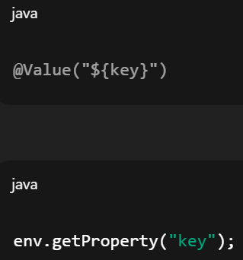
- @EnableAutoConfiguration
  - This enables auto-configuration.
  - 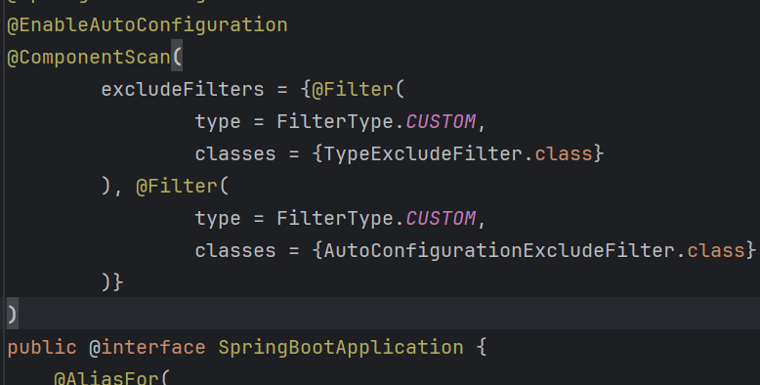
  - You can see here, @EnableAutoConfiguration is used inside @SpringBootApplication.
- @ComponentScan
  - @ComponentScan tells Spring: “Please scan this package and find all classes that are components, services, controllers, configs, etc.”
  - Spring will automatically detect: @Component, @Service, @Repository, @Controller, @RestController, @Configuration and create beans for them.
  - 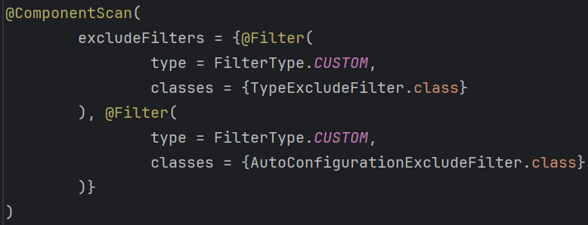
    - “Spring, scan this project for components, BUT DO NOT register classes that Spring Boot wants to exclude (test slice exclusions, auto-config classes).”
- When you click the run button of the main java file, inside the main method there is only one function call that is run.
  - 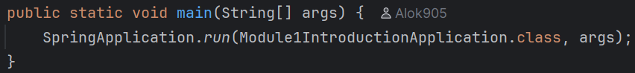
  - If you go to that run method, you’ll see it’d be returning another run method’s return value, and again it’ll repeat. At the end you’ll find the following method:
    - 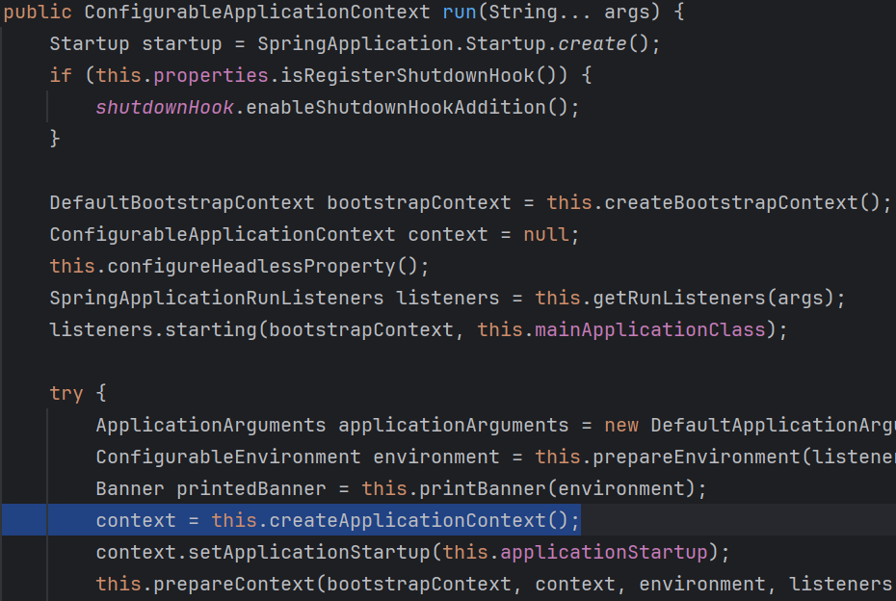
  - You can see this is creating the environment, ApplicationContext (where all the beans will be present) etc etc..

- Maven
  - It is a build tool that is used to build Java applications (not only spring or springboot).
  - 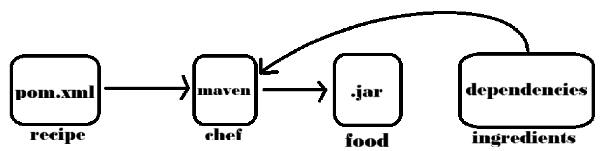
    - Chef (maven) wants to cook the food (.jar or build file)
    - It needs the recipe (pom.xml) and ingredients (dependencies) to make this.
  - Project & Dependency management:
    - Maven provides a standardized way to manage Java projects by defining project structure, dependencies, and build configurations using a declarative XML-based format (pom.xml)
    - Developers use Maven to specify project metadata, dependencies, plugins, repositories, and other project-related configurations.
    - Spring framework and its various modules (e.g. Spring core, Spring MVC, Spring Boot) are managed as dependencies in Maven projects. Developers specify the Spring dependencies in the pom.xml, and Maven handles the rest.
  - Build Automation
    - Maven automates the build process, including compilation, testing, packaging, and deployment, using predefined build lifecycle phases (e.g. clean, compile, test, package, install) .
    - Maven facilitates the building and packaging of Spring applications into deployable artifacts (e.g. JAR files, WAR files) for deployment in production environments.
    - Maven Life Cycle Phases:
      - Validate -- Compile -- Test -- Package -- Integration Test -- Verify -- Install -- Deploy -- [again Validate -- Compile --… etc]
    - mvn compile = compile project and generate class files
    - mvn clean = all previous builds will be removed
    - mvn test = execute testing steps

    - mvn install = deploy packaged WAR or JAR file by storing in local repository as classes
    - mvn package = generates a distributable WAR or JAR
    - mvn deploy = packaged JAR or WAR file is copied to the remote repository to be deployed
    - mvn spring-boot:run = runs a spring boot application directly from the source code without packaging into JAR or WAR file.
    - mvn spring-boot:build-image = builds a docker image of the spring boot application using the spring boot maven plugin.
  - After packaging, you can share the JAR or WAR file and it can be run using the following command:
    - java -jar path/to/jarfile/file.JAR

- Some Important Notes:
  - If you are writing @Component, then you can write @Qualifier in that class it self. But if you are using manual configuration using @Configuration and @Bean then you need to write the @Qualifier in that AppConfig class method itself.
  - Lets say you have one interface Syrup, and there are classes that implement this interface let say ChocolateSyrup and StrawberrySyrup.
    - If you want to create Bean of these 2 child classes, then either you can make anyone @Primary (Same as qualifier; if writing with @Component then write @Primary in that class level; otherwise in the AppConfig method level) or you can use @Qualifier .
      - 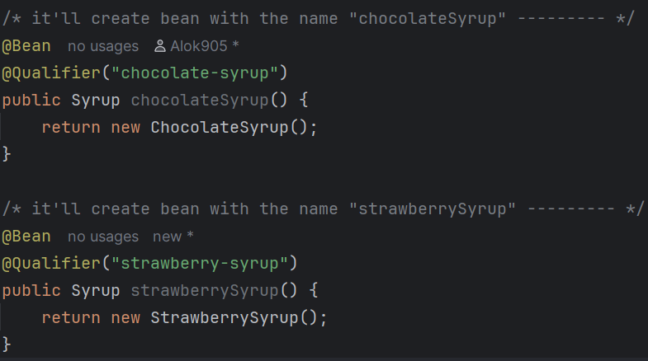
        - @Qualifier example
      - 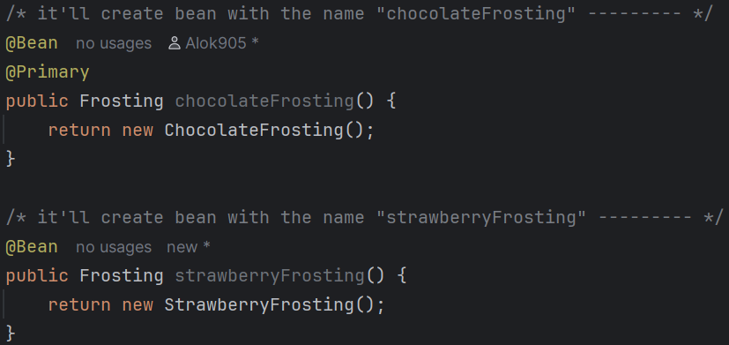
        - @Primary example.
      - Remember, if you are creating Bean of the class inside that AppConfig that is using the Qualifier things then you need to mention the @Qualifier in that AppConfig only.
        - 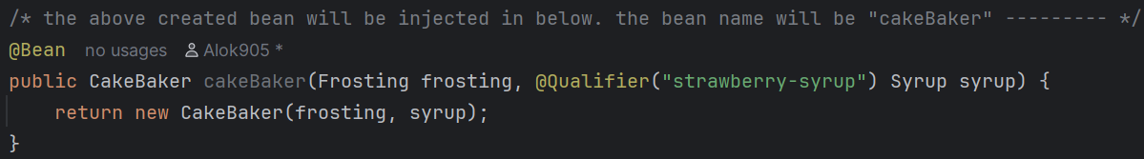
    - You can use @ConditionalOnProperty as well for this.
      - 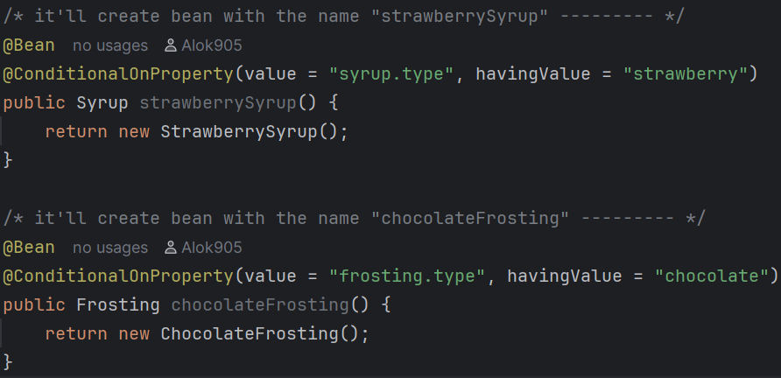
      - NOTE: in application.properties file, don’t use double quote to write the value.

- F
- F
- F
- F
- F
- F
- F
- F
- F
- F
- F
- F
- F
- F

