* Source code (java, .net etc) => Compile (javac, Roslyc etc) => Tests (Unit/Integration) => Packaging (jar, war, .exe, msi, .zip etc) => Health checks (Code analysis, Find bugs)
* Build tools:
  + Maven
    - Language : java
    - Build file format : xml
  + Ant
    - Language : java
    - Build file format : xml
  + MsBuild
    - Microsoft build engine is a platform for building applications.
  + Gradle
    - DSL based on Groovy
  + & NANT
    - Windows .net platform
  + Make
    - Builds executable programs and libraries from source code.
* Maven:
  + 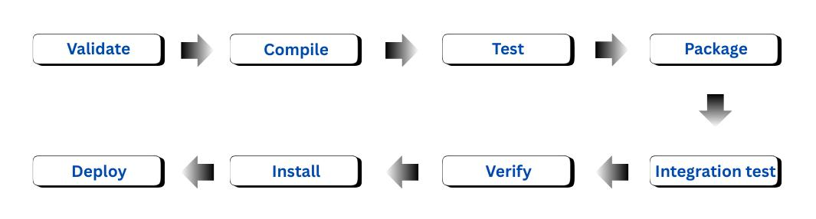
  + Validate:
    - Validate the project is correct and all necessary information is available
  + Compile:
    - Compile the source code of the project
  + Test:
    - Test the compiled source code using a suitable unit testing framework.
    - These tests should not require the code be packaged or deployed.
  + Package:
    - Take the compiled code and package it in its distributable format, such as a JAR.
  + Verify:
    - Run any checks on results of integration tests to ensure quality criteria are met.
  + Install:
    - Install the package into the local repository, for use as a dependency in other projects locally.
  + Deploy:
    - Done in the build environment, copies the final package to the remote repository for sharing with other developers and projects.
* In context of Java:
  + JDK : Java Development Kit
    - Try executing the command **apt search jdk**, you’ll get so many.
    - I am installing **jdk-17** and **jdk-21**.
  + JRE : Java Runtime Environment
    - It is just to run the java application in order to do some development work.
* Steps I followed for **Maven**:
  + **apt search jdk | grep 17** (to find jdk version 17)
  + **apt search jdk | grep 21** (to find jdk version 21)
  + **apt install openjdk-21-jdk -y**
    - Installed jdk version 21.
    - You can verify the version using **java --version** command.
    - 
  + **apt install maven -y**
    - Installed maven.
    - You can verify the version using **mvn --version** command.
    - 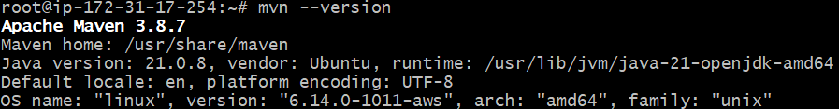
  + Cloned the repo from the github (having java application)
  + **mvn validate**
    - 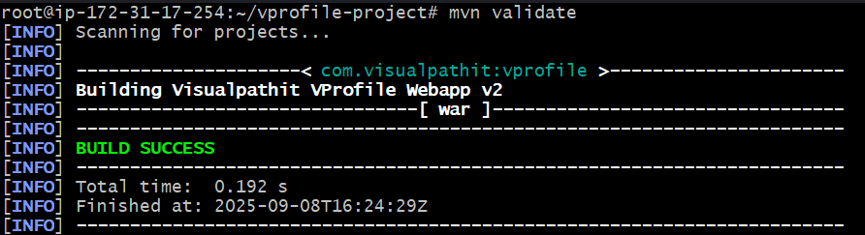
  + **mvn test**
    - Trigger unit testcases written by the developers.
    - Generate report inside target folders.
  + **mvn install**
    - When you execute this command, **mvn** will download all the dependencies present inside the **.pom** file.
    - 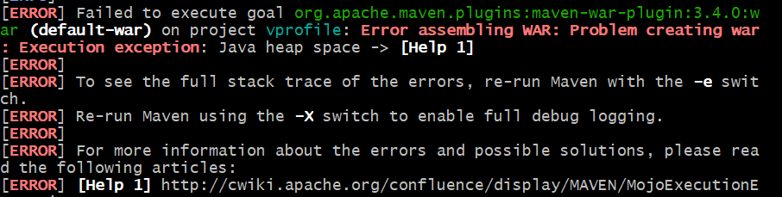
    - Its saying some heap space error.
    - **export MAVEN_OPTS="-Xmx1024m"**
      * It’s telling Maven: “when you run, give your JVM a maximum of 1 GB heap memory.”
    - Now the build succeed.
  + **~/.m2/repository**
    - Here the installed dependencies remain.
    - 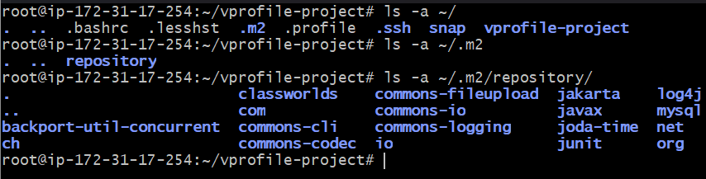
  + **mvn clean install**
    - It’ll delete the target folder (if present) and then start the build process.
    - But it doesn’t delete the dependencies.
    - If you want a proper clean installation, then delete everything inside that repository i.e. **rm -rf ~/.m2/repository/\*** and then run **mvn clean install**.
    - It’ll remove the *target* folder and build the application again.
  + I downloaded **jdk-17** version now.
    - **apt install openjdk-17-jdk**
    - Now if I execute **java --version**, it still displaying *version 21* only.
  + To switch between **jdk versions**: **update-alternatives --config java**
    - 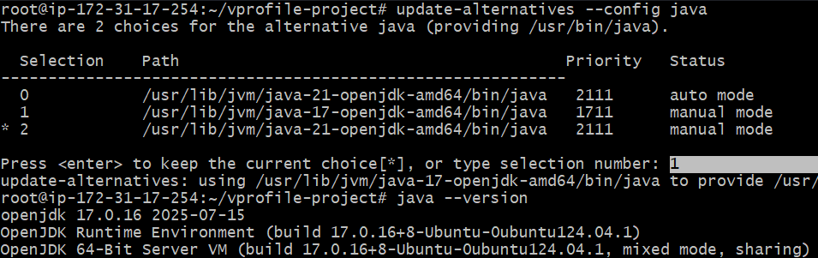
  + If you want to use a different version of **mvn** to be used, then you can download the *binary* file from the ***mvn*** *archive*.
    - <https://archive.apache.org/dist/maven/maven-3/3.9.9/binaries/>
      * I installed 3.9.9 version of **mvn**
      * I downloaded using wget (I downloaded **zip** file, you can even download **tar.gz** file)
      * Unzipped it and moved it inside */usr/local/bin/mvn3.9* folder.
      * 
      * **/usr/local/bin/mvn3.9/bin** : in this folder, **mvn** command presents.
        + 
      * **/usr/local/bin/mvn3.9/bin/mvn clean install**
        + Executed inside the vprofile-project, now it’ll use the installed **mvn** version instead of the *default mvn version.*
* You can open **cloudshell** inside the aws console.
  + Its just a RPM based terminal where you can simulate the things.
  + Button is present at the *bottom-left* cornor.
* Difference in Debian and RPM based:
  + In Debian based (ex: ubuntu), packages are usually named as **openjdk-\*** or **default-jdk**
    - openjdk-11-jdk
    - openjdk-17-jdk
    - default-jdk
  + In RPM based (ex: centos), packages are usually named as **java-\*** (sometimes **java-<version>-openjdk**)
    - java-1.8.0-openjdk
    - java-11-openjdk
    - java-17-openjdk
* **sudo dnf search java | grep 21**
  + Inside cloudshell, used this command to search the **java version 21**packages.
  + 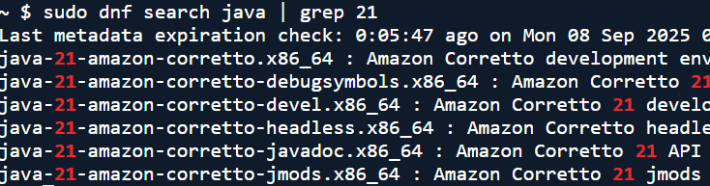
  + When you see *corretto*, means it is from *AWS*.
* **dnf install maven -y**
  + Installed maven as well

DON’T FORGET TO DELETE THIS INSTANCE, OTHERWISE YOU’LL BE CHARGED BY AWS