* **Mark the difference of “” (double quotes) and ‘’ (single quotes)**
  + 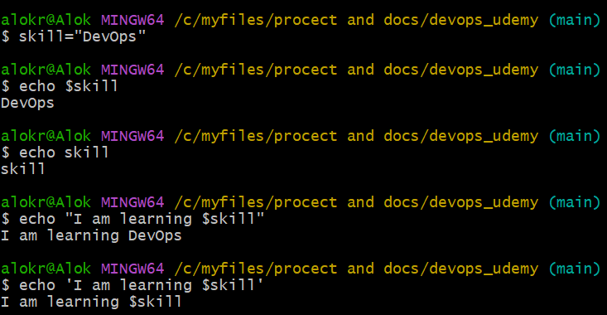
  + $<variable_name> is executed inside “” not inside ‘’.
* **YAML**
  + 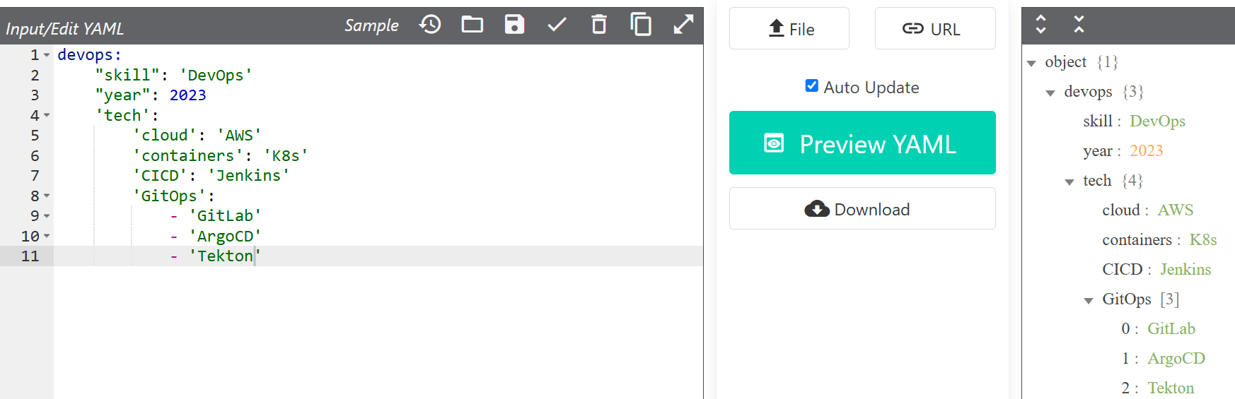
  + Don’t give any brackets.
  + There should be one space after **:** (colon)
  + Properly indent.
  + ***Single quote*** or ***Double quote*** or ***No quote***.. both are acceptable.
  + 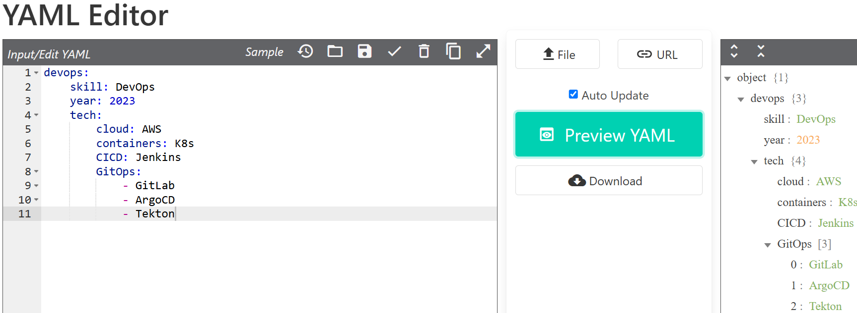
  + Comma is not acceptable.
  + For list, **-** and a space should be given.
  + 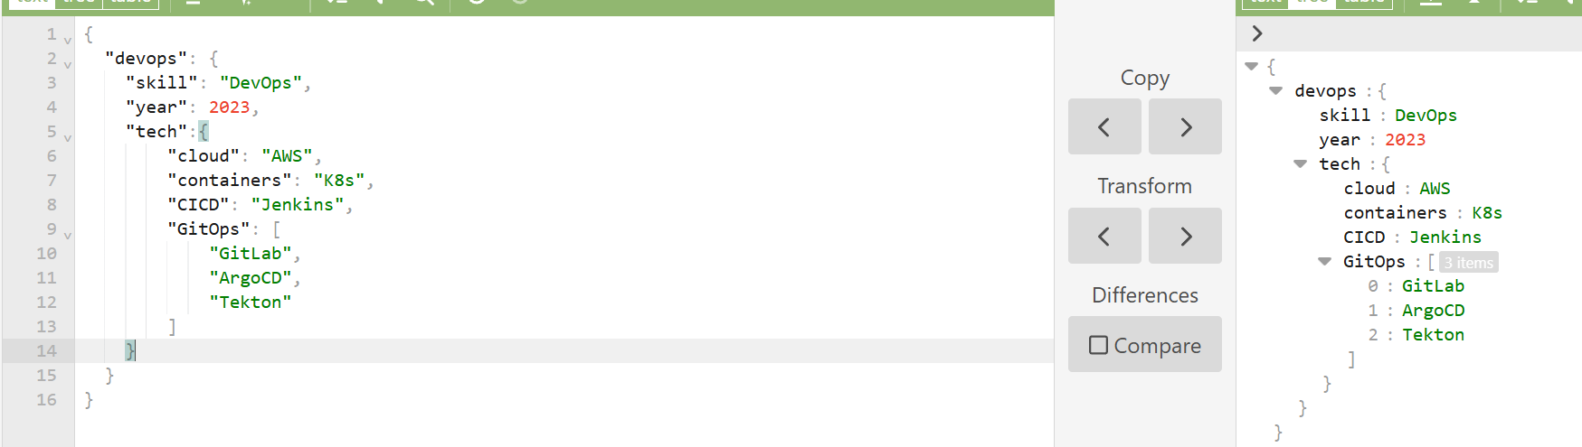
    - This is same as above, just the difference is.. this is **JSON** and above is **YAML**