* If the website is written in Java, then Apache Tomcat is very famous service to host it.
* NFS:
  + Centralized storage for cluster of servers.
  + Sharing home directories or software installations across multiple systems.
  + Clusters and containerized environments (e.g., Kubernetes).
* 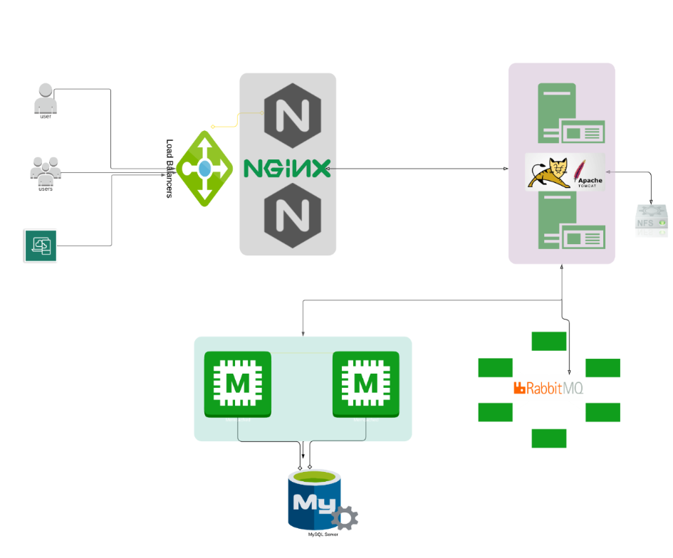
* **Load Balancer:**
  + Imagine:
    - Multiple people want to go to the same place (your website).
    - There are several routes to get there (multiple servers or containers running your app).
    - The traffic cop (load balancer) watches all the routes and sends each person down a route that’s free or less crowded so no single road gets jammed.
    - This way, everyone reaches the destination smoothly without traffic jams (server overload).
  + So, in your website setup:
    - The visitors = people
    - Multiple containers/servers = multiple routes
    - Load balancer = traffic cop deciding who goes where
  + Multiple containers means multiple copy of your website is there in multiple containers.
  + Another benefit is, If one of the containers goes down then also it’ll work smoothly as other containers are having the copy of this website
* **Apache Tomcat or Any Hosting System:**
  + Tomcat is the place where the actual website runs.
  + And Tomcat runs in side a container.
  + It means, **each containers will be having their own Tomcat where the website copies will be running separately.**
* **NFS (Network File System):**
  + Let one user posts a photo or document which went through the container C1, and the document is stored in side C1.
  + Let the same user again send get request to see the photo and now let the container C1 is busy. Then the load balancer will forward the traffic to any other container (let C2).
  + But the document/photo was stored in C1, so the user can’t get the photo as the current container is C2.
  + **This is where NFS comes into play. It is a centralized storage which can be accessed by all the containers.**
* **MySQL & MEMCache:**
  + Now, you must have a doubt that why do we need mysql db now where we already have NFS to store the data.
  + NFS store the files like pdf, images etc etc. But we can’t query in side that.. It’s just like a hard drive.
  + Whereas mysql can be queried.. just imagine you have a book
    - **MySQL: index page (organized and structured, what and where)**
    - **NFS: the actual content**
  + MEMCache is like a cache where frequently used data are stored. First the data is checked in the MEMCache, if it is not there then it’ll go to MySQL.