**GITHUB CLI COMMANDS**

* Simple commands for creating/modifying any file/files and push that to remote repository.
  + **git init**
    - When you create a folder in your local machine, it is not a *local git repository* by default.
    - Use this command to make that directory a local git repository.
    - You must see a folder **.git**.
    - This folder keep the track of all things that is happening or was happened inside your repository.
    - Executing the **git init** command does nothing but create a **.git** folder in your directory.
    - Without that **.git** folder, you can’t execute any git command like **git add**  or **git commit** or anything.
    - 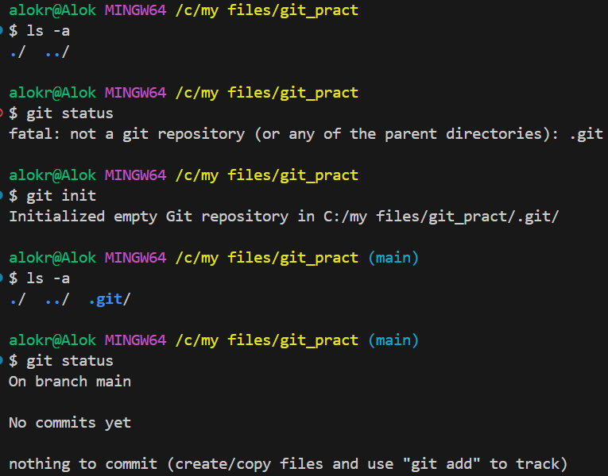
      * You can see here, before **git init**, there was no **.git** folder, that’s why I was unable to execute any git command.
      * After executing **git init**, one folder **.git** got created and then git got to know that this folder is a git repository.
  + **git add**
    - This command make the untracked changes (like adding any new file, or modifying any file, or deleting any file inside the working directory) as tracked.
    - 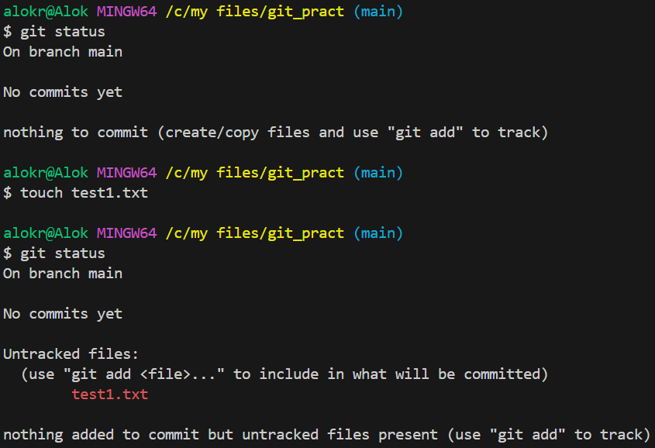
    - You can see, I created one file, so now it’s showing as an **untracked** file as git doesn’t know this file.
    - 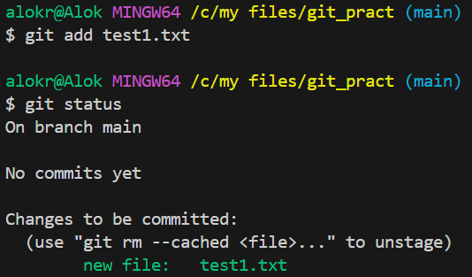
    - Now, I added this file using **git add** command, and now git was able to track this file. So, its telling to commit this file so that it’ll be updated in the local repo.
  + **git commit**
    - This command will update the **tracked changes** (changes that was added using **git add** command) to your local repository (means inside **.git** folder) against a comment that you give while executing **git commit** command.
    - 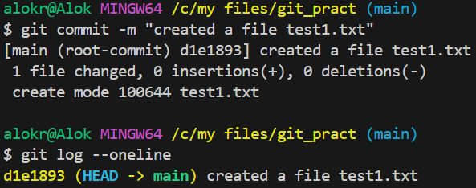
    - I committed that change (means creation of file test1.txt) and when I executed the command **git log**, it displayed my commit and what was done in that commit.
      * That’s why giving a proper message while executing **git commit** is a good practice to know why that commit was made for.
  + I created one git repository in the github (remotely) and I want to connect my this local repo to that remote repo. (it has to be done once only)
    - **git remote add origin** <url of the remote repo>
    - 
  + After connecting with the remote repo, you can push the changes into the remote repository.
    - Till **git commit**, all the changes were happening locally.
    - When you execute **git push**, it’ll update the remote repository.
    - 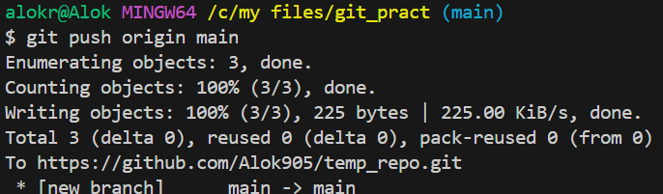
    - 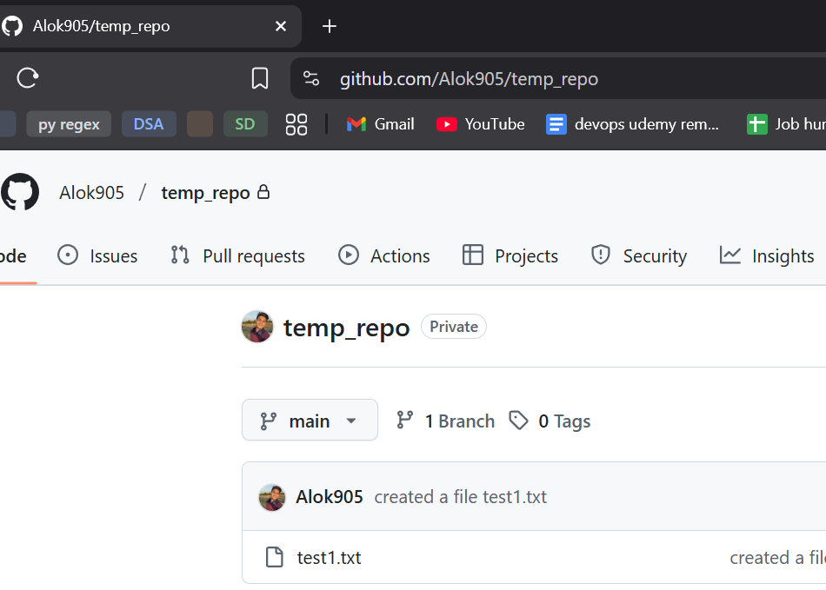
* **Stages:**
  + Working directory:
    - It is your local project where you add/edit/delete files.
    - Changes that are not tracked after the previous commit.
    - Mostly you’ll see **modified** and **untracked** files.
    - **git status**
      * This command can be used to see the status of your current working directory.
    - 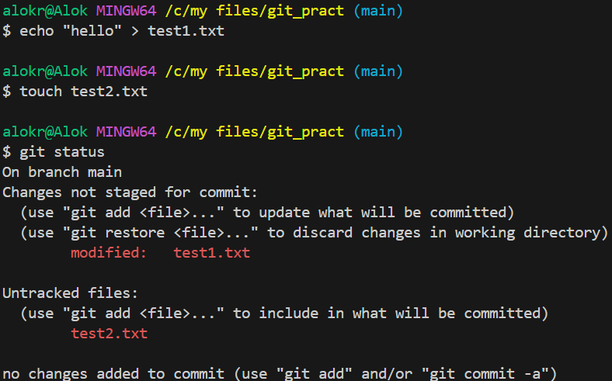
      * I added some texts inside the ***test1.txt*** (which is already tracked by git) and created a new file ***test2.txt***.
      * As git knows **test1.txt** file, but it sees that something has been changed inside that file, so it marks it as **modified**.
      * Where as, git doesn’t know abou the file **test2.txt** as it is created now only, so it marks it as **untracked**.
  + Staging Area:
    - After executing **git add** command, the untracked/modified files go to staging area.
    - Its kind of a bucket where all the modifications are collected which will be submitted in the next commit.
    - Suppose you added/modified something in your working directory and added those to staging area. And again added/modified something in the working directory but didn’t stage those.
      * Now if you commit, then only the modifications those were staged will be committed. Not those which were modified but didn’t stage.
      * 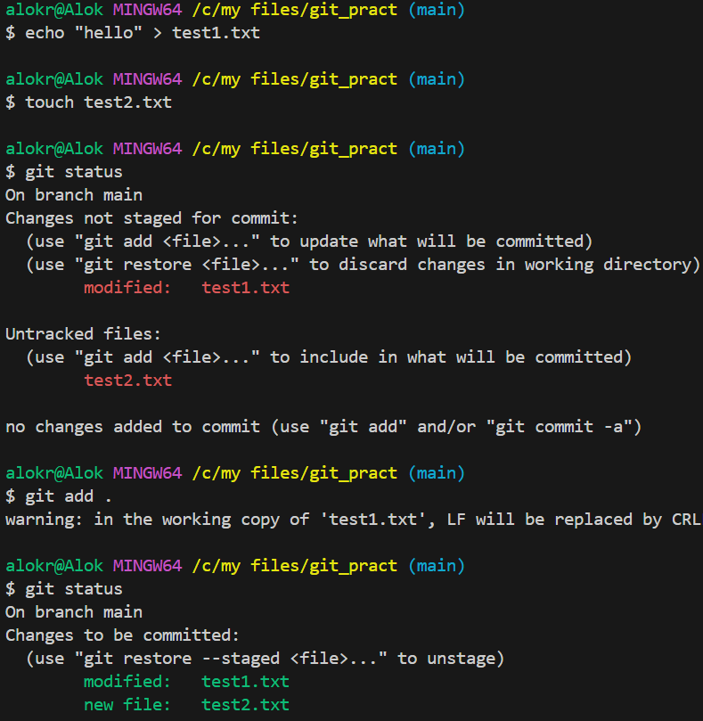
        + I added the files *test1.txt* and *test2.txt* into staging area using command **git add .**

**.**  means you are staging all the changes that you made your working directory.

* + - * 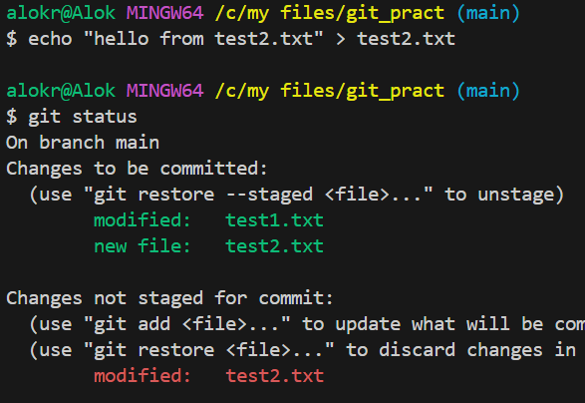
        + Now I added some text inside *test2.txt* and not staging it.
        + *Green* color texts shows what are inside the staging area, and *red* color shows the changes which are not staged yet.
      * 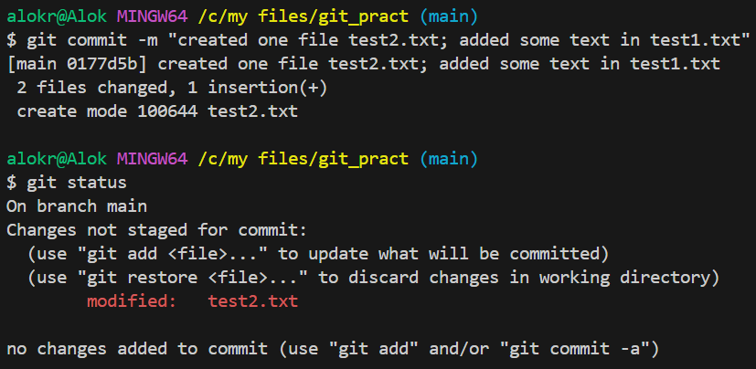
        + Now you can see, only the staged modification got committed, the changed which were not staged are still there.
  + Local Repository:
    - Whatever you commit, it stays in your local repository (you can think it is stored inside the **.git** folder)
    - But the remote repository is still not aware about this.
  + Remote Repository:
    - After the commit, when you push the changes, it goes to the remote repository.
    - After this, your local repository and remote repository will be in sync.
    - 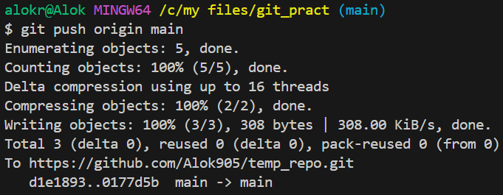
      * Now it is updated in the remote repository.
* If you have made some changes in a file, and want to revert it back as it is there in the last commit then use **git restore** command.
  + 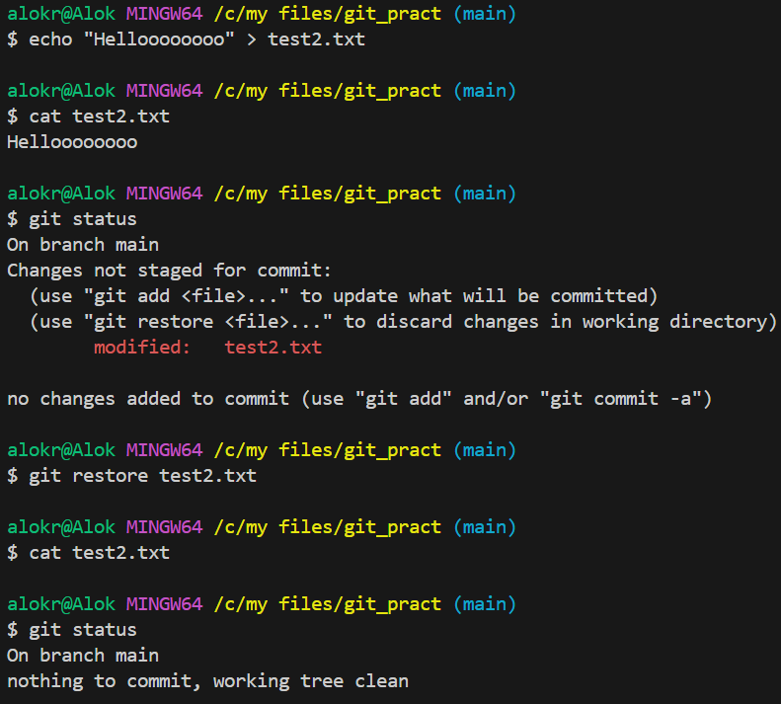
* If you have staged some modification and want to undo those; means you want to transfer the changes from staging area to the working directory then you can use the command **git restore --staged <filename>**
  + 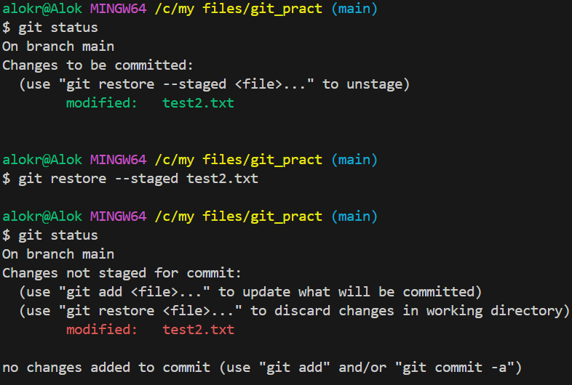
    - Here, the changes in the file was staged. Then I executed **git restore --staged test2.txt** command and now the staged changes became unstaged.
* If you have made a commit but the code but now want to revert back to the previous commit.
  + Let the commits are C1 -> C2 -> C3 -> C4 -> C5
    - Latest commit is C5
  + You want to go back to C3 (let)
  + The command for doing this is: **git reset --hard <commit id>**
  + 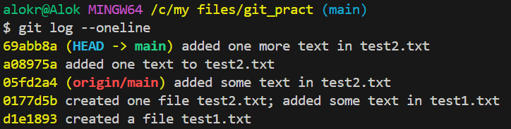
    - These are my current commits. I want to go back to *05fd2a4*.
  + 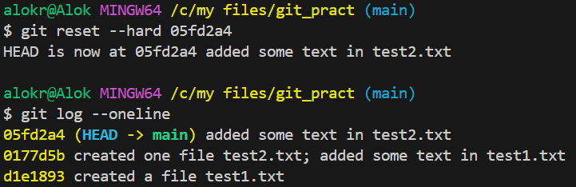
    - All the commits made after *05fd2a4* got deleted.
    - You can see one text “HEAD is now at 05fd2a4 *…”*
      * **HEAD** is nothing but just one pointer that points to the latest commit.
* One more scenario; let you have some commits C1 -> C2 -> C3 -> C4 -> C5; you want to undo the changes made in the commit C5 but don’t want to delete C5.
  + I just want to add one more commit which will contain the things undoing the changes done in C5.
  + Here, you can use **git revert** command.
  + 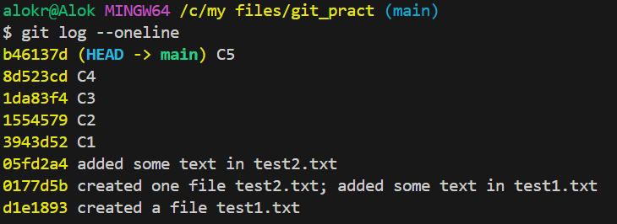
    - I made some changes in the file.
    - 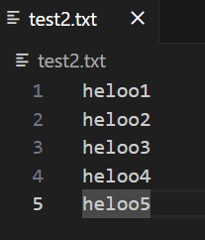
      * This is my file; Every line is a different commit. Means
        + added *hello1* and committed. (C1)
        + Added *hello2*and committed. (C2) … and like this till C5
    - Now I want to undo the commit C5 (means I want to remove *heloo5* from the file)
      * The command will be: **git revert HEAD** (OR) **git revert b46137d**
        + As HEAD is pointing to b46137d commit only (latest commit).
      * After executing this command, one editor will be opened.
        + 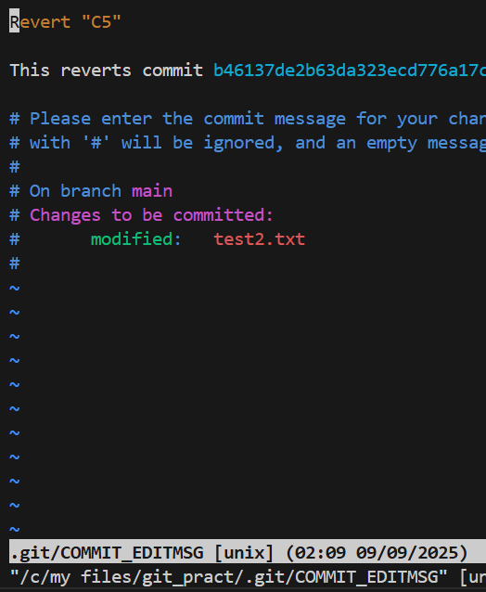

You can write the commit message inside this and save it.

* + - * 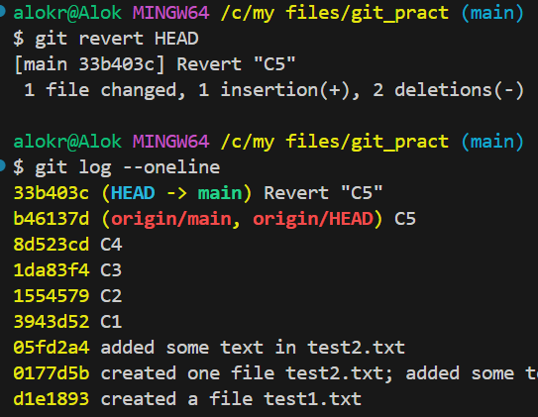
        + Now, one more commit got added undoing the changes of commit C5.
      * 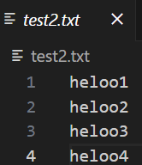(*hello5* was added in C5, which is not there now)
    - It is helpful if you don’t want to delete the commit. Means later someone can see what had been done in that commit.
    - If you want to revert C3 here, it will give conflict; as after C3, you are changing the same file in commits C4, C5;
      * In simple term, C4 and C5 are built on top of C3 in this case.
      * So, it’ll give conflict.
      * 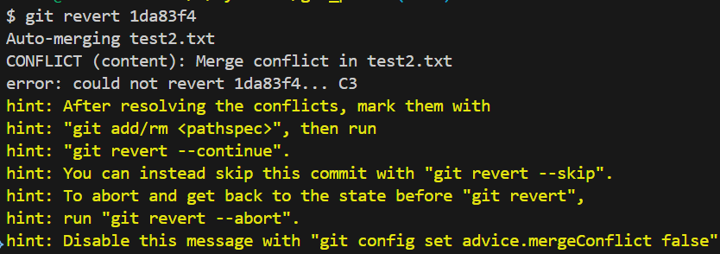
    - If the later commits (C4, C5 in this case) would not be changing the same file that C3 was doing, then reverting would be successful.
      * All the changes in the commits C1 to C5 were made in ***test2.txt***.
      * Now, I am adding one commit in ***test1.txt***
        + 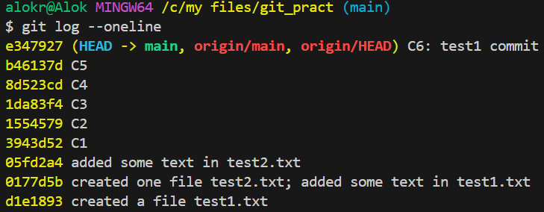

C6: did some changes in test2.txt file

* + - * + Now, if I try to revert the commit C5, then it’ll work fine.

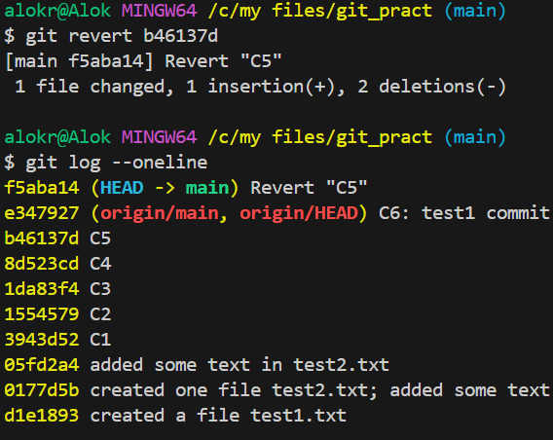

It worked because the commit C5 was not hindering the commit C6; because both were made in different files.

* **git pull**
  + If the remote repository has been updated with some extra commits by other collaborators i.e.
    - Local repo : C1 -> C2 -> C3 -> C4 -> C5
    - Remote repo : C1 -> C2 -> C3 -> C4 -> C5 -> C6 -> C7
    - In this case, you need to update your local repo with the remote repo and then do your required changes. Otherwise it’ll give conflicts while pushing to the remote repo.
    - Command: **git pull origin <branch name>**
      * If I want to update my **main** branch then: **git pull origin main**
  + Conflict scenario (assume every changes are being done in a single file):
    - Initial condition:
      * Local repo : C1 -> C2 -> C3 -> C4 -> C5
      * Remote repo : C1 -> C2 -> C3 -> C4 -> C5
    - I deleted a line in remote repo and committed; But in local repo added some extra texts in that same line and committed;
      * So now, both will conflict; as the same line has been changed in both local and remote repo.
      * For example:
        + (remote repo; deleted the line “hello3”)
        + 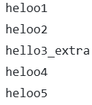(added some extra text on the same line “hello3_extra”)
      * Local repo : C1 -> C2 -> C3 -> C4 -> C5 -> **Cx**
        + 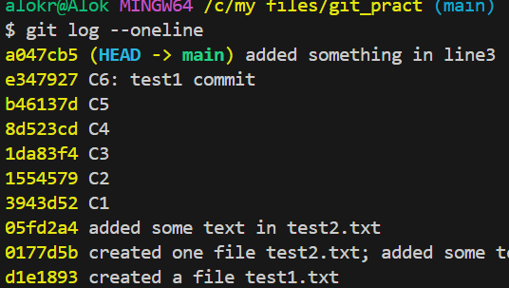

commits: …… e347927 -> **a047cb5**

* + - * Remote repo : C1 -> C2 -> C3 -> C4 -> C5 -> **Cy**
        + 

commits: …… e347927 -> **6c75a2f**

* + - * Now, in local and remote repo, latest commits are different.
        + 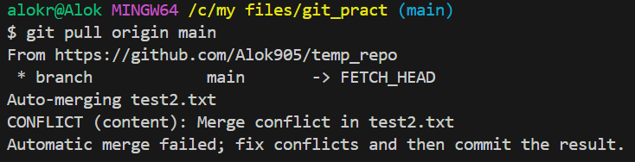
      * 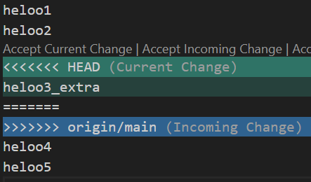
        + You’ll get something like this. Need to fix the merge conflict and then merge.
      * **So, its better to pull the changes from the remote repo before working to avoid the merge conflicts.**

**Branches**

* Some basic commands:
  + **git branch <new branch name>**
    - It’ll just create a branch but doesn’t switch to that new branch.
  + **git switch <branch name>**
    - It’ll switch to a pre-existing branch.
  + **git checkout -b <new branch name>**
    - It’ll create a branch and switch to that branch.
* 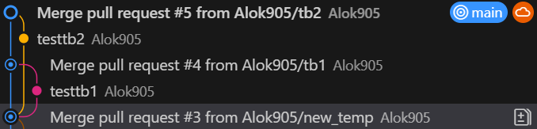

(Lets analyse these things …)

* + **main** branch has commits: C1 -> C2 -> C3 -> C4 -> C5
  + I created 2 branches at this point **tb1**, **teb2** (you can see in the image)
    - In both the branches created one file i.e. in **tb1** one file and in **tb2** another file.
    - Staged those changes, committed and pushed.
    - Created 2 merge requests (one per each branch)
  + So now:
    - **main** : C1 -> C2 -> C3 -> C4 -> C5
    - **tb2**  : C1 -> C2 -> C3 -> C4 -> C5 -> **Cx**
    - **tb3**  : C1 -> C2 -> C3 -> C4 -> C5 -> **Cy**
  + I merged **tb1** with the main branch (accepted the merge request).
    - You can see **tb1** was merged to the main branch, so that one commit got created in main branch.
    - 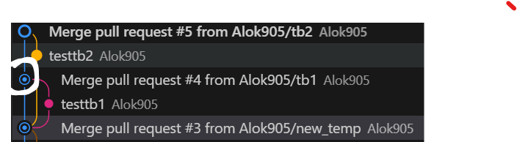
  + After that I merged **tb2** to the main branch. So one more commit got created in the main branch.
    - 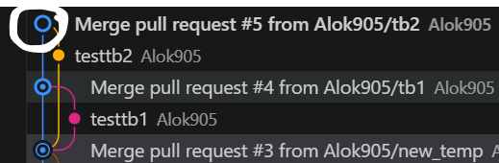
  + As these 2 branches (tb1 and tb2) were not interfering with each other or main branch’s changes; so they got merged easily without any conflict.
* One more case:
  + Initially:
    - main : C1 -> C2 -> C3 -> C4 -> C5
    - branch1 : C1 -> C2 -> C3 -> C4 -> C5
  + After this:
    - main : C1 -> C2 -> C3 -> C4 -> C5 -> **Cx**
    - branch1 : C1 -> C2 -> C3 -> C4 -> C5 -> **Cy**
    - Here, main branch created one file (let) and branch1 created one file (means no conflict)
    - 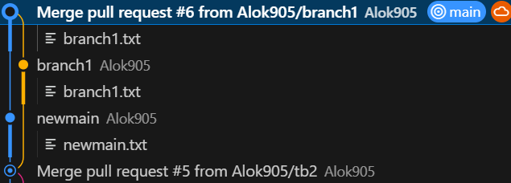
    - Between creating of branch **branch1** and merging it to **main** branch, there is one commit present in **main** branch. But **branch1** was not updated with that commit but still it got merged to **main** branch without any conflict.
    - Because, only the changes mentioned in the merge request that was created from the branch **branch1** will be updated to the main branch; **not** all the files present in **branch1** will be updated in **main** branch.
* Let there is a file **check.txt** inside the main branch having some contents inside it.
  + 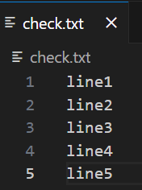
  + Created one branch **my_branch** and made the following changes:
    - 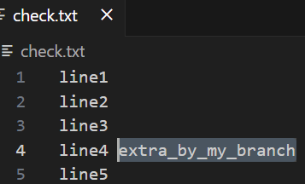
  + Switched to **main** branch and made the following changes:
    - 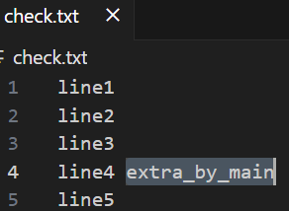
  + Now we can see, both the changes are conflicting each other.
    - Main : C1 -> C2 -> C3 -> C4 -> C5 -> **Cx**
    - my_branch : C1 -> C2 -> C3 -> C4 -> C5 -> **Cy**
    - But in this case, the commits **Cx** and **Cy** are conflicting eachother.
  + So, If I try to merge **my_branch** to **main** branch, then it’ll give conflicts:
    - 