* If you don’t define stages and just write a yml file like the following:
  + 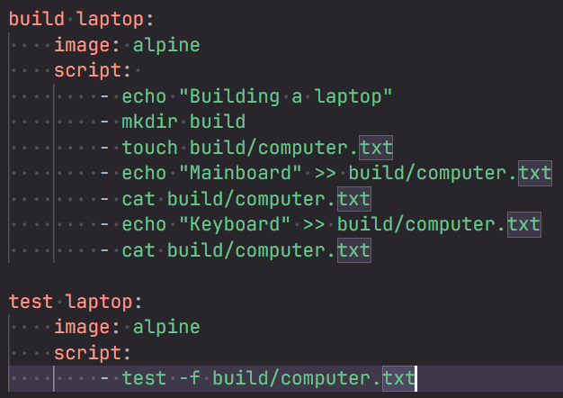 (these 2 are **jobs**)
  + It’ll fail because there is no execution order of the jobs. Any job can run first. So, it’ll fail.
  + You need to mention the stages like
    - 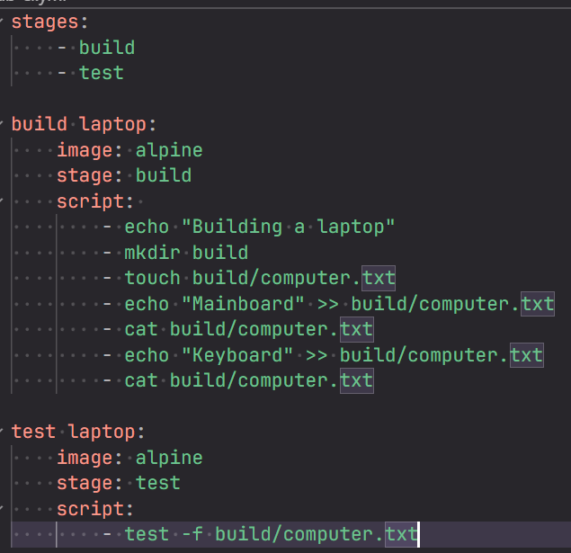
    - It’ll fail because the docker image will be destroyed after the first job. The second job (test laptop) is pulling one more docker image and testing there. So, it failed.
  + Its solution is **artifacts**.
    - It is like a file/folder produced by a job that GitLab saves and makes available for the next job.
    - 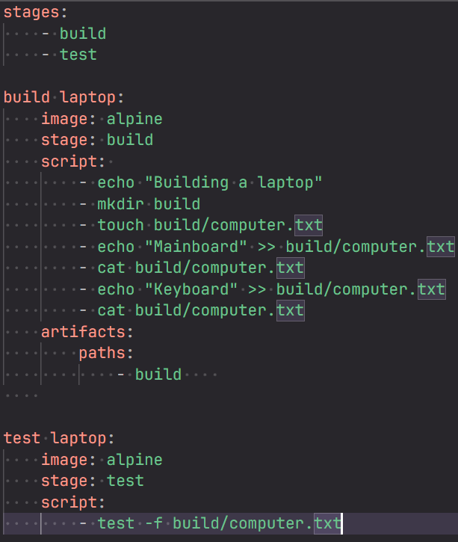
    - Now it’ll pass
    - 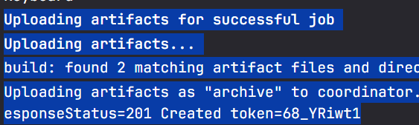(building job)
    - 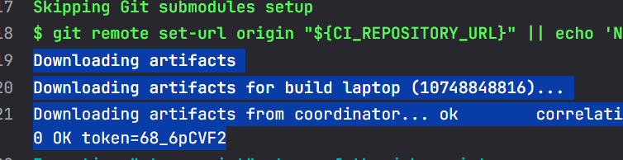(testing job)
    - Coordinator means the GitLab server only, after the job get finished, it tells the GitLab server to save the perticular file as it’ll be used in the next job.
  + 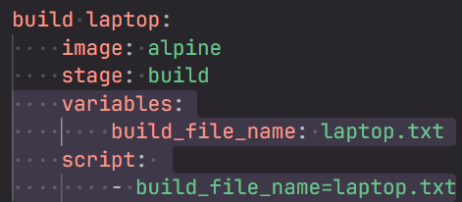
    - These are 2 ways of creating variable. NOTE: inside **variables**, its not a list, its kind of key value pair.
  + 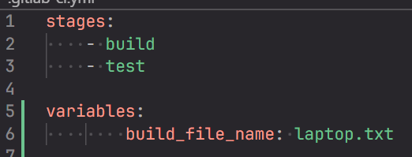(global variable)
* **Setting >> repository >> Branch rules** (you can set here like no one will be able to push to main branch like things)
* Always select correct **image** so that the dependencies are there inside that image.
* 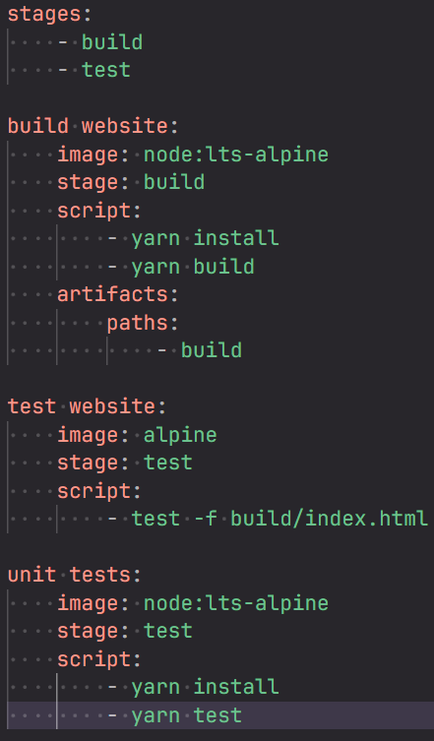
  + In here, the **build website** is having the stage **build**, so it’ll run first.
  + After that, **test website** and **unit tests** are having the stage **test**, so they both will run **parallelly**.
  + 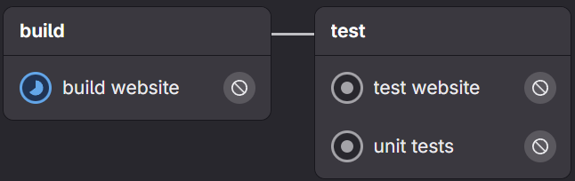
* Merge Requests:
  + The changes should not be pushed to the main branch directly by anyone.
  + If multiple people are pushing to the main branch, then at some point if the build fails, then no one will be able to continue.
  + **Settings >> Merge requests**
    - **Merge method: fast- forward merge** (it directly takes the pointer of the source branch to the destination branch without creating any merge commit leading to a cleaner commit history)
    - **Squash commit where merging: encourage** (it combines all the commits that has been made in the source branch into a single meaningful commit, making it easier to rollback to previous state) (simply takes the merge request title as the commit message for the destination branch)
    - **Merge checks: pipeline must succeed** (if the pipeline fails, merge will not happen)
  + **Settings >> Repository >> Protected branches**
    - (we want that no one will be able to push the changes to the main branch directly)
    - 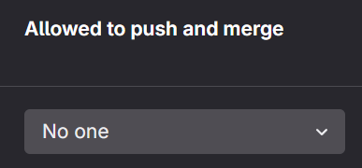(make it **no one**)
  + Now, after changing the rules and settings, try to make some changes and commit to main branch. You’ll not be allowed now. So, you have to create one new branch, commit in that new branch & create one MR (merge request).
  + The pipeline will always run when you are trying to commit some changes to any branch (provided the rules are not there to run it for any particular branch).
  + Then, its depends upon the settings that you have done that even after the failure of pipeline, you can merge or not.
  + 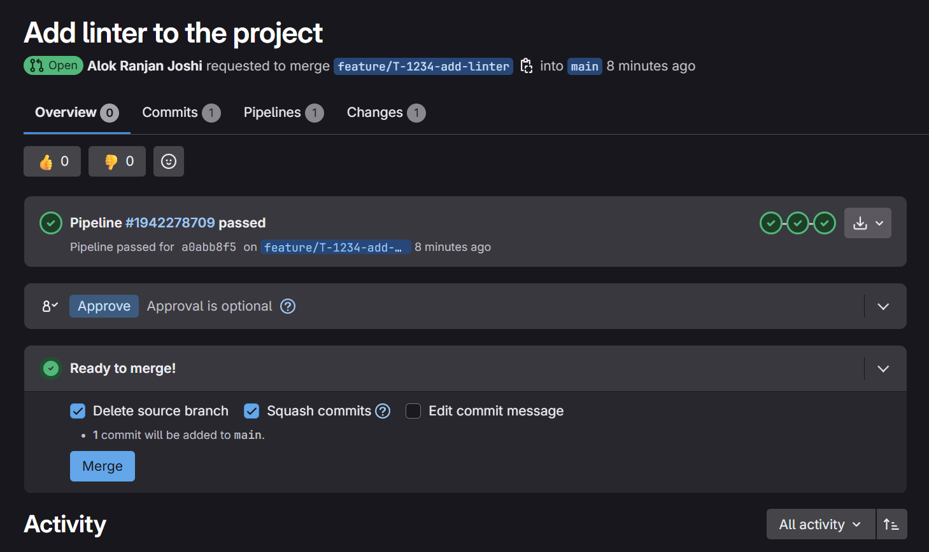(here its showing that the pipeline passed)
  + The people can review that and **approve** this merge request, there might be your team’s internal rule that someone has to review this before merging.
  + 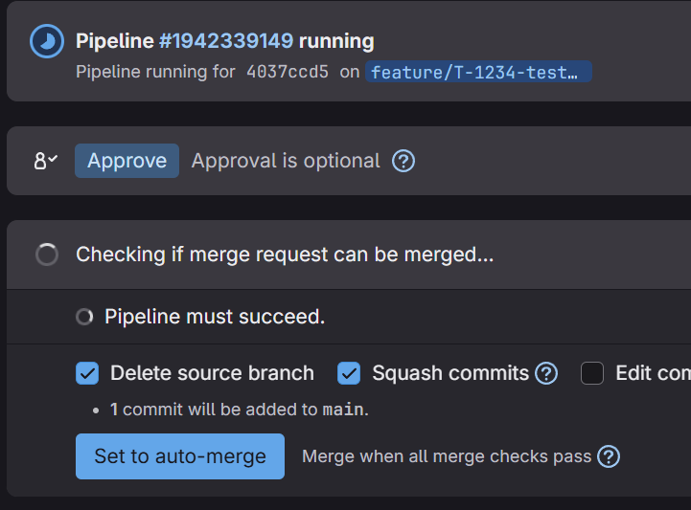
    - As I have set the **pipeline must succeed**, so the merge button is not there. The pipeline must **pass** so that it can be **merged**.
  + 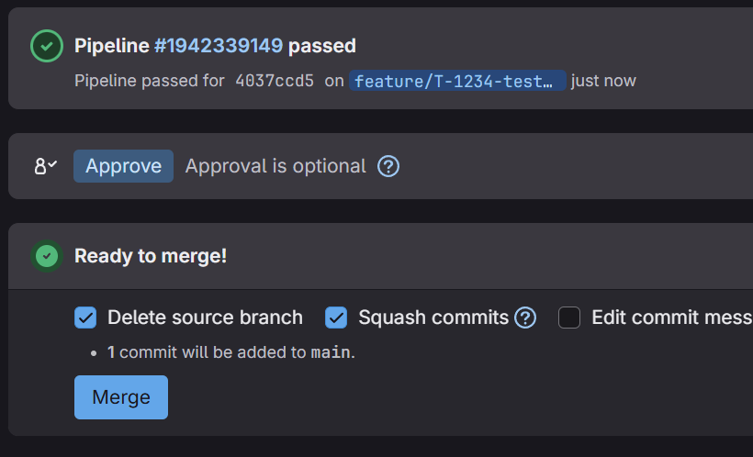
    - After the pipeline passed, the merge button appeared.
  + **NOTE** 
    - When you do some changes and commit in GitLab, the commit message is by default ***“Update file .gitlab-ci.yml”***.
    - Then when you create MR, you add some comments. That is not the commit, that is the MR title.
    - 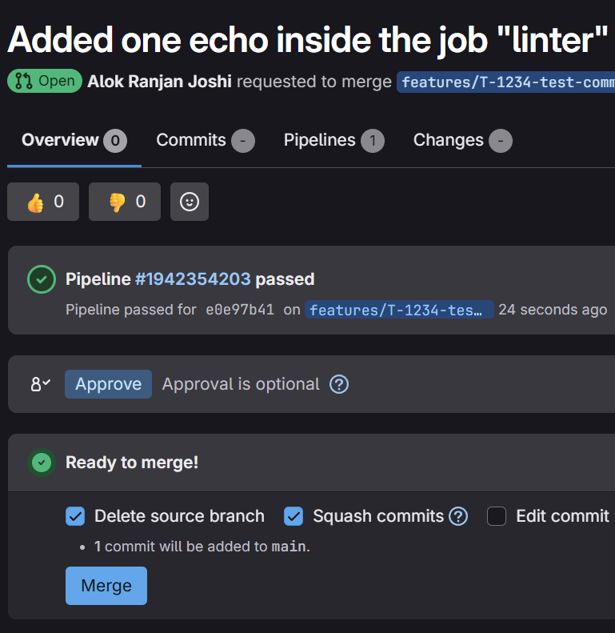(this is the merge request having the given title)
    - 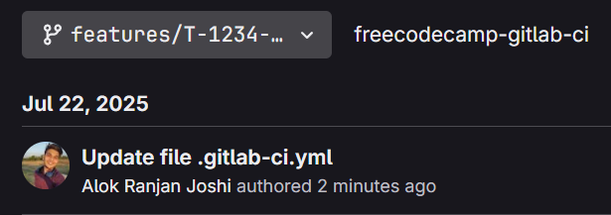 (it is the commit which title was automatically added by GitLab)
  + So, now as the commit was done to the new branch, the pipeline will run once.
  + Now, when you merge that change to the destination branch (for me **main**), the title of the **MR** will be the **commit message** (as I have enabled the squash commit) for the destination branch. If the **squash** was not enabled, then the same commit of the source branch would have transferred to the destination branch.
  + **However, as one commit happened, so the pipeline will run once again now.**
* Some pre-defined stages are there in GitLab **CI** i.e. **.pre** (setup stage), **build**, **test**, **deploy**, **.post** (cleanup stage).
  + So, even if you don’t mention these inside the **stages**, it’ll work properly.
* If you have created a MR after changing something, and there are some more changes required, then you can again change that file and update the same MR.
  + 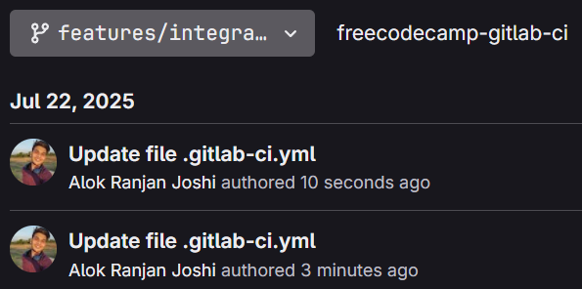
  + Just one more commit will happen to the new branch.
  + The merge request will be same, just the commits will be created in that new branch when you change something and commit.
* 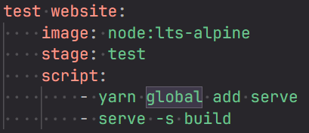
  + There is one issue here, I started the server here which will not stop till the job will be timed out (deffault: 1 hour)
  + 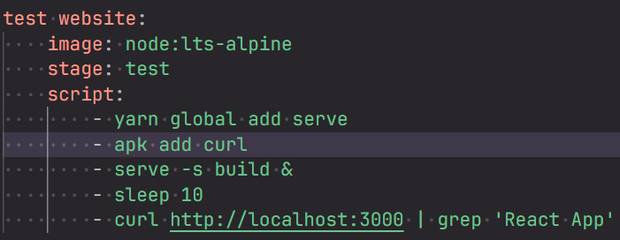
    - **&** means run the command in the background (it is the real game changer)
* 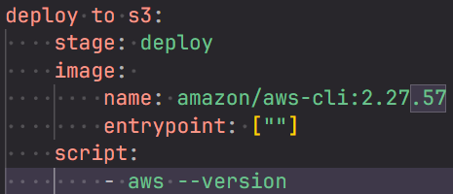
  + Here, we have to give the name & entrypoint of the image bcs its default entry point is “aws” (mentioned in the dockerfile)
  + It means, whatever command we’ll execute, it’ll add **aws** as the prefix.
  + For example, ***echo “hello”*** => ***aws echo “hello”***
  + 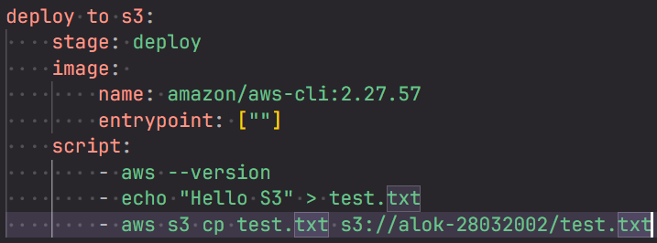
    - Inside the S**3** bucket, click on **upload**. You’ll get the destination i.e. **s3://<etc etc>**
      * 
  + Its better to keep those bucket and all things in a variable, but not inside the **yml** file.
    - **Settings >> CI/CD >> Variables**
      * You can create your variables here.
      * 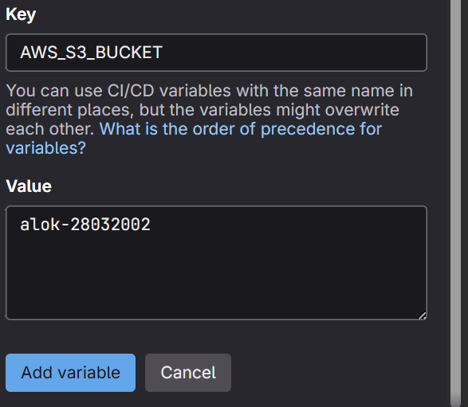
      * 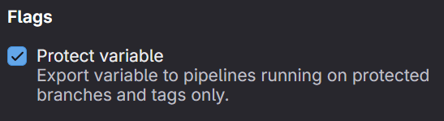
        + If this is enabled, then the variable will only be available for the protected branches.
    - 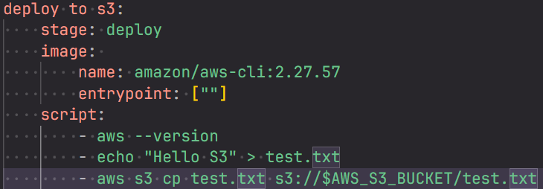
    - But, still the pipeline will be failed due to the credentials.
  + Create one IAM user (without password), add **S3 full access** permission to that.
  + Now open that user and create access key for **CLI** and save the **access key id** & **secret access key**.
  + Now, we’ll add those things (access key id & secret access key) in the variables.
    - Settings >> CI/CD >> Variables
      * 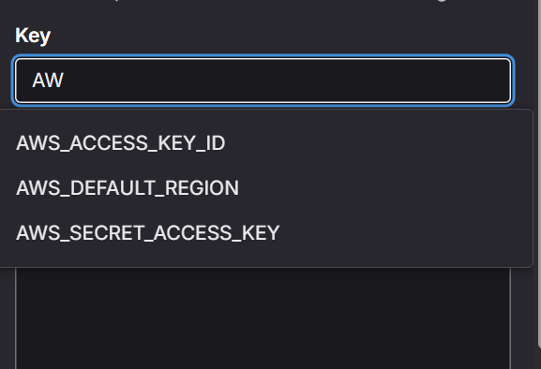
      * There will be some default variables having these kind of names, you just have to assign the values (access key id, secret access key) to this only.
      * 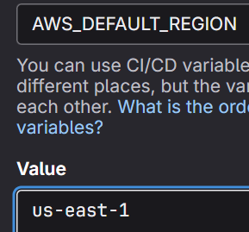(you have to set the region as well)
    - Now, the pipeline will succeed as the authentication will be done now.
    - 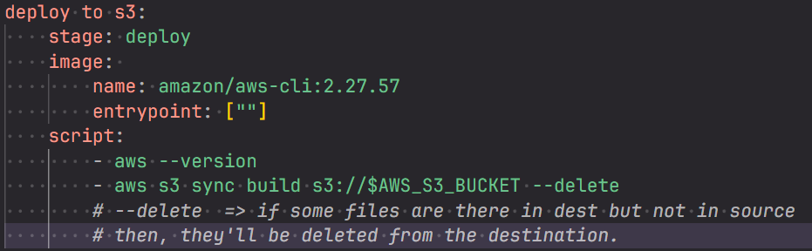
  + 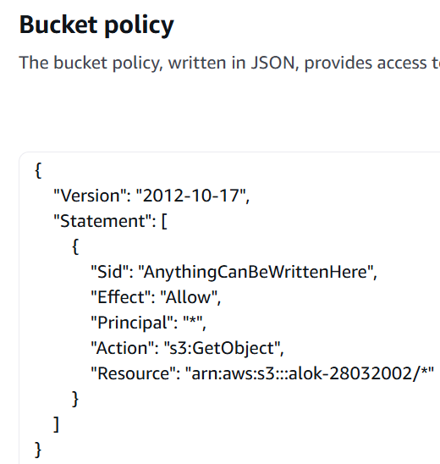
    - Do this after **enabling** static **web hosting** to give public access. Also **disable** that “block public access” thing.
  + There is one issue in our pipeline, everytime when someone changes and commit (in any branch), the website will be deployed in **s3**.
  + But it should not be the case, only after the merge, it should happen.
  + 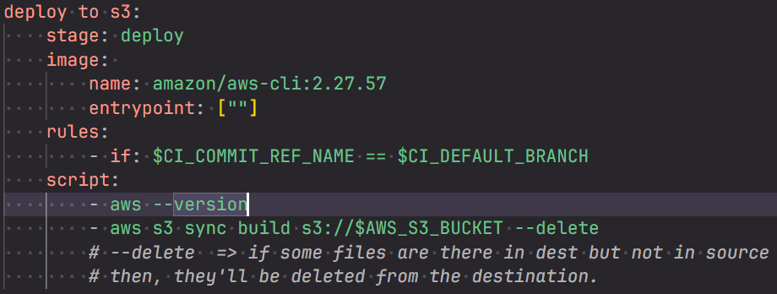
    - Now, it’ll work fine. Only after the merge, the commit branch will be same as the default branch (i.e. **main** in this case). and after that the deployment will happen.