- CSRF
  - CSRF (Cross-Site Request Forgery) is an attack where a malicious website tricks a logged-in user’s browser into sending an unauthorized request to a trusted website using the user’s existing session/cookies.
  - So basically, CSRF attacks doesn’t steal password; It uses user’s cookies stored in the browser to steal the data/money.
  - So, to prevent CSRF, either you need to pass some unique token in the request headers or make the request bind with a particular website (means other website cannot send that request)
  - Someone can steal your cookies, but they don’t have your headers.
- With csrf token, it can be prevented.
  - 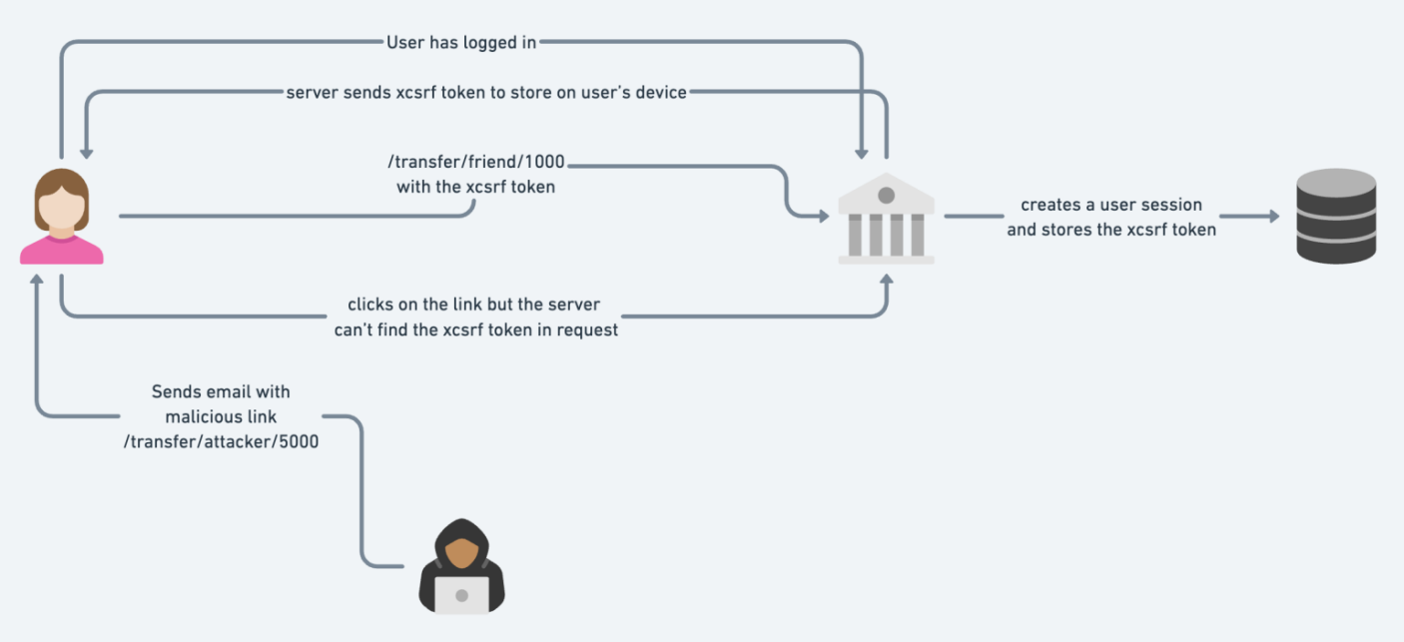

Internal Working Of Spring Security
- The dependency spring-boot-starter-security has to be added in pom.xml which groupId is org.springframework.boot
- After that spring-boot will auro-configure the security with sensible defaults defined in WebSecurityConfiguration class.
- 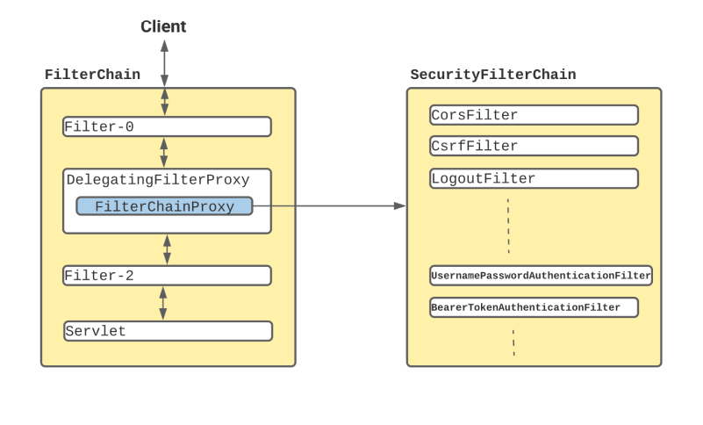
  - In Spring Boot application, SecurityFilterAutoConfiguration automatically registers the DelegatingFilterProxy filter with the name springSecurityFilterChain.
  - Once the request reaches to DelegatingFilterProxy, Spring delegates the processing to FilterChainProxy bean that utilizes the SecurityFilterChain to execute the list of all filters to be invoked for the current request.
- Default behaviour of Spring-Security
  - Creates a bean named springSecurityFilterChain & registers the filter with a bean named springSecurityFilterChain with the Servlet container for every request.

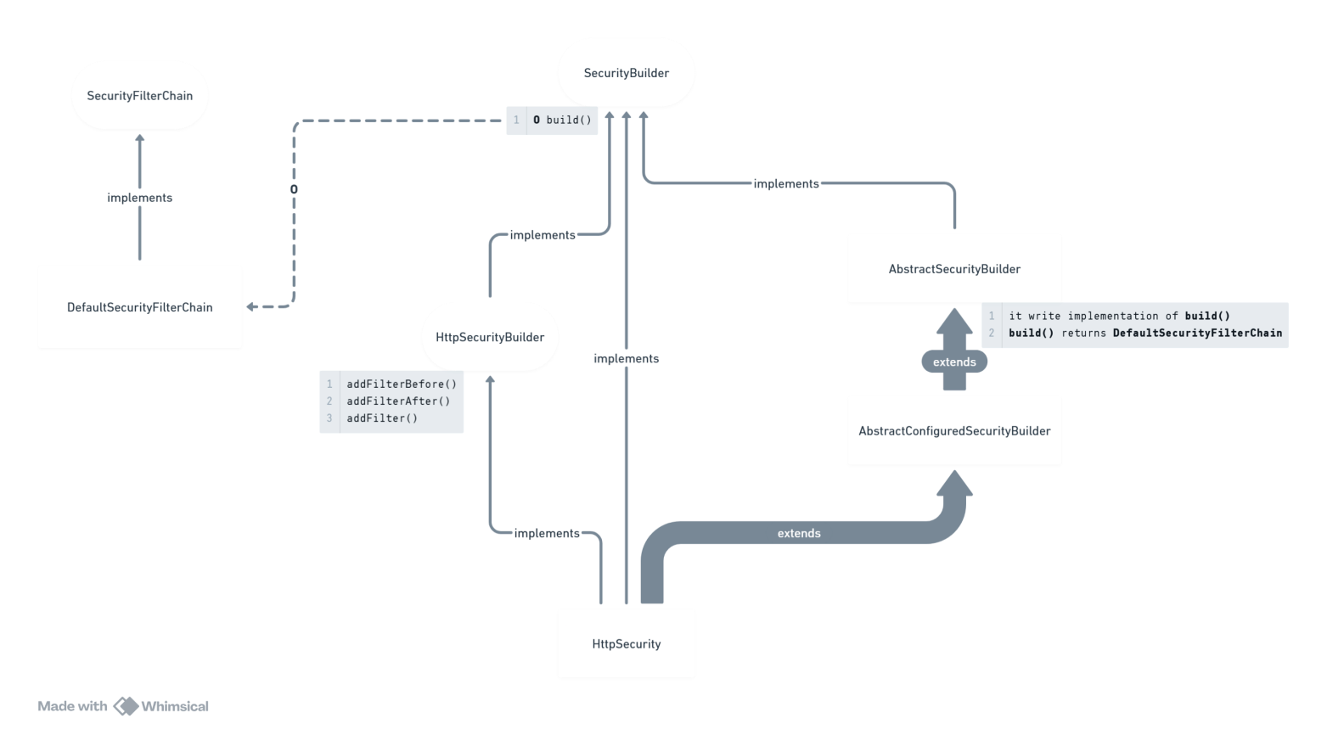
- This is the flow of Security Filters.
- In the class WebSecurityConfiguration, the beans are created.
  - The bean of HttpSecurity is created.
    - 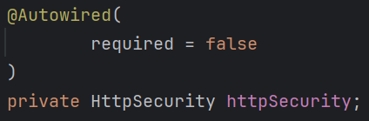
  - One HttpSecurity type of object can build only one SecurityFilterChain.

- HttpSecurity contains build() method that returns object of type DefaultSecurityFilterChain. Then why Spring needs to create a bean of SecurityFilterChain ?
  - WebSecurityConfiguration has a list of SecurityFilterChain
  - Here one method is there to create the bean named as springSecurityFilterChain.
    - 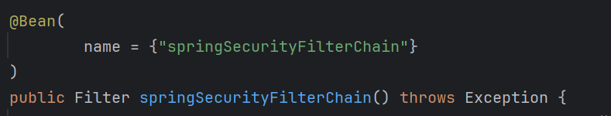
    - But here, Filter is the return type; confusing; will discuss at the end :)
  - If there is no filter chains, it’ll add the default chain from HttpSecurity build() method.
    - it’ll not add the default chain to the list i.e. securityFilterChains, rather it is being added to webSecurity object.
    - It is being added here (WebSecurity class).
    - 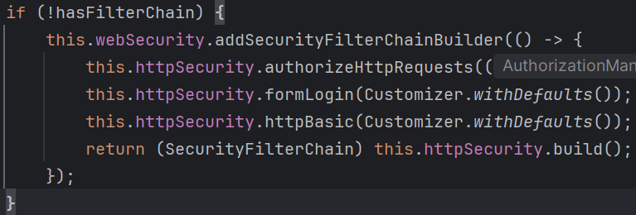
  - If filter chains are already there, then it add those filter chains to webSecurity object.
    - 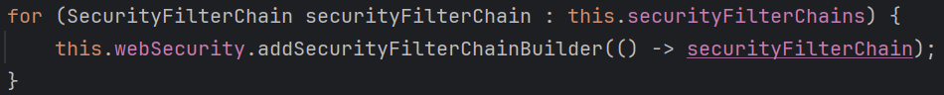
  - At the end it’ll return an object of type Filter

- Spring Filter Behind the Scene
- What we see, chain of filters are being executed in between Servlet Container and Servlet.
  - One servlet containers can have many filters, many servlets; but in case of spring we have only one Servlet which is DispatcherServlet.
  - And, its not by limitation, but by design spring make sure only one Filter should be there in between Servlet Container (tomcat in our case) and Servlet (DispatcherServlet).
  - So, only one Filter should be able to handle multiple Filter Chains where each chain contains multiple Filters.
    - its like one object is equivalent to list of list of the same object.
  - So, FilterChainProxy was introduced which implements Filter. And it contains the list of SecurityFilterChain objects.
    - And the thing is, this SecurityFilterChain class contains a method getFilters() which returns a list of Filter objects.
  - So now, we can return FilterChainProxy object instead of Filter because FilterChainProxy is nothing but the child of Filter.
    - And also it contains list of SecurityFilterChain which means list of ( list of ( Filter )).
- If you want to create your own filter chains.
  - Don’t override the bean creation of the bean springSecurityFilterChain, otherwise spring will only create your bean and all the necessary steps like the below will be skipped.
    - Adding the filter chain to webSecurity.
    - customize using the Customizer object..
  - This all will have to be implemented in your own bean creation method.
  - So, create beans of type SecurityFilterChain
    - 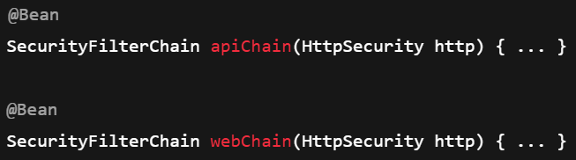
    - Now you might be thinking, if we are creating multiple beans of same type, spring will be confused which bean has to be created; but in this case we spring has list of SecurityFilterChain not a single object of SecurityFilterChain, so all the beans will be added to that list.
      - 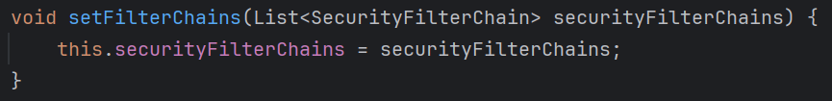
      - This method is inside WebSecurityConfiguration class.
      - All the SecurityFilterChain objects that you created beans of, will be passed to this setFilterChains method.
  - Now, when the list i.e. securityFilterChains (present inside WebSecurityConfiguration.class) has already some elements present, so the default filter chain will not be added to this.
    - 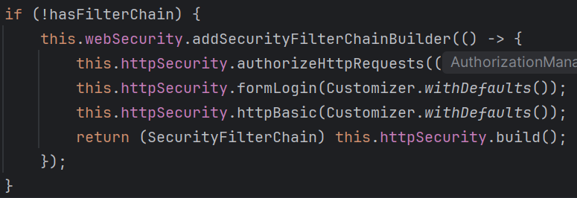

  - F
  - F
  - F
  - F

- When you run the application after including the dependency spring-boot-starter-security, by default one login page will appear to authenticate you.
  - If you inspect that, you’ll find one hidden input field containing the csrf token as its value which is being attached to request.
  - 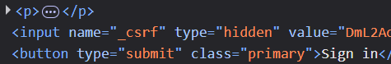
  - Means every time any request being sent, session id (cookie) along with csrf token (request header) are also sent.
- Default Security Filters configurations
  - SecurityFilterChain is an interface containing list of filters.
    - DefaultSecurityFilterChain implements SecurityFilterChain and initializes the filters inside its constructor.
    - But someone needs to call this constructor passing the filters as argument to initialize the filters.
  - HttpSecurity class extends AbstractSecurityBuilder class which contains build() method which returns an object of type DefaultSecurityFilterChain.

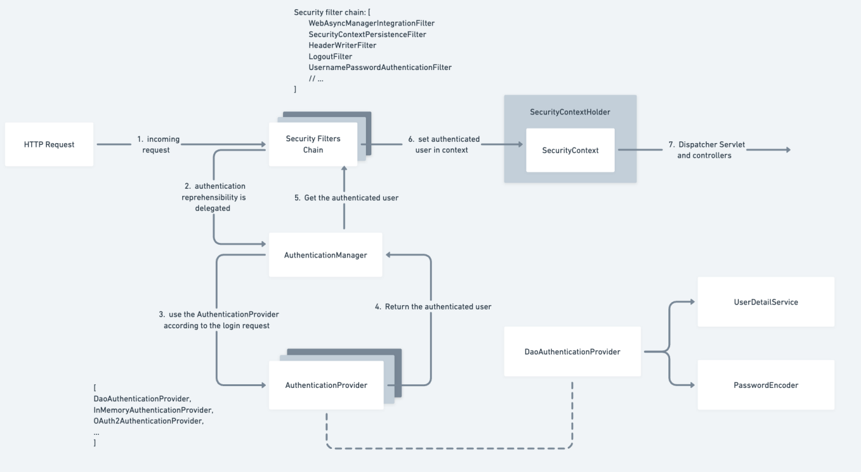
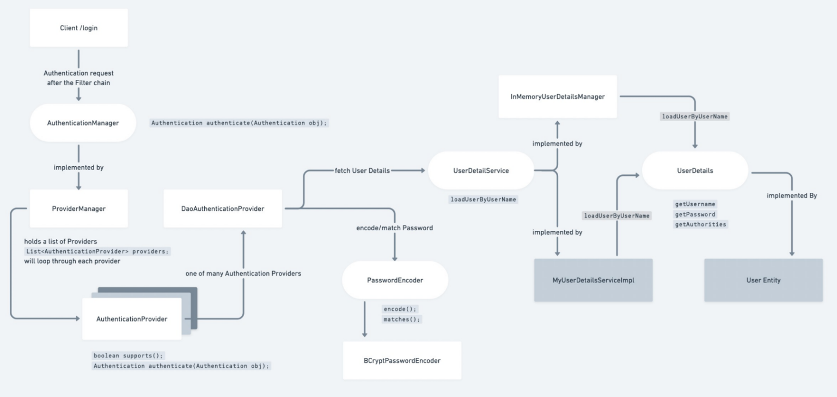
(rectangles: classes, ellipse: interfaces)
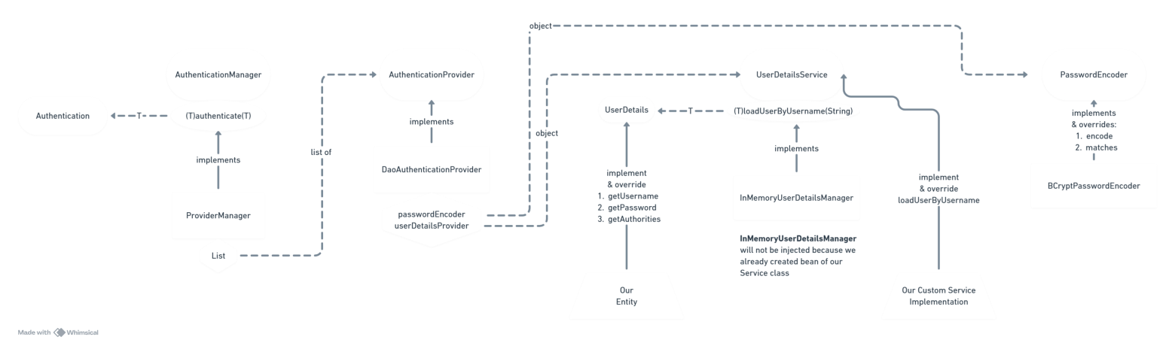
Flowchart of Authentication

- AuthenticationManager is an interface.
  - 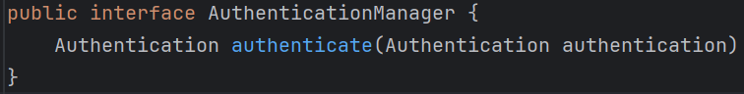
  - Authentication is also an interface containing necessary methods
    - 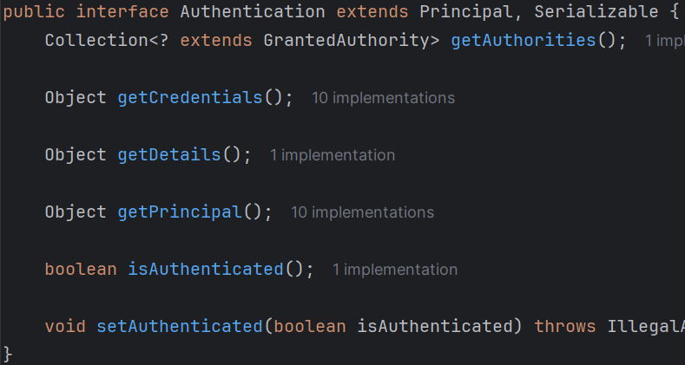
    - After the authentication done,
    - isAuthenticated will be marked as true.
- Now, so many classes implement AuthenticationManager, one of those is ProviderManager
  - It holds a list of AuthenticationProvider (which is also an interface)
- DaoAuthenticationProvider implements AuthenticationProvider
  - It holds the UserDetailsService and PasswordEncoder type of objects.
- UserDetailsService
  - We will implement this interface from our custom Service class and implement the loadUserByUsername method.
  - This method use UserDetails type of object.
- UserDetails
  - Our entity should implement this interface.

- Writing custom Filter Chains
- We’ll create the custom filters like the below
  - 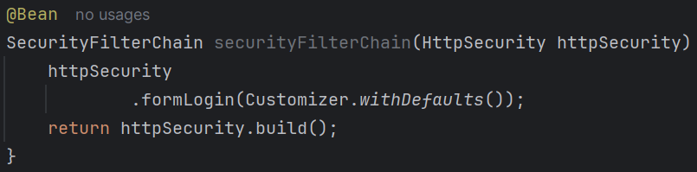
  - You might be thinking, while creating the bean, how this HttpSecurity type of objects is being coming; as according to what we were doing earlier, it didn’t have any argument in the @Bean method.
  - You can mention any type of argument you want in the @Bean method, if that type of bean is created, then Spring will automatically inject that bean to your @Bean method’s argument.

  - F

Udemy Part
- Client --- Servlet Container --- filter-1 --- filter-2 --- …. --- filter-N --- Servlet
  - 2 way (request and response)
- If you include spring-boot-starter-security, whenever you’ll try to hit any api endpoint, it’ll redirect you to the login page;
  - You need to authenticate yourself with username and password then one session id will be generated and will be stored in the browser cookies .
  - whenever you’ll hit any end-point, that session id will also be attached with the request.
  - By default username id user and password will be generated when you’ll run the spring boot application.
  - For customized username and password, you can write those in the application.properties file.
    - 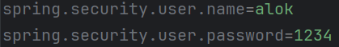
- In the controller, you can get HttpServletRequest type of object which contains details like session id and all.
  - 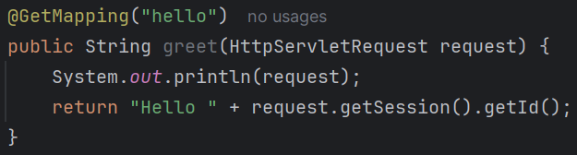
- Get request working; post not working because we are not sending csrf token;
- When you trigger get request, csrf token is not required because its read-only;
  - But, for remaining operations, you need to pass csrf token in the headers.
  - 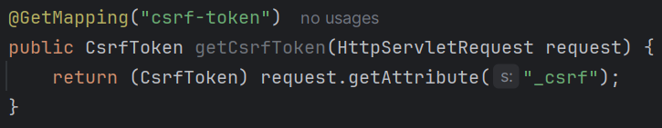
  - I created this end-point to get the csrf token.
    - If you see the default login page generated by spring security, the name will be _csrf here.
    - So the attribute name is _csrf
    - 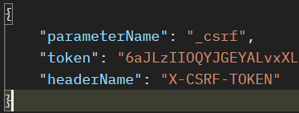
  - While triggering POST request via postman, you need to pass X-CSRF-TOKEN in the headers.
  - It is one way of solving CSRF issue; other way is “Don’t allow any other website to use your session ID”
    - Add this in your application.properties file and it’ll restrict other website to use your session id.
- There are 2 types of application: stateful and stateless.
  - The one we were using now was stateful, because it was using same session ID for all the requests.
  - In case of stateless we need to pass the username & password in each request; so there is no need of csrf token here.

- Spring Security Working
- The filters are present in between the Tomcat and DispatcherServlet’
  - 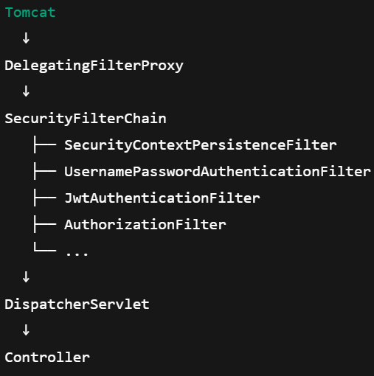
- @EnableWebSecurity
  - It tells Spring “Activate Spring Security’s filter chain for web requests”.
  - Without it, no security filters are applied.
- In Spring Boot, spring security filters are auto-configured if the dependency spring-boot-starter-security is present in the pom.xml
- If you create a bean of type SecurityFilterChain then Spring will not create bean; menas basically you did override the bean creation.
  - 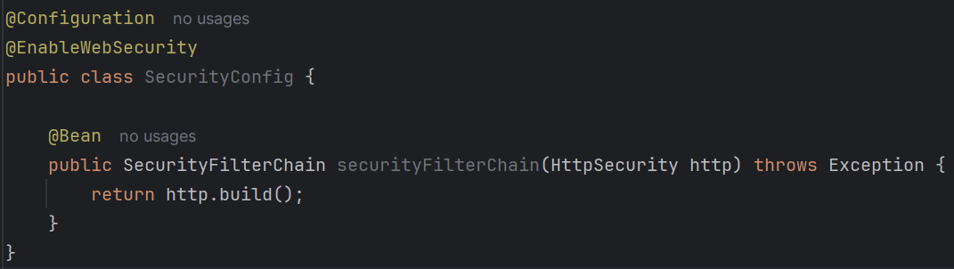
  - Now the filters will not be executed; you need to mention those filters.

- F
- F
- F
- F
- F
- F
- F
- F
- F
- vf

