Red color: DTO, green: Best practice, deep sky: controller methods
- We have multiple end-points. So need to make different response and request DTOs.
  - Previously we were using same DTO for request and response. But now we’ll not.
  - 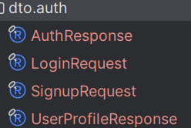
    - AuthResponse = UserProfileResponse+token.
    - LoginRequest and SignupRequest are DTOs for POST request payload.
    - You should create different DTOs for request and response.
    - For getProfile controller, only UserProfileResponse is needed, there is no need of token.

- F
- F
- F
- F
- F
- F
- F
- F
- F
- F
- F
- F
- F
- F
- F
- F
- F

