- To add dev tools, add the following dependency in pom.xml file.
  - 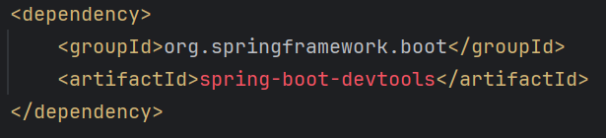
- IntelliJ idea specific settings:
  - Setting >> Build, Execution, Deployment >> Compiler
    - Select the option “Build project automatically”
    - So that the build will be automatically generated if u do any changes to the files (in running or debugging state).
  - Advanced Setting >>
    - Select the option “Allow auto-make to start even if developed applicatoin is currently running”

Auditing
- Auditing in Spring Boot allows you to automatically populate certain fields, such as creation and modification timestamps, as well as the user who created or modified the entity.
- Create Auditable base Entity using the following annotations:
  - @EntityListeners(AuditingEntityListener.class)
    - 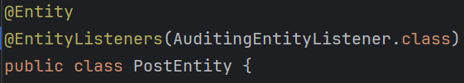
  - Now you can use the annotations @CreatedAt, @LastModifiedAt, @CreatedBy, @LastModifiedBy and create the fields inside the Entity.
    - 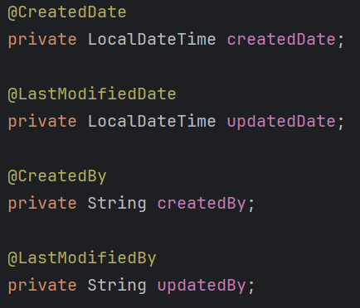
      - These are writtn inside entity; not DTO
  - Now, to make all these things work, you need to add @EnableJpaAuditing in any of the config file (file having @Configuration annotation)
    - 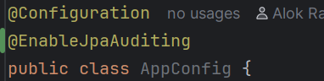
  - Now it’ll work properly when someone use post, put request.
    - Now if someone do some changes, it’ll be visible in the Database;
- Instead of writing @EntityListener in any particular entity, its better to create one class and write this annotation there. Whichever Entity wants to be audited, they can directly inherit that class.
- There is a annotation @MappedSuperClass,
  - lets say you want some common fields to be there in some Entities.
  - So, instead of writing those in every Entity, its better to write in a parent class and extend that class from the actual Entity class.
  - But, here the fields that are defined in the parent class will not be included in the table by default.
  - If you write @MappedSuperClass in the parent class, only then those fields will be part of the Entity table.
  - 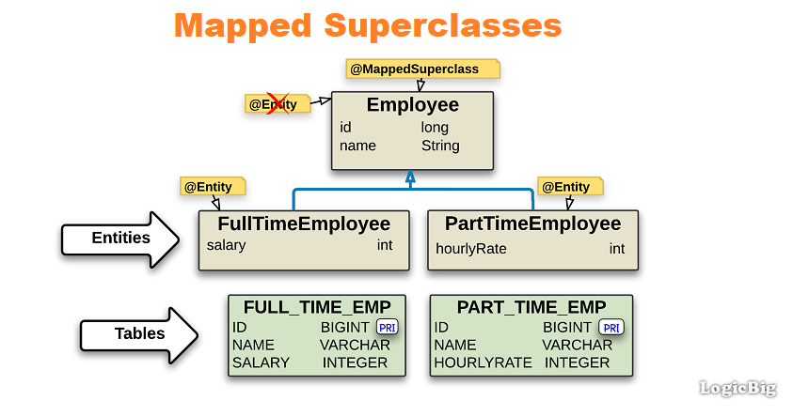
    - @MappedSuperClass is writtn in @Employee, so the entities (FullTimeEmployee, PartTimeEmployee) are having the id, name fields in their tables.
  - 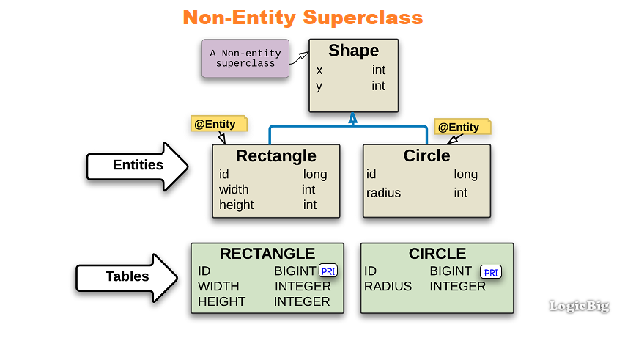
    - @MappedSuperClass is not written for the parent class Shape, so the Entities (Rectangle, Circle) are not having x, y fields in their tables.
- But till now, you’ll only get @CreatedAt and @LastModifiedAt , but the fields for @CreatedBy, @LastModifiedBy will be null only, as it doesn’t know who made the changes.
  - Its part of spring security to fetch the current user and add that user in the database for createdBy or updatedBy fields.
  - For now, we can use some dummy name for this.
- You need to write a class that implement the interface AuditorAware
  - 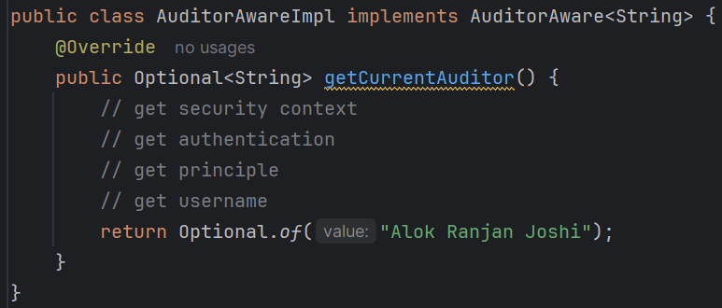
    - For now I am returning “Alok Ranjan Joshi” as the modifier/creator name.
- After this, you need to update the annotation @EnableJpaAuditing of the config class.
  - 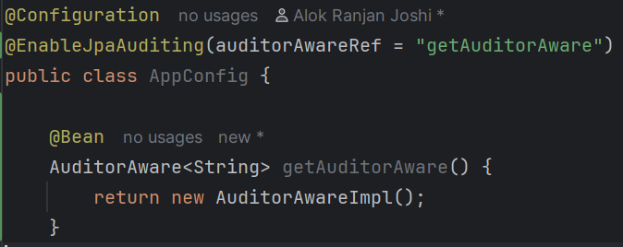
    - auditorAwareRef takes the bean name.
    - As the method name is getAuditorAware, by default method name becomes the bean name if you are not specifically mentioning a different name for the bean.
- F
- F

- So, All the steps are:
  - Create Auditable base Entity using the following Annotations
    - @EntityListeners(AuditingEntityListener.class).
    - You can create the fields using @CreatedBy, @LastModifiedBy, @CreatedAt, @LastModifiedAt.
  - If you are creating a super class for auditing, then use @MappedSuperClass on that parent class, otherwise the entities that inherit that parent class won’t contain the fields defined in that parent class.
  - Now write @EnableJpaAuditing in any config class (annotated with @Configuration).
  - Create an class implementing the interface AuditorAware interface.
  - Then edit the config file’s annotation @EntityListeners and pass the bean name (by default the method name) for the auditorAwareRef.

- Optimized steps:
  - Enable auditing (MANDATORY)
    - 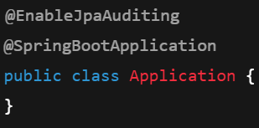
    - Better to write in the main application file (@SpringBootApplication)
  - Create a base audit class (BEST PRACTICE)
    - 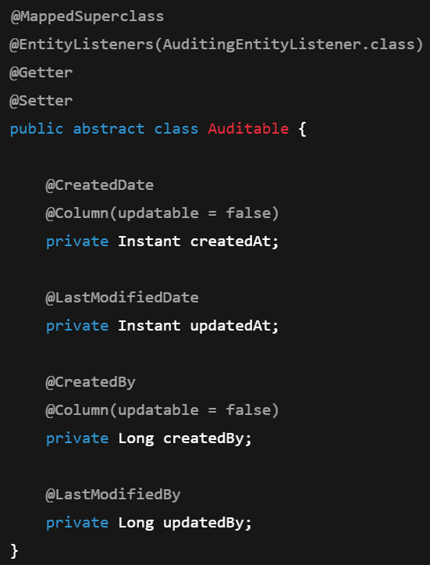
    - @MappedSuperClass is necessary; without that the fields will not be available in the entities that inherits this Auditable class.
    - AuditingEntityListener class contains all the methods that is being triggered to update the entity before create/update.
    - 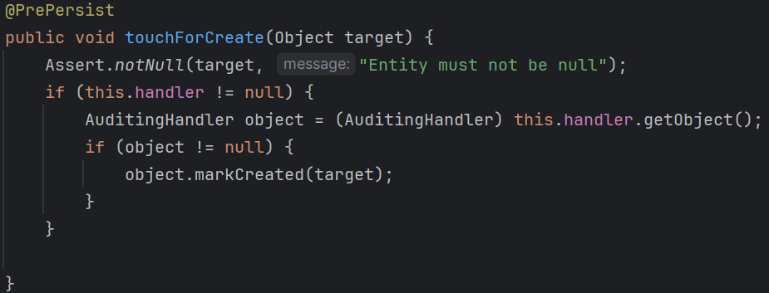
      - It is triggered before create event.
    - 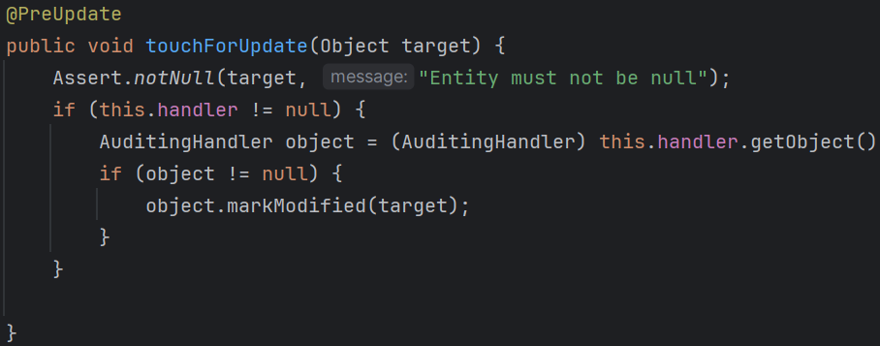
      - It is triggered before update event.
    - You can write your own methods using the annotations @PrePersist, @PreUpdate, @PreRemove that will be triggered before the respective operations.
  - Handling @CreatedBy and @LastModifiedBy
    - 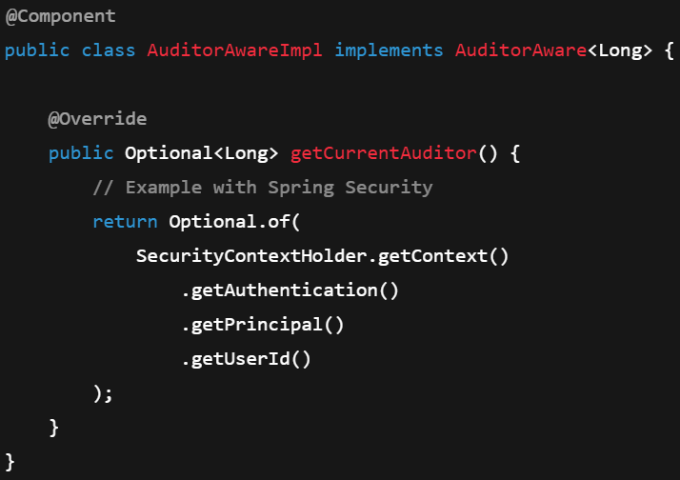
    - You need to create the bean of this class. Either use @Component or @Configuration, @Bean .
    - If you are having more than one classes that implements AuditorAware, and you are creating multiple beans, then you need to pass auditorAwareRef inside @EnableJpaAuditing.
      - 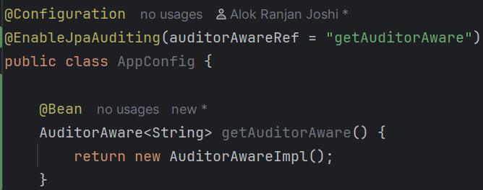
      - Like here, the bean name will be same as the method name i.e. getAuditorAware so I am passing the bean name in the auditorAwareRef.
      - But in case of single bean, no need of passing this.
  - Extend the base class in entities
    - 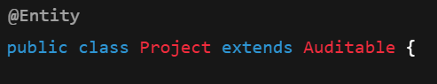
- Overall Annotations ------------------------------------------------------------------------
  - @EnableJpaAuditing(ﻤAuditingEntityListener.class)
  - @MappedSuperClass
  - @CreatedAt, @LastModifiedAt, @CreatedBy, @LastModifiedBy
  - @PrePersist, @PreUpdate, @PreRemove
  - AuditorAware class has to be implemented for @CreatedBy, @LastModifiedBy
  - ------------------------------------------------------------------------------------------
- To keep track of every version like different versions for every change and all will be containing who changed and what was changed and all, you can use Hibernate Envers .

RestClient
- RestClient is a synchronous HTTP client that offers a modern fluent API. It offers an abstraction over HTTP libraries that allows for convenient conversion from a Java object to an HTTP request, and the creation of objects from an HTTP response.
- Generally in case of microservice architecture, one service needs to call another service.
  - Don’t think @RestController and RestClient are same.
  - RestController create API; RestClient consumes those APIs.
- Lets say you have 2 services in your microservice architecture; and one service needs to call another service (API call) then RestClient is used;
  - Order Service ──calls──▶ User Service (for example)
- Steps:
  - First you’ll configure the RestClient giving some base url. For example http://localohost:8080
  - After that you can call any type of method i.e. get, post, put, patch, delete with request body, headers etc etc just like normal API call (just like API call is made using axios in react)
  - Either you can create the object of type RestClient using RestClient.builder()…..build() method or create a bean of this and inject that everywhere.
  - 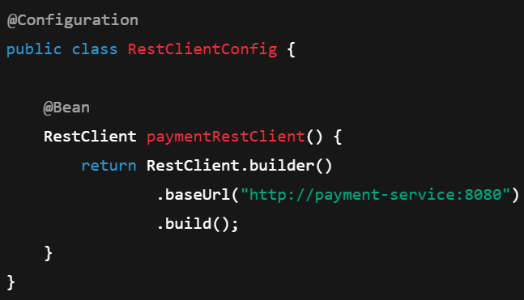

- F
- F
- F
- F

