- Role is the main concept for authorization. Depending upon the role of the user, it’ll be decided that what are the thing he/she can access.
- There are some terminologies in AOP which are Aspect, Advice, Join Point, Point cut, Proxy .
- Understanding these terms:
  - Lets assume you have some methods where you want to add some cross-cutting logic.
    - Cross-cutting logic refers to any secondary code apart from business logic.
    - For example: logging, transactions , security etc etc.
  - Some secondary logic needs to be executed before / after / around the execution of these methods.
    - These methods execution is called Join Points.
    - Method definition is not Join Point; Method execution is Join Point.
  - Since many methods can be executed, all these method executions are Join Points.
  - You usually do not want to apply cross-cutting logic to all join points, so you need, a filtering logic is required to select some of those.
    - This filtering logic is called a Pointcut.
  - A Pointcut defines which join points should be selected for applying cross-cutting logic.
  - The code that has to be executed along with the selected join points, and the timing of its execution, together form an Advice
  - Advice defines:
    - What code to execute (cross-cutting logic)
    - When to execute it (e.g., @Before, @After, @Around, etc.)
  - The class that contains all the advice methods is called Aspect.

- Proxy
- In spring, when you create a bean of a class, Spring doesn’t assign the object of that exact class; rather it assign an object of the proxy of that class (proxy class extends the real class).
- Lets say this is your real class:
  - 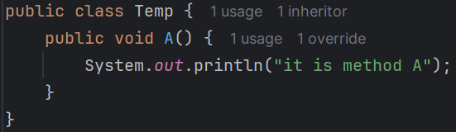
- When you write @Autowired or @Configuration, @Bean or anything to get a bean of that class, you’ll get a bean of a class of following type:
  - 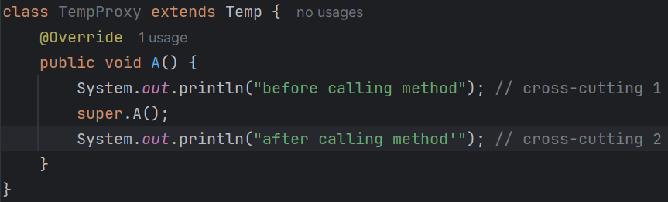
  - This overridden method will be containing all the cross cutting logic and call the real method (its parent class which is real class)
- Consider the below scenario:
  - 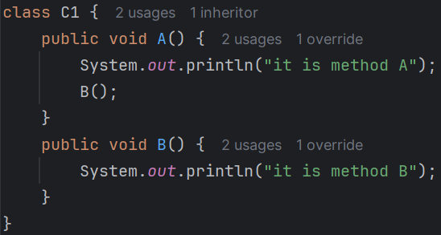
    - Here I am calling B() inside the method A() in the real class.
  - 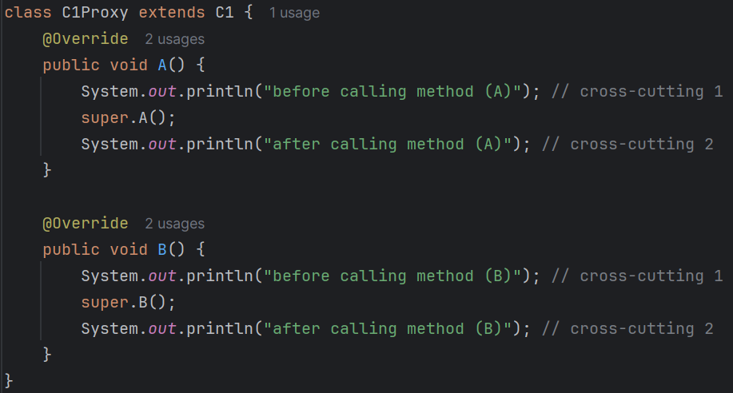
    - It will be proxy class which object will be assigned to your variable.
  - Now lets say you call proxyObject.A() then what will happen? In plain Java
    - proxyObject.A() -------------------- C1Proxy’s A()
    - super.A() -------------------- C1’s A()
    - this.B() --------------------- C1Proxy’s B()
  - Here the output will be proper:
    - 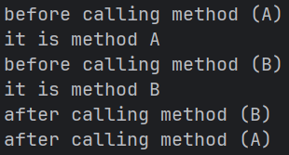 (output)
    - Because here this will refer to the object type only which is of type C1Proxy.
- In case of Spring AOP, the below happens:
  - 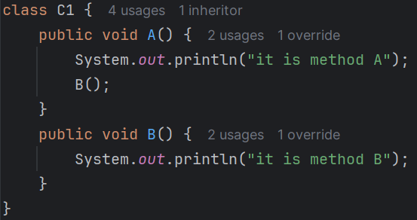
    - It is the real class C1.
  - 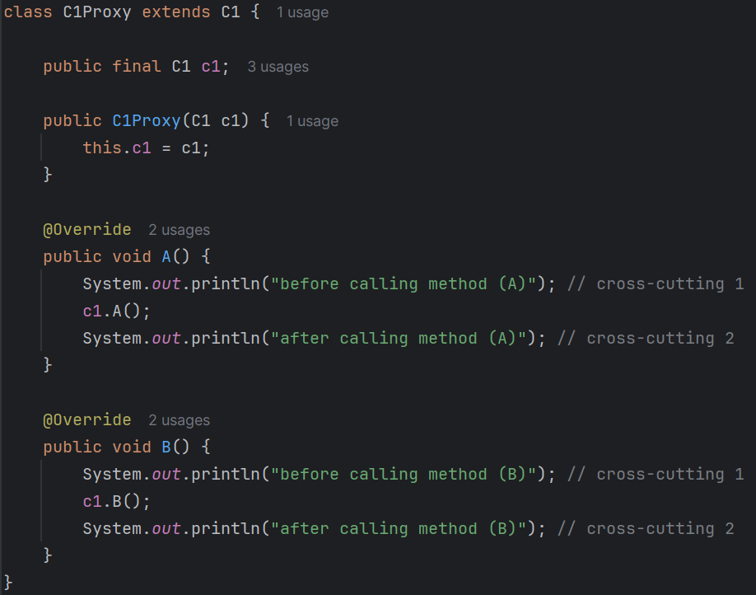
    - It is the proxy class C1Proxy.
    - But it doesn’t extend the real class, rather it keeps one object of the real class.
  - Now lets say you call proxyObject.A() then what will happen? In plain Spring AOP
    - 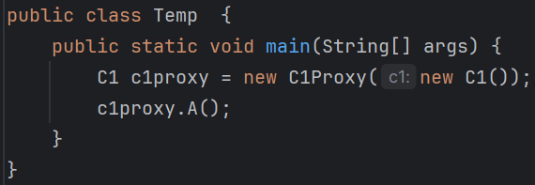
    - c1Proxy.A() -------------------- C1Proxy’s A()
    - super.A() --------------------- C1’s A()
    - this.B() --------------------- C1’s B()
      - Because here public final C1 c1; is the real class’s object which is C1.
  - In our code, Proxy is a proper class (TempProxy) that extends the real class (Temp),
  - This is why, calling one method (present inside the same class) from another method will not work in case of AOP.
- The below is a simple template of spring AOP syntax
  - 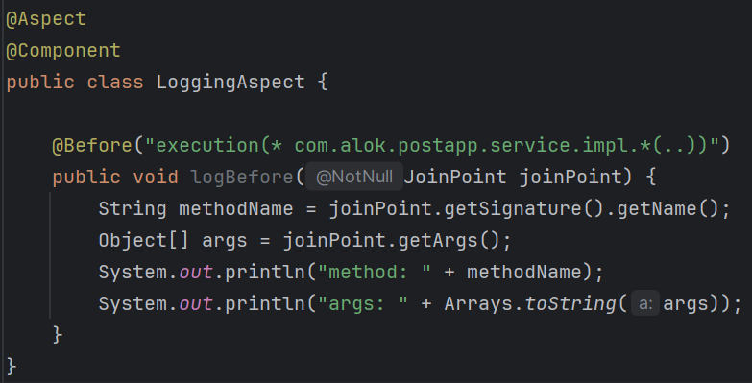
  - LoggingAspect class → Aspect
  - @Before + content of logBefore method → Advice
  - “execution(……)” → Pointcut
  - Method execution matched by the pointcut → Join Point
  - Aspect contains Advice, Advice uses Pointcut, Pointcut selects Join Points
- JoinPoint and ProceedingJoinPoint
  - You can get an object of type JoinPoint to get the details about the method (join point)
  - For the advice type @Around, you can get ProceedingJoinPoint which contains the features of JoinPoint + some extra features.
  - JoinPoint is kind of observer which can get the details about the method and all, but ProceedingJoinPoint can control the method execution and all.
  - ProceedingJoinPoint is only valid in case of @Around advice type.

- F
- F
- F
- F
- F
- F
- F
- F
- F
- F
- F
- F
- F
- F
- F
- F
- F
- F
- F
- F
- F
- F
- F
- F
- F
- F
- F
- F
- F
- F
- F
- F
- F
- F
- F
- F

- Spring AOP

- F
- F
- F
- F
- F
- F
- F
- F
- F
- F
- F
- F

