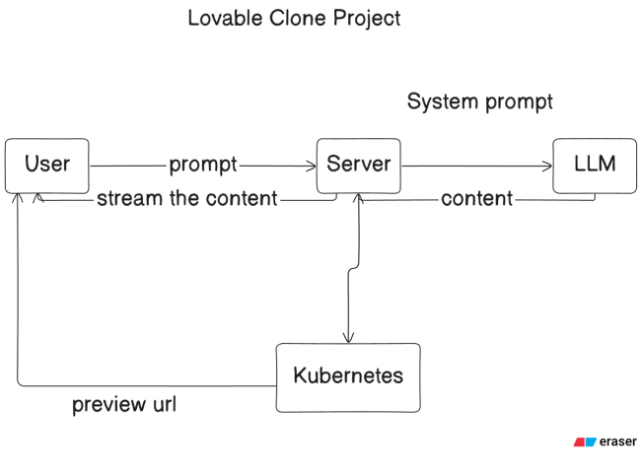
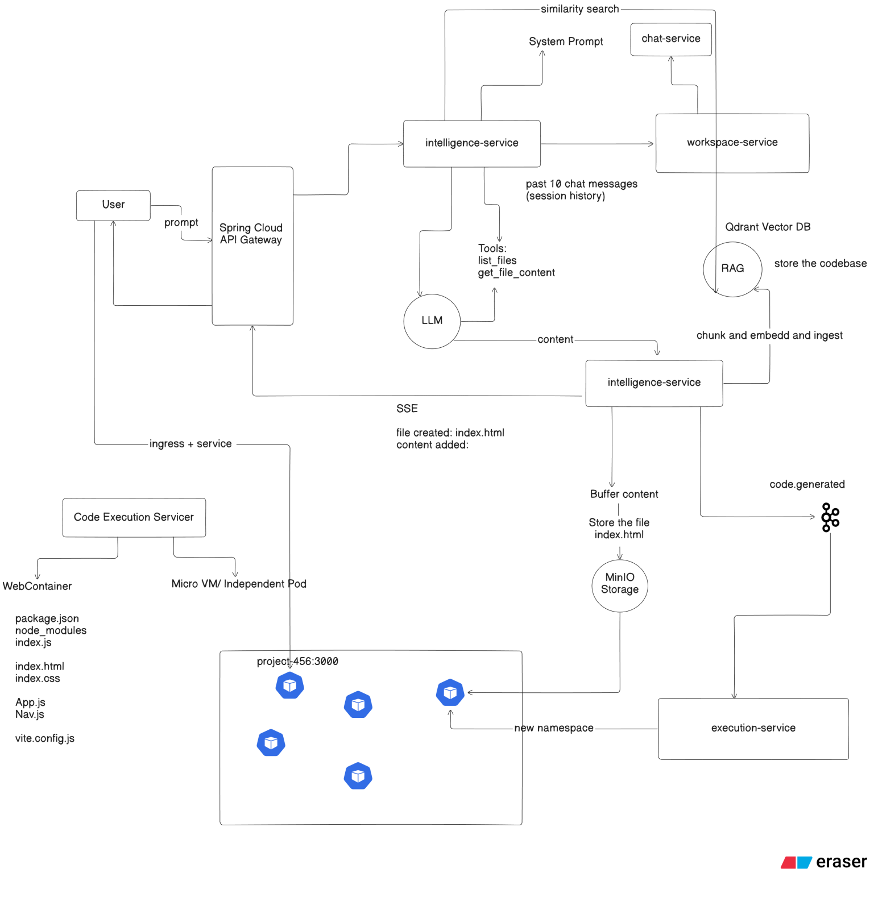
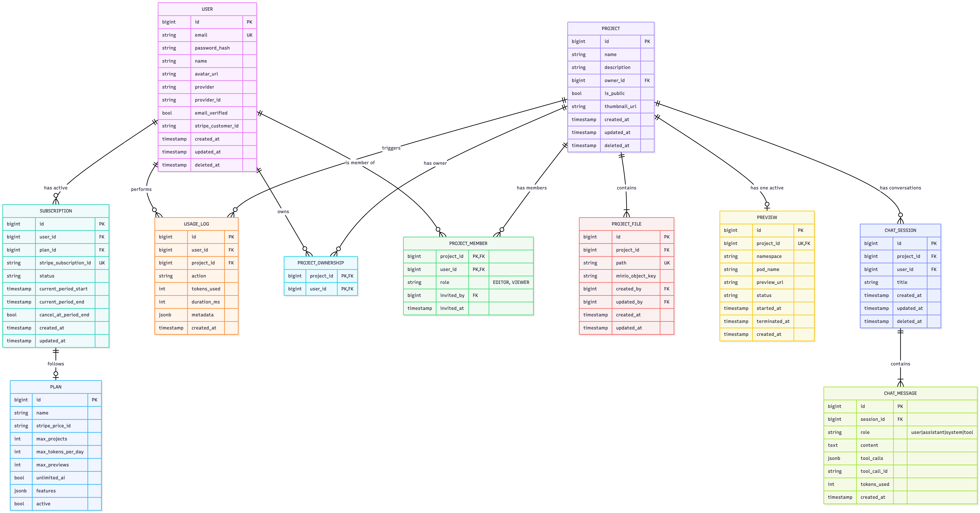
- Features
  - Core Features
    - Projects
      - Create project
      - Manage project
      - List projects
    - Auth
      - Login
      - Signup
      - Get My Profile
    - AI Code Generation
      - List Chat Session
      - Create New Chat Session
      - Load Full Chat History
    - Files
      - Get File Tree + Metadata
      - Get File Content
      - Download All files as a ZIP
    - Preview
      - Get Project Preview
      - Get Logs Stream
  - Additional
    - Payment - Stripe (not sure it’ll be implemented or not)
    - Quota Management
      - Plan: FREE | PRO
    - Token used quota, Previews running quota
    - Rate limiting (maybe via Redis)
    - Zipkin Tracing
  - Members
    - One project to have many people

