- ResponseEntity is not sent to global ResponseHandler (having @RestControllerAdvice and implementing ResponseBodyAdvice)
- If you write the entity name User, it’ll not create because Postgres has its own user table where it maintains the user records.
  - So, better to write users in the @Table annotation.
  - 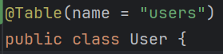

- If you are writing a method for doing some transaction in
  - If the method is private, then it’ll not be saved in the database after the end of transaction. To save, you need to mention repository.save() explicitly.
  - Or, even if the method is public but you are calling this method from some another method of same service (i.e. both normal method and transactional method is written in save service class) then also it’ll not save. Here also you need to mention repository.save() explicitly to save in the database.

- F
- F

