- How Spring Boot Works?
  - dependencies are nothing but .jar files which contains the classes that we want to use.
  - maven just download the JARs, and puts them on the compile + runtime classpath.
  - modules are JARs with extra responsibilities.
    - spring-web, spring-context, spring-jdbc, spring-data-jpa
  - When you run your application, JVM searches for all the .class files inside the classpath which is provided by maven (I.e. classpath list is provided by Maven).
    - target folder is one of the classpaths; but it is not the only classpath;
    - .jar files present in the External Libraries are stored in local Maven Cache. Which is not inside the project.
      - ~/.m2/repository/org/springframework/spring-webmvc/6.1.x/spring-webmvc-6.1.x.jar
  - Then how JVM gets to know about the .class files that will be used?
    - Maven creates a classpath where all the list of paths are present.
    - JVM sees this and use those classes.
    - External Libraries are nothing but the classpaths that are not inside your project.
  - When you create .jar file of your application, the self created classes and the external libraries classes will be stored separately.
    - 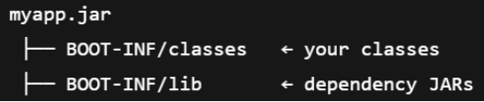
    - classes will contain the self created classes.
    - lib will contain the external libraries classes.
- Maven vs JVM
  - maven works at build time and JVM works at run time.
  - Initially maven is run when you trigger the commands like mvn test, mvn compile, mvn package, mvn spring-boot:run .
    - It downloads the dependencies after reading the pom.xml and stores them in ~/.m2/repository (maven cache path).
    - Then it compiles the .java files and convert those to .class files (bytecodes) (if the command that was executed was mvn compile)
    - Depending upon the maven command executed, it’ll do the thing.
    - One important thing: maven is also written in java. So it also needs one JVM to run it. It is called Maven JVM (its not any special JVM, just normal JVM only)
    - Inside this Maven JVM, maven modules are being used, not spring modules.
    - After finishing its work, Maven creates files on disk (JAR, class files). Later, a separate JVM loads those files and runs the Spring Boot application..
  - Now JVM part comes.
    - JVM never reads pom.xml, it is just read by maven to download the dependencies and provide those to JVM.
    - JVM use those dependencies to run the application.
- There is one plugins that is present in the pom.xml which is “maven-compiler-plugin”.
  - maven-compiler-plugin invokes javac behind the scenes, passing all the required flags, paths, and options.
  - Needful flags means
    - -classpath → where dependencies are
    - -processorpath → where annotation processors (like Lombok) are
    - -source / -target (or --release) → Java version
    - -d target/classes → where compiled .class files go
    - list of .java source files
- spring-boot-maven-plugin
  - spring-boot-maven-plugin does NOT run your application logic.
  - It prepares and packages your Spring Boot application so it can be run easily by the JVM.
  - Without this the dependencies won’t be there in the .jar file, you would have to copy and paste those dependencies to run the application.
  - Also it copies the tomcat jars into that.

- Spring Boot Work-Flow
  - Dependencies are JAR files that contain reusable classes.
  - Maven reads pom.xml, downloads dependencies into ~/.m2/repository, and manages build steps.
  - Plugins are used by Maven to compile, test, package, and run the application.
  - Maven helps prepare classpath information, but the JVM actually uses the classpath to load .class files.
  - IntelliJ shows dependency JARs from Maven cache under External Libraries.
- Runtime Flow
  - JVM starts and executes main()
  - SpringApplication.run() processes @SpringBootApplication
  - Auto-configuration classes listed in the AutoConfiguration.imports file are considered
  - Beans are created only if conditions match, using conditional annotations
- Maven vs JVM
  - Maven works at build time
  - JVM works at run time
  - Maven downloads and prepares dependency JARs
  - JVM loads classes from those JARs and runs the application
- Plugins
  - maven-compiler-plugin
    - Invokes javac with required flags
    - Handles annotation processing (Lombok)
  - spring-boot-maven-plugin
    - Packages the app into an executable fat JAR
    - Bundles dependencies (including embedded Tomcat)
    - Makes java -jar app.jar possible

- In the plugins sections, under maven-compiler-plugin, there is something called annotationProcesssorPaths
  - 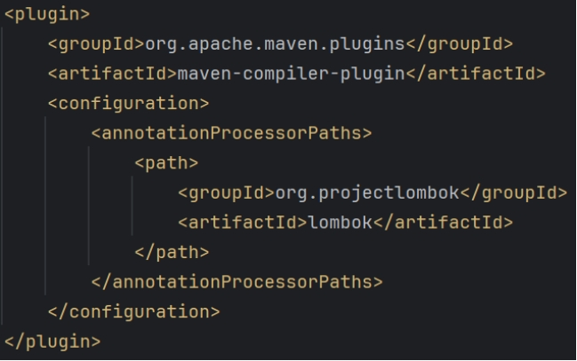
  - annotationProcessorPaths tells javac which JARs contain annotation processors and should be loaded during compilation.
  - Lombok must be available on the annotation processor path for its annotations (@Getter, @Setter, etc.) to work.
  - Annotation processors are compile-time tools that analyze annotations and modify or generate code before .class files are created.
  - The order of entries in annotationProcessorPaths does not control execution order; processors do not run sequentially.
- In case of lombok and MapStruct, why lombok-mapstruct-binding is needed?
  - Lombok does not generate new classes; it modifies existing classes at compile time by altering the compiler’s internal representation (AST: Abstract Syntax Tree).
  - MapStruct generates new mapper classes and relies on the annotation-processing API to inspect methods.
  - Lombok’s AST modifications are not fully visible to MapStruct by default.
  - lombok-mapstruct-binding acts as a bridge, making Lombok-generated getters and setters visible to MapStruct during annotation processing.
  - This problem is about visibility, not execution order.

- Also you can see below, in this plugin lombok is included in the excludes list
  - 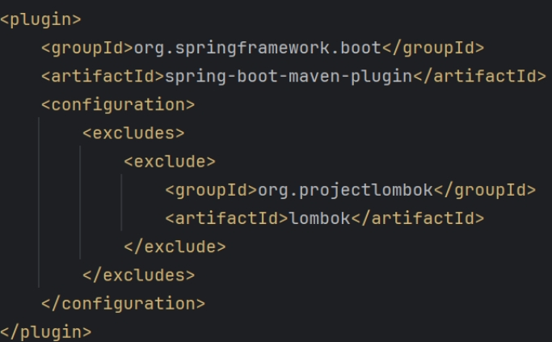
  - This is because, lombok doesn’t provide any .class files that JVM needs to run the application.
  - It just injects the getters and setters to the existing classes during compile-time.
  - When you see the .class files, you’ll see the getters and setters method’s implementations there; lombok runs during compilation-time; as the getters and setters are already generated, hence there is no need ot including lombok in the .jar file.
    - 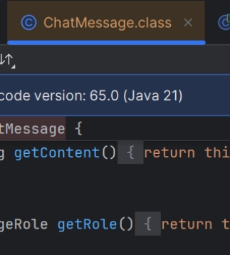

How Auto-Configuration works?
- The imports file inside the auto-configure jar is read
  - Spring reads this fie:
  - This file contains a list of auto-configuration classes, like
- Spring loads those classes, and evaluates their annotations.
- Then it checks the conditional annotations
  - Each auto-config class has things like the below:
    - 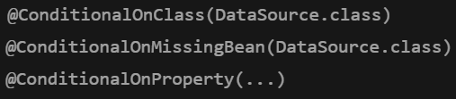
  - Spring checks:
      - Is the required class present? Is the required property set? Is a user-defined bean already present?
  - If all the conditions pass, then only bean is auto-configured.
- If the bean already exists, it will NOT create one
  - Lets say we have manually configured one bean, like
    - 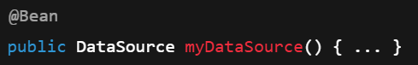
  - Then the below condition will fail
    - Because this bean is already created.
- Overall flow
  - 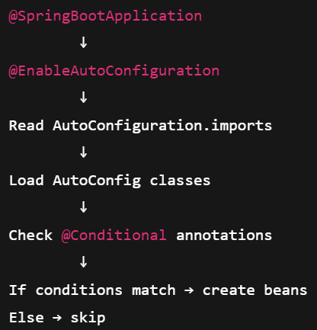
- So, in simple terms: Spring Boot auto-configuration works by scanning predefined auto-configuration classes and conditionally creating beans based on classpath presence, configuration properties, and existing user-defined beans.
- Write debug=true inside the application.properties file to see the beans being auto-configured.

- Spring Web
- Servlet:
  - It’s a Java class that receives HTTP requests and sends HTTP response.
  - Browser → Servlet → Business Logic → Servlet → Browser
- Tomcat
  - Tomcat is a web server + servlet container.
  - A Servlet is a Java class that Tomcat loads, manages, and calls when an HTTP request arrives.
  - Tomcat does 2 jobs:
    - Listens for HTTP requests (like a normal web server)
    - Runs Servlets to handle those requests.
  - So it has 2 parts:
    - HTTP Server + Servlet Container
- Servlet
  - Servlet is just a normal Java class that extends HttpServlet.
  - HttpServlet has methods like doGet(), doPost() ..etc
  - 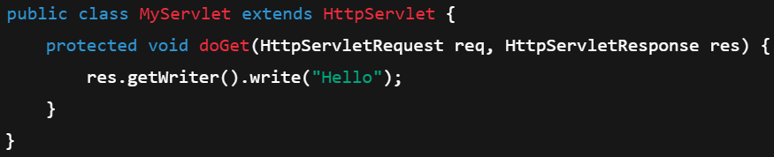
- A servlet does nothing on its own; unless and until tomcat calls it.
- How Tomcat calls the servlets?
  - It maintains a mapping table from URL pattern to Servlet instance
  - 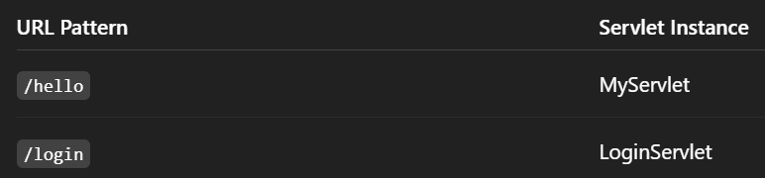
  - There are basically 3 ways to create this mapping:
    - @WebServlet
      - 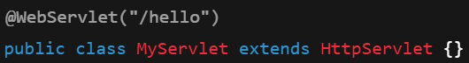

    - web.xml (old way)
      - 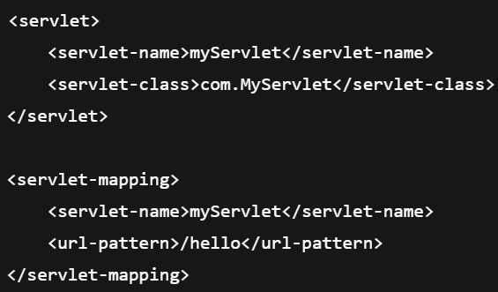
    - Programmatic (Spring Boot style)
      - 
  - Lets say you trigger a GET request on the URL: http://localhost:8080/hello . Then the following steps happens:
    - Browser sends HTTP request
    - Tomcat receives request
    - Tomcat checks URL mapping table
    - Finds: "/hello" → MyServlet
    - Tomcat creates (or reuses) MyServlet instance
    - Calls doGet() method
    - Response returned to browser
  - Tomcat calls your servlet — not Spring
  - NOTE: The servlet instance is created by Tomcat; not by YOU; not by Spring;
    - You can just create the class extending HttpServlet; that’s it;
  - 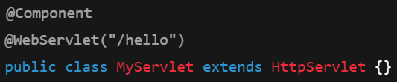
    - Even if you write like this it’ll not work; because here the instance (i.e. bean) is created by Spring; not Tomcat;
    - ❌ Spring DOES NOT scan @WebServlet by default
    - ❌ Tomcat DOES NOT scan Spring beans
  - You can say why to write @Component, just write @WebServlet(“/hello”) and move on.
    - Because we want tomcat to notice this not spring.
    - But, in Spring Boot application, tomcat is handled by Spring.
- 2 scenarios are there:
  - Traditional Tomcat (war deployment)
    - 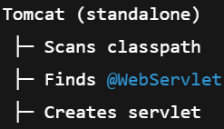
    - @WebServlet works automatically
    - No Spring involvement needed
  - Spring Boot (Embedded Tomcat)
    - 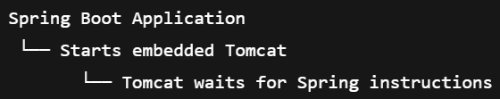
    - ❗ Tomcat does NOT scan for @WebServlet on its own
    - ❗ It only registers what Spring explicitly tells it to

- What happens in Tomcat in Spring Boot Application?
- Key points which is TRUE everytime
  - Tomcat always creates servlet instances.
  - Spring NEVER creates servlet instances for Tomcat to use.
- In traditional Tomcat, it itself scans for @WebServlet and create instance of those and map.
- But in Spring Boot application, Spring embeds Tomcat inside itself;
  - Spring itself start that Tomcat server.
  - And in here, Tomcat doesn’t scan for the @WebServlet, rather it waits for Spring to give it instruction to do the scan (if we write @ServletComponentScan), after that Tomcat scans and registers those servlets.
  - 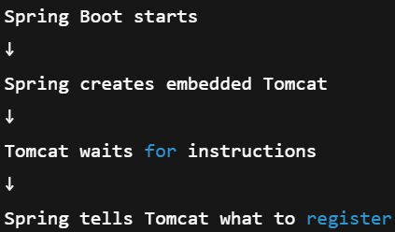
- 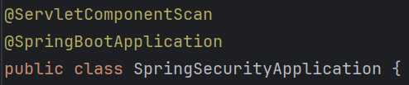
- 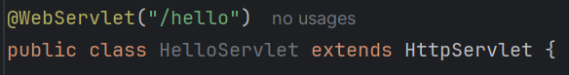
  - No need to write @Component

- Creating Custom Servlet extending HttpServlet class
- HttpServlet
  - You can see, all the methods inside HttpServlet only add some error content in the response.
  - NOTE: the method doesn’t return anything; they do have request and response objects, they just add some content to the response object.
    - 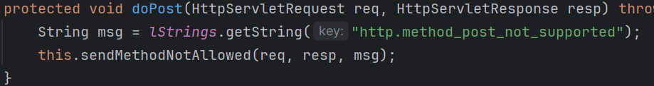
    - If you see here, it is just adding some error to the response via the method sendMethodNotAllowed.
  - HttpServlet is the base class which is to be extended to write custom servlet. But you need to override the method and implement by your own; otherwise error response will be visible.
    - 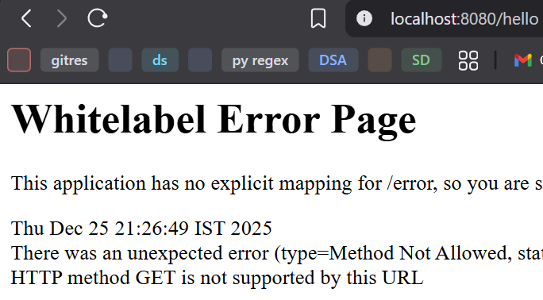
  - I overridden the service method and added in the response
    - 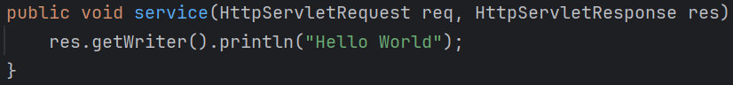
    - Now the response is coming in the browser.
    - 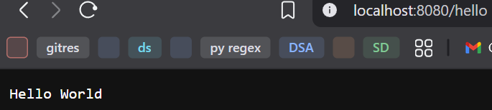

  - You can set the content type of the response as well.
    - 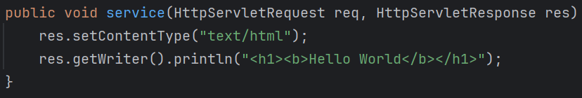
- You can also manually configure the Tomcat without the help of Spring Boot
  - 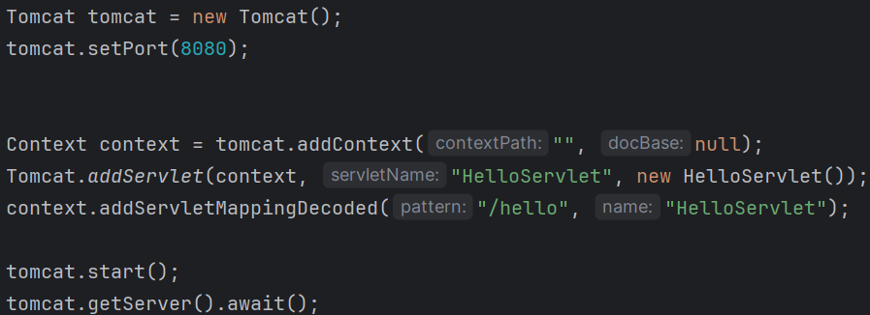
  - SpringApplication.run is not there. And also @WebServlet is not written in HelloServlet class.

- How all the mappings are being done in Spring Boot Application?
- As we know, Tomcat has a mapping table where the end points are mapped to servlets, according to the end-point, tomcat calls the specific servlets.
- But in case of Spring Boot Application, only one servlet is there which is DispatcherServlet (it also extend HttpServlet only); it is auto-configured.
  - Tomcat maps DispatcherServlet for all the end-points which is “/*”
  - After that, DispatcherServlet calls the controllers to update the response object.
  - Tomcat doesn’t know about the controllers at all.

- F
- Ff
- F
- F
- F
- F
- F
- f

