- #! is called shebang. It tells the system which interpreter will be used to run the script.
  - 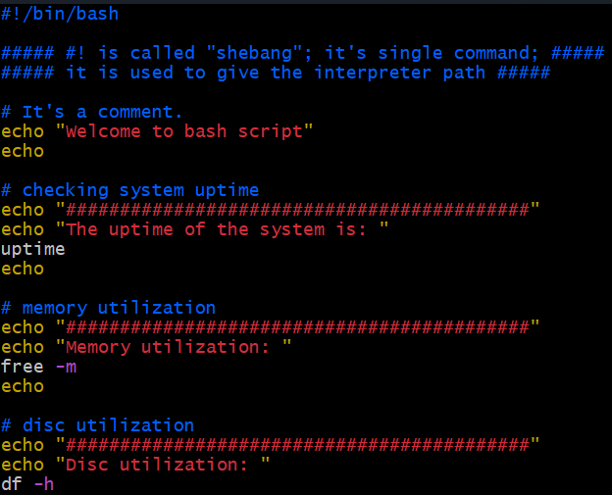
- 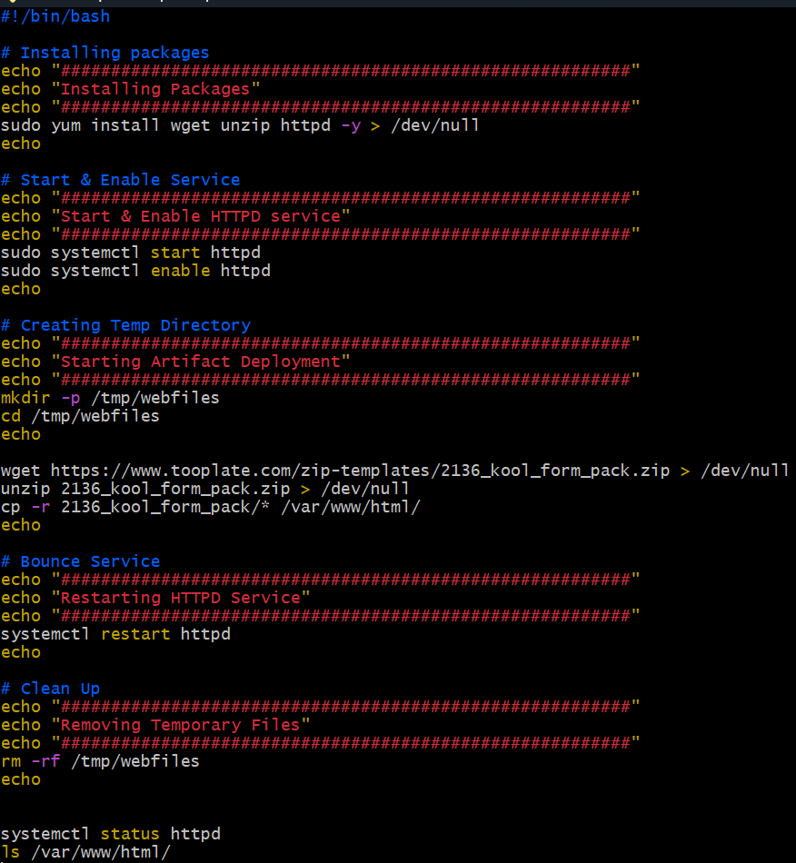
- Variables:
  - 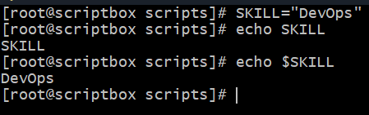 (without $ it’s just a normal string, not a variable)
- Using variables:
  - 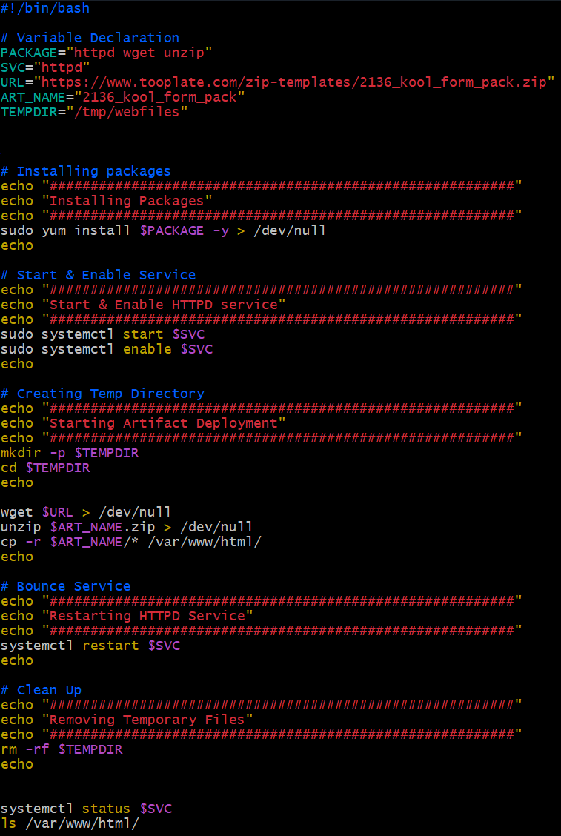
- ✅ Short Rule:
  - Use $i when you're accessing the value of the variable.
  - Use just i when you're declaring, assigning, or iterating over it.
  - Use $ whenever you would expect to "see the value" — like echo, math comparisons, etc.
  - No $ when you’re giving it a value or defining the loop variable.
  - 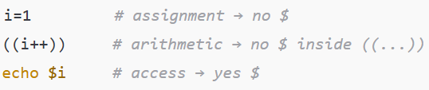
- 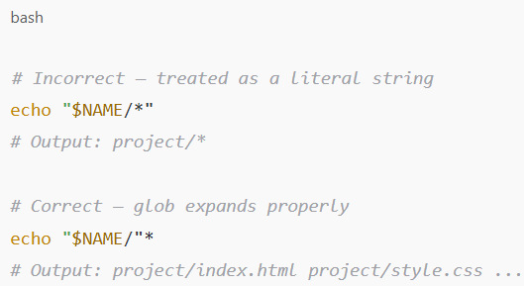
  - Don't quote the * if you want shell expansion.
  - Quote the variable part only, like this: "$NAME/"*
  - Only bcs of * we are not able to write “$NAME/*” .
  - If dir1=abc, dir2=def; we can write cd “$dir1/$dir2” , it’ll be correct. But when we write * inside a sting, it’ll not get expanded.
- Advanced redirection:
  - 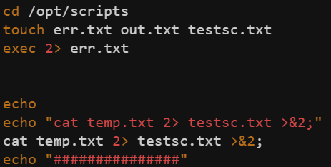
  - Let’s first understand what is >&2
    - command 2> test.txt >&2
    - Here 2> means stderr redirection
    - >&2
      - > means stdout redirection
      - &2 means the path where 2> is referring (here test.txt)
      - >&2 means, stdout will go to the path where >2 is going i.e. test.txt
    - Similarly command > test.txt 2>&1
      - It’s also same;
      - 2>&1
        - Means stderr will to to the path where stdout is going i.e. test.txt
    - So simply &x means the path which is getting referred by x> (x=1, 2)
  - So, now let’s see the above screenshot.
    - I have set all the future stderr path to err.txt
    - Then I wrote cat temp.txt 2> testsc.txt >&2
    - Here, 2> testsc.txt will override the err.txt for this command, so for this command, stderr is referring to testsc.txt.
    - So, >&2 means stdout will go t o the path where stderr is going i.e. testsc.txt (for this command only.. otherwise err.txt)
- In bash 0: true, non-zero: false
- if ! rpm -q httpd > /dev/null 2>&1 means if httpd is installed, it’s exit code will be 0 hence true.
- 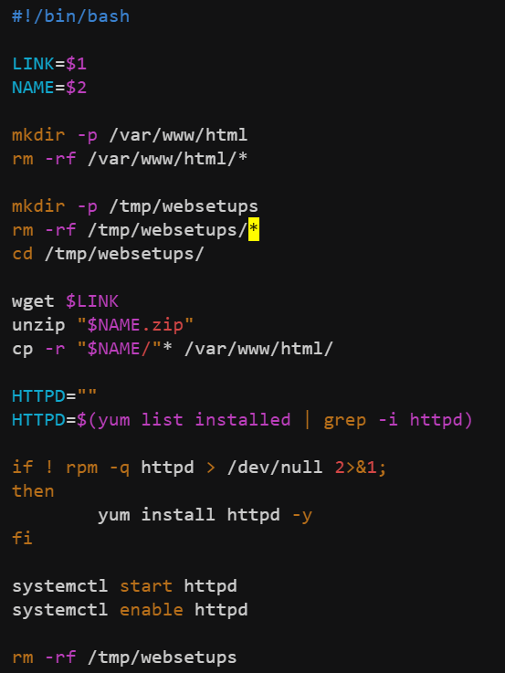(script to host any site in httpd)
  - $1 $2 represents the command line arguments . $0 represents the command itself.

- Variables
    - It’ll install these packages wget, httpd, unzip.
  - While declaring variables I.e. VAR1=”value1”
  - While using variables I.e. echo $VAR1 (use $ while using variables)
- 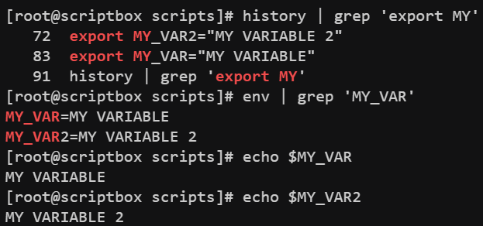
  - export command is used to set any env variable.
  - You can check all the env variables using the commsnd “env”.
- Following are the built-in shell(bash) special/system variables:
Variable | Description
$RANDOM | Returns a random integer between 0 and 32767
$UID | User ID of the current user
$EUID | Effective UID
$HOME | Current user’s home directory
$PATH | Colon-separated list of directories to search for executables
$PWD | Present working directory
$OLDPWD | Previous working directory (cd -)
$SHELL | Path to the current shell
$USER | Username of the current user
$HOSTNAME | Hostname of the system
$SECONDS | Number of seconds since the shell was started
$LINENO | Current line number in the script
$BASH_VERSION | Version of Bash
$BASH_SOURCE | Filename of the current script
Variable | Description
$0 | Script name
$1…$9 | First to ninth argument to script
$# | Number of arguments
$@ | All arguments as separate quoted strings
$* | All arguments as one word
$? | Exit status of last command
$$ | PID of the current shell
$! | PID of last background command

- Command substitution:
  - Stores the output of a command in a variable
  - Use back-tick `` or $()
  - 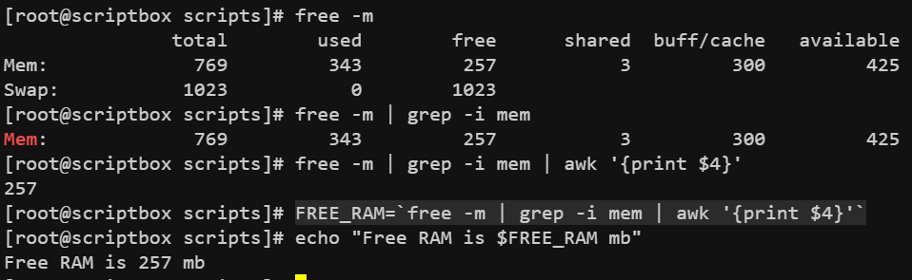
  - NOTE: these are called command substitution. Means the output of the command will not go to the screen now, it’ll be stored in the variable only.
- 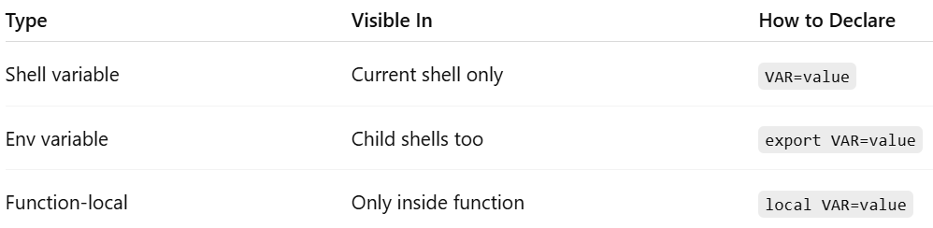
- Child shells:
  - 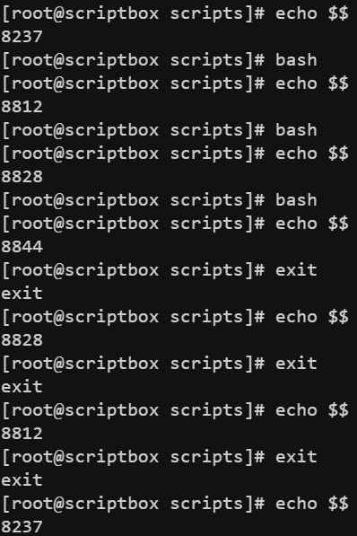
  - $$ is used to print PID of current shell. 8237(parent shell) -> 8812 -> 8828 -> 8844
  - So 3 levels of hierarchy got established.
  - You can get out of child shell to parent shell using exit command.
  - 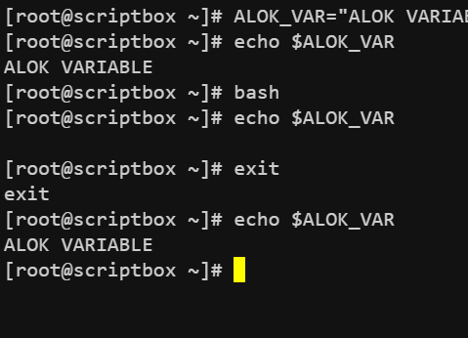
  - In shell script, child shell can’t excess the variables declared in parent shell.
  - 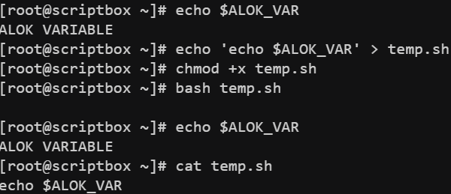
    - By default, shell script files run in child shell. So that also can’t access the variables.
  - 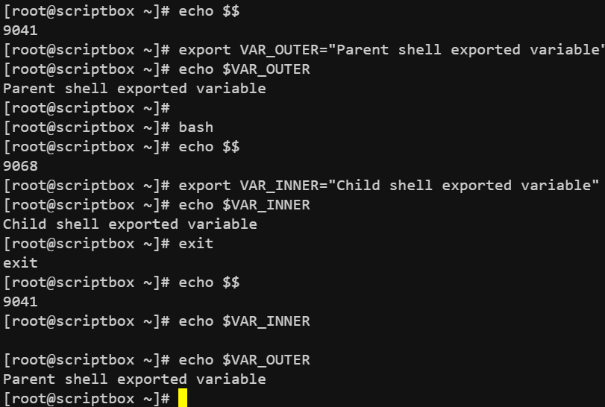
    - When in a shell, a variable is exported, it’ll be available to all of it’s child shells but not to parent shell. & If u export a variable and logout and again login, the variable will not be there.

- When u run a script, it by default gets run in a child shell.
  - 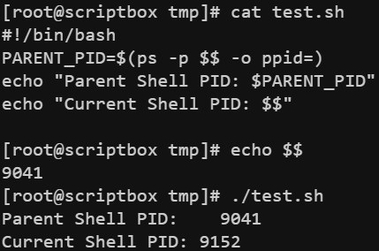(Parent shell PID: 9041, script ran in 9152 which is a child shell)
  - 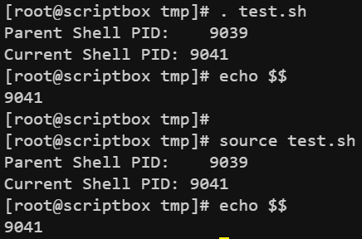
    - If u run the script using . (dot<space><filename>)or source command, then it’ll be run in the current shell only.
  - 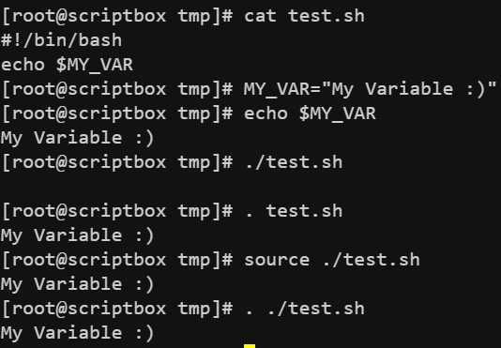(When we ran the script using source or . it accessed the variable MY_VAR)
- In home directory of every user(root or any other user) there is an .bashrc file which is loaded (executed) after log in with that user’s shell. If u want to make a variable be accessed for that user even after logging out and logging in, you can export that variable inside that file.
  - 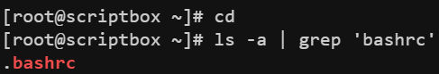
  - NOTE: That variable will only be accessible by the particular user, whose .bashrc file had been updated.
  - If u want to make the variable accessible for all the users, then export the variable inside the file /etc/profile
  - (like this)
  - 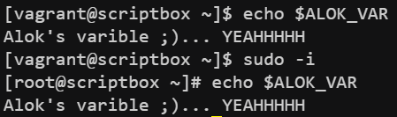(for all user it is accessible)
  - NOTE : First /etc/profile file is sourced and then .bashrc file. So, if same variable is declared in both, then .bashrc will override that /etc/profile .
- Taking input from CLI:
  - 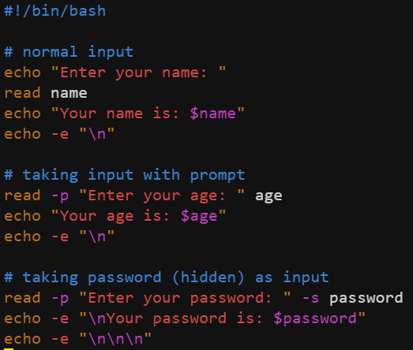(-p for prompt, -s for hidden input)
    - 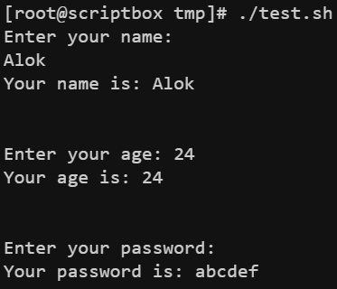
- Decision making(if, elif, else)
  - 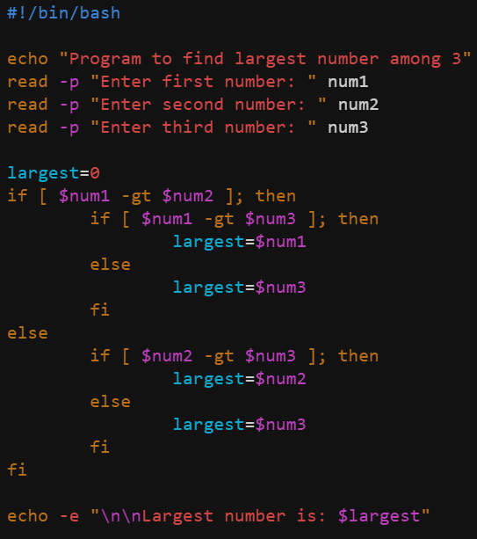
  - 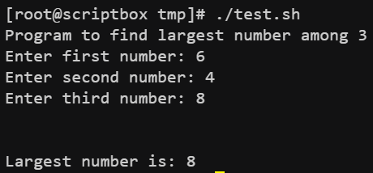
  - NOTE: there must be a space after [ and before ] in if or elif statements. Otherwise it’ll take [<any char> as one single command.

- Crontab:
  - Used to do any repetitive task.
  - crontab lets you schedule commands or scripts to run automatically at specified times and dates. It uses a background service called cron.
  - 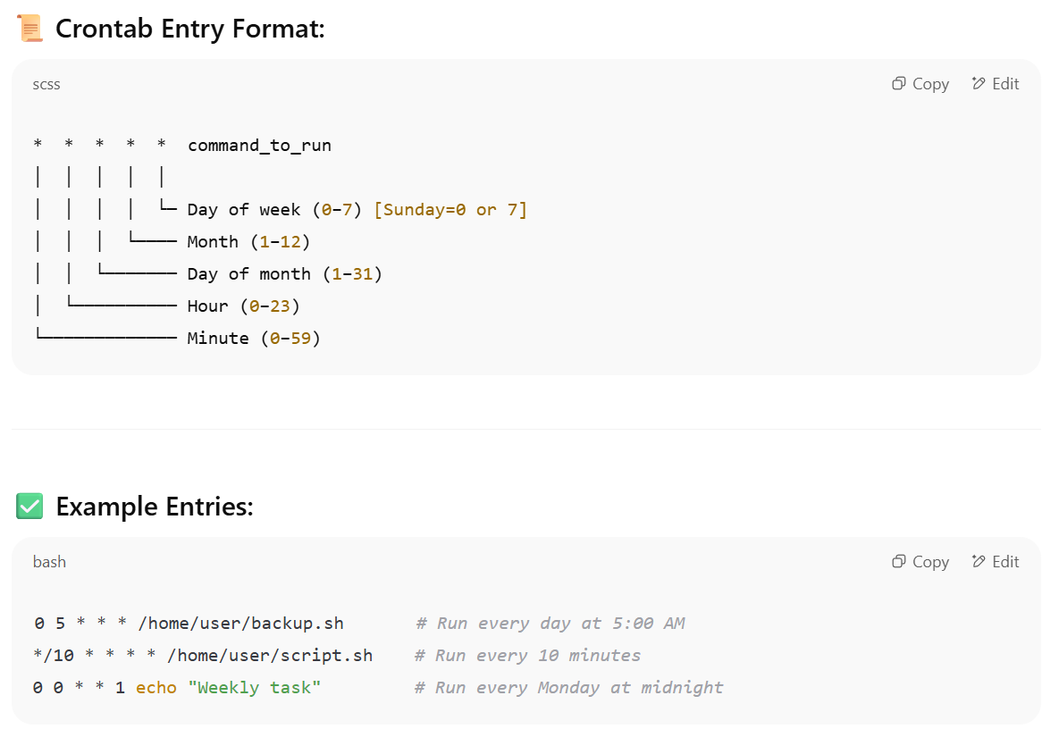
  - Example:
    - 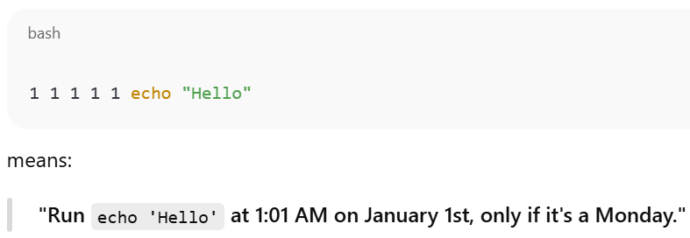
- Once per year on Jan 1st that too if it’s Monday. (which is very rare)
- Loops:
  - The semicolon ; before do is optional if the do is on a new line, but required if it's on the same line as the loop.
  - 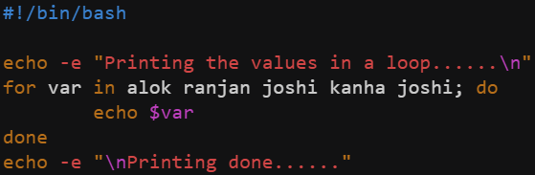(looping through an array)
  - 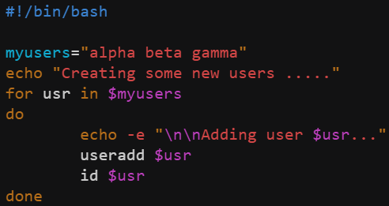
    - While assigning a variable, no space should be given i.e. myusers = “alpha beta gamma”. it’ll think that myusers is a command if space is given between myusers and =
    - Inside the for loop, $ has to be used while accessing the list or array. As for accessing, $ has to be used.
  - 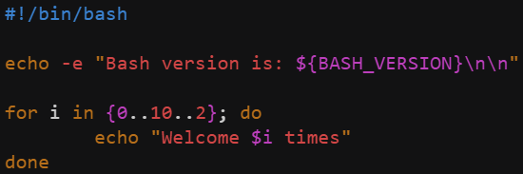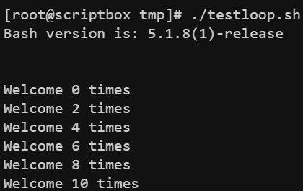
    - Here, {0..10..2} means 0 to 10, step=2
    - Here, I wrote do in the same line. So, I had to put one semicolon ;
    - (output)
  - 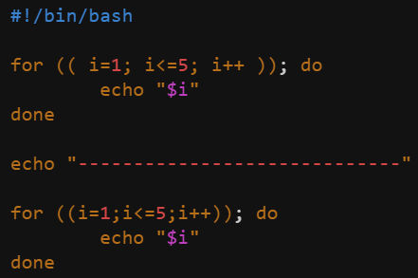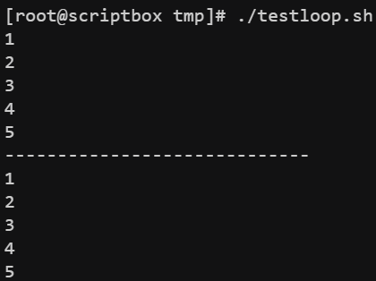
    - gave to examples to show that space is not required here
  - 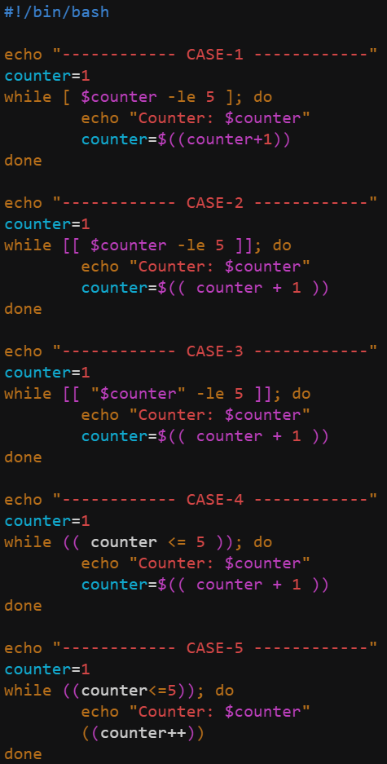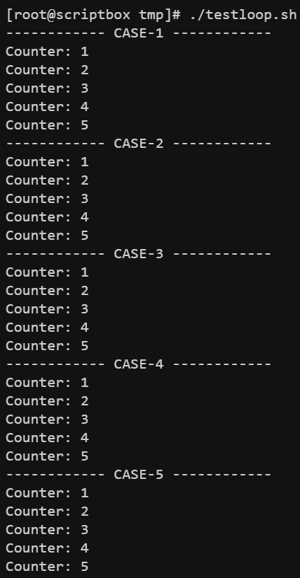
    - Look case-2 & case-3 properly.
    - You can’t write count=count+1 or count=$count+1
- Remote Command Execution:
  - From one vm (let scriptbox), you can do ssh vagrant@web01 like this to enter to the vagrant user shell of the vm web01.
  - There if you execute sudo -i then it’ll switch root user shell of web01.
  - In case of ubuntu, remote connection is disabled by . To enable this, update the file /etc/ssh/sshd_config. (PasswordAuthentication yes) inside that file.
  - Let I execute one command ssh devops@web01 uptime, it’ll login to devops user shell inside web01 vm, execute the command uptime, and get back to the current user’s shell.
  - Every-time you want to ssh you have to enter the password. So, ssh key exchange is used, however it is more safer. ssh-keygen is the command to generate the ssh key.
  - Then ssh-copy-id devops@web01 (means ssh-copy-id <username>@<vm name>)
    - 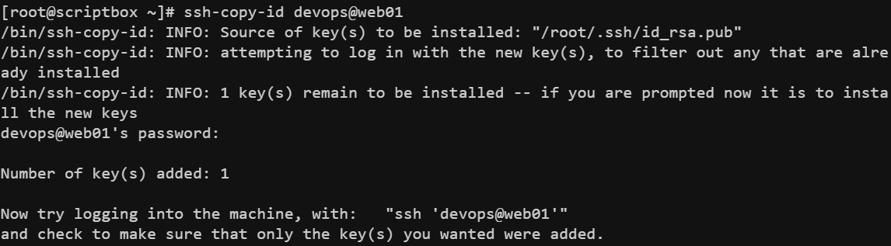
  - Now when we’ll login the user (devops@web01) it’ll not ask the password for this.
  - It basically execute ssh -i .ssh/id_rsa devops@web01 when we execute ssh devops@web01 .
  - 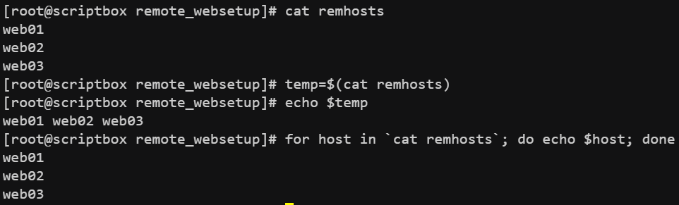
    - If there are so many hosts, you can’t ssh them all manually as it’ll consume a lot of time. Better to use a loop for those as mentioned in the above screenshot.
- scp command:
  - It is used to download/upload (basically copy) the files between current & remote machines.
  - It uses ssh protocol.
  - scp <path from> <path to>
    - scp note.txt alok@web01:home/tmp/ (upload)
    - scp alok@web01:home/tmp/note.txt ./note.txt (download)

- 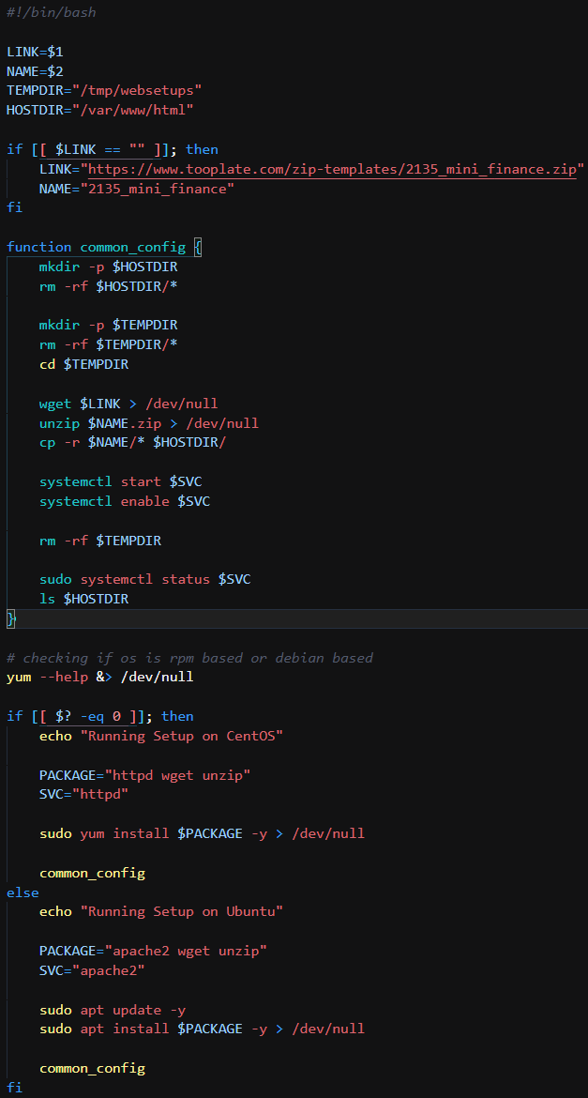
- 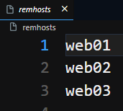
- 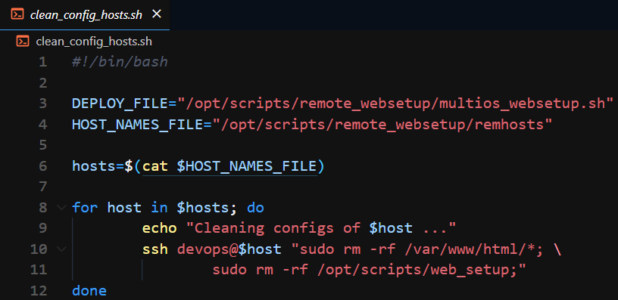
- 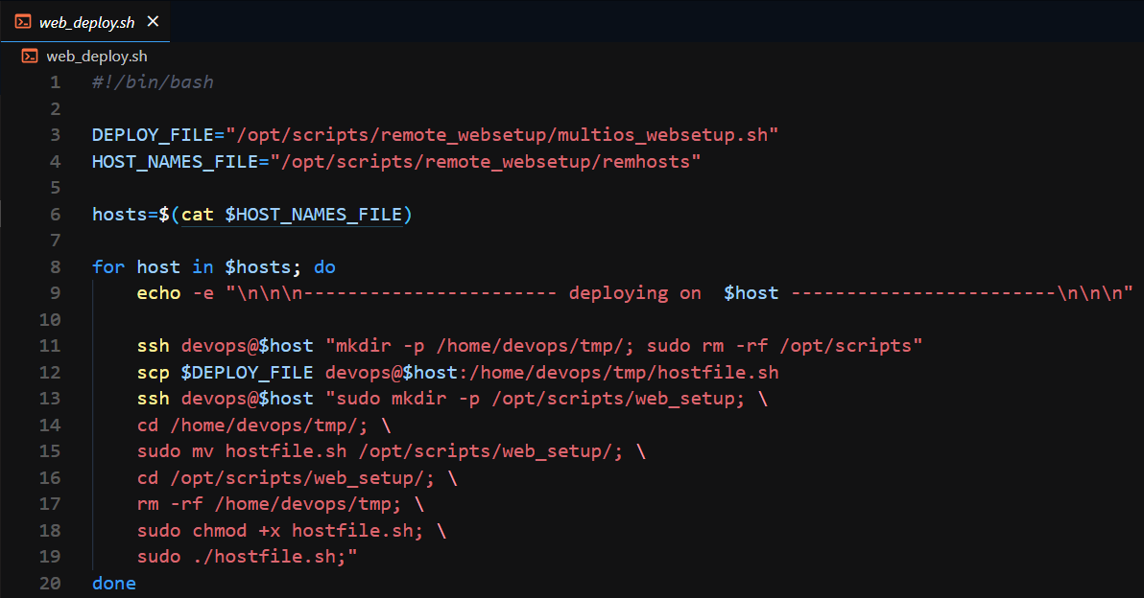
  - It is used to deploy the website in all the hosts.
    - First create a tmp directory inside the home directory of devops user & delete the /opt/scripts/ directory if present.
    - Copy the hostsite file of current host to that tmp directory of remote host.
    - Create a folder and move that hostsite file to that folder (/opt/scripts/web_setup in my case), make it executable and run that file. Remove that tmp file that had been created earlier.
    - As we can’t ssh root directly (we can if PermitRootLogin yes inside /etc/ssh/sshd_config but it’s not preferable), so use sudo to execute all root commands.
- Some important points in shell scripting:
  - Use of $ :
    - Where you are accessing a variable like echo $my_var
    - Inside string i.e. “/tmp/$dir_name/” (here dir_name is a variable, written inside a double quote)
    - In arithmetic expression like sum = $(( x + y )) here $ means return the output of the expression so that sum can store it.
    - NOTE: No use of $ inside (( … )).
    - $(( … )) is not same as $( ( … ) ).
    - $(( … )) is arithmetic expansion and $( … ) runs the command and returns it’s output. However $( (x+y) ) will fail because x+y is not a command.
    - Read variable in condition i.e. if [ $i -lt 5 ] because here you are accessing the value of i and comparing with 5.
  - Use of [ … ]
    - if, elif, else conditions. i.e. if [ $a -lt 5 ] or if [ $str = “alok” ]
      - Note: -lt, -le, -gt, -ge, -e1, -ne are used for numeric variables
      - =, !=, -z, -n are used for strings.
        - if [ -z $str ] means if str is empty.
        - if [ -n $str ] means if str is not empty.
    - 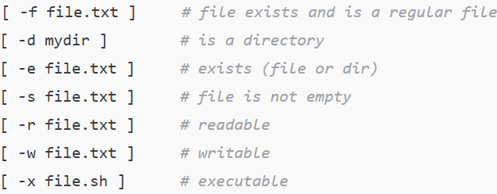(for files)
    - We can combine || and && outside the brackets i.e.
      - if [ -f a.txt ] && [ -s a.txt ]
    - NOTE: [ $str==”alok” ] is wrong. == should have spaces around it. [ $str == “alok” ] it is correct.
    - [ -f file.txt && -s file.txt ] it is wrong. && can’t be used inside [ .. ]
    - 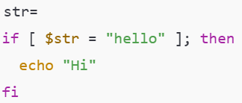
      - Here, it’ll become [ = “hello” ], so will give error Error: unary operator expected.
      - So, best practice is [ “$str” = “hello” ]
    - 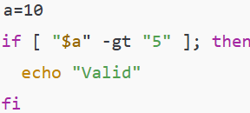
      - as we know -gt is for numeric values not for strings. But here a is a number and this string represents a number. So here -gt will work fine.
      - If a=”alok” and we have written if [ “$a” -eq “alok” ] it’ll give error as -eq is not for strings.
  - Use of [[ … ]]
    - Modern and safer version of [ … ]
    - Same as [ … ] for the strings, but there if the string is empty then we were not able to write if [ $str = “alok” ] kind of thing as it was giving error, but in case of [[ … ]] we can write that. It’ll not give any error.
      - 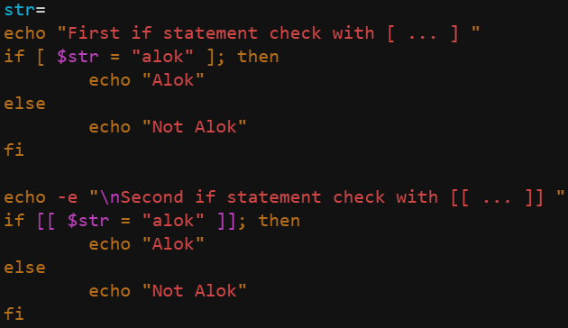
      - 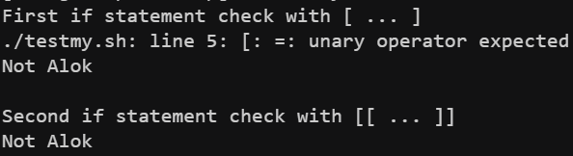
    - One additional thing is regex matching & pattern matching.
      - 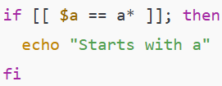
    - In case of [ … ] we were not able to use && and || but in case of [[ … ]] we can use && and || inside that.
      - if [[ $x -gt 5 && $x -lt 20 ]]
  - Use of ( … )
    - It starts a subshell.
    - ( cd /tmp && ls ) is same as these 4 commands in shell script bash, cd /tmp, ls, exit. NOTE: ( …. ) will run the commands in child shell but gives output in the current shell. Whereas bash, cd.., exit will run commands in child shell and also give outputs in that child shell. So, you can’t return those outputs to the current shell.
      - 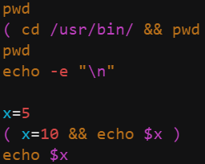(code)
      - 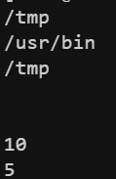(output)
    - We can group commands with redirection.
      - ( echo “Line 1”; echo “Line 2” ) > output.txt
    - Can be used in pipelines
      - ( cd /tmp && ls ) | grep config
    - 
      - This & at the end means it run these grouped commands in the background.
    - 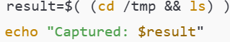 (it is not same as $(( cd /tmp && ls ))
    - ( echo “One”; ( echo “Two” ) ) | grep T
      - You might thinking here, echo “Two” will return “Two” so ultimately:
        - ( echo “One”; “Two” ) | grep T
          - But it becomes One Two at the and so doesn’t give error. Output will be “Two”
      - But if you have given ( echo “One”; “Two” ) then it’d have thrown error.
  - Use of (( … ))
    - It is used for arithmetic operations and comparisons. It’s not for strings or commands.
    - Used for arithmetic operations, assigning values, comparing values, increment/decrement, while & for loops.
    - It returns 0 (true) or 1 (false).
    - Don’t use $ inside this.
    - (( 3 + 5 )) evaluates and return 0 or 1 (as exit status). if you want to store the result then sum=$((3 + 5))
    - NOTE: As it returns 0 or 1 as the exit status, so it can be used in side the if else statements as well to check so that we can get rid of those -gt, -eq etc etc things.
      - 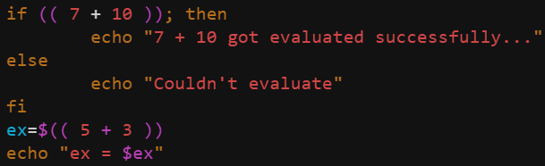(code)
      - 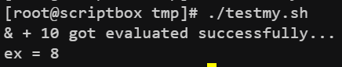(output)
    - Arithmetic operations
      - 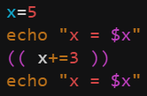(code)
      - (output)
  - For [ … ], [[ … ]] spaces are required but for ( … ) and (( … )) space are optional.
- Arithmetic operation
- Use of {}
  - To access the variable.
  - ${filename}.txt here in this type of scenario it’s helpful and safer. As if we write $filename.txt then it’ll find the variable having name filename.txt
- Functions in Shell Scripts
  - 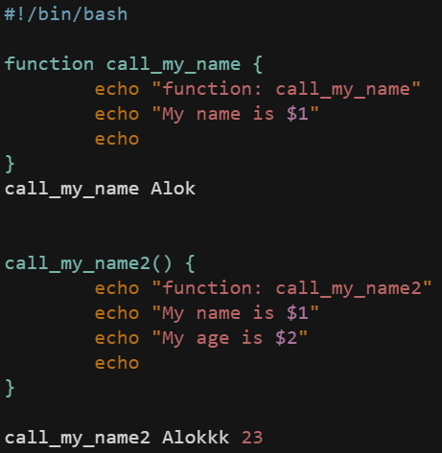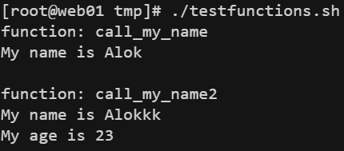
    - These are the 2 types of function declaration. If you are giving the keyword “function” then the parenthesis () is not needed. If you are not giving the “function” keyword then parenthesis () is needed.
    - You can pass the arguments as the cli parameters. Any number of arguments can be passed.
    - $0 doesn’t mean the function name here… it refers to the CLI command.. if I’ve run ./testfunctions.sh then the $0 inside all the function in that script will be “./testfunctions.sh”.
  - $@ represents all the arguments of the function. (list of arguments)
  - $# represents the number of arguments of the function.
  - NOTE
    - Whatever things you print inside that function using echo command will be returned from the function as data i.e. my_data=$(fun_name arg1 arg2). after executing this if u check $? then you can see the return value (i.e. exit code) of the function.
    - If you use return command inside the function then it’ll return the exit code of the function.
    - return statement can only return numeric values from 0-255.

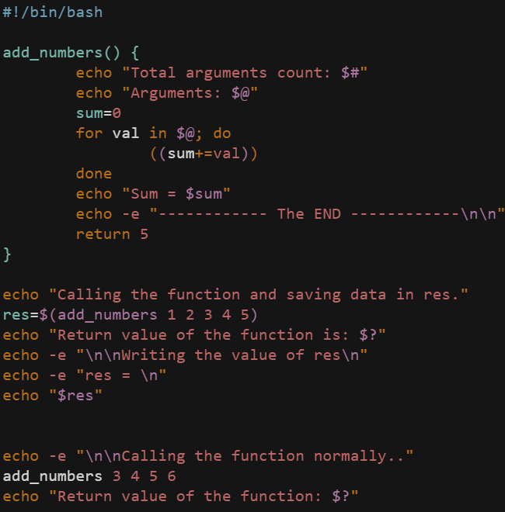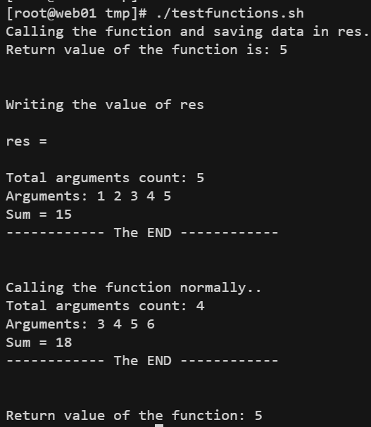
  - In first case the prints inside the function was not executed bcs of command substitution $(…).

