- 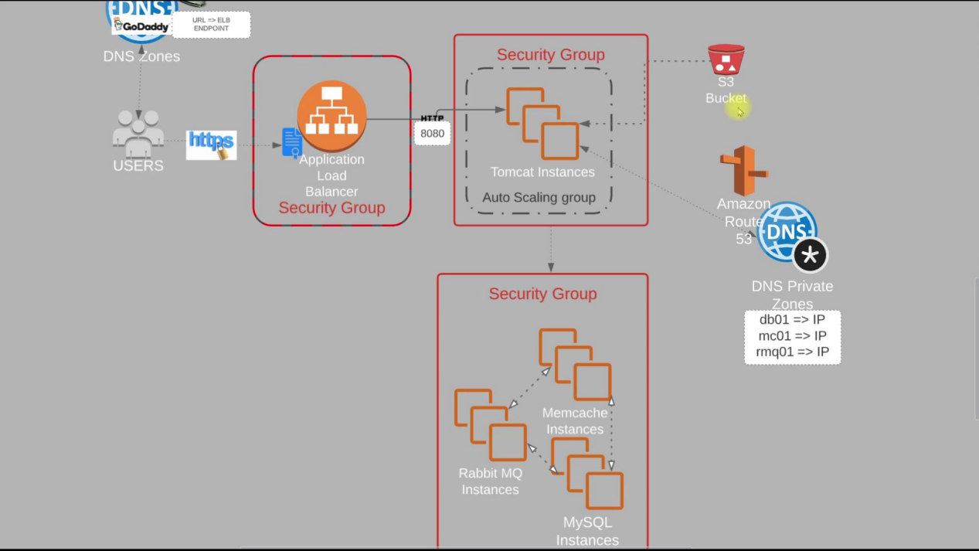
  - It is the flow of our project.
  - 3 security groups are there:
    - sg-elb : for load balancer
      - Inbound rules will be for http & https, from all ipv4 & ipv6 addresses
      - Don’t alter outbound rule. Keep it by default
    - sg-app : for tomcat
      - Inbound rules will be having sg-elb, and ssh from my ip.
      - Don’t alter outbound rule. Leave it as it was by default.
    - sg-backend : for the backend services like memcache, rabbitmq, mysql
      - Inbound rules will be having sg-app with ports mentioned in the code repo for the services like MySql, RabbitMq, Memcache.
      - Also, inbound rule should contain sg-backend itself and allowed for All Traffic, so that the backend services will be able to communicate with each other.
      - And ssh for my ip.
      - Also add the vprofile-app-sg in the inbound rule for All Traffic, otherwise you’ll not be able to ping it from the app instance.
      - 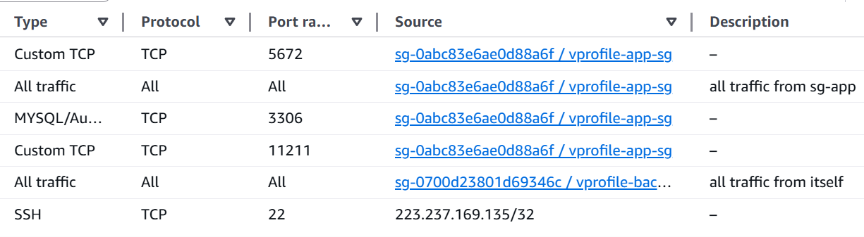
      - Don’t alter outbound rule. Leave it as it was by default.
  - One key pair will be there to ssh the instances
  - Now, we’ll create 4 instances:
    - vprofile-db01 : (sg-backend) : amazon linux
    - vprofile-app01 : (sg-app) : ubuntu because tomcat is there in the package of ubuntu. But in centos we need to install tomcat, create the tomcat.service and all.
    - vprofile-mc01 : (sg-backend) : amazon linux
    - vprofile-rmq01 : (sg-backend) : amazon linux
  - Route 53: (for DNS related things, please refer to end of the document..)
    - The app instance (tomcat) should connect to the backend instances through a IP address.
    - So, there should be something that will map the hostname to the IP addresses.
    - So, Route 53 is used as the DNS service in AWS.
    - Hosted Zone:
      - A container for DNS records for a domain.
      - 2 types:
        - Private: for internal use within VPC (ex: db.local)
        - Public: for publicly accessible domains (ex: example.com)
    - Creating in AWS console:
      - I created hosted zone, because I just want to resolve the hostnames internally.
      - Domain name: vprofile.in (anything can be given; but same entries should be there in application.properties file)
      - Type: private hosted zone (as I just want internal resolution)
      - Region: N. Verginia (for me)
      - VPC: default VPC
    - After creating the hosted zone, go inside that and create one record.
      - For the vprofile-db01
        - Enter the record name: db01
        - Value: give the private IP of the instance vprofile-db01
        - Type: A (means domain to IPv4 mapping)
      - Do the same for the remaining instances (app01 is not mandatory, as we’ll be using load balancer).
    - 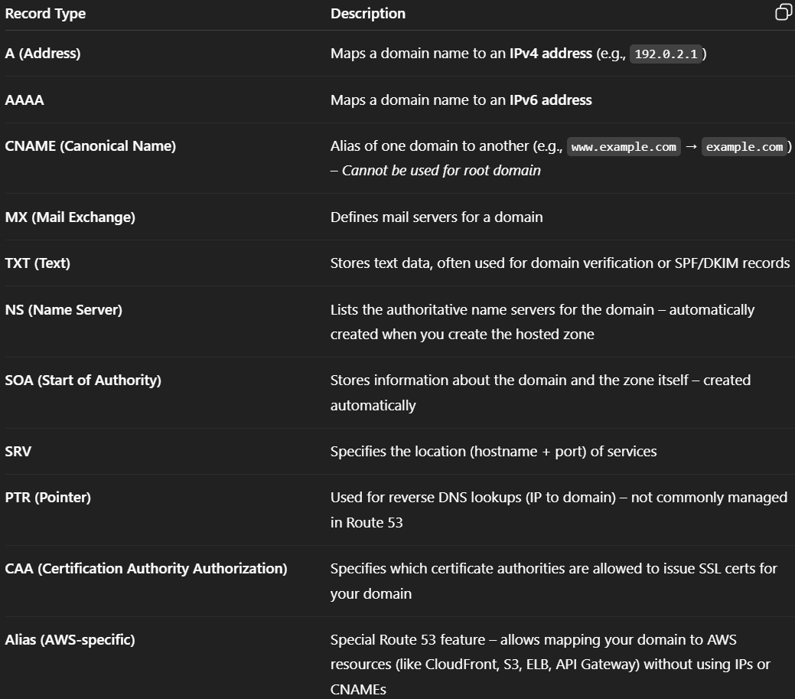
  - Build & Deploy Artifacts:
    - 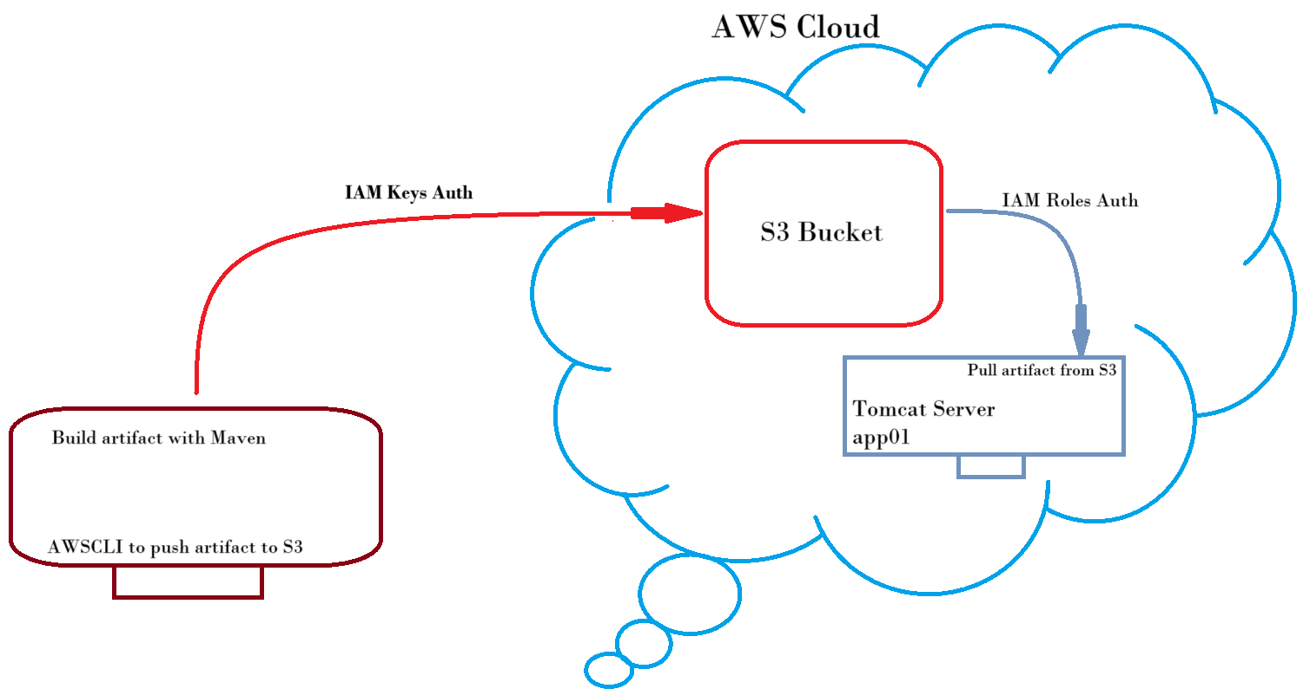
    - We’ll build the artifact from the source code and push that to AWS S3 Bucket.
    - And on the tomcat instance app01, we’ll fetch that artifact and deploy to the tomcat service.
    - Build artifact using Maven, AWSCLI to communicate with S3 bucket.
    - Create one S3 bucket keeping all the values default. Just give one unique name.
    - Create one IAM user, select Attach Policies Directly and choose AmazonS3FullAccess.
      - Go to the user. Under Security Credentials tab, create one Access Key for the user for CLI.
    - Now, IAM Role. For any EC2 instance, you can modify the IAM rule as below.
      - 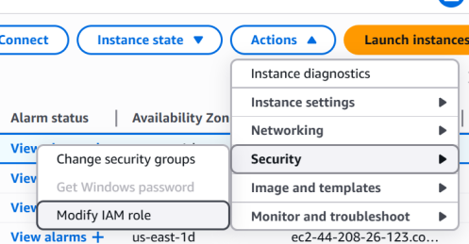
      - You need to create Role to select inside the drop-down.
        - 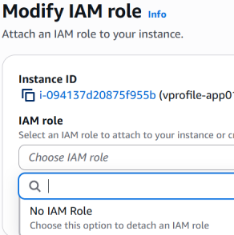
      - Search for IAM >> Roles >> Create Role :
        - Trusted Entity Service : AWS Service
        - Services or Use cases : EC2
        - Permission Policies : AmazonS3FullAccess
        - Give any name and Create the role.
      - IAM roles doesn’t list any IAM user, they just define a rule to make sure which can access the instance.
        - 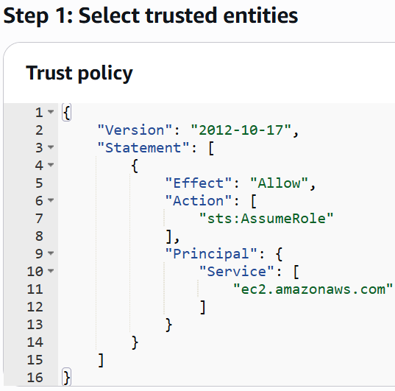
          - It means: Allow EC2 instances to assume this role
          - Assumable means: When EC2 assumes this role, AWS gives that instance temporary credentials so it can access other AWS services (like S3, DynamoDB, etc.), based on the permissions you attach to this role.
        - NOTE ------------------------------------------------------------------
          - IAM Role gives the instance to access something. Like in my case, I gave AmazonS3FullAccess, so the instance can access S3. If we didn’t have attach this role then instance won’t be able to access S3.
          - Security group ensures who can access the instance and where the instance can send traffic to; whereas IAM Role gives access to the instance for some particular things that is mentioned in the IAM Role.

      - Now, add this IAM Role inside the app01 instance.
      - So till now, S3 bucket is created, IAM user, IAM Keys, IAM Role auth is done ✅.
      - Now, we need to build and upload it to AWS S3. First make sure that correct domains (as mentioned in the Route 53) are there inside the application.properties file.
      - To build: mvn install
        - It’ll create one folder “target”, inside that one .war will be there (vprofile-v2.war in my case which is the war version of the folder vprofile-v2 which is inside the “target” folder only)
      - Copy that .tar file to the AWS S3ucket
        - aws s3 cp target/vprofile-v2.war s3://my-bucket-name
      - Now, ssh to the app01 instance.
        - systemctl daemon-reload
        - systemctl stop tomcat10
        - rm -rf /var/lib/tomcat10/webapps/ROOT
        - cp s3://my-bucket-name/vprofile-v2.war /var/lib/tomcat10/webapps/ROOT.war
        - systemctl start tomcat10 (now it’ll extract that .war file)
    - Temporarily add 8080 port from “my ip” in sg-app and try to open the app-instance using port 8080 (8080 is alternate port of HTTP, but in our case tomcat is running on port 8080 so it is required)
    - Now we’ll create one target group (to attach in the Load Balancer).
      - Select protocol: HTTP >>> 8080
        - 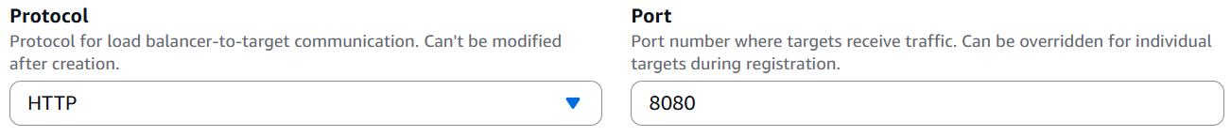
      - Override the port: 8080 (default is 80)
        - 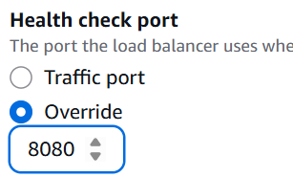
    - Now, create ELB (Elastic Load Balancer)
      - I added 2 listeners (for both HTTP and HTTPS)
        - 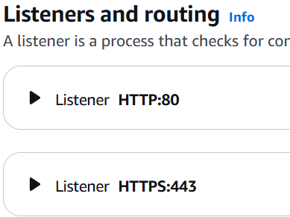
      - For HTTPS, you need to add the ACM certificate. Foe me, I created one before.
        - 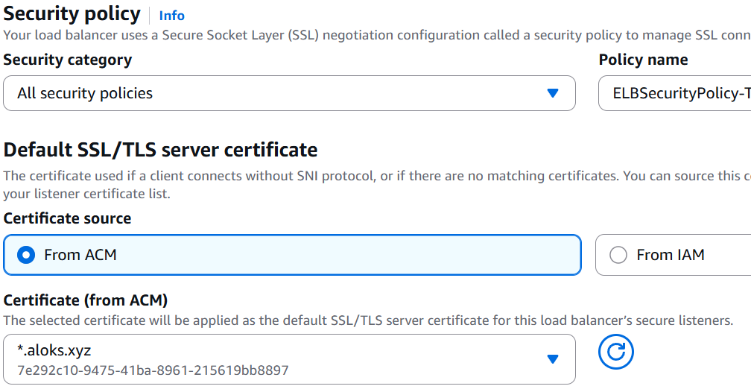
      - Copy the DNS name of the Load Balancer.
        - Go to GoDaddy and open your product (the purchased domain)
        - Click on the DNS button and add a new record.
          - Type: CNAME, Name: name of your website(anything), Value: Paste the DNS of the load balancer.
          - 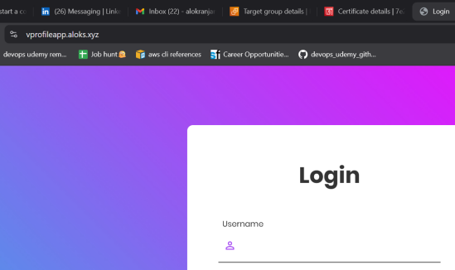
          - Now it is accessible thorough the domain as well.
          - NOTE: add your name(that you have given above) in the beginning
          - <name>.<domain>.<extension>
          - For me, vprofileapp.aloks.xyz
      - Now Autoscaling Group:
        - Create an AMI of the app instance.
        - Create a Launch Template using that AMI, app-sg, particular key-pair.
          - Also, go to Advanced Details section and under the IAM Instance Profile drop-down, select that s3-admin that you have created (otherwise app-instance will not be able to access S3).
        - Create Auto Scaling Group using that Launch Template, use the Created Target Group for the load balancer, and choose the appropriate options.
        - As we have multiple app instance to which the Load Balancer can route to.
          - Turn on Stickiness in Target Groups.
            - Target Groups >> Attributes tab >> Turn on stickiness
            - 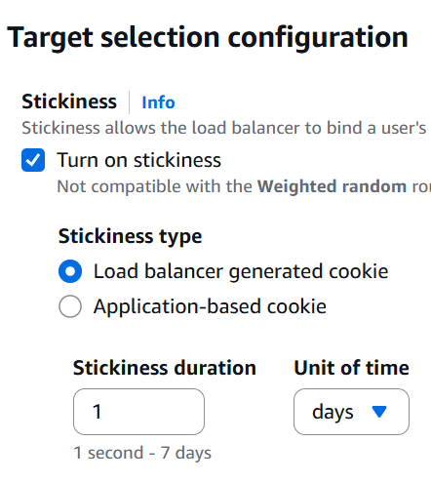
- Domain buying and selling
  - There is a central entity ICANN.
  - It’s a non-profit organization that
    - Manages global DNS
    - verifies the uniqueness of a domain world-wide.
  - ICANN doesn’t sell the domains directly, rather it allows the companies like godaddy (called as registrars) to sell the domain from its registry.
  - Let you are assigning a IP to that domain (for now static), it’ll not be stored directly to that ICANN database.
  - Rather, it’ll be stored in a nameserver like GoDaddy’s DNS, AWS Route 53, Cloudflare, or any custom DNS provider.

- DNS Hierarchy consists of 2 types of companies
  - Registrars
    - These are the companies to which users contacts to buy a domain.
    - They interacts with users and Registry Operators.
    - Lets you choose the domain, provides UI to manage DNS, and Contact TLD registry (or Registry Operators) on your behalf.
  - Registry Operators
    - These companies manages the databases of domains under a proper TLD (i.e. .com, .in, .net etc)
    - There is one-to-one mapping of Registry operators to a particular TLD. For example:
      - 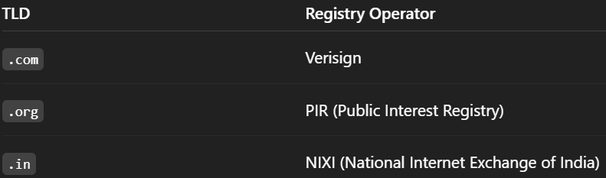

- So, what happens when you buy a domain from the Registrars?
  - When you buy one domain, the Registrar will send info to the Registry Operator of that particular TLD
  - For example Versign (as it is the Registry Operator for .com) for .com TLD if the domain is in the form of example.com

- What if you are trying to buy a domain where that TLD that doesn’t exists?
  - You cannot register example.alok unless .alok is a valid, ICANN-approved TLD.
  - No registrars like GoDaddy's, AWS Route 53 can sell this.
  - If you want to buy this, then contact to ICANN, pay some application fees, be the Registry Operator for this TLD.
- What Happens When a User Enters a Domain in the Browser?
  - Browser Cache Check
    - Browser checks its DNS cache for the domain’s IP.
  - OS Cache Check
    - If not found, browser asks the operating system, which checks the local system cache (hosts file or DNS cache).
  - DNS Resolver (usually ISP or custom like Google DNS)
    - If the OS doesn't have it, it contacts a recursive DNS resolver (like 8.8.8.8 or your ISP's DNS).
    - You can check using this command in cmd: ipconfig /all
  - Root DNS Server Lookup
    - The resolver asks a Root DNS Server: "Where can I find .com TLD servers?"
  - TLD DNS Server Lookup
    - The root server replies with the TLD nameservers for .com.
  - Authoritative Nameserver Lookup
    - The resolver asks the .com TLD server: "Where is example.com hosted? What are its nameservers?"
  - TLD Server Replies with Nameservers
    - It returns the authoritative nameservers (like AWS Route 53 nameservers).
  - Authoritative Nameserver Response
    - The resolver now contacts the Route 53 nameserver asking: "What is the IP address for example.com?"
  - IP Address Returned
    - The authoritative nameserver responds with the actual IP address.
  - Response Passed Back
    - The DNS resolver caches the result and returns the IP to the OS → browser.
  - Browser Makes HTTP Request
    - The browser uses that IP to connect to the server and load the website.

- RECAP
  - In our case, users will be using Godaddy DNS to access our website (ELB dns)
  - Route 53 will contain the backend server’s IPs like db01, mc01, rmq01.
    - Means Route 53 will be used internally in our project.
  - Inside application.properties file you can see the url containing db01 or rmq01 or something like that.
    - 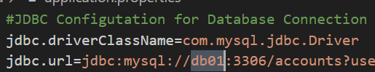
    - If you give IP in here, then everytime something changes, you’ll have to update this application.properties file. Which is not a good idea.
    - So, there should be something which can resolve the dns to ip.
    - Here, we can use Route 53.
  - We’ll create one private hosted-zone inside Route 53 giving the domain name as vprofile.in (anything you can give, but it should be same as application.properties file).
    - Hosted Zone is basically a container for DNS records that define how traffic should be routed for a domain and its sub-domains.
    - Private HZ: routing inside the VPC only
    - Public HZ: routing all over the internet.
  - After creating HZ, now we’ll have to add records.
    - Its like db01.vprofile.in, rmq01.vprofile.in ..etc
    - 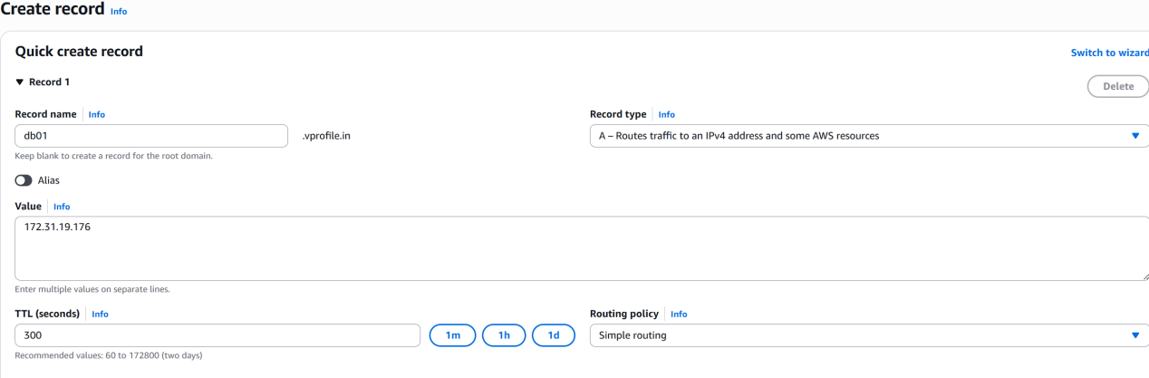
    - Here, record type is A (it means name to IP mapping)
    - And, here the IP that is mentioned is Private IP of db01 instance.
  - ssh to app01 instance and try to ping the backend instances using domain i.e. ping -c 4 db01.vprofile.in .. like this.
    - NOTE: ICMP traffic should be added in the inbound rule of backend-sg for app-sg. Otherwise ping will not work.
  - Create one S3 bucket.
  - Create one IAM user (AmazonS3FullAccess).
    - After creating IAM user, create one Access Key (select CLI in the use case).
    - It’ll be used in my local computer (after running aws configure).
  - Create one IAM role (for EC2 service, AmazonS3FullAccess).
    - Attach it to app01 instance.
  - Now go to that application.properties file and update the dns names
    - 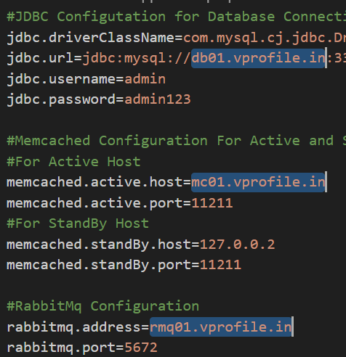
  - Now inside the repo, run mvn install
    - It’ll build the project and create one folder target
    - Inside this folder (target), there will be a .war file.
  - Now do aws configure and give the access key id and secret access key.
    - Region, output format will be stored inside ~/.aws/config
    - Access key id, Secret access key will be store inside ~/.aws/credentials
  - Now, copy that .war file to S3 bucket.
    - aws s3 cp target/vprofile-v2.war s3://vprofile-bucket-07567/
  - ssh to app01 instance and install aws-cli via snap.
    - snap install aws-cli --classic
  - No need to do aws configure inside the app01 instance as the IAM role is already attached to it.
    - Copy the .war file from S3 bucket to /tmp folder inside app01 instance.
    - aws s3 cp s3://vprofile-bucket-07567/vprofile-v2.war /tmp
  - Now its time to deploy the artifact:
    - Stop the tomcat10
      - systemctl stop tomcat10
      - systemctl daemon-reload
      - Systemctl stop tomcat10
    - Delete the ROOT directory from /var/lib/tomcat10/webapps
    - Now copy that .war file into /var/lib/tomcat10/webapps/ as the name ROOT.war
    - 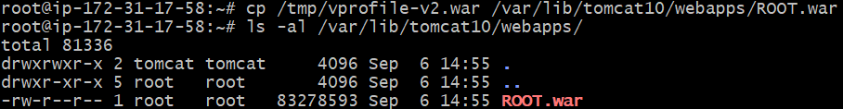
    - start and enable the tomcat10. Now you’ll see ROOT will come inside /var/lib/tomcat10/webapps/ folder.
      - Temporarily add 8080 port for all IPv4 inside app-sg (as tomcat runs on 8080 port) and try to access the server in the browser putting public IP of the app01 instance. You should be able to see the website.
  - Load balancer part comes now:
    - Create one target group (only for app01 instance)
      - Target type: instances
      - Port: 8080
      - Under Advanced health check settings, select override and write the port 8080.
    - Create elastic load balancer.
      - Inside listeners and routing section, keep the listener port as 80 only for HTTP.
      - Also add HTTPS listener there. For HTTPS, you need to select the certificate as well.
      - 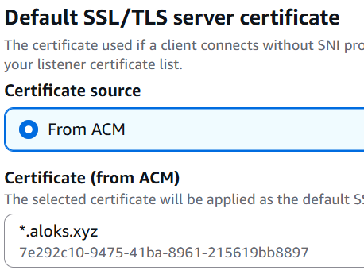
    - Now copy the dns of the load balancer and add that inside the GoDaddy.
      - As you’ll be mapping godaddy domain to your elb dns, so it’ll be of type CNAME (name to name mapping)
      - Add a record inside the DNS of godaddy, and put the elb’s dns.
    - Now you can access the website using both:
      - Dns of the ELB (it’ll be HTTP)
      - https://vprofileapp.aloks.xyz (using HTTPS)
        - vprofileapp is mentioned as the name inside the GoDaddy DNS.
    - Now if you want then can create Auto Scaling Group for the app instance. (Don’t forget to add the IAM role while creating Auto Scaling Group).

