- Different types of SERVICES:
  - IaaS (Infrastructure as a Service):
    - It provides raw computing resources i.e. servers, networking, storage -- on demand.
    - You manages: OS, runtime, data, applications
    - Provider manages: Physical servers, virtualization, networking, storage
    - Examples:
      - AWS EC2
      - GCE (Google Compute Engine)
      - Azure Virtual Machines
    - Devops usecase:
      - Provisioning servers quickly for deployments, running custom environments, hosting databases, setting up CI/CD agents.
  - PaaS (Platform as a Service):
    - It provides a ready-to-use platform for building, testing, and deploying applications. You don’t worry about OS or infrastructure — only your code and configurations.
    - You manage: Applications & data.
    - Provider manages: OS, middleware, runtime, scaling, infrastructure..
    - Examples:
      - AWS Elastic Beanstalk
      - Google App Engine
      - Heroku
      - Azure App Service
    - Devops usecase:
      - Deploying apps quickly without managing servers — great for microservices, CI/CD pipelines, and rapid testing.
  - SaaS (Software as a Service):
    - It provides fully functional end-user applications over the internet. No setup, no server — just use the software.
    - You manage: Nothing (just use the app).
    - Provider manages: Everything (infrastructure, platform, software, updates).
    - Examples:
      - Gmail
      - Google Docs
      - Slack
      - Jira
      - Dropbox
    - Devops usecase:
      - Using SaaS tools for collaboration, project management, monitoring (e.g., Datadog), or CI/CD (e.g., GitHub Actions).
  - Analogy:
    - IaaS → Renting an empty apartment (you bring furniture, design, etc.).
    - PaaS → Renting a fully furnished apartment (you just bring your stuff and live).
    - SaaS → Booking a hotel room (everything is ready; you just check in and use).
- Services that are gonna used:
  - Beanstalk
    - It’ll manage the EC2 instances.
    - It has load balancer and auto scaling as well.
  - S3/EFS
    - Storage
  - RDS Instances
    - Databases
  - Elastic cache
    - In place of Memcached
  - Active MQ
    - In place of Rabbit MQ
  - Route 53
    - For DNS
  - Cloudfront
    - For CDN
      - A CDN is a network of servers located in different regions that cache and deliver website content (images, CSS, JS, videos, HTML) to users from the server closest to them.
      - Example: If your site is hosted in the US, a user in India will get data from a nearby CDN server in India, not directly from the US — making it load much faster.

- 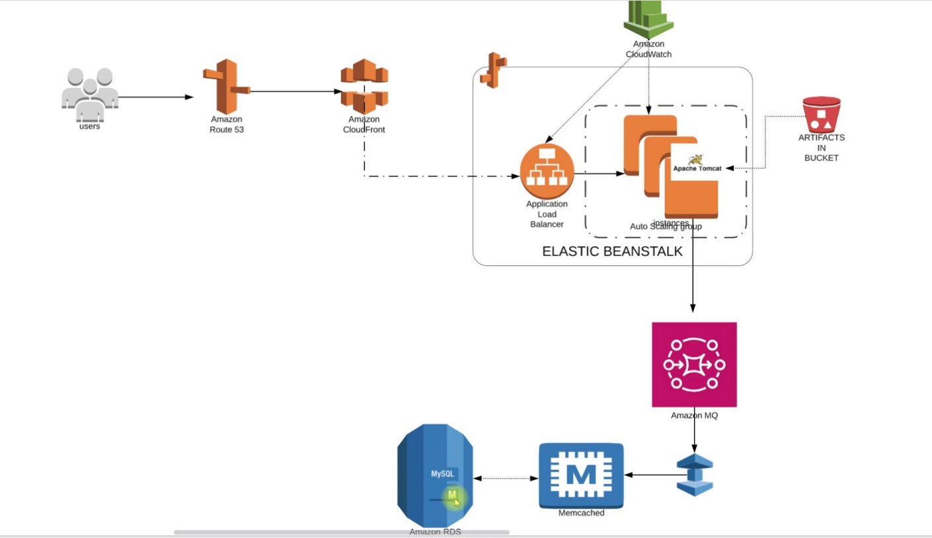
- Quick Overview:
  - Here user will access out URL which will be resolved to an end-point in Route 53 (before it was happening inside GoDaddy).
    - That end-point will be of Amazon CloudFront (CDN) which will cache so many things to serve the Global audience.
  - Elastic Beanstalk:
    - After cloud-front, it’ll fo to Application Load Balancer (which is a part of Elastic Beanstalk).
    - After that it’ll go to the EC2 instances (which is part of Auto Scaling Group).
    - Means Entire frontend will be managed by Beanstalk.
  - For backend;
    - Amazon MQ instead of RabbitMQ
    - Elastic Cache instead of Memcache
    - RDS instead of database running on EC2 instances.
- Requirements:
  - Keypair:
    - For beanstalk instance login
  - Security Groups:
    - 1. Elastic cache
    - 2. RDS
    - 3. Active MQ
  - Create :
    - RDS
    - Amazon Elastic Cache
    - Amazon Active MQ
  - Create Elastic Beanstalk Environment
  - Update SG of backend to allow traffic from Bean SG
- Flow of Execution:
  - Launch EC-2 instance for DB initializing
  - Login to the instance and initialize RDS DB
  - Change health-check on beanstalk to /login
  - Add 443 HTTPS listener to ELB
  - Build artifact with backend information
  - Deploy artifact to Beanstalk
  - Create CDN with SSL certificate
  - Update entry in GoDaddy DNS zones

PROCESS OF CONFIGURING THE SERVERS AND APPS
- Created security group:
  - vprofile-backend-sg:
    - All traffic from it self for the communication between backend servers.
- Inside RDS:
  - Create one parameter group:
    - 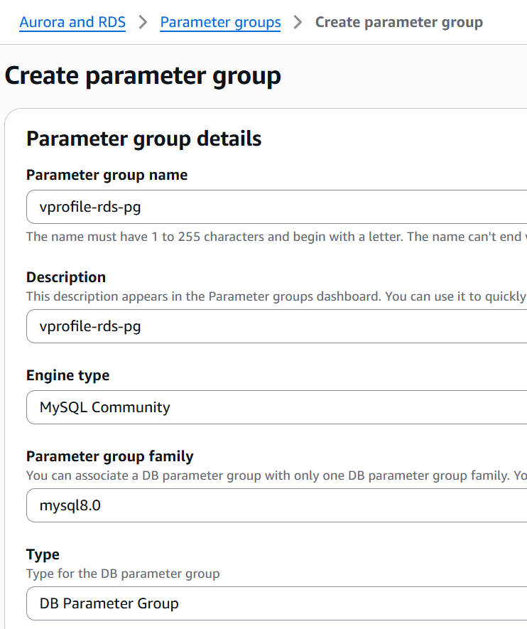
    - Create subnet group:
      - 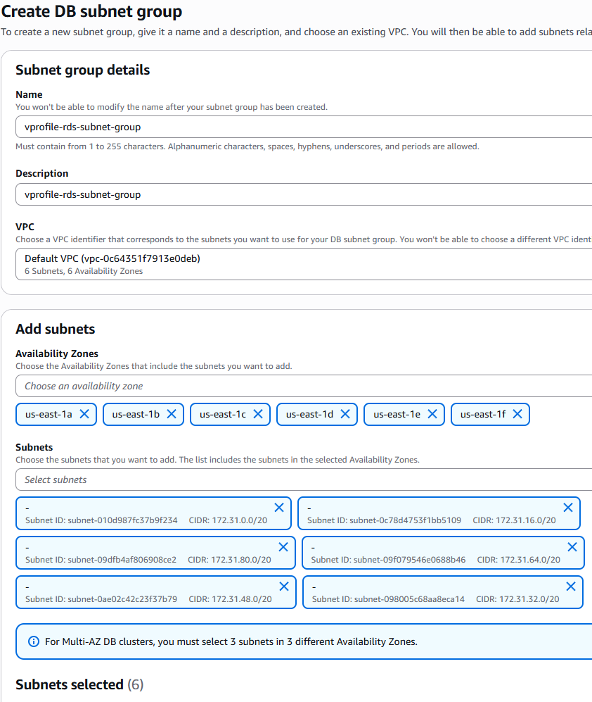
    - Now create database:
      - Standard create
      - MySQL (engiene type)
      - Give one DB instance identifier
      - Under connectivity section,
        - select your created subnet group.
        - Additional details: database port as 3306
      - 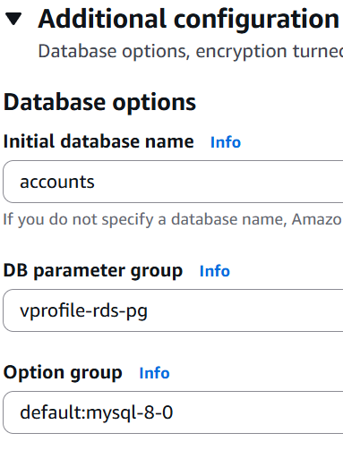
- Create Elastic Cache:
  - Create Parameter Group
    - 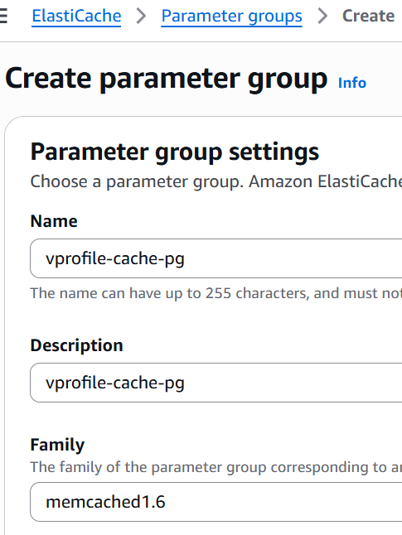
    - So many options are there inside the family like Redis, Memcache, Valkey
  - Create Subnet Group
  - Create Cache (select Memcache)
    - Give the correct port that is mentioned inside the application.properties file.
    - Choose backend-sg as the security group.
- Create Amazon MQ:
  - Engiene type: RabbitMQ
  - Give one username and password.
  - Private access
  - Choose your security group
- Launch one EC-2 instance (ubuntu) (temporarily only):
  - We’ll use this to setup database inside RDS.
  - Install mysql-client, git.
  - Copy the DNS of RDS and execute the command:
    - mysql -h <DNS> -u <username> -p
      - Then enter password
    - Example:
      - mysql -h vprofile-rds.c8v0iamky18r.us-east-1.rds.amazonaws.com -u admin -p
  - I clone the git repo to get the db_backup file and update the RDS database.
  - mysql -h <DNS> -u <username> -p<password; no space between -p and password> accounts < src/main/resources/db_backup.sql (it is the db_backup path in my case)
  - Now DB initialization was successful. You can delete the instance now.
- Create one IAM role for beanstalk application:
  - Service: EC2
  - Policies:
    - AdministratorAccess-AWSElasticBeanstalk
    - AWSElasticBeanstalkCustomPlatformforEC2Role
    - AWSElasticBeanstalkRoleSNS
    - AWSElasticBeanstalkWebTier
- Now, BEANSTALK:
  - Environment: Web server environment
  - Platform: tomcat; branch: tomcat 10
  - Presets: custom configuration
  - 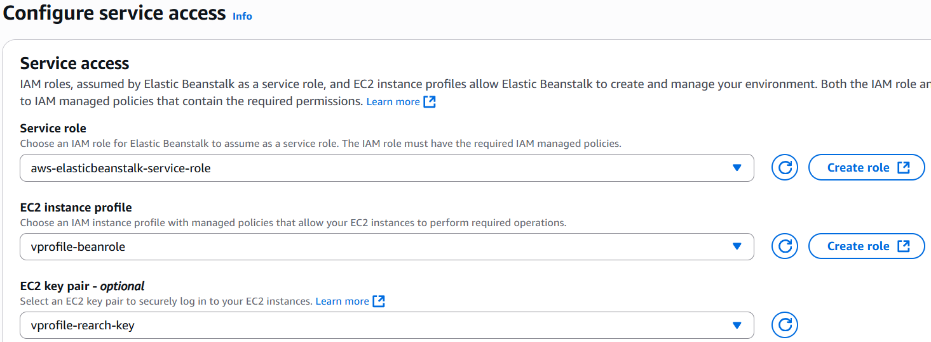
    - If you don’t see that aws-elasticbeanstalk-service-role then just create one clicking the link (create role) at the right.
    - All the options will be auto selected. Just click next, next and create.
  - Under Instance Setting, enable public ip address. And select all the subnets under instance subnets.
  - Keep the database option as disabled only. Because we have our own RDS.
  - Select GP3 as the root volume.
  - Don’t select any security group. Leave it blank so that beanstalk will create one by itself. Later we can edit the roles.
  - Under capacity section, use Load Balanced as environment type.
  - Tomcat runs on port 8080; but in beanstalk it runs on port 80.
  - Enable stickiness in the Processes section.
  - Rolling updates and deployments: Deployment policies (need to explore it separately)
    - In my case, I chose rolling with batch size of 50% (for percentage you need to select that radio button for percentage)
- Now open the backend-sg and add the instance security group (created by beanstalk) in its inbound rule for All Traffic.
- Copy dns of RDS, AmazonMQ, Elastic cache (along with that port, username and password as well if applicable)
  - Then update the application.properties file according to that.
  - Like in place of db01, write the dns of RDS i.e. xyz.com, and update username and password as well.
- After updating the application.properties, execute the command mvn install and then the artifact will be generated (.war file inside the folder target).
- Now just upload the .war file in the beanstalk application.

- You can see:
  - Initially both the instance will be healthy (inside target group)
  - Then as soon as the deployment happens, one will become unhealthy.
  - When the deployment completes, the instance will become healthy.
- Edit Instance traffic and scaling section inside configuration and add one listener for HTTPS traffic (port 443).

- VPC:
  - Virtual Private Cloud: a logically isolated network inside AWS where you can launch resources like EC2, RDS, Load Balancers, etc.
  - One VPC spans across an entire region.
  - By default, one subnet is there for each AZs inside the region.
- RDS:
  - It is a managed service - not just an instance.
  - Under the hood, AWS does run EC2 instance to host your database.
  - But those instances are hidden from you. You can’t ssh to that.
  - Instead AWS gives you service interface (RDS console, API, CLI etc)
    - Launch databases.
    - Configure settings (via parameter groups, option groups).
    - Scale up/down.
    - Enable Multi-AZ.
    - Manage backups, snapshots, failovers.
  - RDS is “not just an EC2 running a DB,” but: “A managed database platform, where AWS controls the underlying infra (EC2, storage, networking, OS, patching), and you only control the database engine and how your app connects to it.”
  - Simply,
    - Creating EC2 instance, installing the database things and running it: IAAS (Infrastructure as a Service)
    - Using RDS: PAAS (Platform as a Service)
- RDS objects:
  - DB Parameter Group:
    - Acts like a configuration file of RDS.
    - Examples of parameters:
      - max_connections (limit of DB connections)
      - innodb_buffer_pool_size
      - log_min_duration_statement
    - Default parameter group is applied automatically.
    - You can create one custom parameter group and apply them to DB instances for file-tuning.
  - DB Subnet Group:
    - Inside which subnet of your VPC (either default or custom), your DB instance will be placed in.

