- Source code (java, .net etc) => Compile (javac, Roslyc etc) => Tests (Unit/Integration) => Packaging (jar, war, .exe, msi, .zip etc) => Health checks (Code analysis, Find bugs)
- Build tools:
  - Maven
    - Language : java
    - Build file format : xml
  - Ant
    - Language : java
    - Build file format : xml
  - MsBuild
    - Microsoft build engine is a platform for building applications.
  - Gradle
    - DSL based on Groovy
  - & NANT
    - Windows .net platform
  - Make
    - Builds executable programs and libraries from source code.
- Maven:
  - 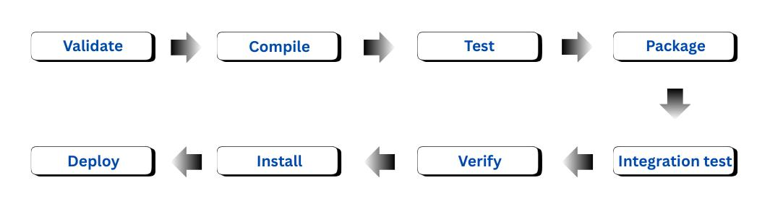
  - Validate:
    - Validate the project is correct and all necessary information is available
  - Compile:
    - Compile the source code of the project
  - Test:
    - Test the compiled source code using a suitable unit testing framework.
    - These tests should not require the code be packaged or deployed.
  - Package:
    - Take the compiled code and package it in its distributable format, such as a JAR.
  - Verify:
    - Run any checks on results of integration tests to ensure quality criteria are met.
  - Install:
    - Install the package into the local repository, for use as a dependency in other projects locally.
  - Deploy:
    - Done in the build environment, copies the final package to the remote repository for sharing with other developers and projects.
- In context of Java:
  - JDK : Java Development Kit
    - Try executing the command apt search jdk, you’ll get so many.
    - I am installing jdk-17 and jdk-21.
  - JRE : Java Runtime Environment
    - It is just to run the java application in order to do some development work.

- Steps I followed for Maven:
  - apt search jdk | grep 17 (to find jdk version 17)
  - apt search jdk | grep 21 (to find jdk version 21)
  - apt install openjdk-21-jdk -y
    - Installed jdk version 21.
    - You can verify the version using java --version command.
  - apt install maven -y
    - Installed maven.
    - You can verify the version using mvn --version command.
    - 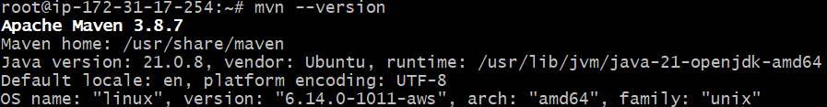
  - Cloned the repo from the github (having java application)
  - mvn validate
    - 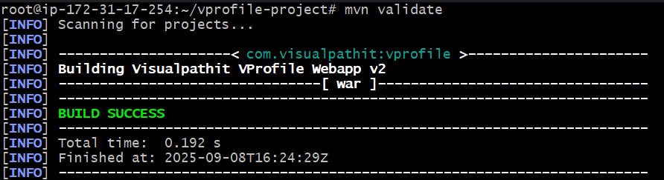
  - mvn test
    - Trigger unit testcases written by the developers.
    - Generate report inside target folders.
  - mvn install
    - When you execute this command, mvn will download all the dependencies present inside the .pom file.
    - 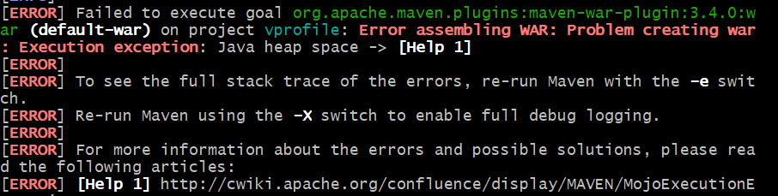
    - Its saying some heap space error.
    - export MAVEN_OPTS="-Xmx1024m"
      - It’s telling Maven: “when you run, give your JVM a maximum of 1 GB heap memory.”
    - Now the build succeed.
  - ~/.m2/repository
    - Here the installed dependencies remain.
    - 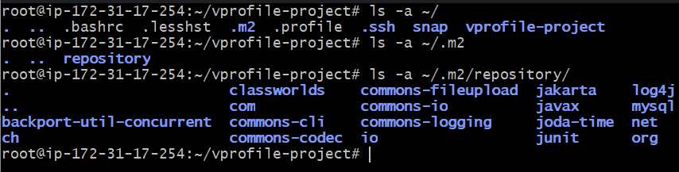
  - mvn clean install
    - It’ll delete the target folder (if present) and then start the build process.
    - But it doesn’t delete the dependencies.
    - If you want a proper clean installation, then delete everything inside that repository i.e. rm -rf ~/.m2/repository/* and then run mvn clean install.
    - It’ll remove the target folder and build the application again.
  - I downloaded jdk-17 version now.
    - apt install openjdk-17-jdk
    - Now if I execute java --version, it still displaying version 21 only.
  - To switch between jdk versions: update-alternatives --config java
    - 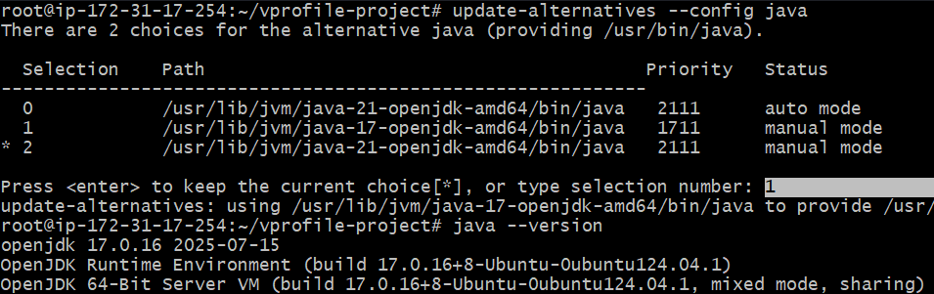
  - If you want to use a different version of mvn to be used, then you can download the binary file from the mvn archive.
    - https://archive.apache.org/dist/maven/maven-3/3.9.9/binaries/
      - I installed 3.9.9 version of mvn
      - I downloaded using wget (I downloaded zip file, you can even download tar.gz file)
      - Unzipped it and moved it inside /usr/local/bin/mvn3.9 folder.
      - /usr/local/bin/mvn3.9/bin : in this folder, mvn command presents.
      - /usr/local/bin/mvn3.9/bin/mvn clean install
        - Executed inside the vprofile-project, now it’ll use the installed mvn version instead of the default mvn version.

- You can open cloudshell inside the aws console.
  - Its just a RPM based terminal where you can simulate the things.
  - Button is present at the bottom-left cornor.
- Difference in Debian and RPM based:
  - In Debian based (ex: ubuntu), packages are usually named as openjdk-* or default-jdk
    - openjdk-11-jdk
    - openjdk-17-jdk
    - default-jdk
  - In RPM based (ex: centos), packages are usually named as java-* (sometimes java-<version>-openjdk)
    - java-1.8.0-openjdk
    - java-11-openjdk
    - java-17-openjdk
- sudo dnf search java | grep 21
  - Inside cloudshell, used this command to search the java version 21packages.
  - 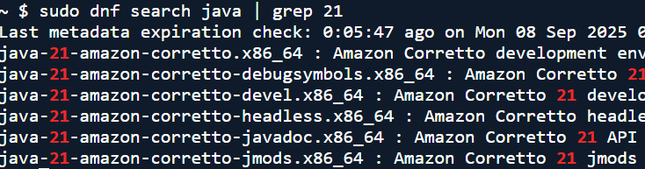
  - When you see corretto, means it is from AWS.
- dnf install maven -y
  - Installed maven as well

DON’T FORGET TO DELETE THIS INSTANCE, OTHERWISE YOU’LL BE CHARGED BY AWS

