CI/CD With Jenkins
- To install Jenkins in Ubuntu:
  - You need to install Java because Jenkins is written in Java.
  - Its not a native program (like .exe or .bin), rather it’s a .war file (Java Web Application Archive).
  - To run it, you need JVM (Java Virtual Machine), which comes from JDE/JRE.
  - 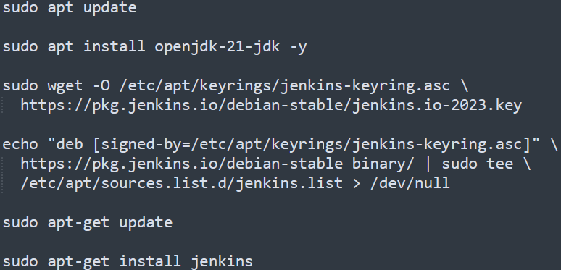
  - /var/lib/jenkins is the home directory of Jenkins. You can see this inside /etc/passwd
  - Inside /var/lib/jenkins the jenkins configuration (config.xml) file exists.
  - After installing jenkins, you can copy the public IP of the instance and open in the browser with port 8080 (remember: TCP with port 8080 should be present in the security group attached to the ubuntu instance).
    - After opening the browser, it’ll show one path where the initial password is present.
    - /var/lib/jenkins/secrets/initialAdminPassword : In this file the initial password is stored.
  - If you can’t open the jenkins ui through browser, then try updating the security inbound rule for TCP 8080 traffic for all IPv4. sometimes, My IP doesn’t work.
  - Change the jenkins url to a random domain. Otherwise it’ll try to access that public ip only. If your instance is rebooted, then the public IP will be changed, and Jenkins will become slow.

- Jobs in Jenkins
  - Freestyle Job
    - In freestyle, everything is configured in the Jenkins UI.
    - Graphical Jobs.
    - Each job has a GUI form where you define:
      - Where to get code (GitHub, SVN, etc.)
      - Build steps (e.g., mvn clean install, npm build)
      - Post-build actions (e.g., deploy, send email)
    - Pros:
      - Easy to create (beginner friendly)
      - Great for simple projects
      - No need to learn syntax.
    - Cons:
      - Hard to maintain (if there are many jobs, have to edit each of them manually)
      - Not portable (configs only stay in Jenkins server, not git repo)
      - Limited flexibility (complex workflows are difficult to manage)
      - If jenkins crashes, you loose job definitions (unless backed up)
  - Pipeline As A Code
    - Instead of configuring Jobs in UI, Jenkinsfile is used.
    - Jenkins read the file and runs the pipeline automatically.
    - Written in Groovy based DSL (Domain Specific Language)
- Plugins vs Tools
  - Simple analogy:
    - Keywords:
      - Programmer (Jenkins)
      - Programming Language (Plugin)
      - Tools (Laptop with compiler installed)
    - If a programmer knows the language (jenkins have plugins installed) but doesn’t have a laptop (the server where jenkins present, doesn’t have that tool): then it’ll be of no use
    - If a programmer doesn’t know the language (jenkins don’t have the plugin) and he is given a laptop (the server where jenkins is present, have the tools installed): then it’ll be of no use
  - Plugins tell Jenkins how to do things; Tools let Jenkins actually do the work.
  - You can install the tools in the server directly executing the command like apt install maven ..etc. OR you can do from the Jenkins GUI as well.
    - Note:
      - In GUI, it’ll display only those Tools, whose Plugins are installed.
      - If you don’t see the particular Tool you want, then install its Plugin first.
      - If you’ll install the Tools via system CLI directly; then also it’ll be of no use if the Plugin is not installed in Jenkins.
  - Ex: I am installing Maven (tool) via GUI
    - 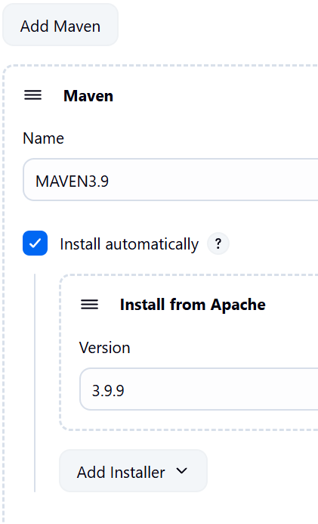
    - Its simple, just give a name and select the version.
  - Ex-2: I am installing JDK via GUI. Its little different
    - 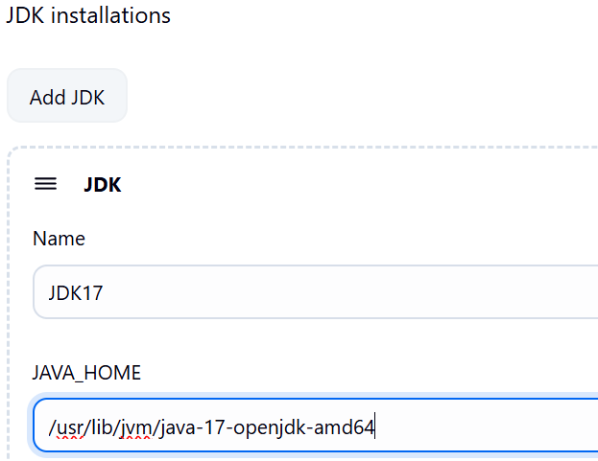
    - Its little different. Installed java-17 version in cli, then gave its home directory path in GUI.
  - The tools whose multiple versions can be installed at once in a system (multiple versions of JDK can be installed in a system), we need to tell jenkins that which version is to be used by giving that version's home directory path.
  - The installed plugins stay in the directory: /var/lib/jenkins/plugins
    - 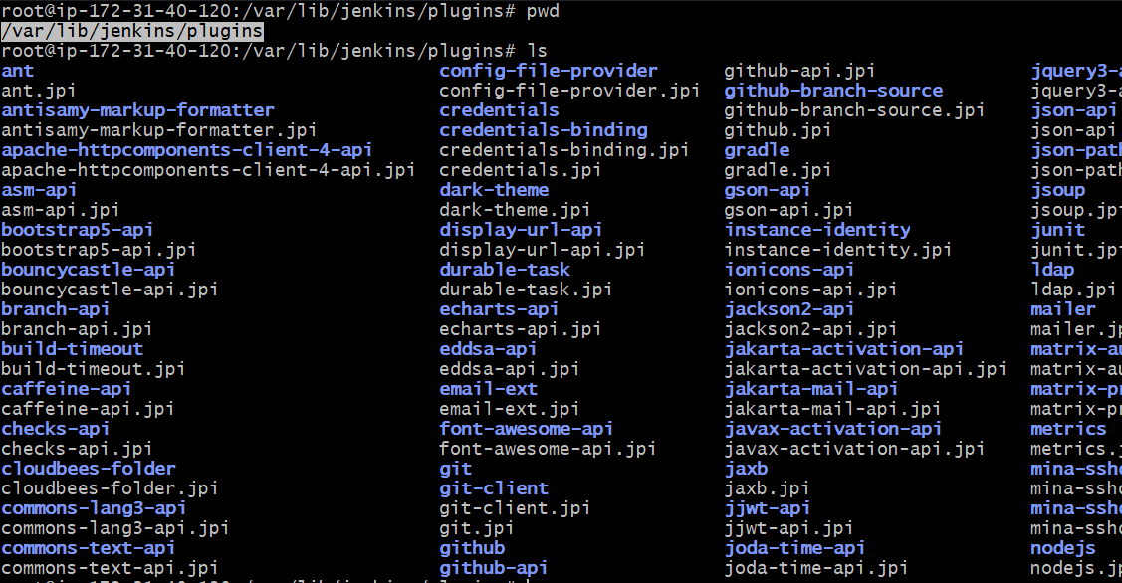
  - All global tools configurations (JDK, Maven, Git, Node.js etc) are stored inside: /var/lib/jenkins/hudson.tasks.*
    - Exception: JDKs are stored inside /var/lib/jenkins/config.xml because Jenkins treats them as a core runtime tool
    - If you have not updated the JDK in Jenkins UI, then you can’t see the JDK inside that config.xml. And Jenkins will use the default JDK that is present globally (in my case, global default was JDK version 21).
      - 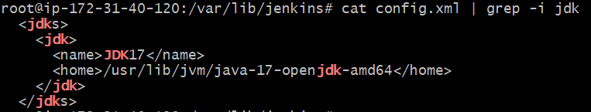
    - If multiples JDKs are configured inside this, then whatever version mentioned in the Job will be used while running the Job inside pipeline.
- Lets create out first Job
  - Create FreeStyle project.
    - Give one description like “Learning Jenkins Jobs”
    - Skip Triggers and Environments for now.
    - Under Build Steps, select Execute Shell (the windows part like execute windows batch commands will not work as the Jenkins is hosted in Ubuntu in our case).
    - Save this now.
  - 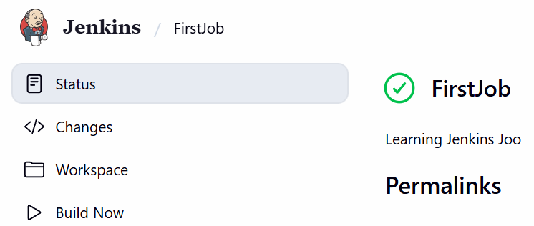
    - Under the created Job, click on that Build Now button 2 or 3 times.
  - 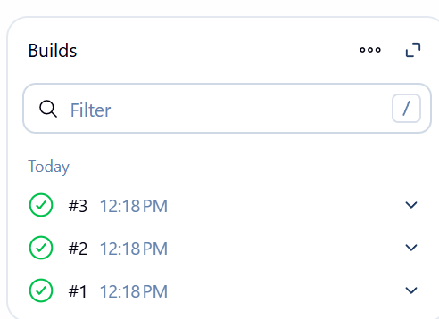
    - You’ll see something like this.
  - 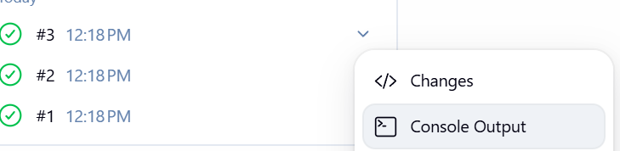
    - You can also see the console output of the build.
    - 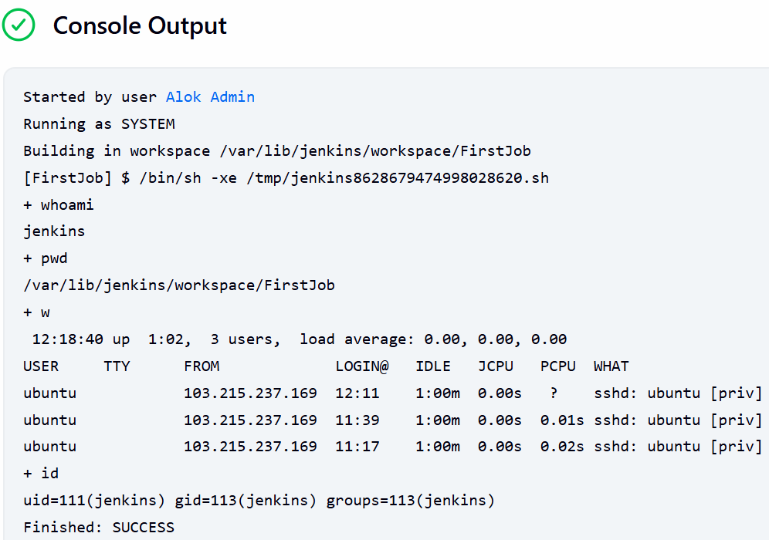
    - You can see the path where the Job ran was /var/lib/jenkins/workspace/FirstJob
  - You can see some folders inside the path /var/lib/jenkins, in which jobs and workspace are there.
    - jobs
      - It contains every detail about the job.
      - Like the build history, configurations, metadata etc.
    - workspace
      - It is where Jenkins actually run build the code and do stuffs.
      - You can think it like it’s a local folder for the Jenkins user where it does the things like pulling any repo, building that and testing etc etc.
      - 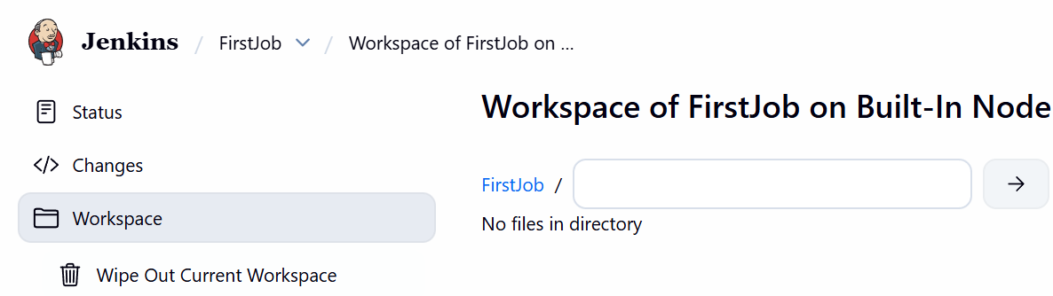
      - Here there is an option Workspace, which remain in sync with the path /var/lib/jenkins/workspace.
      - I created one folder inside that path manually using mkdir command inside the linux and now it came inside the Jenkins website as well.
        - 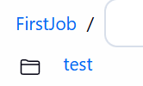
- Note
  - The tools that we configure are available globally for all the jobs. Its not bounded to any particular job.
  - Lets suppose JDK, if I have 2 different JDK present inside the tools, then inside the Job, I can select which JDK will be used in my current Job.

- Creating another job to build the vprofile project from github
  - Give a name and description to the job. (it is also Free Style).
  - Select the JDK version. (I chose 17)
  - Source Code Management: Choose Git.
    - If the repo is public, then no need to give the credentials.
    - Otherwise you need to give clicking on that Add button present in the right.
      - 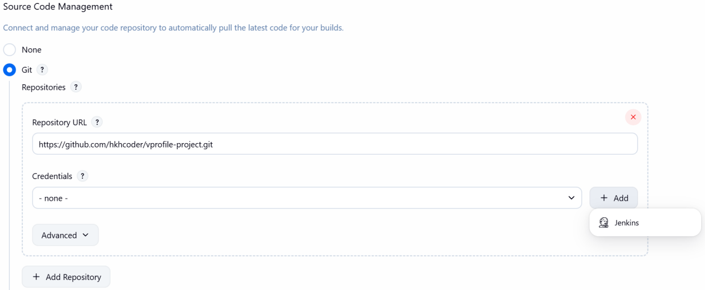
    - You have so many methods using which you can connect to Github.
      - 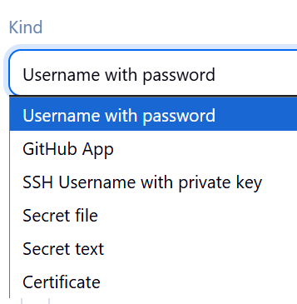
    - 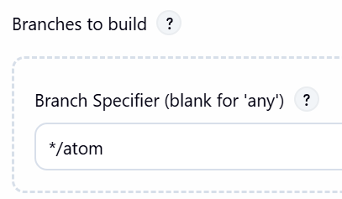
      - Also select the branch from which the code will be build.
  - In the previous job, we used Execution Shell. But its not recommended.
    - Every time use Plugins to do some specific task.
    - If there is no plugin to do the task you are interested in, then only you should write commands in Execution Shell.
    - Here, I chose Invoke top-level Maven targets, chose the maven version and the command in the goal i.e. install because I want to build the source code.
    - You have some advanced settings as well that you can checkout.
    - 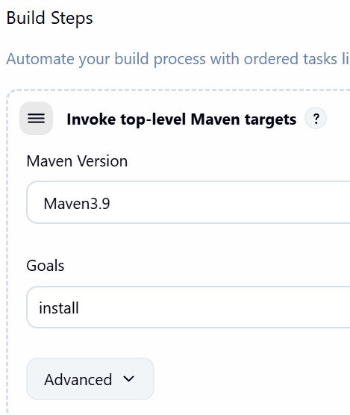
  - Now Lets see the Post-Build Actions
    - I chose Archive the artifacts and gave **/*.war inside the input field Files to archive.
      - ** means it’ll go to every sub-directory and check if any *.war file present and archive that.
    - It stores the archived file in somewhere else and give you one link to download or view that. (in the status section)
      - 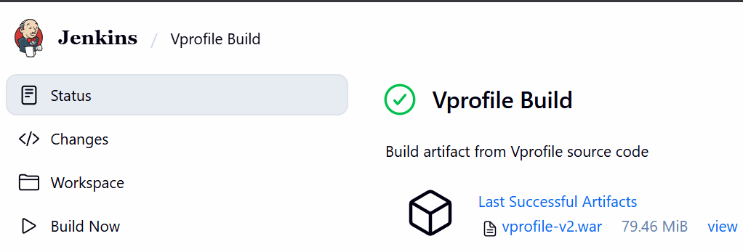
  - IMPORTANT
    - When we install any tools from the Jenkins, it install the tool in the Linux (or whatever server where Jenkins is hosted) for the Jenkins user only; not globally.
    - I installed maven3.9 in the tools section of Jenkins.
    - Ran one job 2 or 3 times (PS: inside the job under the invoke top-level Maven targets the maven3.9 was selected).
    - Then I selected Default instead of maven3.9 in that drop-down and ran built the job again. Now it failed.
    - Because, when you choose default in that option, it checks system default maven, i.e. inside /usr/bin/mvn folder which is accessible globally. But maven is not installed in our server globally.
    - So, you need to install maven in the linux server globally then build the job again. Now it’ll pass.

  - When you create a new job, at the bottom there is an option Copy from, there you can give the name of any existing job you have.
    - It’ll copy all the configs from there to this new job by default.
    - Means all the fields will be auto-selected according to that reference Job.
  - When you install any plugins, then only it’ll be visible in the job.
- Just like Gitlab CI/CD, Jenkins also has environment variables like BUILD_ID, BUILD_NUMBER ..etc etc.
- You can use your own variables inside the job.
  - 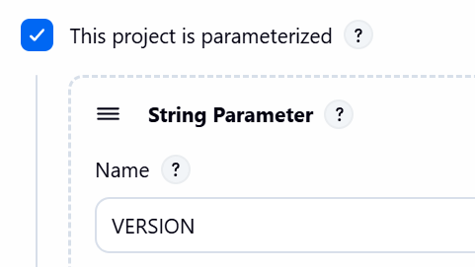
    - Inside the configure section, select this checkbox “This project is parameterized”
  - Then you’ll get the button Build with Parameters in place of Build now.
    - 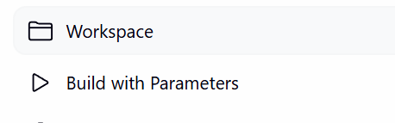
  - When you click that Build with parameters button, you’ll get one page where you can enter the values.
    - 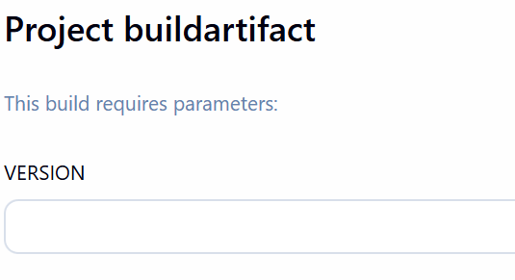
  - Also, you can add the default value in that configure page.
- Inside the Manage Jenkins path, there is an option System.
  - Here you can configure the global configurations. (its not specific to any particular Job)
  - 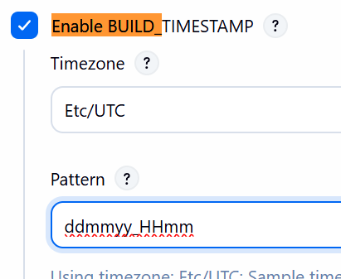 (Here I changed the timestamp pattern)
  - 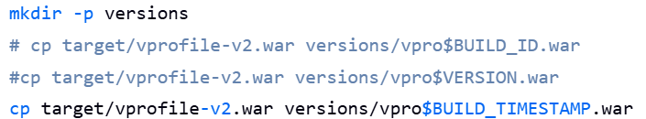
    - Added in the execution shell in Build Steps.
- Disk Space Issue
  - Whenever you get any issue for disk space, just increase the volume capacity.

- Flow of Continuous Integration Pipeline
  - 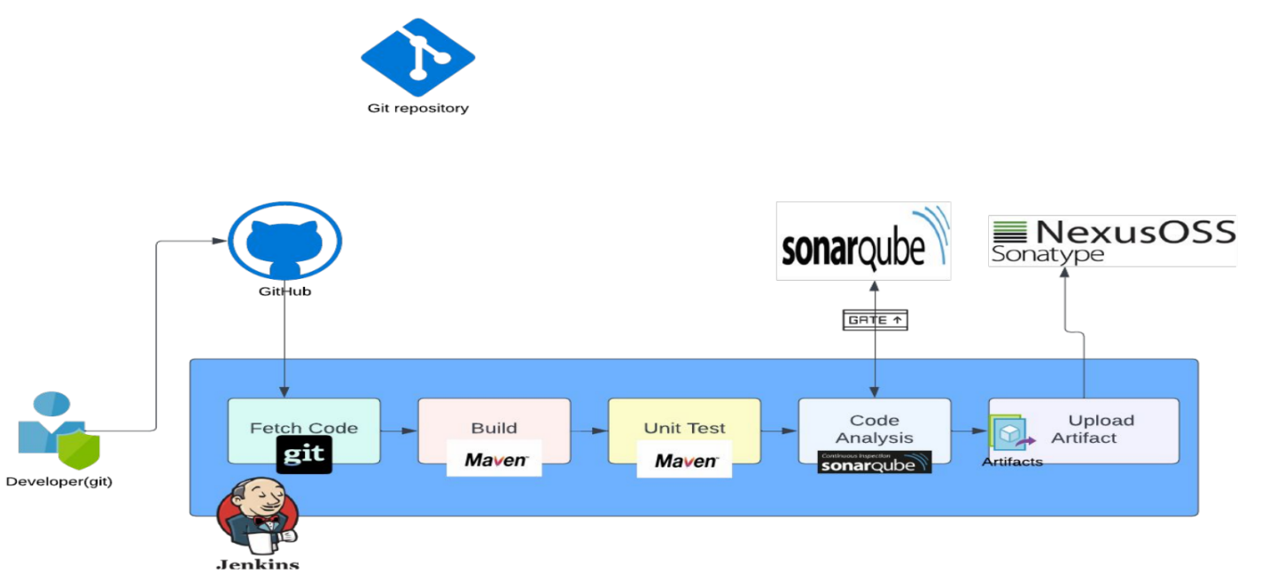
  - SonarQube
    - SonarQube analyzes the source code and generates a report (usually in XML format), which is uploaded to the SonarQube server.
    - Also we can define a Quality Gate — a set of rules (like no critical bugs, minimum 80% test coverage, etc.).
    - If it fails, then pipeline will stop.
    - You can think of SonarQube as your automated code reviewer that runs after your build or before deployment to check the quality of your code — not functionality, but cleanliness and security.
  - Nexus
    - It is you can say an artifact repository manager.
    - It stores built outputs (artifacts) - not source code.
    - Ex: .jar, .war, .zip, .rpm, Docker images, npm packages, Python wheels (.whl)
    - When you execute mvn clean install, one .jar file is created inside the target/ folder. That .jar file is stored inside nexus repo, not github repo.

- Steps for Continuous Integration Pipeline
  - Jenkins setup
  - Nexux setup
  - Sonarqube setup
  - Security group
  - Install necessary plugins in Jenkins (like Nexus, Sonar, Git etc)
  - Integrate
    - Nexus
    - Sonarqube
  - Write pipeline script
  - Set notification
- Nexus setup
  - Created an EC2 instance with volume type t2.medium.
  - In its security group, allowed 8081 port for Jenkins’s sg as it’ll be contacted by the port 8081.
  - Also ssh and 8081 for My IP.
- SonarQube setup
  - Created an EC2 instance with volume type t2.medium.
  - In its security group, allowed 80 port for Jenkins’s sg as it’ll be contacted by the port 80.
  - Also ssh and 80 for My IP.
  - SonarQube will contact Jenkins to provide response after the review; and this will be done via port 8080.
    - So, in the Jenkins SG add SonarQube with port 8080.
- NOTES
  - (all the ports mentioned below is not for the server i.e. EC2 instances, these ports are for the website (jenkins, sonarqube, nexus) hosted on those servers).
  - If an instance is accessible on a particular port (P), and a website is hosted on that same port (P), then any host that connects to the instance via port P will be able to receive responses from that website.
    - means to access the hosted website, first you need to access the instance; then only it’ll provide you access to that hosted website.
  - Jenkins is accessible through the port 8080.
  - SonarQube
    - SonarQube’s default accessing port is 9000.
    - We were able to access SonarQube website (hosted in my EC2 server) was because of Nginx setup.
      - 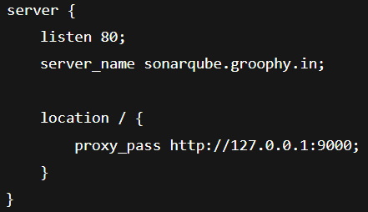
    - It listens on port 80 and forwards that to 9000.
    - If you add 9000 port from My IP in the Sonar security group, then it can be accessible through port 9000 as well.
    - So, to do proper sharing of information between SonarQube and Jenkins:
      - Jenkins SG should allow 8080 traffic from Sonar SG.
      - Sonar SG should allow 80 traffic from Jenkins SG.
    - nginx doesn’t present by default; we had installed that and configured in our code;
  - Nexus
    - Nexus runs on port 8081.
    - So, Sonar SG should allow 8081 traffic from Jenkins SG.

PIPELINE AS A CODE
- Introduction
  - Automate pipeline setup with Jenkinsfile
  - Jenkinsfile defines Stages in CI/CD pipeline.
  - Jenkinsfile is a text file with Pipeline DSL (domain specific language) syntax.
  - Similar to groovy.
  - Two Syntax:
    - Scripted
    - Declarative
- Syntax (the tree structure of the bullet points represents parent/child/siblings relationship of the commands)
  - pipeline { …. }
    - Main block of code.
    - Everything comes inside this pipeline.
    - agent { .. }
      - Where the job is going to run.
    - tools { .. }
      - From the global tools configuration, it you want to include any.
      - For ex: sonar, maven, jdk etc
    - environment { .. }
      - Environment variables.
    - stages { .. }
      - Steps that will be executed in the Job.
      - stage { .. }
        - The syntax will be like stage(“Clone code from git”) { .. }
        - steps { .. }
          - Actual commands
        - post { .. }
          - Post installation steps.
- 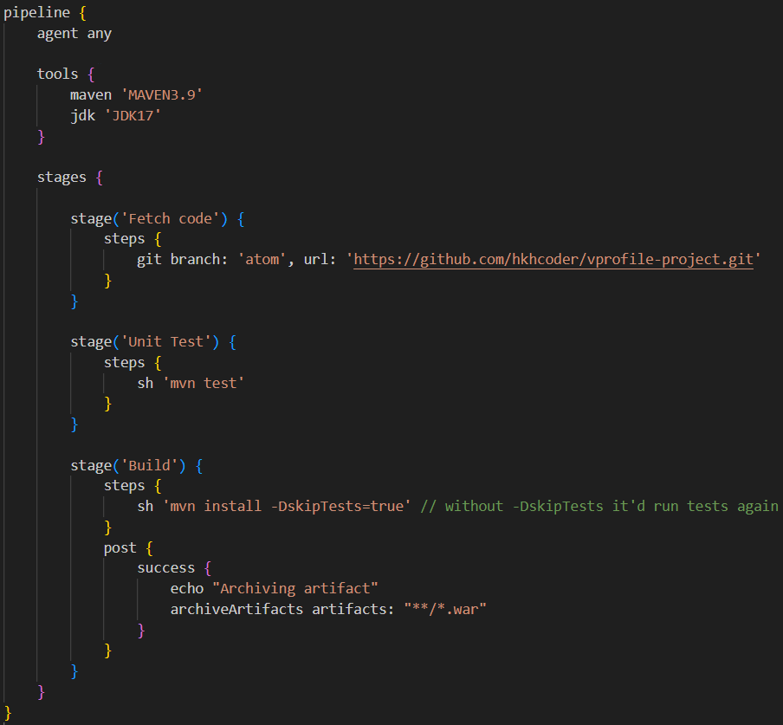
  - tools
    - The names i.e. ‘MAVEN3.9’, ‘JDK17’ should be same as defined in Jenkins global tool configuration.
  - stage
    - The first word is the plugin (git in the provided image)
    - And remaining will be the input fields which comes in the UI to enter the values like branch, url.
    - Multiple stage can be there.
    - Inside the post block, there is another block success, which will be executed if the pipeline succeeds till that.
      - archiveArtifacts is also a plugin.
  - Now go to Jenkins website, create one new file and select Pipeline instead of Freestyle.
  - Inside the created Pipeline item, under the Pipeline section, there will be 2 options.
    - 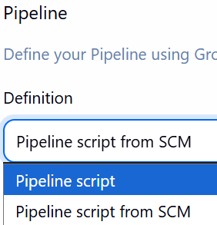
      - First one if you are pasting the Jenkinsfile code directly there.
      - Pipeline script from SCM means if you are taking the code from any repo like git. You need to give the url, and path to the Jenkinsfile (mostly its in the root directory only in the name Jenkinsfile)
      - In my case, I am going with Pipeline script.
    - 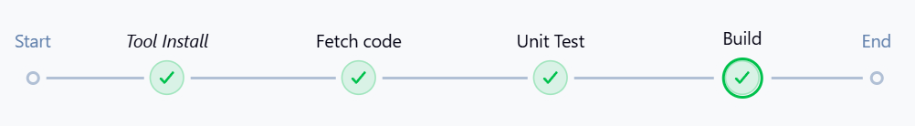
    - If you check the pipeline overview, it’ll be visible after the build.

- In order to integrate with SonarQube, we need to add this in the Tool (as we have installed Sonar Scanner plugin, so there will be an option visible)
  - 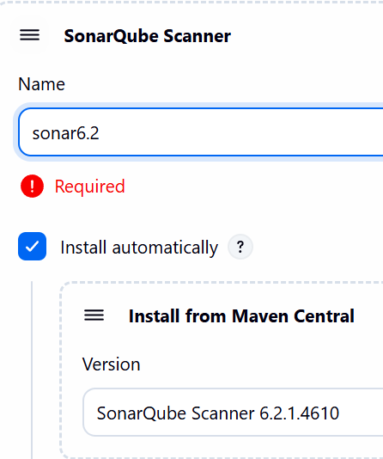
    - The exact name (sonar6.2) should be used in the code as well.
  - Now we need to configure the SonarQube server in the system page of jenkins.
    - Go to SonarQube >> (click on your profile) >> My Account
      - And generate one token.
    - 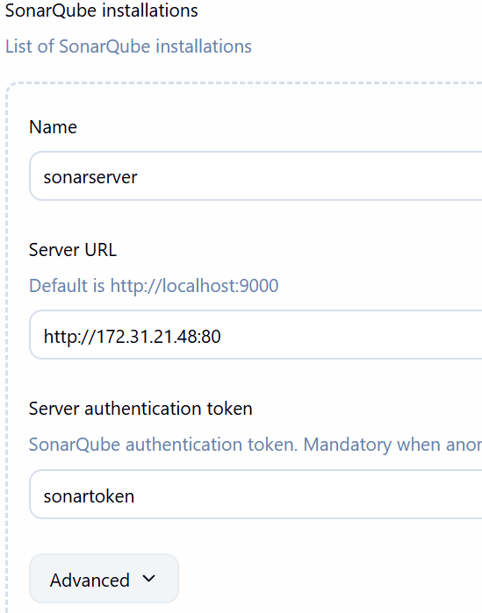(private ip of sonar server instance is given)
    - 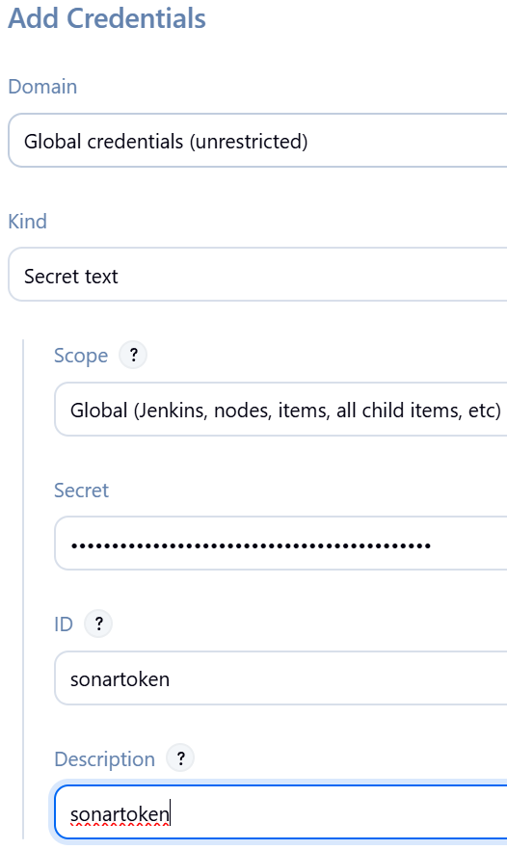(token is of type secret text)
      - This token will be present inside the page: manage jenkins >> credentials .
    - Now added that token here.
- Checkstyle
  - It comes in the through a Maven plugin called maven-checkstyle-plugin.
  - When you execute the command mvn checkstyle:checkstyle or mvn checkstyle:check it’ll download the maven plugin maven-checkstyle-plugin automatically if it is not there.
  - Neither of these commands build the code like mvn install.
  - maven checkstyle:checkstyle =>
    - This command will generate a report in xml file.
    - The execution of this command doesn’t stop even if the validations fails.
    - It is used to get a report of the code.
  - maven checkstyle:check
    - This command doesn’t generate a report in xml file.
    - The execution of this command stops if any validation fails.
    - It is suitable to include in CI/CD. If this command fails, then don’t build.
- In our CI/CD code, we’ll generate a report using checkstyle:checkstyle and upload that to sonar scanner to check properly.
- 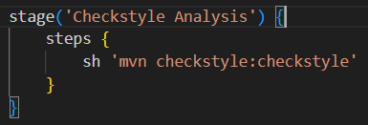
  - I included this stage in the pipeline.
  - NOTE: Whatever the execution happens in the pipeline, it’ll be stored inside the folder /var/lib/jenkins/workspace/<item name>/
  - So inside that folder, the xml report file was generated.
- 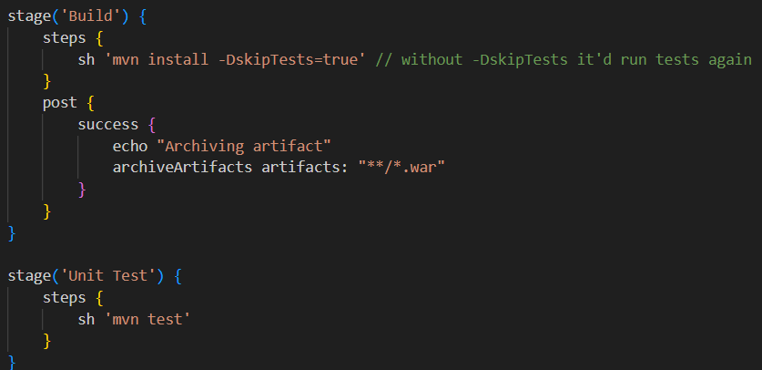
  - In here sh means execute the command in execution shell (in free style items we came across this)
- 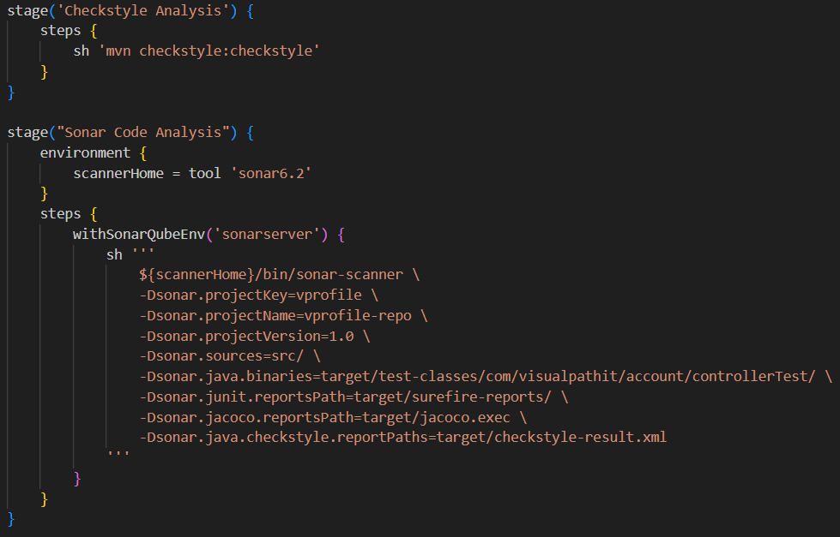
  - That environment block can be given in the top level as well (depending upon your usage).
  - In my case I only needed this in that specific stage “Sonar Code Analysis” so just written the environment inside that stage.
  - withSonarQubeEnv('sonarserver'){ .. }
    - It is not a normal function call like in Java.
    - Its purpose is to wrap a block of steps and inject environment variables for SonarScanner (SONAR_HOST_URL, SONAR_AUTH_TOKEN, etc.).
    - I gave some echo commands to print these default sonar environment variables.
      - 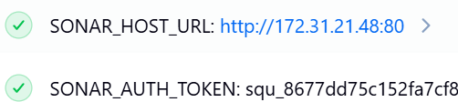
- 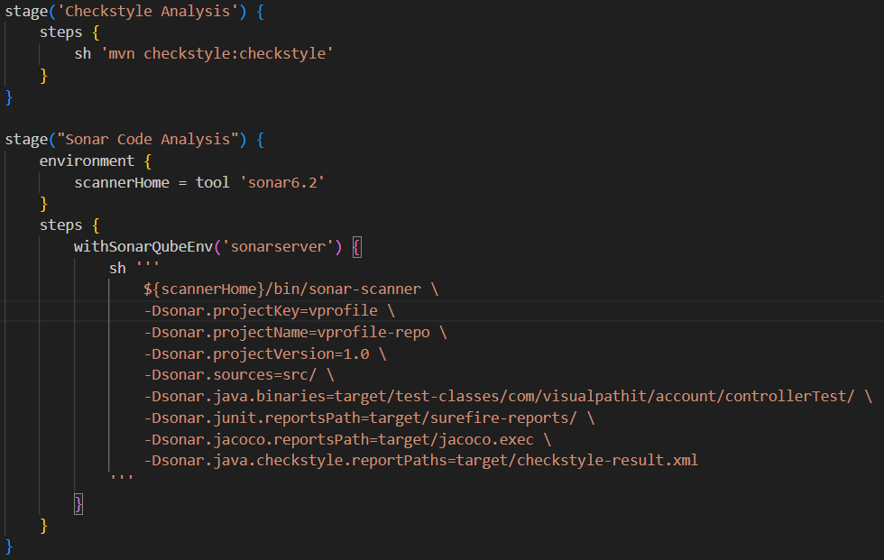
  - Here the xml report is being generated using checkstyle and then its uploaded to sonarqube.
  - Also jacoco is there to test the code coverage.
  - After that, in sonarqube the validation will happen.
    - With the default gate present in sonarqube, the validation will pass for me.
    - If you want to add custom validation, then you can create custom gate and attach that to the project in sonarqube.
    - 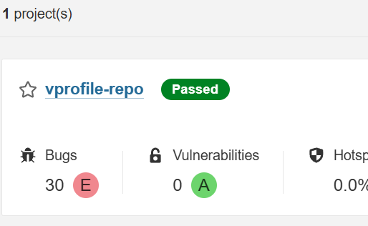 (after the build it’ll be created in sonarqube project page)
- To create and attach custom gate:
  - Click on the link Quality Gates in the navigation bar.
  - Give one name and create.
  - Go inside that newly created quality gate, scroll down and click on Unlock editing button.
  - Click on Add Condition button.
    - 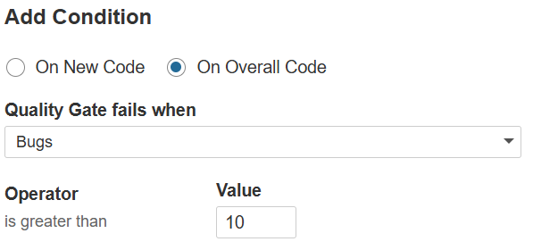
    - Now we need to attach this quality gate to the project.
  - Go inside your project and then:
    - 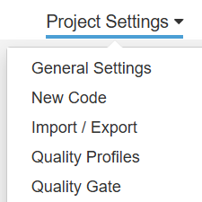 click on Quality Gate
  - Select your created quality gate.
  - Now when we run the pipeline again, if the bugs are greater than 10 then the sonar qube validation will fail.
  - But, the pipeline will still pass as the validation failure occurred in the sonarqube level.
  - So we need to return the response from SonarQube to jenkins in another stage, so that jenkins will validate that and fail the pipeline if the desired response is not received.
  - To achive this we need to configure Webhook.
- Configuring Webhook
  - When you install SonarQube plugin in Jenkins, it automatically exposes a default webhook url http://<jenkins-url>/sonarqube-webhook/
  - Go to the Project Setting (where the link to attach Quality Gate was there) and click on Webhooks.
  - Then Create Webhook giving the url as the above format.
  - 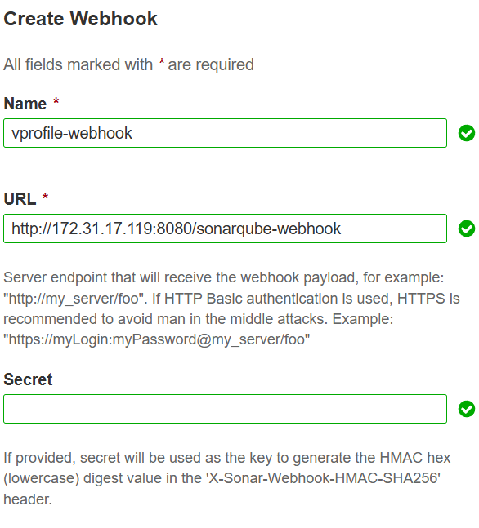 (No need to give Secret)
- 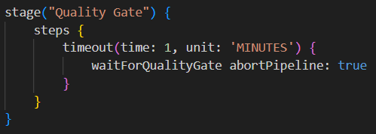
  - After configuring Webhook, I added this stage in the pipeline at the end.
  - So now, it the validation fails in the sonarqube, it’ll send the response to Jenkins so the pipeline will fail.
  - waitForQualityGate abortPipeline: true
    - Here only if the response is for failure, then only abortPipeline: true will be executed otherwise it’ll be skipped.
    - Also for timeout (if sonarqube doesn’t send any response till the desired timeout time)
  - 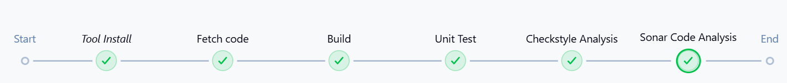
    - Before adding Quality Gate stage.
    - 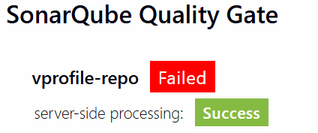(even if SonarQube failed, pipeline passed)
    - After adding Quality Gate stage.
  - NOTE: this Webhook will work only if SonarQube security group is allowed for port 8080 inside the Jenkins security group.
- Nexus setup (to upload the artifacts to nexus repo)
  - first make sure Nexus Artifact Uploader plugin is installed in the Jenkins.
  - First login to Nexus UI and create one repo of type maven2 hosted (hosted because we will upload the artifact). (for downloading: maven2 proxy is used)
  - Go to the page: manage jenkins >> credentials
    - Then click on that global link
      - 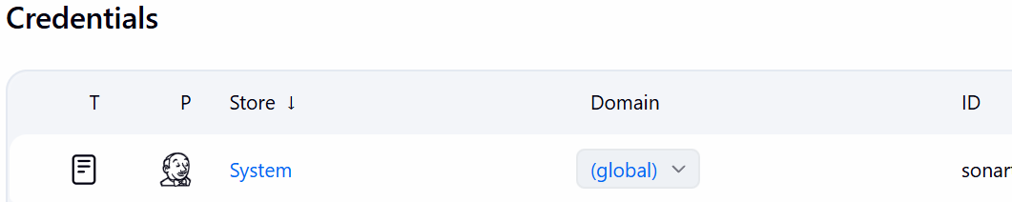
  - Create one credential giving nexus username and password:
    - 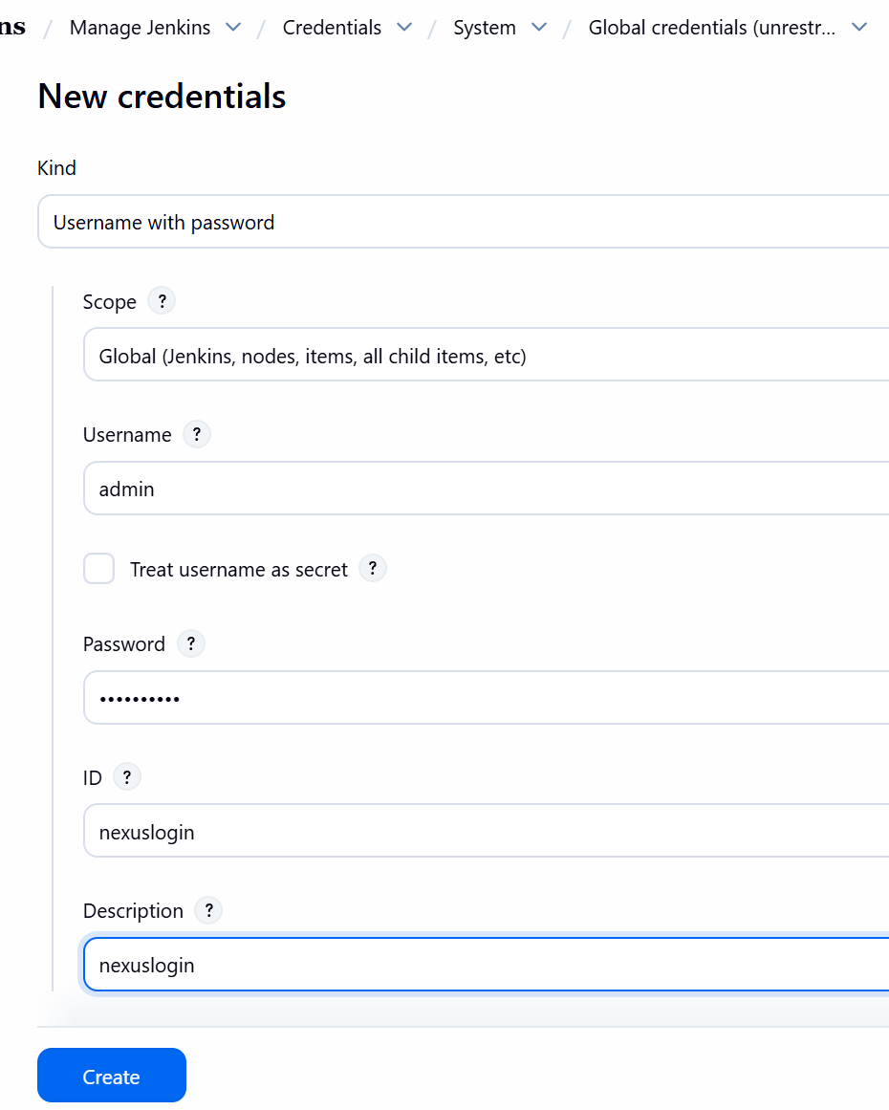
      - NOTE
        - System defines who can manage/access the credentials; Domain defines who (Job/Tool) can use those credentials (usually based on URL).
        - In the URL routing, system comes first then domain.
        - Url of system: …../system/
        - Url of global domain: …../system/domain/_/
        - Url of custom domain: …../system/domain/aloks.xyz/
        - So, system contains domains. And domains contains credentials.
        - If you want to add credentials, then its up to you that you’ll define that credential for any particular domain or global.

  - In groovy, def keyword is used to define both variables and methods.
    - 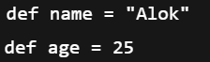
    - 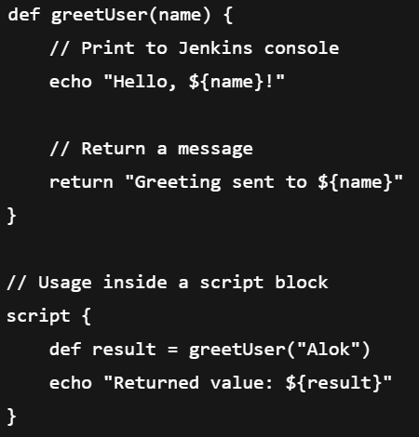
  - 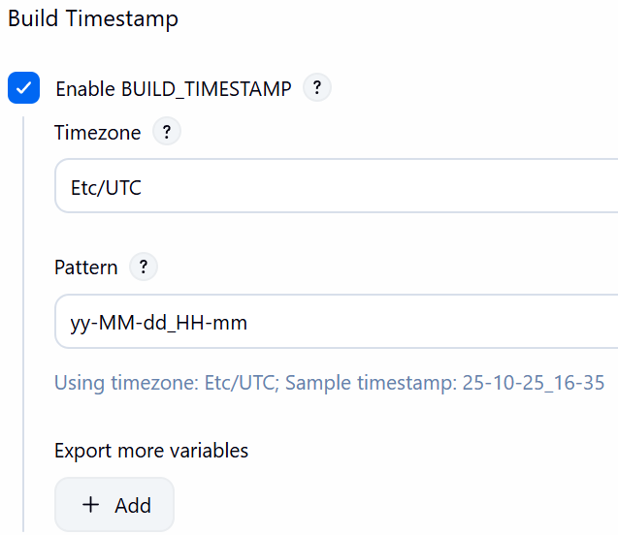(optional: set this timestamp to use in code)
  - Rule of Thumb
    - Built-in Jenkins env vars → always use env.
    - Variables in environment block → use directly in steps
    - Local def variables → only inside the block, without env.

  - 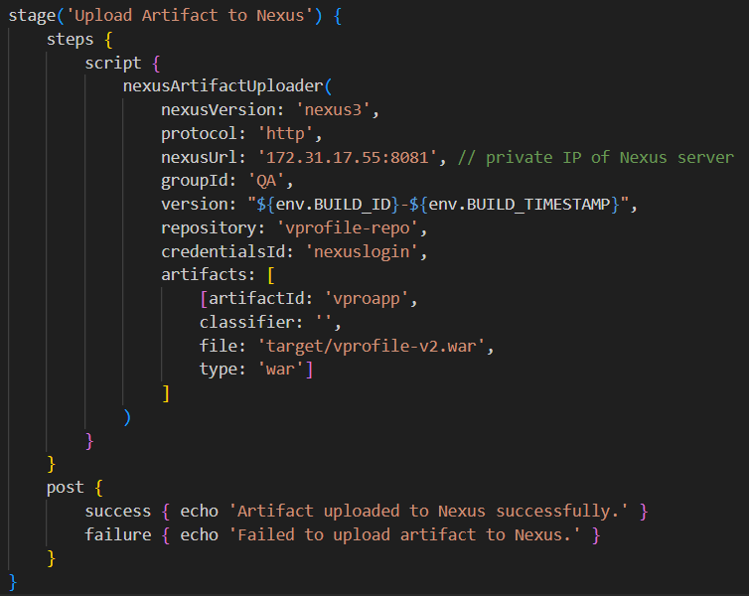
    - This is the method provided by that plugin Nexus Artifact Uploader.
  - 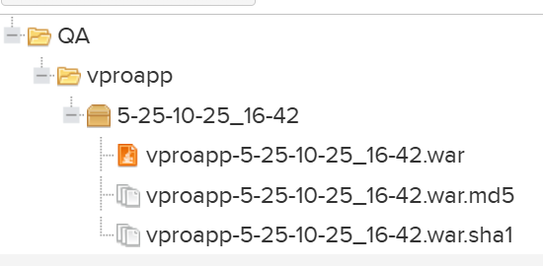
    - After building that pipeline, it was uploaded.
- Notification about success or failure of pipeline
  - I am using slack notification plugin.
  - First you need to create one slack account(if not there).
  - I created one channel devopscicd and added the app to that channel Jenkins CI. (it’s a slack app)
  - After adding that app, scroll down in that instruction page and copy the token.
  - 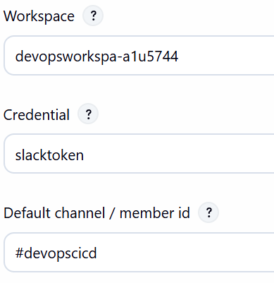
    - slacktoken: you have to add that with that copied token in the previous step
    - Add these things in the system page of Jenkins.
  - 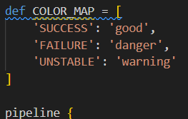
    - Defined this function at the top of the pipeline code.
    - It’ll set the text color based on the Pipeline status.
    - Those keys i.e. SUCCESS, FAILURE, UNSTABLE will be gotten by currentBuild.currentResult .
  - 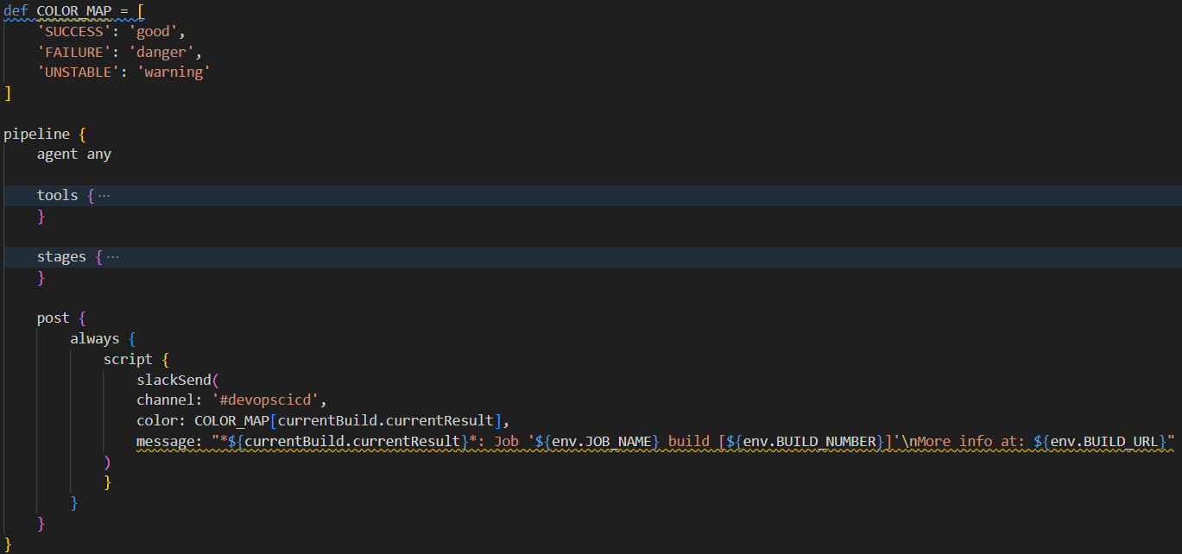
    - Remember: post block should be written outside the stages block otherwise the pipeline will fail even before running.
  - 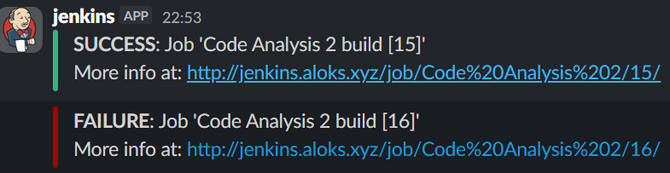
    - Here for success green and for failure red color came in slack.

Using Docker
- 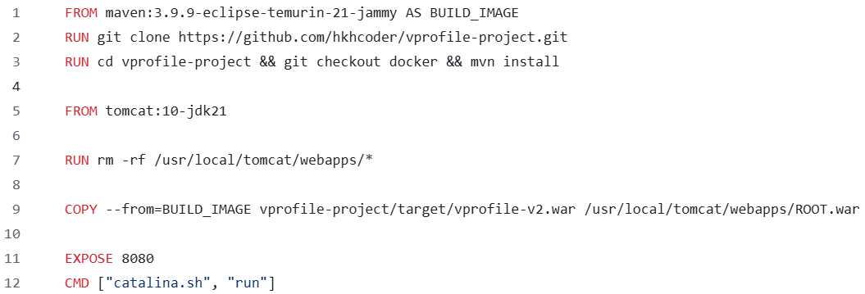
  - We have this Dockerfile, comprising of 2 steps (line 1 to 3, line 4 to last)
  - First it is getting one docker image maven:3.9… and giving alias to that as BUILD_IMAGE.
    - In that it is cloning the repo and building that using mvn install command.
  - Now its getting the tomcat image from dockerhub and hosting that previously built artifact (in the BUILD_IMAGE docker container).
- Steps:
  - AWS => IAM user with Access keys.
  - Install the plugins in Jenkins: Docker, Docker pipeline, ecr, AWS SDK
- SSH to Jenkins instance and install aws-cli using the command: snap install aws-cli --classic
- Install docker in Jenkins instance. Follow those 2 steps in the docker installation in ubuntu documentation: https://docs.docker.com/engine/install/ubuntu/
  - If you check now using systemctl, the docker should be running.
  - But, only the root user will have the permission to see and run the docker commands.
    - 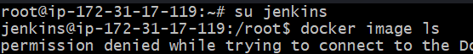
    - When checked the list of docker images after logging in with Jenkins user, it displayed permission denied.
  - There is a file /var/run/docker.sock which is responsible or executing the docker commands.
    - The user and group has that read write access.
    - So, we need to add jenkins user to the docker group.
    - usermod -aG docker jenkins (it’ll add the user jenkins to the group docker)
      - -a means append. It’ll append the group docker without overwriting the existing groups.
      - -G means to specify the secondary group.
    - 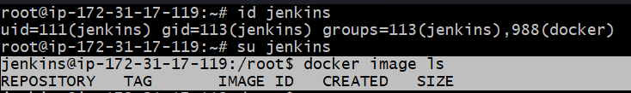
      - Now the docker commands can be run with the jenkins user.
- Now create one IAM user jenkins (I gave this name).
  - The following access should be granted:
    - AmazonEC2ContainerRegistryFullAccess
    - AmazonECS_FullAccess
  - After creating the IAM user, create one Access Key (type CLI).
- Now create one ECR (Elastic Container Registry)
  - ECR is same as Docker hub which is used to store images.
  - ECR by default host the images in private(but can host pubic as well); similarly Docker hub by default host the images in public (but can host private as well).
  - Using ECR is preferable because it can easily be integrated; no need for extra authentication for Docker hub. IAM user will handle everything in case of ECR.
  - 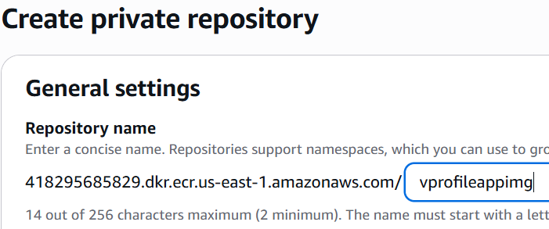
  - Then click on the “create” button to create the ECR.
- Now install the necessary plugins in Jenkins
  - Amazon Web Services SDK :: All
  - Amazon ECR
  - Docker Pipeline (provides methods like docker.build, docker.withRegistry ..etc)
  - CloudBees Docker Build and Publish (used in free style mostly)
- Now we need to add credentials (Manage Jenkins >> Credentials)
  - You’ll get an option AWS Credentials in that drop-down where we were selecting the type of credential i.e. username password, secret text etc etc.
  - 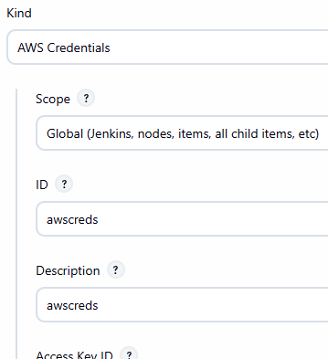
- Added Build App Image stage after the Quality gate stage.
  - We’ll remove the stage which was uploading artifacts to nexus, instead we’ll build docker images and upload those to the ECR.
  - 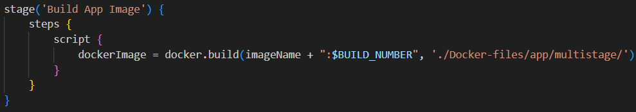
    - 2nd argument is the path to the Dockerfile in our workspace.
    - In github repo, Dockerfile is present at that path.
- So now below is the changes:
  - 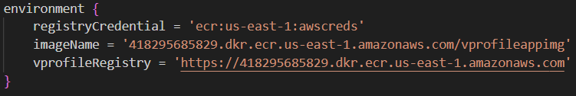
    - That format of registryCredential should be same:
      - ecr:<region of ecr>:<name of aws credential>
  - 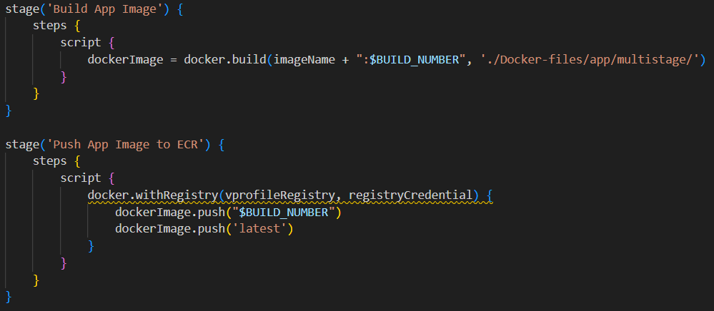
  - 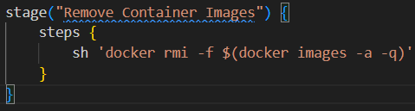
    - It is at the end.
    - It’ll find all the docker images on the host where docker was running (i.e. Jenkins instance) and delete all those images from that machine.
    - Images will not be deleted from ECR (Remember).
- 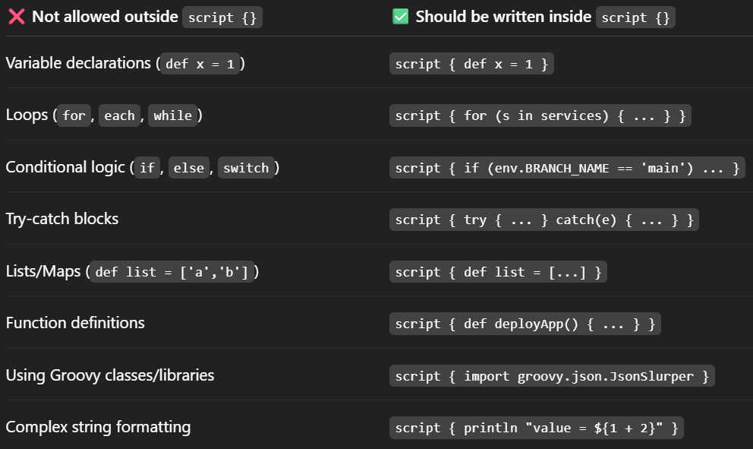
- 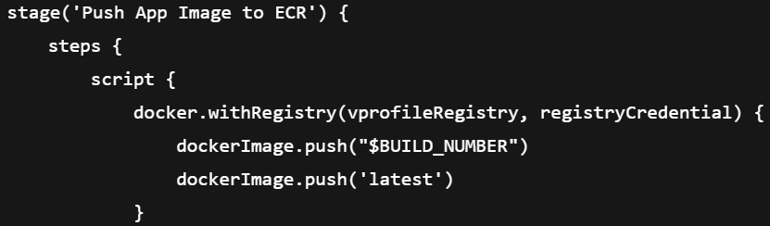
  - Here script block is not required as we’ve not used any groovy specific things.

Docker CICD
- We’ll be using ECS (Elastic Container Service). (alternative of Kubernetes in AWS)
  - We’ll have to create 2 things: cluster, service
  - Service is inside the cluster, which(service) will fetch the container from ECR and run it.
  - We’ll be using withAWS which is available inside the plugin Pipeline: AWS Steps
- NOTE
  - You can imagine cluster as a pc, task definition is a programming code that tells how and what to run, service is something that ensures n copies of that code is running always.
  - Cluster:
    - A logical group or environment that organizes and manages all the compute resources (like EC2 instances or Fargate tasks) where your containers actually run..
    - During creation of cluster you can either choose EC2 or Fargate.
    - If you choose Fargate then you don’t need to worry about the instances or group of instances where the containers will be running.
    - It’ll scale by itself.
    - AWS automatically allocate resources that’ll enough for your container to run.
  - Task definition:
    - It defines which Docker image to use.
    - Its kind of a blueprint that defines how to run the container.
    - It describes cpu utilization, port mapping, env variables, IAM role etc.
    - When ECS creates a task, it’ll see the Task Definition and follow its instruction to spin up the containers.
  - Service:
    - It ensures that a specified number of tasks (containers) are always running.
    - It handles Load Balancing.
    - Supports Auto Scaling.

- Creating ECS cluster and service:
  - Create one cluster after going to the ECS page.
  - Give one name and its better to give one tag as well.
  - Then click on create; if it shows any error then create again; it’ll succeed.
- Now create one Task Definition
  - 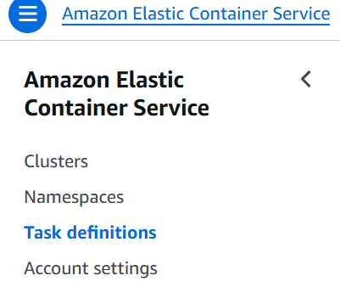
  - I gave the name vprofileapptask, launch type AWS Fargate, OS Linux/X86_64, memory 2gb,
  - 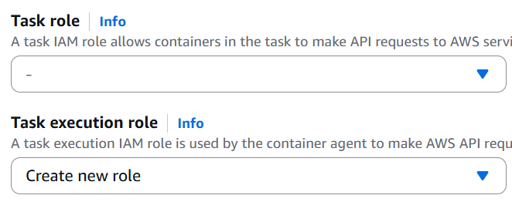
    - Keep these 2 blank now. We’ll update these later.
  - In the Container section, give a name and paste the ECR registry URI in the box.
  - 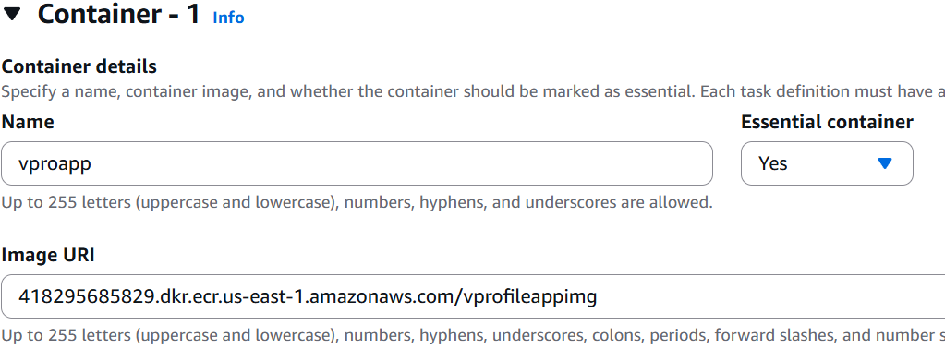
  - As docker is using tomcat and it runs on port 8080, so give 8080 in the container port field.
  - 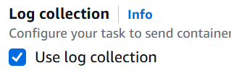
    - Make sure this checkbox is checked. It’ll upload the logs to Cloudwatch.
    - We’ll update that IAM Role to access those as by default the IAM role has don’t have permission to accesss the CLoudwatch logs.
  - Now click on create button to create task definition.
  - Now we need to provide access that IAM Role.
    - Open that Task definition and you’ll find one link of the role.
    - 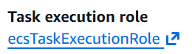
    - Click on this (or you can go to the IAM page and click on Role).
    - 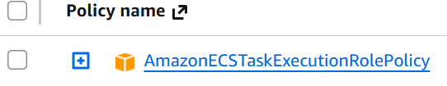
    - You can see only one policy is attached to it.
    - Add the permission CloudWatchLogsFullAccess to that role.
- Now we’ll create the Service
  - Go inside the cluster and create one service.
  - Now you’ll get one option to choose the Task Definition.
    - 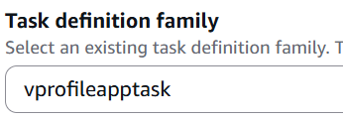
    - Select the previously created Task Definition.
  - Service name: vprofileappsvc, Desired task: 1,
  - For now, un-check the “Use the Amazon ECS deployment circuit breaker” under “Deployment failure detection” section.
  - Under the networking section, create one security group. This will be used by the Load Balancer and Instances (which will run containers).
    - I added 80 and 8080 for all Ip.
  - Now under the Load Balancer section:
    - Select the application load balancer and give one name to that.
    - Under the listener, give the frontend port as 80. means ELB will listen on port 80 and it’ll forward to port 8080.
    - Under Target Group section, give one name to the target group. Target group port: 8080.

- Ports and Security groups during ECS configuration (Very Very Important) -----------
  - First you create the cluster which is simple only.
  - Then while creating Task Definitions :
    - Here we need to give the Port Mapping under the Container section.
      - 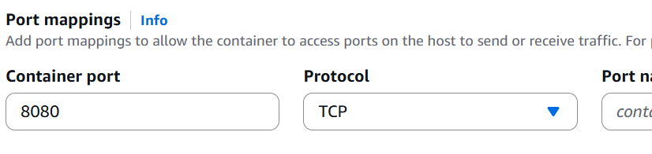
    - This port is for the container i.e. in our case tomcat will be running which listens to the port 8080 so we gave that.
    - This port mapping will appear while creating the Service inside the cluster selecting this Task Definition.
      - 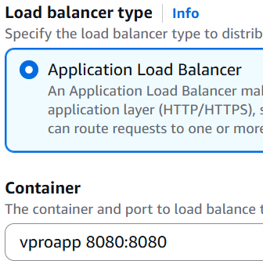
      - So here 8080:8080 mapping appeared as we gave 8080 in the Task Definition Port Mapping.
  - Now while creating Service (VERY IMPORTANT):
    - In the beginning we need to select the Task Definition to let the service know about the port mapping, info about the docker registry, … etc etc.
    - Under the section Networking:
      - You can create or select some already created security groups.
      - Whatever the security groups will be selected or created, all of those will be attached to both Instances (where the docker containers will be running) and ALB (Application Load Balancer).
      - So, in here we need to give both the ports i.e. 80 (for ALB; Because Clients will send request to ALB with port 80) and 8080 (for Instances; Because ALB will send traffic to Instances with port 8080)
    - After that under the section Load Balancing :
      - You’ll have 2 sub-sections here; Listener and Target group.
      - Just like normal Application Load Balancer in EC2 service, here also this Listener means the port which will be accepted by ALB. Means this port is for Client to ALB connection.
      - In Target Group section, the port that you’ll give, will be used for ALB to Instances connection.
      - NOTE: This listeners and Target groups doesn’t create any security group. Security groups are for IP filtering and Listeners are for Port filtering.
  - 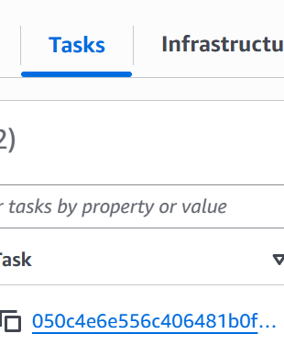(The instances can be seen in Tasks tab of Cluster)
  - If you want to follow the security standard i.e. keep the security groups of ALB and Instances separately then follow the below instructions:
    - Create 2 security groups. Lets sg-elb and sg-instance.
    - sg-elb inbound rule: 80 for all IP
    - sg-instance inbound rule: 8080 for sg-elb
    - Now, create one Load Balancer and attach that sg-elb to it.
    - Now while creating ECS Service, during selecting the security group under the section Networking, just select the sg-instance.
    - And under the Load Balancing section, select the created load balancer that we created before.
    - Now, the security group that we selected during creating Service i.e. sg-instance will not be attached to the Load Balancer. It’ll only be attached to the Instance.
    - Now the Instance is not exposed to all IP.
  - ------------------------------------------------------------------------------------------

- A
- F
- D
- F
- A
- F
- A
- A
- F
- F
- F
- F
- D
- F
- D
- F
- F
- F
- F
- S
- 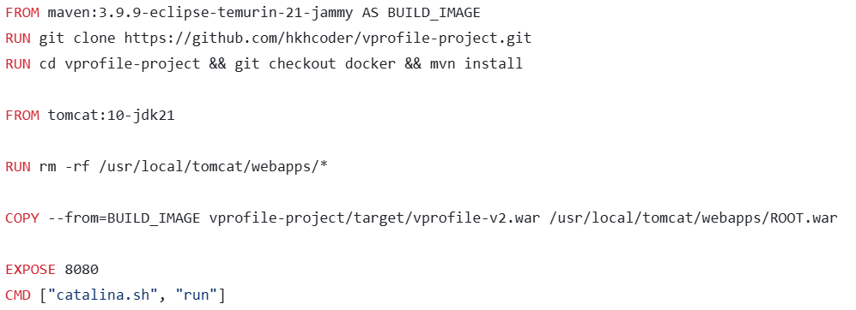
  - Dockerfile that is being used in build stage.
- F
- H
- A
- S
- F
- H
- L
- F
- A
- S

