- Configuring the Vagrantfile
  - When u write “vagrant up”, at the end of the config a shared path is given I.e. /c/devops_udemy/vagrant-vms/ubuntu => /vagrant
  - Here the first path is of the host machine, and 2nd path is of the guest machine.
  - Whatever u create inside that virtual machine on that path, same will be appeared in the physical machine as well and vice-versa.
    - 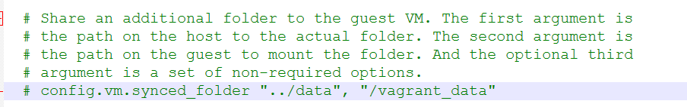
      - It is the Vagrantfile.
    - 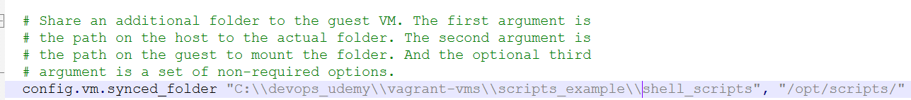
      - I edited this. (remember: 2 backward slash in windows)
      - Note: You need to create folder in host(windows) machine. In guest(linux) machine, it’ll be automatically gets created.
    - 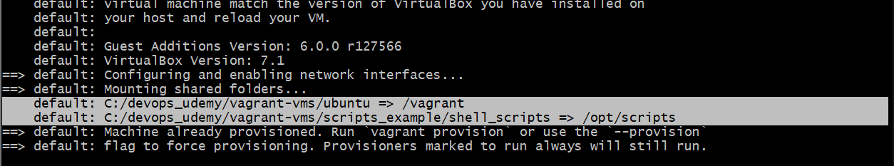
      - Now, you can see 2 sync paths. One is default and one is that we created.
      - 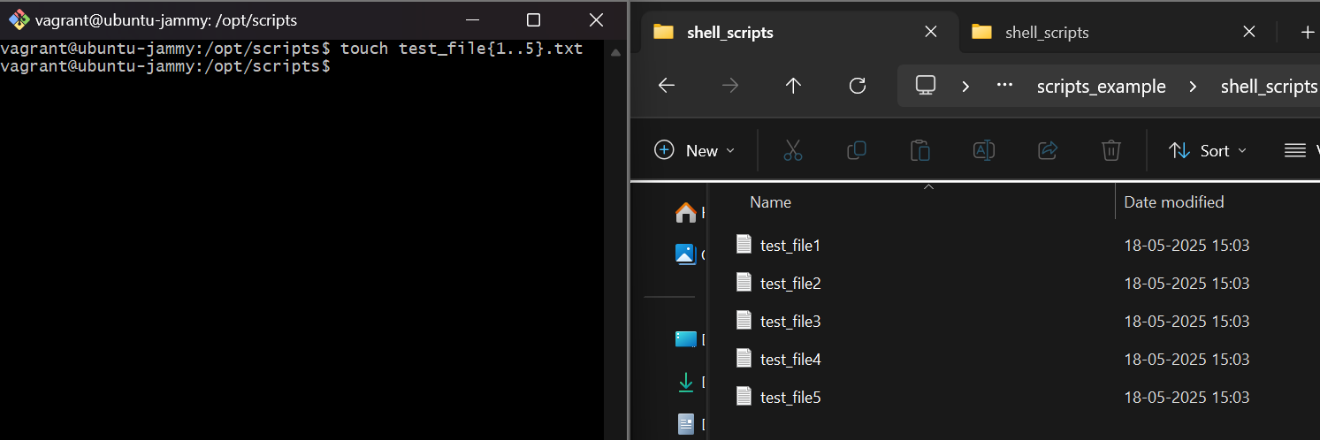
  - Provisioning:
    - 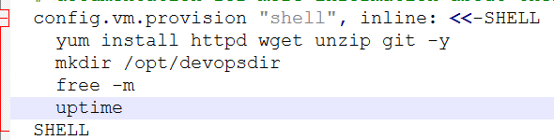
    - Whatever we write inside that -SHELL and SHELL, will be executed while loading the Vagrantfile.
    - “inline:” means we are writing the command in the same file only
    - These commands will be executed while creating the os only, not while reloading.
    - To provision during the reload as well, use the flag --provision. i.e. vagrant reload --provision

- Website
  - 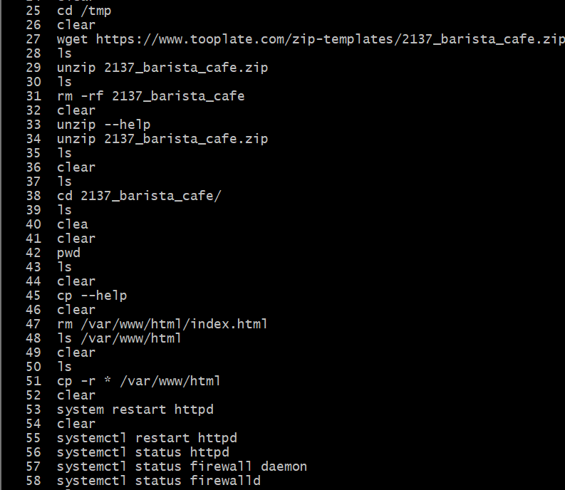
  - Download the zip file (if you want to get from any website, if you have already then no need)
  - Move it to /var/www/html directory.
  - Start httpd
  - Now u can check in the browser using your guest machine IP (not using the NAT ip).
- Multiple VM:
  - vagrant up <vm name> (as multiple vms are there)
  - vagrant ssh <vm name>
  - vagrant destroy <vm name>
    - vagrant destroy (If not specified any vm, it’ll destroy all)
  - Ex:
  - 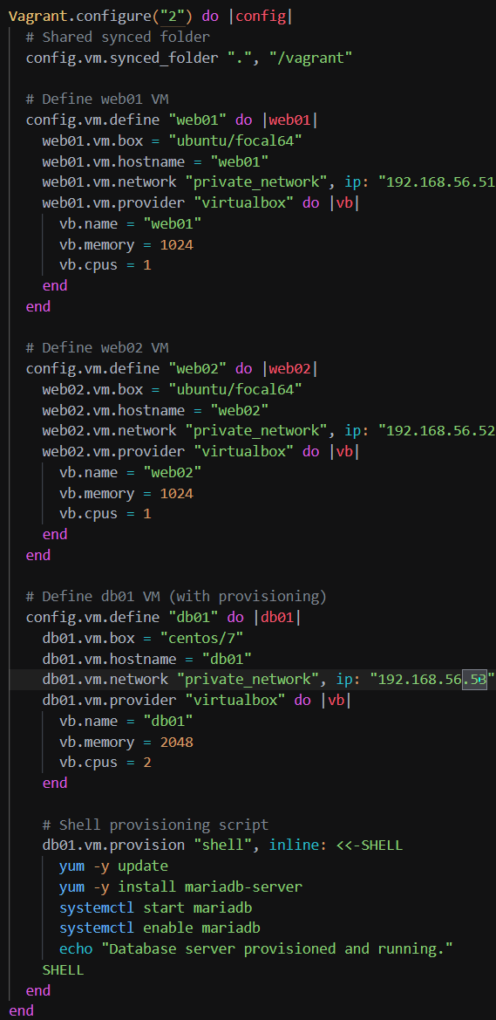
- Systemctl & Tomcat:
  - Apache Tomcat:
    - Free, open-source Java servlet container.
    - It hosts Java-based web apps.
    - Dynamic content & handling web requests.
  - 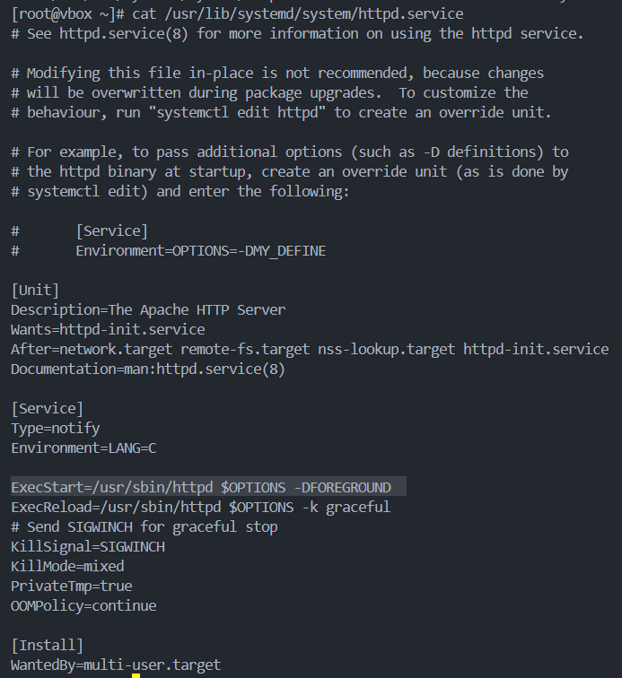
    - You can see, 3 things are there ([Unit], [Service], [Install])
    - When we run systemctl start httpd , it basically runs this command which is there next to “ExecStart”
  - 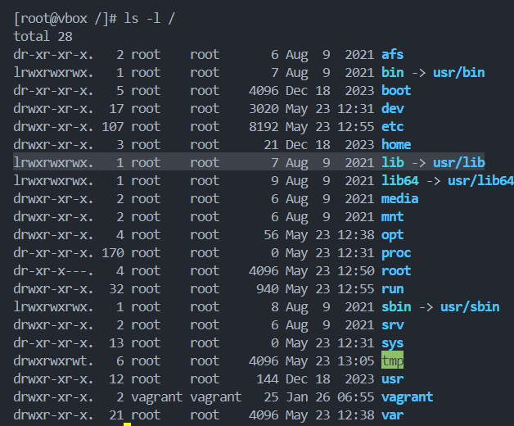
    - /lib is nothing but a link to /usr/lib
  - 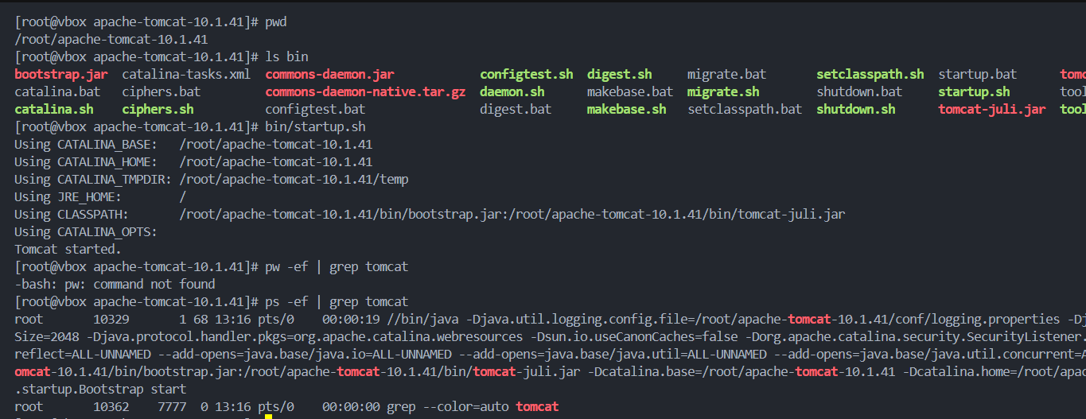
    - This is how, we can run tomcat. (bin/startup.sh contains the code to start the tomcat. It’s just a shell script so we can directly run this to start tomcat).
    - Write ip addr show and take an ip and paste this in browser. Do not forget to give the port 8080. It’ll show display the default apache tomcat page. Ex: 192.168.60.226:8080
    - Abdd

- Systemctl work:
  - When we execute the command systemctl start <service>, It’ll check the file <service>.service inside one of the following directories:
    - /etc/systemd/system
    - /run/systemd/system
    - /usr/lib/systemd/system or /lib/systemd/system
  - When you download a service from a package installer like yum or dnf, It creates a file like <service>.service, so you can give any commands using systemctl.
  - But tomcat is not installed by default, You’ll have to download this package from outside. So, you’ll have to run it’s startup.sh file to start tomcat.

- To automate the enabling of tomcat even after reboot:
  - useradd --home-dir /opt/tomcat --shell /sbin/nologin tomcat
  - 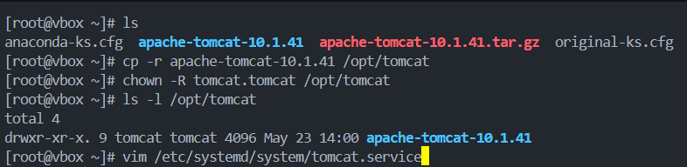
  - 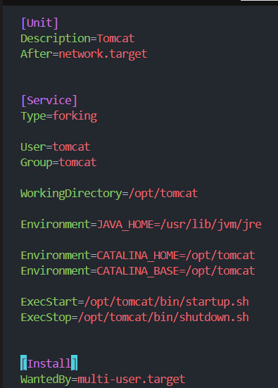
    - Environment=<variable_name>=<variable_value>
    - It is used to define environmental variables.
  - systemctl daemon-reload
- Values of WantedBy
  - 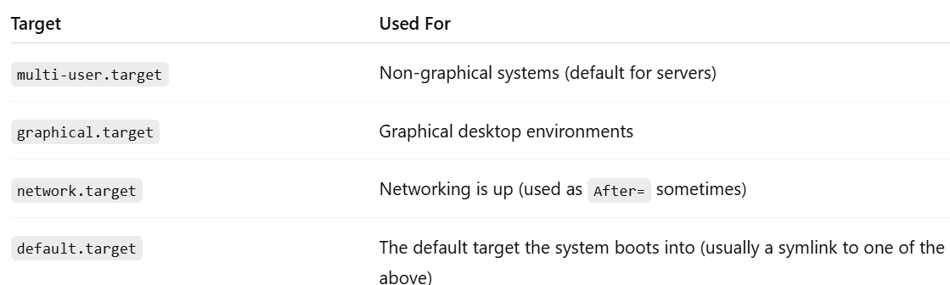

- All Commands:
  - 